West Virginia PYs 2024-2027

Contents
West Virginia PYs 2024-2027 1
I. WIOA State Plan Type and Executive Summary 3
a. WIOA State Plan Type 3
Combined Plan Partner Program(s) 3
b. Plan Introduction or Executive Summary 3
II. Strategic Elements 4
a. Economic, Workforce, and Workforce Development Activities Analysis 4
b. State Strategic Vision and Goals 120
c. State Strategy 130
III. Operational Planning Elements 132
a. State Strategy Implementation 132
b. State Operating Systems and Policies 175
IV. Coordination with State Plan Programs 210
V. Common Assurances (For All Core Programs) 215
VI. Program-Specific Requirements for Core Programs 217
Program-specific Requirements for Adult, Dislocated Worker, and Youth Activities under Title I-B 217
Program-Specific Requirements for Wagner-Peyser Program (Employment Services) 248
Program-specific Requirements for Adult Education and Family Literacy Act Programs 261
Program-Specific Requirements for State Vocational Rehabilitation (Combined or General) 275
VII. Program-Specific Requirements for Combined State Plan Partner Programs 409
Jobs for Veterans’ State Grants 409
Unemployment Insurance (UI) 414
Senior Community Service Employment Program (SCSEP) 524
Community Services Block Grant (CSBG) 558
Performance Indicator Appendix 559
All WIOA Core Programs 559
Additional Indicators of Performance 562
Other Appendices 563

I. WIOA State Plan Type and Executive Summary

a. WIOA State Plan Type
This is a combined plan

Combined Plan Partner Program(s)
Jobs for Veterans State Grants Program (programs authorized under 38, U.S.C. 4100 et. seq.)
Unemployment Insurance programs (programs authorized under State unemployment compensation laws in accordance with applicable Federal law)
Senior Community Service Employment program (programs authorized under title V of the Older Americans Act of 1965 (42 U.S.C. 3056 et seq.))
Community Services Block Grant (Employment and training activities carried out under the Community Services Block Grant Act (42 U.S.C. 9901 et seq.))

b. Plan Introduction or Executive Summary
The State of West Virginia is undergoing an economic renaissance as the economy both fully recovers from the COVID-19 pandemic and continues to diversify. During Governor Jim Justice’s term in office, the state has experienced a number of important business expansion and economic development announcements in diverse industries such as chemical and metals manufacturing, energy technologies, and aerospace. Most economic sectors have fully recovered from the COVID-19 economic downturn, led by construction and business services.¹
As the West Virginia economy continues to grow and diversify, an educated and skilled workforce is crucial. Workers and students must be exposed to the new, high-quality job opportunities available in West Virginia through multiple avenues, especially an enhanced “No Wrong Door” public workforce system, which effectively coordinates work between state and local workforce partners, employers, post-secondary education institutions, and community-based service providers.
The goals and strategies of West Virginia’s No Wrong Door system seek to address chronic issues plaguing West Virginia’s workforce including:
- West Virginia’s labor force participation rate
- Low postsecondary educational attainment rates
- Youth leaving the state for jobs and careers
- Long-term unemployed and dislocated workers moving into new industries and jobs.
West Virginia’s vision and commitment to the following four goals are designed to specifically address the state’s economy and workers in transition:
- West Virginia will expand and implement high-quality work-based learning opportunities for youth and adult learners.
- West Virginia will increase referrals and integration of services to improve access to supportive services customized for individuals needing education and employment.
- West Virginia will implement comprehensive sector strategy approaches to reduce skills mismatches and enhance faster labor market attachment while informing education and training priorities.
- West Virginia will implement the Blue Ribbon Franchise Model of workforce service delivery to increase the efficiency of service delivery and effectiveness in serving businesses, workers, and job seekers.
1. West Virginia Economic Outlook 2023-2027 is published by the Bureau of Business & Economic Research, John Chambers College of Business & Economics, West Virginia University, Josh Hall, PhD, Milan Puskar Dean

II. Strategic Elements

a. Economic, Workforce, and Workforce Development Activities Analysis

1. Economic and Workforce Analysis
West Virginia’s economy is well on its way to recovery from the COVID-19 pandemic. West Virginia continues to address its low labor force participation and lower educational attainment, but new business relocation, investments in economic growth and workforce education, and a focus on transitioning from legacy industries with less employment today to high tech employment in manufacturing and other technologies presents opportunities for West Virginia workers.
According to West Virginia Economic Outlook 2023-2027 produced by West Virginia University, many of the state’s economic indicators now surpass pre-pandemic levels and several have even managed to reach new highs. West Virginia’s economic growth prospects for the next five years are moderately positive overall.
The Economic Outlook highlights the following key indicators:
- Employment fell by roughly 95,000 jobs in March and April 2020. As of late-summer 2022, preliminary data shows nearly 93,000 jobs have been regained—leaving the state nearly on par with its pre-pandemic level.
- Several sectors have seen activity return to or surpass pre-pandemic levels, including construction and business services. Many sectors face high rates of unfilled job openings.
- The state’s unemployment rate reached an all-time low of roughly 3.5 percent during the second quarter of 2022.
- Only 55 percent of West Virginia’s adult population is either working or looking for work. This remains the lowest rate of labor force participation among all 50 states and is a key hurdle to economic growth.
- Per capita personal income in West Virginia increased by more than 7 percent in 2021 and stands at roughly 76 percent of the national average.
- West Virginia’s real GDP increased 4 percent in 2021, helping to offset the drop in economic output observed during 2020. The state’s topline measure of real economic output remains volatile, largely because of the state’s history and role as an energy producing state, and that volatility continues into 2022.
Existing and Emerging Economic Sectors ²
West Virginia’s economy is characterized by 11 major sectors: natural resources and mining; construction; manufacturing; trade, transportation, and utilities; information; financial activities; professional and business services; education and health services; leisure and hospitality; other services; and total government. Between 2018 and 2028, many of these sectors may see employment declines while others will experience growth.
West Virginia's economic landscape reveals a mix of positive and challenging trends across various sectors. Industries such as Accommodation and Food Services, Educational Services, and Transportation and Warehousing show steady employment growth, contributing to the state's economic stability.
In manufacturing, certain sub-industries like transportation equipment, nonmetallic mineral products, plastics, and rubber products are expected to grow, while others face declines. Navigating this diversity within manufacturing is key for effective economic planning.
However, challenges persist in sectors like Mining and Wholesale Trade, where significant declines in employment highlight the need for targeted strategies and support for affected communities.
Negative figures in Finance and Insurance, Utilities, Information, State Government (excluding education and hospitals), Federal Government (excluding post office), and Wholesale Trade emphasize the complexity of the economic landscape. Adapting to these shifts will require proactive measures and a diversified economic approach.
2 Unless otherwise noted, figures and data are produced by the West Virginia Labor Market Information unit.
Figure 1: West Virginia Industry Projections, 2020-2030
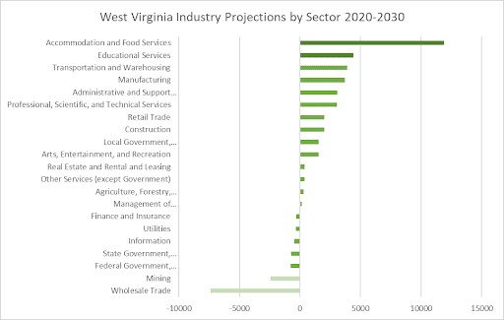
Figure 2: West Virginia Employment Distribution by Sector, 2021
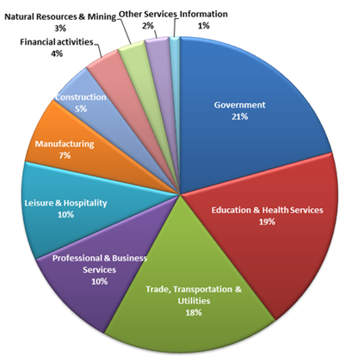
Source: WV Economic Outlook
Projected employment trends in the manufacturing sector for West Virginia through 2030 present a varied landscape, featuring growth in some industries alongside declines in others. Noteworthy expansions are expected in transportation equipment, nonmetallic mineral products, plastics and rubber products, and primary metal manufacturing. Conversely, sectors such as printing and related support activities, electrical equipment, appliance and component manufacturing, and furniture and related product manufacturing anticipate significant declines.
Figure 3: West Virginia Manufacturing Projections, 2020-2030
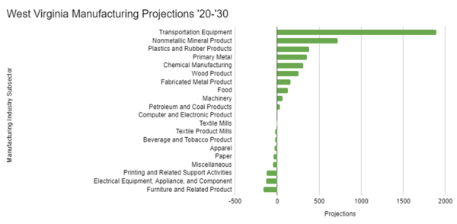
Within the education and health services subsector, West Virginia is expected to experience a notable rise in ambulatory health care services, with hospitals following closely as the second-highest projected industry for growth from 2020 to 2030. Within this subsector there are no projected declines overall.
Figure 4: West Virginia Education and Health Services Projections, 2020-2030
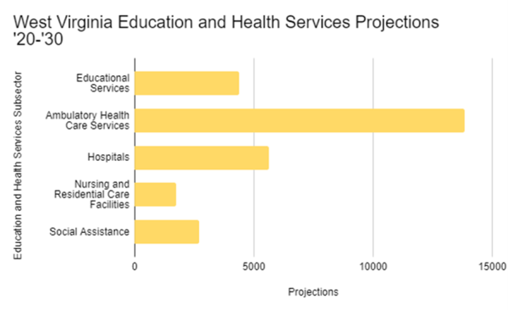
In the energy sector, coal and electricity production have experienced volatility over the past two years but are on track to recover somewhat from the downturn in production during the COVID-19 pandemic. Coal production has increased over 16% since 2020 and is expected to continue rising. Industrial and commercial electricity needs continue to increase as economic activity has increased after the pandemic recession. Despite these production increases, coal employment has not risen at the same pace to date, growing to 11,700 workers in 2021 from 11,650 in 2020, a significant decrease from 2019’s 14,500 workers. Preliminary data shows an increase in workers in 2022, with Q1 showing an 11% increase from the same time in 2021.
Figure 5: West Virginia Regional Coal Production, 2007-2022
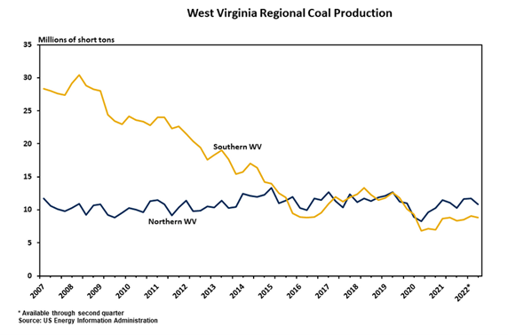

Source: WV Economic Outlook
Future forecasts suggest that coal production numbers will likely return to pre-pandemic levels, and other sources of energy production may rise due to market pricing or policy decisions in the future. Employment numbers will follow similar trends with coal jobs remaining flat and natural gas jobs growing by approximately 5% a year, though increases in natural gas productivity could reduce labor demand and could cause weaker employment growth.
Figure 6: West Virginia Coal and Natural Gas Output, 2005-2027
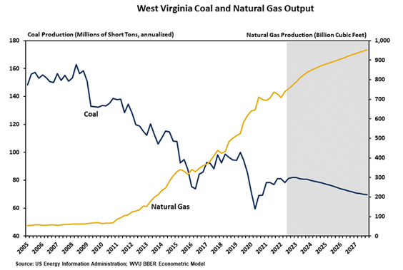
Source: WV Economic Outlook
Figure 7: West Virginia Energy Sector Employment Forecast, 2006-2027
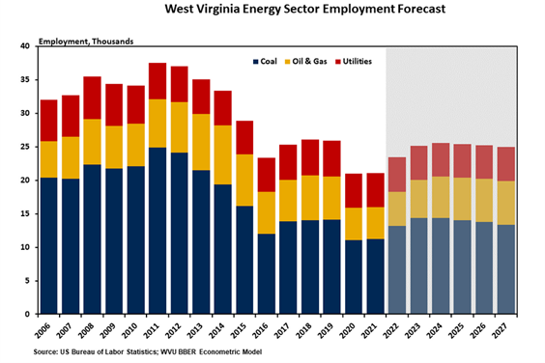
Source: WV Economic Outlook
The manufacturing sector remains a robust part of West Virginia’s economy and is a reason the state is a part of global economic trade. New growth in automotive manufacturing, metals, and food and beverage manufacturing have all contributed to increased rates of production that are expected to continue. Despite this progress, there have been pandemic-related difficulties in manufacturing because of the disruption of global supply chains and closures of two major plants in the state, and there are concerns about impacts of rising interest rates, cost of capital, and potential recessions leading to further downturn of production, and thus employment. That said, the overall outlook is positive with 1) 11 of 14 subsectors expected to increase their employment levels and 2) total manufacturing productivity expected to continue rising.
Figure 8: West Virginia Manufacturing Employment Growth Forecast, 2011-2027
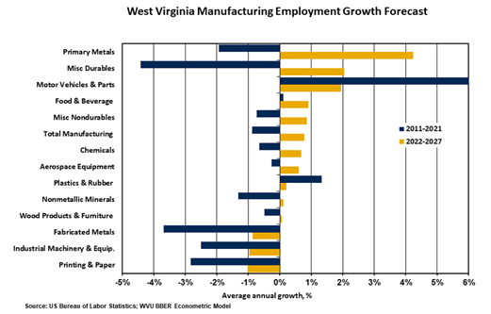
Source: WV Economic Outlook
Figure 9: West Virginia Manufacturing Sector Productivity, 2007-2027
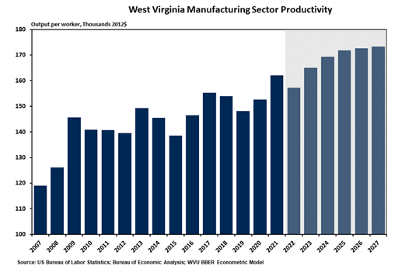
Source: WV Economic Outlook
Construction was one of the first sectors to surpass pre-pandemic levels of activity, and output is expected to continue to grow significantly in the long run. Employment openings have remained high, which has hindered some productivity, but employment is expected to grow by 1.1% per year through the end of 2027. Significant utility sector projects (i.e., Berkshire Hathaway Energy in Jackson County, Competitive Power Ventures, and GreenPower Motors) and public works projects (i.e., the Roads to Prosperity program) will buoy the growth of the construction sector. The state has undertaken various legislative initiatives, such as the Build WV program, to encourage and incentivize construction in some aspects, like housing markets.
Figure 10: West Virginia Construction Employment by Type, 2008-2021
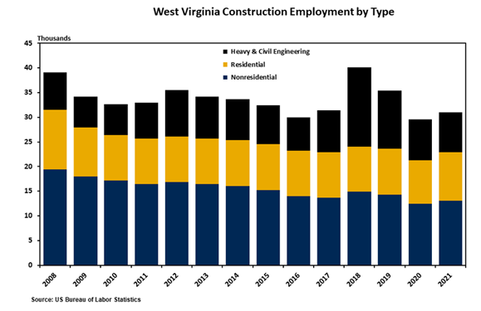
Source: WV Economic Outlook
Looking region by region, the employment trajectory from 2020 to 2030 shows significant similarities in growing and declining industries. Industries expecting expanded employment across regions include health services (ambulatory and hospitals) and food service and drinking places. Most regions are expected to see an employment decline in stores (including clothing, electronics, food and beverage, and personal care) and gasoline stations. Even with these similarities, each region differs in other industries that will grow or shrink employment opportunities and the overall impact of these changes.
In West Virginia's Workforce Development Region 1, the Food Services and Drinking Places industry is set for robust growth, projecting a significant increase of 1,646 jobs at an annual rate of 2.2%, reflecting evolving consumer preferences. Concurrently, the Ambulatory Health Care Services sector anticipates notable expansion, emphasizing the region's commitment to healthcare infrastructure. Declining sectors, such as General Merchandise Stores and Health and Personal Care Stores, signaling the need for strategic interventions.
Figure 11: WDR 1 Industry Projections 2020-2030
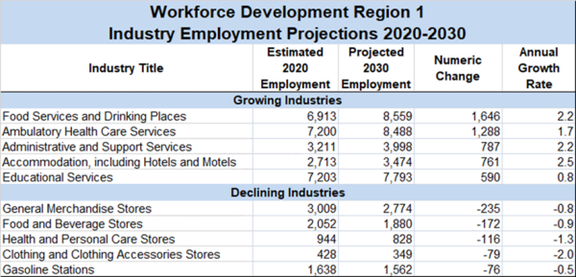
Based on annual growth rate, growing industries in Workforce Development Region 2 are contained largely within healthcare and social assistance. The health services sector contains the greatest numeric growth of industries on the list and includes ambulatory health care services, hospitals, and social assistance. Other growing industries include food services and drinking places and administrative and support services. The greatest declines by growth rate in WDR 2 are found in miscellaneous store retailers, mining (except oil and gas), and telecommunications.
Figure 12: WDR 2 Industry Projections 2020-2030
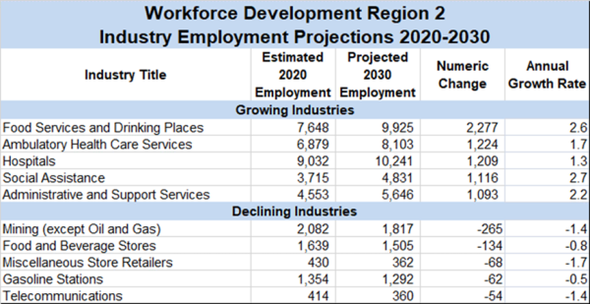
In Workforce Development Region 3, the top growing industries are contained largely in health care and professional and business services. The health care sector contains the greatest numeric growth of industries on the list and includes ambulatory health care services and social assistance. Growth in professional and business services includes professional, scientific, and technical services, and management of companies and enterprises. The greatest declines in WDR 3 are found in merchant wholesalers, durable goods; clothing and clothing accessories stores; and health and personal care stores as many residents have turned to online shopping.
Figure 13: WDR 3 Industry Projections 2020-2030
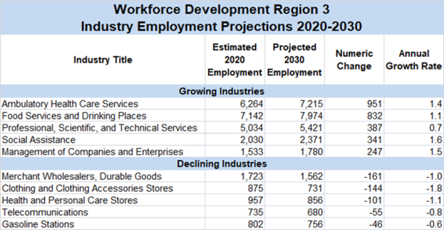
In Workforce Development Region 4, growing industries are contained largely within the health care sector, showing the greatest numeric growth on the list and including ambulatory health care services, hospitals, and social assistance. Other growing industries include food services and drinking places and heavy and civil engineering construction. The greatest declines in WDR 4 occur in clothing and clothing accessories stores, health and personal care stores, and merchant wholesalers, durable goods.
Figure 14: WDR 4 Industry Projections 2020-2030
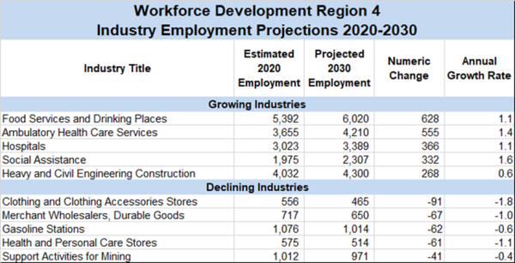
In Workforce Development Region 5, the health care sector contains the greatest numeric growth of industries on the list and includes ambulatory health care services, hospitals, and social assistance. Other growing industries include food services and drinking places and administrative and support services. The greatest industry declines in WDR 5 based on the growth rate include merchant wholesalers (durable goods), fabricated metal product manufacturing, mining (except oil and gas), health and personal care stores and electronics and appliance stores.
Figure 15: WDR 5 Industry Projections 2020-2030
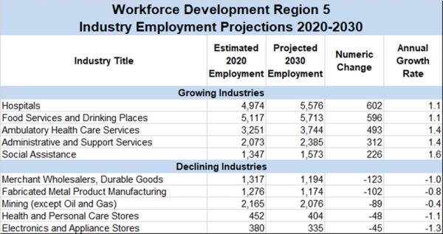
The industries in Workforce Development Region 6 projecting the greatest growth through 2030 are found largely within the health care and social assistance sector, including social assistance, ambulatory health care services, and hospitals. Food services and drinking places and administrative and support services are anticipating employment growth as well. Declining industries in this region include clothing and clothing accessory stores, health and personal care stores, and merchant wholesalers, durable goods.
Figure 16: WDR 6 Industry Projections 2020-2030
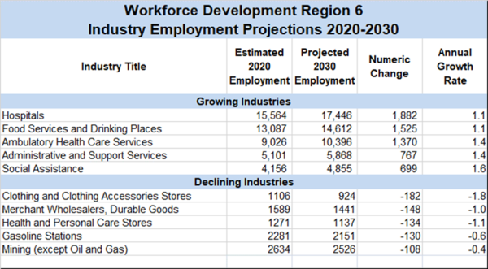
In Workforce Development Region 7, industries showing growth through 2030 are scattered across economic sectors. Industries with the highest projected growth rate include waste management and remediation services, social assistance, ambulatory health care services, and chemical manufacturing. The greatest projected declines in WDR 7 are found in fabricated metal product manufacturing, clothing and clothing accessories stores, and real estate.
Figure 17: WDR 7 Industry Projections 2020-2030
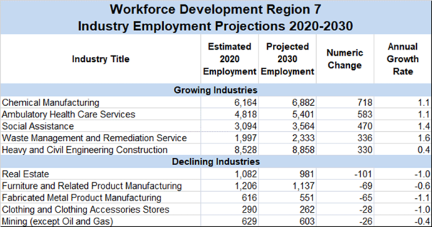
Occupational Demand 2020-2030
West Virginia's workforce is on the brink of a positive transformation, with significant projected growth in key occupation groups from 2020 to 2030. Sectors such as Food Preparation and Serving, Healthcare, and Transportation are poised to flourish, offering exciting opportunities for targeted employment programs and forward-looking training initiatives.
Notably, the Food Preparation and Serving sector anticipates an expansion of 10,542 jobs. This aligns with the region's emphasis on hospitality and culinary services, promising employment opportunities in the food industry. Healthcare continues to be a focal point, with Healthcare Practitioners and Technical occupations projecting substantial growth of 9,949 jobs, and Healthcare Support roles adding 8,669 positions, reflecting a dedication to enhancing medical services and support infrastructure. Transportation and Material Moving occupations forecast an increase of 6,557 jobs, underscoring the importance of logistics and transportation in the state's economic development. Addressing this workforce need can contribute to the overall efficiency of the state's transportation infrastructure. Additionally, the Education, Training, and Library sector is expected to see notable growth, projecting an addition of 3,580 jobs, emphasizing the state's commitment to educational advancement.
While these sectors anticipate growth, other areas require targeted attention because of projected declines. The Office and Administrative Support sector anticipates a decline of 1,240 jobs, emphasizing the need for strategic interventions to address shifts in administrative roles and workflow. Understanding these occupational dynamics provides valuable insights for federal funding allocation, ensuring resources are directed towards fostering growth in high-demand sectors and addressing employment challenges for residents and businesses.
These overall projections for 2020-2030 highlight the potential for a dynamic and resilient workforce in West Virginia's future. By aligning resources with emerging opportunities, we can foster a thriving job market, ensuring the state's position for sustained success.
Figure 18: WV Projected Growth of Occupational Groups 2020-2030
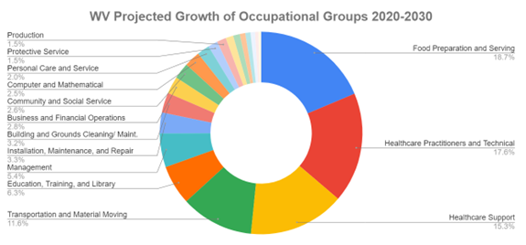
At a more granular level, The Mid-Atlantic Career Consortium (MACC) research and analytics on staff-assisted job orders for WV illuminates current trends of in-demand occupations across sectors. Personal Care Aides stand at the pinnacle with a formidable count of 1000, a testament to the burgeoning demand for personalized caregiving services. Alongside Home Health Aides, at 840, we can see the substantial prioritization of healthcare services.
In other sectors, Laborers and Freight, Stock, and Material Movers are in high demand at 881 instances, underscoring the integral role of logistics in the contemporary economic landscape.
617 job orders for Correctional Officers and Jailers reflect an unwavering commitment to public safety. Construction Laborers, totaling 591, contribute significantly to the workforce, alongside Security Guards and Patrol, who make a formidable presence with 588 job orders. Production Workers, All Other, account for 575 instances, showcasing the diverse facets of industrial production. Occupations such as Maids and Housekeeping Cleaners (416), Customer Service Representatives (340), and Farmworkers and Laborers, Crop, Greenhouse (332) underscore the varied demands within the economy.
MACC’s nuanced data further provides a comprehensive snapshot of the dynamic occupational landscape, allowing us to see the rich economic intricacies of employment across the state.
Figure 19: Top 15 Demand Occupations in Fiscal Year 2023
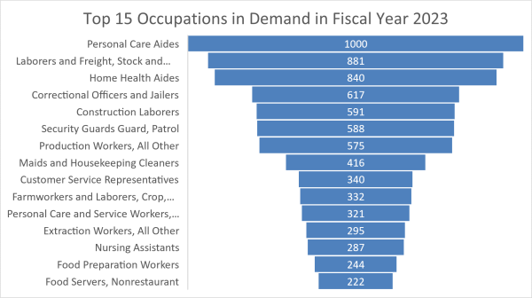
Source: Workforce WV MACC Staff Assisted Job Orders
Looking to the future, the top five occupational groups with the greatest number of annual openings through 2030 are Food Preparation and Serving-Related Occupations, Healthcare Practitioners and Technical Occupations, Healthcare Support Occupations, Transportation and Material Moving Occupations, and Education, Training, and Library Occupations. Occupations with large employment within these five groups include Fast Food Cooks, Waiters and Waitresses, Registered Nurses, Home Health and Personal Care Aides, Nursing Assistants, Heavy and Tractor-Trailer Truck Drivers, Stockers and Order Fillers, and Elementary School Teachers.
Figure 20: Projected Job Openings by Occupational Group 2020-2030.
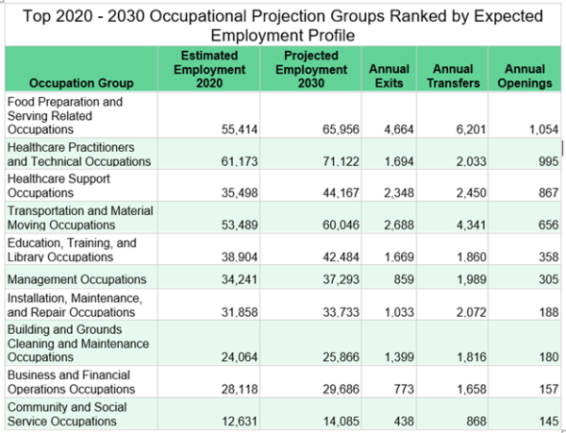
West Virginia is poised for economic growth and vitality, as indicated by the projected job openings in various occupational titles. Closer analysis shows the potential and prospects for the state, highlighting key occupations that are set to play a pivotal role in its economic evolution.
- Home Health and Personal Care Aides (Projected Openings: 4,971):
  - As the demand for personalized care services continues to rise, the significant number of projected openings for Home Health and Personal Care Aides reflects a burgeoning sector that provides essential support to individuals and families.
- Fast Food and Counter Workers (Projected Openings: 3,101):
  - West Virginia's hospitality and food industry is on an upward trajectory, with a substantial demand for Fast Food and Counter Workers. This surge signifies the state's thriving culinary scene and the role it plays in the local economy.
- Cooks, Restaurant (Projected Openings: 2,872):
  - The restaurant industry is a key contributor to West Virginia's economic landscape, with a growing need for skilled culinary professionals. The demand for Restaurant Cooks highlights the potential for expansion within the state's vibrant dining sector.
- Registered Nurses (Projected Openings: 2,564):
  - Healthcare continues to be a cornerstone of West Virginia's economic growth. The projected openings for Registered Nurses underscore the state's commitment to enhancing its healthcare infrastructure, providing opportunities for skilled professionals.
- Stockers and Order Fillers (Projected Openings: 1,808):
  - The logistics and distribution sector is witnessing a surge in demand, with Stockers and Order Fillers playing a crucial role in the supply chain. This points to the state's strategic position as a hub for commerce and trade.
- Waiters and Waitresses (Projected Openings: 1,669):
  - West Virginia's hospitality industry is flourishing, with an increasing demand for service professionals. The projected openings for Waiters and Waitresses signify a positive trend in the state's tourism and dining experiences.
- Heavy and Tractor-Trailer Truck Drivers (Projected Openings: 1,343):
  - Transportation remains a key driver of West Virginia's economic potential. The demand for Heavy and Tractor-Trailer Truck Drivers highlights the state's role in facilitating the movement of goods and services.
As West Virginia looks ahead, the projected job openings in these key occupations paint a picture of a state brimming with potential and growth. The diverse range of sectors, from healthcare to hospitality, logistics to culinary arts, positions West Virginia for a dynamic and prosperous future. Embracing these opportunities will not only fuel economic expansion but also contribute to the well-being and vitality of the state and its residents.
The top five occupations with the largest annual openings through 2030 include Home Health and Personal Care Aides, Fast Food and Counter Workers, Cooks, Restaurant, Registered Nurses, and Stockers and Order Fillers. Other occupations with large projected annual openings which may pay higher wages than some of the top five include Heavy and Tractor-Trailer Truck Drivers, Medical Assistants, Construction Laborers, Heavy and Tractor-Trailer Truck Drivers, and Nurse Practitioners.
Figure 21: Annual Job Openings for Select Occupations 2020-2030.
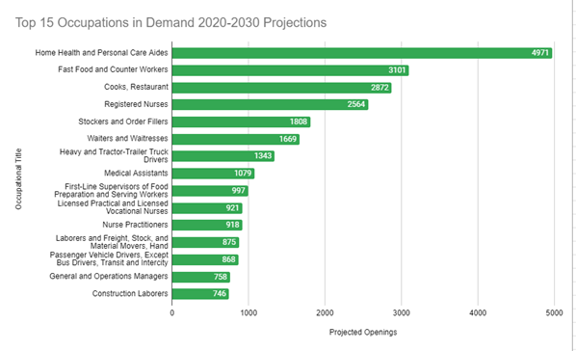
Figure 21 B: In Demand Occupational Wages in the Fiscal Year 2023
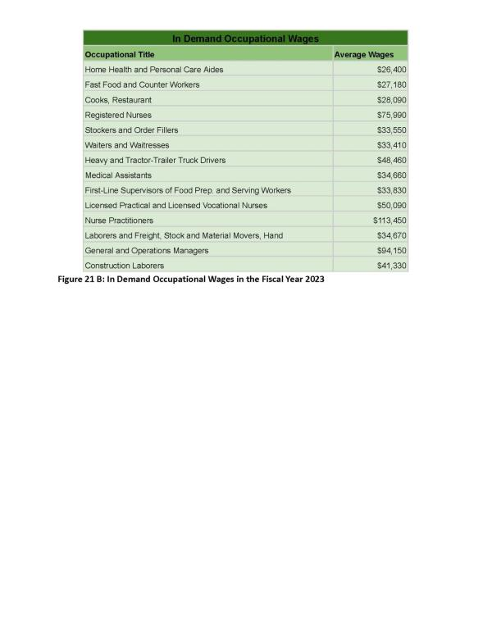
The economic landscape in the employment sector is marked by diverse trends across various occupations in the specified time frame. Notably, Nurse Practitioners lead with a notable growth rate of 5.7%, reflecting a surge in demand for advanced healthcare services. The profession is expected to add 92 new positions, underscoring the pivotal role of healthcare practitioners in the evolving medical landscape. In other healthcare fields, Medical and Health Services Managers, with a growth rate of 3.1%, are poised to contribute significantly to healthcare administration, reflecting the sector's organizational expansion. Concurrently, Medical Assistants, Home Health, and Personal Care Aides all are expected grow over 2.5%, addressing the increasing need for healthcare support services. Meanwhile, Licensed Practical and Licensed Vocational Nurses (1.4%) and Registered Nurses (1.1%) anticipate maintaining stable rates with small-modest amounts of growth.
In the realm of food services, Restaurant Cooks show a growth rate of 4.0%, adding 287 jobs, indicative of the sustained demand for dining services. The growth rate for First-Line Supervisors of Food Preparation and Serving Workers is 1.9%, reflecting the ongoing demand for skilled supervision in this sector. Similarly, Waiters and Waitresses (1.8%) and Stockers and Order Fillers (1.7%) demonstrate similarly modest growth rates, emphasizing the consistent demand for customer service and logistics roles. Fast Food and Counter Works are expected to remain in stable demand with some possibilities for growth at 1.4%.
In other areas, Passenger Vehicle Drivers, Receptionists, and Information Clerks show growth rates of 1.4%, indicating stable demand but with a more modest expansion. Meanwhile, Heavy and Tractor-Trailer Truck Drivers, and Maids and Housekeeping Cleaners contribute to the employment sector with growth rates of 1.2%, 1.1%, and 1.1% respectively, reflecting a balanced employment outlook.
Through this comprehensive overview of the employment landscape of West Virginia, we can see the nuanced growth patterns across various occupations, underscoring the importance of healthcare, culinary services, and support roles, while acknowledging the steady contributions from diverse occupations within the state.
Figure 22: Annual Job Growth Rate for Select Occupations 2020-2030.
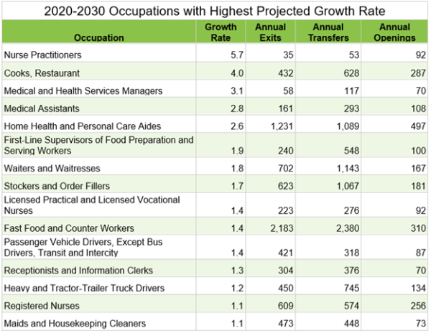
Employers’ Employment Needs
With the intensive growth of Healthcare and Social Assistance industries through 2030, the need for education for higher-skill workers is anticipated. The range of knowledge, skills, and abilities needed in these professions are high, and in order to fulfill demand for these positions, educational structures that teach both prospective and current nurses are needed to maintain a highly skilled workforce in these necessary fields.
Figure 23: Model Knowledge, Skills, & Ability for Registered Nurse
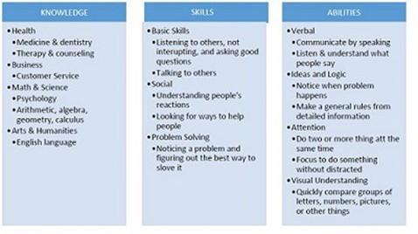
Knowledge needed for the top five healthcare occupations in the state, according to current employees, includes customer and personal services, English languages, psychology, medicine and dentistry, and therapy and counseling. Educational systems that teach this knowledge to potential nurses and help current nurses continue their education to stay on top of changing healthcare needs are required to fulfill the demand for skilled healthcare workers in the state.
Figure 24: Knowledge Assessment for Top 5 Healthcare Occupations
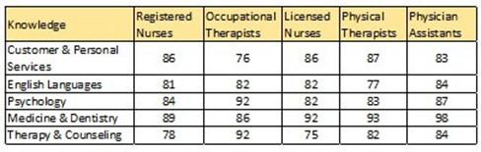
Numerous occupations in West Virginia require licensing. This is to ensure the competency of those practicing these professions, and in many cases the safety of those utilizing their services. There are approximately 110 occupations that require licensure in the State of West Virginia, eleven of which are in-demand occupations. The majority of these in-demand occupations are found in the healthcare field, such as Physician Assistant, Registered Nurse, Licensed Practical Nurse, Pharmacist, Physical Therapy Assistant, Radiologic Technologist, and Dental Hygienist. The remaining in-demand occupations that require licensing include Accountant, Attorney, Elementary School Teacher, and Social Worker. Licensing requires certain amounts of education to fulfill the needs of the license and for applicants to gain the knowledge needed to pass any licensing exams. To adequately license the workers who can fill these in-demand occupations, we will have to continue creating educational opportunities for people to gain the knowledge, skills, and attitudes needed to succeed in these positions.
(B) WORKFORCE ANALYSIS
Demographics of the State’s Economy³
Age
Analyzing the age distribution in West Virginia against the United States reveals distinct patterns. In the younger age groups (15 to 24 years), the state's population aligns with national figures, with 112,676 individuals aged 15 to 19 years and 113,691 in the 20 to 24 years category. As we move into the working-age brackets (25 to 54 years), West Virginia's figures of 210,919 (25 to 34 years), 215,117 (35 to 44 years), and 228,098 (45 to 54 years) show alignment with national trends but at a smaller scale. However, in the 55 to 64 years group, the state's population of 120,980 (55 to 59 years) and 129,971 (60 to 64 years) contrasts with higher national figures. In the older age groups, West Virginia's population in the 65 to 74 years, 75 to 84 years, and 85 years and over categories stands at 219,725, 107,203, and 39,516 individuals, contributing to national figures. This narrative provides a snapshot of West Virginia's age distribution, emphasizing unique characteristics within specific age brackets compared to the national landscape.
3 Unless otherwise noted, figures and data in (B) Workforce Analysis are produced by the US Census Bureau, 2022 American Community Survey
Figure 25: WV and US Population by Age Group
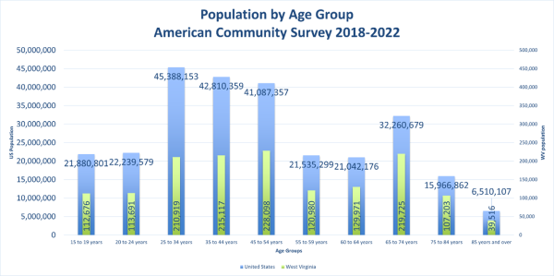
The U.S. Census Bureau's 2019 5-year estimates from the American Community Survey provide a comprehensive overview of West Virginia's workforce demographics. With a total population aged 16 and older at 1,491,316, approximately 53.3% are part of the labor force. The employment to population ratio stands at 49.7%, while the unemployment rate for this population is 6.5%.
Analyzing specific age groups in West Virginia, individuals aged 16 to 19, numbering 89,375, have a labor force participation rate (LFPR) of 34.9%, slightly below the national LFPR of 40.7%.
The 20 to 24 age group, estimated at 114,325, exhibits a robust LFPR of 71.3%, albeit lower than the national LFPR of 76.0%.
For those aged 25 to 29 (102,223), the LFPR is 74.7%, again slightly below the national LFPR of 84.3%.
The trend continues with the 30 to 34 age group (104,869), where West Virginia's LFPR of 73.1% is below the national LFPR of 84.2%.
Moving to the 35 to 44 age group (216,666), West Virginia's LFPR of 75.1% is slightly lower than the national LFPR of 83.6%.
In the 45 to 54 age group (221,995), the state's LFPR of 73.2% is again slightly below the national LFPR of 82.3%.
For those aged 55 to 59 (114,295), West Virginia's LFPR of 63.0% contrasts with the national LFPR of 74.2%.
In the 60 to 64 age group (126,356), the LFPR is 47.7%, below the national LFPR of 59.1%.
For residents aged 65 to 74 (224,674), the LFPR is 18.3%, significantly lower than the national LFPR of 26.6%.
Finally, for those aged 75 and over (151,488), West Virginia's LFPR of 6.8% is notably lower than the national LFPR of 7.3%.
This detailed analysis offers insights into West Virginia's diverse workforce across various age cohorts, highlighting trends and opportunities for targeted strategies and support in the context of both state and national labor force dynamics.
Figure 26: WV and US Labor Force Participation Rate by Age Group
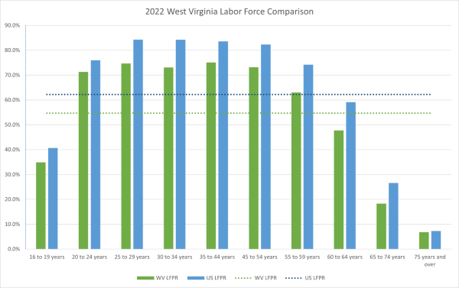
Reviewing long-term projections for jobs in industries and occupations in West Virginia that provide employment opportunities for older workers.The total number of West Virginians aged 55 and older totaled 617,395, comprising 41.23% of the state’s total population (10.89% increase since 2010 census).
According to the Quarterly Workforce Indications (QWI), out of the twenty industries, the industry sectors that represented the largest numbers of employed seniors during 2019-2022 were Health Care and Social Assistance, Education Services, Retail Trade and Manufacturing. These sectors were the top four employers for older workers 55+ during 2019-2022. Table 2- SCSEP illustrates the industries during 2019-2022 that had the largest number of older workers.
Figure 27: Industries With Older Workers
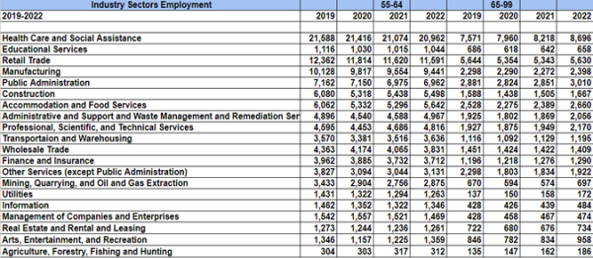
(Source: Table 2 - SCSEP; QWI, NAICS Sectors, 2019-2022)
The QWI information focuses on, of the 20 Industry Sectors which had the highest number hiring older workers (55+). The largest number of hires of older workers during 2019-2022 for the age range 55-64 were Health Care and Social Assistance, Construction, Administrative and Support and Waste Management and Remediation Services, and Retail Trade. Within the age range of 65-99 the results varied. Similar to the age range 55-64, Health Care and Social Assistance was also the top employer for the age range 65-99. Educational Services, Retail Trade, Accommodation and Food Service were the remaining top employers that had the highest number of employed seniors for the age range 65-99. Table 3 - SCSEP illustrates the industries during 2019-2022 that had the largest number of 55+ seniors hired.
Figure 28: Industries With Largest Number of 55+ Seniors Hired
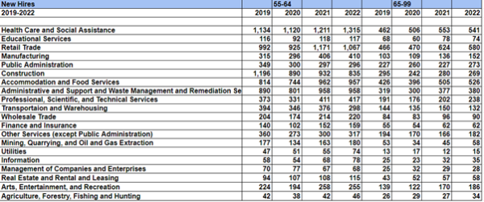
(Source: Table 3 - SCSEP; QWI, NAICS Sectors, 2019-2022)
From the information gathered in Table 3-SCSEP, the staffing patterns from the top three Industry Sectors of New Hires show employment in Healthcare and Social Assistance, Administration and Support Waste Management and Remediation Services, Construction, Accommodations and Food Services, Educational Services and Retail Trade. The forecast predicts that these industries will continue to hire older workers, thus providing employment opportunities in the following Equal Employment Opportunities (EEO) Occupations Groups based off the Industry Sector of New Hires: Transportation, Natural Resources, Construction & Maintenance Occupations, Sales and Office Occupations, Service Occupations, Education, Legal, Community Service, Arts & Media Occupations, Management, Business & Science. EEO Occupational Groups are categorized into fourteen groups and further categorized into nine job categories. Table 4-SCSEP illustrates the twelve Occupational Groups that were narrowed down from the top Industries.
West Virginia’s Net Migration
West Virginia's net migration patterns, as revealed by the American Community Survey 2022 5-Year Estimates, offer insights into the state's demographic shifts and potential implications for its future. The data underscores the dynamic nature of migration, both within the state and from other regions, contributing to a net migration of 5,617 individuals.
Figure 29: WV Net Migration
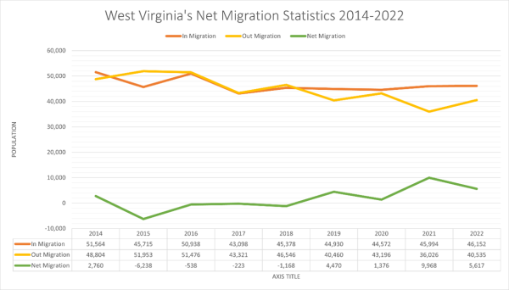
Examining age groups, West Virginia has experienced notable in-migration among those aged 1 to 4 years, with 1,725 individuals moving in, offset by 2,613 individuals moving out, resulting in a net migration of -888. Similarly, the 5 to 17 years age group demonstrates a net migration of 528, indicating a positive trend in this demographic.
Notably, young adults aged 18 to 24 years contribute significantly to West Virginia's net migration, with a positive trend of 2,317 individuals moving into the state. This could potentially be attributed to factors such as education, employment opportunities, or lifestyle choices attracting individuals to West Virginia.
However, the state experiences a net migration loss in certain age groups, notably among individuals aged 25 to 34 years, with a net migration of -449. The age group 35 to 44 years, while showing a small net migration of 87 individuals, could benefit from strategies to attract and retain residents in their prime working years.
For individuals aged 60 and over, West Virginia observes varying net migration patterns. The age group 60 to 64 years shows a modest net migration of 2, while those aged 65 to 74 years and 75 and over exhibit net migration losses of -449 and -542, respectively.
While the overall net migration is positive, the data suggests a need for strategic efforts to enhance migration patterns, especially among the working-age population, and to address potential challenges in retaining residents in certain age brackets. Proactive measures aimed at creating an attractive environment for various age groups could play a pivotal role in shaping West Virginia's demographic landscape and fostering a resilient and vibrant future for the state.
Figure 30: WV Net Migration by Age
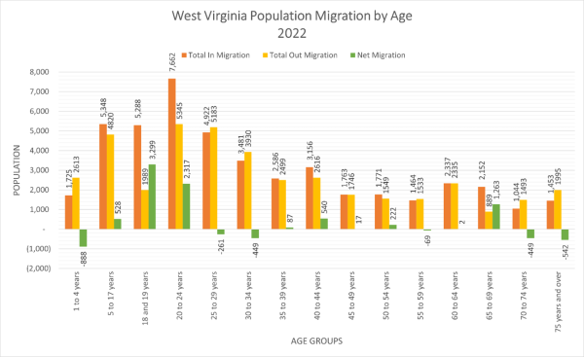
Disability
Data on rates of educational attainment for people with disabilities show that people with disabilities, overall, have lower educational attainment than people without disabilities. 58.2% of people with disabilities have a high school degree or lower, compared to 44.1% of people without disabilities. Of those who have some college or above, 13.7% of people with disabilities graduate from college, compared to the 23.2% of people with disabilities who have some college experience or an associate degree. Meanwhile, the levels for people without disabilities are more similar, 27.1% of the population have some college or associate degrees, while 27.1% have graduated from college. Understanding these patterns can inform targeted interventions, policies, and educational initiatives aimed at promoting inclusivity, accessibility, and equal opportunities for all residents, regardless of their disability status. For example, A higher percentage of people with disabilities are likely to fulfill “some” high school or college credit without graduating, pointing to a need for more support in completing each educational level.
Figure 31: WV Education Attainment by Disability
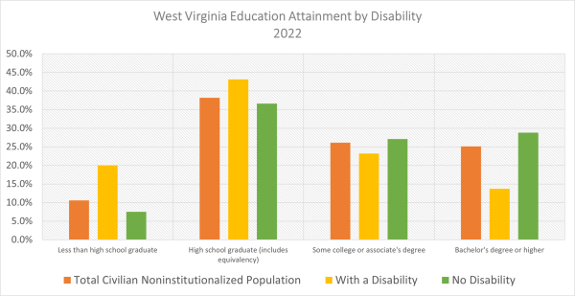
West Virginia's disability profile for 2022 reveals a dynamic landscape. Of the individuals with disabilities, 51,250 are employed, showcasing their significant contributions to the state's workforce. An additional 6,214 individuals with disabilities are unemployed, signaling potential areas for targeted employment support. Additionally, 109,593 individuals with disabilities are not currently in the labor force, suggesting unique challenges or personal choices. The Labor Force Participation Rate (LFPR) for individuals with any disability is 34.40%, emphasizing the need for fostering inclusivity and accessibility. As the state moves forward, addressing barriers, promoting workplace accommodations, and implementing targeted training programs can enhance workforce participation, tapping into the diverse skills and talents of individuals with disabilities for a more inclusive and resilient economy.
Figure 32: Disability Profile
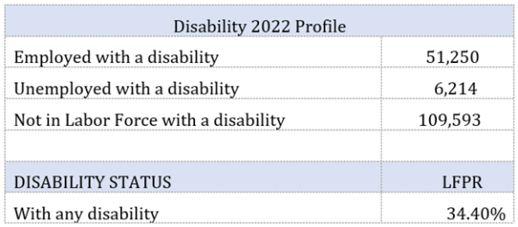
Sex and Race
In the latest demographic snapshot provided by the U.S. Census Bureau's 2022 ACS 5-year estimates, West Virginia's population continues to showcase distinct patterns in sex and race. As of 2022, the total population stands at approximately 1,792,310 residents. The male population is reported at 897,121, slightly surpassing the female population at 895,189.
Analyzing the racial composition, most West Virginia residents identify as White alone, representing 91.5% of the state's population with a total count of 1,639,342 individuals. Black or African American alone constitutes 3.4% of the population, with 61,227 residents. American Indian and Alaska Native alone account for 0.1%, totaling 1,730 individuals. The Asian alone population stands at 0.8%, comprising 13,602 residents. Some other race alone makes up 0.5% of the population, with 9,504 individuals. Notably, the Two or more races category represents 3.7% of the population, totaling 66,905 residents.
Compared to 2021 figures, this data shows subtle shifts in population distribution. While the overall population has seen a marginal decrease, the variations in racial demographics highlight the dynamic nature of West Virginia's population. The comprehensive understanding of these demographic shifts is crucial for informed policymaking, resource allocation, and community engagement initiatives tailored to the diverse needs of West Virginia's residents.
Figure 33: WV Population by Sex and Race
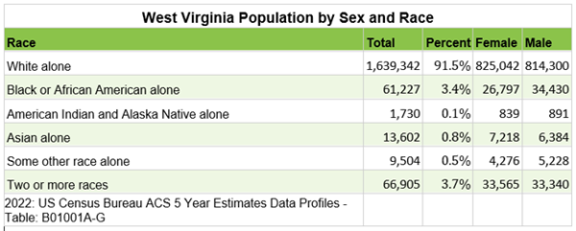
Education and the Labor Force
The Labor Force Participation Rate (LFPR) data in West Virginia, categorized by educational attainment, underscores the significant impact of education on workforce engagement. Among individuals with less than a high school diploma, the LFPR stands at 39.6%. This lower rate is indicative of the challenges faced by this group in accessing and participating in the labor market. Those with a high school diploma or equivalency exhibit a higher LFPR at 61.5%, signaling a notable increase in workforce participation compared to individuals with lower educational attainment.
As educational attainment rises, so does the labor force participation. Those with some college education or an associate degree demonstrate a substantially higher LFPR at 73.1%, emphasizing the positive correlation between post-secondary education and increased engagement in the workforce. The trend continues upward for individuals with a bachelor's degree or higher, reaching an impressive LFPR of 85.3%. This group, which includes those with advanced degrees, illustrates the considerable influence of higher education on active participation in the labor force.
These findings highlight the pivotal role of education as a determinant of labor force engagement. As West Virginia seeks to enhance its economic vitality, focusing on educational attainment and facilitating access to higher education opportunities can be instrumental in fostering a more robust and dynamic workforce. Policymakers and stakeholders can leverage this data to develop targeted initiatives aimed at improving educational outcomes, thereby contributing to higher labor force participation rates and overall economic prosperity in the state.
Figure 34: WV Population and Labor Force Participation Rate by Educational Attainment
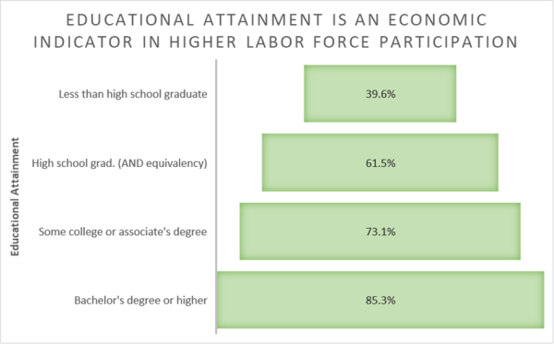
The unemployment landscape in West Virginia illustrates a clear correlation between educational attainment and employment prospects. Among the population aged 25 to 64 years, the overall unemployment rate stands at 5.20%. However, when examining educational levels, a compelling trend emerges showing higher unemployment rates for those with lower educational attainment.
Individuals with less than a high school diploma face a higher unemployment rate, recording at 12.90%. This emphasizes the challenges associated with limited educational attainment and the impact it can have on employability in the state. Conversely, those with a high school diploma or equivalency experience a lower unemployment rate at 7.00%, showcasing a positive correlation between basic educational attainment and improved employment outcomes.
The trend continues with higher education levels contributing to even lower unemployment rates. Individuals with some college education or an associate degree exhibit a reduced unemployment rate of 4.80%. This underlines the potential benefits of post-secondary education in enhancing employability and reducing unemployment.
Notably, those with a bachelor's degree or higher demonstrate the lowest unemployment rate, standing at 1.90%. This emphasizes the substantial advantages associated with advanced education in fostering a resilient and highly employable workforce.
These findings underscore the importance of educational investment in shaping the employment landscape in West Virginia. Initiatives aimed at improving educational attainment, especially at the post-secondary level, can play a pivotal role in reducing unemployment rates and contributing to overall economic resilience in the state. Policymakers and stakeholders can leverage this data to tailor strategies that address educational disparities and enhance workforce development, ultimately fostering a more robust and prosperous economy in West Virginia.
Figure 35: WV Unemployment Rate by Educational Attainment
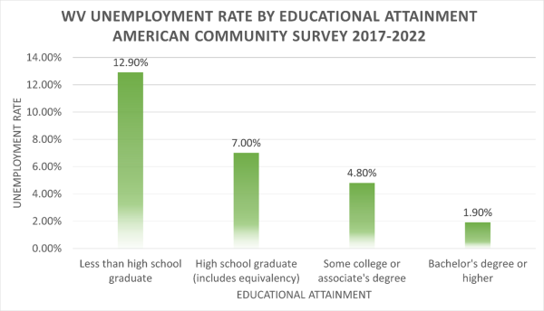
Labor Force
The labor force participation rate (LFPR) in West Virginia registered at 54.7% in 2022, the lowest in the nation. The national labor force participation rate stood at 62.2%.
Fewer than one-half (40.0%) of West Virginia counties recorded a LFPR below 50.0% in 2022. Several of these counties are in the southern coalfields of West Virginia (Workforce Development Regions 1 & 2). McDowell County recorded a labor force participation rate of 32.0%, the lowest in the state. Other southern counties with a labor force participation rate less than 50% included Wyoming (41.8%), Boone (40.2%), Logan (43.2%), Mingo (33.3%), Wayne (47.7%), Summers (46.8%), Lincoln (42.9%), Fayette (46.5%), and Mercer (43.2%).
Ten counties in the state recorded a labor force participation rate greater than 60.0% in 2022. These counties are Putnam (60.2), Ohio (60.7), Doddridge (62.0), Grant (62.4), Harrison (62.8), Preston (63.2), Berkeley (65.5), Pendleton (65.6), Monongalia (67.2), and Jefferson (68.8). In 2022, seven West Virginia counties reported a labor force participation rate greater than the national rate of 62.2%.
Figure 36: WV Labor Force Participation Rate by County
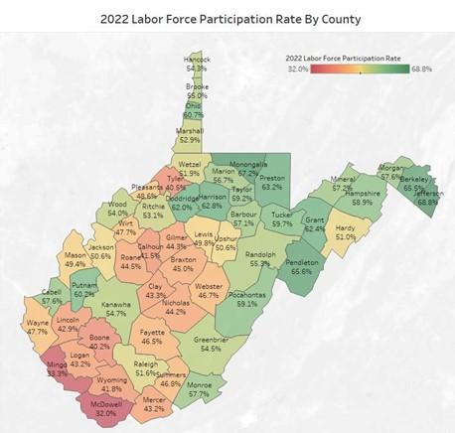
Source: 2022 Workforce WV LMI Data
Examining the LFPR for West Virginia and its contiguous states provides a comprehensive view of the region's workforce engagement in 2022. West Virginia, with an LFPR of 52.8%, exhibited a lower participation rate compared to its neighboring states. WV’s contiguous states showcase varying levels of labor force participation, influencing the overall economic landscape.
Maryland leads the region with a robust LFPR of 67.0%, indicating a high level of workforce engagement. Virginia closely follows with a rate of 65.3%, contributing to a dynamic and active labor market. Ohio, at 63.1%, demonstrates solid workforce participation, aligning with the broader regional trends.
Pennsylvania and Kentucky present LFPRs of 62.8% and 59.9%, respectively, showcasing moderate workforce engagement. Kentucky, although slightly below the national average in LFPR, remains an essential contributor to the regional labor market.
West Virginia, despite its LFPR of 52.8%, plays a crucial role in the regional economy, and there is an opportunity for targeted initiatives to enhance labor force participation. Understanding these LFPR dynamics across contiguous states allows policymakers, businesses, and community leaders to tailor strategies that address specific workforce challenges and leverage regional strengths. As each state contributes uniquely to the economic tapestry, collaborative efforts can foster a resilient and thriving regional workforce.
Figure 37: US Labor Force Participation Rate by State
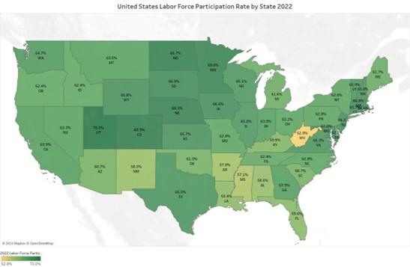
Turnovers
Turnover rates can vary by industry and by a variety of demographic characteristics, such as education, race, sex, and age. In West Virginia, between 2020 and 2022 industry sectors with the highest average turnover rates include Accommodation and Food Services; Arts, Entertainment, and Recreation; Retail Trade; and Transportation and Warehousing. Sectors with the lowest turnover rates include Utilities, Manufacturing, and Wholesale Trade High turnover rates in industry sectors can indicate a number of possibilities, including, but not limited to, seasonality, short business cycles, part-time employment status, employee dissatisfaction, and health risks.
Addressing retention challenges is key for sustained economic stability. West Virginia's economic resilience hinges on maintaining a healthy turnover rate that attracts talent without compromising workforce stability. As West Virginia navigates the economic landscape, policymakers and stakeholders can leverage these insights to formulate targeted initiatives, ensuring workforce resilience and sustained economic growth in the years to come.
Figure 38: WV Average Turnover Rate by Industry
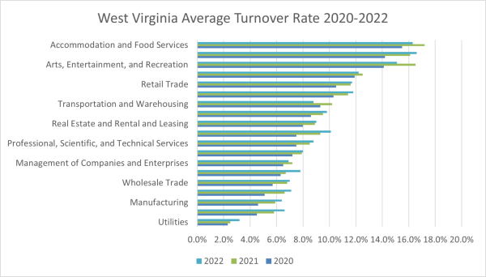
Source: 2021-2023 QWI Explorer
In 2021, turnover rates of female employees (10.2%) were higher than male employees (9.8%), continuing the trend starting in 2019.
Figure 39: WV Average Turnover Rate by Sex
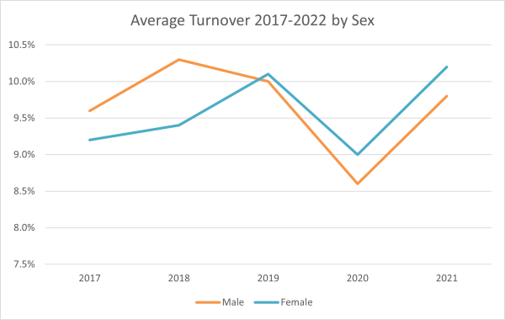
Source: 2017-2021 QWI Explorer
Assessing turnover rate by race reveals that in 2021 turnover rates were lowest among White (9.7%) and Asian (10.4%) populations; The highest turnover rate was among Two or More Races (15.7%), followed by American Indian/Alaskan Native (15.1%) and Native Hawaiian or Other Pacific Islander (14.9%), and Black or African-American (14.2%) populations. Turnover rates across races increased between .9% (White, Asian) and 1.9% (Two or More Races) between 2021 and 2021.
Figure 40: WV Average Turnover Rate by Race
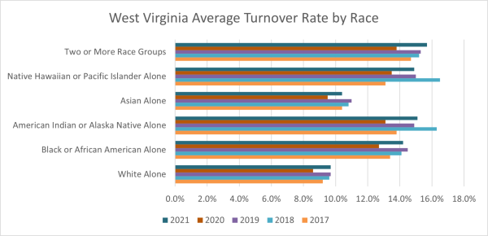
Source: 2020-2021 QWI Explorer
Occupations
Building upon last year's insights, West Virginia's occupational landscape continues to evolve, with a keen focus on the seven workforce development regions. Notably, the occupations anticipating substantial annual growth rates between 2020 and 2030 predominantly align with the healthcare and social services sectors. This persistent trend finds its roots in the state's aging population, the challenges posed by the opioid epidemic, and the prevalence of health issues like obesity, diabetes, heart disease, and tobacco use. The positive aspect is that many of these in-demand healthcare occupations often require less extensive education or offer on-the-job training opportunities, presenting a pathway for aspiring professionals, such as obtaining an associate degree for roles like Registered Nurses. As we explore each region's unique occupational projections, we uncover the intricate interplay between workforce needs, demographic shifts, and the state's ongoing health challenges.
Workforce Development Region 1 Occupational Employment Projections 2020-2030
In Workforce Development Region 1 of West Virginia, the occupational employment projections for the period 2020-2030 spotlight key occupations with the highest anticipated job openings. Leading the projections is the demand for Home Health and Personal Care Aides, with an estimated 700 openings, reflecting the region's emphasis on healthcare and social services. In the culinary sector, Cooks in restaurants and Fast Food and Counter Workers are projected to see 550 and 480 openings, respectively. The list continues through other sectors, including positions such as Registered Nurses, Security Guards, and Construction Laborers. These projections provide valuable insights into the evolving workforce landscape and should guide strategic decisions for regional development and employment planning.
Figure 41: WDR 1 Top 15 Occupations by Projected Job Openings
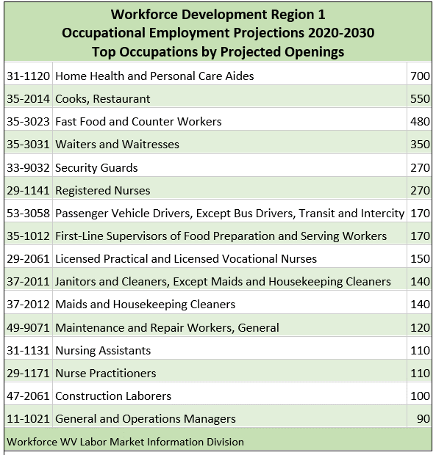
Source: WV Labor Market Information Division
Workforce Development Region 2 Occupational Employment Projections 2020-2030
In Workforce Development Region 2 of West Virginia, the highest demand is in healthcare services, with high numbers for Home Health and Personal Care Aides (960 openings) as well as Registered Nurses (540 openings). In the culinary sector, Fast Food and Counter Workers and Restaurant Cooks are projected to see substantial openings of 880 and 460, respectively. The list also includes positions in retail, customer service, and logistics, with heavy emphasis on Heavy and Tractor-Trailer Truck Drivers, Construction Laborers, and Industrial Machinery Mechanics.
Figure 42: WDR 2 Top 15 Occupations by Projected Job Openings
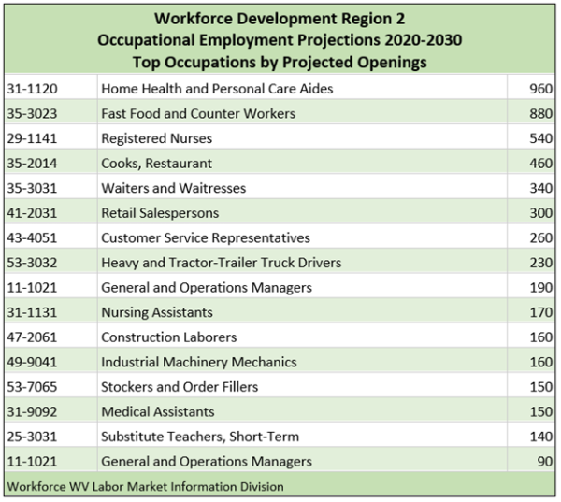
Source: WV Labor Market Information Division
Workforce Development Region 3 Occupational Employment Projections 2020-2030
In Workforce Development Region 3 of West Virginia, Fast Food and Counter Workers lead with a substantial projection of 700 openings, underscoring the importance of the hospitality industry, especially considered next to the number of openings for Restaurant Cooks (400) and Waiters and Waitresses (250). Home Health and Personal Care Aides follow with 480 projected openings, which, alongside openings for Registered Nurses (350), reflects growing demand for healthcare services. Construction Laborers (270) and Heavy and Tractor-Trailer Truck Drivers (190) indicate a demand for skilled workers in essential sectors, aligning with the region's economic needs.
Figure 43: WDR 3 Top 15 Occupations by Projected Job Openings
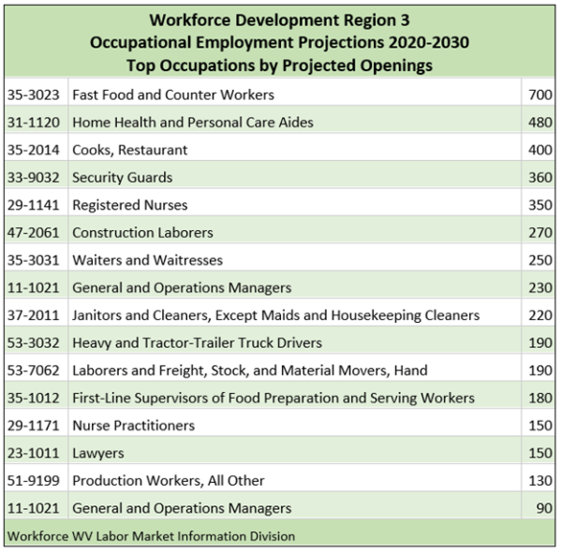
Source: WV Labor Market Information Division
Workforce Development Region 4 Occupational Employment Projections 2020-2030
In Workforce Development Region 4 of West Virginia, the occupational employment projections for 2020-2030 reveal key occupations with projected openings. Home Health and Personal Care Aides lead with 710 anticipated openings, emphasizing the region's focus on healthcare and support services. Fast Food and Counter Workers and Restaurant Cooks reflect the continued demand in the hospitality industry, with 330 and 260 projected openings, respectively. Registered Nurses and Heavy and Tractor-Trailer Truck Drivers follow suit, showcasing the importance of healthcare and transportation sectors. Construction Laborers and First-Line Supervisors of Food Preparation and Serving Workers also feature in the projections, indicating a diverse range of occupational needs. These insights provide a foundation for regional workforce planning and strategic economic development initiatives.
Figure 44: WDR 4 Top 15 Occupations by Projected Job Openings
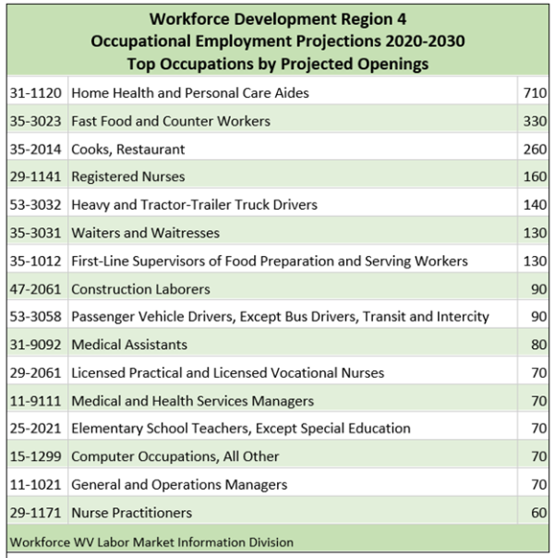
Source: WV Labor Market Information Division
Workforce Development Region 5 Occupational Employment Projections 2020-2030
Within Workforce Development Region 5, Registered Nurses take a prominent position with 320 projected openings, and Home Health and Personal Care Aides anticipate 280 openings, reflecting the continued demand for skilled healthcare professionals. The hospitality industry, exemplified by Restaurant Cooks and Fast Food and Counter Workers, anticipates 310 and 240 openings, respectively. This region also showcases openings in transportation, with projections for Passenger Vehicle Drivers (90) and Heavy and Tractor-Trailer Truck Drivers (80).
Figure 45: WDR 5 Top 15 Occupations by Projected Job Openings
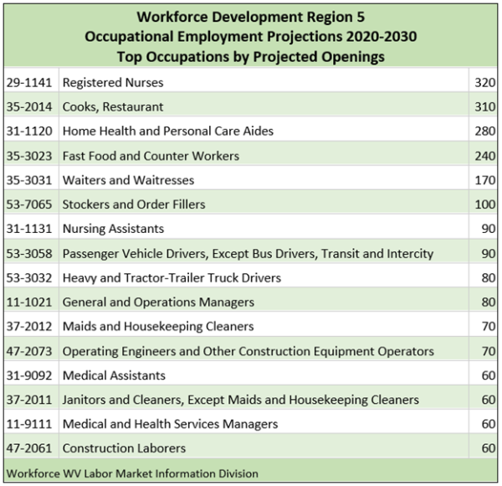
Source: WV Labor Market Information Division
Workforce Development Region 6 Occupational Employment Projections 2020-2030
Workforce Development Region 6 demonstrates a robust demand for positions in the hospitality sector, as evidenced by Fast Food and Counter Workers, Restaurant Cooks, and Waiters and Waitresses, projecting 1610, 970, and 910 openings, respectively. Home Health and Personal Care Aides follow closely at 940, which, along with Registered Nurses at 490, reflect the region's emphasis on healthcare support services. Construction Laborers and Registered Nurses also feature prominently, showcasing the region's commitment to infrastructure development. The demand for skilled workers extends to management roles, such as General and Operations Managers and Food Service Managers, indicating a need for leadership across industries.
Figure 46: WDR 6 Top 15 Occupations by Projected Job Openings
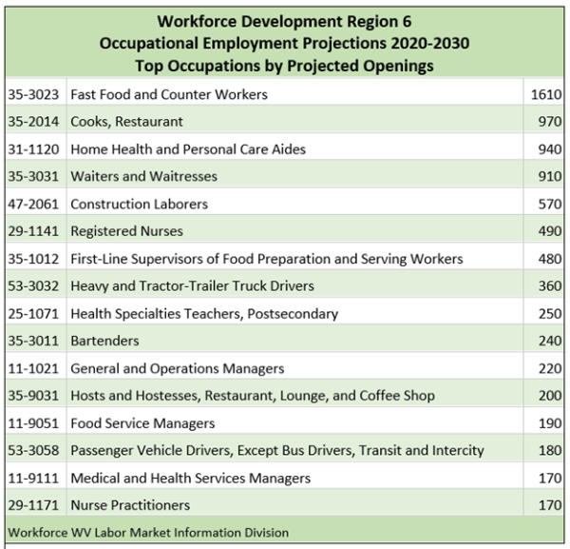
Source: WV Labor Market Information Division
Workforce Development Region 7 Occupational Employment Projections 2020-2030
In Workforce Development Region 7, Home Health and Personal Care Aides project the highest number of openings at 530 and reflect the region's emphasis on healthcare and support services, seen also in 180 openings for Registered Nurses. The culinary industry also features prominently, with significant openings for Restaurant Cooks (410), Fast Food and Counter Workers (270), and First-Line Supervisors of Food Preparation and Service Workers (110), illustrating the region's vibrant food sector. A notable aspect is the demand for transportation roles, including Passenger Vehicle Drivers (230) and Heavy and Tractor-Trailer Truck Drivers (70), indicating the region's reliance on efficient logistics. The projections also highlight the need for skilled professionals across sectors, including education (Elementary School Teachers – 80) and technology (Software Developers – 120).
Figure 47: WDR 7 Top 15 Occupations by Projected Job Openings
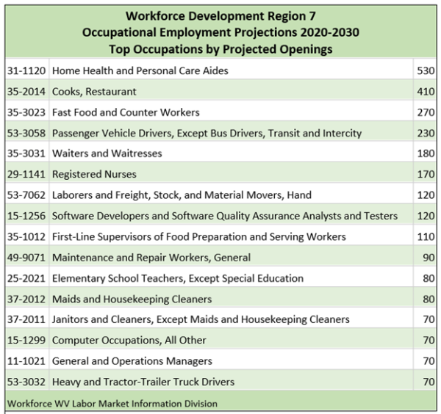
Source: WV Labor Market Information Division
Education
The presented data illustrates the percentage of the population aged 25 years or older holding a bachelor's degree or higher across the nation, providing valuable insights into the educational attainment of different regions. West Virginia stands out with a comparatively lower percentage at 24.8%, emphasizing the need for initiatives that promote higher education in the state. Contiguous states such as Maryland, Virginia, and Pennsylvania boast higher percentages, indicating a more significant proportion of individuals with advanced educational qualifications. Educational attainment plays a crucial role in shaping workforce capabilities and economic development, making it imperative for policymakers and educators to focus on strategies that enhance educational opportunities and attainment levels, particularly in regions with lower percentages. The national average of 34.5% underscores the ongoing national effort to foster a highly educated population.
Figure 48: Population 25 Plus with Bachelor’s Degree or Higher
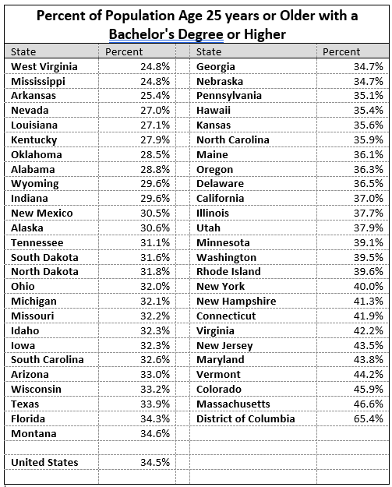
The 2020-2030 Occupational Projections Data by Level of Education for West Virginia provides a comprehensive snapshot of the state's evolving workforce landscape. The data reveals significant shifts in employment distribution across various educational levels, underscoring the dynamic nature of the state's economy. Notably, the projections indicate a modest increase in total employment, with a nuanced focus on educational attainment. High school diploma holders continue to form a substantial part of the workforce, although their percentage of the workforce is anticipated to decrease slightly by 2030. Conversely, the demand for individuals with associate degrees and postsecondary non-degree awards is expected to rise, reflecting a growing need for specialized skills and technical expertise. The projections also highlight the importance of higher education, as employment figures for bachelor's, master's, and doctoral or professional degree holders are set to increase. This data reinforces the significance of educational initiatives and workforce development programs to align with the evolving demands of West Virginia's job market and foster a resilient and well-educated workforce.
Figure 49: WV Occupational Projections by Education
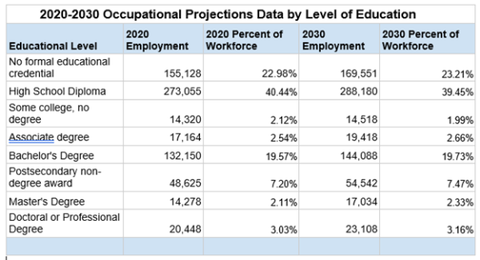
Source: Workforce West Virginia Labor Market Information - Occupational Projections Data
The latest economic data on median earnings by education level in West Virginia reveals important insights into the correlation between educational attainment and financial prosperity. The figures underscore the significance of education in shaping income dynamics across the state.
Overview of Median Earnings:
- For the population aged 25 years and over with earnings, the overall median income stands at $42,738. This figure reflects the combined earnings of both male and female individuals in this age group.
Educational Attainment and Earnings:
- Less than High School Graduate:
  - Individuals with less than a high school diploma have a median income of $26,692. This group demonstrates a substantial income disparity, with males earning $31,728 compared to females earning $22,346.
- High School Graduate (includes equivalency):
  - Those with a high school diploma or equivalency exhibit a higher median income at $35,052. Males in this category have a median income of $42,328, while females earn $26,556.
- Some College or Associate Degree:
  - Individuals with some college education or an associate degree show a further increase in median income, reaching $40,791. The gender disparity continues to be notable, with males earning $51,797 and females earning $33,565.
- Bachelor's Degree:
  - The median income for individuals with a bachelor's degree rises significantly to $52,887. Males with a bachelor's degree earn $61,978, while females earn $46,408.
- Graduate or Professional Degree:
  - Those with a graduate or professional degree demonstrate the highest median income at $63,974. This group showcases a substantial gender income gap, with males earning $81,142 compared to females earning $56,531.
Education plays a pivotal role in determining median earnings in West Virginia. As educational attainment increases, so too does the median income, underlining the importance of fostering educational opportunities and access to higher education. Policymakers and educators can draw from these insights to tailor initiatives that promote educational advancement, address gender income disparities, and contribute to the overall economic well-being of West Virginia's residents.
Figure 50: Median Annual Earnings by Education Level
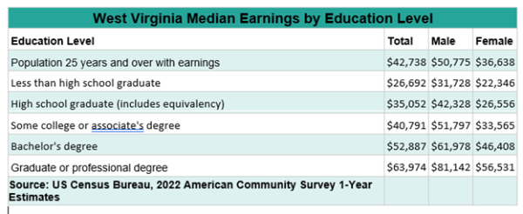
Education levels may also impact turnover rate with data showing a potential correlation between education level and employment stability, with higher educational attainment associated with lower turnover. Individuals with less than a high school education consistently exhibited higher turnover rates, starting at 9.90% in 2017 and slightly decreasing to 9.80% in 2021. Meanwhile, those with a bachelor's degree or advanced degree consistently had lower turnover rates, starting at 7.20% in 2017 and experiencing a modest increase to 7.90% in 2021. Understanding these trends is crucial for policymakers and businesses to tailor strategies that promote workforce stability and leverage the skills of a more educated labor force for sustained economic growth.
Figure 51: Turnover Rate by Education Level
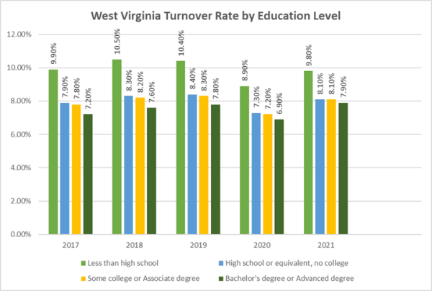
Skill Gaps
The term Skills Gap, defined as “a significant mismatch between the needs of employers for skills and the current capabilities of available workforce,” is of particular concern in West Virginia as it has the lowest labor force participation rate (LFPR) in the nation, and businesses attempting to fill positions vacated during the pandemic have expressed concerns about finding skilled workers to fill these vacancies. This is being addressed in West Virginia through various initiatives, including a blue ribbon task force meant to identify and align employer needs with workforce abilities concluded last year and the “No Wrong Door” program described elsewhere in this plan, which effectively coordinates work between state and local workforce partners, employers, post-secondary education institutions, and community-based service providers.
The West Virginia Skills Assessment for the period 2020-2030 highlights crucial skills that play a pivotal role in employment dynamics. Data from this assessment shows the current employment levels and projected growth for skills that are key for success across industries. Critical Thinking, Active Listening, and Speaking emerge are the three skills with the highest projected employment growth, underlining their significance in the evolving job market. However, challenges are evident, as skills like Mathematics show a negative growth trend, indicating a potential gap that requires attention.
Additionally, the data underscores the importance of interpersonal skills such as Social Perceptiveness, Service Orientation, and Persuasion, which are integral for effective communication and collaboration in diverse work environments. Projected numbers of exits and transfers alongside that project growth signify the need for strategic initiatives to address potential skills gaps and ensure a skilled, adaptable workforce in West Virginia. Labor force exits are the projected number of workers leaving an occupation and exiting the labor force entirely. Labor force exits are more common at older ages as workers retire but can occur at any age. Labor force exits are not necessarily permanent exits from the labor force; for example, some workers exit the labor force to pursue additional education with the intention of returning to the labor force. They do represent permanent separations from an occupation. Occupational transfers are the projected number of workers leaving an occupation and transferring to a different occupation. Transfers represent permanent separations from an occupation, not temporary movements where the worker is expected to return to the same occupation in the future. Policy makers and educators can utilize this data to align training and education programs with the evolving demands of the job market, fostering a resilient and competitive workforce for the state's economic future.
Figure 52: West Virginia Skills Assessment 2020-2030
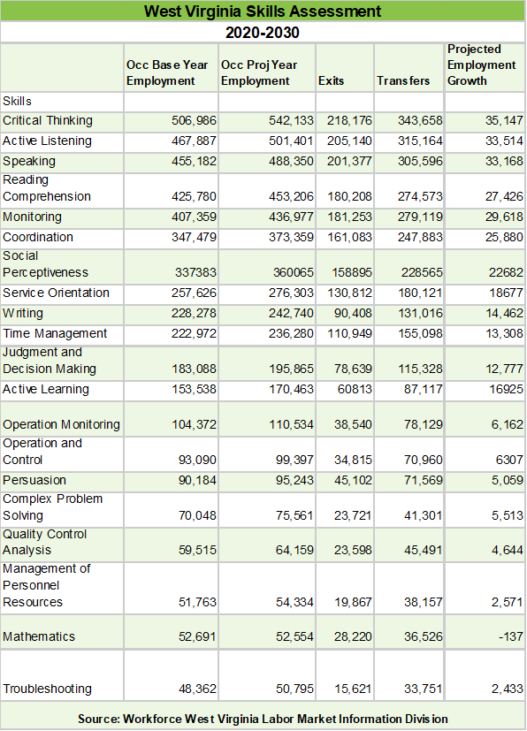
Source: WV Labor Market Information Division
In the evolving landscape of West Virginia's workforce, critical concerns emerge as we examine knowledge gaps projected from 2020 to 2030. The data delineates the anticipated exits, transfers, and changes within various knowledge domains, shedding light on areas where the state may face challenges. English Language and Customer and Personal Service lead the charts, with substantial numbers of individuals exiting or transferring within these knowledge realms. Education and Training, Mathematics, and Administration and Management closely follow, underscoring the importance of addressing gaps in these areas. As we navigate this intricate tapestry of knowledge dynamics, strategic measures are imperative to bridge these gaps and cultivate a resilient and well-rounded workforce for West Virginia. The projections emphasize the need for targeted educational and professional development initiatives to ensure a seamless transition and sustainable growth across diverse sectors within the state.
Figure 53: West Virginia Knowledge Gaps, 2020-2030

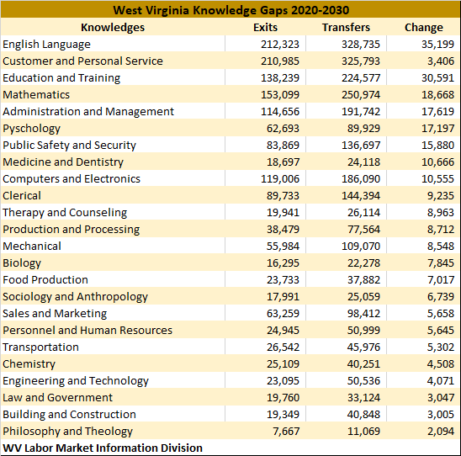
Source: WV Labor Market Information Division
In Workforce Development Region 1, the projected number of occupational openings shows needs across a wide range of disciplines. The demand is notably high in English Language, with 4,789 openings, emphasizing the importance of effective communication skills. Customer and Personal Service, with 4,720 projected openings, underscores the significance of interpersonal skills in meeting the needs of clients and customers. As the region anticipates growth, Mathematics (2,613 openings) and Computers and Electronics (1,604 openings) emerge as critical areas with considerable opportunities, suggesting a need for individuals with proficiency in STEM fields. As the region navigates the evolving workforce landscape, addressing skill gaps in these areas becomes imperative for fostering a robust and adaptable workforce.
Figure 54: Workforce Development Region 1 Knowledge Competency Requirements
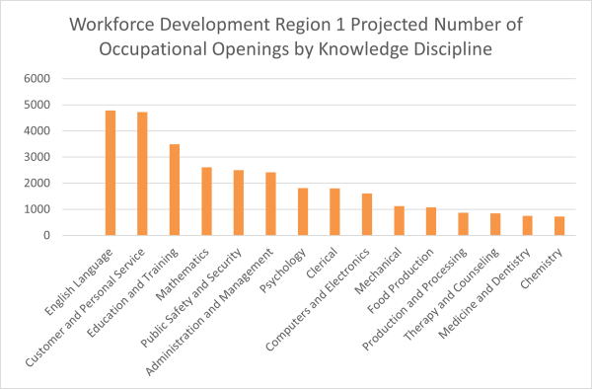
Source: Workforce WV Labor Market Information Projections
In Workforce Development Region 2, occupational openings in English Language (6,991) highlights the significance of strong communication skills in various professional contexts. The Customer and Personal Service sector, with 6,614 openings, emphasizes the continued importance of personalized interactions in service-oriented industries. As the region anticipates growth, Mathematics (4,363 openings) and Computers and Electronics (2,965 openings) emerge as critical areas with considerable opportunities, suggesting a need for individuals with proficiency in STEM fields. Bridging skill gaps to fill these positions will be essential West Virginia’s dynamic workforce landscape to thrive.
Figure 55: Workforce Development Region 2 Knowledge Competency Requirements
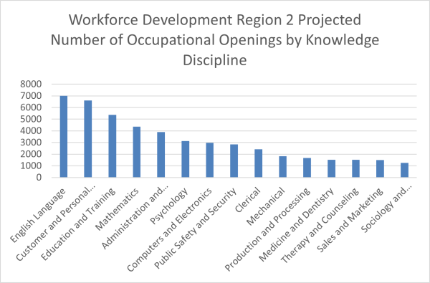
Source: Workforce WV Labor Market Information Projections
Within Workforce Development Region 3, openings in Customer and Personal Service (6,739) emphasizes the region's emphasis on service-oriented professions. English Language (6,644 openings) and Education and Training (5,331 openings) highlight the importance of effective communication and educational expertise in the evolving job market. The prominence of Administration and Management (4,162 openings) and Mathematics (3,948 openings) suggests a demand for individuals with strong leadership and analytical skills. Notably, the presence of Computers and Electronics (2,318 openings) and Mechanical (2,334 openings) positions points to the ongoing significance of STEM-related competencies.
Figure 56: Workforce Development Region 3 Knowledge Competency Requirements
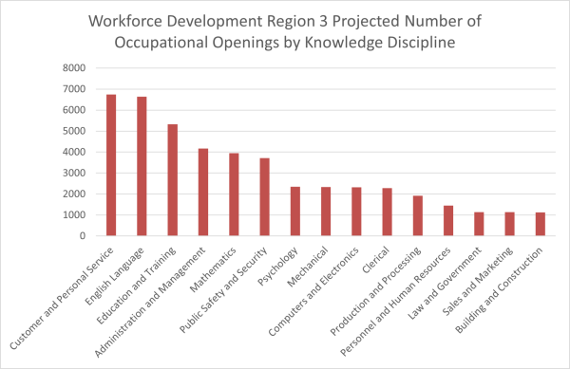
Source: Workforce WV Labor Market Information Projections
Within Workforce Development Region 4, openings in English Language (2,369) emphasize the continued demand for effective communicators. Customer and Personal Service (2,290 openings) and Education and Training (2,139 openings) signify the importance of service-oriented roles and educational expertise. Public Safety and Security (1,369 openings) highlights the region's commitment to ensuring community safety. The presence of Mathematics (1,308 openings) and Administration and Management (1,298 openings) underlines the significance of analytical and leadership skills. Furthermore, the inclusion of Mechanical (852 openings) and Computers and Electronics (665 openings) suggests a growing need for individuals with STEM-related competencies.
Figure 57: Workforce Development Region 4 Knowledge Competency Requirements
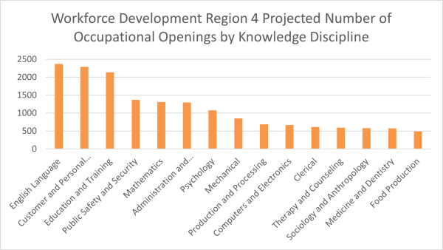
Source: Workforce WV Labor Market Information Projections
Within Workforce Development Region 5, the projected number of occupational openings in Customer and Personal Service (2,438) and English Language (2,424) highlight the continued demand for roles centered around effective communication and service provision. Education and Training (2,123 openings) signifies the region's commitment to fostering a knowledgeable workforce. Administration and Management (1,352 openings) and Public Safety and Security (1,205 openings) underscore the need for strong leadership and safety-oriented skills. Mathematics (1,200 openings) and Computers and Electronics (685 openings) indicate the growing importance of STEM-related competencies. The inclusion of Medicine and Dentistry (751 openings) reflects the region's emphasis on healthcare, while Clerical (712 openings) emphasizes administrative support roles.
Figure 58: Workforce Development Region 5 Knowledge Competency Requirements
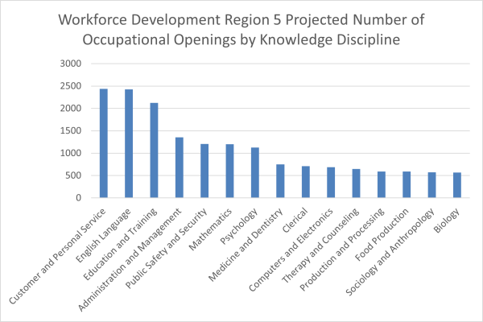
Source: Workforce WV Labor Market Information Projections
Within Workforce Development Region 6, the projected number of occupational openings in English Language (9,549) and Customer and Personal Service (9,503) showcase the region's ongoing reliance on effective communication and service-oriented roles. Education and Training (8,558 openings) underscores the commitment to nurturing knowledge, aligning with the region's dedication to educational excellence. Mathematics (6,572 openings) and Administration and Management (6,058 openings) highlight the increasing importance of STEM-related competencies and leadership skills. Public Safety and Security (5,577 openings) emphasizes the demand for professionals ensuring community well-being. Psychology (3,700 openings) adds a dimension of human understanding to the workforce, while Medicine and Dentistry (1,908 openings) underscores the significance of healthcare.
Figure 59: Workforce Development Region 6 Knowledge Competency Requirements
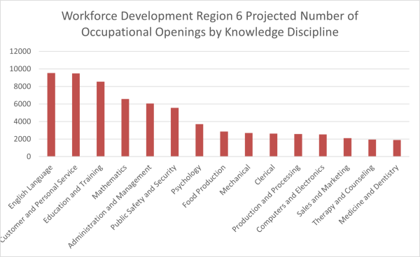
Source: Workforce WV Labor Market Information Projections
Within Workforce Development Region 7, the projected number of occupational openings in Customer and Personal Service (2,956) and English Language (2,918) reflect the region's emphasis on interpersonal skills and effective communication. Education and Training (2,417 openings) speaks to the commitment to fostering learning environments, aligning with the region's dedication to educational excellence. Administration and Management (1,854 openings) and Mathematics (1,840 openings) underscore the growing importance of leadership and STEM-related skills. Public Safety and Security (1,647 openings) emphasizes the need for professionals ensuring community safety. Psychology (1,048 openings) contributes to a nuanced understanding of human behavior, while Medicine and Dentistry (558 openings) signifies the ongoing demand for healthcare expertise.
Figure 60: Workforce Development Region 7 Knowledge Competency Requirements
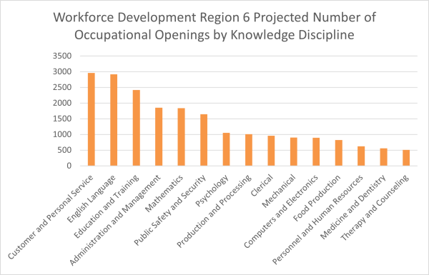
Source: Workforce WV Labor Market Information Projections
Veterans
The veteran population in West Virginia represents a significant and unique demographic with diverse experiences, skills, and needs. Understanding the characteristics and challenges faced by this group is crucial for providing appropriate services, support, and opportunities for veterans in the state. West Virginia has a higher proportion of veterans compared to many other states, with a significant percentage of its adult population having served in the military. According to data from the U.S. Census Bureau, as of the 2020 American Community Survey, West Virginia had a veteran population of approximately 130,000 individuals. Veterans in West Virginia may face employment challenges, including difficulty transitioning to civilian careers, lack of recognition for military experience, and gaps in education or training. Addressing these challenges requires tailored workforce development programs and employer partnerships. U. S. Bureau of Labor Statistics, 2023 annual averages, reports that 43.8% of West Virginia’s veteran population are employed with 68,000 not in the labor force.
Individuals with Disabilities
During Federal Fiscal Years (FYs) 2020-2024 (as of April 2024), the West Virginia Division of Rehabilitation Services (WVDRS) successfully placed over 4,800 individuals with disabilities into competitive integrated employment. The total employment outcomes for each full FY ranges from 846 to 1,365 and span over 25 different occupational categories using Standard Occupational Classification (SOC) Codes. Due to the informed choice and individualized nature of WVDRS' services, no single SOC Code accounted for more than 12.39% of the total occupational categories during any given year.
The top three occupational categories across all FYs are: Healthcare Practitioners and Technical Occupations (ranging from 9.55-12.39%); Transportation and Material Moving Occupations (ranging from 9.09-10.43%); and Office and Administrative Support Occupations (ranging from 8.98-9.77%).
The following three occupational categories account for the remaining top five most common categories across FYs: Education, Training, and Library Occupations (ranging from 7.25-8.75%), Production Occupations (ranging from 5.95-8.51%); and Management Occupations (ranging from 4.32-7.47%).
The full table is below, sorted by the most common occupational categories in FY 2024 (as of April 2024; yellow highlight denotes a top five most common category during the FY):
Occupation Category | 2020 | 2021 | 2022 | 2023 | 2024
Healthcare Practitioners and Technical Occupations | 12.39% | 11.47% | 9.55% | 10.77% | 10.59%
Transportation and Material Moving Occupations | 9.09% | 9.46% | 10.43% | 10.04% | 9.69%
Office and Administrative Support Occupations | 9.77% | 9.22% | 9.55% | 9.38% | 8.98%
Education, Training, and Library Occupations | 8.75% | 8.75% | 7.80% | 7.25% | 7.90%
Production Occupations | 8.41% | 8.51% | 5.95% | 7.47% | 7.54%
Management Occupations | 4.32% | 4.96% | 7.02% | 7.47% | 6.46%
Community and Social Services Occupations | 5.68% | 6.03% | 4.48% | 4.69% | 6.28%
Construction and Extraction Occupations | 3.18% | 2.72% | 3.80% | 5.20% | 5.57%
Food Preparation and Serving Related Occupations | 4.77% | 4.49% | 4.68% | 4.18% | 5.03%
Installation, Maintenance, and Repair Occupations | 3.98% | 2.60% | 3.61% | 5.13% | 4.85%
Healthcare Support Occupations | 4.32% | 4.26% | 5.26% | 4.84% | 4.31%
Sales and Related Occupations | 4.43% | 6.62% | 5.56% | 5.20% | 3.95%
Building and Grounds Cleaning and Maintenance Occupations | 5.45% | 4.85% | 4.78% | 4.10% | 3.95%
Protective Service Occupations | 2.05% | 2.13% | 1.56% | 2.78% | 3.77%
Personal Care and Service Occupations | 4.09% | 3.78% | 3.61% | 3.30% | 2.69%
Other | 1.36% | 1.06% | 2.05% | 1.03% | 2.33%
Business and Financial Operations Occupations | 1.82% | 2.25% | 3.61% | 2.64% | 2.15%
Arts, Design, Entertainment, Sports, and Media Occupations | 2.39% | 1.30% | 1.46% | 1.32% | 1.44%
Architecture and Engineering Occupations | 1.48% | 1.89% | 2.34% | 1.25% | 0.90%
Life, Physical, and Social Science Occupations | 1.14% | 1.77% | 1.95% | 1.17% | 0.90%
Computer and Mathematical Occupations | 1.14% | 1.89% | 0.97% | 0.81% | 0.72%
The West Virginia Division of Rehabilitation Services (WVDRS) believes that coordination with employers is integral to improving the workforce development system. Gathering/collecting information about employer needs, which will also be shared with other Workforce Innovation and Opportunity Act (WIOA) partners, allows WVDRS to provide training and other services to vocational rehabilitation (VR) consumers to meet business needs and expectations of current and future workers. To optimize its coordination with employers to identify competitive integrated employment and career exploration opportunities for consumers with disabilities, WVDRS takes a multifaceted approach. WVDRS utilizes its own personnel in addition to partnering with WorkForce WV to coordinate with employers across the state. Additionally, WVDRS has specific programs/strategies to identify employment and career exploration opportunities for students with disabilities, including the provision of pre-employment transition services (Pre-ETS). The strategies that WVDRS uses are described below.
WVDRS has an in-house Employer Services Section that specializes in providing employers with disability-related information, services, and pre-screened job seekers. The WVDRS Employer Services Section has 10 employment specialists that cover all 55 counties in West Virginia. WVDRS’ team of employment specialists provide business owners and employers with critical business options and assistance in staffing, employee retention strategies, education on disability-related issues, job accommodations, and information about financial incentives for employers who hire individuals with disabilities. In fiscal year 2023, employment specialists provided 647 services to 402 employers; coordinated with WorkForce WV; attended statewide and local Business Services Team meetings; participated in rapid response events; attended local workforce development board (WDB) meetings; provided Job Clubs for students with disabilities; and participated in opportunities for collaboration with community colleges, community rehabilitation programs, and other organizations responsive to the workforce needs of businesses.
Sample of services provided to employers:
- Pre-screened qualified applicants to reduce employers’ cost of recruitment and hiring.
- Consultation, recommendation, and training for retention of employees who acquire a disability.
- Technical assistance on the Americans with Disability Act (ADA).
- Accessibility options and solutions.
- Employer and employee onsite disability awareness training.
- Information on tax credits available to employers.
Direct contact with employers is a key strategy to identify competitive integrated employment and career exploration opportunities for VR consumers, including students with disabilities.
Employment specialists contact employers to identify current and future job openings. To complement this, WVDRS utilizes labor market information provided by WorkForce WV to identify the top employers in each county; contact is always made with the top ten employers in each county. When meeting with employers, employment specialists provide valuable information, including the WVDRS Employer Resource Guide. The resource guide provides the following information:
- Staffing services;
- Training programs and incentives for hiring people with disabilities;
- Financial incentives;
- Accessibility assessments;
- Accommodating employees with disabilities;
- Basic disability etiquette;
- Attitudinal barriers;
- Americans with Disabilities Act;
- Locating a WVDRS office; and
- Where to find additional resources.
The Employer Services Section inputs information into the WorkForce WV database for each WVDRS-employer interaction with employment specialists. The information collected includes the business name, contact person, and current job openings by occupation. If needed, a referral to the WVDRS Rehabilitation Technology Unit is made to address workplace accommodations. This list is distributed to WVDRS field staff to potentially match a job-ready VR consumer with a current job opening. Through positive working relationships with employers, including some of the largest in the state, some now send job postings directly to WVDRS’ Employer Services Section.
WVDRS also coordinates with employers through participation and membership in various community and regional organizations. These activities range from employer-specific organizations to public-private partnerships and allow WVDRS to better understand the needs of employers while jointly developing employment-related activities. Some of these partnerships include:
- Regional Workforce Development Boards;
- Tri-State Society for Human Resource Management;
- Chamber of Commerce of Beckley/Raleigh County;
- Chamber of Commerce of Fayette County;
- Chamber of Commerce of Jefferson County;
- Cabell County Family Resource Network;
- Greater Wheeling Reentry Policy Council;
- Chamber of Commerce of the Mid-Ohio Valley;
- Workforce Business Services Units – Fayette, Greenbrier, Mercer, Monroe, Nicholas, Pocahontas, Raleigh, Summers, and Webster counties; and
- Employment Specialists attend Community Relations Board meetings at the Federal Prisons in Alderson and Beckley.
Another key strategy to coordinate with employers is through collaboration with WorkForce WV, a WIOA core partner. WorkForce WV is the state agency that oversees numerous U.S. Department of Labor programs. This partnership takes place at all levels, including local offices, regional workforce development boards, and state level Interagency Collaboration Team meetings. These partnerships have been of great benefit for West Virginians with disabilities seeking training and employment.
Because of the services it provides, WorkForce WV has the largest database of both job seekers and job openings in the state. WVDRS is able to tap into these resources to identify current employment opportunities for VR consumers, identify needs of employers across the state, and utilize detailed labor market information to assist individuals (including students) with disabilities in identifying future career opportunities. This allows VR consumers to identify potential employment opportunities and any training or other VR services that are required for the job. Additionally, job-ready VR consumers can create an account with WorkForce WV to find employers seeking workers with specific skills they already possess.
In addition to the previously described activities, the Employer Services Section also works with employers to better serve transitioning youth with disabilities, including providing career exploration opportunities for students with disabilities.
Employment specialist services, including Pre-ETS, provided to students with disabilities:
- POWER job shadowing program,
- Transition fairs,
- Job readiness workshops,
- Job clubs,
- Interviewing,
- Resume preparation,
- Application assistance,
- Dressing for an interview/employment,
- Job retention and good work habits,
- Job search and employer contacts,
- Assist students in locating employment opportunities and help with applying to job openings, and
- Advocating on the student’s behalf to employers when requested by the student.

C. Comparison of Economic and Workforce Analytical Conclusion. Describe areas of opportunity for meeting hiring, education, and skills needs identified in the economy compared to the assets available in the labor force in the state.
Labor Force
The labor force participation rate (LFPR) in West Virginia registered at 54.7% in 2022, the lowest in the nation. The national labor force participation rate stood at 62.2%.
Fewer than one-half (40.0%) of West Virginia counties recorded a LFPR below 50.0% in 2022. Several of these counties are in the southern coalfields of West Virginia (Workforce Development Regions 1 & 2). McDowell County recorded a labor force participation rate of 32.0%, the lowest in the state. Other southern counties with a labor force participation rate less than 50% included Wyoming (41.8%), Boone (40.2%), Logan (43.2%), Mingo (33.3%), Wayne (47.7%), Summers (46.8%), Lincoln (42.9%), Fayette (46.5%), and Mercer (43.2%).
Ten counties in the state recorded a labor force participation rate greater than 60.0% in 2022. These counties are Putnam (60.2), Ohio (60.7), Doddridge (62.0), Grant (62.4), Harrison (62.8), Preston (63.2), Berkeley (65.5), Pendleton (65.6), Monongalia (67.2), and Jefferson (68.8). In 2022, seven West Virginia counties reported a labor force participation rate greater than the national rate of 62.2%.
Figure 36: WV Labor Force Participation Rate by County
Source: 2022 Workforce WV LMI Data
Examining the LFPR for West Virginia and its contiguous states provides a comprehensive view of the region's workforce engagement in 2022. West Virginia, with an LFPR of 52.8%, exhibited a lower participation rate compared to its neighboring states. WV’s contiguous states showcase varying levels of labor force participation, influencing the overall economic landscape.
Maryland leads the region with a robust LFPR of 67.0%, indicating a high level of workforce engagement. Virginia closely follows with a rate of 65.3%, contributing to a dynamic and active labor market. Ohio, at 63.1%, demonstrates solid workforce participation, aligning with the broader regional trends.
Pennsylvania and Kentucky present LFPRs of 62.8% and 59.9%, respectively, showcasing moderate workforce engagement. Kentucky, although slightly below the national average in LFPR, remains an essential contributor to the regional labor market.
West Virginia, despite its LFPR of 52.8%, plays a crucial role in the regional economy, and there is an opportunity for targeted initiatives to enhance labor force participation. Understanding these LFPR dynamics across contiguous states allows policymakers, businesses, and community leaders to tailor strategies that address specific workforce challenges and leverage regional strengths. As each state contributes uniquely to the economic tapestry, collaborative efforts can foster a resilient and thriving regional workforce.
Figure 37: US Labor Force Participation Rate by State
Turnovers
Turnover rates can vary by industry and by a variety of demographic characteristics, such as education, race, sex, and age. In West Virginia, between 2020 and 2022 industry sectors with the highest average turnover rates include Accommodation and Food Services; Arts, Entertainment, and Recreation; Retail Trade; and Transportation and Warehousing. Sectors with the lowest turnover rates include Utilities, Manufacturing, and Wholesale Trade High turnover rates in industry sectors can indicate a number of possibilities, including, but not limited to, seasonality, short business cycles, part-time employment status, employee dissatisfaction, and health risks.
Addressing retention challenges is key for sustained economic stability. West Virginia's economic resilience hinges on maintaining a healthy turnover rate that attracts talent without compromising workforce stability. As West Virginia navigates the economic landscape, policymakers and stakeholders can leverage these insights to formulate targeted initiatives, ensuring workforce resilience and sustained economic growth in the years to come.
Figure 38: WV Average Turnover Rate by Industry
Source: 2021-2023 QWI Explorer
In 2021, turnover rates of female employees (10.2%) were higher than male employees (9.8%), continuing the trend starting in 2019.
Figure 39: WV Average Turnover Rate by Sex
Source: 2017-2021 QWI Explorer
Assessing turnover rate by race reveals that in 2021 turnover rates were lowest among White (9.7%) and Asian (10.4%) populations; The highest turnover rate was among Two or More Races (15.7%), followed by American Indian/Alaskan Native (15.1%) and Native Hawaiian or Other Pacific Islander (14.9%), and Black or African-American (14.2%) populations. Turnover rates across races increased between .9% (White, Asian) and 1.9% (Two or More Races) between 2021 and 2021.
Figure 40: WV Average Turnover Rate by Race
Source: 2020-2021 QWI Explorer
Occupations
Building upon last year's insights, West Virginia's occupational landscape continues to evolve, with a keen focus on the seven workforce development regions. Notably, the occupations anticipating substantial annual growth rates between 2020 and 2030 predominantly align with the healthcare and social services sectors. This persistent trend finds its roots in the state's aging population, the challenges posed by the opioid epidemic, and the prevalence of health issues like obesity, diabetes, heart disease, and tobacco use. The positive aspect is that many of these in-demand healthcare occupations often require less extensive education or offer on-the-job training opportunities, presenting a pathway for aspiring professionals, such as obtaining an associate degree for roles like Registered Nurses. As we explore each region's unique occupational projections, we uncover the intricate interplay between workforce needs, demographic shifts, and the state's ongoing health challenges.
Workforce Development Region 1 Occupational Employment Projections 2020-2030
In Workforce Development Region 1 of West Virginia, the occupational employment projections for the period 2020-2030 spotlight key occupations with the highest anticipated job openings. Leading the projections is the demand for Home Health and Personal Care Aides, with an estimated 700 openings, reflecting the region's emphasis on healthcare and social services. In the culinary sector, Cooks in restaurants and Fast Food and Counter Workers are projected to see 550 and 480 openings, respectively. The list continues through other sectors, including positions such as Registered Nurses, Security Guards, and Construction Laborers. These projections provide valuable insights into the evolving workforce landscape and should guide strategic decisions for regional development and employment planning.
Figure 41: WDR 1 Top 15 Occupations by Projected Job Openings
Source: WV Labor Market Information Division
Workforce Development Region 2 Occupational Employment Projections 2020-2030
In Workforce Development Region 2 of West Virginia, the highest demand is in healthcare services, with high numbers for Home Health and Personal Care Aides (960 openings) as well as Registered Nurses (540 openings). In the culinary sector, Fast Food and Counter Workers and Restaurant Cooks are projected to see substantial openings of 880 and 460, respectively. The list also includes positions in retail, customer service, and logistics, with heavy emphasis on Heavy and Tractor-Trailer Truck Drivers, Construction Laborers, and Industrial Machinery Mechanics.
Figure 42: WDR 2 Top 15 Occupations by Projected Job Openings
Source: WV Labor Market Information Division
Workforce Development Region 3 Occupational Employment Projections 2020-2030
In Workforce Development Region 3 of West Virginia, Fast Food and Counter Workers lead with a substantial projection of 700 openings, underscoring the importance of the hospitality industry, especially considered next to the number of openings for Restaurant Cooks (400) and Waiters and Waitresses (250). Home Health and Personal Care Aides follow with 480 projected openings, which, alongside openings for Registered Nurses (350), reflects growing demand for healthcare services. Construction Laborers (270) and Heavy and Tractor-Trailer Truck Drivers (190) indicate a demand for skilled workers in essential sectors, aligning with the region's economic needs.
Figure 43: WDR 3 Top 15 Occupations by Projected Job Openings
Source: WV Labor Market Information Division
Workforce Development Region 4 Occupational Employment Projections 2020-2030
In Workforce Development Region 4 of West Virginia, the occupational employment projections for 2020-2030 reveal key occupations with projected openings. Home Health and Personal Care Aides lead with 710 anticipated openings, emphasizing the region's focus on healthcare and support services. Fast Food and Counter Workers and Restaurant Cooks reflect the continued demand in the hospitality industry, with 330 and 260 projected openings, respectively. Registered Nurses and Heavy and Tractor-Trailer Truck Drivers follow suit, showcasing the importance of healthcare and transportation sectors. Construction Laborers and First-Line Supervisors of Food Preparation and Serving Workers also feature in the projections, indicating a diverse range of occupational needs. These insights provide a foundation for regional workforce planning and strategic economic development initiatives.
Figure 44: WDR 4 Top 15 Occupations by Projected Job Openings
Source: WV Labor Market Information Division
Workforce Development Region 5 Occupational Employment Projections 2020-2030
Within Workforce Development Region 5, Registered Nurses take a prominent position with 320 projected openings, and Home Health and Personal Care Aides anticipate 280 openings, reflecting the continued demand for skilled healthcare professionals. The hospitality industry, exemplified by Restaurant Cooks and Fast Food and Counter Workers, anticipates 310 and 240 openings, respectively. This region also showcases openings in transportation, with projections for Passenger Vehicle Drivers (90) and Heavy and Tractor-Trailer Truck Drivers (80).
Figure 45: WDR 5 Top 15 Occupations by Projected Job Openings
Source: WV Labor Market Information Division
Workforce Development Region 6 Occupational Employment Projections 2020-2030
Workforce Development Region 6 demonstrates a robust demand for positions in the hospitality sector, as evidenced by Fast Food and Counter Workers, Restaurant Cooks, and Waiters and Waitresses, projecting 1610, 970, and 910 openings, respectively. Home Health and Personal Care Aides follow closely at 940, which, along with Registered Nurses at 490, reflect the region's emphasis on healthcare support services. Construction Laborers and Registered Nurses also feature prominently, showcasing the region's commitment to infrastructure development. The demand for skilled workers extends to management roles, such as General and Operations Managers and Food Service Managers, indicating a need for leadership across industries.
Figure 46: WDR 6 Top 15 Occupations by Projected Job Openings
Source: WV Labor Market Information Division
Workforce Development Region 7 Occupational Employment Projections 2020-2030
In Workforce Development Region 7, Home Health and Personal Care Aides project the highest number of openings at 530 and reflect the region's emphasis on healthcare and support services, seen also in 180 openings for Registered Nurses. The culinary industry also features prominently, with significant openings for Restaurant Cooks (410), Fast Food and Counter Workers (270), and First-Line Supervisors of Food Preparation and Service Workers (110), illustrating the region's vibrant food sector. A notable aspect is the demand for transportation roles, including Passenger Vehicle Drivers (230) and Heavy and Tractor-Trailer Truck Drivers (70), indicating the region's reliance on efficient logistics. The projections also highlight the need for skilled professionals across sectors, including education (Elementary School Teachers – 80) and technology (Software Developers – 120).
Figure 47: WDR 7 Top 15 Occupations by Projected Job Openings
Source: WV Labor Market Information Division
West Virginia's regional data indicates that healthcare and tourism are two of the state's most significant industries, presenting a clear need for workforce development initiatives that prepare individuals for careers in these sectors. As the state's economy evolves, these industries are poised for growth, driving the need for a skilled and adaptable workforce.
West Virginia has a growing demand for healthcare professionals due to its aging population and an increased focus on public health. This demand encompasses a wide range of roles, from physicians and nurses to medical technicians and healthcare support staff.
Given West Virginia's rural landscape, there's a particular need for healthcare workers who can serve remote and underserved areas. Workforce development initiatives that target rural healthcare training help to ensure that all regions of the state have access to quality medical services. To sustain the healthcare workforce, programs that offer career advancement and retention support are vital. This includes continuing education, mentorship, and pathways for career progression within the healthcare industry.
West Virginia's tourism industry is a significant contributor to the state's economy, with its natural beauty, outdoor activities, and historic sites attracting visitors. The industry creates job opportunities in hospitality, outdoor recreation, travel services, and more. Workforce development programs tailored to the tourism industry help prepare individuals for roles in hospitality management, customer service, and recreation. These programs often involve partnerships with tourism boards, local businesses, and educational institutions to offer specialized training and certification.
The tourism industry relies heavily on soft skills such as communication, customer service, and teamwork. Programs that focus on developing these skills are crucial for preparing individuals for successful careers in tourism and enhancing the overall visitor experience. West Virginia's unique culture and heritage are central to its tourism appeal. Workforce development initiatives that promote local history, crafts, and traditions contribute to the industry's vibrancy and sustainability.
Many programs included in the state's workforce development plans aim to fill the greatest industry needs, focusing on healthcare and tourism. This alignment ensures that resources are directed toward areas with the most significant potential for job creation and economic growth.
Education
The presented data illustrates the percentage of the population aged 25 years or older holding a bachelor's degree or higher across the nation, providing valuable insights into the educational attainment of different regions. West Virginia stands out with a comparatively lower percentage at 24.8%, emphasizing the need for initiatives that promote higher education in the state. Contiguous states such as Maryland, Virginia, and Pennsylvania boast higher percentages, indicating a more significant proportion of individuals with advanced educational qualifications. Educational attainment plays a crucial role in shaping workforce capabilities and economic development, making it imperative for policymakers and educators to focus on strategies that enhance educational opportunities and attainment levels, particularly in regions with lower percentages. The national average of 34.5% underscores the ongoing national effort to foster a highly educated population.
Figure 48: Population 25 Plus with Bachelor’s Degree or Higher
The 2020-2030 Occupational Projections Data by Level of Education for West Virginia provides a comprehensive snapshot of the state's evolving workforce landscape. The data reveals significant shifts in employment distribution across various educational levels, underscoring the dynamic nature of the state's economy. Notably, the projections indicate a modest increase in total employment, with a nuanced focus on educational attainment. High school diploma holders continue to form a substantial part of the workforce, although their percentage of the workforce is anticipated to decrease slightly by 2030. Conversely, the demand for individuals with associate degrees and postsecondary non-degree awards is expected to rise, reflecting a growing need for specialized skills and technical expertise. The projections also highlight the importance of higher education, as employment figures for bachelor's, master's, and doctoral or professional degree holders are set to increase. This data reinforces the significance of educational initiatives and workforce development programs to align with the evolving demands of West Virginia's job market and foster a resilient and well-educated workforce.
Figure 49: WV Occupational Projections by Education
Source: Workforce West Virginia Labor Market Information - Occupational Projections Data
The latest economic data on median earnings by education level in West Virginia reveals important insights into the correlation between educational attainment and financial prosperity. The figures underscore the significance of education in shaping income dynamics across the state.
Overview of Median Earnings:
- For the population aged 25 years and over with earnings, the overall median income stands at $42,738. This figure reflects the combined earnings of both male and female individuals in this age group.
Educational Attainment and Earnings:
- Less than High School Graduate:
  - Individuals with less than a high school diploma have a median income of $26,692. This group demonstrates a substantial income disparity, with males earning $31,728 compared to females earning $22,346.
- High School Graduate (includes equivalency):
  - Those with a high school diploma or equivalency exhibit a higher median income at $35,052. Males in this category have a median income of $42,328, while females earn $26,556.
- Some College or Associate Degree:
  - Individuals with some college education or an associate degree show a further increase in median income, reaching $40,791. The gender disparity continues to be notable, with males earning $51,797 and females earning $33,565.
- Bachelor's Degree:
  - The median income for individuals with a bachelor's degree rises significantly to $52,887. Males with a bachelor's degree earn $61,978, while females earn $46,408.
- Graduate or Professional Degree:
  - Those with a graduate or professional degree demonstrate the highest median income at $63,974. This group showcases a substantial gender income gap, with males earning $81,142 compared to females earning $56,531.
Education plays a pivotal role in determining median earnings in West Virginia. As educational attainment increases, so too does the median income, underlining the importance of fostering educational opportunities and access to higher education. Policymakers and educators can draw from these insights to tailor initiatives that promote educational advancement, address gender income disparities, and contribute to the overall economic well-being of West Virginia's residents.
Figure 50: Median Annual Earnings by Education Level
Education levels may also impact turnover rate with data showing a potential correlation between education level and employment stability, with higher educational attainment associated with lower turnover. Individuals with less than a high school education consistently exhibited higher turnover rates, starting at 9.90% in 2017 and slightly decreasing to 9.80% in 2021. Meanwhile, those with a bachelor's degree or advanced degree consistently had lower turnover rates, starting at 7.20% in 2017 and experiencing a modest increase to 7.90% in 2021. Understanding these trends is crucial for policymakers and businesses to tailor strategies that promote workforce stability and leverage the skills of a more educated labor force for sustained economic growth.
Figure 51: Turnover Rate by Education Level
Skill Gaps
The term Skills Gap, defined as “a significant mismatch between the needs of employers for skills and the current capabilities of available workforce,” is of particular concern in West Virginia as it has the lowest labor force participation rate (LFPR) in the nation, and businesses attempting to fill positions vacated during the pandemic have expressed concerns about finding skilled workers to fill these vacancies. This is being addressed in West Virginia through various initiatives, including a blue ribbon task force meant to identify and align employer needs with workforce abilities concluded last year and the “No Wrong Door” program described elsewhere in this plan, which effectively coordinates work between state and local workforce partners, employers, post-secondary education institutions, and community-based service providers.
The West Virginia Skills Assessment for the period 2020-2030 highlights crucial skills that play a pivotal role in employment dynamics. Data from this assessment shows the current employment levels and projected growth for skills that are key for success across industries. Critical Thinking, Active Listening, and Speaking emerge are the three skills with the highest projected employment growth, underlining their significance in the evolving job market. However, challenges are evident, as skills like Mathematics show a negative growth trend, indicating a potential gap that requires attention.
Additionally, the data underscores the importance of interpersonal skills such as Social Perceptiveness, Service Orientation, and Persuasion, which are integral for effective communication and collaboration in diverse work environments. Projected numbers of exits and transfers alongside that project growth signify the need for strategic initiatives to address potential skills gaps and ensure a skilled, adaptable workforce in West Virginia. Labor force exits are the projected number of workers leaving an occupation and exiting the labor force entirely. Labor force exits are more common at older ages as workers retire but can occur at any age. Labor force exits are not necessarily permanent exits from the labor force; for example, some workers exit the labor force to pursue additional education with the intention of returning to the labor force. They do represent permanent separations from an occupation. Occupational transfers are the projected number of workers leaving an occupation and transferring to a different occupation. Transfers represent permanent separations from an occupation, not temporary movements where the worker is expected to return to the same occupation in the future. Policy makers and educators can utilize this data to align training and education programs with the evolving demands of the job market, fostering a resilient and competitive workforce for the state's economic future.
Figure 52: West Virginia Skills Assessment 2020-2030
Source: WV Labor Market Information Division
In the evolving landscape of West Virginia's workforce, critical concerns emerge as we examine knowledge gaps projected from 2020 to 2030. The data delineates the anticipated exits, transfers, and changes within various knowledge domains, shedding light on areas where the state may face challenges. English Language and Customer and Personal Service lead the charts, with substantial numbers of individuals exiting or transferring within these knowledge realms. Education and Training, Mathematics, and Administration and Management closely follow, underscoring the importance of addressing gaps in these areas. As we navigate this intricate tapestry of knowledge dynamics, strategic measures are imperative to bridge these gaps and cultivate a resilient and well-rounded workforce for West Virginia. The projections emphasize the need for targeted educational and professional development initiatives to ensure a seamless transition and sustainable growth across diverse sectors within the state.
Figure 53: West Virginia Knowledge Gaps, 2020-2030

Source: WV Labor Market Information Division
In Workforce Development Region 1, the projected number of occupational openings shows needs across a wide range of disciplines. The demand is notably high in English Language, with 4,789 openings, emphasizing the importance of effective communication skills. Customer and Personal Service, with 4,720 projected openings, underscores the significance of interpersonal skills in meeting the needs of clients and customers. As the region anticipates growth, Mathematics (2,613 openings) and Computers and Electronics (1,604 openings) emerge as critical areas with considerable opportunities, suggesting a need for individuals with proficiency in STEM fields. As the region navigates the evolving workforce landscape, addressing skill gaps in these areas becomes imperative for fostering a robust and adaptable workforce.
Figure 54: Workforce Development Region 1 Knowledge Competency Requirements
Source: Workforce WV Labor Market Information Projections
In Workforce Development Region 2, occupational openings in English Language (6,991) highlights the significance of strong communication skills in various professional contexts. The Customer and Personal Service sector, with 6,614 openings, emphasizes the continued importance of personalized interactions in service-oriented industries. As the region anticipates growth, Mathematics (4,363 openings) and Computers and Electronics (2,965 openings) emerge as critical areas with considerable opportunities, suggesting a need for individuals with proficiency in STEM fields. Bridging skill gaps to fill these positions will be essential West Virginia’s dynamic workforce landscape to thrive.
Figure 55: Workforce Development Region 2 Knowledge Competency Requirements
Source: Workforce WV Labor Market Information Projections
Within Workforce Development Region 3, openings in Customer and Personal Service (6,739) emphasizes the region's emphasis on service-oriented professions. English Language (6,644 openings) and Education and Training (5,331 openings) highlight the importance of effective communication and educational expertise in the evolving job market. The prominence of Administration and Management (4,162 openings) and Mathematics (3,948 openings) suggests a demand for individuals with strong leadership and analytical skills. Notably, the presence of Computers and Electronics (2,318 openings) and Mechanical (2,334 openings) positions points to the ongoing significance of STEM-related competencies.
Figure 56: Workforce Development Region 3 Knowledge Competency Requirements
Source: Workforce WV Labor Market Information Projections
Within Workforce Development Region 4, openings in English Language (2,369) emphasize the continued demand for effective communicators. Customer and Personal Service (2,290 openings) and Education and Training (2,139 openings) signify the importance of service-oriented roles and educational expertise. Public Safety and Security (1,369 openings) highlights the region's commitment to ensuring community safety. The presence of Mathematics (1,308 openings) and Administration and Management (1,298 openings) underlines the significance of analytical and leadership skills. Furthermore, the inclusion of Mechanical (852 openings) and Computers and Electronics (665 openings) suggests a growing need for individuals with STEM-related competencies.
Figure 57: Workforce Development Region 4 Knowledge Competency Requirements
Source: Workforce WV Labor Market Information Projections
Within Workforce Development Region 5, the projected number of occupational openings in Customer and Personal Service (2,438) and English Language (2,424) highlight the continued demand for roles centered around effective communication and service provision. Education and Training (2,123 openings) signifies the region's commitment to fostering a knowledgeable workforce. Administration and Management (1,352 openings) and Public Safety and Security (1,205 openings) underscore the need for strong leadership and safety-oriented skills. Mathematics (1,200 openings) and Computers and Electronics (685 openings) indicate the growing importance of STEM-related competencies. The inclusion of Medicine and Dentistry (751 openings) reflects the region's emphasis on healthcare, while Clerical (712 openings) emphasizes administrative support roles.
Figure 58: Workforce Development Region 5 Knowledge Competency Requirements
Source: Workforce WV Labor Market Information Projections
Within Workforce Development Region 6, the projected number of occupational openings in English Language (9,549) and Customer and Personal Service (9,503) showcase the region's ongoing reliance on effective communication and service-oriented roles. Education and Training (8,558 openings) underscores the commitment to nurturing knowledge, aligning with the region's dedication to educational excellence. Mathematics (6,572 openings) and Administration and Management (6,058 openings) highlight the increasing importance of STEM-related competencies and leadership skills. Public Safety and Security (5,577 openings) emphasizes the demand for professionals ensuring community well-being. Psychology (3,700 openings) adds a dimension of human understanding to the workforce, while Medicine and Dentistry (1,908 openings) underscores the significance of healthcare.
Figure 59: Workforce Development Region 6 Knowledge Competency Requirements
Source: Workforce WV Labor Market Information Projections
Within Workforce Development Region 7, the projected number of occupational openings in Customer and Personal Service (2,956) and English Language (2,918) reflect the region's emphasis on interpersonal skills and effective communication. Education and Training (2,417 openings) speaks to the commitment to fostering learning environments, aligning with the region's dedication to educational excellence. Administration and Management (1,854 openings) and Mathematics (1,840 openings) underscore the growing importance of leadership and STEM-related skills. Public Safety and Security (1,647 openings) emphasizes the need for professionals ensuring community safety. Psychology (1,048 openings) contributes to a nuanced understanding of human behavior, while Medicine and Dentistry (558 openings) signifies the ongoing demand for healthcare expertise.
Figure 60: Workforce Development Region 7 Knowledge Competency Requirements
Source: Workforce WV Labor Market Information Projections

Each year, the WV Division of Rehabilitation Services (WVDRS) assists thousands of individuals with disabilities to meet the needs of West Virginia’s employers. DRS’ counselors work one-on-one with each consumer to review pertinent labor market information to identify in-demand jobs and provide ongoing support to ensure they meet, or obtain, the skills required for in-demand occupations. This includes assistance in obtaining their high school diploma and/or additional postsecondary training including four-year and graduate degrees.
WVDRS believes that coordination with employers is integral to improving the workforce development system. Gathering/collecting information about employer needs, which will also be shared with other Workforce Innovation and Opportunity Act (WIOA) partners, allows WVDRS to provide training and other services to vocational rehabilitation (VR) consumers to meet business needs and expectations of current and future workers. To optimize its coordination with employers to identify competitive integrated employment and career exploration opportunities for consumers with disabilities, WVDRS takes a multifaceted approach. WVDRS utilizes its own personnel in addition to partnering with WorkForce WV to coordinate with employers across the state. Additionally, WVDRS has specific programs/strategies to identify employment and career exploration opportunities for students with disabilities, including the provision of pre-employment transition services (Pre-ETS). The strategies that WVDRS uses are described below.
WVDRS has an in-house Employer Services Section that specializes in providing employers with disability-related information, services, and pre-screened job seekers. The WVDRS Employer Services Section has 10 employment specialists that cover all 55 counties in West Virginia. WVDRS’ team of employment specialists provide business owners and employers with critical business options and assistance in staffing, employee retention strategies, education on disability-related issues, job accommodations, and information about financial incentives for employers who hire individuals with disabilities. In fiscal year 2023, employment specialists provided 647 services to 402 employers; coordinated with WorkForce WV; attended statewide and local Business Services Team meetings; participated in rapid response events; attended local workforce development board (WDB) meetings; provided Job Clubs for students with disabilities; and participated in opportunities for collaboration with community colleges, community rehabilitation programs, and other organizations responsive to the workforce needs of businesses.
Sample of services provided to employers:
- Pre-screened qualified applicants to reduce employers’ cost of recruitment and hiring.
- Consultation, recommendation, and training for retention of employees who acquire a disability.
- Technical assistance on the Americans with Disability Act (ADA).
- Accessibility options and solutions.
- Employer and employee onsite disability awareness training.
- Information on tax credits available to employers for hiring individuals with disabilities.
Direct contact with employers is a key strategy to identify competitive integrated employment and career exploration opportunities for VR consumers, including students with disabilities.
Employment specialists contact employers to identify current and future job openings. To complement this, WVDRS utilizes labor market information provided by WorkForce WV to identify the top employers in each county; contact is always made with the top ten employers in each county. When meeting with employers, employment specialists provide valuable information, including the WVDRS Employer Resource Guide. The resource guide provides the following information:
- Staffing services;
- Training programs and incentives for hiring people with disabilities;
- Financial incentives;
- Accessibility assessments;
- Accommodating employees with disabilities;
- Basic disability etiquette;
- Attitudinal barriers;
- Americans with Disabilities Act;
- Locating a WVDRS office; and
- Where to find additional resources.
The Employer Services Section inputs information into the WorkForce WV database for each WVDRS-employer interaction with employment specialists. The information collected includes the business name, contact person, and current job openings by occupation. If needed, a referral to the WVDRS Rehabilitation Technology Unit is made to address workplace accommodations. This list is distributed to WVDRS field staff to potentially match a job-ready VR consumer with a current job opening. Through positive working relationships with employers, including some of the largest in the state, some now send job postings directly to WVDRS’ Employer Services Section.
WVDRS also coordinates with employers through participation and membership in various community and regional organizations. These activities range from employer-specific organizations to public-private partnerships and allow WVDRS to better understand the needs of employers while jointly developing employment-related activities. Some of these partnerships include:
- Regional Workforce Development Boards;
- Tri-State Society for Human Resource Management;
- Chamber of Commerce of Beckley/Raleigh County;
- Chamber of Commerce of Fayette County;
- Chamber of Commerce of Jefferson County;
- Cabell County Family Resource Network;
- Greater Wheeling Reentry Policy Council;
- Chamber of Commerce of the Mid-Ohio Valley;
- Workforce Business Services Units – Fayette, Greenbrier, Mercer, Monroe, Nicholas, Pocahontas, Raleigh, Summers, and Webster counties; and
- Employment Specialists attend Community Relations Board meetings at the Federal Prisons in Alderson and Beckley.
Another key strategy to coordinate with employers is through collaboration with WorkForce WV, a WIOA core partner. WorkForce WV is the state agency that oversees numerous U.S. Department of Labor programs. This partnership takes place at all levels, including local offices, regional workforce development boards, and state level Interagency Collaboration Team meetings. These partnerships have been of great benefit for West Virginians with disabilities seeking training and employment.
Because of the services it provides, WorkForce WV has the largest database of both job seekers and job openings in the state. WVDRS is able to tap into these resources to identify current employment opportunities for VR consumers, identify needs of employers across the state, and utilize detailed labor market information to assist individuals (including students) with disabilities in identifying future career opportunities. This allows VR consumers to identify potential employment opportunities and any training or other VR services that are required for the job. Additionally, job-ready VR consumers can create an account with WorkForce WV to find employers seeking workers with specific skills they already possess.
In addition to the previously described activities, the Employer Services Section also works with employers to better serve transitioning youth with disabilities, including providing career exploration opportunities for students with disabilities.
Employment specialist services, including Pre-ETS, provided to students with disabilities:
- POWER job shadowing program,
- Transition fairs,
- Job readiness workshops,
- Job clubs,
- Interviewing,
- Resume preparation,
- Application assistance,
- Dressing for an interview/employment,
- Job retention and good work habits,
- Job search and employer contacts,
- Assist students in locating employment opportunities and help with applying to job openings, and
- Advocating on the student’s behalf to employers when requested by the student.

2. Workforce Development, Education and Training Activities Analysis
A. The State’s Workforce Development Activities
The State of West Virginia is comprised seven local workforce development areas. A minimum of one comprehensive American Job Center of West Virginia (AJCWV) is located in each area.
- Region 1: The Region 1 Workforce Development Board, headquartered in Beckley, administers workforce activities in an eleven-county region covering the southeastern portion of the State.
- Region 2: The Southwestern West Virginia Workforce Development Board, located in Huntington, governs a seven-county region in the southwestern portion of the State.
- Region 3: The Workforce Development Board of Kanawha County oversees activities in the State’s only single-county workforce development region from its office in Charleston.
- Region 4: Nine counties are served by the Workforce Development Board Mid-Ohio Valley, which is located in Parkersburg.
- Region 5: The Northern Panhandle Workforce Development Board provides services in six counties and is based in Wheeling.
- Region 6: The Region 6 Workforce Development Board, located in Fairmont, provides services in a thirteen-county region in the north-central portion of the State.
- Region 7: Eight counties in the easternmost portion of West Virginia are served by the Region 7 Workforce Development Board located in Moorefield.
West Virginia core and partner programs participate in comprehensive one-stop workforce development services through both in-person programs and as part of a shared electronic referral system. Programs include:
- WIOA Title I Adult- The Adult program serves participants aged 18 or older in need of employment or career advancement, with priority of service given to participants who receive public assistance, other low-income individuals, and individuals who are basic skills deficient. If a participant is also an eligible Veteran or spouse of a Veteran, the priority of service is extended to the covered person. Individuals deemed ready for work are provided career services to assist them in finding existing employment opportunities. Individuals not ready for employment or looking for employment in a new field are provided training to prepare them with the skills necessary to meet the needs of employers.
- WIOA Title I Dislocated Worker- The Dislocated Worker program assists workers, who are 18 years or older, before or after a layoff to help facilitate rapid reemployment. Dislocated Workers with requisite skills may be directly referred to employers with hiring needs. Other Dislocated Workers, such as displaced homemakers and spouses of veterans, may require training and other services to meet the skill requirements of employers.
- WIOA Title I Youth- The Youth program offers eligible youth and young adults (ages 14-24) high-quality case management support toward their educational attainment and future employment. Services include career guidance and exploration, summer and/or year-round work experience opportunities such as internships and pre-apprenticeships, and career pathway skills training for in-demand industries and occupations, along with any necessary supportive services. The attainment of education, skills, and work experience can make youth participants more attractive candidates for employers to hire.
- WIOA Title II Adult Education- Adult Education is a critical partner in establishing career pathways for adults who lack basic skills. Funded programs provide a full range of services from beginning level literacy through high adult secondary and transition activities to support college and career readiness, including English language acquisition activities. Programs provide basic skills instruction in the context of work readiness, incorporating workplace preparation activities as well as career awareness and planning into instruction and services. Adult Education program administrators and other staff develop relationships and partnerships at the local level to support alignment of Adult Education services with those of other programs and workforce development system (WDS) partners, including working with local Business Service Teams (BSTs). Funded programs, when possible and appropriate, provide integrated education and training, which requires three components offered concurrently and contextualized to an occupation or occupational cluster: adult education, workforce preparation, and workforce training. Integrated education and training activities must align with local workforce needs; prepare students for realistic, existing employment opportunities; and be developed in consultation with local workforce development boards (LWDB), employers, and training providers.
- WIOA Title III Wagner-Peyser- Wagner-Peyser staff provide employment services to both job seekers and employers by placing individuals in employment and helping employers recruit workers.
- WIOA Title IV Vocational Rehabilitation- The West Virginia Division of Rehabilitation Services (WVDRS) aims to fulfill its roles and responsibilities as a core WIOA partner by providing high-quality, individualized vocational rehabilitation (VR) services to its consumers with disabilities and expert consultation and technical assistance to employers so they can include or retain people with disabilities in their workforce. WVDRS provides a continuum of services to consumers with disabilities beginning at age 14 to enable them to achieve competitive integrated employment. Through early engagement, WVDRS provides career exploration and planning services to students and youth with disabilities to set them on a path to high-quality employment. This can include postsecondary training, work-based learning experiences, assistive technology, and support services, including those provided by other partner agencies.
- Trade Adjustment Assistance (TAA)- Trade Adjustment Assistance (TAA) helps people who become unemployed due to layoffs that result from foreign imports or a shift of production out of the United States. TAA eligible workers receive services and training to assist them in returning to the workforce. Services and training provided ensure that TAA recipients have the skills needed to find reemployment within the industry they were laid off from or to enter a new industry with more employment opportunities.
- Jobs for Veterans Grant (LVER/DVOP)- Through the Jobs for Veterans Grant program, Disabled Veterans Outreach Program (DVOP) Specialists assist veterans with significant barriers to employment including homelessness, previous incarceration, and low-income status. Another element of the program is carried out by Local Veterans Employment Representatives (LVERs) who meet with employers, plan and participate in job and career fairs, and conduct job development with employers on behalf of job-ready veterans. LVERs work with BSTs to promote qualified veterans to employers seeking candidates.
- Community Services Block Grant (CSBG)- The CSBG is a federal anti-poverty program that provides support and resources to a network of 16 Community Action Agencies (CAAs) and other statewide organizations to reduce poverty, revitalize low-income communities, and provide economic opportunities for low-income families.
- Senior Community Services Employment Program (SCSEP)- SCSEP is a grant-funded, community service and work-based training program that provides eligible seniors (persons aged 55 or older with limited incomes) with the hands-on training experience needed to obtain employment. In order to maximize SCSEP participant placement in unsubsidized employment in high demand jobs, the statewide SCSEP network; which consists of the one State and one National grantee, will focus their on-the-job training opportunities and host agency recruitment efforts with agencies that can provide training for the types of occupations forecasted based on Industry Sector of New Hires 2019 to hire older workers. When available, training opportunities will increase to provide a variety of opportunities that have a higher percentage of developing into unsubsidized employment. Training in computer literacy continues to be at the forefront, as this is a necessity in most occupations that forecast continued employment. Computer training opportunities are provided through entities, such as local American Job Centers (AJC), local Community Colleges, and public libraries. When appropriate, program coordinators and host agencies encourage participation in specialized computer training opportunities. SCSEP has also implemented the Senior Evolve program which provides iPads to eligible participants to help decrease technophobia, and to help improve computer skills and job searching. Another strategy for older workers to be placed into unsubsidized employment would be to investigate occupations that require minimum training, as this would help the statewide SCSEP network meet the employment goals listed in the core measures that are set forth by DOL. The SCSEP Network continues to partner and utilize resources such as transition programs, adult displacement resources, utilization of the MAAC database, resume enhancement, computer classes, mock interviews and all other events offered at the AJC WV. The SCSEP Network will maintain working relationships with all WFWV offices to obtain relevant employment and training information that pertains to that Region. Sub-grantees will continue to inform enrollees of their specific region’s occupational projections.
- Unemployment Compensation- Unemployment compensation provides temporary financial assistance to workers unemployed through no fault of their own who meet West Virginia's eligibility requirements.
- Temporary Assistance for Needy Families (TANF)- The TANF program provides temporary financial assistance to low income families. While receiving TANF benefits, recipients will look for employment and move towards achieving self-sufficiency. WV's TANF program is called WV WORKS. The purpose of WV WORKS is to help economically dependent, at-risk families become self-supporting. It is a work-oriented, performance-based, time-limited program that emphasizes employment and personal responsibility.
- Supplemental Nutrition Assistance Program (SNAP) - SNAP is administered by the WV DHHR and governed by federal law and regulations of the US Department of Agriculture, Food Nutrition Services. SNAP provides monthly benefits to help eligible households buy food. Eligibility to receive benefits is based on household size, income, assets and some household expenses as determined by the federal government.
- National Farmworker Jobs Program- The National Farmworker Jobs Program (NFJP) provides eligible farmworkers and their dependents with the means to reach self-sufficiency through better employment.
- Career and Technical Education (CTE)- Career Technical Education (CTE) programs are changing, evolving and innovating to better serve West Virginia's needs by preparing students to help drive our success and vitality. Further, CTE is creating an educational environment that integrates core academics with real-world relevance. CTE is transforming expectations and making a difference for students, for businesses and industry, for West Virginia and for the global community.
- Indian & Native American Programs- Our purpose is to reduce unemployment among American Indians, traditionally the least serviced and poorest group in the United States.
- Youthbuild- At YouthBuild programs in the United States and across the globe, low-income young people learn construction skills to help build affordable housing and other community assets such as community centers and schools.
Through comprehensive one-stop service delivery, job seekers can find information on and obtain referrals to other partner programs, including the TANF program, Perkins program, vocational rehabilitation, and SNAP E&T. All partners collaborate to better serve West Virginians who use the AJCs by sharing resources, reducing redundancies, and optimizing service delivery. So they can best serve consumers, state and local level staff are kept well informed of the services and other resources available from partner agencies. This communication occurs at the state level, as well as in the AJCs, where daily interaction with partner agency staff occurs. Cross-training of staff is mandatory and results in better service provision to AJC customers while preserving resources for future needs.
In West Virginia, a state in economic transition, the workforce system is undergoing a maturation process, deepening its engagement, and adjusting to rapidly changing economic conditions. As the state adapts to these changes, its workforce development efforts are evolving to meet the needs of employers and job seekers. Moreover, as West Virginia's workforce system matures, efforts are being made to enhance connectivity with other key stakeholders. This includes closer collaboration with government agencies, nonprofit organizations, and community-based entities to create a more integrated and comprehensive approach to workforce development.
West Virginia’s WDS partners collectively contribute to the state’s efforts in developing a workforce that is equipped to meet the demands of a dynamic and evolving economy. The state has a historical legacy of hardworking individuals, particularly in industries like coal mining. This work ethic serves as a strong foundation for workforce development activities. West Virginia has been investing in training and education programs to equip its workforce with the skills needed for evolving industries. This includes vocational training, community and technical college (CTC) programs, and partnerships with industry leaders and employers to address specific skill demands.
In 2022, Governor Jim Justice, with the support of the West Virginia Legislature, created the State Workforce Resiliency Office. This office operates on behalf of the Governor to coordinate workforce development, job training, education, and related programs across numerous state agencies and entities to grow West Virginia’s workforce and to provide more options for West Virginians seeking work. This office advises the Governor on the workforce development landscape across West Virginia and assists in developing policies, plans, and procedures to ensure that state agencies, private partners, and federal programs are effectively utilized for workforce development.
West Virginia has recently unveiled a No Wrong Door platform to address the skills gap addressed above for individual users with the philosophy that there are “No Wrong Doors” when seeking workforce assistance in West Virginia. The platform helps individuals learn about available services without having to go through a myriad of processes and navigational challenges. It also allows them to search for services in their area and input inquiries that are logged and acted upon. This can help expedite access to services and support. Support organizations can share information, which allows for better coordination of services provided. The No Wrong Door approach and vision, which expands face to face service delivery, is further discussed under the customer service delivery section of this Combined Plan.
(B) The Strengths and Weaknesses of Workforce Development Activities
Collaborative workforce activities that support and show strength in West Virginia’s system and a commitment of coordinated resources include:
Ascend WV Program
West Virginia's natural beauty, low cost of living, and quality of life can be attractive factors for skilled workers. Creating a positive living environment contributes to attracting and retaining a talented workforce. The Ascend WV program, a partnership between West Virginia natives Brad D. and Alys Smith, Governor Justice and the departments of Tourism and Economic Development, and West Virginia University, has successfully attracted over 360 new residents to the state. Supported by a $25 million donation from the Smiths, the program focuses on outdoor recreation opportunities to attract and retain skilled workers.
The program offers a unique package to remote workers, including a $12,000 cash relocation incentive paid over two years, one year of free outdoor recreation valued at over $2,500, free co-working space, professional advancement opportunities, and access to outdoor and social programming. The aim is to welcome more than 1,000 remote workers to the state over the next six years. The Ascend WV program is not only attracting new residents, but also fostering a sense of community pride and engagement through service projects that contribute to the state's well-being. Ascend workers moved to West Virginia from thirty-eight states and five countries. Fifty-six percent are renters, and forty-four percent have purchased homes.
West Virginia Nursing Workforce Expansion Program
In December 2021, West Virginia Governor Jim Justice committed $48 million to aggressively address West Virginia’s nursing workforce shortage through a multi-pronged plan to attract, train, and retain nurses in the Mountain State. Thanks to several education initiatives included in the West Virginia Nursing Expansion Program, an additional 2,200 nursing students could graduate from the state’s nursing schools over the following four years. The Governor’s program supports new care models through education as well as regulation changes that lessen the burden on nurses by eliminating non-nursing tasks. In addition, the expansion program creatively increases nursing ranks by allowing for more externs to fill gaps in nursing assistant care and removing barriers to nursing faculty and advanced practice nurses serving in direct care RN roles.
The initiative includes several components to achieve program goals:
- The program creates a statewide incentive program for nurses who move to West Virginia to be employed directly by a West Virginia licensed health care provider organization, providing direct care services—including a cash incentive for re-location and a variety of state perks. The Balance WV program (the out of state recruitment program) brought in 57 nurses, 83% (47) of whom are still working in WV.
- The licensure process for nurses moving into the state is expedited, and the existing 3RNET Recruiting for Retention Academy and other recruitment campaigns are fully utilized for nursing recruitment.
- Capacity has been expanded to create new nursing education programs at West Virginia’s public colleges and universities (both baccalaureate institutions and the community & technical colleges) and Career Technical Education through the West Virginia Department of Education by providing awards that support LPN and RN programs at all levels. The Early Career Nursing Scholarship program was initiated to better assist expanded pre-licensure RN students. This program has awarded 119 students with funds, totaling just under a million dollars.
- Awards are provided to innovative new programs, especially those that speed time to degree completion. Funding supports facility construction, additional faculty salaries, and other resources needed to expand.
- The West Virginia Nursing Scholarship Program, which is administered by the West Virginia Center for Nursing and Higher Education Policy Commission, is fully funded. This program provides RN and LPN students with scholarships after the midpoint of their nursing program in exchange for working in the state after graduation. During the 2022-2023 academic year, the WV Nursing Scholarship was able to supply $1,244,750 in funding to 293 nursing students at 32 institutions across the state. For the current academic year, 2023-2024, the WV Nursing Scholarship program has dedicated 1.6 million dollars in funds towards the award. Currently, 224 students have received awards with an additional 244 pending eligibility for later in this academic year.
- A new Nursing Faculty Investment Program has been created, which is administered by the West Virginia Higher Education Policy Commission. The program will incentivize master’s- and doctoral-level nurses to pursue careers as instructors at schools of nursing. 22 institutions applied for and received funding through this program, and a total of 335 faculty training sessions were held through the nursing faculty investment grant program.
- A centralized nursing program application for public two- and four-year nursing programs has been deployed. This allows nursing program applicants to complete one application for applying to multiple colleges. Colleges that do not fill all their seats can search for qualified applicants who did not receive previous offers and offer them seats in their programs. Use of a common nursing application has been shown to increase nursing enrollment in other states.
The Nursing Expansion program showed the following successes in year 1:
- 716 new RN enrollees above normal enrollment for expanded pre-licensure nursing programs.
- 94 new LPN enrollees above normal enrollment for expanded LPN programs.
- A total of 810 new nurses are being trained at expanded programs.
Tourism Works
The tourism industry in West Virginia recorded its highest-ever economic impact last year—bringing in nearly $5 billion in visitor spending. Tourism already supports 44,400 jobs across the state, and 21,000 job openings are projected annually. These projections include 10,000 annual openings for management-level positions, with salaries approaching $60,000.
West Virginia is taking a bold approach by launching Tourism Works, a comprehensive workforce development program. The program led by the West Virginia Department of Tourism—in collaboration with the West Virginia Department of Economic Development, the West Virginia Department of Education, and the West Virginia Council for Community and Technical College Education—will devote $5.1 million dollars to workforce development and training. This initiative is federally funded by the United States Economic Development Administration.
The Tourism Works program supports this anticipated job growth. Through Tourism Works, Governor Justice’s administration shows its commitment to proactively preparing for the industry’s needs by ensuring that West Virginians have the skills to fill these roles and that tourism businesses have the resources to upskill their existing staff. This program launched in 2023.
Initiatives in the Tourism Works program include:
Train Your Team
- Provides and coordinates customized training and certification programs for new and existing tourism businesses.
- Uses targeted outreach to promote the very successful Learn & Earn workforce program to tourism industry businesses.
Educate Our Communities
- Currently developing a widely accessible online hospitality and tourism course for West Virginians.
Shape Our Future
- Provides tourism education to middle and high school students across the state.
- Establishes career pathways for high school students to begin earning credit toward future degree or certificate programs.
- Creates new degree and certificate programs with our institutions of higher learning.
Grow Your Own - Educator Workforce Pathway
Designed to address West Virginia's critical need for teachers, Grow Your Own Pathway to Teaching programs provide promising high school students an accelerated, funded path for pursuing a career in education. Grow Your Own students take a fast-track into the education field through a combination of dual enrollment/Advanced Placement courses and an accelerated pathway that allows them to graduate with a bachelor's degree in just three years. Designed to provide paid, on-the-job training, the WV Apprenticeship Model provides Grow Your Own students with wage-earning field experiences, preparing them for the teaching career while alleviating financial burdens. Students who have graduated high school and complete the Youth Apprenticeship are certified as a Teacher Apprentice by the U.S. Department of Labor. For the 2023-2024 school year, the program comprises 345 students and 33 actively participating counties. These students are still in high school, so the impact on the workforce will be more evident in the next three to four years. This collaborative efforts includes WV Department of Education, WFWV, WV Higher Education Policy Commission and Higher Education Institutions, and local WDBs.
Learn & Earn
This program is the leading workforce development, economic development, and educational partnership in the Mountain State. Learn & Earn connects college students with employers so they can take technical courses while gaining paid work experience. The student pay is shared by the company and the college, and students receive at least $10 per hour to work in the field they are studying. The program includes partners from Economic Development, WVCTCs, and WFWV. Key factors for the program include:
- Students are enrolled in 1- or 2-year degree programs.
- Co-op experience must pay no less than $10/hour.
- Employer gains a highly qualified employee and a future skilled labor pool.
- Students earn valuable on-the-job training while attending school.
- Employers and college split program costs 50/50.
Rapid Response Advance Grant
This grant is awarded to colleges that partner with industries on projects to address the state's workforce needs, including pre-employment programs, pre-preparation programs, skills upgrades, new and expanding companies, and job retention.
West Virginia Invests
WV Invests, formerly known as the West Virginia Invests Grant Program, is a state initiative aimed at providing affordable pathways for West Virginians to obtain the skills and credentials necessary to secure high-demand jobs, which both fulfills workforce development needs and promotes economic growth within the state. WV Invests offers tuition-free education and training for West Virginia residents pursuing certificates or associate degrees in specific high-demand fields, including healthcare, information technology, manufacturing, construction, and other industries identified as critical to the state's economy. WV Invests is available at participating public institutions, including CTCs, as well as eligible private training providers. Recipients must meet certain academic and progress requirements, such as maintaining a minimum GPA and completing a certain number of credit hours each semester, to maintain eligibility for tuition assistance.
West Virginia Dual Enrollment Program
In 2023, The West Virginia Legislature Gov. Jim Justice established West Virginia’s first statewide dual enrollment program to allow more students to take college courses in high school. West Virginia’s higher education system is developing a four-year pilot program to begin in fall 2024, supporting up to an estimated 10,000 students per year. Through this program, high school students can enroll at West Virginia’s public CTCs and four-year institutions to take courses in certain designated career pathways—such as health care, information technology, advanced manufacturing, construction, engineering, education, and agriculture—that meet workforce needs identified by the West Virginia Department of Commerce. The state’s Higher Education Policy Commission and Community and Technical College System will administer this program, adding to the more than $100 million in state-sponsored financial aid offered each year through the West Virginia Invests program, the state’s tuition-free community college program, the merit-based Promise Scholarship, and the needs-based Higher Education Grant Program, among others.
Jobs & Hope West Virginia
Jobs & Hope West Virginia is a state funded Governor Justice initiative. The program is a comprehensive workforce development initiative launched by the state of West Virginia to provide individuals in recovery from substance use disorder (SUD) with opportunities to reenter the workforce and lead successful, productive lives. The program seeks to address both the addiction and employment barriers faced by individuals in recovery, promoting long-term recovery and stability. The program incorporates integration of services, peer recovery support, educational opportunities, employment assistance and extensive one on one case management through statewide partnerships. Since 2019 the program has graduated over 525 participants, completed 33 expungements, completed 1,811 driver’s license restorations, and assisted 1,326 individuals to exit SNAP benefits.
An analysis of core programs, included combined partner programs and One-Stop delivery system partners strengths and weaknesses are detailed below.
WIOA Title I Adult
Strengths:
· Comprehensive Services: West Virginia's Title I Adult program is commended for offering a wide range of services designed to meet the diverse needs of adult learners. This flexibility allows the program to tailor support to individual participants, addressing specific barriers to employment.
· Tailored Support: The ability to offer tailored support is a key strength, helping participants overcome obstacles and achieve career employment. This customized approach is essential in addressing the complex needs of adult learners.
· Imperative for Workforce Engagement: The statement notes that West Virginia has a relatively small percentage of adults in the labor force, making comprehensive support for adult learners crucial. This focus on adult services can help boost labor force participation, contributing to the state's economic growth.
Weaknesses:
· Funding Constraints: The Title I Adult program may face funding and resource limitations, which can impact the availability of services and support. Insufficient funding could result in reduced capacity to serve all eligible individuals or a narrower range of services.
· Retention and Completion Rates: A significant challenge is retaining participants in training programs and supporting them through completion. Factors like competing priorities, personal barriers, and insufficient support services can lead to lower retention rates, affecting participants' ability to achieve their education and career goals.
· Impact of Personal Barriers: Adult learners often face personal barriers, such as family responsibilities, financial constraints, or transportation issues, which can make it challenging to complete training programs. Addressing these barriers requires comprehensive support services, which may be difficult to provide with limited resources.
West Virginia's Title I Adult program has a strong foundation, with a comprehensive approach to serving adult learners. However, funding constraints and personal barriers can limit the program's ability to deliver consistent support and achieve high retention and completion rates. Addressing these challenges will require a concerted effort to secure funding, develop innovative support services, and enhance engagement with adult learners to ensure they have the resources needed to succeed in their education and career goals.
WIOA Title I Dislocated Worker
Strengths:
· Rapid Response Capability: A significant strength of the Dislocated Worker program in West Virginia is its ability to form partnerships quickly through rapid response services. This speed is crucial in providing timely support to workers who have lost their jobs, minimizing the gap between employment and reemployment.
· Coordination with Local Workforce Development Boards (LWDBs): The joint rapid response team approach between the State Dislocated Worker Services Unit and the LWDB demonstrates effective coordination. This collaborative strategy allows for efficient outreach to employers and dislocated workers, facilitating quicker response times and more comprehensive support.
· Priority Status for Dislocated Workers: Dislocated workers receive priority in the Workforce Development System (WDS), ensuring that they have access to services and resources to support their transition to new employment.
Weaknesses:
· Barriers to Access: Some eligible individuals may face obstacles in accessing Dislocated Worker Program services. These barriers could include a lack of awareness about available resources, geographic isolation, transportation challenges, or language barriers. Addressing these issues is critical to ensuring equitable access to services.
· Systemic Barriers to Employment: Dislocated workers may encounter broader systemic barriers that affect their ability to secure new employment. These can include the lack of affordable childcare, transportation issues, or inadequate access to healthcare. Such systemic barriers can undermine the program's effectiveness, especially if participants struggle to meet basic needs while seeking new jobs.
· Resource Constraints: The program's ability to offer supportive services, such as transportation assistance or childcare support, may be limited by funding constraints or resource availability. Insufficient funding can restrict the range and quality of services, impacting the program's overall effectiveness.
The rapid response capability and collaborative approach of West Virginia's Dislocated Worker program are key strengths, providing prompt support to workers who have lost their jobs. However, the program faces significant challenges, including barriers to access, systemic issues affecting reemployment, and potential funding constraints. Addressing these challenges requires innovative solutions, adequate funding, and expanded partnerships to ensure that dislocated workers receive the support they need to successfully transition to new employment opportunities.
WIOA Title I Youth
Strengths:
· Valuable Skill Development and Career Guidance: WIOA youth programs in West Virginia excel in providing skill development and career guidance. These programs offer training in technical skills, education, and employment readiness, helping youth transition into the workforce.
· Partnerships with Local Employers: By fostering partnerships with local employers, these programs create pathways for employment and internships. These partnerships ensure that youth programs align with regional labor market needs, enhancing job placement rates.
· Holistic Approach and Customization: WIOA youth programs adopt a holistic approach, addressing multiple barriers faced by youth. They offer support services, mentorship, and educational resources. Customization allows the programs to meet unique regional needs, providing tailored support to participants.
Weaknesses:
· Limited Funding: Funding constraints can limit the scope and reach of WIOA youth programs. Insufficient resources might reduce the availability of training and support services, impacting the overall effectiveness of the programs.
· Challenges in Coordination: Coordination among various agencies can be challenging, leading to inefficiencies and fragmented service delivery. Effective coordination is crucial to ensuring comprehensive support for youth participants.
· Inadequate Emphasis on Soft Skills: While technical skills are crucial, soft skills such as communication, teamwork, and problem-solving are equally important. A lack of emphasis on these skills may hinder youth employability and career growth.
· Potential Mismatches with Local Labor Market: Inconsistencies between program offerings and local labor market demands can lead to mismatches. This discrepancy can reduce the effectiveness of training and job placement efforts.
· Policy Inconsistencies Across Regions: Disparities in policies and resources across different regions may lead to unequal access to services and opportunities. This inconsistency could create barriers for youth in underserved areas.
· Barriers to Participation: Issues like internet accessibility and transportation pose significant challenges, especially in rural areas of West Virginia. These barriers can limit youth program participation and reduce access to training and employment opportunities.
Recommendations:
· Maximize Resources and Funding: The State of West Virginia is working towards efficient use of resources and funding. Addressing funding mechanisms is critical to expanding program reach and providing comprehensive services. Integrated services and expanded referral processes among partners can maximize resources to improve training, support services, and employment opportunities.
· Improved Coordination Among Agencies: Streamlining coordination among various agencies can enhance efficiency and ensure a cohesive approach to supporting youth. Better collaboration can lead to more integrated service delivery.
· Enhanced Focus on Soft Skills: Programs should emphasize soft skills development, incorporating communication, teamwork, and other essential skills into training programs to boost employability.
· Addressing Transportation and Internet Accessibility: Innovative solutions, such as mobile training units and partnerships with local transportation providers, can help overcome transportation challenges. Expanding internet access through community centers or public facilities can reduce the digital divide.
· Ensuring Policy Consistency and Equitable Access: Standardizing policies and ensuring equitable access across regions can create a more level playing field for all participants. This approach can reduce disparities and foster greater inclusivity.
WIOA Title II Adult Education
Strengths:
· Accessibility: West Virginia's adult education system provides accessibility to adults seeking to improve their skills. The system accommodates a wide range of learning needs, offering programs for literacy, numeracy, English language proficiency, and workforce training.
· Tailored Programs: Programs are designed to meet the diverse needs of adult learners, including those with disabilities, non-native English speakers, and individuals seeking career advancement. This flexibility allows adults to pursue education regardless of their background or skill level.
· Flexible Learning Options: The system offers flexible learning options such as evening classes, online courses, or hybrid models. This adaptability is crucial for adults with busy schedules, allowing them to balance work, family, and education.
· Collaboration and Partnerships: Collaboration with community organizations, employers, and local agencies strengthens the adult education system. These partnerships provide additional support, resources, and opportunities for learners, enhancing the overall effectiveness of the programs.
· Support Services: Adult education programs in West Virginia offer support services like counseling, tutoring, career guidance, and financial aid. These services help adult learners overcome barriers and stay on track to achieve their educational and career goals.
Weaknesses:
· Lack of Awareness: A significant weakness is that many adults may not be aware of the availability of adult education programs, leading to underutilization of services. This lack of awareness can limit participation and impede efforts to expand the reach of adult education.
· Retention and Completion Challenges: Adult learners may struggle with staying enrolled and completing programs due to competing priorities like work, family responsibilities, or lack of motivation. These challenges can lead to lower completion rates, impacting overall program success.
· Infrastructure Limitations: Insufficient infrastructure, such as outdated technology or lack of internet access, can hinder the delivery of high-quality education. This limitation is especially concerning in rural areas, where access to technology and reliable internet may be limited.
Recommendations:
· Increased Awareness and Outreach: To address the lack of awareness, the adult education system should engage in targeted outreach and marketing campaigns to inform potential learners about available programs and services.
· Enhanced Support Services for Retention: Providing additional support services, such as mentorship programs and flexible scheduling, can help address retention challenges. By offering more personalized support, adult education programs can increase completion rates.
· Investment in Infrastructure: To overcome infrastructure limitations, investments should be made to modernize technology and expand internet access. This approach can improve the quality and reach of adult education programs, especially in rural areas.
· Strengthened Collaboration: Continued collaboration with community organizations, employers, and local agencies can provide a broader range of resources and support for adult learners. These partnerships can help bridge gaps in services and increase the impact of adult education programs.
Overall, West Virginia's adult education system has notable strengths in terms of accessibility, flexibility, and supportive services. However, addressing weaknesses related to awareness, retention, and infrastructure is essential for expanding the system's reach and ensuring equitable access to high-quality education for adult learners across the state.
WIOA Title III Wagner-Peyser
Strengths:
· Early-Intervention Approach: WFWV's early-intervention approach involves dual enrollment for unemployment compensation recipients from day one for Wagner-Peyser reemployment services. This proactive strategy ensures that claimants receive immediate support to reenter the workforce, which can reduce the duration of unemployment and facilitate a quicker transition to new employment.
· Comprehensive Orientation: By providing an orientation to all available One-Stop services, WFWV helps claimants understand the full range of resources at their disposal. This comprehensive introduction can encourage claimants to utilize the services available to them.
· Employer-Focused Services: The Wagner-Peyser program offers a range of services to employers, including job posting assistance, recruitment events, and workforce training programs. This focus on employer needs facilitates stronger partnerships and helps bridge the gap between employers and job seekers.
· Employer Collaboration: Program staff work closely with employers to understand their hiring needs, ensuring that the recruitment process is aligned with employer expectations. This collaboration helps match qualified candidates with available job opportunities.
Weaknesses:
· Fragmentation of Services: Despite efforts to coordinate with other workforce development partners, there are challenges in achieving seamless service integration. Fragmentation across different agencies and programs can lead to confusion for job seekers and employers, potentially hindering access to critical services.
· Complexity and Redundancy: Fragmentation can lead to overlapping services and redundant processes, making it difficult for job seekers and employers to navigate the system. This complexity can create barriers to accessing the right resources and prolong the job search process.
· Service Integration and Coordination: Effective integration of services across various workforce development partners is crucial for providing a seamless experience for job seekers and employers. Inconsistent communication and coordination among different agencies may undermine these efforts, leading to inefficiencies and confusion.
Recommendations:
· Streamline Service Integration: WFWV should focus on improving coordination among different agencies and programs to minimize fragmentation. This can be achieved by centralizing key services, simplifying processes, and ensuring clear communication across all partners.
· Enhanced Communication with Job Seekers and Employers: Providing clear and consistent information to job seekers and employers can reduce confusion and improve service utilization. WFWV can develop user-friendly guides and online resources to help stakeholders navigate the system.
· Continuous Collaboration with Employers: Strengthening partnerships with employers can lead to better alignment of workforce services with employer needs. This ongoing collaboration can facilitate the recruitment of qualified candidates and improve job placement outcomes.
· Regular Program Evaluation: Conducting regular evaluations of the Wagner-Peyser program and other workforce development initiatives can help identify areas of improvement and address fragmentation issues. By analyzing feedback from job seekers, employers, and program staff, WFWV can make informed decisions to enhance service integration and coordination.
WFWV's early-intervention approach and collaboration with employers are strengths that support reemployment and job matching. However, addressing fragmentation and improving service integration will be essential to provide a seamless experience for job seekers and employers, ensuring that the workforce development system is efficient and accessible.
WIOA Title IV Vocational Rehabilitation
Strengths:
· Expertise of WVDRS Staff: The program's strength lies in the expertise of its vocational rehabilitation counselors and employment specialists. These professionals provide comprehensive support to individuals with disabilities to help them gain, maintain, or advance in employment. Their role is crucial in guiding clients through various stages of vocational rehabilitation.
· Wide Range of Services and Partnerships: WVDRS collaborates with various partners, including high schools, career technical education centers, community colleges, and WorkForce WV, to offer a wide range of services to individuals with disabilities. This partnership ensures that clients receive tailored support and training for in-demand jobs, facilitating smoother transitions into the workforce.
· Accessibility and Outreach: WVDRS maintains offices across the state, including itinerant locations at American Job Centers (AJCs), public and private colleges, high schools, and other community locations. This distribution helps ensure coverage and accessibility, even in rural areas of West Virginia.
· Support for Employers: The program provides recruitment, placement, and retention services to businesses, along with training and technical assistance. This support encourages employers to include or retain people with disabilities in their workforce, promoting greater inclusivity.
· Role in Labor Force Participation: By providing individualized services to over 10,000 individuals in 2023 (as of February 2024), WVDRS plays a critical role in increasing the state's labor force participation rate. This contribution is significant in empowering individuals with disabilities to achieve intermediate and long-term employment goals.
Weaknesses:
· Finite Resources: The finite human and fiscal resources to serve the estimated 179,541 individuals with disabilities between the ages of 18-64 in the state could lead to unmet needs. With such a large potential population, WVDRS might not be able to reach everyone who could benefit from its services.
· Inadequate Participation in Individualized Education Programs (IEPs): While WVDRS has a vocational rehabilitation counselor assigned to each high school and postsecondary institution, the agency cannot fully participate in each IEP. This limitation could reduce the program's ability to educate students, parents, and school staff about the VR program, impacting early intervention efforts.
· Reliance on Partner Agencies: WVDRS relies on partner agencies to assist with outreach and referrals to all potentially eligible individuals with disabilities. This reliance, while helpful, could lead to inconsistencies in outreach and create disparities in access and understanding of WVDRS services across the state.
· Challenges in Reaching All Eligible Individuals: Given the vast number of individuals potentially eligible for VR services, WVDRS might struggle to ensure that all individuals in the state have equal access to its programs. This challenge is compounded by the wide distribution of the state's population and the difficulties in maintaining consistent communication.
Recommendations:
· Resource Optimization: To address finite resources, WVDRS could optimize its existing resources and seek additional funding to expand its capacity to serve more individuals with disabilities.
· Improved IEP Participation: WVDRS could explore ways to increase participation in IEPs, potentially through better resource allocation or innovative outreach methods. This could strengthen early intervention and improve outcomes for students with disabilities.
· Innovative Solutions for Outreach: To overcome the challenge of reaching all eligible individuals, WVDRS could continue to implement innovative outreach solutions, such as digital campaigns, mobile VR services, or expanded collaboration with community organizations.
In summary, West Virginia's Vocational Rehabilitation program demonstrates considerable strengths in expertise, service variety, accessibility, and collaboration. Addressing resource constraints, improving outreach, and ensuring equitable access will be critical to expanding the program's impact and supporting a greater number of individuals with disabilities.
Trade Adjustment Assistance (TAA)
Strengths:
· Tailored Training for Affected Workers: A key strength of the TAA program is its ability to provide training that is specifically designed to meet the needs of workers who have lost their jobs due to trade-related reasons. This tailored approach helps prepare workers for employment in high-demand industries or occupations, enhancing their reemployment prospects.
· Comprehensive Support Services: In addition to training, the TAA program offers a range of support services, including counseling, job search assistance, and financial support for reemployment. These services help affected workers navigate the transition from job loss to reemployment, providing a safety net during a challenging time.
· Focus on High-Demand Industries: The program's focus on high-demand industries or occupations ensures that workers are trained in skills that are relevant to the current job market. This alignment with market demand increases the chances of successful reemployment and long-term career growth.
· Flexibility in Training Options: TAA provides flexibility in terms of training options, allowing workers to pursue education, on-the-job training, apprenticeships, or other forms of skill development. This flexibility accommodates different learning preferences and career goals.
Weaknesses:
· Barriers to Accessing Training Opportunities: Despite funding for job training and education programs, some trade-affected workers may face barriers in accessing training. These barriers can stem from limited availability of relevant programs, geographic constraints, or other logistical challenges. For example, rural areas may have fewer training facilities, limiting access to resources.
· Complex Eligibility Criteria: The eligibility criteria for TAA can be complex, potentially excluding certain workers who are affected by trade-related job loss but do not meet specific requirements. The certification process to determine whether a job loss is trade-related can be lengthy and complicated, causing delays in accessing TAA benefits.
· Exclusion of Certain Workers: The eligibility criteria may exclude workers who are affected by trade-related job loss but do not work for a TAA-certified firm. This exclusion creates gaps in coverage and may leave some workers without access to the support they need for reemployment.
Recommendations:
· Simplification of Eligibility Criteria: To address the complexity of eligibility, efforts should be made to simplify the certification process and broaden the criteria to include more workers affected by trade-related job loss. This change could increase access to TAA benefits and reduce delays in providing support.
· Improved Accessibility of Training Programs: To overcome geographic constraints and limited program availability, the TAA program could explore innovative solutions such as online training, mobile training units, or partnerships with community colleges and technical schools to expand training options in underserved areas.
· Enhanced Outreach and Communication: TAA should strengthen outreach efforts to ensure that affected workers are aware of their eligibility and the support services available to them. Clear communication about the eligibility criteria and the benefits of the program can help reduce confusion and increase participation.
· Collaboration with Employers and Local Agencies: Collaborating with employers and local agencies can help identify workers who might be eligible for TAA and facilitate the certification process. This collaboration can also help tailor training programs to meet the specific needs of local industries and employers.
Overall, the TAA program's tailored training and comprehensive support services are key strengths in helping trade-affected workers transition to new employment. However, addressing barriers to accessing training opportunities, simplifying eligibility criteria, and improving outreach and communication are crucial for ensuring that the program effectively serves those in need. By focusing on these areas, TAA can better support workers through trade-related job transitions and contribute to their successful reemployment in high-demand industries.
Jobs for Veterans State Grant (LVER/DVOP)
Strengths:
· Targeted Assistance for Veterans: One of the key strengths of the JVSG program is its focus on providing assistance tailored to the unique needs of veterans. This approach helps address challenges that veterans may face, which general employment programs might not be equipped to handle.
· Specialized Staff and Priority of Service: The program employs specialized staff such as Disabled Veterans' Outreach Program (DVOP) specialists and Local Veterans' Employment Representatives (LVERs) who are trained to understand and address veterans' specific needs. Veterans also receive priority of service in federally funded employment and training programs, ensuring timely assistance over non-veteran participants.
· Comprehensive Support Services: JVSG offers a wide range of services, including career counseling, resume preparation, job search assistance, and follow-up services once veterans find employment. This comprehensive approach helps veterans throughout their job search and after they start a new role, facilitating successful transitions to civilian employment.
· Collaboration with Other Programs: The program collaborates with other federal, state, and local programs to leverage resources and provide comprehensive support to veterans, including those facing significant barriers to employment. This collaborative approach increases the range of services available to veterans and improves the program's reach.
Weaknesses:
· Variability in Quality and Availability of Partner Services: Despite the collaborative approach, there is variability in the quality and availability of partner services across different locations. This inconsistency can affect the level of support veterans receive, leading to unequal access to resources and opportunities.
· Underutilization of the Program: Underutilization can occur due to veterans' lack of awareness of the program or difficulty accessing services, especially for those with geographical constraints, transportation issues, or homelessness. These factors can prevent veterans from benefiting fully from the program's offerings.
· Complexity of Eligibility Criteria: The complexity of eligibility criteria for certain program services may pose challenges for veterans seeking assistance. This complexity can lead to confusion, delays, or exclusion from specific services, reducing the program's effectiveness in reaching all eligible veterans.
Recommendations:
· Standardization of Services Across Locations: To address variability, JVSG should work towards standardizing services across different locations to ensure consistent support for veterans. This standardization could involve clear guidelines, best practices, and quality assurance measures to maintain high service quality.
· Enhanced Outreach and Awareness Campaigns: To tackle underutilization, JVSG should focus on outreach and awareness campaigns targeting veterans. These campaigns can use various communication channels to inform veterans about the program and encourage participation.
· Simplification of Eligibility Criteria: Simplifying the eligibility criteria for certain program services can improve access and reduce confusion. JVSG could review its criteria to identify areas for simplification and implement user-friendly processes to streamline access to services.
· Continued Collaboration with Partners: Maintaining and expanding collaboration with other federal, state, and local programs is crucial for providing comprehensive support to veterans. JVSG could strengthen these partnerships and explore innovative ways to leverage resources and improve outreach.
The JVSG program's targeted assistance, specialized staff, comprehensive support services, and collaborative approach are key strengths in addressing veterans' employment challenges. However, addressing the variability in service quality, underutilization due to lack of awareness, and the complexity of eligibility criteria is essential to enhance the program's impact. By focusing on standardization, improved outreach, simplified eligibility, and continued collaboration with partners, JVSG can better support veterans in West Virginia, ensuring they receive the resources and assistance needed for successful employment transitions.
Community Services Block Grant (CSBG)
Strengths:
· Holistic Approach to Poverty: CSBG programs take a comprehensive approach to addressing poverty, focusing on both immediate needs (food, shelter) and long-term solutions (education, employment, financial stability). This strategy helps individuals and families move towards self-sufficiency and economic independence.
· Flexibility and Adaptability: The flexibility in CSBG programs allows individual Community Action Agencies (CAAs) to allocate resources efficiently and tailor services to meet unique local challenges. This adaptability ensures that CSBG programs can address a wide range of needs, providing effective solutions for each community.
· Encouragement of Collaboration: At a macro level, CSBG programs foster collaboration among various stakeholders, including government agencies, nonprofit organizations, businesses, and community leaders. This collaboration enhances the reach and impact of CSBG initiatives by pooling resources and coordinating efforts.
· Emergency Assistance and Rapid Response: On a micro level, CSBG funds can be used to provide emergency assistance to individuals and families facing crisis situations, such as natural disasters, unemployment, or sudden illness. This rapid response capability allows CAAs to act quickly in times of hardship, offering essential support to those in need.
Weaknesses:
· Insufficient Funding: A significant weakness of CSBG programs is that funding may not be sufficient to meet the needs of all eligible individuals and families in West Virginia. This limitation constrains the scope and reach of services, leaving some vulnerable populations underserved.
· Fragmentation and Duplication of Services: Fragmentation and duplication among different agencies and programs can undermine the efficiency and effectiveness of CSBG initiatives. Lack of coordination and communication among service providers may lead to inefficiencies, gaps in coverage, and confusion for clients seeking assistance.
· Capacity Constraints: Some CAAs in West Virginia face capacity constraints, including staffing shortages, inadequate infrastructure, and limited organizational resources. These constraints can hinder the delivery of high-quality services and limit the ability of CAAs to respond effectively to community needs.
Recommendations:
· Secure Stable Funding Sources: To ensure long-term sustainability, CSBG programs in West Virginia should focus on securing stable funding sources. Diversifying funding and exploring new partnerships can help mitigate funding limitations and ensure the continuity of services.
· Improve Coordination and Communication: Addressing fragmentation and duplication requires improved coordination and communication among different agencies and programs. This effort can reduce inefficiencies and ensure that clients receive seamless services.
· Strengthen Capacity and Infrastructure: To overcome capacity constraints, CAAs should invest in staffing, infrastructure, and organizational resources. These investments can enhance service quality and enable CAAs to meet community needs more effectively.
CSBG programs in West Virginia offer a holistic approach to addressing poverty and provide valuable resources to individuals and families. However, funding constraints, service fragmentation, and capacity limitations pose challenges to the program's effectiveness. By focusing on securing stable funding, improving coordination, strengthening capacity, and enhancing community engagement, CSBG programs can overcome these weaknesses and continue to play a vital role in supporting those in need and promoting economic self-sufficiency.
Senior Community Services Employment Program (SCSEP)
Strengths:
· Targeted Demographic Approach: SCSEP's key strength is its focus on older adults, a demographic that often faces unique barriers to employment, such as age discrimination, lack of modern skills, or fear of re-entering the workforce. This focus allows the program to address the specific needs of older workers and support them in gaining employment.
· Community Engagement and Social Impact: By engaging older adults in part-time positions at nonprofit organizations, government agencies, and other community-based entities, SCSEP contributes to addressing important social needs. This approach not only helps older workers gain experience and skills but also strengthens community connections, leading to broader societal benefits.
· Computer Literacy Training: Recognizing the importance of computer literacy in today's workforce, SCSEP offers training in this area through various entities like American Job Centers (AJCs), local community colleges, and public libraries. This initiative helps older adults develop critical skills to remain competitive in the job market.
· Innovative Programs to Reduce Technophobia: SCSEP has implemented the Senior Evolve program, which provides iPads to eligible participants to help decrease technophobia and improve computer skills. This innovative approach addresses a significant barrier for many older adults and enhances their confidence in using technology.
Weaknesses:
· Impact of Supplemental Benefits on Employment: A major weakness is the potential impact on participants' benefits, such as supplemental insurance, subsidized housing, or Social Security Benefits. Many older adults fear losing or having these benefits adjusted if they gain employment, leading to reluctance to seek work at the end of the SCSEP program. This fear undermines the program's objective of helping participants transition to permanent employment.
· Low Transition to Permanent Employment: Because of the concerns surrounding benefits, the likelihood of participants obtaining employment upon completing the program is slim. This issue represents a significant barrier to SCSEP's success, as the ultimate goal is to help older adults gain permanent employment and achieve financial stability.
Recommendations:
· Addressing Benefit Concerns: SCSEP should work to address concerns about the impact of employment on participants' benefits. This effort could involve providing detailed information about how income from employment affects supplemental insurance, subsidized housing, and Social Security Benefits, aiming to reassure participants and reduce reluctance.
· Promote Transitional Opportunities: SCSEP could develop partnerships with local employers to create transitional employment opportunities for program participants. This approach could include internships, apprenticeships, or other programs that allow participants to gradually enter the workforce without immediate risk to their benefits.
· Enhanced Counseling and Support: Offering counseling services focused on explaining benefits and employment can help participants understand their options and make informed decisions. SCSEP could work with experts in public benefits to ensure participants receive accurate and clear information.
· Strengthen Community Partnerships: To increase the chances of participants finding permanent employment, SCSEP should strengthen partnerships with local businesses and organizations. By engaging with employers, the program can create more opportunities for participants and reduce the barriers they face in transitioning to permanent roles.
West Virginia's SCSEP program has a strong focus on older adults, providing them with opportunities to engage in meaningful employment while addressing social needs. The program's computer literacy training and innovative initiatives like Senior Evolve contribute to its success. However, the fear of losing benefits and low transition to permanent employment are significant weaknesses. Addressing these issues through enhanced support, clearer communication about benefits, and strengthened community partnerships can help SCSEP achieve its goals and better serve its participants.
Unemployment Compensation
Strengths:
· Accessibility of Services: West Virginia’s unemployment insurance program offers services through multiple channels—online, over the phone, and in-person at WorkForce West Virginia's (WFWV) seventeen local offices. This multi-channel approach provides flexibility for those who have lost their jobs or experienced reduced work, ensuring that they can access the support they need in a manner that suits their preferences and circumstances.
· Trained Staff: WFWV’s local office and Connect Center staff are trained in both unemployment and employment services, allowing them to assist clients throughout the process, from applying for benefits to transitioning back to work. This integrated approach helps streamline the experience for those seeking assistance.
· Reemployment Services and Eligibility Assessment (RESEA) Program: The RESEA program, aimed at unemployment claimants most likely to exhaust their benefits, has improved by adding dedicated RESEA program staff, providing self-scheduling options for participants, and enhancing virtual service delivery. These improvements can increase participation and make the program more effective in helping claimants find new employment.
· Implementation of USDOL Tiger Team Recommendations: WFWV is implementing recommendations from the U.S. Department of Labor's (USDOL) Tiger Team initiative to promote equitable access, ensure timely payment of benefits, reduce backlogs, and prevent and detect fraudulent activity. These efforts demonstrate a commitment to enhancing the unemployment insurance program and addressing key challenges.
Weaknesses:
· Outdated Technology Infrastructure: The legacy mainframe system used for unemployment benefits and tax is approximately 40 years old. This outdated system presents significant challenges, impacting service delivery due to the difficulty of implementing changes and scaling to meet new program requirements. The inflexibility of this system can lead to delays and complications, affecting the efficiency and effectiveness of the unemployment insurance program.
Recommendations:
· Modernization of Technology Infrastructure: The most pressing need is to modernize the technology infrastructure. This upgrade would improve service delivery, facilitate the implementation of changes, and enable scalability to meet future demands. A modern system would also allow for better integration with other programs and reduce the risk of errors or fraud.
· Continued Improvement in Service Delivery: Building on the improvements in the RESEA program, WFWV should continue to explore innovative approaches to make services more accessible and efficient. This effort could include expanding virtual services, enhancing self-service options, and improving customer support.
· Enhance Fraud Detection and Prevention: With the increased risk of fraud in unemployment insurance programs, WFWV should focus on strengthening fraud detection and prevention measures. This effort can be achieved through the use of advanced analytics, data sharing with other agencies, and ongoing staff training.
West Virginia's unemployment insurance program demonstrates strengths in terms of accessibility and staff training, with multiple service delivery channels to assist those who have lost their jobs. The program's RESEA improvements and implementation of USDOL recommendations indicate a commitment to enhancing service quality. However, the outdated legacy mainframe system poses significant challenges, affecting service delivery and scalability. Addressing this weakness through modernization, continued service improvement, and enhanced fraud prevention can help the program better meet the needs of unemployed workers and maintain program integrity.
Other programs identified in section A are not included in this combined plan.
Collaborative Workforce Development Challenges and Opportunities for Improvement
In June 2021, by Executive Order, Governor Justice established the Blue Ribbon Task Force on Aligning the Roles and Missions of the State Community and Technical College System and WDS to clear the hurdles West Virginians too often face when trying to enter the workforce. Gov. Justice explained, “I’ve said many times that we need to do everything in our power to create more and more opportunities to educate and train the hard-working, dedicated West Virginians who make up our workforce. By creating this Blue Ribbon Task Force, we’ll have some of our State’s brightest minds all pulling the rope together so that, as more and more businesses move into West Virginia, our people will be ready to fill the numerous high-paying job opportunities that will become available.”
The Blue Ribbon Task Force identified several weaknesses within the WDS in a final report to the Governor, which included the following recommendations that partners are responding to:
Make it easier for citizens to be successful:
- Create a common application to make it easier for citizens to enroll in services.
- Set up a workgroup to engineer case management referral training support infrastructure.
- Expand case management to include knowledge of all workforce programs.
- Locate several services in one location.
Get State Agencies on the same page:
- Develop a combined WIOA strategic plan.
- Establish shared metrics and goals for agencies that align with state interests.
- Establish a strong state workforce development board (WDB) that meets regularly and creates a sense of accountability to the state.
Eliminate duplication:
- Develop a workgroup of agencies to assess duplicative expenditures and other budgetary inefficiencies.
- Conduct asset mapping, including a real estate review and examination of shared location expenses.
Outreach to business and industry:
- Create incentives for employers to engage with the state and its partners.
- Adopt best practices from other states and organizations, potentially including development of a West Virginia employer engagement toolkit.
- Prioritize strategic communications with employers.
The Workforce Resiliency Office has been charged to develop strategic improvements to modernize West Virginia’s WDS utilizing the issue areas identified by the Blue Ribbon Taskforce. Improvements undertaken in the past year include:
- Reshaping the West Virginia WDB to reflect evolving industry sectors through employer and community-based organization representation.
- Conducting a thorough policy review and implementing policies and procedures to guide the work of system partners while engaging the appropriate state agencies in coordinated and streamlined policies and practices.
- Implementing the previously mentioned No Wrong Door referral system.
- Identifying ways to better braid funding, including discretionary investments through IIJA and IRA funds provided to West Virginia agencies and organizations.
- Providing training and technical assistance to state and local system partners and stakeholders, including MOU development and infrastructure agreements, collaborative case management, and implementing the one-stop common identifier.
Underlying all of West Virginia’s workforce development efforts is the persistent problem of West Virginia's labor force participation rate (LFPR), which is the lowest in the nation. Factors such as an aging population, disability rates, and limited job opportunities in certain regions contribute to this lower participation rate. Much of the state’s population resides in rural areas, where access to education, training, and employment opportunities may be limited. Infrastructure constraints, including transportation and broadband access, exacerbate these challenges and hinder workforce participation and economic development. While efforts are underway to strengthen the state's workforce development infrastructure, there may be gaps in service delivery, coordination, and accessibility, particularly in rural and underserved areas. Investing in WDSs and partnerships is crucial to addressing these gaps and ensuring all residents have access to quality education and training opportunities.
While efforts to modernize West Virginia’s WDS continue and work is underway for deepening partner engagement, there are still some structural issues stemming from a slow adaptation to new economic realities. One structural issue is the lag in transitioning from traditional industries to new economic sectors. West Virginia has historically relied on industries like coal mining and manufacturing, which have faced significant challenges in recent years due to market shifts and technological advancements. Additionally, the state's geographical and socioeconomic factors contribute to structural challenges in workforce development. Rural areas often face limited access to education and training resources, exacerbating disparities in skill development and employment opportunities. By addressing these challenges and fostering greater collaboration among stakeholders, West Virginia can better position itself to adapt to new economic realities, promote innovation, and create opportunities for sustainable economic and workforce growth.
C. State Workforce Development Capacity
Locations
West Virginia’s WDS provides coverage for all 55 counties of the State. Workforce development services are provided from over 100 locations, with higher concentrations in more densely populated areas.
West Virginia has seven LWDBs. Each region has one AJC office location for a total of seven AJCs across the state. These centers provide easy access to employment services, such as education and training for workers, and information for economic developers. In addition to the seven AJCs, services are provided to workforce customers through 18 affiliate sites statewide. Each affiliate location provides at least one public computer with Internet to provide an access point to all combined partner services. The AJCs support West Virginia businesses by offering services including hosting job fairs, posting jobs, screening potential workers, and providing training services at no cost to businesses and workers.
The West Virginia Division of Rehabilitation Services (DRS) provides vocational rehabilitation services statewide through 26 local office locations, which includes 6 offices co-located with a combined partner. Additionally, DRS has five itinerant offices within the regional AJC or affiliate office locations.
The West Virginia Department of Human Resources (DoHS) provides SNAP and TANF services in 54 out of 55 counties. DoHS currently provides services to residents in Brooke County through the Hancock County office location. Information on services and individual referrals are conducted through AJCs and affiliate office sites statewide.
The West Virginia Department of Education Office of Adult Education operates 69 classrooms statewide (75 if you include the stand-alone SPOKES classrooms). Of that total, eight are co-located in a regional AJC, eight are co-located on a CTC campus, six are co-located in a public library, 21 are co-located within a state K12 facility, and the remainder are located in a stand-alone facility. Regional AJCs provide access to information on services and individual partner referrals through the regional AJC process.
The West Virginia Department of Economic Development, CSBG Division, has 16 CAAs Agencies statewide which provides services through various CSBG grant services to all 55 West Virginia counties. Regional AJCs provide access to information on services and individual partner referrals through regional AJCs. Additionally, itinerant on-site locations are organized within the AJCs and affiliate offices by the individual CAAs.
The Senior Community Service Employment Program (SCSEP) has two National Grantee office locations. The West Virginia Bureau of Senior Services is located in Charleston. The second National Grantee office is the National Council on Aging (NCOA), located in Wheeling. SCSEP National Grantees continue to provide services at both office locations and at regional AJC and affiliate site locations.
The state-funded combined partner program, Jobs & Hope West Virginia, currently employs 23 Transition Agents statewide. The Transition Agents are placed within the local WFWV office locations or co-located within the regional AJCs or an affiliate office location. Individual referrals are conducted through the local WFWV office location or regional AJC and affiliate sites.
The Post-Secondary Carl Perkins Vocational and Applied Technology Education Services (Perkins) combined partner has nine CTC locations throughout the state. Currently, eight West Virginia Adult Education classrooms are co-located on the campus of the CTCs. Itinerant on-sites are organized through the regional AJCs and affiliate office locations. Individual referrals to CTC training programs are conducted through regional AJC and affiliate sites.
West Virginia is making and receiving considerable investments in technology and infrastructure upgrades that will improve the delivery of workforce development services. The state is working to expand capacity by fostering public-private partnerships and collaborations to leverage additional resources, expertise, industry associates, and community stakeholders.
Services
The WDS provides a wide array of career and training services to promote quality employment outcomes to job seekers in WV and assist WV employers with their labor needs. These services are provided not only at AJCs and field offices, but also at homes, schools, businesses, and online.
West Virginia’s WDS provides multiple services to residents, including Job Seeker Services, Veterans Services, Dislocated Workers Services (including TAA, TRA, and ATAA/RTAA), Employer Services, Unemployment Compensation, and Labor Market Information. In addition, WV offers multiple opportunities to assist those who are seeking training such as on-site classes, customized training (conducted in cooperation with employers), and technology training designed to enhance student transition and retention. They also offer programs that provide cash assistance, along with a variety of employment and education related services for low-income families with dependent children to help establish self-sufficiency. Finally, West Virginia is fully committed to providing comprehensive vocational rehabilitation services to individuals with disabilities, especially those with significant disabilities, who seek to obtain, retain, or maintain competitive, integrated employment. DRS services, together with pre-employment transition services, cover a spectrum of individualized needs, including medical, educational, employment, career and training, and other support needs.
Business Relations
A key component of the success of West Virginia’s WDS is the success that the system has had in maintaining strong relationships with businesses and employers across the state.
DRS employs nine Employment Specialists who provide statewide coverage in their task of maintaining business relations in the State of West Virginia. These relations entail not only placement of individuals with disabilities into positions, but also the acquisition of labor market information, complementing the information acquired by WFWV. DRS and WFWV work together to provide the most comprehensive labor market information available.
WFWV produces and provides extensive labor market information to its participants, and to the public in general, thanks to communication and the exchange of information with employers regarding opportunities, expected growth, and the knowledge, skills, and abilities that these employers expect from potential employees.
In 2019, West Virginia established a Business Services Unit (BSU) using an approach proposed by Training and Employment Guidance Letter (TEGL) 10-16 WIOA Operating Guidance. WFWV has chosen to focus on “Retention” and “Repeat” as pilot approaches and primary indicators of performance for measuring effectiveness in serving employers. The BSU continues to focus on these primary indicators of performance and establish strong employer engagement connections throughout the state. In October 2022, WFWV scheduled monthly Virtual Job Fair Platform events to establish another venue for connecting employers with qualified job seekers. Also, the BSU team organized and conducted specific job fairs geared towards “industry specific” occupations.
The BSU works closely with employers statewide and by the end of 2023, 2,133 employers have registered for job fairs with over 11,000 job postings. Registered job seekers exceeded 10,000 with over 94,000 employer booth visits and 5,100 resumes submitted. Approximately 75% of employers “repeat” each month. Consistency and collaboration with employers, partner agencies, and community resources have been integral in the success of the virtual job fair platform and in-person job fairs.
- Approach 1: “Retention with the Same Employer” addresses the programs’ efforts to provide employers with skilled workers. In 2022, the retention rate was 66%.
- Approach 2: “Repeat Business Customers” addresses the programs’ efforts to provide quality engagement and services to employers and sectors and establish productive relationships with employers and sectors over extended periods of time. In 2022, the repeat rate was 59%.
In establishing a BSU, West Virginia is using indicators to show areas needing improvement, increase employer engagement, provide technical assistance, and focus on indicators at quarterly meetings. Members include:
- Employer Representatives from our seven LWDBs
- WFWV Local Veteran Employment Representatives
- State Business Services Unit
- DRS
- Adult Education
- Senior Services
- Community Resources
- Partner Agencies
Programs and initiatives offered by the BSU are available to all employers and enhance the labor force by utilizing the following programs and services:
- Work Opportunity Tax Credit (WOTC)
- Federal Bonding
- On-the-Job Training (OJT) programs
- Apprenticeship promotion
- Recruiting employers to AJCs
- Connecting jobseekers by facilitating relationships
- Rapid Response Activities
- Veterans Services
- Migrant Seasonal Farm Worker (MSFW)
- Facilities usage for recruiting and interviewing
- Assistance with job fairs
- Assistance in providing accommodations for employees (DRS)
- Educational assistance programs
- Labor Market Information
- Employer engagement in unemployment adjudication
- Resume workshops
- Interviewing workshops
- Job Development assistance
- Early intervention strategies for layoff aversions (WV Development Office)
- Industry and Sector Strategies
The West Virginia Workforce Development Board (WVWFDB) is structured to satisfy both federal and state requirements, maintaining a majority of business representation and additional needs set forth by State legislation.
Continued emphasis on the improvement of service delivery through organizations such as the WVWFDB and the ICT will result in a more responsive and responsible system that will meet the needs of its customers. This will also promote increased economic development through the attraction, retention, and growth of businesses by providing properly trained workers who will equip businesses to compete in today’s economy. The ICT includes policy-making representatives of all State agencies involved in workforce development. Monthly meetings are conducted to discuss new initiatives, collaborations, and provide cross training information on respective partner programs. These regular meetings ensure strong coordination of policies relating to workforce programs and activities.

b. State Strategic Vision and Goals
1. VISION
The State of West Virginia’s vision for the 2024-2027 state plan cycle is to modernize the workforce system so that every West Virgininian needing services can access the menu of options available through a No Wrong Door approach. The urgency is clear. West Virginia’s demographic profile makes both retaining younger workers and engaging older workers critical to the state’s sustainability. This includes veterans, youth, and unemployed workers, which are an inherent focus in the strategic goals and actions under this Plan. The state’s geography and rural composition create unique workforce obstacles. Disproportionate challenges with substance use disorder have workforce impacts through both distributed caregiving responsibilities and labor force attachment and/or reattachment. Higher poverty rates and lower educational attainment translate to barriers for many West Virginia workers, especially in the transition to a service and knowledge economy.
And yet, despite these historic realities, the state also shows signs of an economic renaissance. In the past several years, 18 large employers have established or announced their intent to establish large, new manufacturing hubs in the state. In October 2023, the Commerce Department’s Economic Development Agency (EDA) selected West Virginia for two Tech Hubs Strategy Development Grants from CHIPS investments. West Virginia is receiving $550 billion in Infrastructure Investment and Jobs Act (IIJA) funding to boost maintenance of the state’s approximately 7,000 bridges. The state is also receiving $1.2 billion in federal funding through the Bipartisan Infrastructure Law’s Broadband Equity, Access, and Deployment (BEAD) program within the National Telecommunications and Information Administration (NTIA), the second highest award in the nation. The BEAD funding is accompanied by a workforce plan development by partners of the state WDS.
Modernizing West Virginia’s workforce system to meet the skill needs of employers in the high-growth, high-tech economy is not easily or quickly done; the state’s vision focuses on evidence of change in both short- and long-term metrics. The following outcomes will guide West Virginia’s public workforce system and partnership efforts over the next four years:
- Increase prime-age LFPR for both men and women.
This is an ongoing challenge for the Mountain State. As of December 2023, overall LFPR was at 55.3%, which is the state’s highest rate since March 2010. However, this rate was also the second-lowest national LFPR (with seasonal adjustment) for December. West Virginia’s prime-age men and women both have the country’s lowest LFPR, contributing to the challenges posed by its aging population. To achieve even a modest increase in the prime-age LFPR, the state would need to attract thousands of additional workers to join its workforce.⁴
- Increase youth employment and retain a higher percentage of WV graduates (high school or postsecondary) for in-state employment.
Youth employment can be examined through the LFPR of the age group between 16 and 19 years old. West Virginia will analyze data over the past four years and calculate the year-over-year growth in annual employment within this age bracket. This data will provide insight into trends and patterns in youth employment, offering valuable information for understanding the dynamics of the labor market for younger individuals.
- Improve job-matching quality for workers outside of the workforce through increased number of referrals and shorter durations to reemployment.
Improving job-matching quality for workers outside of the workforce requires a comprehensive approach that addresses both supply and demand-side factors. By implementing targeted interventions and fostering collaboration among stakeholders, workforce development agencies can help job seekers find meaningful employment faster and more efficiently. Through the MACC data system, West Virginia can track the number of dislocated worker referrals and develop baseline data to show achievement or improvement over time.
^{4 Sources:}https://fred.stlouisfed.org/series/LBSSA54;https://fred.stlouisfed.org/release/tables?eid=784070&rid=446;https://wvpublic.org/raising-w-va-labor-force-participation-to-national-average-would-means-thousands-more-workers/
2. GOALS
Translating this new economic paradigm to the public workforce system’s operations and outcomes will require ingenuity, clarity, and a commitment to shared goals. The state’s goals follow four broad themes:
Expand work-based learning: West Virginia will expand high-quality work-based learning opportunities for both youth and adult learners.
Robust evidence shows the positive effects of work-based learning. Workers develop skills (technical or soft skills), improve their employability, open doors for career advancement, and expand their network. Employers can recruit or retain skilled employees, reduce recruitment costs, and build their own pipeline of skilled talent. Educational institutions build effective two-way partnerships with employers and gain feedback to ensure that their coursework is directly connected and relevant to real-word work experiences.
The state intends to widen the aperture on all forms of work-based learning, including but not limited to apprenticeships, co-ops, intern and externships, and service learning. These formats, even when used informally for incumbent workers, can engage workers otherwise at risk of leaving the state and/or the workforce. For youth and young adult learners and workers, this is particularly important as they navigate the transitions between education and employment.
One immediate challenge is the lack of comprehensive knowledge about the current state of all publicly funded efforts on work-based learning. Cataloging the full spectrum of such opportunities is already underway, the first step of the state board and WIOA system’s efforts to meet the goal of expanding work-based learning.
West Virginia plans to operationalize this goal by:
- Increasing the proportion of statewide workforce funding going to work-based learning investments.
- Increasing the number of WV pre-apprenticeship and apprenticeship programs and number of learners enrolled in these programs.
- Expanding the number of quality work-based learning opportunities at WV secondary education institutions and K12 Career and Technical Education (CTE) programs.
- Increasing the number of students who gain college credit through work-based learning options.
The intent of these measures is to see outcomes improvement in both #1 (improve prime-age LFPR) and #2 (increase youth employment and graduate retention).
Reduce barriers to sustainable employment: West Virginia will address the specific barriers that preclude or reduce the likelihood of stable employment for West Virginians who would otherwise be able and available to work.
Two of the largest and recurring employment barriers are transportation and caregiving responsibilities.
Transportation and demographics are inextricably linked. Although there has been more population growth in suburban and urban areas, the transportation infrastructure of these areas is typically more diverse and developed. This leaves residents, particularly those without access to and/or ability to drive a car, disproportionately vulnerable to transit-related employment barriers. Transportation barriers are often a challenge for other populations: workers in re-entry, workers in recovery from substance abuse disorder, and the youngest groups of workers. West Virginia's future and sustainability depends on having workers from all of these groups contributing to its momentum. Given that, reducing transportation barriers is one of the primary goals over the next four years.
Caregiving barriers, especially related to reliable and affordable childcare, present obstacles to steady work for many West Virginians. The state lacks adequate childcare capacity for the current workforce and does not have the additional capacity that will be required for new and incoming investments. This is also an issue for the large number of West Virginia grandparents raising their grandchildren, often as a direct result of the opioid epidemic. This has forced some older workers to return to the labor force and forced other workers out of the workforce due to caregiving responsibilities.
A third of West Virginia’s children have parents without stable employment. 13% of WV families with children under the age of five had to change jobs due to childcare problems in 2023. Transportation and childcare barriers often intersect because many areas, even in more densely populated parts of the state, do not have childcare centers nearby. From the Kids Count annual survey, funded in part by the Annie E. Casey Foundation:
“Even if parents can find an opening at a childcare center near their home, they often can’t pay for it. West Virginia’s average cost of center-based childcare for a toddler was $7,955, 9% of the median income of a married couple and 35% of a single mother’s income. While the cost of care burdens families, childcare workers are paid worse than 98% of professions. Median national pay for childcare workers was $28,520 per year or $13.71 an hour in 2022, less than the wage for retail ($14.26) and customer service ($18.16) workers.” (Source)
The pressing childcare situation and its resulting impacts on workers has attracted employer, legislative, and public workforce system attention. Although many of the needed solutions could come from outside of the core WIOA programs, the WIOA system plans to coordinate efforts to address childcare and transportation issues, particularly because so many WIOA customers face one or both of these barriers.
West Virginia plans to operationalize this goal by:
- Producing and/or assembling existing in-depth research analysis (including lessons learned) of the populations, demographics, and needs of those workers most impacted by the top two challenges of transportation and childcare.
- Improving the internal data collection and tracking on employment barriers to drive evidence-based changes to WIOA service delivery.
- Implementing a comprehensive referral system and increasing the organizational database of service providers (including but not limited to transportation and childcare providers).
- Analyzing demographics to identify the subpopulations most at risk of labor market exit due to these top two barriers.
The intent of these measures is to see outcomes improvement in both #1 (improve prime-age LFPR) and #3 (improve job matching for those outside of the workforce).
Invest in high-growth sector strategies for key industries: The state’s workforce team will prioritize three sectors where wage premiums and labor market demand create win-wins for workers and employers—surveying, consolidating, and aligning sector-strategy investments for these industries to effectively measure outcomes and prevent duplication.
Although the coming influx of public and private economic investment to West Virginia is somewhat diverse, certain industries and associated skill sets have disproportionate demand: advanced manufacturing, healthcare, tourism, and energy.
Sector strategies and partnerships are foundational, evidence-based practices in workforce development, bridging the demand gap between employers’ needs and future workers’ needs. Focused employer engagement, worker training, and continuous learning are necessary elements of the successful sector strategies that are central to deploying a modernized and effective public workforce system. The Governor’s Workforce Resiliency Office and the State WDB are bolstering services for job seekers and workers through the No Wrong Door strategy, which effectively coordinates work between state and local workforce partners, employers, post-secondary education institutions, and community-based service providers.
As part of this sector-based approach, alignment between the state and local workforce system and the nine West Virginia CTCs can boost the skills of workers in alignment with employer engagement and feedback. As a key strategy, CTCs have created “hubs” of sector-based education and training for referrals by workforce system partners including federal investments.
The following table captures the CTC Sector Education and Training Hub Model:
Sector | CTCs
Healthcare Technology | BridgeValley, Mountwest, Pierpont, Southern, Blue Ridge, Northern
Business | New River & Northern
Hospitality | Pierpont & Blue Ridge
Legal | Blue Ridge, BridgeValley, Mountwest, New River, Pierpont
Education | Northern & Mountwest
Energy | WVUP & BridgeValley
Manufacturing | Blue Ridge, BridgeValley, WVUP
Information Technology | Mountwest, Blue Ridge, BridgeValley, WVUP
Agriculture | Eastern & Blue Ridge
CDL/Automotive/Diesel: | New River, BridgeValley, Eastern
Complementing direct alignment of education and training investments through the Hub Model, West Virginia is implementing the following tactics:
- Collecting and cataloging all federal or state-funded sector strategy interventions across the state, including post-secondary education and industry partnerships.
- Recommending creation of a sector-strategy liaison in the governor’s office (for the top three industry clusters) to ensure ongoing executive attention and prioritization; this person should also be nominated to the West Virginia State WDB.
- Producing sector-specific, region-relevant opportunity awareness training for all case management or frontline staff across the core programs and large non-core partners (SNAP E&T, TANF, Perkins).
- Creating a statewide, public data visualization dashboard to show the current and future demand for specific job skills and how many state residents either currently possess those skills or have been/are being trained in them.
The intent of these measures is to see outcomes improvement in both #1 (improve prime-age LFPR), #2 (increase youth employment and graduate retention), and #3 (improve job matching).
Integrate and innovate for service design and delivery: West Virginia will streamline and focus its workforce development infrastructure.
The state’s service delivery model has not changed significantly under the Workforce Innovation and Opportunity Act, and in the face of the pandemic experience and post-pandemic economic conditions, the status quo is no longer acceptable. After the June 2021 creation of the Blue Ribbon Taskforce on “Aligning the Roles and Missions of the State Community and Technical College System and Workforce Development System,” the Taskforce’s final report included many directly relevant recommendations related to infrastructure, service design, and delivery:
Make it Easier for Citizens to be Successful
- Create a common application so citizens can easily enroll in services across organizations.
- Set up a work group to engineer case management referral and training support infrastructure.
- Expand Jobs and Hope case management services and train case managers to be familiar with all SNAP, TANF, federal and state financial aid, and core workforce programs.
- Preferably locate several services in one location.
Get State Agencies on the Same Page
- Establish shared metrics and goals for agencies that align with state interests.
- Establish a strong state WDB that meets regularly and creates a sense of accountability to the state.
Eliminate Duplication
- Develop a workgroup of agencies to assess duplicative expenditures and other budgetary inefficiencies.
- Conduct asset mapping, including a real estate review and examination of shared location expenses.
These recommendations point to the previous challenges within the system’s structure: program duplication; lack of coordination or communication; lack of shared definition of success; knowledge gaps between programs; diffuse service delivery locations; and lagging oversight by the State WDB. Further, many of these pressing problems are symptomatic of the need in West Virginia to overhaul the one-stop service delivery design to incorporate a “Franchise Model” whereby customers can expect high-value, consistent services tailored to their economic region. This is one goal of the “No Wrong Door” initiative described elsewhere in this plan.
Some of the needs for governance improvements are not unique to West Virginia. Therefore, West Virginia is tracking federal efforts to reform WIOA. The state supports opportunities to utilize expanded waiver authority and implement a statewide demonstration project, as consistent with current congressional proposals. West Virginia is also committed to using all available workforce system flexibility to reduce unnecessary layers, reorient the center of gravity for service delivery, and invest in streamlining processes, technology, and operations.
To operationalize this goal, West Virginia will:
- Strengthen and reestablish the role of the state board as the policy and strategy leader for the public workforce system.
- Refresh (or overhaul where needed) the state’s workforce policy infrastructure to ensure appropriate consistency of service delivery.
- Invest in a statewide referral tool (as part of the “No Wrong Door” initiative) to provide insight about customer journeys and service response, especially across partner programs.
- Conduct ongoing training and technical assistance for state and local partners to ensure compliance, but more importantly, create a dynamic and collaborative environment for implementing best practices and bolstering a shared commitment to one-stop system outcomes.
3. PERFORMANCE GOALS
Each core program will be assessed on the following performance measures from section 116(b) of WIOA:
- Employment (second quarter after exit)
- Employment (fourth quarter after exit)
- Median earnings (second quarter after exit)
- Credential attainment rate
- Measurable skills gains
- Effectiveness in serving employers
The Performance and Accountability Committee of the WVWDB is developing metrics and measurements for publishing comprehensive workforce data that will enable the West Virginia Workforce System to measure comprehensive accountability and performance. More details are provided in the Assessment section below. The committee is currently developing and recommending performance measures to be reported by partners to develop baseline data and annual performance goals related to the goals of this plan.
Benchmark development includes item such as:
- Baseline prime age workforce participation rate and annual increase benchmarks.
- Baseline youth employment rates and annual increase benchmarks to help indicate a smooth connection between education and employment for youth.
- Baseline and annual benchmark reduction in migration data for youth age to indicate retention of more high schools students with WV employment and employers.
- Collection of detailed budgeting information to create an increased allotment of state workforce funding going to work-based learning investments.
- Set annual benchmarks for the increased number of WV pre-apprenticeship programs and learners. As of March 2024 the state has 4,707 active apprentices in 129 active apprenticeship programs. Committee will recommend an annual increase target.
- Working with CTC’s and CTE’s to determine baseline data and annual increase to show expansion of work-based learning opportunities at WV secondary education institutions and k12 Career and Technical Education programs and to measure increase in the number of students who gain college credit through work-based learning options.
The state’s workforce system is working to restructure and better operationalize the roles and responsibilities of all partners. Through this process the state is using the strategic plan to create new measurable goals, create performance and assessment tools to measure achievement of the goals, and to encourage involvement and collaboration from all partners with inclusion in the process of development of the goals and assessments. The performance goals will be in addition to the performance measures collected for WIOA. The committee will develop reporting mechanisms that allow all partners to easily report information to the WVWDB. These performance indicators and proposed collection mechanisms will be discussed at the June and August meetings of the WVWDB.
4. ASSESSMENT
The WVWDB and program partners use several means to assess and monitor progress towards accomplishing the strategic vision and goals for the WDS. The State Board has taken a more proactive approach in assessing the performance and impact of the workforce system with quarterly meetings of the entire Board to discuss issues, such as better coordination and integration of services. Through the subcommittees, particular assessments occur with system partners engaged and involved.
WVWDB Enhanced Oversight: The WVWDB has revamped its approach to its quarterly meetings and business agendas. Meetings engage partners at a deeper level, including holding labor market information updates, inviting partner and community presentations on services to different workforce populations, and engaging WVWDB members through subcommittees, new policies, and performance reports. The WVWDB has updated its committee infrastructure and has four standing committees:
Operations Committee: The Operations Committee supports the goal of utilizing a variety of strategies to align the core programs, one-stop partners, and other resources to achieve fully integrated customer services. This includes creating workforce development activities regarding gaps identified in the state’s workforce analysis; setting collaborative performance goals, certifying one-stop centers, sharing information/data working together to resolve problems and addressing gaps; and collaborating and coordinating on training, marketing and feedback by utilizing existing committees, workgroups and programs while aligning and sharing resources when appropriate.
Industry Partnerships and Employer Engagement Committee: The Industry Partnerships and Employer Engagement committee creates partnerships that pair employers across several industries with colleges, high schools, labor agencies, workforce agencies, community organizations, and other community stakeholders. These partnerships ensure that training aligns with skills needed for a particular industry, while also facilitating training, hiring, and career advancement for workers.
Performance and Accountability Committee: The Performance and Accountability Committee develops metrics and measurements for publishing comprehensive workforce data that will enable the West Virginia Workforce System to measure comprehensive accountability and performance. This committee, in consultation with other committees and the Board, recommends policy, budget, and administrative actions to the Governor to ensure that West Virginia can measure what matters for businesses, job seekers, and government entities. Elements from the Board’s strategic plan specifically assigned to this committee include:
- Design and implement a statewide survey measuring businesses’ satisfaction with the workforce system.
- Develop and deliver a consolidated budget report including performance data to improve transparency in workforce funding, enabling smarter policy decisions.
- Advance recommendations to the Governor to improve system alignment, accountability, and efficiencies.
- Endorse a set of common state performance measures and champion the delivery of a performance accountability system to track workforce program outcomes.
- Promote a model that determines the return on public investment for workforce system programs in order to inform policy and resource allocation.
This committee is particularly engaged in identifying common cross-agency, cross-program performance metrics and ensuring that decisions made by the Workforce Board are informed by sound data and analysis.
Career Pathways Committee: The Career Pathways Committee is comprised of representatives from educational, community, business, and workforce organizations. This committee meets with partners from around the state to gather information and ideas on how these groups can align, share resources, and collaborate.
Convene Partners: WFWV convenes core and combined program agency partners on a regular basis to discuss streamlined service delivery, coordinate policy, and track the strategic goals of the WIOA State Plan. They also focus on cross-agency training on new WVWDB state policies and procedures to ensure that partner agencies can operationalize these in a No Wrong Door manner that is accountable and transparent. Enhanced communications are a priority as the state moves in a coordinated direction to help employers, workers, and job seekers.
Performance Data Reviews: Leaders of program partner agencies engage in a performance accountability process that is informed by data and aligned to the vision and goals of the Governor and the WIOA State Plan. Under the WIOA State Plan, a renewed focus on dashboards and system performance is being implemented with shared responsibility for transparency and accountability in its systems. The WVWDB, the Performance and Accountability Committee, and WFWV staff will establish baseline data points and annual accountability points to measure success in meeting goals. The assessment process will:
- Establish performance metrics and indicators aligned with the goals of expanding work-based learning, reducing barriers to sustainable employment, investing in high-growth sector strategies, and integrating and innovating service design and delivery.
- Conduct regular data analysis and performance reviews to assess LWDB performance in these areas.
- Provide ongoing technical assistance, resources, and support to LWDBs to address challenges and capitalize on opportunities for improvement.
- Foster collaboration and information-sharing among LWDBs, state agencies, employers, educational institutions, and other stakeholders to maximize impact and achieve shared goals in workforce development.
State Monitoring: Through the state’s monitoring system, fiscal monitors will conduct at least one annual onsite monitoring review for each of the seven LWDBs for compliance with federal and state laws and regulations. Any issues are handled through the state’s monitoring resolution process.
Evaluation: The WVWDB and WFWV is developing a robust evaluation agenda and utilizing a portion of the state set-aside funds to conduct more formal mixed-methods evaluations of programs focused on best practices and impactful components of the state’s strategy that positively influence labor force participation, youth services, work-based learning enrollments, and access to education and training for skills development. The evaluation agenda will dig deeper into issues so as to inform stakeholders and the public about effective workforce development practices in West Virginia.

c. State Strategy
(1) Describe the strategies the State will implement, including industry or sector partnerships related to in-demand industry sectors and occupations and career pathways
West Virginia is participating in the USDOL ETA Workforce System Technical Assistance Collaborative and is working with SAFAL Partners to complete a sector partnerships/employer engagement strategies study. Toward that end, state partners will elect staff to serve on a West Virginia Sector Strategies Team. Recent information sessions in West Virginia have shed light on the vision, goals, and potential impact that sector-based strategies could have in the state. These strategies will serve to foster collaboration, share expertise, and collectively address workforce challenges. This work is beginning now and will continue through the year with the end goal being a sector strategies framework identifying key partners in industry sectors that will work to provide clear career pathways that include educational outlines and employment opportunities.
The WVWDB includes an advisory committee related to industry partnerships and employer engagement, which includes multiple employers from several industries that will work to collaborate with colleges, high schools, labor, workforce agencies, community organizations, and other community stakeholders. These partnerships will help align training with the skills needed for that industry while facilitating training, hiring, and career advancement for workers. Main goals of this committee include continued partnerships with employers to identify key workforce needs and improving job matching rates.
The Career Pathways Committee of the WVWDB comprises education, community organizations, employer, and workforce partners. This committee meets with partners from around the state and gathers information and ideas on how groups can align, share resources, and collaborate. Key goals of this committee include enhancing West Virginia’s current Career Pathways system, sharing information about career pathways training with individuals and employers, providing youth a clear pathway to success, and exploring additional opportunities to establish career development in K-12 education curriculum starting with eighth grade.
CTCs in West Virginia actively participate in sector strategies by engaging with industry partners to identify skill gaps, develop relevant curriculum, and provide training programs that align with industry standards and certifications. Each college has industry advisory boards comprising representatives from local businesses and industry associations. These boards provide input on curriculum development, equipment needs, and workforce trends to ensure that the college’s programs are relevant, up-to-date, and responsive to needs of employers. Many West Virginia CTCs offer customized training programs tailored to the needs of specific employers or industries, which are often developed in collaboration with industry partners and delivered on-site or at college campuses. By offering customized training solutions, colleges can help employers address immediate skill needs and support workforce development initiatives.
(2) Describe the strategies the State will use to achieve fully integrated customer services
West Virginia is working on fully integrated customer service from multiple angles, including the following in-flight and planned strategies:
West Virginia’s No Wrong Door Approach: The WVWDB has been discussing this model and plans to move forward with policy development based on this approach. West Virginia’s No Wrong Door approach utilizes a “franchise model” design to deploy services to employers, workers, and job seekers. No Wrong Door asserts a vision where people in need of workforce development services can seamlessly obtain the services regardless of the program or organization providing those services. In doing so, state and local workforce, education, social services, and economic development partners come together to fashion a unified program delivery and referral structure that ensures statewide consistency and regional flexibility in the services provided.
Under the No Wrong Door model, the Governor and WVWDB set standards and expectations for West Virginia’s No Wrong Door approach and the delivery of services through the one-stop delivery system. LWDBs and Chief Local Elected Officials have responsibility for adopting and applying standards to deliver services in a way that is accountable, transparent, and high quality while collaborating closely with state and community-based partners.
LWDBs are the regional franchisees of the No Wrong Door model. LWDBs are expected to leverage regional planning and policies to implement strategies that maximize positive impact of services for customers while meeting regional economic development priorities. LWDBs establish policy for their respective local workforce development areas within the state policy framework, and they are expected to serve as regional strategic conveners in partnership with state and other local partners to provide workforce solutions for their customers. LWDBs provide administrative oversight over one-stop centers and ensure that centers provide value-added and cost-effective services, using a braided funding approach that does not overly rely on WIOA title I programs for service provision.
To support No Wrong Door implementation, WVWDB and WFWV host multiple training sessions for LWDB and partner staff on MOU and IFA expectations and development, roles and responsibilities of partners, and best practices from other states on integration of services. The No Wrong Door model seeks to utilize flexibilities and innovation embedded in current law to achieve statewide consistency in service delivery while allowing for appropriate flexibility in local service delivery tied to unique features of communities and people who are served.
No Wrong Door WV Platform: This is a statewide initiative in West Virginia that operates on the basis that there are no wrong doors for accessing workforce assistance. It seeks to streamline the process by identifying available resources by zip code, ensuring that individuals receive support tailored to their unique needs, and facilitating quick access to services. Benefits of No Wrong Door include eliminating the need for individuals to repeatedly share personal information, expediting access to services, enhancing coordination among support organizations, reducing duplicative processes, and improving the tracking of individual referral progress. The system allows different service providers to securely share data and make electronic referrals, ensuring that relevant information is readily available to partners serving the same individual. Current partners in the No Wrong Door initiative include WFWV, WV DoHS, WV DRS, Jobs & Hope WV, WV Department of Education, WV Adult Education, WV Community and Technical College System, WV Higher Education Policy Commission, and LWDBs.
No Wrong Door does not replace existing case-management systems but instead serves as a connector for automated referrals and tracking. Referrals can extend to non-partner organizations, with an online platform managed by Findhelp that accesses a nationwide social care network. There are no fees associated with becoming a No Wrong Door partner and utilizing this technology, which enables a stronger statewide approach to streamlining services.

III. Operational Planning Elements

a. State Strategy Implementation

1. State Board Functions
Governor Justice’s vision is to create a dynamic and inclusive workforce ecosystem in West Virginia that empowers individuals to thrive, drives economic prosperity, and fosters a resilient and innovative economy. WVWDB is the Governor’s agent for the development, oversight, and continuous improvement of West Virginia’s workforce development system. Members collaborate to provide state-level coordination and integration of federal and state workforce development policies and strategies with a goal of creating a more job-driven service delivery system. The goals and strategies included in this plan were developed in a collaborative effort with partners and approved by the WVWDB.
The WVWDB has recently focused and enhanced its strategic role in assuring that a policy and procedures framework is in place for consistent service delivery and, working closely with WorkForce West Virginia (WFWV), that training and technical assistance occurs among all partners and the local workforce development boards (LWDBs) to further the No Wrong Door model that is the cornerstone of the state’s vision.
Full Board meetings occur every quarter. Significant decisions are made with the approval of a simple majority of a Board quorum. Status updates on any current initiatives are given, as appropriate, to the full Board during regular meetings, and if action is required, the Board is able to act accordingly. Public notice of regular Board meetings will be provided to all members no less than seven days before the day of the meeting. All meetings of the Board will be publicly announced in advance and open and accessible to the public. Information on the state board’s activities and schedules can be found on the Board’s new public website: https://workforcedb.wv.gov/
State Workforce Board Functions:
(a) Development, implementation, and modification of the 4-year State Plan;
The WVWDB provides oversight for all steps of the 4-year State Plan. The oversight includes analyzing labor market trends, demographic data, employment rates, industry growth sectors, skills gaps and other relevant factors. Based on analysis, members and stakeholders establish clear and achievable goals for the state’s workforce development over the next 4 years.
A leadership planning team for the development of the WIOA strategic plan includes staff from the Governor’s Workforce Resiliency Office, the WVWDB, and WFWV. The team conducted an analysis of workforce and employment data, resulting in the identification of four strategic focus areas that were presented to the Board and partners as the strategic goals for 2024-2027.
Partners reviewed and provided feedback related to the goals before they were presented to the WVWDB and approved at the December 13, 2023 meeting. Each partner identified a point of contact for their WIOA planning who participated in meetings and submitted partner plans by December 22, 2023. The plan was available for WVWDB review and partner comment from February 5-9, 2024 and is then available for public review and comment from February 12-28, 2024. Public comments will be reviewed by the leadership planning team and to consider for incorporation before the March 4, 2024 submission deadline.
The Interagency Collaborative Team (ICT), established under the state Workforce Investment Act, ensures coordination between the agencies engaged in workforce development activities, LWDBs, and WFWV. The ICT operates as a state interagency source for addressing issues or concerns related to building and maintaining the most effective and efficient implementation of WIOA and the overall workforce development system in West Virginia. The team focuses on how best to collaborate between and among the state agencies directly involved in workforce development activities. The ICT serves as a forum for the LWDBs to seek information or recommendations to fulfill their responsibilities. WFWV convenes the team at least monthly and provides administrative and other services.
To ensure seamless alignment of activities and goals across programs, partners maintain continuous communication to enhance awareness of each other's initiatives. This commitment to information sharing ensures that state and local staff remain well-informed about the comprehensive array of services and resources available from partner agencies. Regular communication takes place at both the state level and within AJCs, where daily interactions with partner agency staff occur. Mandatory cross-training initiatives further optimize service delivery to AJC customers, simultaneously preserving resources for future demands.
(b) Review of statewide policies, programs, and recommendations on actions that must be taken by the State to align workforce development programs to support a comprehensive and streamlined workforce development system. Such review of policies, programs, and recommendations must include a review and provision of comments on the State Plans, if any, for programs and activities of one-stop partners that are not core programs;
The WVWDB recently reorganized advisory committees to include state partners and to align with goals developed for the WIOA strategic plan. The Operations Committee supports the State Plan’s goal of utilizing a variety of strategies to align the core programs, one-stop partners, and other resources to achieve fully integrated customer services. This includes 1) creating workforce development activities regarding gaps identified in the state’s workforce analysis; 2) setting collaborative performance goals, certifying one-stop centers, sharing information/data, and working together to resolve problems and addressing gaps; and 3) collaborating and coordinating on training, marketing and feedback by utilizing existing committees, workgroups, and programs while aligning and sharing resources when appropriate.
(c) Development and continuous improvement of the workforce development system;
The ICT serves as a key group to ensure continuous improvement. The group encourages and promotes stakeholder engagement, barrier assessment for individuals, data analysis related to the economy and workforce, mapping programs and resources, collaborative problem-solving, and training and capacity building.
The Career Pathways Committee comprises education, community organizations, employers, and workforce organizations. This committee meets with partners from around the state and gathers information and ideas on how these groups can align, share resources, and collaborate. The goal of this committee is to make recommendations to the WVWDB on how to better coordinate education, training, and supportive services to create clear and accessible pathways for individuals to enter and progress with targeted industries or career fields.
Industry Partnerships and Employer Engagement Committee: The Industry Partnerships and Employer Engagement committee includes multiple employers within several industries to collaborate with colleges, high schools, labor and workforce agencies, community organizations, and other community stakeholders. These partnerships align training with the skills needed for that industry while facilitating training, hiring, and career advancement for workers.
To ensure seamless alignment of activities and goals across programs, partners maintain continuous communication to enhance awareness of each other's initiatives. This commitment to information sharing ensures that state and local staff remain well-informed about the comprehensive array of services and resources available from partner agencies. Regular communication takes place at both the state level and within AJCs, where daily interactions with partner agency staff occur. Mandatory cross-training initiatives further optimize service delivery to AJC customers, simultaneously preserving resources for future demands.
(d) Development and updating of comprehensive State performance and accountability measures to assess core program effectiveness under WIOA sec. 116(b);
The Performance and Accountability Committee is established to develop metrics and measurements for publishing comprehensive workforce data that will enable the West Virginia Workforce System to measure comprehensive accountability and performance. The Performance and Accountability Committee, in consultation with other committees and the Board, recommends policy, budget, and administrative actions to the Governor to ensure that West Virginia can measure what matters for businesses, job seekers, and government. Elements from the Board’s Strategic plan specifically assigned to this committee include:
- Design and implement a statewide survey measuring businesses’ satisfaction with the workforce system.
- Develop and deliver a consolidated budget report including performance data that improves transparency in workforce funding to enable smarter policy decisions.
- Advance recommendations to the Governor to improve system alignment, accountability, and efficiencies.
- Endorse a set of common state performance measures and champion the delivery of a Performance Accountability System to track workforce program outcomes.
- Promote a model that determines the return on public investment for workforce system programs in order to inform policy and resource allocation.
The committee is particularly engaged in cross-agency, cross-program performance metrics, in identifying common performance metrics, and in ensuring that decisions made by the WVWDB are informed by sound data and analysis.
Leaders of program partner agencies engage in a performance accountability process that is informed by data and aligned to the vision and goals of the Governor and the WIOA State Plan. Under the WIOA State Plan, a renewed focus on dashboards and system performance is being implemented with shared responsibility for transparency and accountability in its systems. The WVWDB, the Performance and Accountability Committee, and WFWV staff will establish baseline data points and annual accountability points to measure success in meeting goals. The assessment process will:
- Establish performance metrics and indicators aligned with the goals of expanding work-based learning, reducing barriers to sustainable employment, investing in high-growth sector strategies, and integrating and innovating service design and delivery.
- Conduct regular data analysis and performance reviews to assess LWDB performance in these areas.
- Provide ongoing technical assistance, resources, and support to LWDBs to address challenges and capitalize on opportunities for improvement.
- Foster collaboration and information-sharing among LWDBs, state agencies, employers, educational institutions, and other stakeholders to maximize impact and achieve shared goals in workforce development.
State Monitoring: Through the state’s monitoring system, fiscal monitors will conduct at least one annual onsite monitoring review for each of the seven LWDBs for compliance with federal and state laws and regulations. Any issues are handled through the state’s monitoring resolution process.
Evaluation: The WVWDB and WFWV will develop an evaluation agenda and utilize a portion of the state set-aside to conduct more formal mixed-methods evaluations of programs focused on best practices and impactful components of the state’s strategy that positively influence labor force participation, youth services, work-based learning enrollments, and access to education and training for skills development. The evaluation agenda will dig deeper into issues so as to inform stakeholders and the public about effective workforce development practices in West Virginia.
(e) Identification and dissemination of information on best practices, including best practices;
The ICT serves as a key group to ensure continuous improvement. The group encourages and promotes stakeholder engagement, barrier assessment for individuals, data analysis related to the economy and workforce, mapping programs and resources, collaborative problem-solving, and training and capacity building.
(f) Development and review of statewide policies affecting the coordinated provision of services through the State's one-stop delivery system described in WIOA sec. 121(e);
The WVWDB has spent the past year reviewing policy structure and making necessary changes to policies. An entire section of policy has been developed for One-Stop Delivery System. Policies recently approved and implemented include One-Stop System Vision, One-Stop Delivery, Requirements for Local Memorandum of Understanding policy and template, One-Stop Infrastructure Funding policy and template, One-Stop Certification, One-Stop Operator Requirements, and Common Identifier. Current policies can be found here.
(g) Development of strategies for technological improvements to facilitate access to, and improve the quality of services and activities provided through the one-stop delivery system;
West Virginia is making and receiving considerable investments in technology and infrastructure upgrades that will improve the delivery of workforce development services.
WFWV needs a comprehensive approach that encompasses both technological advancements and investments in human resources. The agency acknowledges that technological improvements, including modernizing the UI System and establishing call centers to address information demand, are essential. These technologies also require a skilled and dedicated workforce to use them, thus highlighting the need for effective training programs to ensure staff readiness to handle workload fluctuations and new challenges.
(h) Development of strategies for aligning technology and data systems across one-stop partner programs to enhance service delivery and improve efficiencies in reporting on performance accountability measures, including design implementation of common intake, data collection, case management information, and performance accountability measurement and reporting processes and the incorporation of local input into such design and implementation to improve coordination of services across one-stop partner programs;
West Virginia’s MACC (Managed Administrative Computing Environment) data system is a comprehensive database used to manage various aspects of workforce development programs and services. It serves as a centralized platform for collecting, storing, and analyzing data related to employment, training, and workforce activities across the state.
The MACC data system is designed to support the implementation of the WIOA and other federal and state workforce development initiatives. It allows state agencies, LWDBs, service providers, and other stakeholders to track participant information, program outcomes, and performance metrics in real time. The system incorporates Wagner-Peyser, Adult, Dislocated Workers, Youth, Trade Act, National Dislocated Worker Grants, Rapid Response, Jobs for Veterans State Grants, Migrant and Seasonal Farm Workers, Jobs & Hope WV, and the Eligible Training Provider List.
The core partners have developed interfaces between the WFWV MACC system, the Adult Education MIS system, and the DRS iECM system that allows co-enrollment of individuals under three core partners and the real-time sharing of participant activities and common data elements in the respective systems. This allows case managers to immediately know what services are being provided to a participant as well as follow up, performance, and other informational needs.
(i) Development of allocation formulas for the distribution of funds for employment and training activities for adults and youth workforce investment activities, to local areas as permitted under WIOA secs. 128(b)(3) and 133(b)(3);
The Funding Stream Report quantifies the level of both fiscal and programmatic (service delivery) involvement of all the entities involved either directly or tangentially with workforce development in West Virginia. The data collected for the report is critical to assessing the AJC system. With the original passage of House Bill 4083 in 2002, the West Virginia Legislature required this annual report regarding the source, use and outcomes of all funds received for workforce development activities in the state.
The Funding Stream Report requires information on:
- Source and amount of federal, state, and other funds received for workforce development activities,
- Purpose of each of the above funds,
- Services provided in each of the seven regional workforce development areas, and
- The measure used to evaluate program performance (including current and baseline performance data) and any other information the council requests.
All publicly funded workforce development programs operating in the state are to report:
- Amount of federal funds expended by each program,
- Amount of state funds expended by each program,
- How the funds are spent,
- The resulting improvement in the workforce.
The purpose, beyond identifying sources and uses of funds, is to focus on the outcomes of workforce development. Holding agencies and programs accountable for results is vitally important. Getting the most value from the dollars invested, whether federal, state, or independent grants, is critical to the success of West Virginia’s WDS.
(j) Preparation of the annual reports described in paragraphs (1) and (2) of WIOA sec. 116(d);
Annual reports are developed and reported by WFWV. Each year, WFWV issues an assessment of the West Virginia WDS, called the Workforce Development System Report. This serves as the primary assessment of one-stop partner program services in the state, reporting on the AJC System, funding streams (the Funding Stream Report), performance requirements, positive practices, and the Interagency Collaborative Team (ICT) Memorandum of Understanding (MOU). This summary document gives a public account and assessment of the current operations, structures, activities, finances, and future direction of AJCs. The report is published annually, as required by the West Virginia Legislature, and reported to the Legislative Oversight Commission on Workforce Investment for Economic Development.
(k) Development of the statewide workforce and labor market information system described in sec. 15(e) of the Wagner-Peyser Act;
Labor market information is provided through the WFWV website at lmi.workforcewv.org.

2. Implementation of State Strategy

A. Core Program Activities to Implement the State’s Strategy
Core partner and combined plan partners are actively engaged in coordinating and implementing strategies aligned to the four key strategic goals outlined in this plan:
- Expand work-based learning: West Virginia will expand high-quality work-based learning opportunities for both youth and adult learners.
- Reduce barriers to sustainable employment: West Virginia will address the specific barriers that preclude or reduce the likelihood of stable employment for West Virginians who would otherwise be able and available to work.
- Invest in high-growth sector strategies for key industries: The state’s workforce team will prioritize three sectors where wage premiums and labor market demand create win-wins for workers and employers—surveying, consolidating, and aligning sector-strategy investments for these industries to effectively measure outcomes and prevent duplication.
- Integrate and innovate for service design and delivery: West Virginia will streamline and focus its workforce development infrastructure.
All partner programs are coalescing around these four goals to integrate services and activities so that the larger public workforce development system provides a high level of consistent services across the state no matter which partner is accessed first.
Title I Adult, Dislocated Worker, Youth
Title I funding is primarily delivered through the LWDBs who are then tasked with creating the environment and processes for ensuring a No Wrong Door approach is actualized. A key area of focus is WFWV working with other state agency partners and the LWDBs to ensure that a framework of contribution and cooperation occurs to systematically support the No Wrong Door model with each partner providing leadership and contributions on the direction of the West Virginia’s workforce development system and continued evolution of what “one-stop service delivery” looks like–for both physical and virtual access to services. This includes collaborative local MOU and IFA negotiations and development, growing engagement and access of services through the American Job Centers (AJCs), flexible funding models, technology integration, and increased employer engagement.
A key aligned focus for Title I resources will be on investing to expand work-based learning. This investment strategy is combined with facilitating a better understanding of how LWDBs can be conveners in sector partnership opportunities, particularly in coordination with the Community and Technical Colleges (CTCs), which are conducting much of the sector-based training in West Virginia. By focusing laser-like on work-based training options, West Virginia can equip adult learners with the skills and experience needed to succeed in the workforce, meet employer demand for skilled workers, and drive economic growth and prosperity across the state. To support workers in work-based learning, WFWV and LWDBs will engage partners in strategic alignment and use of supportive services, particularly when participants are accessing multiple programs for services.
Title II Adult Education and Family Literacy
Title II works with state, regional, and local partners to research, develop and implement Integration Education and Training programs based on labor market in-demand occupations. Partnering with the Governor’s No Wrong Door Workforce Development initiative enables students to locate resources to reduce barriers. Adult Education guides students through education and career exploration to match skills, interests, and abilities with available education, training, and employment. Appropriate referrals are made to partners and service providers.
Title III Wagner-Peyser
To promote innovation service delivery, WFWV has implemented an online training program aimed at enhancing the knowledge base of local office staff regarding the array of services available to customers. Additionally, tailored training sessions are conducted during statewide staff meetings as needed. These initiatives are strategically designed to bolster staff proficiency in employment services and partner offerings, thereby equipping them to provide whole system support, serving as more of a generalist case manager. Subject matter experts in areas such as Unemployment Insurance (UI), the Workforce Innovation and Opportunity Act (WIOA), and employment services, collaborate with core partner agencies to identify pertinent training topics. This collaborative effort ensures that training content remains relevant and aligned with the evolving needs of both staff and customers. Supportive services allowable through Wagner-Peyser funding will continue to help individuals reduce barriers to sustainable employment.
Title IV: Vocational Rehabilitation
Expand Work Based Learning:
The West Virginia Division of Rehabilitation Services (DRS) defines a work-based learning experience (WBLE) as an educational approach or instructional methodology that uses the workplace or real work to provide participants with the knowledge and skills that will help them access future career opportunities. WBLEs benefit participants with disabilities in many ways, including providing an individual with initial or additional content for a résumé, helping to guide an individual in determining suitable employment, and frequently functioning as a starting point for a participant to begin building a network with employers and co-workers within his or her community.
While partner agencies offer similar WBLEs to their clients, DRS provides the additional guidance for individuals with disabilities to navigate the social and physical aspects of the work environment so they can navigate potential concerns (i.e., stamina, accessibility, ergonomics) to ensure their employment and job retention success.
During FFY 2023, DRS provided WBLE services to 254 individuals with disabilities. DRS anticipates the number of individuals participating in WBLEs to grow over the next four years as the DRS utilizes growth strategies to increase business engagement, community rehabilitation program (CRP) collaboration, and public awareness of the availability of this service. DRS also encourages co-enrollment in partner programs, core and otherwise while participating in WBLEs, expanding awareness of the WBLE program to people participating in other partner programs.
The DRS Employer Services Section maintains a database of each DRS-employer interaction with employment specialists. This list is distributed to field staff to potentially match a job-ready vocational rehabilitation consumer with a current job opening. Through ongoing development of positive working relationships, 47 employers (including some of the largest in the state) now send job postings directly to DRS’ Employer Services Section.
Data-Drive Sector/Industry Strategies:
To meet the workforce needs of WV employers, DRS employment specialists and rehabilitation counselors use state, regional, and local market data to ensure consumers are equipped with the necessary information to actively engage with in-demand industries in different geographical locations. Consumers also gain knowledge of what steps are required to reach those identified jobs, and Labor Market Information (LMI) is acquired through O*NET OnLine and via the WFWV dashboard.
DRS provides experiential learning opportunities to individuals with disabilities as a way of meeting West Virginia’s employment needs. DRS is attentive to the constant flow of information available that outlines in-demand employment sectors and industries, including from new businesses migrating to West Virginia. Using this information, DRS matches participants with identified employment opportunities based on their skill sets, gained knowledge, and vocational desires. DRS is a significant resource for employers needing a skilled workforce.
DRS staff are committed to collaborative connections with the Governor's office, core partners, and other partners outlined in this current state plan. Through continued connection and communication, DRS staff and consumers have access to the most up-to-date labor market information, which DRS vocational counselors use to assist individuals with securing the necessary training required to attain viable employment. Training options remain vast for DRS participants through an expansive network of training providers, including the adult education system; vocational training facilities; two-year, four-year, and graduate level education programs from colleges and universities; and curriculum provided by both DRS and community rehabilitation programs. This path provides opportunities for DRS consumers to reach occupational success and to ensure employer needs are met.
The Systemic Transition Enhancement Project (STEP 21) is a DRS initiative, developed in 2021, where DRS consumers, DRS vocational rehabilitation counselors and other staff, DRS partners, and stakeholders collaborate to expand access and opportunities for individuals with disabilities, especially students with disabilities, to participate in and succeed in education and training programs that lead to high-quality employment. STEP 21 is designed to maximize opportunities for youth with disabilities to achieve their highest potential, which will continue to improve the prime-age LFPR. The ongoing success of STEP 21 is directly linked to coordination with DRS partners including Special Education, Career Technical Education, local schools and their administrators, community service providers, and other partners as appropriate. DRS counselors are assigned to all 55 county school systems across the state to further enhance relationships and increase buy-in that will facilitate systemic change and a systematic approach to help students with disabilities maximize their potential.
Youth and students with disabilities are encouraged to enter the vocational rehabilitation program at or around the age of 14 to strengthen their participation in and understanding of career exploration activities (Pre-Employment Transition Services) and other support services to better prepare them for future training, education, and employment opportunities. To ensure DRS remains focused on early intervention, DRS has expanded the variety of services available, pushed for innovative curricula to cover all areas of job readiness, and grown into the basis of the STEP 21 framework. Also, as a function of STEP 21, DRS fosters awareness of the availability of a continuum of services to meet the various work-related needs and career goals of individuals with disabilities throughout their lifetime. STEP 21 encourages DRS and its partners to “step up” to better serve West Virginia students with disabilities, which, in turn, empowers DRS consumers to “step up” to take advantage of increased opportunities to achieve higher quality, integrated competitive employment outcomes.
Reduce Barrier to Workforce, Education, and Training:
DRS strives to focus attention on populations that have higher unemployment rates and lower earnings than the overall population. Vocational counselors work closely with consumers to discuss not only disability-related barriers to education, training, and employment, but also a myriad of other potential barriers including backgrounds as displaced homemakers; low income people of Indian, Alaskan Native, or Native Hawaiian descent; older persons; previously incarcerated people; unhoused people, including children and youth; people who have been in the foster-care system; English language learners; people with low levels of literacy; people with substantial cultural barriers; farmworkers (as defined at section 167(i) of WIOA and Training and Employment Guidance Letter No. 35-14); people within two years of exhausting lifetime eligibility under the Temporary Assistance for Needy Families program; people who receive SSDI and/or SSI; single parents (including single pregnant women); and long-term unemployed people.
DRS vocational counselors provide consumers with a comprehensive assessment, which includes referral and funding for functional capacity evaluations, referral and funding for psychoeducational evaluations, home modification evaluations (provided by DRS), driver capability evaluations, and worksite accommodations assessments, as needed. After identifying disability-related barriers and consumer needs, the vocational counselor and the consumer determine the services needed to meet his or her employment goals. The services provided, unique to DRS, include vocational counseling and guidance; job coaching; work adjustment training; interpreter services; benefits consultation (if the individual is receiving SSI and/or SSDI); physical restoration and mental health services; diagnosis of and treatment for mental and emotional disorders by a licensed psychiatrist, licensed psychologist, or a psychologist employed by a school system; reader services; rehabilitation teaching services; orientation and mobility services for individuals who are blind; supported employment services; post-employment services necessary to assist consumers to maintain, regain, or advance in employment; occupational licenses; tools/equipment/supplies; rehabilitation technology services; telecommunications; sensory and other technological aids and devices; vehicular modifications; maintenance for additional costs incurred while participating in vocational rehabilitation services; vocational rehabilitation services to family members (an individual who either is a relative or guardian of an applicant or eligible individual or lives in the same household as an applicant or eligible individual, has a substantial interest in the wellbeing of that individual, and who requires vocational rehabilitation services to enable the applicant or eligible individual to achieve an employment outcome); and personal assistance services.
DRS focuses on assisting those who are seeking to gain or retain employment, while recognizing individuals often have other needs that may prevent long-term success in employment. Therefore, along with a comprehensive assessment, DRS vocational counselors evaluate a consumer’s needs for equitable recovery, access to transportation, and access to mental and/or physical restoration services. Based on a consumer’s needs, DRS vocational counselors collaborate and assist consumers in tandem with WFWV, WV Department of Health and Human Resources, the Senior Community Service Employment Program, Jobs for Veterans, career and technical education programs, four-year and graduate level higher education institutions, Jobs and Hope WV, Legal Aid of WV, and the Adult Education system.
Integrate, Innovate, and Align Service Delivery:
DRS provides integrated vocational rehabilitation services to West Virginians with disabilities to promote attainment of a high school education, postsecondary education, and training opportunities to increase their ability to move through meaningful career pathways. DRS counselors are trained to be knowledgeable about beneficial services offered by private service providers and agency partners so that they can describe them to consumers and make referrals, as appropriate.
Stronger partnerships and better alignment of services are necessary moving forward. Cross-training initiatives, promoting the “No Wrong Door” approach, and ensuring equitable DRS services across the state will be advantageous over the next four years and will assist in aligning service delivery in general. In terms of innovation, DRS will continue to expand upon the variety of services being offered to consumers, and the DRS will adapt their website to meet consumers’ needs by moving towards a more user-friendly composition to include a menu of services available to consumers and links to partner websites.
SCSEP
SCSEP partners with local employers to create on-the-job training (OJT) opportunities for older workers. By collaborating with businesses in various industries, SCSEP facilitates the placement of participants in OJT positions that provide hands-on training, skill development, and customized training plans. SCSEP leverages technology to enhance service delivery by implementing online platforms for participant intake, virtual training sessions, and remote support services. SCSEP is exploring remote work opportunities for participants, allowing them to engage in meaningful activities from the comfort of their homes. SCSEP continues to collaborate with community organizations, government agencies, educational institutions, and employers to co-create innovative solutions to local workforce challenges.
West Virginia’s statewide SCSEP network includes the State Grantee and one National Grantee operating in WV. Communication with this network is accomplished through email and teleconference as needed throughout the Program Year. The State Grantee is the West Virginia Bureau of Senior Services, which provides a multitude of services for older Americans in West Virginia under the Older Americans Act (OAA). As the designated State Unit on Aging, the Bureau administers all OAA services throughout the fifty-five counties tailored to Older West Virginians. The Bureau maintains contracts with each of the County Aging Programs, three Statewide Aging & Disability Resource Centers and four Area Agencies on Aging. The Bureau’s mission is to be West Virginia’s premier advocate for the provision of in-home and community-based services for the state’s seniors and others served by our programs and to be a faithful steward of the federal and state monies entrusted to our care for the provision of services throughout West Virginia.
Through a Memorandum of Understanding, the SCSEP network, a mandated partner, partners with the local Workforce Investment Boards operating the American Job Center (AJC) One-Stop Centers. The mission and vision between the AJC and WV SCSEP are to empower area employers, individuals, and communities to prosper and grow the region’s economy through a workforce development system that is inherently customer-centered, seamless, and effective by adopting the No Wrong Door franchise model. The mission is to establish a workforce system that provides data-driven and employer-validated talent solutions through the integration of education, workforce, and economic development resources across the systems.
West Virginia’s American Job Centers (AJCs)One-Stops are currently located within the local Workforce centers in West Virginia. All SCSEP information is disseminated throughout the AJC for other programs and to the public. The SCSEP network will continue to work closely with the AJCs to utilize the partners’ resources tailored to SCSEP’s target audience by co-enrolling and by providing SCSEP’s program eligibility requirements, priorities, and training slots availability. SCSEP will continue to have a weekly presence at the AJC One Stop. The SCSEP network continues to require enrollment of SCSEP enrollees into the Local Workforce to ensure that enrollees are informed of employment opportunities in their areas. The network will continue to utilize all training, job postings and job fairs offered at the local AJCs and will also participate and relay information from other resources outside of the AJCs One-Stop Partners. The SCSEP network encourages enrollees who are approaching their durational limit to enroll in supplementary training programs to ensure a continuous improvement of skills. The SCSEP network encourages AJCs to become Host Agencies or consider enrollees for employment opportunities.
The SCSEP is a member of the Interagency Collaborative Team (ICT). One of the primary goals of this group is to enhance communications, maximize resource sharing and program standardization. Additionally, the Bureau sits on the WV Workforce Development Board, which is composed of key state players within the workforce arena, including legislators, members of the Governor’s Cabinet, labor leaders and corporate representatives. The main purpose of this group is to approach system-based issues.
SCSEP will continue to increase partnerships with organizations that provide resources on how to alleviate employment barriers throughout the state, such as transportation, rural location, age discrimination, fear of health care being discontinued due to program participation, fear of losing subsidized housing benefits. The Area Agencies on Aging (AAAs) that contract with county aging providers continue to be utilized and researched to determine what additional employment barriers seniors in rural and urban counties might face. The Bureau will take a more active approach by reaching out to AAAs to determine additional resources and training opportunities. Faith based and community organizations are utilized to disseminate information regarding the program while reaching the most in need populations and increasing Host Sites.
West Virginia’s local SCSEP projects will continue to recruit public and non-profit organizations in the communities that are covered. Local Projects will continue to advocate for older workers through presentations, brochure dissemination, poster dissemination, job fair and community Page 526 events participation and increasing awareness of the program's vision and mission to community stakeholders. Local SCSEP projects train participants to help develop the skills and experience necessary to be competitive in the current labor markets. Due to the longevity of organizations that participate as Host Agencies, local SCSEP projects have built a rapport with current Host Agencies and past Host Agencies to consider enrollees for employment opportunities within their organization when available. These projects have established cooperative relationships with the local AJC and public and private employers as well. Coordination and co-location of services at the AJCs help to identify suitable job openings in high demand occupations. Local SCSEP projects will continue to build strong rapport with the communities they are in.
West Virginia will continue its recruitment efforts in serving and recruiting eligible minority individuals as well as other eligible individuals. SCSEP projects will continue to locate offices in culturally and ethnically diverse neighborhoods (i.e., Community Centers, Church's). The SCSEP network will continue to have a presence at events such as AJC collaborative events, Senior Centers, Senior listening meetings, the West Virginia Minority Business Expo, Juneteenth Celebration and Herbert Henderson Office of Minority Affairs Listening Tours to target minority audiences throughout the state. SCSEP will continue to collaborate with the State’s Minority Affairs office when available. Per the United States Census, West Virginia’s 55+ Older American population during 2020 represented 41.23 % of the overall population.
SCSEP has a two-fold approach: helping Older Americans reacclimate themselves back into the workforce with the skills and training needed to be more marketable in the workforce while also helping the communities that the program operates in. The participant training hours support social services and other services provided in communities throughout the State.
West Virginia’s top occupations per the West Virginia Workforce, Labor Market Information (LMI) 10-year projections of high demand occupations that require minimum education that fit our SCSEP participants’ education and training levels include the following:
- Bus Drivers, Transit and Intercity
- Customer Service Clerks
- Social and Human Service Assistants
- Community Health Workers
- Animal Caretakers
- Post-Secondary School
- Personal Care Aides
- Home Health Aides
- Rehabilitation
- Janitors
- Counter Attendants
With these projections, Host Agency (H.A.) training site recruitment will focus more on entities that will develop skills for these high demand jobs, local SCSEP projects will continue to research nonprofits, religious organizations and Government agencies in the counties that are covered to assess if there is a need. Recruitment of entities such as the West Virginia Department of Agriculture where they have programs such as Veterans and Warriors to Agriculture and Rural Rehabilitation programs that need participants will be utilized.
Recruiting of Host Agencies (H.A.) is currently accomplished by relationships with past and current H.A., rapport with the American Job Centers (AJCs), attending meetings, community events, job fairs, health fairs and presenting on behalf of SCSEP. Other avenues of recruitment include marketing campaigns, where Project Directors market SCSEP services and the skills of job ready participants to organizations. Word of mouth is also utilized to recruit host agencies.
Local SCSEP projects will continue to utilize Senior Centers, Aging & Disability Resource Centers (ADRN), OAA programs, AJCs, and one-stop partners to determine the need in the counties and will continuously refine the strategy for job development to guide employer outreach and participant readiness. The WV Statewide SCSEP network will also continue to have a virtual Page 529 training presence to utilize in the event a training site is shut down due to circumstances at hand.
CSBG
The Community Advancement and Development division (WVCAD) of the West Virginia Department of Economic Development administers the Community Services Block Grant (CSBG) to 16 Community Action Agencies (CAAs) throughout the State. The program has established active partnerships to facilitate and encourage coordination between the 16 CAAs participating in the State’s CSBG program and statewide and local workforce development systems. Whereas a workforce agency provides assessment and job training, CAAs often provide funding for resume writing, job-related clothes and tools, and transportation to interviews or to a place of employment. Many CAAs help reduce barriers to employment by providing funds to assist with the cost of textbooks, licensing, testing, special employment related clothing, and other items necessary for the client to become employed after the training.
Trade Adjustment Assistance (TAA)
WFWV administers the TAA program for workers impacted by foreign trade. TAA and Title I Dislocated Worker programs operationalize strategic goals by coordinating and enhancing services through coordinated case management, which gives workers stronger knowledge about growing sectors, good-paying jobs, and avenues to training so they can make informed decisions about reemployment and careers.
Unemployment Insurance (UI)
The UI Program has made significant strides in managing the workload accumulated during the pandemic. Over the past year, the workload has steadily decreased due to a lower unemployment rate. However, the agency still faces challenges in clearing backlogs related to non-monetary decisions, appeals, and overpayments. To address these challenges, WFWV has adopted a two-team approach, wherein staff work simultaneously on both the backlog and current workload, ensuring that the agency can efficiently clear the backlog without compromising the timeliness of processing current claims.
While initial projections aimed to complete the backlog by early 2023, certain areas persist, such as pandemic-era non-monetary determinations and appeals. Despite these challenges, WFWV is committed to not only resolving all backlogs, but also restoring performance criteria to pre-pandemic levels. The strategic plan prioritizes the completion of backlog items and focuses on enhancing the timely delivery of all facets of the Unemployment Program.
To achieve these objectives, WFWV needs a comprehensive approach that encompasses both technological advancements and investments in human resources. The agency acknowledges that technological improvements, including modernizing the UI System and establishing call centers to address information demand, are essential. These technologies also require a skilled and dedicated workforce to use them, thus highlighting the need for effective training programs to ensure staff readiness to handle workload fluctuations and new challenges.
Furthermore, WFWV is dedicated to promoting equitable access to the UI program, particularly for underserved communities. Initiatives include utilizing equity grant funding to enhance demographic data collection, improving claimant communication and outreach, and developing a mobile application for easier access to UI benefits.
Supporting the reemployment of UI claimants is another top priority for WFWV, and, toward that end, they utilize evidence-based strategies such as the WPRS profiling model and Job Search Assistance. The agency is also incorporating online virtual experiences to enhance participation in reemployment services.
In addition to these initiatives, WFWV actively addresses issues related to fraud prevention, federal reporting compliance, worker misclassification, and staff retention. The agency has established specialized units, implemented training programs, and leveraged partnerships to improve performance across various functional areas.
Looking ahead, WFWV remains committed to achieving its mission critical goal of maintaining an Unemployment Program characterized by high performance and excellent customer service. By fostering a skilled workforce, embracing technological advancements, and implementing strategic initiatives, the agency aims to adapt to future challenges and deliver efficient and effective services to the citizens of West Virginia.
Jobs for Veterans State Grant (JVSG)
In West Virginia, JVSG staff including Disabled Veterans' Outreach Program (DVOP) specialists and Local Veterans' Employment Representatives (LVERs) strategically work across the state to address the employment challenges faced by veterans. DVOP specialists provide Individualized Career Services (ICS) to eligible veterans and individuals facing challenges such as educational or economic disadvantage. They offer comprehensive assessments, goal setting, and ongoing support, as documented in the state's management system. DVOP specialists also collaborate with AJC partners for outreach and access to resources. LVERs, stationed at AJCs, address employers' needs by placing veterans in available positions as well as in apprenticeships or training opportunities that can help fill skill gaps identified by employers through outreach activities conducted by LVERs and DVOP specialists.
Also, to ensure mandatory partners remain aligned with and actively involved in the progress of this plan, West Virginia has included the following statute in State Code:
WV State Code: §5B-2B-9. Coordination between agencies providing workforce investment programs, local workforce development boards, and the Executive Director of WorkForce West Virginia-
(a) To provide ongoing attention to addressing issues that will build and continually improve the overall workforce investment system, the Workforce Investment Interagency Collaborative Team is hereby created. The team shall be the single state interagency source for addressing issues or concerns related to building and maintaining the most effective and efficient implementation of the federal Workforce Investment Act and the overall workforce development system in West Virginia. The team shall focus on how best to collaborate between and among the state agencies directly involved in workforce investment activities and shall develop a strategic plan to that end. The team shall serve as a forum for the board to seek information or recommendations in furtherance of its responsibilities under this article. Workforce West Virginia is the entity which shall convene the team at least monthly and shall provide administrative and other services to the team as the team requires.
(b) The team shall consist of members from each agency subject to the reporting provisions of section five of this article. Each agency shall appoint two representatives to the team consisting of the chief official of the department or division and the official within that department or division who is directly responsible for overseeing the workforce investment program or activities at the state level. A designee may be selected to represent a member appointed to the team: Provided that the designee has policy-making decision authority regarding workforce investment activities including program and fiscal issues. The team members have authority to make decisions on behalf of the agency at the level required for the team to address issues and advance system improvements.
(c) The team shall coordinate the development of a self-sufficiency standard study for the State of West Virginia. The self-sufficiency standard is to measure how much income is needed for a household of a given composition in a given place to adequately meet its basic needs without public or private assistance. Beginning on the first day of November, two thousand four, and every year thereafter, this study is to be reported to the Speaker of the House of Delegates, the President of the Senate, the Workforce Development Board and the Legislative Oversight Commission on Workforce Investment for Economic Development.
(d) Beginning the first day of January, two thousand three, in order to lawfully continue any workforce investment activities, any agency subject to the reporting provisions of section five of this article shall enter into a memorandum of understanding with the Executive Director of WorkForce West Virginia and any local workforce Development Board representing an area of this state in which the agency is engaged in workforce investment activities. To the extent permitted by federal law, the agreements are to maximize coordination of workforce investment activities and eliminate duplication of services on both state and local levels.
(e) No memorandum of understanding may be effective for more than one year without annual reaffirmation by the parties.
(f) Any state agency entering a memorandum of understanding shall deliver a copy thereof to both the West Virginia Workforce Development Board (WVWDB) and the legislative oversight commission.
Each WIOA agency/program has roles and responsibilities in serving individuals and employers through the AJCs, which allow partners to collaborate—sharing resources, reducing redundancies, and innovating service delivery. Through the AJCs, one or more agencies can provide services to a customer, depending on their individual needs, available services, and resources from programs (eligibility dependent).
To ensure the alignment to state strategic goals and best serve consumers, partners maintain ongoing communication to foster awareness of other program activities and resources from partner agencies. This communication occurs at the state level, as well as in the AJCs, where daily interaction with partner agency staff occurs. Cross-training of staff is mandatory and results in better service provision to AJC customers while preserving resources for future needs.
WV is developing an innovative integrated service delivery IT system that allows partners to best serve individual customers who are co-enrolled across programs, aligning their services across WIOA agencies. The system updates daily to inform service providers of the services that other agencies are providing to a co-enrolled customer. This knowledge enables each agency to coordinate services while also avoiding duplication. In addition, partners can host and participate in community forums targeting special populations and provide public service announcements about services available. This system is currently being developed and is in the initial stage of implementation. Core and other required partner programs are collaborating to ensure that resources are leveraged, and services are not duplicated.
AJC services provide improved access and efficiency as well as value-added services to customers of the WDS. Partners are responsible for the delivery of workforce education and training programs and related services, including those that support career preparation and advancement. Affiliated programs and agencies work together strategically either to serve a common customer or to achieve similar employment and education outcomes for their targeted customer groups, including those most in need and those with disabilities. These services include:
- Providing services that facilitate the match between high-demand jobs, employers, and job seekers;
- Providing employment, training, and retention services for eligible WIOA participants and prioritizing services to recipients of public assistance and other low-income individuals and individuals who are disabled and/or basic skills deficient, to spur financial self-sufficiency;
- Developing adult education and family literacy programs that ensure all adults have the basic education skills they need to contribute to their families and communities;
- Providing employment, training, and retention services to individuals with barriers to employment, including veterans, individuals with disabilities, trade-affected individuals, older individuals, ex-offenders, homeless individuals, long-term unemployed individuals, and youth;
- Encouraging the use of training services that provide portable, stackable, and transferable credit and credentials;
- Providing “wrap around” support services, such as childcare, unemployment insurance, and transportation to enable eligible individuals to work or participate in employment and training activities;
- Monitoring and evaluating compliance of local area service delivery for fiscal accountability and program effectiveness; and
- Providing technical assistance to LWDBs and training providers to ensure the most effective delivery of workforce services.
Additionally, the state is taking further actions to coordinate services between WIOA core programs and non-core programs and services to create an effective career pathway system by developing work-based learning options and focusing on high need sectors. These actions include:
- Fostering collaborations between education agencies, educational institutions, the WVWDB, and LWDBs to build career pathways that include secondary and postsecondary career and technical education programs of study.
- Expanding skill-building services funded through SNAP E&T, including leveraging federal funding available through SNAP E&T 50/50 funds for employment, training, and related support services, and coordinate those services with WIOA core programs.
- Increasing the integration of TANF employment and training services with WIOA core programs.
- Designing career pathways with an entry point along the pathway that meets the adult education and workforce program alignment requirements in the “ability to benefit” provision of Title IV of the federal Higher Education Act, enabling eligible participants without a high school diploma to qualify for Pell Grants and other federal student financial assistance.
Local Workforce Development Boards (LWDBs)
The LWDBs support service delivery of core and partner programs in an integrated No Wrong Door fashion. Operationalizing of service delivery among core and partner programs in each LWDB is described below.
Region 1
The R1WDB provides work-based learning programs in the form of Transitional Jobs and OJT programs. The Transitional Jobs program is a time-limited work-based experience that allows participants with barriers to employment to gain valuable work experience, skills, and references through placement at approved worksites. Participants work 32 hours per week for 26 weeks under the payroll of the R1WDB. The OJT program allows employers to hire those with a documented skill gap and receive up to a 75% reimbursement of wages for up to 499 hours. The Business Services team provides information on these programs during Regional Business Services team meetings, employer visits, roundtable discussions, business after hours events, community events, visits to recovery centers/day report centers/work release programs, and homeless shelters. Outreach is provided to reach employers and residents across Region 1.
R1WDB partners with Fruits of Labor, Seed Sower, Region 4 Planning & Development Council and WV Hive on the Communities of Healing (COH) Initiative. The initiative strives to create a recovery to work ecosystem and encourages small businesses to hire those in recovery. To date, the R1WDB has place thirty-six employees in recovery at five COH employers through the Transitional Jobs program. As COH expands, the R1WDB is making additional Transitional Jobs placements with new COH employers. Additionally, R1WDB staff attend COH gatherings multiple times throughout the year to present programs and services to both current and potential COH employers.
R1WDB is committed to providing high quality services for all youth and young adults through career exploration and guidance, support for educational attainment, and opportunities for skills training in in-demand industries and occupations through pre-apprenticeships and internships—all of which combine for a jump start into a career pathway. The Youth Program offers a 90-day paid work experience component, which include mentoring and work readiness training for participants that can lead to employment opportunities.
R1WDB both identifies and develops solutions for employment barriers of individuals. The removal of barriers is a key component to improving WV’s LFPR. R1WDB uses comprehensive interviewing, educational/career assessment, and counseling to identifies barriers and pinpoint support services needed so individuals can be successful in obtaining training and meeting employment goals. To ensure support services needs are being met, individuals may be co-enrolled in partner programs such as Jobs and Hope WV.
After initial enrollment, R1WDB maintains close contact with participants to continue assessing what needs they have and how they can be address through counseling and supportive services offered by R1WDB, or through referral to a partner agency. R1DWB responds to a wide variety of needs, including: travel, work attire, training and education, driver’s license assistance, physical and mental health assistance, housing assistance, child and dependent care assistance and more.
R1WDB collaborates with employers utilizing a variety of methods to develop solutions to their workforce needs. The R1WDB Business Services team has participated in events to identify workforce needs through business and industry roundtables, business after hours, forums, sector strategy meetings, and career fairs. The Business Services team collaborates closely with WFWV’s business services representative to ensure employers receive appropriate information regarding programs and services without duplication. R1WDB continues to improve upon the expansion of sector strategies as determined by labor market data and employer needs.
For WIOA to be successful, the workforce development system (WDS) must be seamless, comprehensive, and accessible. R1WDB uses several approaches to form an integrated WDS, including: (1) collaboration with partners for an integrated workforce system; (2) active participation of all workforce development staff in cross training; (3) consistent communication with all WDS partners; and (4) uniform use of the IT system currently being developed. Toward that end, R1WDB coordinates and cooperates with all partners through MOUs, quarterly partner meetings, Opportunities in Action Core Partner meetings, and Opportunities in Action County Partner meetings.
Region 2
The Region 2 Workforce Investment Board Inc. (R2WDB) has been a member of the Southern Mountains District Consortium for several years, which includes CTC personnel, public school K-12 local educators, CTE staff, state educational officials, economic development organizations, state, and federal agencies, and non-profits. The group focuses on bringing all levels of education together to build a stronger workforce in the southern counties of Region 2 (Logan, Lincoln, Mingo and Boone counties) and the bordering state of Kentucky. They collaboratively creates accessible pathways in workforce development programs across allied health, electrical, welding, commercial truck driving, and more as well as early college academies (ECA- K12).
Since 2019, R2WDB has administered the WIOA Youth Program where eligible youth participants ages 16-24 partake in employment and education assistance programs that relate to 14 WIOA Youth required elements per DOL. Staff work with youth in developing an ISS/DP Plan (Individual Service Strategy – Developmental Plan) to help youth reach employment and education goals by using wrap-around services from local providers within the region. R2WDB introduces the youth to education opportunities for in-demand occupations and writes ITA (Individual Training Agreements) with local community colleges and career centers on behalf of eligible young adults. R2WDB works with young adults without a high school diploma to achieve their diploma and bring them into the workforce. R2WDB also regularly offers expos and hands-on training opportunities in several fields that are in-demand such as allied health, trades, and other workforce development programs. For example, in one upcoming expo, youth learn about manufacturing glassware in Milton, WV by touring a manufacturing plant and factory and watching employees work.
Additionally, R2WDB works with a wide range of programs to expand collaborative efforts. For example, R2WDB partners with Coalfield Development to introduce individuals into the trades, offering WIOA funding to aid job seekers with training costs and supportive services. This aid allows individuals to train in opportunities for growth and aid them in discovering a career pathway with an outcome of reduced recidivism.
Region 3
Expanding work-based learning opportunities through apprenticeship programs and structured career pathways is a key focus of R3WDB’s workforce development initiatives. R3WDB partners with employers to create a range of programs, including ones that aim to: 1) provide on-the-job training for job seekers while fulfilling the employer’s needs; 2) work with at-risk youth after school to gain professional development and career readiness skills; 3) expose individuals to technology-based learning with VR headsets; 4) provide minority youth with valuable career exploration opportunities, mentorship, and resources to help them make informed decisions about their future careers through the Minority Youth (MY) Career Academy. Beyond these specific examples, R3WDB consistently develops effective and comprehensive workforce development programs using a collective impact approach that includes partner agencies with the same mission, and they also promote programs offered through Career Centers that include hands-on training.
R3WDB works to make their services accessible to all people, identifying and eliminating barriers to employment across the region by conducting comprehensive needs assessment and offering case management services. One proven success is Pop-Up One Stops, which make the services provided at the AJC accessible to everyone. Additionally, continued outreach informs the public about the available programs, resources, and wraparound services they can receive. One such outreach activity is co-hosting the Frontline Unity Network Conference, which empowers and strengthens our instrumental frontline teams by creating networking opportunities and facilitating learning about innovative programs, resources, referrals, and services.
Sector strategies are crucial for aligning workforce development efforts with the needs of employers and job seekers. To enhance our approach, we are piloting the State's No Wrong Door initiative through findhelp.com, ensuring seamless access to resources and support for individuals seeking employment opportunities. Additionally, leveraging labor market information and surveys from both employers and job seekers enables us to identify key employment needs and skill gaps in various sectors. This data-driven approach allows us to allocate funding for training programs or create new initiatives tailored to address specific workforce challenges. By harnessing the power of data and technology, we can better align our efforts with the evolving needs of our labor market, ultimately fostering a more responsive and effective workforce development system.
Integration and innovation in service delivery are essential for enhancing the effectiveness and accessibility of our programs. By collaborating with other agencies, we can ensure seamless coordination and delivery of services, minimizing barriers and maximizing impact for our clients. Seeking and incorporating community feedback through customer surveys allows us to gain valuable insights into the needs and preferences of our constituents, enabling us to tailor our services more effectively. Moreover, we are committed to implementing innovative service delivery models such as pop-Ups, VR headsets, and virtual job fairs, leveraging technology and creative approaches to expand our reach and improve the overall client experience. Through these initiatives, we provide innovative, responsive, and client-centered services that empower individuals to achieve their employment and career goals.
Region 4
The Region 4 Workforce Development Board of the Mid-Ohio Valley (WDBMOV) has infused a cultural shift in the delivery of service. The mission of the WDBMOV is to Capture Appalachian Prosperity and Economic Success (CAPES). Engaging and encouraging our customers, whether they are youth, adults, or dislocated workers, to take “a leap of faith” is our driving force. Providing customers with pertinent and specific information related to job training, professional development, and industry-specific training as it relates to in-demand occupations as well as emerging industries is critical for that goal. More importantly though, WDBMOV offers guidance and hands-on experiences alongside that information, which deepens engagement and allows people to reach their goals more easily. WDBMOV partners with a virtual reality platform company called Transfr to create a safe and realistic exposure to a library of careers ranging from culinary, aviation, and skilled trades jobs. They engage many of the Mid-Ohio Valley's system partners in the process. In particular, WDBMOV and the local building and trades council are forging connections with secondary education institutions to develop talent pipelines that are relevant to the area’s employers. Equitable delivery is a key consideration in how people in the region can access services through WDBMOV. Adults and youth alike are provided opportunities for work-based learning through work experience, job shadowing, on-the-job training, apprenticeships, and employment.
Career Specialists provide core services such as assistance with preparing for interviews and writing resumes. Supportive services are available to address training and work-related expenses, as well as transportation barriers. The Business Services Team coordinates with one stop partners to choose the appropriate referrals for each customer, ensuring that they are not faced with the burden of multiple appointments and travel time to various partner agencies. Referrals consist of partner agencies that can help with barriers such as reentry, substance abuse, and low educational attainment. Additionally, WDBMOV provides transitional job work experience opportunities. By addressing the above barriers to employment, they can equip job seekers with necessary resources, skills, and knowledge to help reduce their barriers. Sector strategies are provided through sector-focused training fairs, which offer direct links to employment and training opportunities. The WDBMOV provides information relevant to necessary work skills and competencies required in different industries—reducing skills mismatches and offering resources and training to acquire pertinent skills. Labor market and employment trends are shared across partners and implemented in concert with our virtual platform to allow customers to “choose their career path as opposed to settling for the future.” Information is provided on various educational programs and training opportunities based on the customer’s interest and career goals.
WDBMOV engages employers across sectors by conducting monthly business engagement team meetings where dedicated staff are available to address employer training and hiring needs. Through these partnerships, WDBMOV is working towards adding pre-apprenticeship and apprenticeship opportunities while continuing to support the current registered apprenticeships within our region.
Perhaps most importantly, WDBMOV is securing and leveraging additional funding to offset the WIOA allocation, whereby they are continuing to develop their holistic approach to offering services to our communities.
Region 5
Region 5—the Northern Panhandle Workforce Development Board, Inc. (NPWDB) has been a member of the "TEAM" (Tri-State Energy & Advanced Manufacturing) Consortium for the past 4 years, which includes educators, workforce and economic development organizations, state and federal agencies, nonprofits, and private industry across southwest Ohio, southwestern Pennsylvania, and northern West Virginia. This dedicated group of regional partners are committed to building a skilled workforce for the tri-state area. Additionally, the consortium works together to create accessible pathways in the energy and manufacturing sectors.
NPWDB is also partnering with 12 counties in Ohio and one county in Pennsylvania to apply for a new ARISE (Appalachian Regional Initiative for Stronger Economies) planning grant. This grant allows for the creation of a roadmap to help students innovate in their communities and prepare for in-demand careers across three states. Toward that end, partners will collaborate on a set of recommendations for employer recruitment, school recruitment (for pre-apprenticeships), and policy changes to expedite and improve the upward mobility of workers regardless of state residency.
Also, NPWDB sponsors Youth Expos for older youth participants, ages 18-24, to introduce and familiarize WIOA eligible youth with training and educational opportunities for in-demand fields. The expos are two-day events where activities include guest speakers, panels, and workshops on topics such as resume writing, interview skills, career pathways, and available resources, and participants tour a relevant company or training program facility.
Additionally, NPWDB partners with the Lee Day Report Center to provide services to their clients who are mandated to attend Drug Court by a judge. Drug Court is a specially designed court program to reduce recidivism and substance abuse. The Lee Day clients attend a once-a-week life skill and career pathway workshop conducted by NPWDB staff at the Wheeling AJC. These workshops address barriers to employment and training to increase participants’’ likelihood of successful rehabilitation.
Region 6
R6WDB, located in Fairmont, provides services in a thirteen-county region in the north-central part of the State. They promote work-based learning such as OJT to job seekers and employers, recently increasing the number of individuals served from seventeen in PY19 to 74 in PY22. OJT is an effective means of training new hires for the region’s employers and constitutes a substantial expenditure of training funds in the region.
The R6WDB Executive Director serves on several economic development boards, including on the Executive Team of the Tri State Energy and Advanced Manufacturing (TEAM) Consortium as co-chair of the Workforce and Economic Development Working Group for the past six years. The TEAM Consortium partners of Ohio, Pennsylvania and West Virginia share a regional vision of guaranteeing an adequate number of properly skilled workers for the critical energy and advanced manufacturing sectors in the tri-state initiative. The TEAM Consortium is developing occupational pathways through a seamless network of education and training providers, relevant agencies, and private companies, creating pipelines for jobs in the energy and manufacturing industries. In PY22, the TEAM group developed an “Energy and Advanced Manufacturing Career Pathway Exploration Guide” that highlights thirteen pyramids showing education, learn-at-work, and career pathways offered at multi-state CTCs throughout the 45-county area of the consortium. The TEAM Consortium is also building regional initiatives around Hydrogen and Carbon Capturing Technology. The Executive Director has most recently joined two new strategic planning groups: 1) ARISE: an interstate group of workforce boards in Ohio, West Virginia and Pennsylvania collaborating on an ARC planning grant to research promising approaches to employer and school recruitment, exchange of best practices, and apprenticeship models for multi-state employers to improve the upward mobility of workers regardless of state residency. 2) I-79 Development Council: a group dedicated to promoting the innovation economy; stimulating growth in the industrial/business sectors of biometrics, biotechnology, aerospace, advanced energy technologies and information technology; and creating new and expanded job opportunities for all residents along the I-79 corridor counties of Monongalia, Marion, Harrison and Lewis counties.
Furthermore, in recognition of the statewide shortage of LPN/RN’s, R6WDB instituted a pilot program to fund this critical, in demand occupation at a higher tuition reimbursement rate than other occupational training programs in the region, encouraging WIOA eligible participants to choose the nursing pathway. Through these efforts, R6WDB saw an increase in the number of WIOA ITA’s for nursing programs by 29% from the previous year. The higher reimbursement rate is continuing past the pilot program to continue increasing the percentage of nursing students in the next few years.
Region 7
R7WDB is advancing workforce development initiatives and collaboration in the eight counties of the Potomac Highlands (Pendleton, Hardy, Grant, Hampshire, and Mineral) and the Eastern Panhandle (Morgan, Berkeley, and Jefferson) of West Virginia. Their efforts align with the goals and objectives of WIOA as they enhance the economic prosperity of our region through various implemented activities and strategies.
One such initiative is the creation and implementation of a web-based referral system, which includes nearly 100 WIOA partners within Region 7 that provide a wide array of workforce development services. This system, the first of its kind in West Virginia, has revolutionized the way individuals navigate the WDS in Region 7. It has simplified the process of accessing services by providing a centralized platform where individuals can easily find and connect with the resources they need. This has not only made it more convenient for individuals, but it has also improved the efficiency of service delivery for our partner agencies. By streamlining the referral process, R7WDB ensures individuals receive the appropriate services in a timely manner, leading to better outcomes for everyone involved. Over the last three years R7WDB has averaged over one thousand referrals per year to various workforce partners.
A key focus for the region is advanced manufacturing, which dominates the three easternmost counties of Jefferson, Berkeley, and Morgan. R7WDB recognizes the importance of providing the workforce with the necessary skills and training to excel in this industry. To achieve this, they are partnering with local manufacturing companies and educational institutions to develop customized training programs that equip individuals with the technical skills and knowledge required for employment in advanced manufacturing.
Transportation is another industry that plays a significant role in region 7 and requires a skill workforce to support the region’s transportation needs. To address this, R7WDB collaborates with transportation companies and agencies to offer training programs in areas such as logistics, supply chain management, and commercial driving. These programs ensure that individuals are prepared for the diverse career opportunities available in the transportation industry.
R7WDB also promotes opportunities in skilled trades, such as welding, plumbing, and electrical work, which offer excellent career opportunities with competitive salaries. Pre-apprenticeship programs for youth provide hands-on training and mentorship in various skilled trades, serving as a pathway for young individuals to enter the workforce directly after high school and embark on a fulfilling and potentially great-paying career.
In addition to these three foci, R7WDB also recognizes the growth opportunities in entry-level healthcare training and professions. The healthcare industry is constantly evolving, and there is a high demand for individuals with the necessary skills to fill entry-level positions. To address this need, R7WDB offers training programs and partnerships with healthcare organizations and educational institutions that provide individuals with the knowledge and skills needed to pursue careers in fields such as medical assisting, phlebotomy, pharmacy technology as well as multiple levels of nursing. By offering these opportunities, R7WDB not only meets the demands of the healthcare industry, but also provides individuals with pathways to stable and rewarding careers.
Work-based learning and work experience programs are key to preparing individuals for successful employment. R7WDB, in partnerships with local businesses, facilitates opportunities for individuals to gain practical experience and develop essential workplace skills. For example, individuals in work experience programs can work with employers for a specified period, gaining valuable on-the-job training and insight into their chosen industry.
Eliminating barriers to employment and training is a priority for R7WDB. Toward that end, they offer a variety of supportive services through WIOA, including assistance with transportation, childcare, and job readiness training. When these barriers are addressed, individuals have more equitable access to employment and training opportunities, regardless of their circumstances. This enables them to fully participate in the workforce and reach their full potential.
Another area of R7WDB’s work is addressing the impact of the opioid crisis across their communities. They partner with in- and out-patient opioid crisis facilities to provide work-based learning opportunities for individuals in recovery, giving them the chance to gain valuable skills and experience while on their journey to rebuilding their lives. R7WDB also collaborates with local drug courts and re-entry programs to provide work-based learning opportunities and support services to individuals transitioning back into the workforce after completing treatment or serving time. By addressing the unique needs of individuals affected by the opioid crisis, R7WDB is not only helping them overcome challenges but also ensuring they have the necessary support to succeed in their chosen careers.
R7WDB is actively engaged in workforce development initiatives and strategies that yield multiple successes in line with the goals and objectives of WIOA. Through efforts in advanced manufacturing, transportation, healthcare, pre-apprenticeship programs for youth, work-based learning, and supportive services, R7WDB enhances the economic prosperity of the region and provides individuals with opportunities for great paying careers. They are committed to eliminating barriers to employment and training so as to ensure that all individuals have access to the resources and support they need to succeed in the workforce.

B. Alignment with Activities Outside the Plan
The West Virginia WDS extends beyond the core programs to include programs administered by numerous state agencies and quasi-governmental entities. With a market-based and customer-focused plan, LWDBs continue to refine and improve West Virginia’s structure for aligning core and optional programs under WIOA and other available resources to realize the state’s vision and achieve its goals. The WVWDB, which has representatives from all core and required partners, works diligently to promote alignment and collaboration across LWDBs and community organizations.
Specific collaborations among partner programs, beyond the high level strategic and planning efforts taking place through the interagency work group and WVWDB, include:
- The DRS works extensively with education partners including Local Education Agencies (LEAs) to coordinate the provision of pre-employment and other transition services for students with disabilities. These partnerships align with the goals of reducing barriers to sustainable employment and expanding work-based learning.
- WIOA Youth service providers coordinate with LEAs, adult education agencies, county human service offices, county assistance office income maintenance caseworkers, EARN contractors, juvenile justice and local law enforcement agencies, local housing authorities, DRS, economic development entities and other community and faith-based organizations to ensure participants have access to all the services they need to be successful in training activities and find employment. These partnerships address the goal of reducing barriers to employment while addressing the strategy of several state goals to increase the workforce participation rate.
- DoHS encourages dual participation in SNAP E&T/TANF and WIOA. Case managers work directly with WIOA career specialists to provide aligned resources and avoid duplication of services. WIOA Youth are notified of opportunities to co-enroll in the TANF program and are also referred to the Adult Education program as appropriate. This work addresses goals of expanding work-based learning, increasing the labor force participation rate, reduction of employment barriers, and integration of service delivery.
- The braiding of WIOA funded programs with other youth-directed state and local entities allows comprehensive services to be offered to all eligible low-income populations under WIOA. Available TANF funding supports WIOA year-round services and summer employment activities addressing state goals of barrier reduction and integrated service delivery.
- DoHS has issued 55 grants for the creation and development of Family Support Centers (FSC) across the state. These centers serve families with children up to 300% of the federal poverty level with services designed to help families overcome barriers to employment, enhance life skills, and connect with services such as SNAP E&T, ultimately enabling families to obtain self-sufficiency.
- Adult Education applicants for services are required to describe how they will align services with local and state workforce development plans and how they will coordinate with other available education, training, and social services in the community. Strengthening the state’s vision of an integrated and innovative service delivery system.
- Strengthening Career and Technical Education Act for the 21st Century (Perkins V) providers assist job seekers in identifying their interests and abilities and aligning skills needs with training and financial resources. Training is linked to the state’s high-demand jobs and is designed to lead to credential attainment. Credential attainment for high-demand jobs helps job seekers secure employment with family-sustaining wages.
- The state co-enrolls all trade-impacted workers in the WIOA Dislocated Worker program to ensure all individuals receive the full range of available services and benefits to dislocated workers. Co-enrollment of WIOA/DW and TAA individuals maximizes the use of partner resources, improves the availability and consistency of services, and increases the opportunity for positive outcomes.
- The Office of Adult Education works with staff from the West Virginia Schools of Diversion & Transition (WVSDT), the West Virginia Division of Corrections and Rehabilitation (DCR), and other education stakeholders to identify best practices to support the requirements of Section 225 of Title II.
- WVSDT works closely with CTE, CTCS, DoHS and other partners to align its career pathways and reentry initiatives with on-going efforts in the workforce and education systems. These partnerships provide opportunities for offenders to enhance skills and earn post-secondary credentials. WVSDT has added reentry liaisons to their staff who work with individuals 30 to 90 days prior to their release date to ensure they have a career or education goal outlined and have partner connections made prior to reentry. These partnerships help work towards several state goals including increased work-based learning opportunity, barrier reduction, and service integration.
- DRS continues to build new and strengthen existing partnerships with the DCR, increasing and improving the agency’s involvement in reentry employment training to assist individuals with disabilities in the correctional system showing that service delivery can be innovative when integrated.
- WFWV is partnering with other agencies and programs that are focused on combating veteran unemployment while recognizing that the emerging needs of veterans and their families are unique. Eligible veterans are entitled to priority services. Public Law 107-288, Title 38, U.S. Code and State Legislation mandates that qualified veterans receive priority in all employment and training programs including: referral to jobs and job training programs, counseling, testing and job development assistance. Co-enrollment of veterans in core partner services is a priority.
- DRS works to align its activities and services with other agencies, including WIOA partners. Because DRS provides services under an IPE, many alignment activities occur on the individual consumer level. DRS’ Client Services Manual Section 2501.3 requires VR counselors to assess and utilize, if appropriate, any third-party comparable benefits and services. For example, when DRS consumers choose to receive four-year and/or community college training, they must utilize grants and other non-loan resources prior to DRS providing financial support.
- DRS is mandated not only to coordinate services and resources with comparable services and benefits providers, but also to collect and report these data (any involvement with a comparable services benefits provider in approximately 30 service categories) to the federal Rehabilitation Services Administration at the individual consumer level. The collection, monitoring, and evaluation of these data allow DRS to ensure coordination and alignment is taking place across the state.
- Staff members from WFWV and the WV Dept. of Economic Development participate in monthly meetings on Registered Apprenticeship Programs to ensure partners and employers are aware of their apprenticeship opportunities and the continuing successes that employers and sponsors are having with this vital learn and earn model. Encouraging LWDBs to utilize WIOA Incumbent Worker Training and Customized Training funds with other state program funds for employers to train their workforce. These key resources afford WV the opportunity to better align and leverage the WDS activities and both state and federal funding to serve individuals and employers, addressing all goals of the state’s strategic plan.
- SCSEP has developed strategies to improve services that includes the creation of a marketing campaign that not only disseminates information regarding SCSEP but also promotes the program at key meetings to educate organizations of the Mission and Vision. Reach out to hiring entities to discuss SCSEP, exchange information regarding eligible Older Workers with AJCs. Assist AJCs to become H.A., encourage cross training in training opportunities for enrollees, inclusion within the WIOA State Plan. SCSEP will provide more incentives, such as drug screenings, criminal background checks for hiring entities. Develop relationship with State DoH to improve requirements for SCSEP target audience (i.e. Medicaid allotment of income). Revise goals with DOL to reflect actual program funding and increase funding to provide more training for enrollees. Increase H.A. recruitment for a variety of training opportunities (i.e., having all state agencies utilize the SCSEP program), partnering with local Correctional industries to minimize recidivism rate of seniors 55+ and finally, creating a virtual training platform to help most in need individuals. These recommendations will strengthen the SCSEP program within the State, affording not only potential and current enrollees’ opportunities, but also strengthening the organizations that work with the program. Regarding the long-term changes in the use of grantee and program operators to better achieve goals, the SCSEP network, with its sub grantees, continuously refines its expertise on the basic elements of job development by staying abreast of the many barriers that eligible enrollees face. By trying to alleviate these barriers, Sub-Grantees are continuously assessing skills of participants, revamping Individual Employment Plans, offering additional resources, preparing for exit, resume revamping through workshops and offering one-on-one interaction with SCSEP Staff. As new barriers arise, grantee staff will adapt and provide resources.
- The flexible funding that CSBG’s can provide gives the state an opportunity to address all goals with one partner. Partnerships within the program help support childcare transportation, and financial literacy programs helping individuals address their barriers to employment. These collaborations strengthen the network or resources available to job seekers, fostering a more integrated approach to workforce development. By supporting local businesses, promoting entrepreneurship, and fostering economic growth, CSBGs create a stronger local economy, which ultimately leads to more job opportunities. The work to foster partnerships and promote community revitalization can help identify sector strategies focused on workforce development and economic growth in those communities
Also, to ensure mandatory partners remain aligned to state goals and are actively involved in the progress of this plan, West Virginia has included the following statute in State Code:
WV State Code: §5B-2B-9. Coordination between agencies providing workforce investment programs, local workforce development boards and the Executive Director of WorkForce West Virginia-
(a) To provide ongoing attention to addressing issues that will build and continually improve the overall workforce investment system, the Workforce Investment Interagency Collaborative Team is hereby created. The team shall be the single state interagency source for addressing issues or concerns related to building and maintaining the most effective and efficient implementation of the federal Workforce Investment Act and the overall workforce development system in West Virginia. The team shall focus on how best to collaborate between and among the state agencies directly involved in workforce investment activities and shall develop a strategic plan to that end. The team shall serve as a forum for the board to seek information or recommendations in furtherance of its responsibilities under this article. Workforce West Virginia is the entity which shall convene the team at least monthly and shall provide administrative and other services to the team as the team requires.
(b) The team shall consist of members from each agency subject to the reporting provisions of section five of this article. Each agency shall appoint two representatives to the team consisting of the chief official of the department or division and the official within that department or division who is directly responsible for overseeing the workforce investment program or activities at the state level. A designee may be selected to represent a member appointed to the team: Provided that the designee has policy-making decision authority regarding workforce investment activities including program and fiscal issues. The team members have authority to make decisions on behalf of the agency at the level required for the team to address issues and advance system improvements.
(c) The team shall coordinate the development of a self-sufficiency standard study for the State of West Virginia. The self-sufficiency standard is to measure how much income is needed for a household of a given composition in a given place to adequately meet its basic needs without public or private assistance. Beginning on the first day of November, two thousand four, and every year thereafter, this study is to be reported to the Speaker of the House of Delegates, the President of the Senate, the Workforce Development Board and the Legislative Oversight Commission on Workforce Investment for Economic Development.
(d) Beginning the first day of January, two thousand three, in order to lawfully continue any workforce investment activities, any agency subject to the reporting provisions of section five of this article shall enter into a memorandum of understanding with the Executive Director of WorkForce West Virginia and any local workforce Development Board representing an area of this state in which the agency is engaged in workforce investment activities. To the extent permitted by federal law, the agreements are to maximize coordination of workforce investment activities and eliminate duplication of services on both state and local levels.
(e) No memorandum of understanding may be effective for more than one year without annual reaffirmation by the parties.
(f) Any state agency entering a memorandum of understanding shall deliver a copy thereof to both the West Virginia Workforce Development Board (WVWDB) and the legislative oversight commission.

C. Coordination, Alignment and Provision of Services to Individuals
The main theme of this cycle's WIOA plan in West Virginia is focused on the restructuring of the statewide workforce system to foster collaboration and build communication from the federal, state, and local partnerships. While changes to the system have been recurring over the last several years, the establishment of the Governor’s Office of Workforce Resiliency in late 2022 has guided a robust overhaul to processes, policies, and procedures to address gaps in the systems overall delivery.
The Workforce Resiliency Office has been charged to develop strategic improvements to
modernize West Virginia’s WDS utilizing the issue areas identified by the Blue Ribbon
Taskforce. Improvements undertaken in the past year include:
- Reshaping the West Virginia WDB to reflect evolving industry sectors through employer
and community-based organization representation.
- Conducting a thorough policy review and implementing policies and procedures to
guide the work of system partners while engaging the appropriate state agencies in
coordinated and streamlined policies and practices.
- Implementing the previously mentioned No Wrong Door referral system.
- Identifying ways to better braid funding, including discretionary investments through
IIJA and IRA funds provided to West Virginia agencies and organizations.
- Providing training and technical assistance to state and local system partners and
stakeholders, including MOU development and infrastructure agreements, collaborative case management and implementing the one-stop common identifier.
The Governor’s Office of Workforce Resiliency, the Workforce Development Board, and WorkForce West Virginia began the process of restructuring operating procedures, review and modifying internal and external policies, education on roles and responsibilities, and with the creation of the 2024 – 2027 WIOA Plan West Virginia’s workforce system is establishing a new way of doing business.
Underlying all of West Virginia’s workforce development efforts is the persistent problem of
West Virginia's labor force participation rate (LFPR), which is the lowest in the nation. Factors
such as an aging population, disability rates, and limited job opportunities in certain regions
contribute to this lower participation rate. Much of the state’s population resides in rural areas,
where access to education, training, and employment opportunities may be limited. Infrastructure constraints, including transportation and broadband access, exacerbate these challenges and hinder workforce participation and economic development. While efforts are underway to strengthen the state's workforce development infrastructure, there may be gaps in
service delivery, coordination, and accessibility, particularly in rural and underserved areas. Investing in WDSs and partnerships is crucial to addressing these gaps and ensuring all residents have access to quality education and training opportunities.
While efforts to modernize West Virginia’s WDS continue, and work is underway for deepening partner engagement, there are still some structural issues stemming from a slow adaptation to new economic realities. One structural issue is the lag in transitioning from traditional industries to new economic sectors. West Virginia has historically relied on industries like coal mining and manufacturing, which have faced significant challenges in recent years due to market shifts and technological advancements. Additionally, the state's geographical and socioeconomic factors contribute to structural challenges in workforce development. Rural areas often face limited access to education and training resources, exacerbating disparities in skill development and employment opportunities. By addressing these challenges and fostering greater collaboration among stakeholders, West Virginia can better position itself to adapt to new economic realities, promote innovation, and create opportunities for sustainable economic and workforce growth.
The State of West Virginia’s vision for the 2024-2027 state plan cycle is to clarify and consolidate the state’s efforts to meet the unique and localized needs of West Virginia workers and residents. The urgency is clear. West Virginia’s demographic profile makes both retaining younger workers and engaging older workers critical to the state’s sustainability. The state’s geography and rural composition create unique workforce obstacles. Disproportionate challenges with substance use disorder have workforce impacts through both distributed caregiving responsibilities and labor force attachment and/or reattachment. Higher poverty rates and lower educational attainment translate to barriers for many West Virginia workers, especially in the transition to a service and knowledge economy. And yet, despite these historic realities, the state also shows signs of an economic renaissance. In the past several years, 18 large employers have established or announced their intent to establish large, new manufacturing hubs in the state. In October 2023, the Commerce Department’s Economic Development Agency (EDA) selected West Virginia for two Tech Hubs Strategy Development Grants from CHIPS investments. West Virginia is receiving $550 billion in Infrastructure Investment and Jobs Act (IIJA) funding to boost maintenance of the state’s approximately 7,000 bridges. The state is also receiving $1.2 billion in federal funding through the Bipartisan Infrastructure Law’s Broadband Equity, Access, and Deployment (BEAD) program within the National Telecommunications and Information Administration (NTIA), the second highest award in the nation. The BEAD funding is accompanied by a workforce plan development by partners of the state WDS. Modernizing West Virginia’s workforce system to meet the skill needs of employers in the high growth, high-tech economy is not easily or quickly done; the state’s vision focuses on evidence of change in both short- and long-term metrics. The following outcomes will guide West Virginia’s public workforce system and partnership efforts over the next four years:
1. Increase prime-age LFPR for both men and women. This is an ongoing challenge for the Mountain State. As of December 2023, overall LFPR was at 55.3%, which is the state’s highest rate since March 2010. However, this rate was also the second-lowest national LFPR (with seasonal adjustment) for December. West Virginia’s prime-age men and women both have the country’s lowest LFPR, contributing to the challenges posed by its aging population. To achieve even a modest increase in the prime-age LFPR, the state would need to attract thousands of additional workers to join its workforce.
2. Increase youth employment and retain a higher percentage of WV graduates (high school or postsecondary) for in-state employment. Youth employment can be examined through the LFPR of the age group between 16 and 19 years old. West Virginia will analyze data over the past four years and calculate the year-over-year growth in annual employment within this age bracket. This data will provide insight into trends and patterns in youth employment, offering valuable information for understanding the dynamics of the labor market for younger individuals.
3. Improve job-matching quality for workers outside of the workforce through increased number of referrals and shorter durations to reemployment. Improving job-matching quality for workers outside of the workforce requires a comprehensive approach that addresses both supply and demand-side factors. By implementing targeted interventions and fostering collaboration among stakeholders, workforce development agencies can help job seekers find meaningful employment faster and more efficiently. Through the MACC data system, West Virginia can track the number of dislocated worker referrals and develop baseline data to show achievement or improvement over time.
West Virginia’s No Wrong Door Approach
The WVWDB has been discussing this model and plans to move forward with policy development based on this approach. West Virginia’s No Wrong Door approach utilizes a “franchise model” design to deploy services to employers, workers, and job seekers. No Wrong Door asserts a vision where people in need of workforce development services can seamlessly obtain the services regardless of the program or organization providing those services. In doing so, state, and local workforce, education, social services, and economic development partners come together to fashion a unified program delivery and referral structure that ensures statewide consistency and regional flexibility in the services provided. Under the No Wrong Door model, the Governor and WVWDB set standards and expectations for West Virginia’s No Wrong Door approach and the delivery of services through the one-stop delivery system. LWDBs and Chief Local Elected Officials have responsibility for adopting and applying standards to deliver services in a way that is accountable, transparent, and high quality while collaborating closely with state and community-based partners. LWDBs are the regional franchisees of the No Wrong Door model. LWDBs are expected to leverage regional planning and policies to implement strategies that maximize positive impact of services for customers while meeting regional economic development priorities. LWDBs establish policy for their respective local workforce development areas within the state policy framework, and they are expected to serve as regional strategic conveners in partnership with state and other local partners to provide workforce solutions for their customers. LWDBs provide administrative oversight over one-stop centers and ensure that centers provide value added and cost-effective services, using a braided funding approach that does not overly rely on WIOA title I programs for service provision.
To support No Wrong Door implementation, WVWDB and WFWV host training sessions for LWDB and partner staff on MOU and IFA expectations and development, roles and responsibilities of partners, and best practices from other states on integration of services. The No Wrong Door model seeks to utilize flexibilities and innovation embedded in current law to achieve statewide consistency in service delivery while allowing for appropriate flexibility in local service delivery tied to unique features of communities and people who are served. No Wrong Door WV Platform: This is a statewide initiative in West Virginia that operates on the basis that there are no wrong doors for accessing workforce assistance and supportive services. It seeks to streamline the process by identifying available resources by zip code, ensuring that individuals receive support tailored to their unique needs, and facilitating quick access to services.
Benefits of No Wrong Door include eliminating the need for individuals to repeatedly share personal information, expediting access to services, enhancing coordination among support organizations, reducing duplicative processes, and improving the tracking of individual referral progress. The system allows different service providers to securely share data and make electronic referrals, ensuring that relevant information is readily available to partners serving the same individual. Current partners in the No Wrong Door initiative include WFWV, WV DoHR, WV DRS, Jobs & Hope WV, WV Department of Education, WV Adult Education, WV Community and Technical College System, WV Higher Education Policy Commission, and LWDBs. No Wrong Door does not replace existing case-management systems but instead serves as a connector for automated referrals and tracking. Referrals can extend to non-partner organizations, with an online platform managed by Findhelp that accesses a nationwide social care network. There are no fees associated with becoming a No Wrong Door partner and utilizing this technology, which enables a stronger statewide approach to streamlining services. https://nowrongdoor.wv.gov/
By providing greater access and ease of access to supportive services through the No Wrong Door referral platform, partners can maximize their funding, time and efforts to allow for true wrap-around services and address gaps rather than duplication. Collaboration with community organizations and effective delivery mechanisms are essential for providing comprehensive supportive services and fostering successful workforce participation. Programs within WIOA and outside partners are key to providing a full array of support services to individuals.
The West Virginia Division of Rehabilitation Services (WVDRS) maintains cooperation and coordination with various agencies and entities. This section describes WVDRS’ association with agencies or entities that are not in the statewide workforce development system, education officials, private nonprofit vocational rehabilitation service providers, and supported employment and extended services providers for individuals with the most significant disabilities.
WVDRS continues to maintain strong relationships with many agencies and organizations that are not in the statewide workforce development system and whose functions, in some capacity, involve the provision of services to individuals with disabilities. WVDRS’ association with other organizations occurs with varying degrees of involvement depending upon joint initiatives that may be planned and/or that may occur within any given year. Generally, WVDRS representatives may be included in advisory functions for other agencies, as are other agencies with the strategic planning that occurs within WVDRS. Some examples include:
- A WVDRS representative is actively involved with the West Virginia Behavioral Health Planning Council in the monitoring and oversight of behavioral health services in the state. The WVDRS representative participates in quarterly Council meetings and serves on various subcommittees.
- WVDRS representatives participate with the West Virginia Developmental Disabilities Council. WVDRS maintains a close working relationship with the staff and members of this Council and has provided support and received effective feedback for its work.
- WVDRS is partnering with the West Virginia Bureau for Behavioral Health in implementing the pilot project "Enhancing Employment for People with Mental Illness."
- WVDRS also collaborates with the West Virginia Bureau for Behavioral Health, which involves increasing employment opportunities for individuals in recovery who want to become Peer Recovery Support Specialists through our On-the-Job Training program.
- WVDRS is represented on the State’s Interagency Collaborative Team (ICT), a group (including agencies not under the state workforce development system) centered around WorkForce WV to provide ongoing attention to addressing issues that will build and continually improve the statewide Workforce Development System (WDS). The team is the single state-level interagency group for addressing issues or concerns regarding building and maintaining the most effective and efficient implementation of the overall WDS in WV. WVDRS participates in and hosts regular, monthly meetings of the ICT, and is one of the signatories of the ICT Memorandum of Understanding, which is drafted annually. The ICT membership includes:
  - Department of Commerce – WorkForce WV – WV Employment Service
  - Department of Commerce – Division of Rehabilitation Services
  - Department of Commerce – Development Office – Community Development Division
  - Department of Commerce – Development Office – Business Industry Development
  - Bureau of Senior Services – State Unit on Aging
  - Council for Community and Technical College Education
  - Department of Education – Office of Adult Education and Workforce Development
  - Department of Education – Office of Diversion and Transition Programs
  - Department of Human Services – Bureau of Children and Families
  - Department of Human Services –Temporary Assistance for Needy Families
  - Department of Human Services – Food Stamp Employment and Training, United States Department of Agriculture
- WVDRS has a good working relationship with the Department of Veterans Affairs (VA) at the district level, which allows direct referrals of appropriate veterans from VA facilities to WVDRS’ Rehabilitation Technology Unit for assistive technology and rehabilitation engineering services. Furthermore, WVDRS maintains liaisons for multiple VA offices in WV. WVDRS representatives from one district office also attend the yearly Homeless Veteran Stand Down event to increase outreach to veterans who are unhoused. WVDRS will continue to provide internship opportunities for veterans to increase their knowledge, skills, and abilities which will allow them to be more competitive job seekers.

D. Coordination, Alignment and Provision of Services to Employers
While WFWV has consistently tailored its services to meet the specific needs of employers, a significant shift occurred in 2019 with the establishment of a Business Services Unit (BSU) focused on enhancing employer engagement and retention. Currently, this unit operates with representatives stationed in each local region, collaborating closely with LWDBs, DRS, Adult Education, Senior Services, and other partner agencies to seamlessly connect employers with skilled job seekers. Quarterly meetings facilitate discussions on strategies and best practices to effectively bridge the gap between employers and job seekers. Regular virtual and in-person job fairs cater to individual hiring needs and help re-engage employers with WFWV and its partners. Additionally, Business Services representatives attend rapid response meetings to swiftly reintegrate displaced workers into the labor force.
The WVWDB, being business-driven, provides crucial input into the direction of workforce programs alongside LWDBs at the local-level. The WVWDB standardizes the delivery of products and services to businesses. Employers benefit from job listings, employee searches, analysis of Labor Market Information (LMI), and access to business services through a statewide data system that minimizes duplication. WFWV serves as a one-stop center for workforce resources, offering the state's largest online database of job seekers, worker training assistance, referrals to partner agencies, and unemployment processing.
Throughout the state, OJT providers and Business Services representatives engage with employers to promote available opportunities across the state.
Local Veterans' Employment Representatives (LVERs) are fully integrated into Business Services, establishing strong relationships with employers, sharing business service knowledge, coordinating resources, and boosting awareness and utilization of services and incentives for veterans. They emphasize the unique skills and competencies veterans bring to the civilian workforce.
The DRS leads in accessibility standards, disability talent recruitment, and related issues. DRS employment specialists gather employment information from business contacts, inputting job orders into WFWV's online system and sharing across the WDS. DRS continues to serve on Business Service Teams (BSTs), providing comprehensive WDS information during employer visits to maximize impact and ensure awareness of available resources.
West Virginia Adult Education creates career pathways identified by employers and the workforce system by developing and implementing bridge and pre-bridge programs to assist youth and adults through postsecondary education training. These programs prepare participants for employment in high growth and high demand occupations. Adult Education partners with several CTCs and CTE programs to offer credentials that demonstrate measurable skill gains and are part of a clearly defined career pathway for individuals with barriers to employment. Achieving industry recognized credentials is paramount for securing sustainable employment. Toward that end, the Career Pathway Programs collaborate with all core and required WIOA partners, numerous additional state agencies, local educational authorities, workforce development boards, community colleges, career and technical education centers, and business and industry. Additionally, Integrated Education and Training Program opportunities are made available, when appropriate, to allow participants to develop adult education, literacy, and other workplace skills simultaneously while training for an in-demand occupation. Adult Education strengthens West Virginia’s business climate by supporting employers and helping job seekers gain the skills and knowledge required to obtain employment, remain employed, and advance in their careers.
WFWV provides business driven services responsive to the specific needs of agricultural employers. By building relationships with agricultural employers, they can connect businesses to resources, promote employer engagement and employer retention, match employers with qualified workers, and conduct virtual and in person job fairs. To establish such relationships, WFWV compiles a comprehensive list of agricultural employers around the state, allowing them to inform employers of available services and to identify additional domestic MSFWs. WFWV then communicates with employers regularly in an effort to market their services as well as those provided by partners and other state and federally-funded agencies. WFWV also holds in-person and virtual meetings with agricultural employers statewide to solicit their feedback on the quality of services and share crucial updates regarding the foreign labor certification processes and other pertinent information on resources such as grant opportunities, support services for farmworkers, and changes in federal regulations. WFWV will continue building relationships with employers through outreach and networking to provide information on how they can fulfill their hiring needs, and they will continue to work with the WVU Extension Office, the West Virginia Farm Bureau, and the West Virginia Department of Agriculture to raise greater awareness of the services provided by the WDS.
The DRS Employer Services Section maintains a database of each DRS/employer interaction with employment specialists. This list is distributed to field staff to potentially match a job-ready VR consumer with a current job opening. Through ongoing development of positive working relationships, 47 employers (including some of the largest in the state) now send job postings directly to DRS’ Employer Services Section.
All West Virginia Department of Education (WVDE) CTE programs must have an advisory council in compliance with Perkins V, and a majority of members must represent business/industry to identify local labor market demand and guide program curriculum, certification needs, and program improvements. Advisory employers are deeply connected to CTE programs. For example, some employers provide onsite clinical experiences for high school CTE students enrolled in health therapeutics and adult CTE students in Practical Nursing programs, and business and industry representatives inspect simulated workplace classrooms to ensure alignment with industry needs. These representatives evaluate CTE program facilities, safety, equipment, space, tools, supplies, technology, professional skills, customer service, and teaching materials using a scorecard. Results are communicated to the administrators and teachers so they may shift programs to better meet employer standards and needs.
Learn & Earn
Through the Learn & Earn program, CTCs have a 50/50 partnership with employers students spend half of their time working on site and half of their time in the classroom.
Business Surveys
West Virginia is developing statewide business surveys to gather information on business needs, which will become a regular exercise to ensure that service and workforce training is relevant and responsive to the needs of the business community.
AJC customers, including those with disabilities, frequently require additional training to meet employer needs and their own employment goals. West Virginia CTCs often provide this training and have an excellent track record of training individuals with the skills that employers need to fill high quality jobs.
Through its employer partnership programs, West Virginia’s CTCs provide the training an individual needs while leveraging a company’s training dollars to maximize worker productivity. The CTCs deliver training to hundreds of employers across the state, providing customized training, skill enhancements, certificate, and associate degree programs.
The Industry Partnerships and Employer Engagement Committee of the WVWDB plays a pivotal role in bridging the gap between West Virginia's workforce development initiatives and the dynamic needs of its industries. Comprising a diverse array of employers across multiple sectors, this committee collaborates closely with colleges, high schools, labor groups, workforce agencies, community organizations, and other stakeholders. Together, they forge strategic partnerships that ensure training programs align seamlessly with industry demands, thereby fostering opportunities for employment, advancement, and career growth among workers.
Aligned with the objectives outlined in the WIOA State Plan, the committee operates with a clear focus on achieving two key goals:
- Strengthening West Virginia's relationships with employers.
- Forge strategic partnerships with employers to gain insights into their workforce needs.
- Bringing West Virginia's LFPR closer to the National LFPR
- Enhance the job matching process to improve employment outcomes.
Through proactive engagement and strategic alignment with these goals, the Industry Partnerships and Employer Engagement Committee drives meaningful impact in West Virginia's workforce development landscape, ensuring that the state remains competitive and responsive to the evolving needs of its industries and workforce.

E. Partner Engagement with Educational Institutions and other Education and Training Providers.
In West Virginia, the WDS’ education and training strategies and ETPL are largely represented by programs through secondary and postsecondary public school systems, including career and technical education (CTE) schools, the nine (9) community and technical colleges (CTC), and four-year institutions across the higher education system. Coordination occurs across all sectors of education, particularly with CTEs and CTCs. State partners understand how and why both employers and job seekers value having a recognized postsecondary degree. As employers and the WDS develop career pathways, the core programs work with the education system to support them. For example, WFWV already partners with the CTEs in their simulated workplace program. Our goal is to continue developing even stronger relationships with educational institutions across the state.
The state strives for quality, career-based employment outcomes for its consumers, when appropriate. The state has a long history of providing consumers with the necessary training that leads to a recognized postsecondary credential. In FY 2023, over $12 million in DRS funding went toward training. Of this amount, the majority was for four-year college/university and CTC tuition.
Core partners have a liaison with postsecondary institutions across the state including 44 colleges, universities, and CTCs. Furthermore, cross-training between agencies is routinely conducted at state meetings and conferences. The Higher Education Policy Commission (HEPC) is an example of an agency that cross-trains with core partners. HEPC develops and oversees a public policy agenda for West Virginia’s four-year colleges and universities and the state’s CTC system.
Leveraging other federal, state, and local investments to enhance access to workforce development programs at CTCs in West Virginia requires a coordinated approach. Community and technical colleges are positioned within the community to partner with local employers and industry associations to create tailored workforce development programs. These collaborations lead to internships, apprenticeships, and job placement opportunities for students. Local governments and economic development agencies contribute to workforce development efforts by providing funding for specific programs or initiatives. This investment can help community colleges align their programs with local industry needs. Public-private partnerships can amplify the impact of investments in workforce development. Many of these partnerships involve employers providing resources, equipment, or expertise to community colleges, fostering a direct link between education and employment.
One notable partnership is a collaboration between BridgeValley CTC And Toyota Motor Manufacturing. The partnership centers on workforce training and education in manufacturing and automotive technology. Through this collaboration, BridgeValley CTC offers specialized training programs tailored to meet the needs of Toyota's manufacturing operations in West Virginia. Toyota provides resources, equipment, and technical expertise to support the training programs at BridgeValley. The partnership includes apprenticeship and internship programs, allowing students to gain practical experience at Toyota's manufacturing facilities. The partnership establishes clear career pathways for students, with a direct connection to employment at Toyota or other manufacturing companies.
As discussed in the strategic section of this plan, the state uses data and works with employers to identify the skills and competencies necessary to attain family-sustaining employment, offering high quality training to individuals so they can obtain those skills. The state also works closely with employers, industry partnerships, registered apprenticeship programs, and LWDBs to identify or develop the badges, micro-credentials, certifications, and other credentials that adequately represent attainment of those skills. Registered apprenticeship programs are an effective model providing structured, paid on-the-job learning experiences combined with job-related technical instruction with a mentor that leads to a nationally recognized credential.
Title II: Adult Ed and Family Literacy
Adult Education as a core partner is fully engaged with all levels of education within the state, including CTE centers, CTCs, and public and private colleges and universities.
Adult Education providers implement the college and career readiness standards for adult education. Students who do not earn a high enough score on placement tests at the postsecondary institution are referred to a local adult education program for remedial work. After the student has demonstrated sufficient academic progress, the student is referred back to the postsecondary institution. Adult education and postsecondary programs work together to identify key content areas to support successful transition to specific postsecondary programs. Postsecondary career and technical education is a critical partner in providing integrated education and training for successful transition to postsecondary education and training programs throughout the state.
Title IV: Vocational Rehabilitation - West Virginia Division of Rehabilitation Services (DRS)
Since the enactment of WIOA, DRS has focused on providing services, particularly Pre-Employment Transition Services (Pre-ETS) to high school students with disabilities, starting in the 9th grade. To accomplish this, 53 counselors work with students with disabilities. Pre-ETS are mandated under WIOA and include the following:
- Job exploration counseling;
- Work-based learning experiences, which may include in-school or after school opportunities or experience outside the traditional school setting (including internships), that are provided in an integrated environment to the maximum extent possible;
- Counseling on opportunities for enrollment in comprehensive transition or postsecondary educational programs at institutions of higher education;
- Workplace readiness training that develops social skills and independent living; and
- Instruction in self-advocacy, which may include peer mentoring.
DRS works closely with the West Virginia Office of Special Education to ensure that special education teachers, parents, and students with disabilities are aware of the availability of Pre-ETS. Toward that end, DRS offers joint-training conferences with special education staff from across the state and provides additional, intensive training on the Pathways to the Future Pre-ETS website to special education teachers. As part of its outreach campaign, DRS places large Pathways to the Future banners in high schools and distributes Pre-ETS materials to students with disabilities across the state. Additional outreach using large posters targets eighth grade, career and technical education, and post-secondary students at locations across the state.
In addition to Pre-ETS, DRS debuted the POWER program in 2015, which provides job shadowing experiences to transitioning students, who may be having a difficult time choosing a career path. Students can experience an occupation by spending time with a professional working in their career field of interest prior to committing to training. POWER guides the student to take a serious, realistic look at the occupation, allowing them to make a more informed choice.
Another DRS activity is STEP 21, which utilizes school personnel to facilitate a seamless transition from high school to post-secondary activities (employment or training) for students with disabilities. STEP 21 enables students to continue working with people who are most familiar with their interests, skills, and potential barriers to employment—their high school classroom teachers and providers of transition services. For example, Science and math teachers provide students with further career exploration opportunities in STEM fields, and many teachers provide work-based experiences and college preparation activities, such as ACT test preparation.
By engaging students with disabilities earlier and providing them with activities such as Pre-ETS, STEP 21, and POWER, recipient students have a better understanding of the labor market and the value of obtaining a postsecondary credential, and students with disabilities who, in accordance with their IPE, are eligible for VR services receive assistance from DRS in obtaining postsecondary training.

F. Improving Access to Postsecondary Credentials
West Virginia is improving access to post-secondary credentials through a variety of initiatives aimed at expanding opportunities and reducing barriers for individuals seeking further education and training.
Credential Alignment
The state is working to identify and align credentials with career pathways for high growth sectors and key industries. This ensures that credentials earned by individuals are relevant to current workforce needs and provide pathways to meaningful employment. Newly introduced programs highlighting credential alignment include the West Virginia Nursing Workforce Expansion Program, Tourism Works, and Learn & Earn.
The state promotes the attainment of postsecondary credentials through multiple programs and initiatives. Examples include:
- All training providers are required to describe the credential(s) to be earned. All Perkins V postsecondary recipients report on credential, certificate, or degree earned as part of their required accountability measures.
- Business and industry partners encourage training that results in a postsecondary credential by making credentials a required outcome measure for all proposals, requiring them to identify credentials/certifications to be obtained.
- DRS analyzes labor market demand and model service delivery systems to identify opportunities for industry-recognized certificates that lead to increased and improved employment outcomes for individuals with disabilities.
- Education programs, including secondary and postsecondary Perkins V and adult basic education, provide professional development opportunities to help providers understand and navigate the full credentialing spectrum and develop expertise in occupational counseling.
All postsecondary institutions with Perkins V funding have advanced credit offerings aligned with at least one approved CTE program of study and offer additional advanced credit opportunities. Students can earn between two and 22 college credits for their secondary technical coursework before high school graduation as permitted in the specific CTE approved program of study and the Perkins V Statewide Articulation Agreement.
Micro-Credentials and Badging Programs
Adult Education is exploring the use of micro-credentials, particularly for individuals with barriers to employment, to allow for the attainment of skills in shorter segments that lead to an industry-recognized credential to demonstrate skill competency to potential employers. In addition, students enrolled in WVDE-approved CTE programs can earn badges. Badges are earned when a student meets or exceeds the workforce entry score for the state identified program of study technical assessment. A digital badge is an electronic indicator of one’s skills, performance, and achievement. Badging programs and micro-credentials can provide stackable learning paths to promote expanded training portfolios to match specialized industry positions. WVCTCs and higher education institutions are providing access to multiple micro-credential options and allowing for skills exchanges for individuals.
Articulation Agreements
In accordance with the Strengthening Career and Technical Education Act for the 21st Century (Perkins V), West Virginia requires postsecondary institutions receiving Perkins V funding, including the CTCs, to articulate with secondary schools that offer WVDE-approved CTE programs of study. These articulation agreements allow qualified students enrolled in approved career and technical programs of study to receive college credit toward a diploma, certificate, or degree in a similar program at a postsecondary institution. These programs serve as a seamless pathway from secondary to postsecondary education and ensure students transition from one level to another without delays or duplication of learning.
Financial Support
The state provides financial aid programs, scholarships, and grants to help individuals afford post-secondary education and training. These financial resources help reduce financial barriers and make it easier for individuals to pursue and complete credentialing programs. Programs providing even more financial support include Promise Scholarship, Learn & Earn, Rapid Response Advance Grant, and West Virginia Inviests.
In 2023, The West Virginia Legislature Gov. Jim Justice established West Virginia’s first statewide dual enrollment program to allow more students to take college courses in high school. West Virginia’s higher education system is developing a four-year pilot program to begin in fall 2024, supporting up to an estimated 10,000 students per year. Through this program, high school students can enroll at West Virginia’s public CTCs and four-year institutions to take courses in certain designated career pathways—such as health care, information technology, advanced manufacturing, construction, engineering, education, and agriculture—that meet workforce needs identified by the West Virginia Department of Commerce. The state’s Higher Education Policy Commission and Community and Technical College System will administer this program, adding to the more than $100 million in state-sponsored financial aid offered each year through the West Virginia Invests program, the state’s tuition-free community college program, the merit-based Promise Scholarship, and the needs-based Higher Education Grant Program, among others.
WorkForce West Virginia recognized the need to establish a new Apprenticeship unit to help coordinate and promote not only current registered apprenticeship programs but to encourage and assist in the development of new registered apprenticeship programs. A new Director of Apprenticeships was hired in December 2023 to begin building the unit and to establish partnerships with various entities. The agency has already been working closely with the Office of Registered Apprenticeships, other State agencies such as WV Department of Education, Department of Economic Development and Division of Rehabilitation Services, Trades organizations and individual employers. The focus has been to coordinate efforts in increasing not only the amount of registered apprenticeships statewide but the amount of job seeker awareness leading to potential enrollment in registered apprenticeships. There are a significant number of 18-24 year olds graduating high school without any clear direction. Emphasis will be placed on collaborating with various partners to promote registered apprenticeships to West Virginia’s youth.
Further identifying West Virginia’s commitment to advancing Registered Apprenticeships, the West Virginia Legislature passed HB5162 in 2024 solidifying a Youth Apprenticeship Program. The program allows students to enroll in apprenticeship programs, receive secondary credit, and receive necessary credentials for the apprenticeship while earning credits towards their high school diploma. A pilot for the program will be implemented during the 2024-2025 school year with a comprehensive apprenticeship program for all school systems beginning the 2025-2026 school year.
By implementing these initiatives, West Virginia ensures that individuals have increased access to post-secondary credentials that are aligned with workforce needs, relevant to career pathways, and accessible to all residents across the state

G. Coordinating with Economic Development Strategies
Economic development strategies are primarily formulated and executed by the West Virginia Department of Economic Development. Collaborating closely with entities such as WFWV, CTCs, CTE programs, and higher education institutions, the Department evaluates labor market resources to present to existing and prospective businesses. Throughout the state, West Virginia maintains local economic and community development offices, along with small business development centers. The WDS engages with these local entities to advance economic development efforts. Additionally, all these entities are integral parts of West Virginia's business service model, which fosters collaboration to identify and address the needs of the business community in each workforce region.
Recognizing the changing economic landscape, West Virginia is diversifying its industries, including supporting high growth sectors such as technology, healthcare, tourism and renewable energy, which opens up new opportunities for workforce development. West Virginia has shown resilience in adapting to economic changes, including the decline of certain traditional industries. This adaptability is crucial for workforce development in the face of evolving market demands.
The following is a snapshot of the new business, across diverse industries, locating to West Virginia from the West Virginia Department of Economic Development:
Company | Industry | Job Creation Number | Job Creation Period | County
Nucor | Metals | 550 | Completed by December 2026 | Mason
CMC Metals | Metals | 230 | Completed by December 2026 | Berkeley
Treplar | Manufacturing | 200 | Completed by December 2026 | Berkeley
Thirumalai Chemicals Limited | Chemical | 50 | Completed by December 2025 | Marshall
CleanVision | Chemical | 40 | Completed by March 2026 | Kanawha
MHI RJ Aviation | Aerospace | 200 | Ongoing beginning early 2024 | Harrison
Aurora Flight Sciences | Aerospace | 150 | Ongoing beginning early 2024 | Harrison
Form Energy | Manufacturing | 750 | Completed by December 2028 | Hancock
Mountaintop Beverage | Food and Beverage | 105 | Completed by January 2026 | Monongalia
NOVA North American Innovation Center - LG | High-tech | 275 | Completed by 2025 | Cabell, Jefferson, and Monongalia
WDS partners work with the economic development team to focus training and education needs to their business recruitment efforts. The Apprenticeship In Motion (AIM) program promotes and expands registered, nontraditional apprenticeship activity in the Mountain State. This collaborative group of partners identifies, standardizes and develops courses that are needed statewide in order to increase and improve the registered apprenticeship programs within West Virginia.
The Governor’s Guaranteed Workforce Program also helps business and promotes economic growth through workforce development. This vital program provides new or expanding companies training funds and technical assistance to support effective employee training strategies. Not limited to new employees, this program targets the business’s entire workforce, training, re-training and upgrading skills across all levels. Since the program’s launch, more than $54 million has been awarded to employers and nearly 200,000 employees have received training.
Another economic development initiative from the Department of Economic Development that connects business to local area workforce development is Opportunity Zones. Opportunity Zones provide a win-win solution for everyone. Created to support recovery and growth in distressed communities, these zones also provide tax incentives for investors willing to invest in rural and low-income areas. In 2018, the Governor designated various Opportunity Zones in West Virginia that are eligible to receive this private funding for community improvement. Investors benefit from the real estate or business investments within these areas, while also enjoying tax deferring benefits on any capital gains received from these investments and the support of local area workforce development partners.
The Career Pathways Committee of the WVWDB is primarily responsible for issues at the intersection of education, training, and labor market integration for youth and young adults. This committee is composed of employers and educational, community, and workforce organizations. They meet with partners from around the state and gather information and ideas on how groups can align, share resources, and collaborate. This committee examines economic development growth regions and makes recommendations to the WVWDB regarding key industries to target for workforce development. The Career Pathways Committee is co-chaired by a team member from the Department of Economic Development who works with registered apprenticeships.
West Virginia engages consultants to provide technical support to state agencies and their partners, including the WDS, to assist in the development of a proactive grant strategy that will:
1. prioritize the agency’s projects that are most “grant competitive,”
2. match them to one or more funding programs,
3. identify ways to strengthen weaker projects to make them “grant competitive,” and
4. assemble this information in a timeline to provide a proactive strategy for grant pursuits.
This strategy allows agencies to communicate which projects will be put forward for discretionary grant funding and why and to describe why some grant programs are utilized and others are not. This statewide approach allows for the optimization of resources when identifying project priorities within individual sectors and across industries. This coordinating mechanism facilitates the sharing of information and decision-making between state agencies and WFWV, especially for grants with a workforce development component.
To support the implementation of IIJA, CHIP and IRA, the state’s WDS partners with other state agencies, including Energy and Tourism, to:
1. develop materials for competitive grant applications,
2. coordinate with its network of workforce partners to facilitate participation in projects funded by these programs, and
3. work with other state agencies to leverage funding needed for grant matching.
The state is receiving $1.2 billion in federal funding through the Bipartisan Infrastructure Law’s Broadband Equity, Access, and Deployment (BEAD) program within the National Telecommunications and Information Administration (NTIA), the second highest award in the nation. The BEAD funding is accompanied by a workforce advisory group that includes WIOA and other state workforce partners. Deployment of workforce preparation programs will include all partners in some manner. With various potential applicants, including educational institutions, local governments, and private sector partners, the program's funding will support a range of activities. These include creating new certificate programs, offering comprehensive support services, and establishing apprenticeships, all aimed at equipping West Virginians with the skills needed for the burgeoning broadband sector.
The BEAD Workforce Committee includes all WDS partners referenced in this strategic plan. This group meets monthly to plan education and training responses needed for the upcoming broadband industry demand. Worker recruitment will soon be a focus of this committee including an Adult and Dislocated Worker subcommittee.

b. State Operating Systems and Policies
West Virginia’s Management Information System (MIS), "The MACC", data system is a comprehensive database used to manage various aspects of workforce development programs and services. It serves as a centralized platform for collecting, storing, and analyzing data related to employment, training, and workforce activities across the state.
The MACC data system is designed to support the implementation of the WIOA and other federal and state workforce development initiatives. It allows state agencies, LWDBs, service providers, and other stakeholders to track participant information, program outcomes, and performance metrics in real time. The system incorporates Wagner-Peyser, Adult, Dislocated Workers, Youth, Trade Act, National Dislocated Worker Grants, Rapid Response, Jobs for Veterans State Grants, Migrant and Seasonal Farm Workers, Jobs & Hope WV, and the Eligible Training Provider List.
The core partners have developed interfaces between the WFWV MACC system, the Adult Education MIS system, and the DRS iECM system that allows co-enrollment of individuals under three core partners and the real-time sharing of participant activities and common data elements in the respective systems. This allows case managers to immediately know what services are being provided to a participant as well as follow up, performance, and other informational needs.
Several new initiatives are intentionally focused on smoothing and accelerating interoperability between partners via data sharing. The state has recently launched a unified login (single sign-on) for both unemployment and workforce job seeker applications. The customer has a seamless experience, and both unemployment and employment services get richer and more actionable data.
Additionally, the state is launching public-facing improvements to the jobseeker module. The new module is mobile-friendly and responsive and was developed with input from frontline staff, leadership, and customers to ensure better usability. When job seekers look for jobs, location-based LMI data is included to support informed job-matching. The state plans to conduct improvements to the employer-facing module to provide similar levels of service and, ultimately, create more secure file transfer systems to facilitate more timely and effective communication between jobseekers, state frontline staff, employers, and other key stakeholders.
Labor market information is provided to data seekers through the WFWV website at http://lmi.workforcewv.org/
West Virginia employs a grants management system to oversee the administration of federal, state, and private grants awarded to state agencies, local governments, and nonprofit organizations. This system serves as a centralized platform for managing the entire lifecycle of grants, from application and award to reporting and compliance. Key features of the grants management system include: grants application, award management, financial management, reporting and compliance, monitoring and oversight, and training and technical assistance. This system plays a critical role in streamlining the administration of grants, enhancing transparency and accountability, and maximizing the impact of grant-funded initiatives across the state. By providing a centralized platform for grant management, the system enables efficient and effective stewardship of public funds and supports the achievement of state priorities and objectives.

2. The State policies that will support the implementation of the State’s strategies (for example. co-enrollment policies and universal intake processes where appropriate). In addition, provide the State’s guidelines for State-administered one-stop partner programs’ contributions to a one-stop delivery system and any additional guidance for one-stop partner contributions.
West Virginia has undertaken a thorough policy review to identify gaps in its policy framework for the No Wrong Door System at the State Board level. As a result of the gap analysis, we are aggressively incorporating new policies and procedures in coordination with appropriate state agencies responsible for the individual workforce programs, e.g. WFWV, Department of Education, etc. As new policies and procedures are adopted, system stakeholders receive training, and WFWV and other state agencies adopt guidance and ongoing support to ensure consistent implementation of procedures and best practices. All new and ongoing state policies that support the state’s strategies and those related to one-stop partner programs’ contributions and guidance can be found at: https://workforcedb.wv.gov/pages/policies.aspx The initial focus on system policies has resulted in the following policy adoption:
Policy 300-1, West Virginia One-Stop System Vision, describes the vision for West Virginia’s one-stop workforce services delivery system. This policy sets the overarching vision for this WIOA plan. The core tenet of West Virginia’s approach is “No Wrong Door”—a vision for workforce services delivery espoused by the Governor’s Blue Ribbon Taskforce. In operationalizing West Virginia’s No Wrong Door approach, this policy outlines the principles, expectations, and quality standards for West Virginia’s one-stop system partners under the Workforce Innovation and Opportunity Act (WIOA).
Under West Virginia’s No Wrong Door franchise model, the one-stop system utilizes four critical factors:
1. Customer Service ensures that employers, workers, and job seekers—the customers of the one-stop system—are at the forefront of processes and workflows and that the system provides positive impact and value to customers.
2. Operational Relationships defines the ways and means by which program partners collectively contribute to the provision of services to customers and actively seek to build and improve organizational relationships and sustain best practices.
3. Resource Management focuses on the ways in which financial and material resources are deployed under the one-stop system framework, including the accountability for such resources to customers and the public.
4. Professional Development seeks to collectively build staff knowledge and skills through appropriate training and technical assistance to ensure consistency in service delivery throughout the entire one-stop system.
Other policies that support implementation of State’s strategies and guidance for a one-stop delivery system include:
300-02 One-Stop Delivery: Comprehensive and Affiliated One-Stop Centers - This issuance defines and describes the requirements for comprehensive and affiliated one-stop centers in West Virginia, including use of the Common Identifier, as authorized under the Workforce Innovation and Opportunity Act (WIOA).
300-03 Requirements for Local Memorandum of Understanding and MOU Template - The purpose of this issuance is to detail the requirements for a local Memorandum of Understanding (MOU) under the Workforce Innovation and Opportunity Act (WIOA) and apply a consistent set of standards for MOU development.
300-04 One-Stop Infrastructure Funding and Template - The purpose of this issuance is to detail the requirements for funding one-stop infrastructure and provide guidance to West Virginia’s Local Workforce Development Boards (LWDB) under the Workforce Innovation and Opportunity Act (WIOA).
300-05 One-Stop Center Certification - This issuance outlines the policy and procedures for certification of comprehensive and affiliate one-stop centers in the State of West Virginia per statutory and regulatory requirements authorized under the Workforce Innovation and Opportunity Act (WIOA).
300-06 One-Stop Operator Requirements - This issuance outlines the policy and procedures for competitive selection of one-stop operators under the Workforce Innovation and Opportunity Act (WIOA).
300-07 Common Identifier - This issuance outlines the requirements of the Common Identifier described in the Workforce Innovation and Opportunity Act (WIOA) statute and regulations.

3. State Program and State Board Overview

A. State Agency Organization
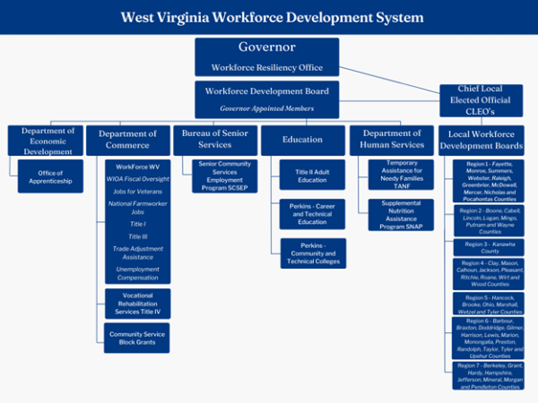
WFWV is responsible for the administration and oversight of all WIOA programs under Title I and III. The DRS is responsible for the administration and oversight of WIOA programs under Title IV. The WVDE is responsible for administration and oversight of Title II Adult Education programs. The combined partners and their programs areas are as follows:
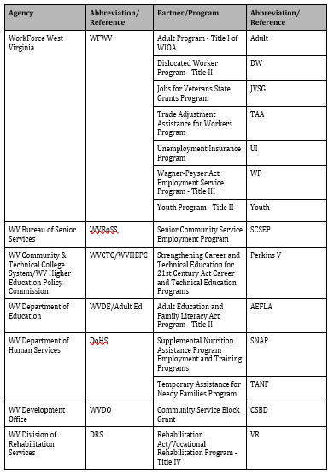

B. State Board
The WVWDB plays a critical role in overseeing and coordinating workforce development efforts across the state, engaging in strategic planning and policy development activities to set priorities, establish goals, and guide the direction of workforce development efforts in the state. The WVWDB is currently engaged in revising its policy framework. Drawing inspiration from Virginia's established policy framework, WVWDB seeks to refine its own policies, utilizing Virginia's model as a reference point. This model serves as a foundational guide for delineating the functions over which the WVWDB exercises oversight.
Section 100: State Governance
Section 200: Local and Regional Governance
Section 300: One-Stop Delivery System
Section 400: Programs and Services
Section 500: Performance and Accountability
Section 600: Administrative Provisions
Advisory Committees of the WVWDB provide support and guidance to partners:
Executive Committee: The Executive Committee comprises key leaders within the WVWDB and is responsible for providing oversight, guidance, and decision-making on behalf of the full board. It often handles matters requiring immediate attention, sets the agenda for board meetings, and ensures that board initiatives are effectively implemented.
Career Pathways Committee: This committee is composed of education, community organizations, employers, and workforce organizations. It is a vital component of the state's workforce development efforts, focused on creating and promoting clear pathways for individuals to obtain the skills and credentials needed to secure high-demand jobs and advance in their careers. This committee plays a key role in identifying industry sectors with growth potential, assessing skill needs within those sectors, and developing pathways that align education, training, and employment opportunities to meet those needs.
Industry Partnerships and Employer Engagement Committee: This committee includes multiple employers across industries to collaborate with colleges, high schools, labor and workforce agencies, community organizations, and other community stakeholders. These partnerships align training with the skills needed for a particular industry, facilitating training, hiring, and career advancement for workers.
​Operations Committee: The Operations Committee supports the alignment of core programs, one-stop partners, and other resources to achieve fully integrated customer services. Its work includes creating workforce development activities regarding gaps identified in the state’s workforce analysis; setting collaborative performance goals, certifying one-stop centers, sharing information/data, and working together to resolve problems and addressing gaps; and collaborating and coordinating on training, marketing, and feedback by utilizing existing committees, workgroups, and programs while aligning and sharing resources when appropriate.
Performance and Accountability Committee: The Performance and Accountability Committee monitors the performance of workforce development programs and initiatives funded under the WIOA. It assesses program outcomes, evaluates the effectiveness of service delivery, and recommends strategies for improving program performance and accountability. This committee establishes baseline data and performance goals to match the new goals and strategies presented in this plan.
In 2022, Governor Justice, with the support of the West Virginia Legislature, created the State Workforce Resiliency Office. This office operates on behalf of the Governor to coordinate workforce development, job training, education, and related programs across numerous state agencies and entities to grow West Virginia’s workforce and provide more options for West Virginians seeking work. This office advises the Governor on the workforce development landscape across West Virginia and assists in developing policies, plans, and procedures to ensure that state agencies, private partners, and federal programs are effectively utilized for workforce development. This office has taken over administrative duties related to the WVWDB and works closely with WFWV to provide guidance to workforce partners regarding implementation of policies and procedures.
West Virginia's State Board, provided in the table below, consists of the following required membership types:
- State Government
  - Governor
  - Representatives of State Legislature
- Business Representatives
- Workforce Representatives
  - Labor Organizations
  - Joint Labor/Management Registered Apprenticeship Program
  - Other Workforce Representatives
- Representatives of Government with Responsibility Over Core Programs
  - Lead State Official for Adult, Dislocated Worker, and Youth (Title I) and Wagner-Peyser (amended by Title III)
  - Lead State Official for Adult Education and Family Literacy Act program (Title II)
  - Lead State Official for the Vocational Rehabilitation program (amended by Title IV)
- Representatives of Local Government
  - Chief Elected Officials
- Optional Representation
Name | Representation | Organization
Scott Adkins | Government Representative | WorkForce West Virginia
Stephanie Ahart | Youth Organization Representative | Human Resource Development Fund - HRDF
Jason Asbury | Business Representative | Terradon Corporation
Ben Ashley | Business Representative | ZMM Architects & Engineering
Sarah Bolyard | Business Representative | YMCA of Kanawha Valley
Pisnu Bua-Iam | Government Representative | West Virginia Division of Rehabilitation Services
Phillip Cantrell | Youth Organization Representative | Mountaineer Challenge Academy
Anne Cavelier | Chief Elected Official | Mayor of Smither
Justin Chad Morrison | Business Representative | Mountaineer Food Bank
Michael Chirico | Business Representative | Marshall Health
Steve Cox | Business Representative | Toyota Motor Manufacturing of West Virginia
Paul Espinosa | State Elected Official | West Virginia House of Delegates
Jacob Green | Youth Organization Representative | West Virginia Schools of Diversion and Transition - WVSDT
Deborah Harris | Government Representative | Jobs & Hope West Virginia
Cassandra Hensley | Business Representative | NGK Spark Plugs
Traci Leigh Nelson | Business Representative, Chair | OMEGA WV Oil Marketers
Pedro Machado | Business Representative | Procter & Gamble
Mendy Marshall | Government Representative | West Virginia Adult Education
John O’Neal IV | Business Representative, Vic-chair | Development Authority of Mercer County
Cynthia Persily | Government Official | West Virginia Department of Human Services
Jay Powell | Chief Elected Official | Pleasants County Commissioner
Abby Reale | Business Representative | Mountain Health Network
Jeff Rowe | Labor Representative | Smart LU 24
Casey Sacks | Community and Technical College System | BridgeValley Community and Technical College
Lisa Samples White | Business Representative | White Insurance and Associates
Sean Sawyer | Business Representative | Higginbotham & Higginbotham
Jennifer Smith | Business Representative | Berkeley County Development Authority
Vic Sprouse | Business Representative | Berkshire Hathaway
Brian Stanley | Labor Representative | IUPAT DC 53
Diane Strong | Business Representative | Manpower of West Virginia
Chandler Swope | State Elected Official | West Virginia Senate
Joshua Sword | Labor Representative | AFL/CIO
Jennifer Tenney | Youth Organization Representative | WVU Center for Excellence in Disabilities
Kimberly Tieman | Community Based Organization | Benedum Foundation
Chris Treadway | Government Representative | West Virginia Community and Technical College System
Ann Urling | Governor’s Representative | Deputy Chief of Staff for Governor Justice
Heather Vanater | Business Representative | American Electric Power
Alex Weld | Business Representative | Generation WV
Jason Wilburn | Business Representative | Paul Wissmach Glass
H. Julian Woods | Business Representative | WVU Medicine
Denise Worley | Government Representative | Bureau of Senior Services

4. Assessment and Evaluation of Programs and One-Stop Program Partners

A. Assessment of Core and One-Stop Program Partner Programs.
To assess the quality, effectiveness, and improvements of the programs, core programs, including WFWV, DRS, and Adult Education, are assessed each year through the state performance accountability measures described in section 116(b) of WIOA. The assessments are conducted at the state, local, and regional levels, while taking into account local/regional planning goals, as appropriate. The WV WDS "data warehouse" ensures that the state will have the capability to conduct assessments at various levels across programs in addition to assessments of the system. Assessments help the state maintain its focus on service quality, progress towards its goals, identify promising practices, and pinpoint areas in need of improvement.
Each core program will be assessed on the following performance measures from section 116(b) of WIOA:
- Employment (second quarter after exit)
- Employment (fourth quarter after exit)
- Median earnings (second quarter after exit)
- Credential attainment rate
- Measurable skills gains
- Effectiveness in serving employers
Additional assessments may be conducted utilizing other measures, as appropriate.
The West Virginia AJC system partner programs include the following:
- Alien Labor Certification Program
- Work Opportunity Tax Credit (WOTC)
- Adult Basic Education
- Wagner-Peyser
- Trade Adjustment Assistance (TAA)
- Career and Technical Adult Education
- Higher Education Adult Part-Time Student
- Workforce Development Initiative Grant
- West Virginia Advance Grant and Technical Program Development Initiative
- WIOA Title I Adult
- WIOA Title I Youth
- WIOA Dislocated Worker
- Governor’s Discretionary Fund
- Division of Rehabilitation Services (DRS)
- Senior Community Service Employment Program
- Veterans Programs
- Labor Exchange
- Community Services Block Grant
- Unemployment Compensation
- Governor’s Guaranteed Workforce Program (Including Small Business Workforce Development)
- National Dislocated Worker Grants (including Opioid and COVID)
Each year, WFWV issues an assessment of the West Virginia WDS, called the Workforce Development System Report. This serves as the primary assessment of one-stop partner program services in the state, reporting on the AJC System, funding streams (the Funding Stream Report), performance requirements, positive practices, and the Interagency Collaborative Team (ICT) Memorandum of Understanding (MOU). This summary document gives a public account and assessment of the current operations, structures, activities, finances, and future direction of AJCs. The report is published annually, as required by the West Virginia Legislature, and reported to the Legislative Oversight Commission on Workforce Investment for Economic Development.
The Funding Stream Report quantifies the level of both fiscal and programmatic (service delivery) involvement of all the entities involved either directly or tangentially with workforce development in West Virginia. The data collected for the report is critical to assessing the AJC system. With the original passage of House Bill 4083 in 2002, the West Virginia Legislature required this annual report regarding the source, use and outcomes of all funds received for workforce development activities in the state.
Specifically, the Funding Stream Report requires information on:
- Source and amount of federal, state, and other funds received for workforce development activities,
- Purpose of each of the above funds,
- Services provided in each of the seven regional workforce development areas, and
- The measure used to evaluate program performance (including current and baseline performance data) and any other information the council requests.
All publicly funded workforce development programs operating in the state are to report:
- Amount of federal funds expended by each program,
- Amount of state funds expended by each program,
- How the funds are spent,
- The resulting improvement in the workforce.
The purpose, beyond identifying sources and uses of funds, is to focus on the outcomes of workforce development. Holding agencies and programs accountable for results is vitally important. Getting the most value from the dollars invested, whether federal, state, or independent grants, is critical to the success of West Virginia’s WDS.
For each workforce development program or activity, the report includes the following:
- State Organization
- Funding Unit
- Operations Unit
- Program
- Program Type
- Program Purpose
- Target Population
- Service Level (number of individuals served)
- Evaluation Measurement (specific to each program)
- Outcome
- Service Locations
- Funds, by Source
- Percentage of Funds used for Workforce Development
Local and Regional Planning Data are collected from the local one-stops within each region. The report also aggregates data by workforce development region and includes data from the previous two years for comparison and assessment purposes. A sample of the data includes:
- The number of individuals receiving services in each region, by program,
- Contributions of each partner agency and non-mandated partner programs at each one-stop and region,
- Program performance for the most recent three years, including negotiated benchmarks and actual performance.
To ensure system and program oversight is communicated and analyzed properly, the Workforce Development System Report is provided to the Legislative Oversight Commission on Workforce Investment for Economic Development to assess the activities and outcomes of the WV WDS. The report allows the governor, legislators, agency and program administrators, and other stakeholders to assess performance and develop appropriate, data-driven planning goals. Through this comprehensive data collection, activities are reported at the local, regional, and state levels to facilitate administrators’ ability to examine and compare performances across levels and areas.
WFWV has overall responsibility for the process to collect information for the Funding Stream Report and provides information to the WVWDB so they can report to the legislature, Governor’s Office, and others.

* Communicating as directed: This section is not currently completed as we are working with partners to obtain additional information. As this was deemed a TA feedback, it was not required for completion at this time.

B. Previous Assessment Results
Program Year 2022 Annual Report provided here:
https://drive.google.com/file/d/1GKP4eeHtPO3ZLFVqKG-6JZ2yCUZ7MuSD/view?usp=sharing
Program Year 2021 Annual Report provided here:
https://www.dol.gov/sites/dolgov/files/ETA/Performance/pdfs/PY2021/WV_PY21%20WIOA%20Annual%20Performance%20Narrative%20Report.pdf
2021 - 2022 Workforce Development Report for West Virginia provided here:
https://drive.google.com/file/d/1D3PgfE8xbrOd5c29iuFvlZ04ZF6NHKMv/view?usp=sharing
Report compiled biennially. 2023-2024 report not yet finalized.
West Virginia's WDS continuously adapts its strategies based on ongoing assessments and reviews of performance to ensure alignment with evolving economic conditions and workforce needs. These assessments involve comprehensive evaluations of factors such as labor market trends, industry demands, demographic shifts, and the effectiveness of current programs and initiatives. Based on these assessments, the WDS identifies areas for improvement and adjusts its strategies accordingly.
One key aspect of adaptation is identifying high growth sector strategies for high-demand occupations within the state's economy. By analyzing labor market data and conducting industry assessments, the WDS can prioritize training and education programs that align with these sectors, ensuring that job seekers are equipped with the skills needed for available employment opportunities.
Moreover, assessments help identify gaps in service delivery and areas of inefficiency within the WDS. This information allows for the reallocation of resources, restructuring of programs, or implementation of new initiatives to address these gaps and enhance service delivery to job seekers, employers, and other stakeholders.
The findings from annual reports, assessments, and the Department of Labor's Monitoring Report highlight the need for West Virginia to establish a unified and shared vision for workforce services provided to individuals and employers. This entails developing a cohesive framework that outlines the goals, priorities, and strategies of the WDS, ensuring alignment and collaboration among various stakeholders. Creating a shared vision requires fostering collaboration and coordination among various agencies and organizations involved in workforce development. This involves breaking down silos, sharing resources and information, and leveraging partnerships to maximize impact and avoid duplication of efforts.
Engaging stakeholders by soliciting input and feedback from across the WDS, including government agencies, employers, educational institutions, community organizations, and LWDBs, is essential for ensuring that West Virginia’s shared vision reflects the needs and priorities of all parties involved. This process includes the collaborative nature of the WIOA Combined Plan, rotating WVWDB meetings across the state to allow local workforce partners to participate and highlight areas, and the implementation of a No Wrong Door approach for all employers, workers, and job seekers. Effective communication and transparency are essential for building trust and buy-in among stakeholders. By having the Workforce Resiliency Office as the Governor’s voice in workforce activities and with workforce partners, West Virginia communicates the shared vision clearly and consistently, keeping stakeholders informed about progress, challenges, and opportunities. This shared vision allows for enhanced coordination, effectiveness, and accountability within the WDS, ultimately leading to improved outcomes for individuals, employers, and the state's economy.
The establishment of clear and measurable goals is crucial for defining the direction and focus of the WDS. The goals of expanding work-based learning; reducing barriers to sustainable employment; investing in high-growth strategies for key industries; and integrating and innovating service delivery are relevant for all workforce partners and individuals in West Virginia, creating a shared vision for all parties to work toward together.

C. Evaluation
Selected research/evaluations and improvement projects are aligned to strategies in this plan and monitored by the WVWDB’s Performance and Accountability committee. The WVWDB develops an annual evaluation agenda connected to workforce and related issues identified by state agency partners. The evaluation agenda for the coming two years includes projects designed to measure the ability of participants to access the full array of services available and the success of newly implemented referral networks. This includes:
- An implementation study on the extent of West Virginia’s referral network development, including number of new partners, use of the system by participants and services most inquired about and/or accessed by participants.
- A mixed-methods study on customer experience using the local one-stop system and the extent to which employers and workers access the system, what services they receive, customer satisfaction with the system, and the penetration rate of employers using the system.
Prior to conducting the evaluations, the annual evaluation agenda details research questions which will lead to an evaluation’s purpose and scope, so stakeholders, partners, and customers understand what is being researched and why.
Research questions include:
- What are the program processes used for the services provided?
- Does the menu of services provided meet the intended program objectives or goals (for example, employment and increased wages for customers)?
- Do some services result in better outcomes than other services (for example, do participants who receive an “extra” package of services have higher earnings or longer retention rates than those who receive the “standard” package of services)?
- Is a statewide career pathways system helping or hindering institutions in making a difference for students and workers?
- Which types of work-based learning (e.g., OJT, registered apprenticeships, paid internships, etc.) provide labor force attachment and credential attainment for youth and adults?
To ensure that the evaluation agenda is coordinated with other evaluations occurring through the Department of Labor and Education, the WVWDB works with partners, such as WVDE and WV CTCs to catalog such evaluations, including discretionary grant efforts where evaluations are happening, particularly through the CTCs and LWDBs.
Final evaluation reports are documented through the WVWDB’s website, including those conducted as workforce system evaluations and those for discretionary and other related programs.
Because WV’s WDS includes multiple agencies, measuring the collaboration and effectiveness of WDS partners is necessary to ensure services are coordinated and effective, federal and state funding is leveraged, and activities are accurately assessed to determine whether individuals and employers are being served per WIOA’s and the Governors’ vision.
The Performance and Accountability Committee is primarily responsible for issues around the data and measurement of workforce program operations and programmatic outcomes, developing metrics and measurements for publishing comprehensive workforce score cards and other longitudinal data that will enable the West Virginia Workforce System to measure comprehensive accountability and performance—important data used in evaluations.
The Performance and Accountability Committee, in consultation with other committees and the Board, recommends policy, budget, and administrative action to the Governor to ensure that West Virginia can measure what matters for business, job seekers, and government. This committee is a resource to other committees assisting in the establishment of standards and metrics to assess and continuously improve program and system performance. The committee engages in identifying cross-agency, cross-program performance metrics and ensuring that decisions made by the WVWDB are informed by sound data and analysis.

5. Distribution of Funds for Core Programs

A. For Title I Programs

i. Youth Activities in Accordance with WIOA Section 128(b)(2) or (b)(3)
Once the US DOL issues the Training and Employment Guidance Letter (TEGL) and WFWV receives the Notice of Obligation (NOO), Research, Information, and Analysis (RIA) gathers information to begin the allocation process. The RIA data breaks out unemployment numbers and ‘economically disadvantaged youths’ by county and region.
Each region is guaranteed to receive no less than 90 percent of the average allocation percentage of the local area for the prior two years. Per the guidance in the TEGL and WIOA regulations, the remaining funds after the ‘hold harmless’ portion of the allocation has been calculated, the remaining funds are broken down by unemployed, excess, and economically disadvantaged youth.

ii. Adult and Training Activities in Accordance with WIOA Section 133(b)(2) or (b)(3)
WFWV follows the same guidelines for allocating Adult funds as used in Youth funds except for ‘economically disadvantaged adult’ rather than ‘economically disadvantaged youth.’ Each region is guaranteed to receive no less than 90% of the average allocation percentage of the local area for the prior two years.

iii. Dislocated Worker Employment and Training Activities in Accordance with WIOA Section 133(b)(2) and Based on Data and Weights Assigned
The funds distributed for Dislocated Workers (DW) are based on different factors than utilized for Youth and Adult funds. The ‘hold harmless’ provision is not taken into account for the dollars distributed.
Each region is guaranteed to receive no less than 90% of the average allocation percentage of the local area for the prior two years.
DWs funds are distributed based on the categories and the percentages listed below:
- Insured unemployment data: 20%
- Unemployment concentrations: 20%
  - Annual average count of unemployed
  - Annual average unemployment rates
  - Index to state rates
- Plant closings and mass layoff data: 0%*
  - Initial claims in MLS
  - Exhaustees involved in MLS
- Declining industries data: 5%
- Farmer-rancher economic hardship data
  - Percentage of delinquent loans to the estimated number of farms. Base data provided by FHA and US Department of Commerce Census of Agriculture.
- Long-term unemployment data: 40%
  - Last pays from UC 217 report
*In PY22 WFWV updated its allocation formula for DW programs. Due to the unavailability of the software previously used to obtain Plant Closing and Mass Layoff Data, WFWV no longer considers this data source in the formula, applying a zero weight for this category. After reviewing the warn notices and monthly rapid response reports submitted by LWDAs and consulting with the Executive Directors of each LWDA, WFWV determined that this change has made minimal impact on the formula

B. For Title II

i. Describe the methods and factors the eligible agency will use to distribute title II funds.
Methods and Factors for Title II
West Virginia Adult Education conducts a competition, multi-year grant award process for Adult Education and Family Literacy Act (AEFLA) and Corrections Education and Integrated English Literacy and Civics (IELCE) grants. In accordance with 34 CFR part 463, Subpart C, a multi- year grant is awarded through a Request for Proposal (RFP) process; the first year being the initial grant award year with subsequent renewal years.
West Virginia awards grants established on need. The needs-based formula is used to allocate funding based on programmatic requirements. It assures local programs receive resources to deliver quality instruction. The needs-based formula ensures funding regardless of the program size (i.e. part-time or full-time program, rural or urban area) due to the vastly differing regions of the state.
Grants are awarded on a multi-year cycle with an annual continuation grant submitted. Each year’s renewal will be based on evidence of success in provision of the contracted services and subject to the availability of funds. West Virginia Adult Education will use the following process to distribute funds to approved applicants: 1. shall use not less than 82.5 percent of the grant funds to award grants and contracts under Section 231 and to carry out Section 225, Programs for Corrections Education and Other Institutionalized Individuals, of which up to 20 percent of such amount shall be available to carry out Section 225; 2. shall use not more than 12.5 percent of the grant funds to carry out State leadership activities under Section 223; and 3. shall use not more than 5 percent of the grant funds, for administrative expenses of the eligible agency.
As part of the application process West Virginia Adult Education will collect basic information from the eligible provider (e.g., location, service area, scope of the program, demographics served, demonstrated need, data collection, and fiscal management procedures). Additionally, each applicant will be required to submit a proposed budget and program design information.
All eligible applicants will respond to the statewide RFP announcement and will be expected to address the thirteen considerations:
1. Needs Assessment: The degree to which the provider is responsive to (A) regional needs as identified in the local plan under section 108; and (B) serving individuals in the community who are identified in such plan as most in need of adult education and literacy activities, including individuals who have low levels of literacy skills and who are English language learners.
2. Individuals with Disabilities: The degree to which the provider is able to serve eligible individuals with disabilities, including eligible individuals with learning disabilities.
3. Past Effectiveness: The degree to which the provider demonstrates past effectiveness in improving the literacy of eligible individuals, to meet state-adjusted levels of performance for the primary indicators of performance described in section 116, especially with respect to eligible individuals who have low levels of literacy.
4. Alignment with One-Stop Partners: The degree to which the eligible provider is responsive to, and demonstrates alignment between, proposed activities and services and the strategy and goals of the local plan under section 108, as well as the activities and services of the One-Stop partners.
5. Intensity, Quality, and Instructional Practices: The degree to which the eligible provider’s program is of sufficient intensity and quality and based on the most rigorous research available so that participants achieve substantial learning gains; and uses instructional practices that include the essential components of reading instruction.
6. Research-Based Educational Practices: The degree to which the eligible provider’s activities, including reading, writing, speaking, mathematics, and English language acquisition instruction, are based on the best practices derived from the most rigorous research available and appropriate, including scientifically valid research and effective educational practice.
7. Effective Use of Technology: The degree to which the eligible provider’s activities effectively use technology, services, and delivery systems, including distance education in a manner sufficient to increase the amount and quality of learning and how such technology, services, and systems lead to improved performance.
8. Integrated Education and Training: The degree to which the eligible provider’s activities offer learning in context, including through integrated education and training, so that an individual acquires the skills needed to transition to and complete postsecondary education and training programs, obtain and advance in employment leading to economic self-sufficiency, and to exercise the rights and responsibilities of citizenship.
9. Qualified Staff: The degree to which the eligible provider’s activities are delivered by well- trained instructors, counselors, and administrators who meet minimum qualifications established by the state, where applicable, and who have access to high quality professional development, including through electronic means.
10. Partnerships and Development of Career Pathways: The degree to which the eligible provider’s activities coordinate with other available education, training, and social service resources in the community, postsecondary educational institutions, institutions of higher education, Local Boards, One-Stop centers, job training programs, and social service agencies, business, industry, labor organizations, community-based organizations, nonprofit organizations, and intermediaries, for the development of career pathways.
11. Flexible Schedules and Coordination with Support Services: The degree to which the eligible provider’s activities offer flexible schedules and coordination with federal, state, and local support services (such as child care, transportation, mental health services, and career planning) that are necessary to enable individuals, including individuals with disabilities or other special needs, to attend and complete programs.
12. Data Collection: The degree to which the eligible provider maintains a high-quality information management system that has the capacity to report measurable participant outcomes (consistent with section 116) and to monitor program performance.
13. English Language Acquisition and Civics Education: The degree to which the eligible provider has a demonstrated need for additional English language acquisition programs and civics education programs.
Previously funded programs will be required to provide data demonstrating they have met previously proposed state targets for the required percent of students making a measurable academic gain. Programs must also provide data demonstrating successful transition to post-secondary education or employment by students. For programs not previously funded, programs with data demonstrating student learning gain and successful transition to post-secondary education or employment, especially for individuals with low-levels of literacy, will be given preference. Both measurable skill gain data and transition data must be disaggregated to demonstrate a history of success with students who have low levels of literacy, disabilities (including learning disabilities), or are English language learners.
Programs will need to clearly articulate how their instructional delivery model will be aligned to the needs of one-stop, postsecondary, and employer partners. This alignment at a minimum must include the ability to offer flexible scheduling so that adult education services coordinate with the students’ wrap-around support services and logistic needs. The delivery model must be of sufficient intensity and duration so that the students’ will exit with the necessary skills to attain their career goal. Existing programs will base intensity and duration of service on demonstrated past effectiveness (student skill gain and transition outcomes) and the latest research on the effectiveness of time and intensity. It will be critical for each program to validate their commitment to an instructional delivery model that can support high school equivalency attainment, as well as preparation for entrance into postsecondary, a training program, or employment for adults with, or without, a high school diploma. This support must lead to preparation for a career pathway for all students, including the low-skilled and under employed, who are most in need of increasing their knowledge and skills for the next career step. All eligible programs will assess the need for providing an English language acquisition and civics education program in their area and provide services when there is a demonstrated need.
Eligible programs will verify that adult education activities are conducted by licensed instructional staff and confirm that all staff will participate in high quality professional development offered by the state professional development unit. Professional development activities will include face-to-face and distance education, so all staff will be able to participate in a variety of delivery venues. Programs must ensure they will follow all state assessment policies and publisher guidelines for administering and scoring.
Instruction in all content areas (reading, writing, speaking, mathematics, and English language acquisition) will be delivered by staff who are knowledgeable of the essential components of high quality instruction. Programs must use scientific, effective research-based instructional delivery models for students in all content areas. Programs will articulate how distance learning, and other modes of technology, will be integrated into instruction to support digital literacy attainment and meet students’ specific learning needs. The overarching goal of instruction for all students will be a successful transition to employment, postsecondary, or training according to their chosen career pathway. This will require instruction be contextualized, and student pathways guided by labor market needs and data from collaborative partnerships (education, one-stop partners, and employers).
The array of program activities that support the individual students’ career pathway must be based on each student’s Education and Career Plan (ECP). Eligible programs will describe how they will assist all students in setting up their ECP through a series of lessons in the College Foundation of West Virginia’s website at www.CFWV.com or alternative career exploration resource. Programs will detail how teachers will be assisting students in aligning their skills and interests with a career choice and helping them to create long-and-short term goals to enter their career pathway. Each program will share their protocol for linking student career pathways to academic lessons that are relevant and supportive of students’ career goal. Programs will confirm that they are providing learning activities that are contextualized, so students acquire the knowledge and skills needed for transition to their individual career pathway. Programs will ensure that the teaching staff offer a variety of instructional strategies that engage students and promote student persistence and retention; this should include whole group instruction, peer tutoring, and individualized instruction along with distance learning. The variety of instructional strategies will integrate academics, career counseling, employability and soft skills to bolster the students’ ability to gain employment, go to college, or enter a training program that could include an apprenticeship. Integrated education and training programs will align with the needs of the local labor market. The occupational training provided as part of an integrated education and training program will be connected to realistic, existing employment opportunities in the local area that connect to a career pathway for the participants.
The state management information system will collect all data elements that will be required for the WIOA Annual Statewide Performance Report. Primary indicators of performance that will be reported include:
- participants in unsubsidized employment during the second quarter after exit,
- participants in unsubsidized employment during the fourth quarter after exit,
- median earnings from unsubsidized employment the second quarter after exit,
- the percentage of students who obtain a postsecondary credential or a high school equivalency diploma,
- the percentage of students who participate in an education or training program, and
- percent achieving a measurable skill gain.
To facilitate this process, funded programs must ensure they will: collect and provide participant social security numbers to enable a data-match (to the best of their ability), input data accurately and within prescribed timelines, and adhere to all state policies and guidelines regarding data privacy.
Programs must provide evidence of activities with other education institutions, local workforce partners, and agencies that support student career pathways. The National Career Clusters® Framework provides a vital structure for organizing and delivering quality Career and Technical Education (CTE) programs through learning and comprehensive programs of study. This National Career Clusters® Framework is the basis for the Career Pathways Programs established at WV Career and Technical Centers and articulated with WV Community College and University Systems.
Beyond assisting students for attainment of a measurable skill gain, achieving a high school equivalency or postsecondary credential, or entering a career pathway, eligible programs must demonstrate that they have established cross-agency partnerships to help students navigate system challenges (completing applications, writing resumes, scheduling campus visits, etc.) that can be barriers to success. Programs must be willing to cooperate with agency partners to provide the wrap-around services common clients will require.
Through ongoing labor market analysis all programs will have an awareness of regional labor market needs to provide teachers with a working knowledge of regional career opportunities. Programs must be able to disclose their methodology for ensuring that employer and labor market needs are driving their instructional practice. Effective programs will be those that deliver instructional activities that support student transition to specific occupations or career clusters.
The RFP is the mechanism through which Adult Education will identify, assess, and award multi-year grants to eligible providers throughout the state that have demonstrated effectiveness in providing adult education activities to eligible individuals. An eligible individual is a person 16 years of age or older who is not enrolled or required to be enrolled in secondary school under state law; is basic skills deficient; does not have a secondary school diploma or its recognized equivalent; has not achieved an equivalent level of education; or is an English language learner.
Programs previously funded by Adult Education will be evaluated for their ability to meet designated state performance measures. Applicants not previously funded by Adult Education are required to provide data that demonstrate their past ability to achieve success in comparable measures. For both groups, these measures include effectiveness in helping students develop their academic skills, achieve high school equivalency, and transition into employment and/or postsecondary education and training.
Eligible providers submitting applications to Adult Education may include:
- A local education agency;
- A community-based or faith-based organization;
- A volunteer literacy organization;
- An institution of higher education;
- A public or private nonprofit agency;
- A library;
- A public housing authority;
- A nonprofit institution with the ability to provide adult education and literacy services;
- A consortium or coalition of agencies, organizations, institutions, libraries, or authorities described above; or
- A partnership between an employer and an entity described above.
Local grants will be distributed based on whether they meet the requirements of AEFLA purposes outlined in WIOA, which include their ability to:
- Assist adults to become literate and obtain the knowledge and skill necessary for employment and economic self-sufficiency;
- Assist adults who are parents or family members become a full partner in the education development of their children;
- Promote transition from adult education to post-secondary education and training through career pathways; and/or
- Assist immigrants and English language learners improve reading, writing, math, speaking and comprehending the English language and acquire understanding of American government, individual freedom, and responsibilities of citizenship.
As part of the application process, LWDBs will review applications to ensure that funds allotted align with their local plans. Adult Education will consider the review and any recommendations made by LWDBs when scoring the related sections of the applications.
The RFP process is as follows:
- Statewide announcement
- Release of application
- Technical assistance webinar
- Application due date
- Review by LWDBs
- Evaluation by review committee
- Notification of awards
- Distribution of grant awards

ii. Describe how the eligible agency will ensure direct and equitable access to all eligible providers to apply and compete for funds and how the eligible agency will ensure that it is using the same grant or contract announcement and application procedure for all eligible providers.
To ensure that the same grant announcement is made available to all eligible providers, when RFPs are ready for release, Adult Education publishes an official press release containing information about the availability of funds and the application process, written as a legal notice in compliance with the WVDE Office of Communication’s approved policies and procedures. The RFPs are then posted on the WVDE website for download.
Submissions from eligible applicants are reviewed for completeness, adherence to grant guidelines, content development, and overall quality. A review committee scores each application and makes funding recommendations. Final funding decisions are made by Adult Education staff based on the review committee’s recommendations.

C. Vocational Rehabilitation Program
Not applicable.

6. Program Data

A. Data Alignment and Integration
West Virginia has an integrated data collection and performance management system (MACC) that covers the following programs:
- WIOA Adult, Dislocated Worker, Youth
- National Dislocated Worker Grants (NDWG)
- Migrant and Seasonal Farmworkers
- Wagner-Peyser
- Trade Adjustment Assistance (TAA)
- Jobs for Veterans State Grants
- Jobs & Hope WV
- West Virginia’s Unemployment Compensation MIS interfaces with MACC
Other partners have management information systems that are customized to meet the needs of their programs. WFWV, DRS, and Adult Education have each made the necessary changes to their systems to collect the required data elements. As previously mentioned in this plan, WV's WDS system collects data elements, develops research questions, and identifies additional metrics so proper studies and evaluations can be conducted to assess partner services and performance.
Front line staff and leadership partners, such as DoHS, can access information in real time. Employment and wage data are shared with partners to the extent allowed by the State Wage Interchange System (SWIS) agreement.
While each partner agency does have their own MIS, they are all interoperable and can send and retrieve data to and from each other in real time. All individuals served by the West Virginia WDS are assigned a unique identifier that is used across partner agencies for data sharing and reporting purposes (i.e., co-enrollment with other core programs).
The No Wrong Door Approach initiative creates a common application to make it easier for citizens to enroll in services across organizations. At this stage of planning, the state seeks a vendor solution incorporating a phased implementation approach, which enables the state to evaluate the effectiveness of the solution at each stage and validate intended outcomes and deliverables. Additionally, a phased approach enables the state to enact cost control measures. Phases are anticipated to consist of planning and account set up, data processing and preparation, application build, testing and iteration, rollout, and post-project work. WV also intends for staff working with customers to take more of a 'generalist' role in their day-to-day work so shared customers, and those who should be shared, are served the most coordinated, appropriate, and successful way possible. The generalist concept prevents a 'silo' approach from occurring, ultimately removing additional barriers placed on individuals and employers seeking services, preventing the provision of duplicated or unnecessary services, and avoiding missed opportunities.
Front-end users also benefit from shared data. For example, the DRS MIS, iECM (Internet-based Electronic Case Management System), has a link in each case for “WIOA Partner Data.” When a DRS counselor clicks this link, iECM sends a request for data (using the unique identifier) to the WFWV and Adult Education MIS. If available, the information is transmitted and displayed in real time. Information provided by partner agencies includes current and previous employment goals, services received, and assessment results, which is then used by DRS counselors to optimize service delivery with the goal of improving the participant’s employment outcome.
The MACC is WFWV’s management information system that covers all U.S. Department of Labor (USDOL) programs that it manages, except for the Unemployment Compensation systems where an interface allows for the immediate transfer of registration data from the UC benefits payment system to the MACC. All partners have interfaces in their information system that allow real time exchange of participant tracking information among all systems partners. Using the system, case managers can streamline the intake process by eliminating the need to duplicate data that is already available in the partner systems. They can also track an individual’s participation in all programs, including what services have been given or are scheduled to be given, development plans, outcomes, and other pertinent information.
Current WFWV initiatives are designed to enhance and expedite interoperability among partners and individuals through data sharing. Recently, the state introduced a unified login system (single sign-on) for both unemployment and workforce job seeker applications. This seamless integration ensures a cohesive experience for customers, while simultaneously providing both unemployment and employment services with more comprehensive and actionable data.
The state plans to create more secure file transfer systems to facilitate more timely and effective communication between jobseekers, state frontline staff, employers, and other key stakeholders. Additionally, DoHS continues the implementation of its WV People's Access to Help (WV PATH) Integrated Eligibility System (IES) for serving SNAP, TANF, Medicaid, Child Support, and Child Welfare Clients. The full implementation of this IES offers enhanced opportunities for systems integration with other partners across the WDS to improve tracking of and outcomes for shared clients.
The WVWDB is fully committed to the goal of aligning technology and data systems across required one-stop partner programs, making it a priority at quarterly meetings to ensure progress is being made toward the governor’s vision. WFWV, DRS, and Adult Education are using aligned technologies and data systems, and the WVWDB continues to work within the framework of the WIOA legislation and federal guidance to improve service delivery by facilitating collaboration and coordination among relevant stakeholders, including government agencies, LWDBs, and service providers. This alignment requires designing and implementing common intake processes, data collection systems, and technology platforms to streamline service delivery and improve coordination among partner programs so that individuals seeking services will experience a more seamless and efficient process when accessing resources and support.
In conjunction with the work and recommendations of the Blue Ribbon Task Force and following the No Wrong Door Initiative, a team from West Virginia is working through the Aligned Case Management (ACM) Institute (“the Institute”). The Employment and Training Administration Office of Workforce Investment (ETA-OWI) is working to identify opportunities for improvement in the case management system by better understanding the first-hand experience of case managers and job seekers in the nation’s workforce development system. They engaged NASWA’s Workforce ITSC to provide a replicable framework and an on-demand toolkit of resources that reflects the shared System’s case management needs. As part of that engagement, West Virginia enrolled a team in the Institute to identify problems in the current state of case management the state would like to address.
Ultimately, the mission of this Project is:
- To identify how professional staff and customers might make optimum use of No Wrong
- Door to improve referrals and access to the full breadth of partner services;
- To identify actions leaders and managers should take to support optimum utilization of
- the tool;
- To make recommendations on action steps and resources required to support the
- successful deployment of No Wrong Door;
- To discuss and identify opportunities, leadership might consider following the successful
- execution of No Wrong Door to continue the longer-term effort toward better Aligned
- Case Management in West Virginia.
From this collaborative work, a set of recommendations will be made to the WVWDB and the Governors that includes next steps and priority in the support of a better Aligned Case Management approach in West Virginia. The first meeting of this leadership team occurred in April 2024.
The WVWDB employs a multifaceted approach to support the governor effectively. Firstly, committee work serves as a cornerstone, allowing for in-depth exploration and discussion of pertinent issues. These committees, composed not only of WVWDB members but also of knowledgeable professionals, analyze data, assess current goals and strategies, and propose innovative solutions to address workforce challenges. West Virginia will be transitioning to a new Governor in 2025 so this group will be essential in advising a new Governor regarding workforce initiatives and goals included in this state plan.
Regular quarterly board meetings provide a platform for ongoing evaluation and refinement of initiatives. The Executive Committee of the Board provides a quick turn around for decisions and responses between quarterly meetings.
The WVWDB is currently engaged in revising its policy framework. The Governor saw a need to better outline functions of workforce partners. The WVWDB is using this policy work to respond to the Governor’s request. Drawing inspiration from Virginia's established policy framework, WVWDB seeks to refine its own policies, utilizing Virginia's model as a reference point. This model serves as a foundational guide for delineating the functions over which the WVWDB exercises oversight.
- Section 100: State Governance
- Section 200: Local and Regional Governance
- Section 300: One-Stop Delivery System
- Section 400: Programs and Services
- Section 500: Performance and Accountability
- Section 600: Administrative Provisions
WFWV’s MACC system has produced the required reports for USDOL programs in the past and can continue complying with the section 116 reports without difficulties. The MACC system has been able to track performance for participants for year, producing reports on WIOA training performance. The MACC system has limited fiscal information available, which could be the basis of a fiscal management system once the requirements are established.
The WIOA core partners in West Virginia, including WFWV, DRS, and Adult Education have implemented a practical and effective system to fulfill the data alignment and integration requirements of WIOA. Each program has a unique system of data collection that is tailored to meet its unique needs. To maximize the efficient exchange of data to support assessment and evaluation, the core partners have collaborated to develop and implement a system for data sharing.
This system operates as follows:
1. Each consumer in the system is assigned a unique participant identifier upon entering the system (WFWV, DRS, Adult Education). The date each consumer enters and exits each program is recorded. The unique participant identifier and program entry/exit dates are used to identify common consumers across the core programs and provide access to common data elements collected by other partners in the AJC system.
2. To ensure effectiveness and efficiency in the AJC system, data collected by each program on new consumers is made available for each program to track service delivery of common consumers. This process ensures that service delivery for each consumer can be tracked across all programs.
3. The data collected is used to generate reports required under section 116, performance accountability system.
Alignment of each partner’s system of data collection has improved service delivery to individuals at the AJC including individuals with barriers to employment, especially those with disabilities, by providing the three core partners with more information about how consumers are being assisted across programs in the AJCWV. This information enables the core partners to have a greater understanding of how the needs of their consumers are being met across programs, to track their progress, and to minimize duplication of service. Alignment and integration of data across programs in a data sharing system supports a consumer-focused approach to service delivery that generates quality employment outcomes for consumers in the AJC.

B. Assessment of Participants’ Post-program Success
As part of West Virginia’s ongoing efforts to fundamentally restructure the WDS and access to services for employers and workers, the following steps are being taken to assess post-program success:
- Improved longitudinal tracking of what happens to participants after they receive and exit services, including examining post-program employment and wages.
- Mapping what referrals were made and what follow-through occurred to receiving services from a variety of state agency and community-based partners.
- Determine effective methods of intake–both physical and virtual–and preferences for residents, particularly in rural areas of the state.
Using these three core activities, the WVWDB will conduct an annual assessment of progress in moving toward a No Wrong Door approach and make policy recommendations to foster a more integrated and performance-based system. Working with the appropriate state agencies, the WVWDB will coordinate actions designed to meet performance goals.
The WDS as a whole will explore mechanisms to track the progress of participants in workforce development programs by monitoring key metrics such as program completion rates, employment outcomes, wage growth, and career advancement. By requiring regular reporting from workforce development programs and service providers, state agencies can analyze trends and identify areas where participants are succeeding or facing challenges. The No Wrong Door referral platform is developing an inventory of all programs, services, and resources available to participants.
Another tool to assess participants’ progress could be West Virginia’s P20 data system. This system allows for comprehensive tracking of the education-to-employment pipeline. By leveraging this system, WDS partners could evaluate program effectiveness, enhance collaboration. WDS partners can access the public facing portions of the P20 data system. Areas of improvement could include a detailed training provided to partners by the P20 staff to allow for better understanding or reported information and how to translate reports.

C. Use of Unemployment Insurance (UI) Wage Record Data
WorkForce West Virginia (WFWV) accesses Unemployment Compensation wage data, vital for performance evaluations and labor market analyses. As a participant in The Wage Record Interchange System (WRIS, WRIS2), and The State Wage Interchange System (SWIS), WFWV gains insights into workforce dynamics. However, due to constraints on directly sharing wage data, WFWV focuses on providing aggregated performance data instead. This approach ensures compliance with legal and privacy considerations while still offering valuable insights into workforce trends and program effectiveness.
WFWV is actively discussing the implementation of the newly approved Employment Flag outlined in SWIS Amendment 4. These discussions involve leadership, programmers, and key staff, focusing on establishing protocols for handling Annex 3 data.
WFWV is evaluating the best approach to using either Annex 3-A or Annex 3-B within the SWIS framework, considering factors like data compatibility and legal compliance.
With its in-house Information System (MACC), WFWV plans to process changes internally, ensuring greater control and customization to meet state and federal requirements.

D. Privacy Safeguards
Scope
WorkForce West Virginia is an agency within the West Virginia Department of Commerce. This Privacy Notice Summary is based on the West Virginia Department of Commerce Privacy Policy; however, it is specific to WorkForce West Virginia.
Personal Information
- We need certain personal and non-personal information to assist you with your employment, unemployment and training needs.
- The Personally Identifiable Information (PII) we collect may include your name, address, social security number, date of birth and more.
Uses of Information
- By West Virginia law and the Privacy Act of 1974, we must collect certain PII to assist you. Without certain PII, we may not be able to determine the services for which you are eligible, such as Unemployment Insurance benefits.
- The information we collect may be combined with information obtained from other Executive Branch Departments’ websites and services.
- We use personal information for purposes that relate to the reason you provide it. If information is used for another purpose, we will obtain your permission.
- For purposes matching the reason you provided, we may share your information with other state and federal agencies for the limited purpose of data processing or storage.
- In certain cases, we may share your information when required by state or federal law.
- Your information may be shared with others we have hired to assist us; however, all staff and contractors are bound by a West Virginia Executive Branch Confidentiality Agreement.
- We do not sell or rent your PII to third parties for marketing purposes.
- We may share non-personal, aggregated, or de-identified data for purposes related to improving our business practices.
Your Rights and Choice
- You have the right to review the personal information you provide us and to update or correct that information.
- If you have consented to an electronic exchange of information, you may cancel that consent by following the instructions in the email you receive.
- If you provide any information to any of our agency websites, you may choose to remove it at any time, except where such information is required by state or federal regulation.
Security
- WorkForce West Virginia computer systems are constructed and maintained by WorkForce West Virginia agency staff, the West Virginia Office of Technology, and/or WorkForce West Virginia and state approved contractors.
- Regardless of the system or personnel responsible for it, multiple techniques and technologies are used to protect your PII. This means we use industry standards and several in-house safeguards to protect your information.
How to Contact Us
For more information on our privacy requirements and practices, please call 800-252-5627 and your call will be directed to the WorkForce West Virginia Privacy Officer for response.
Sharing Your Information
By enrolling with WorkForce West Virginia, you agree that WorkForce West Virginia and its mandated partners may access and use all of the information contained within your application in order to best assist you in obtaining employment and in determining your eligibility for training and other services. These services may include testing, assessment, placement services and career counseling, and we may share test scores and job eligibility data with our partners to best serve you. Personal information such as race, ethnicity, sex and disability status is being requested for federal record keeping and reporting requirements and is kept confidential; however, it may be shared with the partners to determine your eligibility for specific programs.
WorkForce West Virginia Partner Agencies
- Adult Education and Literacy Services
- Vocational Rehabilitation Services
- Post-Secondary Carl Perkins Vocational and Applied Technology Education Services
- Welfare-to-Work Funded Under Social Security Act
- Senior Community Service
- Veterans Workforce Programs
- Community Services Block Grant (Community Action)
- Housing & Urban Development (HUD) Employment & Training Programs
- Job Corps
- Migrant & Seasonal Farmworker (MSFW) Services
- Temporary Assistance to Needy Families (TANF)
- Food Stamp Employment & Training
- Navigator Program
Civil Rights Statement-Equal Opportunity is the Law!
It is against the law for this recipient of Federal financial assistance to discriminate on the following basis:
- Against any individual in the United States, on the basis of race, color, religion, sex (including pregnancy, childbirth and related medical conditions, sex stereotyping, transgender status, and gender identity), national origin (including limited English proficiency), age, disability, political affiliation or belief; OR,
- Against any beneficiary of, applicant to, or participant in programs financially assisted under Title I of the Workforce Innovation and Opportunity Act (WIOA), on the basis of the beneficiary’s citizenship status or participation in any WIOA I-financially assisted program or activity.
The recipient must not discriminate in any of the following areas:
Deciding who will be admitted, or have access, to any WIOA Title I-financially assisted program or activity; providing opportunities in, or treating any person with regard to, such a program or activity; or making employment decisions in the administration of, or in connection with, such program or activity; or making decisions in the administration of, or in connection with, such a program or activity. Recipients of federal financial assistance must take reasonable steps to ensure that communications with individuals with disabilities are as effective as communications with others. This means that, upon request and at no cost to the individual, recipients are required to provide appropriate auxiliary aids and services to qualified individuals with disabilities.
If you think that you have been subjected to discrimination under WIOA Title I-funded program or activity, you may file a complaint within 180 days from the date of the alleged violation with either the recipient:
Equal Opportunity Officer, WorkForce West Virginia, 1900 Kanawha Boulevard, East, Charleston, WV 25305, 304-558-1600; WV Relay 7-1-1 (TDD)
The Director, Civil Rights Center, (CRC), U.S. Department of Labor, 200 Constitution Avenue NW,
Room N-4123, Washington, DC 20210, 202-693-6502; 202-693-6515 (TTY).
If you file a complaint with the recipient, you must wait either until the recipient issues a written Notice of Final Action, or until 90 days have passed (whichever is sooner), before filing with the Civil Rights Center (see address above). If the recipient does not give you a written Notice of Final Action within 90 days of the day on which you filed your complaint, you do not have to wait for the recipient to issue that Notice before filing a complaint with the CRC. However, you must file your CRC complaint within 30 days of the 90-day deadline (in other words, within 120 days after you filed your complaint with the recipient). If the recipient does give you a written Notice of Final Action on your complaint, but you are dissatisfied with the decision or resolution, you may file a complaint with CRC. You must file your CRC complaint within 30 days of the date on which you received the Notice of Final Action.
To apply for jobs you must be a United States citizen, a permanent resident alien, or be authorized to work in the United States.
WV DIVISION OF REHABILITATION
West Virginia Division of Rehabilitation Services staff are required to complete a confidentiality agreement. The agreement is utilized to ensure that all West Virginia Division of Rehabilitation Services staff with access to protected information or any other information deemed confidential, fully understand their obligations to limit their use of such information and to protect such information from disclosure. The agreement also details special attention items, as well as definitions of different types of information including personal health information (PHI), personally identifiable information (PII), sensitive personally identifiable information (SPII), and nonpublic personal information (NPII). The confidentiality agreement pertains to information in all forms, including electronic and paper.
WV ADULT EDUCATION
Handling Confidential Information
If a student discloses any of the following types of information (verbally or in writing), legally that information is to be considered confidential and therefore “private”:
- Disclosure of a diagnosed learning disability
- Disclosure of previous status as a "special education" student
- Disclosure of any other type of diagnosed physical or mental disability
- Disclosure of a diagnosed medical condition
- Disclosure of use of any prescription drugs
- Disclosure of history of drug/alcohol abuse and/or treatment
- Disclosure of status as HIV positive or of having the AIDS virus
- Official transcripts
Filing cabinets or drawers containing confidential information must be labeled as “Confidential.” They must remain locked, must not be accessible to students or support staff, and must have a log filed foremost in each locked drawer to indicate when confidential files are accessed by any instructional or administrative staff person. Confidential information files should be maintained at the local program level for a period of not less than five years and must be shredded when discarded. Confidential information regarding a student cannot be discussed, nor can any record be shared without a written release of information.
Instructors sign the Adult Education Personnel Confidentiality Agreement, and it is maintained by the administrator in the personnel file.

* Communicating as directed: This section is not currently completed as we are working with partners to obtain additional information. As this was deemed a TA feedback, it was not required for completion at this time.

7. Priority of Service for Veterans.

A. Describe how the State will implement the priority of service provisions for covered persons in accordance with the requirements of the Jobs for Veterans Act, codified at section 4215 of 38 U.S.C., which applies to all employment and training programs funded in whole or in part by the Department of Labor.

B. Describe how the State will monitor priority of service provisions for veterans.

C. Describe the triage and referral process for eligible veterans and other populations determined eligible to receive services from the Jobs for Veterans State Grants (JVSG) program’s Disabled Veterans’ Outreach Program (DVOP) specialist/Consolidated Position.
(A) Describe how the State will implement the priority of service provisions for covered persons in accordance with the requirements of the Jobs for Veterans Act, codified at section 4215 of 38 U.S.C., which applies to all employment and training programs funded in whole or in part by the Department of Labor.
Priority of service for veterans is implemented by WFWV in accordance with Title 38 part III Ch. 42. 4215 via AJCs located throughout the state, by using clear and concise guidelines, and by trained staff knowledgeable with state guidelines. To ensure access to services for covered persons, the state has established formal guidance regarding priority of service that all Wagner-Peyser and WFWV staff must follow which includes determination of veteran’s status and eligibility. WIOA guidance notice 4-16 referencing Workforce Innovation & Opportunity Act of 2014 section 3(63) (A), 38 U.S.C 4215, and 20 CFR 1010 provides this guidance.
Covered persons can obtain information concerning priority of service through WFWV’s website, flyers posted in AJCs, banners, and in person from appropriate staff in work groups, from unemployment compensation groups, during the job seeker enrollment process, and during the provision of services. WFWV provides staff information, training, and assistance regarding available employment programs, training opportunities, services, eligibility requirements, and veteran’s priority of service.
WFWV provides a covered person’s priority of service under all state and federally funded employment and training programs. "Veterans priority of service" means that an otherwise covered person shall be given priority over non-veterans for the receipt of employment, training, and placement services provided under that program, notwithstanding any other provision of the law. When services are limited due to available funding, priority of service should be applied. For example, if there are only sufficient funds to provide services to one individual and a veteran is in the pool, the veteran must receive priority.
All WFWV staff, including managers, are trained on implementation of priority of service and integrating it into the service delivery process. Eligibility for priority of service is identified within the state’s MIS by symbols that indicate a covered person has been verified by staff or the covered person has self-attested concerning eligibility status. These symbols serve to easily identify individuals who may be eligible for priority of service. Eligible veterans and eligible persons who have a Significant Barrier to Employment (SBE) or are a member of an additional population designated by USDOL VETS in accordance with Veterans' Program Letter (VPL) 03-19 and need Individualized Career Services (ICS) are referred to Disabled Veterans’ Outreach Program (DVOP) specialists.
(B) Describe how the State will monitor priority of service provisions for veterans
Priority of service is monitored quarterly at the state level via the ETA-9173 Performance Report for JVSG. A review of total participants served is compared to eligible veterans and analyzed for accuracy. Once every three years a comprehensive audit by DOL staff will be conducted to ensure that management receives information and that they are made aware of the operations and actions taken to provide priority of service to covered persons as written by law. West Virginia’s Director of Veterans Employment and Training works with the State Veterans Coordinator to ensure that priority of service is administered in accordance with the law. Additional oversight of the provision of priority of service is provided by DOL’s Employment and Training Administration.
(C) Describe the triage and referral process for eligible veterans and other populations determined eligible to receive services from the Jobs for Veterans State Grants (JVSG) program’s Disabled Veterans’ Outreach Program (DVOP) specialist/Consolidated Position.
West Virginia strategically positions adequate staff, including Disabled Veterans' Outreach Program (DVOP) specialists and Local Veterans' Employment Representatives (LVERs), throughout the state to meet JVSG performance goals and program expectations. DVOP specialists facilitate the provision of Individualized Career Services (ICS) to as many eligible veterans and eligible persons as possible. ICS particularly focuses on those veterans and eligible persons who are educationally or economically disadvantaged, lack access to public transportation or to broadband internet, and those who have been identified as having at least one Significant Barrier to Employment (SBE) and/or a veteran who is a member of an additional population designated by USDOL VETS and in accordance with Veterans' Program Letter (VPL) 03-19. DVOP specialists provide ICS through the case management framework which includes a comprehensive initial assessment, the development of a plan that establishes short and long-term goals leading to suitable employment, and consistent contact pre- and post-employment. All services to eligible veterans are documented in the state's MIS. DVOP specialists use outreach activities to cultivate relationships with AJC partners and service providers, which provides them with access to beneficial resources for the veterans they serve. Outreach efforts also promote enrollment into the state's MIS, leading to referrals of eligible veterans and persons to the DVOP specialists.
There are two ways for a covered person to identify themselves as such. The first is at the AJC in person. This is done by Wagner-Peyser Staff asking “Are you a Veteran or the Spouse of a Veteran?”. Wagner-Peyser staff are the first point of contact in the AJCs for eligible veterans and eligible persons. If a covered person is identified this way Wagner-Peyser staff enroll eligible veterans and eligible persons into the WDS if necessary, where they receive priority of service. The enrollment process is utilized to identify and determine veterans’ eligibility. The second way a covered person may be identified is through self enrollment through the WFWV website. Both processes are self attested. If our intake system is unavailable, staff will use the DOL approved Eligibility Triage Form (04-2021) to refer covered persons to the DVOPS.
Veterans who are identified with a Significant Barrier to Employment (SBE) should be referred to the DVOP specialist for service. The referral is conducted through the WFWV case management system. Wagner-Peyser staff will assess the covered person, if SBE’s are identified the system will offer the option to refer to DVOPS. The DVOP specialist will conduct a comprehensive assessment, and they will place eligible veterans or persons into case management and create a Veterans Development Plan. The DVOP specialist will provide consistent contact and information about a wide range of resources available.
LVERs are assigned to AJCs throughout West Virginia, which present the best opportunity to address the needs of employers in an effort to place veterans in available positions. LVERs identify the unique needs of employers and collaborate with AJC staff, including DVOP specialists, to formulate plans to place veterans in apprenticeships or training opportunities to meet skills gaps identified through their employer outreach activities.
Identify employers interested in hiring veterans by utilizing the HVMP database and online platforms, collaborate with military transition programs, attend veteran-focused job fairs and networking events, reach out to veteran service organizations, explore corporate veteran hiring programs, leverage professional networking platforms like LinkedIn, and seek recommendations from fellow veterans or military contacts.
Promoting job fairs for veterans and eligible persons and actively advocating and creating awareness for employment events that offer targeted opportunities and a supportive environment, ensuring priority of service and meaningful employment opportunities for those who have served or meet specific eligibility criteria.
Consolidated position Staff serve a dual role as DVOP specialist and LVER, focusing on the rural areas of the state to provide services to both employers and SBE veterans/eligible persons. They conduct employer outreach, job searches, and establish job search groups. After they have removed all barriers to employment through individualized career services, consolidated staff coordinate with AJC apprenticeship, OJT programs and local business engagement team staff to match veterans with job opportunities. Consolidated staff also provide training to other AJC staff to ensure programmatic compliance in serving the needs of veterans seeking our assistance.

8. Addressing the Accessibility of the One-Stop Delivery System for Individuals with Disabilities
Section 188 of WIOA ensures nondiscrimination and equal opportunity for various categories of persons, including persons with disabilities, who apply for and participate in programs and activities operated by recipients of WIOA Title I financial assistance. WFWV uses the "Promising Practices in Achieving Universal Access and Equal Opportunity: A Section 188 Disability Reference Guide'' as a boilerplate in assuring compliance with Section 188 of WIOA. The guide is designed to ensure meaningful participation of people with disabilities in programs and activities operated by recipients of financial assistance under WIOA, including those that are part of AJCs.
The guide outlines promising practices in the provision of universal access and equal opportunity to programs and activities under WIOA. Using the guide in coordination with the Governor’s WIOA Non-Discrimination Plan, WFWV monitors its own compliance and that of its recipients with Section 188 and its implementing regulations that pertain to persons with disabilities.
The West Virginia WDS is committed to ensuring physical and programmatic accessibility at its locations, including those at one-stop centers (AJCs). Policies and procedures have been developed at the state and local levels to certify one-stop locations, based in part on an assessment of accessibility.
At the state level, WVWDB Policy 300-02 One-Stop Delivery: Comprehensive and Affiliated One-Stop Centers addresses the need for AJCs to provide accessibility and reasonable accommodations. WIOA stresses physical and programmatic accessibility, including the use of accessible technology to increase access to high quality workforce services to individuals with disabilities. Policy 300-05 One-Stop Center Certification sets a criteria for certification that includes Evaluations of Effectiveness for Accessibility for Individuals with Disabilities to Evaluate Compliance.
One-stop centers must effectively serve individuals with disabilities as measured by the following criteria:
(a) Providing reasonable accommodations for individuals with disabilities.
(b) Making reasonable modifications to policies, practices, and procedures where necessary to avoid discrimination against persons with disabilities. Disability discrimination is against the law. We shouldn’t just be avoiding it. Policies, procedures, and practices should be built to be universally available regardless of disability instead of modified if applicable.
(c) All programs and services must be equally open and accessible to all individuals, there shouldn’t be settings which would be “more” integrated as that implies there are settings that are less integrated.
(d) Communicating with all people regardless of disability or any other difference equally using assistive technology or other strategy to remove a handicap (note, handicap is different from a disability). It is a barrier experienced by the disabled, the disability itself is not the barrier. For example, an office that is not accessible for someone with motility issues, that creates the handicap. Fixing the handicap is installing a ramp for example.
(e) Providing appropriate auxiliary aids and services, including assistive technology devices and services, where necessary to afford individuals with disabilities an equal opportunity to participate in, and enjoy the benefits of, the program or activity.
To provide guidance to Local Boards, Chief Elected Officials, and one-stop system partners concerning the criteria to be used to evaluate and certify one-stop centers, the WVWDB developed Policy 300-05 One-Stop Center Certification, which establishes what the WVWDB considers the baseline, or minimum, requirements for AJC certification. Among the numerous requirements, potential AJCs must meet requirements regarding programmatic and physical accessibility, such as providing reasonable accommodations and completing regular accessibility reviews. WFWV provides guidance and technical support related to Policy 300-05.
Policy 300-03 Requirements of Local Memorandum of Understanding provides guidance for what must be included in a One-Stop MOU to include Access. The MOU must include methods to ensure the needs of workers, youth, and individuals with barriers to employment, including individuals with disabilities, are addressed in providing access to services, including access to technology and materials available through the one-stop system.
To afford individuals with disabilities an equal opportunity to participate in and enjoy the benefits of WIOA Title I programs and activities, AJCs must furnish appropriate auxiliary aids or services where necessary. In determining what type of auxiliary aid or service is appropriate and necessary, AJCs must give primary consideration to the requests of the individual with a disability, which means honoring the choice unless the agency can demonstrate that another equally effective means of communication is available or that using the means chosen would result in a fundamental alteration in the service, program, activity, or undue financial and administrative burdens. There are many forms of reasonable accommodations, and the individual with a disability and the AJC should work together to identify the most effective reasonable accommodation for each individual through informal discussions known as the “interactive process” whereby the individual is provided the opportunity to articulate their needs, and the AJC is able to determine how best to meet those needs.
At the local level, LWDBs have their own policies and procedures to ensure accessibility and certify one-stop locations. For example, Region 4 WIOA Policy: #23 - Accessibility and Accommodation establishes that programs, services (including services using technology and the Internet), and facilities of the AJCs in the LWDB region are accessible to all. The Region 4 Equal Opportunity (EO) officer conducts ADA assessments annually for all offices of WFWV in Region 4. In addition, an inclusion team has been created as a subset of the One Stop Managers and is charged with making sure the AJCs are accessible and can accommodate all customers regardless of disability or limitations. The inclusion team conducts annual (or more) “secret shopper” walk-throughs by individuals with various barriers to determine areas that need improvement and highlight areas that are working well. Technology is used to provide access to documents in an accessible manner to customers who may need them in a larger format, different language, etc. The lobby of the AJC is laid out to be friendly to persons with various barriers, and staff can access appropriate offices to accommodate persons as necessary. AJC staff are provided with training at least annually to assist them in understanding how best to provide services to customers with various barriers to employment/training. For example, all WIOA staff at the AJC have completed “Welcoming Customers with Disabilities” training from the ADA website, and the AJC has recommended it to partner staff. Additional sources of training include the Job Accommodation Network and the Civil Rights Center. The inclusion team meets monthly to discuss issues and determine how to address any current needs using partner resources, technology and other appropriate means.
As the VR core partner agency, DRS is readily available to provide disability-related technical assistance, provide one-stop staff training, and other related assistance to AJCs across the state. DRS’ Rehabilitation Technology Unit is available statewide to provide detailed ADA assessments, recommendations for rehabilitation technology, and engineering plans/drawings. DRS also provides training and technical assistance relating to assistive technology, including various hardware and software options. The DRS Information Technology Unit is available to provide assessments and technical assistance relating to websites, electronic documents, etc. to ensure accessibility and Section 508 compliance. An example of these services can be found in Region 5, where DRS staff regularly meet with AJC staff to identify opportunities for improvements at regional AJCs, conduct cross-training, provide technology assistance for AJCs, and coordinate programs and services to better address the diverse needs of job seekers with disabilities. As a result, staff are better able to identify advanced opportunities for individuals with disabilities, as well as the possibility for co-enrollment in other programs.
The WV Division of Rehabilitation Services (WVDRS) makes its services and expertise available to all workforce development regional boards and One-Stop/American Job Center locations. This includes providing physical and programmatic assessments for compliance with the Americans with Disabilities Act to ensure all job seekers are provided any needed accommodations, as appropriate.

9. Addressing the Accessibility of the One-Stop Delivery System for Individuals who are English Language Learners
The State coordinates with AJC partners to meet the needs of non-English speaking customers. WFWV Guidance Notice 2-17, “Communication with Persons with Limited English Proficiency (LEP)” details some methods that are used, such as translating vital documents into Spanish (and other languages, as needed) and providing interpreters when requested.

IV. Coordination with State Plan Programs
Governor Justice’s vision is to create a dynamic and inclusive workforce ecosystem in West Virginia that empowers individuals to thrive, drives economic prosperity, and fosters a resilient and innovative economy. WVWDB is the Governor’s agent for the development, oversight, and continuous improvement of West Virginia’s workforce development system. Members collaborate to provide state-level coordination and integration of federal and state workforce development policies and strategies with a goal of creating a more job-driven service delivery system.​ The goals and strategies included in this plan were developed in a collaborative effort with partners and approved by the WVWDB.
As a proactive measure to address the need for comprehensive and streamlined service delivery, Governor Justice issued Executive Order 19-21 in 2021 to establish the Blue Ribbon Task Force to “better-integrate the training and certification programs offered through the West Virginia Community and Technical College system and West Virginia’s Workforce Development system, opening the door to better job opportunities for all West Virginians.”
Blue Ribbon Task Force Recommendation
Make it Easier for Citizens to be Successful
- Create a common application to make it easier for citizens to enroll in services across organizations
- Set up a workgroup to engineer case management referral and training support infrastructure
- Expand Jobs and Hope case management services and train case managers to be familiar with all SNAP, TANF, federal and state financial aid, and core workforce programs
- Preferably locate several services in one location
- Pay for the expansion of case management through the Substance Use Disorder (SUD) Medicaid Waiver, maximizing federal funds
Get State Agencies on the Same Page
- Develop a combined plan for West Virginia that will include, but not be limited to, Perkins, WIOA, Temporary Assistance for Needy Families (TANF), and the Supplemental Nutrition Assistance Program (SNAP)
- Establish shared metrics or goals that agencies are measured on that are important to the state;
- Have DoHS explore policy changes that drive accountability for benefit recipients to comply with job placement opportunities
- Establish a strong state workforce development board that meets regularly with regional boards and creates a sense of accountability to the state
Eliminate Duplication
- Develop a workgroup of agencies to assess duplicative expenditures and other budgetary efficiencies
- Conduct asset mapping, including a real estate review and examination of shared location expenses.
Outreach to Business and Industry
- Create incentives for employers to engage with the state and its partners
- Adopt best practices from other states and organizations that could include the development of a West Virginia employer engagement toolkit
- Prioritize strategic communications with employers, so they know what opportunities are available to them
As a result of the Blue Ribbon Task Force’s work, the No Wrong Door Initiative was created to implement recommendations centered on providing access to the complete array of employment, education, training, and social assistance services regardless of which program or agency is accessed initially by job seekers, students, and workers. While the Blue Ribbon Task Force focuses specifically on better service integration between the state’s CTCs and public workforce system, the No Wrong Door Initiative also encompasses social assistance programs and community partners who provide support services for populations and/or address specific barriers to education and employment.
This No Wrong Door Roadmap identifies actionable strategies designed to realize the vision of the Blue Ribbon Task Force through efficient, holistic, and integrated services for West Virginia’s workers, job seekers, and residents.
To gather data about the No Wrong Door Initiative and issues around coordination of services, interviews were conducted with stakeholders representing state agencies, program partners, regional workforce systems, and nonprofit service providers. Interviews centered upon four areas of inquiry:
- Context and Understanding of the No Wrong Door Initiative
- Participant Referrals
- Systems, Technology, and Policies
- Integrated Service Delivery
Based on this data, the No Wrong Door Franchise Model has been recommended to combat wide regional variation in service provision while balancing the need for regional flexibility and innovation. The No Wrong Door Franchise Model is led and guided strategically by West Virginia’s WDB as constituted and charged by the Governor. State and local No Wrong Door partners provide support and carry out the activities that move the state to a customer-centered franchise operation. Implementing the No Wrong Door Franchise Model through the following plan components provides the state with a means to significantly address better service provision, referrals to services, and integration of services throughout the state.
Component 1: Develop a consistent set of statewide workforce policies and procedures.
Component 2: Launch a new “one-stop certification” process intended to define a consistent access and referral system where partners can better engage in the “affiliate” role.
Component 3: Develop a consistent data sharing and local MOU process informed by understood and agreed-to privacy limitations.
Component 4: Undertake a cross-agency and program Infrastructure Funding Agreement (IFA) process to create a consistent approach locally and statewide.
Component 5: Implement a customer mapping initiative that identifies intake, eligibility and referral processes no matter which agency engages first.
Component 6: Implement an automated referral system incorporating referrals made at one-stop centers and virtually.
In conjunction with the work and recommendations of the Blue Ribbon Task Force and following the No Wrong Door Initiative, a team from West Virginia is working through the Aligned Case Management (ACM) Institute (“the Institute”). A draft charter of the proposed work is provided below.
I. BACKGROUND: The Employment and Training Administration’s Office of Workforce
Investment (ETA-OWI) identifies opportunities for improvement in the case management system by better understanding the first-hand experience of case managers and job seekers in the nation’s workforce development system. They engage NASWA’s Workforce ITSC to provide a replicable framework and an on-demand toolkit of resources that reflect the shared system’s case management needs. As part of this engagement, West Virginia enrolled a team in Workforce ITSC’s Aligned Case Management Institute to identify problems in the current state of case management the state would like to address.
II. VISION: Because of the need for a common referral system that better assesses needs and refers customers to partner services, the West Virginia team’s vision is to optimize the use of the state’s No Wrong Door application to route and refer customers more seamlessly to appropriate supportive services based on a “whole person” assessment of their needs. The successful deployment of No Wrong Door is a critical first step to begin the team’s commitment to an improved case management approach in West Virginia.
II. PROJECT MISSION: The mission of the West Virginia Team is to identify actions that will improve the referral process by and between program partners by optimizing the use of the No Wrong Door approach. The goal is to effectively implement No Wrong Door by better supporting this new tool’s adoption by professional staff and creating positive momentum for future initiatives that advance a better aligned case management approach in West Virginia. Steps toward achieving this goal include:
- Identifying how professional staff and customers might make optimal use of No Wrong Door to improve referrals and access to the full breadth of partner services;
- identifying actions that leaders and managers should take to support optimal utilization of the tool;
- Recommending action steps and resources required to support the successful deployment of No Wrong Door;
- Discussing and identifying new opportunities that leadership might consider to continue the long-term effort toward better ACM in West Virginia, following the successful execution of No Wrong Door.
III. PROJECT OBJECTIVES: Objectives for this project include:
- Create a shared vision for the optimized implementation of No Wrong Door by and between all programs and partners to improve access to system services for the customer;
- Identify actions, activities, and resources required to properly support professional staff across the broader WDS (including partner programs) in the use of No Wrong Door;
- Identify metrics to measure “success” in the deployment of No Wrong Door;
- Gain approvals as necessary to proceed in securing necessary resources;
- Produce an Action Plan to successfully launch No Wrong Door; and
- Create a set of recommendations to the Leadership Group for next priorities in the support of a better ACM approach in West Virginia.
In 2022, Governor Justice, with the support of the West Virginia Legislature, created the State Workforce Resiliency Office. This office operates on behalf of the Governor to coordinate workforce development, job training, education, and related programs across numerous state agencies and entities to grow West Virginia’s workforce and provide more options for West Virginians seeking work. This office advises the Governor on the workforce development landscape across West Virginia and assists in developing policies, plans, and procedures to ensure that state agencies, private partners, and federal programs are effectively utilized for workforce development.
The WVWDB recently reorganized advisory committees to include state partners and to align with goals developed for the WIOA strategic plan. Those goals include: 1) Expand and implement high-quality work-based learning opportunities for youth and adult learners; 2) Increase referrals and integration of services to improve access to supportive services customized for individuals needing education and employment; 3) Implement comprehensive sector strategy approaches to reduce skills mismatches and enhance faster labor market attachment while informing education and training priorities; 4) Implement a franchise model for workforce delivery to increase the efficiency of service delivery and effectiveness in serving businesses, workers, and job seekers.
The following advisory committees report information and recommendations from partners to the WVWDB quarterly:
- Operations Committee (Goals 2 and 4)
- Industry Partnerships and Employer Engagement (Goal 3)
- Performance and Accountability (Goals 1, 2, 3 and 4)
- Career Pathways (Goal 1)
In addition to the WVWDB committees, the seven LWDBs meet quarterly with their local partners (WIOA, Adult Education, Wagner-Peyser, Vocational Rehabilitation, TANF, Career Technical Education, Economic Community Development, etc.) Based on these reports, technical assistance is provided to the LWDBs where performance and/or other operational goals are not meeting the objectives of their respective regional plan. LWDBs showing promising practices are highlighted among the WVWDB committees as well as with other local planning areas within the state.
A leadership planning team for the development of the WIOA strategic plan includes staff from the Governor’s Workforce Resiliency Office, the WVWDB, and WFWV. The team conducted an analysis of workforce and employment data, resulting in the identification of four strategic focus areas that were presented to the Board and partners as the strategic goals for 2024-2027. Partners reviewed and provided feedback related to the goals before they were presented to the WVWDB and approved at the December 13, 2023 meeting. Each partner identified a point of contact for their WIOA planning who participated in meetings and submitted partner plans by December 22, 2023. The plan was available for WVWDB review and partner comment from February 5-9, 2024 and is then available for public review and comment from February 12-28, 2024. Public comments will be reviewed by the leadership planning team and to consider for incorporation before the March 4, 2024 submission deadline.
The Interagency Collaborative Team (ICT), established under the state Workforce Investment Act, ensures coordination between the agencies engaged in workforce development activities, LWDBs, and WFWV. The ICT operates as a state interagency source for addressing issues or concerns related to building and maintaining the most effective and efficient implementation of WIOA and the overall workforce development system in West Virginia. The team focuses on how best to collaborate between and among the state agencies directly involved in workforce development activities. The ICT serves as a forum for the LWDBs to seek information or recommendations to fulfill their responsibilities. WFWV convenes the team at least monthly and provides administrative and other services.
To ensure seamless alignment of activities and goals across programs, partners maintain continuous communication to enhance awareness of each other's initiatives. This commitment to information sharing ensures that state and local staff remain well-informed about the comprehensive array of services and resources available from partner agencies. Regular communication takes place at both the state level and within AJCs, where daily interactions with partner agency staff occur. Mandatory cross-training initiatives further optimize service delivery to AJC customers, simultaneously preserving resources for future demands.
To better coordinate efforts with federal funded projects such as IIJA/IRA/CHIPS opportunities for West Virginia, Governor Justice’s staff meets weekly with key state partners. Staff also created and operate Governor’s Infrastructure Funding Summits, which provide a valuable platform to promote collaboration in workforce development by bringing together key stakeholders from government, industry, education, and the community to address infrastructure challenges and opportunities. These events serve as a forum for discussing the workforce needs associated with infrastructure projects, such as construction, engineering, and skilled trades. The events also provide information on training programs, funding opportunities, and resources available to support workforce development efforts in infrastructure-related fields.

V. Common Assurances (For All Core Programs)
The State Plan must include | Include
1. The State has established a policy identifying circumstances that may present a conflict of interest for a State Board or local board member, or the entity or class of officials that the member represents, and procedures to resolve such conflicts; | Yes
2. The State has established a policy to provide to the public (including individuals with disabilities) access to meetings of State Boards and local boards, and information regarding activities of State Boards and local boards, such as data on board membership and minutes; | Yes
3. The lead State agencies with optimal policy-making authority and responsibility for the administration of core programs reviewed and commented on the appropriate operational planning elements of the Unified or Combined State Plan, and approved the elements as serving the needs of the populations served by such programs; | Yes
4. (a) The State obtained input into the development of the Unified or Combined State Plan and provided an opportunity for comment on the plan by representatives of local boards and chief elected officials, businesses, labor organizations, institutions of higher education, the entities responsible for planning or administrating the core programs, required one-stop partners and the other Combined Plan programs (if included in the State Plan), other primary stakeholders, including other organizations that provide services to individuals with barriers to employment, and the general public, and that the Unified or Combined State Plan is available and accessible to the general public;  (b) The State provided an opportunity for review and comment on the plan by the State Board, including State agency official(s) for the Unemployment Insurance Agency if such official(s) is a member of the State Board; | Yes
5. The State has established, in accordance with WIOA section 116(i), fiscal control and fund accounting procedures that may be necessary to ensure the proper disbursement of, and accounting for, funds paid to the State through allotments made for the core programs to carry out workforce development activities; | Yes
6. The State has taken appropriate action to secure compliance with uniform administrative requirements in this Act, including that the State will annually monitor local areas to ensure compliance and otherwise take appropriate action to secure compliance with the uniform administrative requirements under WIOA section 184(a)(3); | Yes
7. The State has taken the appropriate action to be in compliance with WIOA section 188, Nondiscrimination, as applicable; | Yes
8. The Federal funds received to carry out a core program will not be expended for any purpose other than for activities authorized with respect to such funds under that core program; | Yes
9. The State will pay an appropriate share (as defined by the State board) of the costs of carrying out section 116, from funds made available through each of the core programs; | Yes
10. The State has a one-stop certification policy that ensures the physical and programmatic accessibility of all one-stop centers with the Americans with Disabilities Act of 1990 (ADA); | Yes
11. Service providers have a referral process in place for directing Veterans with Significant Barriers to Employment (SBE) to DVOP services, when appropriate; and | Yes
12. Priority of service for veterans and eligible spouses is provided in accordance with 38 USC 4215 in all workforce preparation, development or delivery of programs or services funded directly, in whole or in part, by the Department of Labor. | Yes

VI. Program-Specific Requirements for Core Programs

Program-specific Requirements for Adult, Dislocated Worker, and Youth Activities under Title I-B

a. General Requirements

1. Regions and Local Workforce Development Areas
The State of West Virginia is divided into seven local workforce development areas. While the attached map shows the geographic breakdown of the seven areas/regions, a brief description of each follows:
Region 1: The Region 1 Workforce Development Board, headquartered in Beckley, administers workforce activities in an eleven-county region covering the southeastern portion of the State.
Region 2: The Southwestern West Virginia Workforce Development Board, located in Huntington, governs a seven-county region in the southwestern portion of the State.
Region 3: The Workforce Development Board of Kanawha County oversees activities in the State’s only single-county workforce development region from its office in Charleston.
Region 4: Nine counties are served by the Workforce Development Board Mid-Ohio Valley, which is located in Parkersburg.
Region 5: The Northern Panhandle Workforce Development Board provides services in six counties and is based in Wheeling.
Region 6: The Region 6 Workforce Development Board, located in Fairmont, provides services in a thirteen-county region in the north-central portion of the State.
Region 7: Eight counties in the easternmost portion of West Virginia are served by the Region 7 Workforce Development Board located in Moorefield.
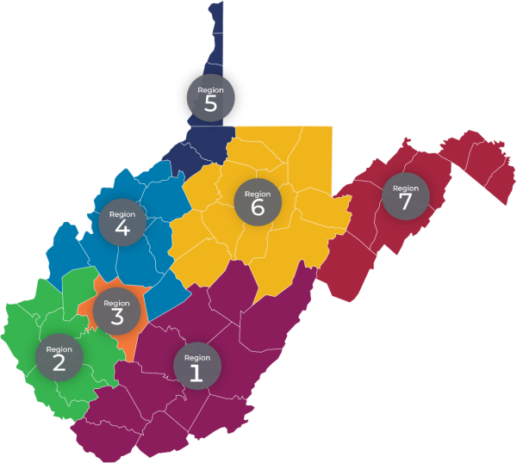

The West Virginia Workforce Development Board (WVWDB) adopted a statewide policy on re-designation of local areas as part of a policy overhaul to provide the appropriate oversight framework for West Virginia’s workforce system. Policy 200-01”Designation of Local Workforce Areas'' contains the following procedures in compliance with federal statute and regulations.
For this planning cycle, the Governor received no formal requests for subsequent designation, so he considered each of the seven local areas as having requested no changes to designated areas as defined in state policy. In considering the current regional configuration, the Governor used the current federal statutory and regulatory definitions of “performed successfully” and “sustained fiscal integrity” and considered the extent to which current local area designation is consistent with labor markets and economic development areas in the state. Taken together, at this time the Governor has approved subsequent designation requests; however, ongoing reviews will be occurring and at the midcycle point of the state planning cycle, West Virginia will be conducting further reviews of local area commensurate with monitoring federal WIOA legislation that may provide additional criteria and options for designating local areas.
In determining “performed successfully” the Governor reviewed local area negotiated core indicators of performance for the prior two program years and determined that each of the seven local designated areas met the minimum requirements for this criterion. For “sustained fiscal integrity,” the Governor reviewed financial records, audits, and compliance with policies and procedures, including a new policy on executive compensation limits, to ensure fiscal integrity was met. Each of the seven local areas met the criterion for sustaining fiscal integrity.
During the onset of this four-year planning cycle, the Governor determined that each local area is a single area region aligned to labor markets and economic development areas. During the first two years of this planning cycle, the state will undertake a thorough review and consultation with chief local elected officials to develop an agreed-to set of criteria for determining if regional configuration should be adjusted during the midcycle phase of the state plan process. Potential criteria include new business growth and locations in the state, changes to commuting patterns as a result of new business growth, updates to economic development configuration, and better alignment with community and technical college service areas to better align workforce and training activities.
During the remainder of calendar year 2024, the state will be undertaking data gathering for regional planning. West Virginia will be electing a new Governor whose term will start in 2025 and consultation with chief local elected officials will occur during the first year of the new term to gauge what changes and realignments can occur.
An area or areas seeking to be designated or re—designated, as a Local Workforce Development Area, which has requested but has been denied its request for designation or re—designation as a Local Area, may appeal the decision to the West Virginia Workforce Development Board.
- If the appeal is connected to a request for initial or subsequent designation under section V. A. or section V. B. of this policy, and if the appeal does not result in designation, the entity may request a review by the Secretary of Labor to determine if procedural rights were granted or if the minimum criteria of WIOA Section 106(b)(2) or Section 106(b)(3) were met. This second level of appeal must be sent within 14 days to the Assistant Secretary of Employment and Training U.S. Department of Labor, 200 Constitution Avenue, N.W. Washington, DC 20210. A copy of the appeal must be simultaneously provided to the ETA Regional Administrators U.S. Department of Labor The Curtis Center, Suite 825 East 170 South Independence Mall West Philadelphia PA 19106-3315. In addition, a copy must be sent to WFWV at 1900 Kanawha Boulevard East, Building 3, Suite 300, Charleston, WV 25305.
- If the final decision of any appeal reverses the prior decision, it will become effective July 1st of the following year.
- Definition: Where the term “days” appears, it shall be defined as calendar days, not working days.
New WVWDB Policy 200-01 ”Designation of Local Workforce Areas'' contains the basic procedure for the appeals process and is complemented by WFWV guidance. An appeal must be in writing and filed with the WVWDB within fourteen (14) days after notification of the decision regarding designation of local areas. Appeals must contain specific statements and include concrete evidence of the grounds upon which the appeal is sought. Pursuant to 20 CFR 679.290 (b) and 20 CFR 683.630 (a), the WVWDB will provide the parties with the opportunity for a hearing, review the appeal, and then the WVWDB has 60 days to review the appeal and make a recommendation to the Governor. The review will take into account the information in the original request and supplemental information provided in the appeal to determine if the criteria set in this policy have been met. The final decision rests with the Governor and will be provided within 30 days of the recommendation submission of the WVWDB.

The WVWDB adopted a statewide policy on one-stop infrastructure funding as part of a policy overhaul to provide the appropriate oversight framework for West Virginia’s workforce system. Policy 300-03 “Requirement for Local Memorandum of Understanding” and Policy 300-04 ”One-Stop Infrastructure Funding'' contain procedures and the process for appealing infrastructure funding decisions.
If a partner appeals an infrastructure determination as defined in Section 121(H)(2)(E), such appeal goes to the WVWDB prior to May 30 of the year in which negotiations occur. The WVWDB shall provide technical assistance to the local area and relevant partners to seek a settlement. If an impasse occurs, the WVWDB shall utilize the state infrastructure mechanism, including verification that one-stop centers have been certified, to provide infrastructure funds to the local area.

2. Statewide Activities
Starting in the calendar year 2023, the WVWDB embarked upon a review of state policies and procedures, including what policies and procedures gaps existed. This review led to a complete overhaul and establishment of ‘system’ policies developed at the state board level upon which partner agencies could issue further guidance and technical assistance, including specific program-related policies and procedures.
To date, a set of policies has been adopted for “One-Stop Delivery System'' and initial policies for “State Governance” and “Local Governance.” During the remainder of calendar year 2024, the WVWDB plans to adopt further Local Governance policies, as well as specific “Program” and “Administrative” policies appropriately done at the state board level and in compliance with WIOA statute and regulations. Included within these further policy issuances will be specific procedures on how the Governor’s Reserve funds will be utilized and allocated.
The process for WVWDB policy development includes identification of the specific issue, discussion of the issue by the appropriate WVWDB committee, development of the policy and procedures draft, final review by the respective WVWDB committee, public comment, and final discussion and adoption by the full WVWDB. WVWDB policies and meeting minutes that document which policies were adopted during WVWDB meetings can be found at: https://workforcedb.wv.gov/pages/policies.aspx
West Virginia will use state set aside funds to conduct all mandatory activities.
Rapid Response will be conducted as described in section a.2.C., a.2.D., and a.2.E.
Set aside funding is utilized for mandatory activities for dissemination of appropriate information regarding training providers, ways to access various means of work-based learning, including apprenticeships and on-the-job training, and performance information as described throughout the state plan. Workforce West Virginia (WFWV) is responsible for carrying out these activities. Planned strategies for using funds to meet these activities include (1) development of an annual dissemination plan; (2) utilizing funds to develop appropriate dissemination materials such as pamphlets, brochures, and website materials; and (3) engaging partners in disseminating appropriate materials throughout physical and online locations. Dissemination strategies will be maintained throughout a year and adjusted on an as-needed basis.
The WVWDB and WFWV is developing a robust evaluation agenda and utilizing a portion of the state set-aside funds to conduct more formal mixed-methods evaluations of programs focused on best practices and impactful components of the state’s strategy that positively influence labor force participation, youth services, work-based learning enrollments, and access to education and training for skills development. The evaluation agenda will dig deeper into issues so as to inform stakeholders and the public about effective workforce development practices in West Virginia.
WFWV has a process in place whereby the Local Workforce Development Boards (LWDB) can identify technical assistance needs and request the provision of technical assistance or request funds to meet gaps in service delivery. During the past two years, statewide funds have been used for technical assistance regarding local MOU development and IFA negotiations, new state policy and procedures implementation and training, and compliance issues identified through monitoring. Improved communication strategies and options for requesting technical assistance have been a priority of WFWV in collaboration with the Governor’s office and other program partners.
In addition to the mandatory activities, West Virginia is changing how discretionary activities are funded to meet statewide priorities. In the past and currently, statewide funds have been used to bolster local programming and service delivery. For instance, funds have been used to focus on partnerships with employers for on-the-job training programs, transitional jobs, and skills training. When the LWDB exhausts or becomes low on formula funds or collaborates with businesses and partners to produce a comprehensive program, they may request additional funds. Awards are made based on the amount of funds requested and the proposal documentation submitted. West Virginia supports innovation by reviewing the results of current and recent projects to identify those that show positive results, could benefit from additional resources, and address the state’s strategic plan goals.
A greater priority for use of the Governor’s set aside under this plan will be specific workforce initiatives of the Governor based upon data and identified demand. Examples include the Governor’s Nursing Initiative and initiatives focused on increasing the number of quality and affordable childcare slots in West Virginia to support working parents. West Virginia is facing rapid job growth and new business relocations, so a focused use of statewide funds will be in conjunction with the Department of Economic Development to address needed worker skills upgrades and availability. This has already been a success with the implementation of the nursing expansion program to meet the high demand in the healthcare industry.
To support the Governor, the WVWDB will make recommendations for funding based on the program’s ability to address the strategic goals outlined in this plan. The WVWDB will allow funding applications to be submitted on a biennial basis. After the set-aside funds are allocated and programs are implemented, ongoing monitoring and evaluation efforts are conducted to assess the effectiveness of the investments and make any necessary adjustments to ensure that the funds are being used efficiently and achieving the intended outcomes.
The determination of the WIOA Governor's set-aside involves a careful assessment of workforce development needs, strategic planning, stakeholder engagement, and ongoing oversight to ensure that the funds are effectively utilized to support the state's workforce development goals.
West Virginia uses WIOA funds to support a state Rapid Response unit called the State Dislocated Worker Services (DWS) Unit. The unit conducts rapid response activities to dislocated workers through employer outreach, which is coordinated as a joint rapid response team approach between the DWS Unit and the LWDB. The Trade Act unit is also part of the State DWS section to provide information on the Trade Adjustment Assistance (TAA) program. When a rapid response meeting is conducted, research begins with the TAA state office to determine if a company meets the eligibility criteria for TAA and a petition can be filed. If a petition is filed and certified prior to a rapid response meeting, a coordinated meeting is conducted emphasizing all the benefits and services provided through WFWV and partner agencies.
Each rapid response meeting includes representatives from the American Job Center of West Virginia (AJCWV) explaining services and benefits to assist dislocated workers, including, but not limited to unemployment, job services, career planners for training eligibility purposes, and specific partner agencies. For dislocations, all WFWV processes are discussed. After the meeting is conducted, the individual is registered in WV’s MACC system and a questionnaire is completed highlighting the individual’s employment/training objectives and goals. These questionnaires assist in serving the individual in a timely and more effective manner by following the career pathway of their choosing and involving partner agencies in achieving these objectives and goals.
Businesses that will be experiencing layoffs or closure come to WFWV through various communication methods: AJC staff, Worker Adjustment and Retraining Notices (WARNs), Business Services Representatives, news outlets, employees and unemployment reports showing noticeable claims, which the Rapid Response coordinator then investigates.
Additional services are organized at Rapid Response meetings such as special sessions with unemployment to answer more in-depth questions, resume writing, and interviewing skills workshops on-site or at an AJC. Sometimes, these workshops are incorporated into the Rapid Response meeting. WFWV’s integrated system provided employment, partner, and resource information to Constellium Rolled Products and Homer Laughlin China Company in 2020 and Mylan Pharmaceuticals in 2021 for workers receiving rapid response informational packets. The dissemination of information included questionnaires to assist in identifying individual goals and objectives and to provide job search and training activities for dislocated workers. Ongoing communication with workers conducted by the rapid response team was conducted through emails, telephone calls, and follow-up letters.
Rapid Response provides a comprehensive array of services to offer transitional assistance in the form of available community resources and contact information, reemployment services available through the AJCWVs, such as job search and training opportunities, and unemployment services to accelerate the reemployment process. Other Rapid Response activities include community resource fairs, job fairs, and training provider fairs, etc. that may be conducted in conjunction with Rapid Response Informational Meetings or separately. While most of the effort is usually expended in the early stages of a dislocation event or an impending dislocation, it is important to continue Rapid Response services until all worker and employer needs are met. Follow-up with workers allows the Rapid Response Unit and the LWBD staff to collaborate and provide appropriate services if needed.
The State coordinates layoff aversion strategies through the direct and immediate efforts of the Governor’s Office in connection with the West Virginia Development Office’s (WVDO) Business and Industrial Development representatives, who mobilize concentrated efforts to salvage at-risk companies or entities through incumbent worker training through the Governor’s Guaranteed Workforce Program, etc. When companies advise the State they are experiencing difficulties, there is timely sharing of all pertinent information of at-risk companies between the State Dislocated Worker Services Unit and the Business and Industry Development representatives so the layoff aversion strategies can be quickly implemented. In the event the strategies have not been shared at all local and State levels because of the sensitivity and confidentiality of some of the processes involved in averting a layoff, the State DWS Unit communicates directly with the Secretary of the West Virginia Department of Commerce with a notification of a need for the provision of Rapid Response services. This occurs often for the majority of dislocations anywhere in the state and usually results in receiving clearance to proceed with Rapid Response services.

WFW has specific procedures in place to provide Rapid Response services in case of a Natural Disaster as stated in Part 687 of the WIOA Public Law. In such a case, the State immediately applies for a National Dislocated Worker Grant (NDWG) for a temporary work program for disaster clean-up activities, which would be coordinated with Federal Emergency Management Agency (FEMA) and State Homeland Security and Office of Emergency Services. In addition to applying for an NDWG, dislocated workers experiencing displacement due to a natural disaster, such as flooding, would be covered under the State’s Rapid Response coordination of services and would be a call to address more than just a quick return to work. Therefore, a State Rapid Response Team , in conjunction with local Rapid Response Team members and partners, could be deployed to the disaster site to conduct Rapid Response Informational Meetings and related Rapid Response activities, if necessary.
Rapid Response would coordinate with FEMA, the Small Business Administration (SBA), and other relief organizations to ensure the affected workers have a full array of resources to assist them in recovering from a natural disaster. If a natural disaster occurred followed by a FEMA disaster declaration, the availability of the temporary work program would also be highlighted at Rapid Response meetings. If the magnitude of the disaster resulted in mass layoffs/plant closures, and there was not enough WIOA formula funding or Governor’s Discretionary funding available at the state level, then the State would apply accordingly for a mass layoff NDWG. If the disaster led to a sizeable mass layoff NDWG being awarded to the State, the Governor’s Office would take the lead in implementing a state emergency plan mobilizing a host of state and federal resources, which include close coordination of the mass layoff NDWG with the efforts of FEMA and State Homeland Security and Office of Emergency Services, as well as other State agencies.
Partner Services as part of our response team may be comprised of Wagner-Peyser, Department of Health and Human Resources (DHHR), Department of Rehabilitation (DRS), LWDBs, Healthcare navigators for those who have lost their insurance due to job loss, SBA, a FEMA Partner, a Business Services Representative, FEMA representative, Veteran Representative, and Union representatives to assist those represented by a union.
Rapid Response operates in the same manner regardless of whether a TAA petition is involved and provides timely information to dislocated workers with the goal of returning workers back to the labor market in sustainable employment.
West Virginia’s early intervention to worker groups, on whose behalf a TAA petition has been filed, is in conjunction with our WIOA Rapid Response activities. In most cases, by the time a TAA petition is filed, WIOA rapid response activities have already taken place, and basic and individual services are being provided.
After a TAA petition has been filed and certified by the State TAA Unit, additional information specific to TAA is explained through a TAA/ Trade Readjustment Allowances (TRA) Benefit Rights Informational Meeting (BRIM) to thoroughly explain the TAA program. Since the impacted workers have already received critical information at a previous Rapid Response meeting, the BRIM Meeting focuses specifically on TAA benefits and services and required deadlines.
West Virginia continues to strive for improvements and increased coordination between the TAA and WIOA programs by mandating co-enrollment, providing necessary services, and data sharing to create a seamless and effective process for dislocated workers. All TAA paperwork and documentation is imaged into the MACC and WIOA /TAA staff have access to all WIOA/TAA services to eliminate the duplication of services and to strengthen the ability to share accessible data benefiting the dislocated workers.

b. Adult and Dislocated Workers Program Requirements

1. Work-Based Training Models
As part of the WVWDB’s development of a new policy framework, work-based training policies, including a policy on incumbent worker training, will be developed and established before the end of calendar year 2024.
West Virginia will increase training opportunities for individuals via alternative training models such as Transitional Jobs, On-the-Job Training (OJT), and Incumbent Worker Training (IWT). The LWDBs are encouraged to leverage current and develop new, local partnerships with community businesses and industry to support economic development in their areas. AJCWVs will provide access to training services aligned with in-demand occupations, which may include occupational skills training, OJT, IWT programs that combine workforce training with related instruction, skill upgrading and retraining, entrepreneurial training, transitional jobs training, job readiness training provided in combination with other training, Adult Education and Literacy activities, and customized training (customized training is designed to provide local areas with flexibility to ensure that training meets the unique needs of the job seekers and employers or groups of employers). The underlying advantage of work-based learning is that by definition, it incorporates skill competencies needed by the business. There is no doubt participants are learning the specific skills needed, and furthermore, they are learning to apply skills in the way the employer prefers. These arrangements practically guarantee that individuals who complete training are positioned to immediately add value in the workplace and have marketable skills to provide upward mobility in a career pathway.
Transitional Jobs
Transitional jobs are reserved for those chronically unemployed and provide real-life work experience when it is greatly needed to be successful in the workplace. Transitional jobs is an employment strategy that seeks to overcome employment barriers and transition people with labor market barriers into work using wage-paid, short-term employment that combines real work, skill development, and supportive services. Transitional Jobs program participants earn a paycheck, learn skills, may become eligible for the Earned Income Tax Credit, and receive intensive mentoring and support.
The Transitional Jobs program should have at a minimum the following three components:
- Paid work experience (i.e. three days per week)
- Classroom training (i.e. soft skills, occupational skills, etc.)
- Supportive services
Each LWDB must submit a Transitional Jobs Plan to WFWV for approval. Collaborative partnerships will be an essential piece of a transitional jobs plan and are highly encouraged. LWDBs may allocate up to 10 percent of local Adult and Dislocated Worker funds to transitional jobs for individuals with barriers to employment.
On-the-Job Training
OJT ensures high-quality training for both the participant and the employer because both have a vested interest in the success of the program. The employer has the unique opportunity to train potential candidates in the correct and most efficient way to perform tasks for their company at a subsidized cost. The participant has the opportunity to receive direct training and experience that increases their current skill set. Participants also gain new skills to meet the requirements of a new occupation or industry and are better equipped to compete for available jobs. All OJT experiences are provided through contracts between local employers and the LWDB. OJT is primarily designed to hire the participants and provide them with the knowledge and skills necessary for the full performance of the job. Both training providers and employers providing OJT opportunities must be providing the highest quality training to participants. OJT contracts must be continually monitored so that the WIOA funds allocated are providing participants with the training to retain employment successfully. It is imperative that OJTs provide participants with the relevant skills and opportunities for career advancement and provide employers with a skilled workforce.
Incumbent Worker Training
WV also supports IWT. To qualify as an incumbent worker, the worker needs to be employed, meet the Fair Labor Standards Act requirements for an employer-employee relationship, and have an established employment history with the employer for six months or more. The training must satisfy the requirements in WIOA Section 134(d)(4) and §680.790 and increase the competitiveness of the employee and/or employer. An incumbent worker does not necessarily have to meet the eligibility requirements for career and training services for adults and dislocated workers under WIOA. LWDBs may reserve and expend up to 20 percent of their combined adult and dislocated worker formula allotments for IWT. States may use state Rapid Response funds [WIOA Section 134(a)(3)(A)(i))] for layoff aversion and WIOA Governor’s discretionary funds for statewide incumbent worker training activities.
LWDBs must consider the following factors when determining the eligibility of employers to receive the WIOA share of funds to provide training to incumbent workers using either, local Adult and/or Dislocated Worker formula funds or WIOA statewide discretionary funds provided by the Governor:
- The characteristics of the incumbent workers to be trained, specifically the extent to which they historically represent individuals with barriers to employment as defined in WIOA Section 3(24), and how they would benefit from retention or advancement;
- The quality of the training (e.g., industry-recognized credentials, advancement opportunities);
- The number of participants the employer plans to train or retrain;
- The wage and benefit levels of participants (before and after training);
- The employer must not have laid off workers within 12 months and must have a commitment to retain or avert the layoffs of the incumbent worker(s) being trained;
- The employer must not be delinquent in unemployment insurance or workers’ compensation taxes, penalties, and/or interest.
- LWDBs must document these factors in approving an incumbent worker training project with an employer.
Employers participating in incumbent worker training are required to pay the non-WIOA (non-federal) share of the cost of providing training to their incumbent workers. Employers will be reimbursed the WIOA (federal) share. The employer share is based on the size of the workforce (wages paid to the participant while in training can be included as part of that share) as follows:
- At least 10 percent of the cost for employers with 50 or fewer employees.
- At least 25 percent of the cost for employers with 51 to 100 employees.
- At least 50 percent of the cost for employers with more than 100 employees.
Incumbent worker training is designed to either assist workers in obtaining the skills necessary to retain employment or to avert layoffs and must increase both a participant’s and a company’s competitiveness. The IWT policy allows local Boards the flexibility to provide IWT to employers when needed. Local areas may use up to 20 percent of their local adult and dislocated worker funds for IWT. IWT aims to improve the participants' skills and competitiveness and increase the employers' competitiveness. The training should, wherever possible, allow the participant to gain industry-recognized training experience and ultimately should lead to an increase in wages. To receive incumbent worker funding under WIOA, an incumbent worker must have an employer-employee relationship and an established employment history with the employer. Incumbent workers are employed at the time of their participation, and the contract funds are paid to the employer for training provided to the incumbent worker either to avert a lay-off or otherwise retain employment. A “model” incumbent worker training would be one where a participant acquires new skills, allowing him or her to move into a higher skilled and higher paid job within the company, thus permitting the company to hire a job seeker to backfill the incumbent worker’s pre-training position.
Work-based training can be an effective strategy that can provide additional opportunities for participants and employers to find high-quality work and develop a highly skilled workforce. Each of these work-based models can be effectively used to meet a variety of job seeker and employer needs. To ensure high-quality training for both the participant and the employer, priority consideration will be given to training programs related to an in-demand occupation, aligned with career pathways and industry sectors, and resulting in a recognized postsecondary credential. LWDBs must not continue to contract with employers who fail to provide participants with long-term employment opportunities, wages, benefits, and working conditions comparable to other employees who have worked a similar amount of time doing the same type of work. LWDBs will monitor employer onsite contracts to ensure training, wages, hours, benefits, and working conditions are provided in accordance with the contract. Training participants’ performance and progress will be monitored during the training to determine supportive service needs, the appropriateness of the training activity, and if placement in unsubsidized employment has occurred. WFWV will pursue the following strategies to ensure work-based training models are of high quality:
- Promote and develop sector strategies based on labor market information and employer needs.
- Connect employers to participate in business-education partnerships. These partnerships connect schools, employers, and community organizations with individuals to provide career-related experiences and employment opportunities such as soft skills development, internships, OJT, workplace shadowing, and career mentoring.
- Emphasize career pathways to assist individuals entering and moving within the labor force and to educate employers on the advantages of career pathways.
- Ensure career pathways are aligned to in-demand occupations likely to pay sustaining wages. The LWDBs will engage employers to accomplish this goal.
- Require OJT and IWT to be tied to a career pathway.
Registered Apprenticeships also prove to be a valuable strategy serving both individuals and employers. Examples follow of how the workforce development system intends to further integrate activities:
- Partners taking applications and conducting assessments as necessary.
- Office of Apprenticeship (OA) representatives serve as members of the State Board and Interagency Collaborative Team (ICT).
- OA collaborating on State Plan development.
- WDS partnering and supporting apprenticeship initiatives through Title I funding.
More information can be found in the following section.

2. Registered Apprenticeship
The State will continue to incorporate Registered Apprenticeships into its strategies and services by requiring American Job Center (AJC) staff to seek out and assist Registered Apprenticeship Programs (RAPs) with recruitment into their individual training programs.
Director of Apprenticeship
The state intends to widen the aperture on all forms of work-based learning, including but not limited to apprenticeships, co-ops, intern and externships, and service learning. WFWV recognized the need to establish a new Apprenticeship unit to help coordinate and promote not only current registered apprenticeship programs but to encourage and assist in the development of new registered apprenticeship programs. A new Director of Apprenticeships was hired in December 2023 to begin building the unit and to establish partnerships with various entities. The agency has already been working closely with the Office of Registered Apprenticeships, other State agencies such as WV Department of Education, Department of Economic Development and Division of Rehabilitation Services, Trades organizations and individual employers. The focus has been to coordinate efforts in increasing not only the amount of registered apprenticeships statewide but the amount of job seeker awareness leading to potential enrollment in registered apprenticeships. There are a significant number of 18-24 year olds graduating high school without any clear direction. Emphasis will be placed on collaborating with various partners to promote registered apprenticeships to West Virginia’s youth.
Youth Apprenticeships
Further identifying West Virginia’s commitment to advancing Registered Apprenticeships, the West Virginia Legislature passed HB5162 in 2024 solidifying a Youth Apprenticeship Program. The program allows students to enroll in apprenticeship programs, receive secondary credit, and receive necessary credentials for the apprenticeship while earning credits towards their high school diploma. A pilot for the program will be implemented during the 2024-2025 school year with a comprehensive apprenticeship program for all school systems beginning the 2025-2026 school year.
Recruitment
Recruitment is an ongoing process with Registered Apprenticeship Programs. With the establishment of a new WFWV Apprenticeship unit a partnership has been made with the Office of Apprenticeships through DOL to assist in the promotion and recruitment of new apprenticeship programs such as conducting combined meetings with new prospective employers who are interested in establishing a new RAP. This will happen on an as needed basis. The new Apprenticeship unit has worked with the Office of Apprenticeships to receive an updated combined list of all the active apprenticeships in WV which is not available through the DOL website. This list has been shared with various partners who work with Apprenticeship programs to allow us the ability to reach out to those programs to reconnect and assist in their recruitment. This will be an ongoing process. Recruitment of job openings including the whole process of referral through determining eligibility will be continuous and dependent upon the needs of the Apprenticeship program. This could be yearly with updates done each quarter or as needed dependent upon the RAP's hiring cycle. The WFWV Apprenticeship unit has also connected the WV Division of Rehabilitation Services Career Services manager with several of the apprenticeships through a joint partnership to inform those apprenticeship programs of the opportunities of job ready individuals with Disabilities. Future sessions are being worked on to not only educate the career case managers for DRS on apprenticeship programs but to also educate the apprenticeship programs on inclusion opportunities through DRS.
Recruitment will include posting and advertisement of Registered Apprenticeship statewide announcements, job orders, phone notifications of apprenticeship openings, veteran priority of service, pre-application testing, initial screening of eligibility requirements, and referral. Referral includes referral to the job order and to our partners for orientation and eligibility determination for WIOA funding for training. AJC staff taking applications and conducting assessments will support better service design and delivery for partners, employers, and individuals alike and ensure all customers receive access to all services available across the WDS.
Promotion and Awareness
Promotion and awareness of the RAP's will not only be through job postings but participation in Career Fairs/Expos either sponsored by partners, apprenticeship programs or WFWV, on-site job fairs, website information dedicated to RAP's and Youth Apprenticeship Awareness events. These will happen regularly throughout the year. The first Virtual Youth Apprenticeship Awareness Fair happened in May 2024 as part of a partnership with WFWV, WV Department of Education, WV Department of Economic Development and the Office of Apprenticeships. This event will take place each year between January and March.
Additional strategies and services will include making space available to the apprenticeship programs for onsite job fairs for recruitment, advertising space for apprenticeship marketing items, space for onsite interviews, and assistance, as needed, with testing applicants at offsite locations.
Collaboration
Registered Apprenticeship Program within WFWV and those staff members in the WV Dept. of Economic Development working to promote apprenticeships continue to participate in monthly meetings to ensure partners and employers are aware of their apprenticeship opportunities and the continuing successes that employers and sponsors are having with this vital learn and earn model. Encourage LWDBs to utilize WIOA Incumbent Worker Training and Customized Training funds with other state program funds for employers to train their workforce. These key resources afford WV the opportunity to better align and leverage the WDS’s activities and both state and federal funding to serve individuals and employers, providing more dimension and value to an already robust menu of services.
WFWV's Apprenticeship unit has established a better working relationship with the WV Department of Economic Development to ensure we are both utilizing the services we both have available and define our roles so that we are not in direct competition or duplicating efforts when working with apprenticeships.
WFWV's Apprenticeship unit has made it a priority when speaking with apprenticeship programs to be inclusive of the opportunities to those programs of potential funding available through not only the LWDB's and Economic Development but also through the Division of Rehabilitation Services as that new partnership increases. As the partnerships with all these areas grow, combined meetings with apprenticeship programs have occurred and will continue to occur on an as needed basis in the future. Referrals and communication has and will increase as to what each other may have available to offer. With the decrease in WIOA dollars it will be more critical to partner and combine resources to not only assist the Job Seeker interested in apprenticeships but the Employer offering the apprenticeship program as well.
State Apprenticeship Expansion Formula (SAEF)
The State Apprenticeship Expansion Formula (SAEF) Funding opportunity will focus on the pathways for youth as they graduate from high school and move into good, high paying jobs that follow the eight Good Jobs Principles outlined by the Departments of Commerce and Labor.
The program is statewide in its scope through initial RAPs development and RAP expansion. The SAEF base funding will be used to support employers through incentives as they develop the infrastructure needed to support RAPs in their industry. Employers will be able to request wage support for up to 50% of the apprentices’ wages for the grant cycle.
The program will focus on youth, primarily persons between the ages of 16 years and 24, who are in-school youth (high school to career). Within the youth population, the following will be identified as target areas for individuals who receive services: unemployed workers, dislocated workers, incumbent workers, and underemployed workers.
Key activities of the grant include:
- Build Statewide capacity to increase the number and quality of RAPs through stronger alignment with the education and workforce systems.
- Create and improve outreach materials and communication strategies for engaging employers, parents, educators, underrepresented populations, other critical stakeholders and state residents; explaining the benefits of registered apprenticeship; and generating further support across the State.
- Improve and/or develop marketing and advertising materials for RAPs (i.e., produce RAP public service announcements that are targeted to the Care Economy (Healthcare, Childcare, Home Care, etc.), Educational Services (Teachers), Hospitality, invest in targeted social media, or contribute printed materials to accelerator events in the State.
- Utilize funding to support drafting of policies, procedures, and/or State regulations to strengthen the Registered Apprenticeship system.
- Provide support for development of internal LEA processes for recruitment / retention of apprentices in teaching.
These activities will support the State’s Grow Your Own program. Designed to address West Virginia's critical need for teachers, Grow Your Own Pathway to Teaching programs provide promising high school students an accelerated, funded path for pursuing a career in education. Grow Your Own students take a fast-track into the education field through a combination of dual enrollment/Advanced Placement courses and an accelerated pathway that allows them to graduate with a bachelor's degree in just three years. Designed to provide paid, on-the-job training, the WV Apprenticeship Model provides Grow Your Own students with wage-earning field experiences, preparing them for the teaching career while alleviating financial burdens. Students who have graduated high school and complete the Youth Apprenticeship are certified as a Teacher Apprentice by the U.S. Department of Labor. For the 2023-2024 school year, the program comprises 345 students and 33 actively participating counties. These students are still in high school, so the impact on the workforce will be more evident in the next three to four years. This collaborative effort includes WV Department of Education, WFWV, WV Higher Education Policy Commission and Higher Education Institutions, Department of Economic Development and local WDBs.

3. Training Provider Eligibility Procedure
WFWV and LWDBs target training programs that support industry sectors and prepare participants for jobs in identified career pathways. Using Labor Market Information (LMI), WFWV and LWDBs are able to determine higher-paying jobs, in-demand industry sectors, and occupations in the local area, enabling them to work with local employers to determine the minimum requirements for these jobs and the types of training and certification requirements for these positions.
As a continued process of implementing a policy framework under the WVWDB structure, the ETPL policy will be reviewed for necessary changes to comply with TEGL 8-19 and change 1. This work will be done through the Operations Committee, will complete a public review period, and will be presented to the WVWDB by the end of the 2024 calendar year.
Eligibility and Continued Eligibility
Training providers use the MACC to provide all required information for initial eligibility as well as the required applications for each program of study. MACC doubles as WFWV’s program certification system and the Statewide ETPL, as required by WIOA §122 (a)(3).
All approved programs are available to the public and to WIOA partners in the MACC. WFWV and the LWDBs share the responsibility of managing the ETPL, including approving programs for initial and continued eligibility, ensuring training provider compliance, ensuring the accuracy of information, removing training providers or programs, and monitoring training providers. Upon receipt of the completed application and program data, WFWV shall attempt to make an initial determination of statewide eligibility within 15 business days. Training providers will be contacted via email if the completed application and/or program data requires clarification. The LWDB will then have 10 business days to review and make comments to the state prior to the official determination of eligibility and placement on the ETPL. Subsequent eligibility determinations take place on an annual biennial basis. Once the training provider is approved, each training program is evaluated to determine if it meets ETPL requirements, resulting in a federally or locally recognized credential and being related to an in-demand sector or occupation in West Virginia. The State ETPL Coordinator reviews required ETPL program information on the application, including the following: a detailed description of the program, the total cost of the program, including the cost of tuition, books, and any fees, credential information, and labor market information for the related occupation, to assure demand for the occupation.
As policy stands now, training providers who currently have programs listed on the ETPL and want to have their programs remain on the ETPL must follow the procedures for continuing eligibility determination as follows:
- Submit a completed Providers of Training Services Renewal Application for processing to WFWV via https://macc.workforcewv.org
- The application must include:
  - updated provider information;
  - updated information on each program pertaining to the alignment of training with in-demand occupations;
  - updated program data.
- Submit student data as referenced in WIOA sections 116 and 122 for calculation of State Performance Information by September 30th for the previous academic year defined as July 1 through June 30 (i.e. on September 30, 2016, data will be due for students who completed by June 30, 2015). This data will be included on the ETPL for the upcoming calendar year (CY).
- Submit ETP performance on WIOA performance indicators (employment 2nd & 4th Quarter after exit, median earnings, credential attainment) as well as:
  - Total number of participants enrolled in the program.
  - Total number of participants completing the program.
  - Total number of participants exiting the program.
  - Information regarding the completion rate of participants.
- Information reported to State agencies on Federal and State training programs other than programs within WIOA title 1B, including partner programs, (i.e. Adult Basic Education and Literacy, Division of Vocational Rehabilitation, etc.) that are used to provide additional information about overall effectiveness, quality, and utilization of programs.
- Address ETP's ability to offer industry-recognized certificates and credentials.
- Information on recognized post-secondary credentials received by program participants.
- Describe the quality of the program of training services including a program that leads to a recognized postsecondary credential.
- Timeliness and accuracy of ETP's performance reports.
- Upon receipt of the completed application and student data, WFWV will make a determination of continuing statewide eligibility based on the completeness of submitted information.
- The LWDB will then have 10 business days to review and comment to the state before the official determination of continuing eligibility and placement on the ETPL.
- The statewide ETPL will be published at: https://public.workforcewv.org/JobSeeker/TrainingCourseSearch.asp
- Continued eligibility will be reviewed by the state annually.
Performance Accountability
The State ETPL Coordinator will review the training provider’s program performance based on the performance accountability measures, using data on all participants who participated in the training program during the performance period. Each program’s performance will be evaluated against state performance standards to determine if the program will remain on the list.
Change 3 states it is a substantial violation of the requirements to timely and accurately submit all of the information required for completion of the eligible training provider performance reports required under WIOA sec. 116(d)(4) if the provider knowingly supplies false performance information, misrepresents costs or services, or violates requirements of WIOA law or regulations. Providers who substantially violate the requirements of providing appropriate, accurate, and timely information for participants receiving training, will be removed from the ETPL. Such providers are liable to repay all adult, dislocated worker, and youth funds received during the period of non-compliance. WFWV will take into account exceptional circumstances beyond the provider’s control, such as natural disasters, unexpected personnel transitions, and unexpected technology-related issues, when determining appropriate action.
Training Providers who currently have programs listed on the ETPL and want to have their programs remain on the ETPL must submit student data as referenced in WIOA Sections 116 and 122 for calculation of State Performance Information for the previous academic year defined as July 1 through June 30. In lieu of answering questions/when data cannot be provided in full from the ETP for all students, training providers may upload information into MACC for exited students during the performance period. The information must include the following: Name, SSN, and exit date (exit defined as completion, withdraw, dropout, or transfer) - preferably in Excel format.
In addition, the state has commenced initial discussions with the West Virginia Higher Education Policy Commission (WVHEPC) to establish a collaborative process for auto-reporting performance measures. This partnership aims to streamline and enhance efficiency for the state and training providers. By leveraging the expertise and resources of the WVHEPC, significant improvements in the accuracy and timeliness of performance reporting are anticipated, benefiting all stakeholders involved.
Registered Apprenticeships
Regarding the role of registered apprenticeship programs, the Final Rule emphasizes the key role WIOA envisions for registered apprenticeship programs by highlighting these programs as a training service for both Individual Training Accounts (ITAs) and On the Job Training (OJT). The Final Rule allows apprenticeship programs that are not registered to go through the eligible training provider (ETP) process if they want to be on the ETP list (ETPL)(must opt-in); the rule does not provide apprenticeship programs that are not registered special access to the ETPL. The Department also clarifies in this Final Rule that registered apprenticeship programs are automatically eligible for the ETPL and the State is required to notify them of their automatic eligibility and allow the registered apprenticeship program an opportunity to consent to be on the State ETPL (see § 680.470). This mechanism must be a minimal burden to registered apprenticeship programs and must comply with Federal guidance. The State periodically communicates this information via available contact information (mail and/or email) to RAP Sponsors and provides the State MIS (MACC) link for their enrollment.
The following information is also requested to complete a partial, staff-assisted enrollment onto the ETPL:
Registered Apprenticeship Number; Federal Tax ID Number; Provider Name; Mailing and/or Campus Street Address, City/State/Zip/County; Phone Number; Contact Person Name/Information; Course/Program Name; Brief Course Description; Occupation Codes. Note: demand status is not verified for RAP Occupation Codes; and information concerning whether the provider is in a partnership with a business.
RAP Sponsors are encouraged to enroll themselves and their course into the MACC for full enrollment, but it is not required. RAP Sponsors are periodically informed they will remain on the ETPL as long as they remain registered or until we are notified they would like to be removed.
RAPs are allowed to opt-in any time throughout the year and are added to the ETPL and local lists in a timely manner. WIOA WFWV Policy 01-15 - ETPL
https://workforcewv.org/images/files/PublicInfo/guidance-notices/WIOAPolicyNo.01-15-EligibleTrainingProviderList.pdf
https://workforcewv.org/images/files/PublicInfo/guidance-notices/Updated_WIOA_Policy_01-15_ETPL.pdf
https://workforcewv.org/images/files/PublicInfo/public-notices/WIOA_Policy_01-15_-_ETPL_Change_3.pdf

4. Describe how the State will implement and monitor for the Adult Priority of Service requirement in WIOA section 134 (c)(3)(E) that requires American Job Center staff, when using WIOA Adult program funds to provide individualized career services and training services, to give priority of service to recipients of public assistance, low-income individuals, and individuals who are basic skills deficient (including English language learners).
West Virginia will ensure the priority of service for individualized career services and training services funded with Title I Adult funds During calendar year 2024, as part of the WVWDB policy initiative, a policy on Adult priority of service will be implemented. The policy will reflect West Virginia’s current practices, which include the following:
- First Priority: Veterans and eligible spouses (covered persons) who are low-income or recipients of public assistance or who are deficient in basic skills.
- Second Priority: Individuals (non-covered persons) who are low-income or recipients of public assistance or individuals who are basic skills deficient.
- Third Priority: Veterans and eligible spouses who are not low-income and are not recipients of public assistance or are deficient in basic skills.
- Fourth Priority: Individuals who do not meet the above priorities.
In addition to these statewide priorities of service, each LWDB has the flexibility to implement additional priorities for individuals after the four state priorities have been met.
Priority of service occurs after establishing eligibility for Adult services. Priority of service means that if funds and services are limited, individuals with a priority of service gain access to the services before individuals who do not meet a priority. LWDB staff must ensure individuals who qualify for priority of service receive individualized career and training services before other non-covered individuals and receive first priority on any waiting lists that are maintained for training slots. However, once a participant is enrolled in a workshop, training, or service, he or she may not be displaced by an individual qualified for priority of service.
Each LWDB documents priority in the State MIS/participant file. State MIS provides career planners with the appropriate data fields to record eligibility (data fields include, but are not limited to: Veteran status, eligible spouse, low income, public assistance, basic skills deficient, case notes) and either upload appropriate documents into State MIS or place them in the participant’s file.
WFWV provides oversight and monitoring of priority of service requirements. Strategies deployed by WFWV including: (1) onsite monitoring, including review of the Participant Individual Record Layout; (2) review of any other available federal report data elements and performance metrics to test for compliance with the priority of service; (3) cross-training provided for all LWDB staff, service provider staff, and relevant program staff; and (4) ongoing technical assistance that engages cross-agency personnel to ensure that different priority of service groups are served consistently and appropriately.
Although a new policy will be considered for approval soon, current WFWV WIOA Policy 2-16 Priority of Service Policy for Adult Title 1 Funding can be found at: https://workforcewv.org/images/files/PublicInfo/guidance-notices/WIOA_Policy_2-16_Priority_of_Service_Policy.pdf

5. Describe the State’s criteria regarding local area transfer of funds between the adult and dislocated worker programs
West Virginia recognizes that WIOA allows up to 100% of funds between programs with prior approval from the Governor. The state will ensure that any transfer of funds between WIOA programs complies with the WIOA law. LWDBs are required to record and document the use and application of local funds in accordance with instructions set forth in the grantee-sub-grantee agreement.
Requesting and gaining approval for a transfer of funds begins with a request to the state from an LWDB. The request must specify the type of funding (whether adult or dislocated worker) to be transferred to the other program. As part of the request, LWDBs must answer the following questions:
- Are there adequate funds to maintain services to currently enrolled participants?
- What is prompting the request?
- How will you respond to unforeseen events?
All requests for transfer must include a written justification addressing each of the above-mentioned considerations and the reasons such transfer is necessary to provide adult or dislocated worker employment and training activities.
West Virginia believes in providing appropriate flexibility for service delivery, so approval for a request is based upon:
- Ensuring that funds are available to serve all dislocated workers needing assistance
- Alignment with the need for funds transfer with populations being served in the local region
- A clear plan for use of funds with a priority on funds availability for skills training
- Appropriate rationale for the funds transfer and use of funds
Funds shall retain the year of appropriation identity (e.g., program year allocation) and must be reported and accounted for accordingly. To transfer funds, the LWDB will use the transfer-related expenditure codes of the program from which funds are being transferred in the state's financial system to report costs incurred by the program receiving funding.
WFWV will coordinate the funds transfer request and will update the WVWDB annually.
The transfer limit of up to 100 percent, with approval from the state, shall apply to new allocations of adult and dislocated worker funding issued in the fiscal year beginning on or after July 1, 2015. This higher transfer limit does not apply to funds received in a prior fiscal year that may be carried into the new fiscal year. The level of transfer authority that existed at the time the funding was awarded shall continue to apply to those funds for their period of availability at the local level.
Through the state’s monitoring system, fiscal monitors will review the area’s transfer of adult and dislocated worker funds during the annual onsite monitoring review for compliance with federal and state laws and regulations. Any issues will be handled through the state’s monitoring resolution process.
WFWV Policy 01-17
https://workforcewv.org/images/files/PublicInfo/guidance-notices/WIOA_Policy_1-17_Transfer_of_Funds.pdf

6. Describe the State’s policy on WIOA and TAA co-enrollment and whether and how often this policy is disseminated to the local workforce development boards and required one-stop partners. Trade Act Sec. 239(f), Sec. 235, 20 CFR 618.325, 20 CFR 618.824(a)(3)(i).
The TAA State Office has a WIOA/TAA CO-Enrollment Policy in Place: WFWV Policy 3-22 identifies the Process of establishing Co-Enrollment for all TAA participants. The policy was reviewed and approved by the US Department of Labor and implemented in March 2022 and identifies the mandatory requirement of Co-Enrollment based on the law. All Local Workforce Development Boards, WIOA Career Planners, TAA Case Managers, and Local one-stop staff were given guidance on the Policy and were offered technical assistance on the requirements of the TAA program.
WFWV Policy 3-22
https://acrobat.adobe.com/id/urn:aaid:sc:US:00e12435-f24d-47f7-b7b4-214dd4ae3659

7. Describe the State’s formal strategy to ensure that WIOA and TAA co-enrolled participants receive necessary funded benefits and services. Trade Act Sec. 239(f), Sec. 235, 20 CFR 618.816(c)
Data shows that co-enrollment between TAA and the WIOA Title I Dislocated Worker program results in better performance outcomes that are significant and consistent over time. The current strategy to ensure co-enrolled WIOA/TAA participants receive the necessary funding and benefits is to require WIOA enrollment before participants can enroll in the TAA program. Since Petitions are not always certified after a layoff, WIOA can offer services prior to TAA participation. WIOA career planners work in conjunction with TAA case managers to establish a coordinated and unified approach to providing timely delivery of benefits and services. The TAA program maintains an electronic file on all TAA participants and WIOA Career Planners have access to these files and the TAA services being offered. Once training is completed and a job search is necessary, the TAA participants are referred back to WIOA if additional services are required. If training is part of the Individual Employment Plan, training outcomes are completed for both programs.
WFWV Policy 3-22 issues scenarios of perceived barriers and possible solutions along with a side by side comparison of eligibility and benefit service provisions table for DW and TAA. The accompanying resources for this policy also includes a WIOA/TAA process flow and case management checklist to be used by TAA case managers and WIOA career planners when working with individuals to make sure all co-enrollment is maximized.
WFWV Policy 3-22 supporting documents can be found here
https://acrobat.adobe.com/id/urn:aaid:sc:US:3630ad1b-af0f-49cb-b22c-80c4aa01ed25

8. Describe the State’s process for familiarizing one-stop staff with the TAA program. 20 CFR 618.804(j), 20 CFR 618.305
Since TAA participants are often co-enrolled in WIOA programs, cross-training with WIOA staff is beneficial. This approach ensures that one-stop staff understand how TAA services integrate with WIOA programs. WFWV Policy 3-22 provides case scenarios that allows staff to review possible real life scenarios of participants and identifies possible solutions to remove the perceived barriers. Familiarizing one-stop staff with the TAA program's services and rules requires a combination of comprehensive training programs, collaboration with TAA experts, cross-training, continuous communication, and resource sharing.
Supporting documentation to the policy also includes a case management checklist. This checklist can help ensure consistency, efficiency, and quality in providing services to job seekers. The checklist is helpful because it promotes consistency, efficiency, comprehensive service provision, improved communication, quality assurance, accountability, and flexibility. Case managers can better serve their clients, ensuring that all aspects of their cases are addressed and that they receive the support needed to achieve their employment and career goals.
One Stop Staff are given a list of Certified Petitions in their Regions and are part of the Rapid Response Informational meetings where TAA is discussed. The Reemployment Services and Eligibility Assessment (RESEA) staff are given a monthly listing of all Petitions to identify potential TAA participants. This is an ongoing process. Once a TAA Petition is Certified, the TAA State Staff works with the Local One-Stop staff to ensure all potential TAA participants are identified and served in a timely manner.
WFWV Policy 3-22 supporting documents can be found here
https://acrobat.adobe.com/id/urn:aaid:sc:US:3630ad1b-af0f-49cb-b22c-80c4aa01ed25

c. Youth Program Requirements.

1. Identify the State-developed criteria to be used by local boards in awarding grants or contracts for youth workforce investment activities and describe how the local boards will take into consideration the ability of the providers to meet performance accountability measures based on primary indicators of performance for the youth program as described in section 116(b)(2)(A)(ii) of WIOA.¹¹ Further, include a description of how the State assists local areas in determining whether to contract for services or to provide some or all of the program elements directly.
The LWDBs follow the State’s procurement policies when awarding grants for workforce investment WDS activities. The following clause is included in the workforce grant agreement:
Sub-granting:
The Grantee shall not enter into a sub-grant agreement for any of the work performed under this grant agreement without obtaining the prior written approval of WVWF. If sub-grant agreements are approved, they shall contain, at a minimum, sections of this grant agreement pertaining to indemnity, conflicts of interest, lobbying, nondiscrimination, audit requirements, public notice, and any other state and/or federal requirements. Sub-grantee program performance accountability measures are assessed by program staff.
Examples of how local boards will take into consideration the ability of the providers to meet performance accountability are listed below:
- States offer technical assistance for specific inquiries, but local workforce development boards (LWDBs) autonomously decide on the delivery method for WIOA services, whether through subcontracting or in-house provision.
- Utilize an RFP Request for Proposal (RFP) process for youth services. When the rating committee reviews the RFP, performance is one of the key factors in scoring.
- RFPs specifically address USDOL-required performance measures as a requirement for any proposals that are submitted and/or accepted.
- Reference checks are completed on all proposals received, including USDOL performance in other contracts operated by the proposing organization
- During the course of the year, if a performance measure is not met, the contractor will be part of any corrective action plans developed.
- Setting real-time outcome goals for proposers to meet. Meeting the real-time outcome goals would be financially tied to a contract renewal for the option year(s). Real-time outcome goals could be:
- The provider will be required to hold two recruitment events targeting Out-of-School youth (OSY) during the program year.
- The provider should enroll a minimum of 80% of their youth (80% Out-of-School and 80% In-School) in a work experience activity during the program year.
- The provider will be in contact with every active youth during the program year at a minimum of 2 times a month, with one contact being in person. The other contact may be by phone or social media. The contacts will be documented in the youth files and in the MACC as case notes for verification at scheduled file review visits by LWDB staff.
- The criteria for an award(s) of funding is based on: past performance, cost effectiveness, demonstrated overall program effectiveness, youth group(s) targeted for services, placement and retention efforts in offered education or employment programs, ability of the subcontractor(s) to meet and/or exceed performance goals and ability to meet administrative and fiscal grant responsibilities, to name a few.
- Subcontractor(s) are made aware of performance measures for the region and the importance of meeting/exceeding them via a contractual agreement. Specific language about meeting and/or exceeding performance measures is included in contractual agreements signed with a subcontractor(s). Performance-based contracts are used for all subcontractor(s). Identified performance measures serve as benchmarks in the contractual agreement and are used for measuring progress.
- Subcontractor(s) are monitored no less than five (5) times per program year to review and evaluate the delivery of program curriculum, program performance, etc., and address any issues that arise. A corrective action plan, along with technical assistance, is provided to the subcontractor(s) should program performance not be met.
- Programs for in-school and out-of-school youth will focus on measurable skill gains.
- States can ensure all 14 program elements of the WIOA Youth program are available regionally through strategic planning, resource allocation, training, performance monitoring, and flexibility. This involves coordination among stakeholders, quality assurance measures, effective outreach, and fostering innovation in service delivery to maximize program impact.

2. Explain how the State assists local workforce boards in achieving equitable results for out-of-school and in-school youth. Describe promising practices or partnership models that local areas are implementing and the state’s role in supporting and scaling those models within the state for both in-school and out-of-school youth.
In the endeavor to ensure equitable outcomes for both out-of-school and in-school youth, the State plays a vital role in assisting LWDBs by providing guidance, resources, and support for implementing promising practices and partnership models tailored to the unique needs of these populations.
The State aids LWDBs in adopting and expanding effective practices through technical assistance, funding, policy guidance, data-driven evaluation, and collaboration. By providing resources, guidance, and opportunities for networking, the State empowers LWDBs to implement successful initiatives, leading to improved outcomes for youth in the workforce.
- The state can play a crucial role in ensuring that work experience remains a key element within local areas' broader career pathways strategy by providing guidance, resources, funding, policy support, technical assistance, and collaboration opportunities. Specifically, the state can offer guidance on best practices for integrating work experience into career pathways, provide funding to support work experience initiatives, develop policies that incentivize and prioritize work experience opportunities, offer technical assistance to help local areas implement effective work experience programs, and facilitate collaboration among stakeholders to share resources and knowledge. Additionally, the state can conduct evaluations to assess the effectiveness of work experience initiatives and provide feedback to local areas for continuous improvement. By offering these forms of support and assistance, the state can ensure that work experience remains a central component of local career pathways strategies, ultimately enhancing opportunities for participants to gain valuable skills and experiences that lead to successful careers.

3. Describe how the State assists local workforce boards in implementing innovative models for delivering youth workforce investment activities, including effective ways local workforce boards can make available the 14 program elements described in WIOA section 129(c)(2); and explain how local areas can ensure work experience, including quality pre-apprenticeship and registered apprenticeship, is prioritized as a key element within a broader career pathways strategy.
The State will contract with each LWDB to ensure the administration of all 14 program elements in their local areas. State monitors will use the State MIS to assess the availability and provision of these elements before annual reviews, ensuring compliance with WIOA section 129(c)(2). Currently, the state is working with a third-party vendor to assess each LWDB's WIOA program delivery, with completion scheduled by December 31, 2024.
Once the data is compiled, LWDBs will be notified of any deficiencies and required to submit corrective action plans. After reviewing and approving these plans, WorkForce WV will collaborate with each LWDB to provide necessary technical assistance related to the Youth Program and its 14 elements, expected to be completed by the end of the first quarter of 2025.
The 14 program elements will be included in the statement of work in the grant agreement that LWDBs must sign.
PROGRAM ELEMENTS
The State will assist LWDBs in implementing innovative models for delivering WIOA youth workforce activities through the following strategies:
- Providing technical assistance, guidance, training, and resources.
- Allocating funding to support infrastructure, staff training, and program enhancements.
- Offering policy guidance to ensure compliance with state and federal regulations.
- Conducting data-driven evaluations to assess effectiveness and inform adjustments.
- Facilitating collaboration among LWDBs, employers, education providers, and community organizations to share best practices.
By supporting these strategies, the State ensures equitable access to effective programs, ultimately improving youth employment outcomes and promoting economic mobility.
The 14 elements of the Workforce Innovation and Opportunity Act (WIOA) youth program are:
- Tutoring, study skills training, and instruction leading to secondary school completion, including dropout prevention strategies.
- Alternative secondary school services or dropout recovery services.
- Paid and unpaid work experiences, including internships and job shadowing.
- Occupational skills training.
- Education offered concurrently with workforce preparation activities and training for a specific occupation.
- Leadership development opportunities.
- Supportive services.
- Adult mentoring for at least 12 months during and after program participation.
- Follow-up services for at least 12 months after program completion.
- Comprehensive guidance and counseling, including drug and alcohol abuse counseling and referral.
- Financial literacy education.
- Entrepreneurial skills training.
- Services providing labor market and employment information about in-demand industry sectors or occupations.
- Activities to help youth prepare for and transition to postsecondary education and training.
The State plays a crucial role in integrating work experience into local career pathways strategies by providing guidance on best practices, funding support, policy development, technical assistance, and collaboration opportunities. Evaluations will be conducted to assess effectiveness and provide feedback for continuous improvement. This support ensures that work experience remains central to career pathways, enhancing opportunities for participants to gain valuable skills and experiences for successful careers.

4. Provide the language contained in the State policy for “requiring additional assistance to enter or complete an educational program, or to secure and hold employment” criterion for out-of-school youth specified in WIOA section 129(a)(1)(B)(iii)(VIII) and for “requiring additional assistance to complete an education program, or to secure and hold employment” criterion for in-school youth specified in WIOA section 129(a)(1)(C)(iv)(VII). If the state does not have a policy, describe how the state will ensure that local areas will have a policy for these criteria.
Currently the State does not have a policy to specifically define “requiring additional assistance to enter or complete an education program, or to secure and hold employment. WV has relied on Guidance Notice 6-16 Eligibility Change 2 which broadly defines this barrier as follows:
- In School Youth: An individual who requires additional assistance to enter or complete an educational program or to secure or hold employment.
- Out of School Youth: A low-income individual who requires additional assistance to enter or complete an educational program or to secure or hold employment.
Going forward the State in conjunction with local stakeholders will develop an Eligibility Policy which includes an expanded definition of this barrier. Suitable criteria will be identified determining when to use this barrier for eligibility purposes. The State will work with Local Workforce Development Boards (LDWBs) to ensure alignment between state and local eligibility policies and will provide technical assistance as needed. Such alignment will provide clarity to frontline staff around which youth fall under this category and ensure that youth who are in need of services due to additional barriers receive services. The State anticipates completing the policy by the end of the 2024 calendar year.

d. Single-area State Requirements

1. Any comments from the public comment period that represent disagreement with the Plan. (WIOA section 108(d)(3).)

2. The entity responsible for the disbursal of grant funds, as determined by the governor, if different from that for the State. (WIOA section 108(b)(15).)

3. A description of the type and availability of WIOA title I Youth activities and successful models, including for youth with disabilities. (WIOA section 108(b)(9).)
NOT APPLICABLE TO WEST VIRGINIA.

4. A description of the roles and resource contributions of the one-stop partners.
NOT APPLICABLE IN WEST VIRGINIA.

5. The competitive process used to award the subgrants and contracts for title I activities.
NOT APPLICABLE IN WEST VIRGINIA.

6. How training services outlined in section 134 will be provided through individual training accounts and/or through contracts, and how such training approaches will be coordinated. Describe how the State will meet informed customer choice requirements regardless of training approach.
NOT APPLICABLE IN WEST VIRGINIA.

7. How the State Board, in fulfilling Local Board functions, will coordinate title I activities with those activities under title II. Describe how the State Board will carry out the review of local applications submitted under title II consistent with WIOA secs. 107(d)(11)(A) and (B)(i) and WIOA sec. 232.
NOT APPLICABLE IN WEST VIRGINIA.

8. Copies of executed cooperative agreements which define how all local service providers will carry out the requirements for integration of and access to the entire set of services available in the one-stop delivery system, including cooperative agreements with entities administering Rehabilitation Act programs and services.
NOT APPLICABLE IN WEST VIRGINIA.

e. Waiver Requests (optional)
WEST VIRGINIA IS NOT REQUESTING A WAIVER.

Title I-B Assurances
The State Plan must include | Include
1. The State has implemented a policy to ensure Adult program funds provide a priority in the delivery of training services and individualized career services to individuals who are low income, public assistance recipients and basic skills deficient; | Yes
2. The State has implemented a policy to ensure local areas have a process in place for referring veterans with significant barriers to employment to career services provided by the JVSG program’s Disabled Veterans’ Outreach Program (DVOP) specialist; | Yes
3. The State established a written policy and procedure that set forth criteria to be used by chief elected officials for the appointment of local workforce investment board members; | Yes
4. The State established written policy and procedures to ensure local workforce investment boards are certified by the governor every two years in accordance with WIOA section 107(c)(2); | Yes
5. Where an alternative entity takes the place of a State Board, the State has written policy and procedures to ensure the alternative entity meets the definition under WIOA section 101(e) and the legal requirements for membership; | Yes
6. The State established a written policy and procedure for how the individuals and entities represented on the State Workforce Development Board help to determine the methods and factors of distribution, and how the State consults with chief elected officials in local areas throughout the State in determining the distributions; | Yes
7. The State will not use funds received under WIOA Title I to assist, promote, or deter union organizing in accordance with WIOA section 181(b)(7); | Yes
8. The State distributes adult and youth funds received under WIOA equitably throughout the State, and no local area suffers significant shifts in funding from year-to-year during the period covered by this plan; | Yes
9. If a State Workforce Development Board, department, or agency administers State laws for vocational rehabilitation of persons with disabilities, that board, department, or agency cooperates with the agency that administers Wagner-Peyser services, Adult and Dislocated Worker programs and Youth Programs under Title I; | Yes
10. The State agrees to report on the impact and outcomes of its approved waivers in its WIOA Annual Report. | Yes
11. The State has taken appropriate action to secure compliance with the Uniform Guidance at 2 CFR 200 and 2 CFR 2900, including that the State will annually monitor local areas to ensure compliance and otherwise take appropriate action to secure compliance with the Uniform Guidance under section WIOA 184(a)(3); | Yes

Adult Program Performance Indicators
Performance Indicators | PY 2024 Expected Level | PY 2024 Negotiated Level | PY 2025 Expected Level | PY 2025 Negotiated Level
Employment (Second Quarter After Exit) | 72.7% | 73.0% | 72.8% | 74.0%
Employment (Fourth Quarter After Exit) | 70.5% | 71.0% | 71.0% | 72.0%
Median Earnings (Second Quarter After Exit) | $6368.00 | $7000.00 | $6436.00 | $7500.00
Credential Attainment Rate | 82.9% | 79.0% | 84.9% | 80.0%
Measurable Skill Gains | 48.1% | 48.0% | 50.7% | 50.0%
Effectiveness in Serving Employers | Not Applicable ¹ | Not Applicable ¹ | Not Applicable ¹ | Not Applicable ¹
¹
The Departments have not issued the final rule defining Effectiveness in Serving Employers. As a result, states will not submit expected levels of performance for this indicator and the Departments will not establish negotiated levels of performance for PYs 2024 and 2025.

Dislocated Program Performance Indicators
Performance Indicators | PY 2024 Expected Level | PY 2024 Negotiated Level | PY 2025 Expected Level | PY 2025 Negotiated Level
Employment (Second Quarter After Exit) | 79.6% | 79.0% | 81.6% | 80.0%
Employment (Fourth Quarter After Exit) | 83.0% | 83.0% | 83.7% | 84.0%
Median Earnings (Second Quarter After Exit) | $9697.00 | $10500.00 | $9893.00 | $11000.00
Credential Attainment Rate | 84.3% | 83.0% | 84.5% | 84.0%
Measurable Skill Gains | 43.3% | 44.0% | 43.5% | 45.0%
Effectiveness in Serving Employers | Not Applicable ¹ | Not Applicable ¹ | Not Applicable ¹ | Not Applicable ¹
¹
The Departments have not issued the final rule defining Effectiveness in Serving Employers. As a result, states will not submit expected levels of performance for this indicator and the Departments will not establish negotiated levels of performance for PYs 2024 and 2025.

Youth Program Performance Indicators
Performance Indicators | PY 2024 Expected Level | PY 2024 Negotiated Level | PY 2025 Expected Level | PY 2025 Negotiated Level
Employment (Second Quarter After Exit) | 65.7% | 65.7% | 66.5% | 66.5%
Employment (Fourth Quarter After Exit) | 64.6% | 64.6% | 67.7% | 67.7%
Median Earnings (Second Quarter After Exit) | $3432.00 | $3600.00 | $3450.00 | $4100.00
Credential Attainment Rate | 60.2% | 61.0% | 60.3% | 62.0%
Measurable Skill Gains | 46.9% | 50.0% | 49.8% | 51.0%
Effectiveness in Serving Employers | Not Applicable ¹ | Not Applicable ¹ | Not Applicable ¹ | Not Applicable ¹
¹
The Departments have not issued the final rule defining Effectiveness in Serving Employers. As a result, states will not submit expected levels of performance for this indicator and the Departments will not establish negotiated levels of performance for PYs 2024 and 2025.

Program-Specific Requirements for Wagner-Peyser Program (Employment Services)

a. Employment Service Staff

1. Describe how the State will staff the provision of labor exchange services under the Wagner-Peyser Act, such as through State employees, including but not limited to state merit staff employees, staff of a subrecipient, or some combination thereof.
West Virginia will continue to use state employees for all programs.

2. Describe how the State will utilize professional development activities for Employment Service staff to ensure staff is able to provide high quality services to both jobseekers and employers
WFWV developed an online training focused on expanding the knowledge of local office staff as it relates to services available to our customers. Additionally, training is provided to all staff as needed during statewide staff meetings. These trainings are designed to strengthen staff knowledge of Employment Services and partner services, which would allow well-trained staff to assist the customer in obtaining the proper services needed for employment. Experts in the fields of UI, WIOA, Employment Services, and core partner staff will recommend related topics. WFWV will continue to train employees on the pertinent skills needed in the AJC through peer and management direction.

3. Describe strategies developed to support training and awareness across core programs and the Unemployment Insurance (UI) program and the training provided for Employment Services and WIOA staff on identification of UI eligibility issues and referral to UI staff for adjudication
As training needs are identified, WFWV will develop a curriculum and conduct instructional sessions. Self-paced UI process training tutorials are available via the intranet. These tutorials will be enhanced to incorporate the identification of eligibility issues and appropriate referral for UI adjudication.

b. Explain how the State will provide information and meaningful assistance to individuals requesting assistance in filing a claim for unemployment compensation through one-stop centers, as required by WIOA as a career service
WFWV’s UI and ES staff are fully cross-trained to assist individuals access a full range of services. The State maintains a presence in each AJC to ensure that customers meet the eligibility requirements during the initial application process and to offer support throughout the entire claim cycle. Eligibility information and claimant rights and responsibilities are also available on the website in a mobile-friendly environment.

c. Describe the State’s strategy for providing reemployment assistance to UI claimants and other unemployed individuals
West Virginia claimants are profiled at the time the initial claim is filed to determine the level of assistance and support necessary to return to work. New and additional claims are taken online, and the information is reviewed for UI eligibility. Once a claim is processed, WFWV staff attempt to contact the claimant to explain the services offered by WFWV and partner agencies. Additionally, attempts are made to refer individuals to suitable employment. Every claimant is advised of the requirement to be able, available, and actively seeking full-time work for each week UI is claimed and must attest to the number of job contacts made during the week claimed. They are advised they must apply for and accept suitable work based on their work experience, training, and claim duration. UI eligibility requirements and the consequences for failing to meet them are reviewed during the benefit rights section and are available for further review online or through handout materials by visiting a local office.
In addition, those selected to participate in the Reemployment Services and Eligibility Assessment (RESEA) will receive all of the mandatory program components including the creation of an Individualized Reemployment Plan and additional services such as individual job search assistance or referrals to other partner programs. WFWV has developed an online self-scheduling process for those selected to participate and has moved from phone interviews to a more individualized virtual interview. The RESEA program is designed to motivate and encourage those likely to exhaust benefits by exploring previous work experience, accomplishments, and unique skill sets and how to use them effectively while job searching. During the virtual interview, individuals identify strengths and skill sets, set short- and long-term goals, begin developing a job search plan, and learn how to network effectively both in person and using social media.

d. Describe how the State will use W-P funds to support UI claimants, and the communication between W-P and UI, as appropriate including the following:
WFWV’s UI and ES staff are fully cross-trained to assist individuals in accessing a full range of services. Concentrated, individualized, and group services , including reemployment assessment, continuing eligibility, and job placement, are provided to claimants identified as either most or least likely to exhaust benefits. Regionalized claimant-centered labor market information is available through handouts or via https://workforcewv.org/.
WFWV applies an early intervention approach to delivering services to unemployment compensation recipients. Claimants are dual enrolled from day one for Wagner-Peyser reemployment services and provided an orientation to all available One-Stop services. Information is provided to claimants who file online where detailed information is conveyed about available partner services, WIOA training eligibility, and available opportunities. Common data is uploaded daily from the UI mainframe to the ES registration system.
The State administers the unemployment insurance work test as required. Claimants who appear to have failed to participate or report to suitable opportunities are notified to respond as to the reason why. Based on the result a determination will be made as to their eligibility. The UI management information system identifies potential eligibility issues by the claimant’s responses to weekly certification questions and by assessing the data entered by staff during eligibility assessments. Any job referral made is reconciled either by the claimant the employer or both. The management information system (MACC) is able to generate a follow-up form for the employer to obtain the results of any referrals.
WFWV ES/UI staff will coach and direct claimants to educational opportunities if training is advisable for the desired employment outcome. Income test information will be provided to assist the customer apply for available financial aid. Cost and performance data, when available, will be available for review so customers will be able to make informed decisions on schooling. Joint partner staff training sessions will provide information and resource tools for staff to guide their referrals.

e. Agricultural Outreach Plan (AOP). Each State agency must develop an AOP every four years as part of the Unified or Combined State Plan required under sections 102 or 103 of WIOA. The AOP must include an assessment of need. An assessment need describes the unique needs of farmworkers in the area based on past and projected agricultural and farmworker activity in the State. Such needs may include but are not limited to: employment, training, and housing.

1. Assessment of Need. Provide an assessment of the unique needs of farmworkers in the area based on past and projected agricultural and farmworker activity in the State. Such needs may include but are not limited to: employment, training, and housing.
Due to the fact that the majority of West Virginia farms are family owned and only 13% of our farms overall hire farm workers, there are a limited number of agricultural jobs available and limited opportunities for training. Housing has not been reported as an issue, most employers utilizing migrant workers have housing available. Additional farmworker housing is being built by Eastern Action in the eastern part of the state to house workers from the poultry factory in the area. Larger employers are hesitant to hire local workers out of concern that they will not stay the entire busy season. While there are health care institutions geared towards MSFWs in the eastern panhandle region of the state, health care options are limited throughout the rest of the state.
Historically, MSFWs have expressed to outreach staff the need for training to obtain a driver’s license, education assistance for their families, career assessment for family members, and obtaining financial assistance to purchase housing and land to meet family needs. However, in recent years, the demographics of MSFWs have shifted in West Virginia in that the vast majority of our farmworkers are now foreign workers as opposed to domestic migrant workers. Consequently, their needs have changed. Over the last two years, MSFWs have noted to outreach staff specific needs in the following areas: affordable access to medical care, financial assistance when they first arrive in West Virginia for purchasing personal items such as hygiene products, bedding, and towels; financial assistance for obtaining cell phones to be able to communicate with their families back home; food and clothing assistance; jackets and boots for working in cold weather.
WorkForce West Virginia will work with our NFJP partner as well as our other partners and area charitable organizations to address the financial, food, and clothing needs of MSFWs when they first arrive to work in West Virginia. Additionally, WorkForce West Virginia will collaborate with these partners to assist employers with providing worker training related to pesticides, heat stress, and general farm safety. The NFJP grantee can provide Work protection Standards (WPS) and Heat Stress training at no charge to employers. During outreach, domestic MSFWs will frequently be made aware of all training opportunities provided by partners such as WIOA, Adult Education, and the NFJP grantee.

2. An assessment of the agricultural activity in the State means: 1) Identifying the top five labor-intensive crops, the months of heavy activity, and the geographic area of prime activity; 2) Summarize the agricultural employers’ needs in the State (i.e. are they predominantly hiring local or foreign workers, are they expressing that there is a scarcity in the agricultural workforce); and 3) Identifying any economic, natural, or other factors that are affecting agriculture in the State or any projected factors that will affect agriculture in the State
The top 5 labor intensive crops in WV are hay, apples, corn for grain, soybeans and tobacco. The eastern panhandle has the majority of our agricultural activity and is most active from June-November.
In general, West Virginia employers have difficulty finding workers and agriculture employers are no different. Many agricultural employers rely on the use of foreign labor to meet their need for workers. According to the US Census, 40% of West Virginia residents are either under the age of 18 or over the age of 65 which often makes jobs in agriculture not suitable for that demographic. Additionally, West Virginia has one of the lowest labor participation rates in the nation, so the labor pool for agricultural vacancies is even smaller.
Several of our larger apple growers have experienced issues finding buyers for apples due to a surplus, however many of them were able to take advantage of a joint effort by the USDA and the WVDA to purchase the surplus apples and distribute them to hunger fighting charities across West Virginia.
Due in part to its topography, West Virginia experiences a variety of weather events such as flooding, occasional drought, snowstorms, and high wind, which can adversely affect agriculture in the state. Climate change potentially will enhance these weather events in the coming years: annual precipitation is expected to increase as well as the frequency and intensity extreme precipitation events. Moreover, rising temperatures are expected to increase the rate of soil moisture loss during times of lower-than-average rainfall. While these weather conditions will certainly impact agriculture in West Virginia, it is unknown precisely how they will affect agricultural employment in the state.
Moreover, West Virginia’s rugged terrain has always been a factor in the state’s agriculture. In many parts of the state, particularly in the southern counties of McDowell, Wyoming, Logan, and Mingo, large tracts of flat land are scarce and consequently, farming in this region of the state has historically been of subsistence nature. On the contrary, the terrain in the northeastern counties is less rugged and more conducive to larger-scale agriculture. Historically, the state’s Eastern Panhandle has produced commercial-quantities of fruits and grains and thus most of the state’s paid agricultural workforce is located here. Nevertheless, as urban sprawl has taken place in parts of the Eastern Panhandle over the last 20 years, the area used for farming has declined and may continue to do so. Economic and population growth particularly in Berkeley and Jefferson counties has and will continue to impact agriculture as most of this growth is outside of the agricultural sector.

3. An assessment of the unique needs of farmworkers means summarizing Migrant and Seasonal Farm Worker (MSFW) characteristics (including if they are predominantly from certain countries, what language(s) they speak, the approximate number of MSFWs in the State during peak season and during low season, and whether they tend to be migrant, seasonal, or year-round farmworkers). This information must take into account data supplied by WIOA Section 167 National Farmworker Jobs Program (NFJP) grantees, other MSFW organizations, employer organizations, and State and/or Federal agency data sources such as the U.S. Department of Agriculture and the U.S. Department of Labor (DOL) Employment and Training Administration
In recent years, West Virginia’s agricultural employers have increasingly been relying on the H-2A visa program to find qualified farmworkers, in keeping with national trends. As a result, most of West Virginia’s migrant farmworkers come from Mexico, Honduras, Guatemala, Barbados, and South Africa as revealed in data gathered by WorkForce West Virginia outreach staff. The predominant language spoken by migrant farmworkers in the state is Spanish, though a sizable number of workers speak English as their native language. WorkForce local office staff in the eastern mountains have identified workers from Ethiopia and other countries who are employed at the local poultry plant.Currently we have seen a large influx of Haitian Creole workers in the Hardy County poultry plant. Outreach staff will work with employers prior to workers arriving to ensure that outreach materials such as farmworker rights, information on the complaint system and services available by other agencies is in a language that the workers can understand. The NFJP grantee provides heat stress and program information during the onboarding events for Pilgrims Poultry Plant on a weekly basis. While WorkForce West Virginia outreach staff are native Spanish speakers and can communicate effectively with the majority of MSFWs in the state, WorkForce will also work with partner agencies or rely on a handheld translator to effectively communicate with workers who speak languages other than Spanish or English.
In West Virginia, the peak agricultural season begins in July and runs through the end of November. During peak season, there are approximately 350 migrant/seasonal farmworkers in West Virginia. The non-peak season runs from December through June – the number of migrant/seasonal farmworkers during this period varies from a low of approximately 60 workers in January to a maximum of 200 by June.
West Virginia’s largest agricultural export is poultry. This industry is primarily located in the eastern part of the state. According to West Virginia University Extension, in the next five years, a large number of poultry growers are expected to retire, which may have important ramifications for the future of the poultry industry in West Virginia. As poultry growers retire, it is possible that the industry will turn more toward large corporate growers. At this time, it is unclear how such a change will impact employment in the poultry industry. West Virginia does have year-round farmworkers employed in the poultry processing industry. These workers receive outreach services from our NFJP partner in addition to services provided by WorkForce West Virginia.

4. Outreach Activities
Response to follow in next sections.
WorkForce has an adequate number of outreach workers for the amount of MSFWs that are present in West Virginia. Due to the relatively low numbers of MSFWs in the state during peak season, WorkForce West Virginia has determined that two outreach workers is sufficient to conduct outreach. WorkForce West Virginia will adjust the number of outreach workers based on the number of MSFWs in the state. Currently our outreach workers devote 100% of their time to MSFW outreach during the peak season and conduct some level of outreach outside of the peak season. Outreach is conducted in person to known MSFWs on a weekly basis and these workers are provided contact information so they can reach the outreach worker by phone or email.
WorkForce West Virginia is working to compile a comprehensive list of agricultural employers around the state which will allow us to inform employers of available services and to identify additional domestic MSFWs. We will continue to attend conferences and partner with relevant organizations to build relationships with agricultural stakeholders in order to identify and locate domestic MSFWs throughout West Virginia. Working alongside our NFJP grantee and identifying partner or community agencies that might be interacting with this population is a way to identify those farmworkers who are not otherwise being reached. The NFJP grantee has one staff strategically located in Hardy county to provide workforce and career services to MSFWSs and the families. Once identified, outreach staff will work to contact workers to provide information on services available by WorkForce West Virginia and partners.
Upon hire, outreach staff are provided with training from our Wage and Hour partner and are trained on all MSFW rights and the complaint system. In addition, the outreach staff will be trained on the warning signs of human trafficking and sexual harassment among farmworkers within the first six months of hire. Moreover, continuing technical assistance will be provided by subject matter experts to outreach staff through conducting monthly training sessions. These sessions will cover such topics as Wagner-Peyser services, WIOA services, Unemployment benefits, FLC regulations, the ES Complaint System, farmworker rights, federal regulations governing MSFW outreach, and the Monitor Advocate System.
Outreach staff will receive ongoing guidance and technical support from their supervisor and, when appropriate, from the SMA to ensure farmworkers are being provided quality services and accurate information. This will also give outreach staff opportunities to convey to the SWA any issues or concerns that farmworkers have so that they can be addressed timely.
In addition to training previously described, quarterly training will be conducted with WorkForce outreach staff on the Unemployment Insurance Program, Wagner-Peyser, Adult Education, and the Division of Rehabilitation Services.
We will work with our SMA and FLC unit to ensure that outreach staffstay up to date with all MSFW related policies and laws.
In the first quarter of each calendar year, outreach staff will participate in a professional development session(s) that will provide in-depth information on services available to MSFWs from WorkForce West Virginia and our partner agencies. Additional training offered throughout the year may also include relevant materials available on Workforce GPS and/or development sessions offered by local, state, or federal entities.

Unlike other states, West Virginia doesn't have a large migrant population, migrant camps or agencies that provide childcare to MSFWs. We are continuing to explore ways to coordinate MSFW outreach with our NFJP grantee and building relationships with other agriculture entities such as WV Department of Agriculture, Farm Bureau and WVU Extension.
Funding provided by the NFJP program enables the provision of workforce and career services to the easternmost counties in West Virginia, with virtual services accessible statewide. The NFJP grantee focuses on the Potomac Highlands area, encompassing Grant, Hardy, Hampshire, Mineral and Pendleton Counties. WorkForce West Virginia coordinates with the NFJP grantee for outreach activities in these designated counties, fostering joint outreach and effective planning. Additionally ,collaborative outreach extends to Berkeley, Jefferson and Morgan Counties. Regular quarterly meetings are held with the NFJP grantee and other organizations serving farmworkers, fostering discussion and strategy development to enhance services for MFSWs.
WVU Extension focuses on providing educational programs and information to help individuals and businesses prosper in the state. Within WVU Extension, there is a division solely focused on agriculture and offers assistance with farm management, agribusiness, agritourism, horticulture and other aspects of agriculture. Additionally there is a WVU Extension office in each county with agents that are focused on delivering relevant information to individuals within the county. By working with WVU Extension, we hope to be able to disseminate information about services available from WorkForce West Virginia through the Extension Agents in each county. We hope this partnership provides us valuable information on the needs of farmers, data on agriculture within each county and access to MSFWs.
The WV Farm Bureau is another partnership that we are working on building. The Bureau has approximately 3,000 members and prides itself on being the “voice of agriculture in the Mountain State”. The Farm Bureau offers educational services and they promote and educate individuals about agriculture and leadership opportunities to both women and young farmers/ranchers. This partnership will possibly assist in locating farmers who may be in need of services and help disseminate information on services available to both farmers and farmworkers.
The West Virginia Department of Agriculture provides various services to agriculture and agribusiness within the state. Specifically, they help individuals grow their current business and they provide assistance to farmers to get their product to a farmers’ market or into local schools. Additionally, they have health and safety coordinators who provide various training such as pesticide, heat exhaustion, farm safety and heavy equipment to individuals across the state. Once again this partnership will potentially allow us to connect with farmers and farm workers who utilize services offered through the department.

5. Services provided to farmworkers and agricultural employers through the one-stop delivery system
- i. How career and training services required under WIOA Title I will be provided to MSFWs through the one-stop centers
All MSFWs will have access to necessary career, training, and support services in a timely manner. MSFWs are encouraged to visit their local One-Stop center to access these services. Those not wishing or not able to do so will be provided services on-site by outreach staff.
- ii. How the State serves agricultural employers and how it intends to improve such services
WorkForce WV will work to provide business driven services responsive to the specific needs of our agricultural employers. WorkForce will build relationships with agricultural employers in order to connect businesses to resources, promote employer engagement and employer retention, match employers with qualified workers, and conduct virtual and in person job fairs. Additionally, WorkForce will communicate with employers regularly in an effort to market our services as well as those provided by our partners and other state and federally-funded agencies that serve agricultural employers.
WorkForce WV will also continue to schedule in-person and virtual meetings with agricultural employers statewide to solicit their feedback on the quality of our services to them in order to seek better methods of serving our agricultural employers. Such meetings also provide an opportunity for WorkForce to pass along to employers crucial updates regarding the foreign labor certification process and other pertinent information on additional resources such as grant opportunities, support services for farmworkers, and changes in federal regulations.
WorkForce West Virginia displays the complaint system poster in each One-Stop center and on our webpage, which provides information on how to file a complaint. Yearly training on the complaint system is provided and staff have access to the WorkForce Complaint System Manual, the ETA-8429, and the Complaint System Log. When farmworkers arrive in West Virginia, outreach staff provide MSFWs with detailed information on the complaint system during their first outreach visit. On subsequent outreach visits, outreach staff continue to promote the use of the complaint system to MSFWs and they offer workers the opportunity to file complaints.
Attendance at yearly conferences such as the Small Farm Conference gives the opportunity for the SMA and Business Services staff to speak with employers about services offered through the Agricultural Recruitment System. Partnerships with the Farm Bureau and WVU Extension offers us the ability to provide information to agricultural employers who may not be aware of using the Agricultural Recruitment System for finding workers. The WorkForce West Virginia website also provides information to agricultural employers on finding workers for their farms and agribusinesses.

6. Other Requirements

A. Collaboration
The state will continue to collaborate with our National Farmworker Jobs Program (NFJP) grantees and other service providers. The state will continue to collaborate with the NFJP grantees and the LWDBs. The state will exchange information with these groups and seek inclusion in the establishment of the LWDB and NFJP Memorandum of Understanding. The state will work toward identifying additional NFJP grantees and their respective directors who are operating components of this program in West Virginia and work with them to streamline and coordinate services in a seamless manner.
The current MOU with the NFJP grantee outlines the coordination of outreach services, distribution of information by both WorkForce West Virginia and the NFJP grantee, providing statistical information for federal reporting, cross training of staff as it relates to the Employment Service Complaint System and human trafficking, and office space when needed.
At this time, there are no additional formal agreements with other MSFW service providers or NFJP grantees. The current MOU expires in 2026 at which time another MOU will be drafted and signed.
WorkForce West Virginia will work to strengthen current relationships with WV Farm Bureau, WVU Extension and the West Virginia Department of Agriculture. These relationships will be built by communication of relative data as it relates to agriculture in West Virginia, including these entities in meetings/trainings with agriculture employers, and discussing ways to support the agriculture industry. Research will begin on locating active agricultural employer organizations and organizations serving MSFWs with the end goal in creating partnerships.

B. Review and Public Comment
On 12/7/23 WorkForce submitted a draft of the AOP to our NFJP partner Telemon for review and comment. Telemon returned the AOP with no comments or additional feedback and agreed to the state's proposed plan for agricultural outreach over the next 4 years. The WIOA State Plan was posted on our website (workforcewv.org) from February 14th 2024 to March 1 2024. Two responses were received but none related to the AOP.
On April 12th, the updated AOP was sent to WVU Extension, WV Farm Bureau, NFJP grantee and those employers where we have conducted outreach for their comments and feedback. A follow up email was sent on April 30th, reminding them to review the plan and provide any comments by May 11th. The only comments received were from the NFJP grantee. The comments were reviewed and appropriate changes were made to the plan.
Feedback/Comments:
Section 1: ASSESSMENT OF NEED. PROVIDE AN ASSESSMENT OF THE UNIQUE NEEDS OF FARMWORKERS IN THE AREA BASED ON PAST AND PROJECTED AGRICULTURAL AND FARMWORKER ACTIVITY IN THE STATE. SUCH NEEDS MAY INCLUDE BUT ARE NOT LIMITED TO: EMPLOYMENT, TRAINING, AND HOUSING.
- First paragraph
  - Telemon provided clarification of who was building worker housing for the poultry industry. This was updated in the plan.
- Second paragraph
  - Telemon suggested adding “and H2A workers” into the demographics of MSFWS in WV. That was not added as the current sentence states that the majority of the workers are foreign workers as opposed to domestic migrant workers. The fact that the AOP stated they are foreign workers also means they are H2A workers so the suggestion was not added.
  - Telemon commented that in order to provide services to H2A workers, Telemon must ensure that state outreach workers validate the support is not something that is covered under the employer contract and that all community resources have been exhausted. This was not added to the plan because the plan was not specific in the requirements from obtaining those issues for Telemon or community partners.
- Third paragraph
  - Telemon commented on the Worker Protection Standards (WPA) and heart stress training that is provided to agriculture employers at no charge. This was added to the plan.
Section 3: AN ASSESSMENT OF THE UNIQUE NEEDS OF FARMWORKERS MEANS SUMMARIZING MIGRANT AND SEASONAL FARM WORKER (MSFW) CHARACTERISTICS (INCLUDING IF THEY ARE PREDOMINANTLY FROM CERTAIN COUNTRIES, WHAT LANGUAGE(S) THEY SPEAK, THE APPROXIMATE NUMBER OF MSFWS IN THE STATE DURING PEAK SEASON AND DURING LOW SEASON, AND WHETHER THEY TEND TO BE MIGRANT, SEASONAL, OR YEAR-ROUND FARMWORKERS). THIS INFORMATION MUST TAKE INTO ACCOUNT DATA SUPPLIED BY WIOA SECTION 167 NATIONAL FARMWORKER JOBS PROGRAM (NFJP) GRANTEES, OTHER MSFW ORGANIZATIONS, EMPLOYER ORGANIZATIONS, AND STATE AND/OR FEDERAL AGENCY DATA SOURCES SUCH AS THE U.S. DEPARTMENT OF AGRICULTURE AND THE U.S. DEPARTMENT OF LABOR (DOL) EMPLOYMENT AND TRAINING ADMINISTRATION
- Telemon commented that they have seen a large influx of Haitian Creole workers in the Hardy County poultry plant. This was added to the plan
- Telemon commented that they provide heat stress train and NFJP program information during the onboarding events for Pilgrims Poultry plant on a weekly basis. This was added to the plan.
Section 4:
A. THE LOCAL OFFICES OUTREACH ACTIVITIES MUST BE DESIGNED TO MEET THE NEEDS OF MSFWS IN THE STATE AND TO LOCATE AND CONTACT MSFWS WHO ARE NOT BEING REACHED THROUGH NORMAL INTAKE ACTIVITIES. DESCRIBE THE STATE AGENCY’S PROPOSED STRATEGIES FOR: A. CONTACTING FARMWORKERS WHO ARE NOT BEING REACHED BY THE NORMAL INTAKE ACTIVITIES CONDUCTED BY THE EMPLOYMENT SERVICE OFFICES.
- Telemon commented they have one staff person strategically located in Hardy County to provide workforce and career services to MSFWs and their families. This was added to the plan.
C. INCREASING OUTREACH WORKER TRAINING AND AWARENESS ACROSS CORE PROGRAMS INCLUDING THE UNEMPLOYMENT INSURANCE (UI) PROGRAM AND THE TRAINING ON IDENTIFICATION OF UI ELIGIBILITY ISSUES
- Telemon suggested “NFJP grantee” be added to the list of core programs. This was not added as the NFJP grantee is not a core WIOA program.
E. COORDINATING OUTREACH EFFORTS WITH NFJP GRANTEES AS WELL AS WITH PUBLIC AND PRIVATE COMMUNITY SERVICE AGENCIES AND MSFW GROUPS
- Telemon commented that their funding enables the provision of workforce and career services to the easternmost counties of West Virginia, with virtual services accessible statewide.
Telamon focuses on the Potomac Highlands area, encompassing Grant, Hardy, Hampshire, Mineral, and Pendleton Counties. WorkForce West Virginia coordinates with the NFJP grantee for outreach activities in these designated counties, ensuring joint efforts and effective planning. Additionally, collaborative outreach extends to Berkeley, Jefferson, and Morgan Counties. Regular quarterly meetings convene with our NFJP partner and other organizations serving farmworkers, fostering discussion and strategy development to enhance services for MSFWs. This was added to the plan.
OTHER REQUIREMENTS
(A) Collaboration. Describe any collaborative agreements the State Workforce Agency (SWA) has with other MSFW service providers including NFJP grantees and other service providers. Describe how the SWA intends to build upon/increase collaboration with existing partners and establish new partners over the next four years (including any approximate timelines for establishing agreements or building upon existing agreements).
- Telemon wanted the following sentence removed “ The state will work toward identifying additional NFJP grantees and their respective directors who are operating components of this program in West Virginia and work with them to streamline and coordinate services in a seamless manner.” Their comments was “we are the only grantee in the state, please don’t look to replace us” There was no change made in the plan based on these comments.

C. Data Assessment
Over the past four years, the state has consistently been unable to meet the Wagner-Peyser Act performance data goals in relation to services for MSFWs. The primary reason for this is a lack of eligible domestic MSFW participants and our inability to capture data on domestic farmworkers in general. WFWV is in the process of developing an agricultural employer universe in order to better understand where our agricultural businesses are located and the nature of the types of workers they hire. Additionally, we have partnered with the WVU extension and the Farm Bureau of WV to raise awareness among farmworkers about our services and programs in order to try to provide services to a larger number of domestic seasonal farmworkers.

D. Assessment of Progress
Since the previous AOP, the landscape of MSFWs in West Virginia has shifted to a population of primarily foreign workers here on H2A visas. Therefore, our focus has shifted from the previous plan to better accommodate outreach and services to this population. WFWV now maintains two full-time bi-lingual outreach workers who dedicate 100% of their time to outreach during peak season. We have also begun partnering with the WVDA to provide pesticide training to our outreach workers and any farmworkers who may not have access to safety training in their native language. The agency has also produced video training on the complaint system, MSFW outreach, and the agricultural recruitment system to train and educate staff at our offices around the state with MSFW activity nearby.
There were several things from the previous AOP that were successfully achieved.
- WorkForce West Virginia ensured that training was provided to outreach staff and local offices staff in the following areas: correctly identifying MSFWs, knowledge of services available to MFSWs, requirements of outreach and the Complaint System.
- WorkForce West Virginia reviewed and updated the MOU with Telemon, NFJP grantee, and started monthly meetings to strengthen the relationship. These meetings went to quarterly meetings after about 6 months but additional partners who serve MSFWs need to be included in these meetings.
- WorkForce West Virginia also hired two outreach workers who are bilingual which has tremendously helped to effectively communicate with workers about the Complaint System, farmworker rights, available services and develop a trust between the outreach workers and MSFWs.
Since the last AOP, there were some areas where we did not achieve the expected goals.
- WorkForce attempted to find a NFJP grantee that would be able to serve the central and north central portions of the state not served by the current grantee. After some research, we were not able to find a grantee to do such.
- Although routine visits have not been conducted to agriculture employers, Business Service staff did attend the Small Farm Conference the last two years to talk with agriculture employers about services available and how they can utilize the Agriculture Recruitment System to find workers. Over 300 individuals attend this conference each year and it is a good way to make connections with several employers in one location.
- Collaboration with the Local Workforce Development Boards has not taken place as planned. WorkForce realizes the importance of this collaboration and plans to work on that in the next four years. This collaboration along with the NFJP partner, will assist with getting information to MSFWs regarding ES services available.

E. State Monitor Advocate
The State Monitor Advocate assisted in the compiling of data for this plan and has reviewed and approved the AOP.

Wagner-Peyser Assurances
The State Plan must include | Include
1. The Wagner-Peyser Act Employment Service is co-located with one-stop centers or a plan and timeline has been developed to comply with this requirement within a reasonable amount of time (sec 121(e)(3)); | Yes
2. If the State has significant MSFW one-stop centers, the State agency is complying with the requirements under 20 CFR 653.111, State Workforce Agency staffing requirements; | Yes
3. If a State Workforce Development Board, department, or agency administers State laws for vocational rehabilitation of persons with disabilities, that board, department, or agency cooperates with the agency that administers Wagner-Peyser Act services, Adult and Dislocated Worker programs and Youth Programs under Title I; and | Yes
4. SWA officials:  1) Initiate the discontinuation of services;  2) Make the determination that services need to be discontinued;  3) Make the determination to reinstate services after the services have been discontinued;  4) Approve corrective action plans;  5) Approve the removal of an employer’s clearance orders from interstate or intrastate clearance if the employer was granted conditional access to ARS and did not come into compliance within 5 calendar days;  6) Enter into agreements with State and Federal enforcement agencies for enforcement-agency staff to conduct field checks on the SWAs’ behalf (if the SWA so chooses); and  7) Decide whether to consent to the withdrawal of complaints if a party who requested a hearing wishes to withdraw its request for hearing in writing before the hearing. | Yes
5. The SWA has established and maintains a self-appraisal system for ES operations to determine success in reaching goals and to correct deficiencies in performance (20 CFR 658.601). | Yes

Wagner Peyser Program Performance Indicators
Performance Indicators | PY 2024 Expected Level | PY 2024 Negotiated Level | PY 2025 Expected Level | PY 2025 Negotiated Level
Employment (Second Quarter After Exit) | 61.6% | 61.6% | 61.6% | 61.6%
Employment (Fourth Quarter After Exit) | 66.8% | 64.0% | 66.8% | 65.0%
Median Earnings (Second Quarter After Exit) | $6411.00 | $6500.00 | $6411.00 | $6700.00
Credential Attainment Rate | Not Applicable | Not Applicable | Not Applicable | Not Applicable
Measurable Skill Gains | Not Applicable | Not Applicable | Not Applicable | Not Applicable
Effectiveness in Serving Employers | Not Applicable ¹ | Not Applicable ¹ | Not Applicable ¹ | Not Applicable ¹
¹
The Departments have not issued the final rule defining Effectiveness in Serving Employers. As a result, states will not submit expected levels of performance for this indicator and the Departments will not establish negotiated levels of performance for PYs 2024 and 2025.

Program-specific Requirements for Adult Education and Family Literacy Act Programs

a. Aligning of Content Standards
West Virginia Adult Education adopted the College and Career Readiness Standards (CCRS) for Adult Education. In 2016, the West Virginia Board of Education implemented West Virginia College and Career Readiness Standards for English Language Arts and Mathematics which were developed through the collaborative efforts of West Virginia teachers, parents, and business and community stakeholders that address the learning needs of West Virginia’s students. West Virginia Adult Education has continued to use the CCRS for Adult Education, as they are aligned with the WVCCR standards.

b. Local Activities

Adult Education and Literacy Activities (Section 203 of WIOA)
West Virginia Adult Education award grants on a multi-year cycle with an annual continuation grant submitted. Each year’s renewal will be based on evidence of success in provision of the contracted services and subject to the availability of funds. West Virginia Adult Education will award grants in Section 203, in accordance with 34 CFR part 463, Subpart C and use the following process to distribute funds to approved applicants: 1. shall use not less than 82.5 percent of the grant funds to award grants and contracts under Section 231 and to carry out Section 225, Programs for Corrections Education and Other Institutionalized Individuals, of which up to 20 percent of such amount shall be available to carry out Section 225; 2. shall use not more than 12.5 percent of the grant funds to carry out State leadership activities under Section 223; and 3. shall use not more than 5 percent of the grant funds, for administrative expenses of the eligible agency.
As part of the application process West Virginia Adult Education will collect basic information from the eligible provider (e.g., location, service area, scope of the program, demographics served, demonstrated need, data collection, and fiscal management procedures). Programs will focus instruction in the areas of adult education, literacy, workplace education and literacy activities, English language acquisition, integrated English literacy and civics education, workforce preparation and integrated education and training. Additionally, each applicant will be required to submit a proposed budget and program design information. Applicants will be expected to respond to West Virginia Adult Education priorities and the Title II considerations for funding Adult Education and Family Literacy Act (AEFLA) programs. The requirements to be considered include:
1. NeedsAssessment: The degree to which the provider is responsive to (A) regional needs as identified in the local plan under section 108; and (B) serving individuals in the community who are identified in such plan as most in need of adult education and literacy activities, including individuals who have low levels of literacy skills and who are English language learners.
2. Individuals with Disabilities: The degree to which the provider is able to serve eligible individuals with disabilities, including eligible individuals with learning disabilities.
3. Past Effectiveness: The degree to which the provider demonstrates past effectiveness in improving the literacy of eligible individuals, to meet state-adjusted levels of performance for the primary indicators of performance described in section 116, especially with respect to eligible individuals who have low levels of literacy.
4. Alignment with One-Stop Partners: The degree to which the eligible provider is responsive to, and demonstrates alignment between, proposed activities and services and the strategy and goals of the local plan under section 108, as well as the activities and services of the One-Stop partners.
5. Intensity, Quality, and Instructional Practices: The degree to which the eligible provider’s program is of sufficient intensity and quality and based on the most rigorous research available so that participants achieve substantial learning gains; and uses instructional practices that include the essential components of reading instruction.
6. Research-Based Educational Practices: The degree to which the eligible provider’s activities, including reading, writing, speaking, mathematics, and English language acquisition instruction, are based on the best practices derived from the most rigorous research available and appropriate, including scientifically valid research and effective educational practice.
7. Effective Use of Technology: The degree to which the eligible provider’s activities effectively use technology, services, and delivery systems, including distance education in a manner sufficient to increase the amount and quality of learning and how such technology, services, and systems lead to improved performance.
8. Integrated Education and Training: The degree to which the eligible provider’s activities offer learning in context, including through integrated education and training, so that an individual acquires the skills needed to transition to and complete postsecondary education and training programs, obtain and advance in employment leading to economic self-sufficiency, and to exercise the rights and responsibilities of citizenship.
9. Qualified Staff: The degree to which the eligible provider’s activities are delivered by well- trained instructors, counselors, and administrators who meet minimum qualifications established by the state, where applicable, and who have access to high quality professional development, including through electronic means.
10. Partnerships and Development of Career Pathways: The degree to which the eligible provider’s activities coordinate with other available education, training, and social service resources in the community, postsecondary educational institutions, institutions of higher education, Local Boards, One-Stop centers, job training programs, and social service agencies, business, industry, labor organizations, community-based organizations, nonprofit organizations, and intermediaries, for the development of career pathways.
11. Flexible Schedules and Coordination with Support Services: The degree to which the eligible provider’s activities offer flexible schedules and coordination with federal, state, and local support services (such as child care, transportation, mental health services, and career planning) that are necessary to enable individuals, including individuals with disabilities or other special needs, to attend and complete programs.
12. Data Collection: The degree to which the eligible provider maintains a high-quality information management system that has the capacity to report measurable participant outcomes (consistent with section 116) and to monitor program performance.
13. English Language Acquisition and Civics Education: The degree to which the eligible provider has a demonstrated need for additional English language acquisition programs and civics education programs.
Previously funded programs will be required to provide data demonstrating they have met previously proposed state targets for the required percent of students making a measurable academic gain. Programs must also provide data demonstrating successful transition to post-secondary education or employment by students. For programs not previously funded, programs with data demonstrating student learning gain and successful transition to post-secondary education or employment, especially for individuals with low-levels of literacy, will be given preference. Both measurable skill gain data and transition data must be disaggregated to demonstrate a history of success with students who have low levels of literacy, disabilities (including learning disabilities), or are English language learners.
Programs will need to clearly articulate how their instructional delivery model will be aligned to the needs of one-stop, postsecondary, and employer partners. This alignment at a minimum must include the ability to offer flexible scheduling so that adult education services coordinate with the students’ wrap-around support services and logistic needs. The delivery model must be of sufficient intensity and duration so that the students’ will exit with the necessary skills to attain their career goal. Existing programs will base intensity and duration of service on demonstrated past effectiveness (student skill gain and transition outcomes) and the latest research on the effectiveness of time and intensity. It will be critical for each program to validate their commitment to an instructional delivery model that can support high school equivalency attainment, as well as preparation for entrance into postsecondary, a training program, or employment for adults with, or without, a high school diploma. This support must lead to preparation for a career pathway for all students, including the low-skilled and under employed, who are most in need of increasing their knowledge and skills for the next career step. All eligible programs will assess the need for providing an English language acquisition and civics education program in their area and provide services when there is a demonstrated need.
Eligible programs will verify that adult education activities are conducted by licensed instructional staff and confirm that all staff will participate in high quality professional development offered by the state professional development unit. Professional development activities will include face-to-face and distance education, so all staff will be able to participate in a variety of delivery venues. Programs must ensure they will follow all state assessment policies and publisher guidelines for administering and scoring.
Instruction in all content areas (reading, writing, speaking, mathematics, and English language acquisition) will be delivered by staff who are knowledgeable of the essential components of high quality instruction. Programs must use scientific, effective research-based instructional delivery models for students in all content areas. Programs will articulate how distance learning, and other modes of technology, will be integrated into instruction to support digital literacy attainment and meet students’ specific learning needs. The overarching goal of instruction for all students will be a successful transition to employment, postsecondary, or training according to their chosen career pathway. This will require instruction be contextualized, and student pathways guided by labor market needs and data from collaborative partnerships (education, one-stop partners, and employers).
The array of program activities that support the individual students’ career pathway must be based on each student’s Education and Career Plan (ECP). Eligible programs will describe how they will assist all students in setting up their ECP through a series of lessons in the College Foundation of West Virginia’s website at www.CFWV.com or alternative career exploration resource. Programs will detail how teachers will be assisting students in aligning their skills and interests with a career choice and helping them to create long-and-short term goals to enter their career pathway. Each program will share their protocol for linking student career pathways to academic lessons that are relevant and supportive of students’ career goal. Programs will confirm that they are providing learning activities that are contextualized, so students acquire the knowledge and skills needed for transition to their individual career pathway. Programs will ensure that the teaching staff offer a variety of instructional strategies that engage students and promote student persistence and retention; this should include whole group instruction, peer tutoring, and individualized instruction along with distance learning. The variety of instructional strategies will integrate academics, career counseling, employability and soft skills to bolster the students’ ability to gain employment, go to college, or enter a training program that could include an apprenticeship. Integrated education and training programs will align with the needs of the local labor market. The occupational training provided as part of an integrated education and training program will be connected to realistic, existing employment opportunities in the local area that connect to a career pathway for the participants.
The state management information system will collect all data elements that will be required for the WIOA Annual Statewide Performance Report. Primary indicators of performance that will be reported include:
- participants in unsubsidized employment during the second quarter after exit,
- participants in unsubsidized employment during the fourth quarter after exit,
- median earnings from unsubsidized employment the second quarter after exit,
- the percentage of students who obtain a postsecondary credential or a high school equivalency diploma,
- the percentage of students who participate in an education or training program, and
- percent achieving a measurable skill gain.
To facilitate this process, funded programs must ensure they will: collect and provide participant social security numbers to enable a data-match (to the best of their ability), input data accurately and within prescribed timelines, and adhere to all state policies and guidelines regarding data privacy.
Programs must provide evidence of activities with other education institutions, local workforce partners, and agencies that support student career pathways. The National Career Clusters® Framework provides a vital structure for organizing and delivering quality Career and Technical Education (CTE) programs through learning and comprehensive programs of study. This National Career Clusters® Framework is the basis for the Career Pathways Programs established at WV Career and Technical Centers and articulated with WV Community College and University Systems.
Beyond assisting students for attainment of a measurable skill gain, achieving a high school equivalency or postsecondary credential, or entering a career pathway, eligible programs must demonstrate that they have established cross-agency partnerships to help students navigate system challenges (completing applications, writing resumes, scheduling campus visits, etc.) that can be barriers to success. Programs must be willing to cooperate with agency partners to provide the wrap-around services common clients will require.
Through ongoing labor market analysis all programs will have an awareness of regional labor market needs to provide teachers with a working knowledge of regional career opportunities. Programs must be able to disclose their methodology for ensuring that employer and labor market needs are driving their instructional practice. Effective programs will be those that deliver instructional activities that support student transition to specific occupations or career clusters.
As part of the application process, proposals will be submitted to the Local Workforce Development Boards for review to ensure the application aligns with the local/regional plan. West Virginia Adult Education will consider any comments or recommendations made by the Local Workforce Development Board when scoring the related sections of the applications.
Administrative costs consisting of non-instructional costs (planning, administration, performance accountability, or professional development) that are considered reasonable, necessary, and allowable when carrying out adult education and literacy activities. An amount not to exceed 5% may be used for these non-instructional activities. In cases where the costs described are too restrictive, the eligible provider shall negotiate with the Office of Adult Education to determine an adequate level of funding.

c. Corrections Education and other Education of Institutionalized Individuals
The West Virginia Office of Adult Education will ensure that the same grant announcement, application process and review process is made available to all eligible providers, including correctional education and education programs providing services to institutionalized participants. These measures will ensure that West Virginia Office of Adult Education meets requirements to provide (1) all eligible providers with direct and equitable access to apply and compete for grants or contracts under this section; and (2) the same grant or contract announcement process and application process will be used for all eligible providers in the State.
The West Virginia Office of Adult Education will award no more than 20 percent of the 82.5 percent of the state grant to local programs for activities under Section 225 in accordance with 34 CFR part 463, Subpart C. Program recipients use funds, as allowable, to provide educational programs for criminal offenders in correctional institutions and other institutionalized individuals. The Adult Education office will give priority to programs serving individuals who are expected to be released from the correctional institution within five years of participation in the program. Academic program activities include adult basic education, workplace adult education and literacy activities, integrated education and training, career pathways, English language acquisition and transition to re-entry initiatives and other release services with the goal of reducing recidivism. These program activities can be achieved by:
- offering innovative, research-based educational opportunities, best practices and approaches
- teaching the content, skills and attitudes for success in school, community and the workplace
- providing the appropriate academic, social and vocational skills development and transitional services
- collaborating with others vested in achieving the same outcomes
- employing and encouraging dedicated, quality staff throughout the organization
- acting as a role model and mentor for students to learn positive attitudes and behaviors and high standards of ethical and moral conduct
- being accountable and fostering performance improvement
- reducing recidivism through education
- advocating the value of each individual's re-entry into the community
- promoting successful reintegration into school, community and the workplace
- encouraging participation in educational opportunities, including career technical education co-enrollment
- supporting all aspects of classroom operations to ensure a quality environment for teaching and learning
The West Virginia Schools of Diversion and Transition Program prepares incarcerated adults for successful transition to school, employment, and to life in their communities as responsible and productive citizens.

d. Integrated English Literacy and Civics Education Program
West Virginia Adult Education will consider whether an eligible provider has demonstrated the need for these types of services through its use of data sources that may include tables from the U.S. Census Bureau, reports from the Office of Immigration Services, and documentation of prior participation in these types of services, or other data. West Virginia Adult Education will award grants for a multi-year period with yearly grant contracts. Renewal of the grant for the continuation years will be based on evidence of success and subject to the availability of funds.
Programs applying for IELCE funds under Section 243, in accordance with 34 CFR part 463, Subpart C will be required to provide IELCE instruction that includes integrated education and training activities. Applicants will be required to provide extensive data to demonstrate the need and potential for success of IELCE activities in conjunction with integrated education and training in the proposed service area. Such data will include, but not be limited to, immigration trends, demographics of the English language learners in the area where the program will be provided, and employment and labor market statistics for the area. In addition, applicants will be asked to provide evidence that they have developed or will be able to develop in a timely fashion, partnerships that support the purpose of the program. Applicants will be required to provide assurances that the occupational training included as part of the program will be provided by qualified providers. Funding under this title will be awarded based upon the criteria for evaluation of program applications contained in Section 231(e) of WIOA.
Federal adult education legislation does not specify the need to prove legal status of ELLs as a condition for enrollment in adult education classes. Students (with F-1 Visas) enrolled in universities or private English language institutes may not simultaneously enroll in publicly funded adult education programs. Spouses and family members of these foreign students may be served because they are assigned a different visa classification. English language learners who have completed post-secondary education in another country but who lack English language skills may enroll in WVAdultEd programs, if they do not have an F-1 Visa.
Adult Education receives the minimum ($60,000) allotment of section 243 funds to prepare English language learners for unsubsidized employment in in-demand industries and occupations that lead to economic self-sufficiency. Programs partner with local businesses to develop workplace activities and lessons to enhance specific related job skills.
Workplace literacy provides individuals the ability to read, write, and speak at levels proficient to function on the job, within the family, and in society. Programs focus on enhancing occupational language skills, along with workplace preparation training. Participants receive additional support beyond the curriculum, including assistance with resume building, career assessments, and job search assistance.
Educational services will be provided for English Language Learners, including professionals with degrees and credentials in their native countries, that enables them to achieve competency in the English language and acquire the basic and more advanced skills needed to function effectively as parents, workers, and citizens in the United States. Academic program activities include adult basic education, workplace adult education and literacy activities, family literacy activities, integrated education and training, and career pathways.
Programs are designed to include instruction and lessons on citizenship and civic participation. It is important for immigrants and refugees to understand the rights, responsibilities, and legal requirements of the national, state, and local government. Civic involvement can include voting, political activism, volunteering, community engagement and democratic processes.
Applicants will be required to provide data to demonstrate the need and potential for success of IELCE activities in conjunction with integrated education and training in the proposed service area. Such data will include, but not be limited to, immigration trends, demographics of the English language learners in the area where the program will be provided, and employment and labor market statistics for the area. In addition, applicants will be asked to provide evidence that they have developed or will be able to develop in a timely fashion, partnerships that support the purpose of the program. Applicants will be required to provide assurances that the occupational training included as part of the program will be provided by qualified providers
Programs will use regional labor market information showing in-demand industries and occupations from which employer partnership are established. In cooperation with the employer, a specific educational pathway will be determined. Elements that may be included: workplace employability skills, contextualized English workplace vocabulary, and industry-recognized stackable credentials.
Programs will work with local workforce development boards to provide training on online job search skills and resume writing. Workforce provides weekly on-the-job training opportunities and individuals are referred whom may be qualified for these positions. Regional labor market results are used to develop integrated training opportunities.

e. State Leadership

1. Describe how the State will use the funds to carry out the required State Leadership activities under section 223 of WIOA
Adult Education collaborates with all core and required partner agencies under WIOA, as well as other agency partners to provide programs and services to eligible participants. Adult Education is co-located with the American Job Center (AJC) in eight locations statewide. Data sharing continues as an Adult Education staff member enters services in the Mid Atlantic Career Consortium (MACC) system to capture and report business services related to strategic planning, economic development, accessing untapped labor pools, training services, incumbent worker training services, rapid response/business downsizing assistance, and planning a layoff response.
Adult Education partners in the No Wrong Door initiative developed by the Governor’s Office providing citizens of WV with online access to services where all partners receive referrals from one source. To streamline services for adults, Adult Education provides assessment services for AJC clients seeking access to training. WorkForce WV operates two regional call centers for which Adult Education provides critical customer service and employability skills training for new employees.
To expand and enhance career pathway development with business and industry, Adult Education participated in an Advanced Integrated and Education Training (IET) design camp hosted by the US Department of Education to provide new training opportunities and resources to assist professional development providers and local staff in program development for career pathways leading to employment.
Adult Education continues to develop career services as requested by business and industry to fill voids in in-demand occupations. Two examples of those include: WV School Service Personnel testing in assisting potential applicants with successfully completing the competency exams and Direct Support Professional training for aids who assist citizens being cared for in-home.
Instructors are required to maintain professional development hours for continuation of employment. Many professional development opportunities are offered for instructors and administrators throughout the year. Trainings emphasize areas such as programmatic changes, assessment, data management, monitoring, National Reporting System (NRS), career pathways, Integrated Education and Training Programs (IETPs), certifications, distance education, instructional strategies, and other professional development initiatives. The West Virginia Adult Education Association, Inc. hosts an annual fall conference to provide instructors the opportunity to obtain required professional development hours. The conference also includes partner agencies as well as numerous vendors.
Ready, Read, Write, West Virginia an initiative created by the West Virginia Department of Education to increase literacy proficiency for all students and provides training opportunity for instructors. It is rooted in the science of reading and based on the belief that all students can learn to read proficiently with effective reading instruction.
Three Adult Education staff members are certified to deliver Ruby Payne’s Framework for Understanding Poverty training to assist instructors in understanding poverty and how to assist students.
The West Virginia Department of Education offers Adult Education professional practitioners the opportunity to participate in a Career and Technical Education Teacher Preparation Program. This collaborative effort with Marshall University allows adult education instructors hired through an alternative teaching path the opportunity to obtain a Professional Teaching Certification (K12 credential) to earn a Career Technical Education (CTE) Certificate with an Adult Education Endorsement. This certificate is equivalent to a Professional Teaching Certification and provides a pathway to a permanent certification. Additionally, Adult Education offers other opportunities for instructors to earn non-degree graduate credits for specific professional development.
The state is divided into six regions with an Adult Education Coordinator for each region. Coordinators are responsible for oversight of programs within their regions to provide technical assistance for intensity and duration of instruction, data management, and assessment and program implementation. In addition, monthly reviews and quarterly meetings are held to ensure compliance to monitor program performance. All Adult Education staff are available to provide technical assistance to programs as needed or upon request.
Adult Education has provided programs with various technology tools to support class instruction. The tools are designed to assist instructors with the skillset to increase measurable skill gain attainment and improve core indicators. Learning management system and technology vendors attend and present sessions to instructors at the conference to provide skillful utilization by instructors to assist students. Adult Education implemented a technology loan program for students without technology devices so they can study outside of the classroom. WV still struggles with internet accessibility in various parts of the state.
Adult Education programs are regularly monitored to confirm compliance of National Reporting System standards. All programs are evaluated annually, and each is monitored on a recurring schedule. LACES, the Adult Education data management system effectively provides a higher level of accountability through improved data analysis at both the state and local levels.
Data Quality Audits are completed by the accountability team with the support of regional coordinators that represent the six individual segments of the state. The audits monitor the accuracy of data entered in LACES, while ensuring all required documents are complete. The monitoring process aids in identifying areas of improvement in local programs with the goal of preventing inconsistencies with data. An Annual Performance Profile Report is compiled to determine how individual programs achieved Federal Core Measures and Indicators. The Annual Performance Profile Report ranks individual classes to award programs of the year at the Annual Awards Celebration as well as pinpoint programs not meeting state standards and identifying classes subject to technical assistance and/or monitoring.
Adult Education uses the following criteria to monitor classes and provide technical assistance:
- All programs are monitored statewide by the desktop monitoring report, which summarizes multiple reports from LACES. Regional adult education coordinators and state staff review desktop monitoring reports monthly and provide technical assistance to programs with low program performance.
- Programs failing to meet at least 60% of the core measures for two consecutive years were prioritized for technical assistance. In addition to the steps in (1) above, these programs were scheduled for a future on-site monitoring visit.
- Requests from program grantees or administrators, correctional institutions undergoing re-accreditation, or regional coordinators identify programs in need of support.
- On-site monitoring reports include findings, recommendations, and commendations. Corrective Action Plans (CAPs) identify the finding, required actions, evidence of completion, responsible parties, and goal dates for addressing findings. After programs address all findings, evidence is submitted for review, and the Office of Adult Education issues a CAP closure letter.

2. Describe how the State will use the funds to carry out permissible State Leadership Activities under section 223 of WIOA, if applicable
Adult Education hired a Curriculum and Instruction Coordinator to provide instructional coaching in low-level literacy, curriculum development, content standard mastery, and instructional strategies.
Each region of the state develops career pathways and bridge programs based on local in-demand careers. Programs are being developed in areas where new businesses plan to locate to help prepare for future employment.

f. Assessing Quality
West Virginia Adult Education strives to focus professional development on skills instructors require to address student’s needs and challenges to help students learn and raise achievements. The quality of professional development provided will be assessed by reviewing various data reports and the student achievement reports available in the state management information system. Student outcomes, achievements, successes, and measurable skill gains are monitored by staff and program administrators for each class. Students are asked to complete a Satisfaction Survey before exiting the program to provide feedback on the program, to inquire if their goals and needs were met, and suggestions to improve the quality of the program.
All professional development training sessions, online courses, and conferences are evaluated. Presenters and training teams review the evaluations, consider feedback, and adjust as needed. A comprehensive statewide needs assessment is utilized to determine professional development areas of need and/or improvement. Those identified areas are addressed regionally and at the annual West Virginia Adult Education Association, Inc. (WVAEA) statewide conference where guest speakers and selected trainers present creative and innovative research-based practices such as the essential components of reading instruction. Providers and instructional staff are encouraged to attend state and national conferences relating to adult education to further enhance their knowledge-base and program. All professional development is tracked via the state management information system, where reports can be generated to identify non-compliance with state mandated requirements.
To ensure the quality of adult education programs, the state will employ a comprehensive approach involving program monitoring, data analysis, and program monitoring. Through regular evaluations, we will assess various aspects of program effectiveness, including student outcomes, instructor performance, and overall program impact. Data analysis will provide insights into trends, areas of improvement, and best practices. Program monitoring will involve ongoing oversight to ensure compliance with standards and identify areas needing attention. This information will be used to enhance the quality of adult education activities statewide. Findings from evaluations and data analysis will inform targeted interventions and adjustments to program delivery. Program monitoring will enable prompt identification of issues and proactive measures to address them, ensuring adult education programs consistently meet quality standards.

Adult Education and Family Literacy Act Program Certifications
The State Plan must include | Include
1. The plan is submitted by the State agency that is eligible to submit the plan; | Yes
2. The State agency has authority under State law to perform the functions of the State under the program; | Yes
3. The State legally may carry out each provision of the plan; | Yes
4. All provisions of the plan are consistent with State law; | Yes
5. A State officer, specified by title in the certification, has authority under State law to receive, hold, and disburse Federal funds made available under the plan; | Yes
6. The State officer who is submitting the plan, specified by the title in the certification, has authority to submit the plan; | Yes
7. The agency that is submitting the plan has adopted or otherwise formally approved the plan; and | Yes
8. The plan is the basis for State operation and administration of the program; | Yes

Adult Education and Family Literacy Act Program Assurances
The State Plan must include | Include
1. The eligible agency will expend funds appropriated to carry out title II of the Workforce Innovation and Opportunity Act (WIOA) only in a manner consistent with fiscal requirements under section 241(a) of WIOA (regarding the supplement-not-supplant requirement); | Yes
2. The eligible agency will ensure that there is at least one eligible provider serving each local area, as defined in section 3(32) of WIOA; | Yes
3. The eligible agency will not use any funds made available under title II of WIOA for the purpose of supporting or providing programs, services, or activities for individuals who are not “eligible individuals” within the meaning of section 203(4) of WIOA, unless it is providing programs, services or activities related to family literacy activities, as defined in section 203(9) of WIOA; | Yes
4. Using funds made available under title II of WIOA to carry out a program for criminal offenders within a correctional institution, the eligible agency will give priority to serving individuals who are likely to leave the correctional institution within five years of participation in the program. | Yes
5. The eligible agency agrees that in expending funds made available under Title II of WIOA, the eligible agency will comply with sections 8301 through 8303 of the Buy American Act (41 U.S.C. 8301-8303). | Yes

Authorizing or Certifying Representative
APPLICANT’S ORGANIZATION | Enter information in this column
Applicant’s Organization | WV Department of Education
PRINTED NAME AND TITLE OF AUTHORIZED REPRESENTATIVE | Enter information in this column
First Name | Clinton
Last Name | Burch
Title | Assistant Superintendent
Email | ccburch@k12.wv.us

Section 427 of the General Education Provisions Act (GEPA)

1. Describe how your entity’s existing mission, policies, or commitments ensure equitable access to, and equitable participation in, the proposed project or activity.
West Virginia Adult Education programs provide equal access to services without regard to race, color, creed, religion, national origin, sex, age, marital status, disability or sexual orientation. It does not discriminate in admission to its programs, services or activities; in access to them; in treatment of individuals with disabilities; or any aspect of their operations.
Students and staff are required to follow a Code of Conduct which explains the expectations regarding appropriate behavior, attendance, progress, and dress code. This assists in providing a stable safe environment for all. Classrooms are free of discrimination, harassment, violence, or abuse.
All class locations are considered diverse learning centers. All students are connected by interest and need rather than limited by gender, age, race, sexual orientation or culture.

2. Based on your proposed project or activity, what barriers may impede equitable access and participation of students, educators, or other beneficiaries?
Adult education programs are often designed to meet the diverse needs and learning styles of adult learners. By offering flexible scheduling, personalized instruction, and alternative learning pathways, these programs accommodate individuals with varying backgrounds, abilities, and life circumstances, making education more accessible to a wider range of students.
Many adult learners face socioeconomic barriers such as financial constraints, lack of access to transportation or childcare, and competing work or family responsibilities. Adult education programs can provide support services such as financial aid, transportation assistance, and on-site childcare to help mitigate these barriers and enable individuals to participate fully in education and training activities.
All adult education programs and high school equivalency testing services are free to students.

3. Based on the barriers identified, what steps will you take to address such barriers to equitable access and participation in the proposed project or activity?
Adult Education programs will address any potential barriers to access, provide any necessary accommodations, and make available equal opportunities. Programs will actively promote inclusivity.
Materials available for students with disabilities include Braille TABE, Large Print TABE, Audio TABE, Large Print CASAS and a talking calculator. Materials available for ELL students include Spanish TRA and additional curriculum.
West Virginia Adult Education is prepared to provide an interpreter for those students who are hearing impaired. This is through a partnership with the West Virginia Division of Rehabilitation Services. Interpreters are contracted on an as needed basis.
Distance Education opportunities for ELL students as well as literacy level students includes Burlington English software. This online courseware can be accessed outside of an adult education classroom as an additional learning resource.
The public has access to the West Virginia Department of Education website which is ADA compliant.

4. What is your timeline, including targeted milestones, for addressing these identified barriers?
Any programs with identified barriers will receive immediate technical assistance and be monitored regularly to ensure compliance.

Adult Education and Literacy Program Performance Indicators
Performance Indicators | PY 2024 Expected Level | PY 2024 Negotiated Level | PY 2025 Expected Level | PY 2025 Negotiated Level
Employment (Second Quarter After Exit) | 30.1 | 43.0% | 31.0 | 43.1%
Employment (Fourth Quarter After Exit) | 36.0 | 38.2% | 37.0 | 38.5%
Median Earnings (Second Quarter After Exit) | $2700 | $3950 | $2800 | $3951
Credential Attainment Rate | 40.0 | 40.0% | 41.0 | 41.0%
Measurable Skill Gains | 53.0 | 49.0% | 54.0 | 49.5%
Effectiveness in Serving Employers | Not Applicable ¹ | Not Applicable ¹ | Not Applicable ¹ | Not Applicable ¹
¹
The Departments have not issued the final rule defining Effectiveness in Serving Employers. As a result, states will not submit expected levels of performance for this indicator and the Departments will not establish negotiated levels of performance for PYs 2024 and 2025.

Program-Specific Requirements for State Vocational Rehabilitation (Combined or General)

a. State Rehabilitation Council.

1. All VR agencies, except for those that have an independent consumer-controlled commission, must have a State Rehabilitation Council (Council or SRC) that meets the criteria in Section 105 of the Rehabilitation Act. The designated State agency or designated State unit, as applicable, has:
(B) has established a State Rehabilitation Council

2. In accordance with Assurance (a)(1)(B), if selected, please provide information on the current composition of the Council by representative type, including the term number of the representative, as applicable, and any vacancies, as well as the beginning dates of each representative’s term.
Council Representative | Current Term Number/Vacant | Beginning Date of Term Mo./Yr.
Statewide Independent Living Council (SILC) | 1 | December 2023
Parent Training and Information Center | n/a | February 2024
Client Assistance Program | n/a | December 2023
Qualified Vocational Rehabilitation (VR) Counselor (Ex Officio if Employed by the VR Agency) | 1 | August 2023
Community Rehabilitation Program Service Provider | 2 | October 2021
Business, Industry, and Labor | 1 | October 2021
Business, Industry, and Labor | 2 | September 2023
Business, Industry, and Labor | 1 | August 2023
Business, Industry, and Labor | 1 | August 2023
Disability Advocacy Groups | 2 | October 2021
Current or Former Applicants for, or Recipients of, VR services | 1 | August 2023
Section 121 Project Directors in the State (as applicable) | n/a | n/a
State Educational Agency Responsible for Students with Disabilities Eligible to Receive Services under Part B of the Individuals with Disabilities Education Act (IDEA) | 1 | August 2023
State Workforce Development Board | 1 | February 2024
VR Agency Director (Ex Officio) | n/a | July 2023
Community Rehabilitation Program Service Provider | 1 | August 2023
Disability Advocacy Groups | 2 | September 2023
Due to size constraints in the above table, information for two additional Council Representatives continues below:
Other: Higher Education Representative, 2nd term, October 2021
Other: Special Education Representative, 1st term, October 2021

3. If the SRC is not meeting the composition requirements in Section 105(b) of the Rehabilitation Act and/or is not meeting quarterly as required in Section 105(f) of the Rehabilitation Act, provide the steps that the VR agency is taking to ensure it meets those requirements.
The West Virginia State Rehabilitation Council meets quarterly for a total of at least four meetings per year. Meetings may be added if necessary. WVDRS representatives attend and participate in all meetings of the SRC.

4. In accordance with the requirements in Section 101(a)(21)(A)(ii)(III) of the Rehabilitation Act, include a summary of the Council’s input (including how it was obtained) into the State Plan and any State Plan revisions, including recommendations from the Council's annual reports, the review and analysis of consumer satisfaction and other Council reports.
The West Virginia Division of Rehabilitation Services (WVDRS) received input from the West Virginia State Rehabilitation Council (WVSRC) members and chairperson regarding the Combined State Plan to be submitted by the Workforce Innovation and Opportunity Act (WIOA) partners in 2024. The input and the agency responses are reported below.
Observation 1: The partnership between West Virginia Division of Rehabilitation Services (WV DRS), the WV Department of Education (DOE), WV Schools for the Deaf and the Blind (WV SDB), Workforce Investment and Opportunity Act (WIOA) partners create a valuable community for people with disabilities. WV DRS continues to have successful outreach to students with disabilities from ages 14 – 21 to encourage increased enrollment at a younger age for VR services, like pre-employment transition services (Pre-ETS) to achieve vocational training, postsecondary education, and employment goals. WV SRC recognizes the inclusion of their partnerships and CRPs on the “Pathways to the Future” website (pathwayswv.org) and looks forward to seeing additional growth in this area.
Recommendation 1: The WV SRC recommends WV DRS continue longitudinal tracking with WIOA measurements to highlight the benefits of Pre-ETS and VR services for the students’ long-term success. WV DRS has increased communication efforts with their long standing and newly innovated partnerships who can offer additional support for students’ continuation of care. WV DRS could bring in the local agencies, councils, partners, and programs, like CRPs, at the end of their Pre-ETS camps or have their booths at the Pre-ETS camps. These WV DRS connections aid students to receive more services, more frequently, from this evolved community of support. The ongoing communication and collaborative efforts made by WV DRS are beneficial for students throughout the 55 counties of WV.
Observation 2: WV DRS prioritizes people with disabilities to go through the application and enrollment process to receive individualized services as soon as possible. This is evident as WV DRS continues in their innovative efforts to serve students during their secondary education, as young as 14 years of age. The Individual Plan for Employment (IPE) will promote the student to get on board and include VR services while identifying their future goals.
Recommendation 2: The WV SRC recommends that WV DRS continues their frequent presence in high schools and/or vocational schools. Having VR Counselors available to inform students on all the WV DRS services and programs will give the students a variety of choices on what to incorporate into their IPE. Keeping the students well informed allows them to have ownership of their personalized IPE. Building awareness of WV DRS services is also crucial in non-traditional educational settings, such as Home Schools. WV DRS counselors have opportunities to assess the needs of students’ families for additional supportive programs from WV DRS and their partners.
Observation 3: There has been an increased awareness of how effective communication between first responders and people with disabilities is vital. WV DRS continues to empower individuals with varying disabilities to live more independently, including driving and excelling in their career goals. There have been noticeable efforts from WV DRS to assure their consumers have a multitude of resources to achieve their goals. One of these efforts can be seen on the WV DRS website’s Consumer Affairs Committees (CAC) page, which reads, “The committees’ activities focus on a broad range of goals, including public awareness and support for the rights, individual dignity, personal responsibility, full inclusion, equal access, self-determination, and community involvement of people with disabilities.”
Recommendation 3: The WV SRC recommends that WV DRS has their Consumer Affairs Committees collaborate with partners, such as the WV Department of Education (DOE), West Virginia Schools for the Deaf and the Blind, WorkForce, and additional partners as needed, to create materials for effective communication between first responders and people with disabilities statewide. The WV SRC and partnering councils, such as WV SILC could provide support in this endeavor as well.
After further discussion with CSAVR Director, she described training programs that have been created, alongside law enforcement, for disability awareness with an emphasis on effective communication and interaction. One specific example can be seen on the Oklahoma Department of Rehabilitation Services website (https://oklahoma.gov/okWVDRS/newsroom/2023/09/sdhhdeafawarenessweek.html). David Hankinson is a Program Manager, from the Services to the Deaf and Hard of Hearing (SDHH), within the Oklahoma WVDRS VR division. The Oklahoma School for the Deaf also provided support with SDHH and OK WVDRS to collaboratively work with law enforcement to create laminated “police communication cards.” These cards were distributed in 2023 for free, during Deaf Awareness Week, in September. The laminated card is something that people who are hearing impaired can keep in their car visor for easy access, which can be used for other first responders, for effective communication. This allows for the person with hearing impairments to point out on the laminated card to items, like their preferred way of communication, if they need roadside assistance, or emergency medical attention. The first responder can also point to the card to communicate why the individual is being stopped, if they need to see identification, and additional commands. Hankinson explained that first responders’ interactions can cause misunderstandings and frustration on both sides; especially if there is a flashlight obstructing the person with hearing impairments to not see the queues or read lips, possibly leaving the officer to assume they are being intentionally non-compliant. If a person who is hard of hearing relies on sign language, but their interaction leads to handcuffs, they are physically silenced. WV DRS has the resources and support to create a variety of first responder, community, and employment communication cards to reduce barriers experienced by people with disabilities (vision, hearing, etc.). This initiative would build a relationship with first responders, increase community awareness statewide, create promotional opportunities, but most importantly – empower individuals with disabilities.
Observation 4: WV DRS continues collaborative efforts with partners at WorkForce, WV DOE, WV SDB, CRPs, councils, and local agencies who can optimize an individual’s independence and provide support in helping someone maximize their employment opportunities and income. These programs can help individuals achieve their employment goals, which increase career options through local connections (especially in rural areas). Stronger collaboration promotes employment sustainability for consumers with a significant disability. This previous observation has been expanded since there has been a noticeable decline in “Performance Indicator 1.4 – Significance of Disability” which measures the percentage of consumers with a significant disability to earn at least minimum wage. Even though the measurement was less than 5% shy of RSA’s federal benchmark of 62.4%; there has been a significant decline from FY 2019 being at 99.4% to FY 2022 reporting at 57.7%. This goal was understandably impacted during the global COVID 19 pandemic as the economy continues in the recovery process.
Recommendation 4: WV SRC recommends WV DRS and consumers to benefit from all the effort WV DRS has put in to building better relationships with partners at WorkForce, WV DOE, WV SDB, CRPs, councils, and local agencies. WV SRC commends WV DRS in their ongoing and newer strategies, like hosting Quarterly CRP Meetings. WV SRC recommends WV DRS have an updated supportive services summary sheet, categorized, and divided by region, to be made easily accessible on WV DRS website for potential and current consumers. WV DRS Counselors could provide this updated supportive services summary sheet along with WV DRS handouts to offer additional services to encourage employment retention and continued support.
Observation 5: WV DRS continues collaboration with WIOA partners, such as when WV DRS hosted the first-ever WIOA Partners Conference in June of 2022 to enhance teamwork and coordination with hundreds of participants from WIOA partners and stakeholders. WV DRS has an opportunity to further integrate and coordinate with WIOA program partners on WIOA common performance measures, such as the Measurable Skills Gain Rate measure. The American Job Centers (AJC) buildings house WorkForce programs, as well as other community partners. There is a WV DRS office in AJC buildings, such as the Kanawha County location.
Recommendation 5: WV SRC recommends WV DRS coordinate with WIOA program partners for historical knowledge on WIOA common performance measures for leverage and reuse of resources and methodologies. This will further prepare WV DRS consumers while increasing measures, like the Measurable Skills Gain Rate. WV DRS will build onto their top-tier services with educational, skills, employment, and networking opportunities. Since the relationship pre-exists between WV DRS and WIOA partners (e.g., AJC) this would be a streamlined process for the most elite toolkit to benefit WV DRS and consumers.
Observation 6: Persistent efforts needed for competitive long-term employment in the business industry. This was another area impacted nationally by the COVID 19 Pandemic and was reflected in the Performance Indicator 1.6 — Self-Support. This measured consumers whose earnings were at least minimum wage, the difference in the percentage of individuals who at program entry reported their income as the largest single source of support, and the percentage that reported their personal income as the largest single source of support at program exit. (Federal Requirement – 53% mathematical differences). WV DRS reported above the federal benchmark in FY 2019 at 62.9% but in FY 2022 it was 37.5% - causing a 15.5% gap in meeting the federal standard, which is a national, if not global issue, deriving from the job market and economy shift during and post-COVID 19. The pandemic also impacted reporting from the mandated social distancing policies with the service industry and virtual schooling inevitably posing as a problem for this measurement.
Recommendation 6: The WV SRC recommends the continuation of educating and showcasing businesses who integrate WV DRS consumers as noted in the “WV DRS Annual Report 2022.” - There were barrier shattering accomplishments by WV DRS Employment Services Unit for FY 2022. Some of these accomplishments include increasing business engagement strategies like joining the Chamber of Commerce to more than double employment opportunities for individuals with disabilities in On-the-Job Trainings (OJT); implementing an Employer Recognition Program; Providing a comprehensive two-day disability inclusion training from WINDMILLS; and many more. WV SRC encourages WV DRS to continue conducting workshops and include firsthand testimonials in email blasts. Coordinating WV DRS presence with local organizations, such as the Charleston Area Alliance who hosts monthly “Business After Hours” social events. There are also WV One Stop Business Center locations that are frequented by new and established businesses owners. Additional income opportunities for those qualifying for WVABLE is another program WV DRS partners with and should continue to encourage consumers to include WVABLE as a resource for financial support.
Observation 7: WV DRS has opportunities to raise awareness of their consumers’ vocational rehabilitation and successful careers. Having this additional knowledge spread throughout our state lowers barriers for people with disabilities and raises opportunities in the community. WV DRS has proven this ongoing initiative from the success for job opportunities derived when joining a local Chamber of Commerce, more than doubling On-the-Job Training (OJT) for people with disabilities.
Recommendation 7: WV SRC recommends WV DRS have a publicity committee established, or rejuvenated to boost publication efforts through websites, newspaper articles, statewide magazine advertisements, and being more active on social media platforms. Public broadcasting on local news channels can be increased, especially for special events, like the WV DRS Annual Ability Works Ceremony, and the Annual Essay Contest. Further opportunities and services will be made available to people with disabilities as communities witness the WV DRS consumer success stories.
Observation 8: WV DRS has been working with The Behavioral Health, Corrections, and Community Assets Programs and other agencies to provide information on WV DRS programs and services. WV DRS Counselors have also received resources to offer to consumers involved in the criminal justice system. This networking has assisted consumers with co-occurring conditions, such as mental health and substance related disorders to manage barriers and achieve employment goals.
Recommendation 8: The WV SRC recommends WV DRS continues working together with active participation in Behavioral Health Planning Council, WV Olmstead Council, WV Achieving a Better Life Experience (WVABLE) Advisory Committee, Developmental Disabilities Council, Traumatic Brain Injury Advisory Board, Fair Shake Network, Dangerous Assessment Advisory Board, Bridging Resources West Virginia Advisory Committee, the Creating Opportunities for Recovery Employment (CORE) Regional Advisory Council, and Jobs and Hope program. WV SRC recommends expanding these endeavors, like Jobs and Hope, to the known underserved areas with transportation barriers. WV SRC is interested in reviewing additional reporting deriving from these impressive partnerships to combat this complex crisis.
Observation 9: WV DRS consumers typically need a variety of transportation methods, depending on their short-term and long-term goals. Some consumers may require public transportation education until they can afford a vehicle, regain their driving privileges, and/or have vehicle modifications. Others will benefit from options, such as transportation services programs, or drivers’ education and tutoring. WV DRS consumers receive support to increase independence with programs such as the Rehabilitation Technology Unit who travel across the state to provide accommodation services and driving instructors. This unit offers continued training, such as self-advocacy, workplace readiness, money management, driver education and training for various modes of transportation.
Recommendation 9: WV SRC recommends WV DRS continues growing programs, such as the Rehabilitation Technology Unit. WV DRS counselors should be well informed of the more unique services, such as vehicle modifications, accommodation services, and driving instructors. WV DRS impresses the importance of employment, so incorporating preparation for the appropriate transportation resource is crucial for the consumers’ careers and independence. WV DRS consumers would benefit from education of the public transportation system, specifically for people with visual, hearing, or mobility classified disabilities.
WV SRC recommends WV DRS research Driving Simulators, including Commercial Driver License (CDL) Training Simulators (e.g., WVU Occupational Therapy and WV Community College). These additional driving training opportunities would significantly increase skills and confidence in WV DRS consumers to go into careers requiring specialized driving operational licenses, like CDLs.
Observation 10: WV DRS continues to host dynamic and impactful conferences for internal training and collaboration with partners. This large undertaking assures knowledge of the services and programs available from WV DRS and their abundant amount of collaborations are known internally and across the rehabilitation network in West Virginia. A healthy company culture increases productivity, which can also be seen in the high quality of services provided to WV DRS consumers.
Recommendation 10: WV SRC recommends WV DRS to continue hosting valuable conferences and training courses with their partners and CRPs, as well as internally. These events and recurring meetings provide a platform to encourage a positive working culture of appreciation. Having key-note speakers can re-ignite passion and purpose. WV SRC recommends incorporating feedback from the WV DRS consumers’ real-life experiences to WV DRS internally. This effort would be another source of encouragement, like the success stories shared at the Ability Works Ceremony. WV SRC recommends WV DRS have a publicity committee established. WV DRS also has self-advocacy training for consumers. Encouraging WV DRS consumers in self-advocacy training to communicate on the barriers they are overcoming and their successes along the way will increase their self-advocacy skills. Connecting these WV DRS consumers to an internal publicity committee would allow them to confidently use their voice. Utilizing opportunities like this will support recognition for the valuable work of the WV DRS staff as well; and share knowledge of consumer services available.
CONSUMER SATISFACTION
As part of its program improvement efforts, WVDRS continued to support the implementation of consumer satisfaction surveys of its clients to ensure quality services for WVDRS consumers. The WV State Rehabilitation Council (WVSRC) conducted the surveys (with full WVDRS assistance and cooperation). WVSRC is primarily responsible for completion of the consumer satisfaction survey for Vocational Rehabilitation (VR) consumers. WVDRS continued to provide and supplement fiscal and human resources needed for its successful completion. WVSRC members selected a survey method that allowed former WVDRS clients and individuals who were not accepted for VR services to be contacted via mail surveys as soon as they exit WVDRS from various statuses throughout the fiscal year. The findings were based on consumer satisfaction information gathered from 211 responses across the six WVDRS districts. Respondents to the consumer satisfaction survey were asked to rate their agreement with statements about their interactions with WVDRS. The ratings were “strongly agree,” “agree,” “neutral,” “disagree,” and “strongly disagree.” Respondents were provided an option to indicate replies that were neutral or that the survey item was not applicable. Selected highlights of the December 2022 Consumer Satisfaction Survey of WVDRS clients as reported by the WVSRC were: Overall, responses for the 2021-2022 survey were slightly higher than the reported satisfaction in previous years. The mean rating across the ten satisfaction items was 88% for 2021-22, compared to 86% for 2020-21, 86% for 2019-20, 80% for 2018-19, 78% for 2017-18, and 76% for 2016-17. Major findings of the consumer satisfaction survey included: (1) respondents felt their rehabilitation counselor treated them with respect (94%), (2) they felt that the eligibility requirements and process for receiving services were clearly explained by WVDRS staff (94%), (3) their questions were answered clearly by WVDRS (93%), (4) they received the services they needed (90%), and (5) they were satisfied with the services provided (90%). Respondents also reported that their counselor stayed in contact, so they knew what was happening (89%) and that they were made aware of the steps and responsibilities to achieve their employment goal (89%). Consumers also reported high ratings (“Above Average” or “Excellent”) for accessibility of local offices (95%), and the overall experience with WVDRS (91%).
STRATEGIC PLANNING
Strategic planning discussions occur on a regular basis at WVDRS Executive Management Group meetings, which include representatives of the SRC and Statewide Independent Living Council (SILC), as appropriate. Needs assessment results are shared with the SRC and SILC. WVDRS Goals and Priorities were presented at meetings of the SRC, where the SRC has opportunities for input. The SRC meetings include a variety of stakeholders, including representatives from the Client Assistance Program, SILC, other state agencies, and stakeholders.
To ensure transparency and public awareness regarding the Program Year (PY) 2024 VR portion of the WV Combined State Plan, WVDRS posted a draft version on the agency’s website for review.
The West Virginia Division of Rehabilitation Services (WVDRS) held a public meeting on the Vocational Rehabilitation portion of the WV Combined State Plan for Program Years 2024-2027 on December 19, 2023 to receive comments and questions from VR stakeholders pertaining to the Vocational Rehabilitation Portion of the Combined State Plan. The meeting was publicized on both the WV Secretary of State’s and WVDRS’ websites. The meeting was also announced during stakeholder meetings and emails to stakeholders, including the WV State Rehabilitation Council and the Client Assistance Program. Thirteen individuals attended the meeting either in person or virtually. DRS also held a public comment period on the Vocational Rehabilitation portion of the WV Combined State Plan for Program Years 2024-2027 from December 11, 2023-January 10, 2024. Disability Rights of West Virginia (DRWV), the federally mandated protection and advocacy system for the state of West Virginia, submitted comments on the VR Portion; there were no other comments received. The following is a summary of the comments received from DRWV and the WVDRS responses to the comments.
DRWV Comment:
Page 6: WVDRS Response to Observation/Recommendation 2: “WVDRS agrees that it is important for students and youth with disabilities to begin the vocational rehabilitation process as early as appropriate after reaching 14 years of age. WVDRS is open to the recommendation and has requested that counselors identify any possible opportunities for additional embedded VR offices within high schools. WVDRS continues to maintain an office on campus at the WV Schools for the Deaf and Blind to provide awareness and services, including PreETS, in an expeditious manner. If additional opportunities arise, WVDRS will move forward to establish offices, where appropriate and agreed upon by both parties.” DRWV also agrees that it’s important for students and youth with disabilities to begin vocational rehabilitation services as early as appropriate after reaching 14 years of age. However, while providing advocacy services throughout the state of WV, DRWV has become aware of gaps in DRS services. DRWV recommends that DRS work closely with the Local Educational Agency (LEA) to educate parents, students, and school personnel on DRS services and eligibility requirements. DRS could set up resource tables and/or request time on assembly agendas during open houses, Local School Improvement Council (LSIC) meetings, and /or parent resource fairs. In addition, most LEAs have a communication system that regularly sends information blast to parents, students, and school personnel. DRS could request the LEA to share information regarding DRS services. There are many students across West Virginia who are enrolled in public schools and some students who receive services in facilities that could benefit from DRS services, but the information is not readily available. DRWV believes that there are opportunities for DRS to have a meaningful presence at LEAs. However, it appears that DRS Counselors mostly visit schools to attend IEP meetings for a few students but have no other interaction with potential clients.
WVDRSResponse:
WVDRS has a long history of serving students and transitioning youth with disabilities and has sustained this focus through the continued implementation of the Workforce Innovation and Opportunity Act. WVDRS’ ongoing efforts are evidenced by the large percentage of applicants who are students with disabilities, which comprise over half of all individuals who apply for and receive WVDRS services. WVDRS serves students with disabilities who are enrolled in both public and private schools, homeschool, and other educational settings.
WVDRS maintains formal interagency agreements with the WV Department of Education, the WV Schools for the Deaf and the Blind, and each of the 55 county boards of education. For many years, WVDRS has assigned a vocational rehabilitation counselor to each public high school in the state, and this practice continues today.
WVDRS and Education have a shared partnership and shared responsibility to students with disabilities, and WVDRS takes its role to fully engage with and supplement education for students and transitioning youth with disabilities very seriously. Through the Systemic Transition Enhancement Project starting in 2021 (STEP21) initiative, WVDRS has encouraged full participation from our partners, stakeholders, staff, and our consumers to increase awareness of the availability of our services and to advance high-quality employment outcomes for participating students with disabilities.
WVDRS works with the WV Department of Education (WVDE), Office of Special Education to cross train WVDRS and Education staff, including special education coordinators and teachers. WVDRS also works with WVDE to develop and disseminate outreach materials to students with disabilities and their parents, grandparents, and/or guardians. Special Education staff across the state have been trained on the use of PathwaysWV.org, WVDRS’ website, which targets students with disabilities, their parents/guardians, and Education staff.
As part of the STEP21 initiative, WVDRS renewed its commitment to maximize outreach and services to students with disabilities, while calling on stakeholders, including the school system, to assist WVDRS with its outreach and referral efforts. Additionally, WVDRS conducts a variety of outreach efforts across the state that vary by county and school. These activities include outreach by WVDRS and/or Education staff and are not limited to parents’ nights, transition fairs, job fairs, and community and sporting events. For over five years, WVDRS has provided large informational banners to all public high schools in the state to be placed in high traffic areas of the schools. The banners target high school students with disabilities and provide a summary of WVDRS' services, DRS contact information, website address, and a QR code to allow smartphone users to quickly access the WVDRS website.
WVDRS rehabilitation professionals do attend IEP meetings whenever invited (WVDRS staff cannot attend unless invited), but as illustrated, these meetings are not the only WVDRS presence within West Virginia's educational system.
DRWV Comment:
Page 7: continue WVDRS Response to Observation/Recommendation 2: “Additionally, WVDRS has made concerted efforts to provide outreach and services to nontraditional education settings for youth with disabilities, such as juvenile centers and facilities, Youth Reporting Centers, and other similar locations. The youth in these settings are afforded the same opportunity to receive Pre-ETS and other VR services as individuals in traditional settings, as appropriate. Further outreach continues to be conducted with stakeholder groups, such as parent and grandparent organizations, to include those students who may be in homeschool, private school, or other educational settings.” DRWV’s direct advocacy with youth with disabilities in non-traditional education settings has NOT shown that DRS provides the same outreach and services to these individuals. Often the facility staff are not familiar with DRS services. DRWV recommends that DRS becomes actively involved, responsive, and work closely with the Youth Transitional Facilities and private and state Children’s Residential Facilities.
WVDRSResponse:
In recent years, WVDRS Director Bua-Iam launched a targeted outreach effort to increase awareness of its services to individuals working and residing in Youth Transitional Facilities, state Children's Residential Facilities, and other nontraditional educational settings. The initial efforts were conducted in conjunction with a DRWV staff attorney, who was also member of the WV State Rehabilitation Council during this time, WVDRS' Program Specialist over Behavioral Health/Corrections/Community Assets, and local WVDRS rehabilitation counselors and managers. After the initial outreach process, which included direct contact with all related facilities, WVDRS staff continue to visit and meet with potential consumers and facility staff. As always, WVDRS is ready and willing to act on any specific information regarding potential locations where additional outreach may benefit potential consumers.
DRWV Comment:
Page 8: WVDRS Response to Observation/Recommendation 3: “WVDRS is in agreement with the benefits of materials that enhance the communication between individuals with disabilities and first responders. The agency appreciates the research and examples provided by the SRC, CSAVR, and other VR agencies. WVDRS will work with its CACs, and other stakeholders including the SRC, to explore the development, creation, and distribution of materials that would afford more effective communication between first responders and people with disabilities statewide, as appropriate.” DRWV developed an EMS Communication Card with WVU CED, National Down Syndrome Society, City of St. Albans Fire Rescue, WV Commission for the Deaf and Hard of Hearing. There is also a D/HH Visor Card for use by a Deaf or Hard of Hearing individual in a vehicle. This material that has already been developed may be of assistance to DRS and its clients. DRWV shared electronic and physical copies of this material.
WVDRSResponse:
WVDRS greatly appreciates DRWV providing these valuable materials to assist individuals with disabilities across the state with communicating with first responders. WVDRS will make those materials, in both electronic and physical forms, available to its consumers and other stakeholders whenever appropriate and allowable.
DRWV Comment:
Page 14: of the VR Portion of the WV Unified State Plan for Program Years 2020-2023, effective beginning July 1, 2020: “DRS also maintains communication and works with other non-educational agencies that serve out-of-school youth in order to introduce and provide VR services. These agencies include Youth Reporting Centers under the WV Division of Juvenile Services and Peer Support Centers, funded by the WV Bureau for Behavioral Health. Youth Reporting Centers are community-based centers that provide intervention programs for at-risk youth and also provide reintegration services for youth returning to the community. The Peer Support Centers provide a variety of support services for qualifying youth with behavioral health conditions.” Page 13: of the draft Vocational Rehabilitation Portion of the WV Combined State Plan for Program Years 2024-2027, 4. Non-Educational Agencies Serving Out-Of-School Youth: DRWV questions the removal of language outlined in the PY 2020-2023 plan. It appears DRS has transferred all efforts to introduce and provide VR services to Workforce Innovation and Opportunity Act (WIOA) partners.
WVDRSResponse:
WVDRS appreciates the opportunity to clarify the referenced section of the VR Portion of the WV Combined State Plan. To be clear, WVDRS has not "transferred all efforts to introduce and provide VR services to Workforce Innovation and Opportunity Act (WIOA) partners." This section of the VR Portion of the WV Combined State Plan requires DRS to describe its interagency cooperation with other agencies, including those noneducational agencies serving out-of-school youth (a separate and distinct population served by a required program under Title I of WIOA and administered by the U.S. Department of Labor at the federal level and by WorkForce WV in West Virginia). This program is required to serve youth who are not enrolled in certain educational or training programs. Participants and potential participants of this program may also have disabilities, making them potentially eligible for VR services through WVDRS. Because of these potential VR consumers, WVDRS works with this program to coordinate outreach and referrals. Furthermore, WorkForce WV and WVDRS strive to co-serve eligible individuals, whenever appropriate and allowable, to maximize services, resources, and expertise to increase quality employment outcomes.
DRWV Comment:
Page 15: Subminimum Wage Employment: “Section 511 of the WIOA imposes requirements on WVDE and Rehabilitation with regard to youth with disabilities seeking subminimum wage employment. Rehabilitation and WVDE shall work cooperatively to ensure that the individual, before beginning work that is compensated at a subminimum wage, has completed, and produces documentation indicating completion of, each of the following actions…” DRWV would like to know why DRS is promoting subminimum wage employment to students. DRWV suggests that DRS educate students about competitive integrated employment. According to the US Department of Labor’s website list of 14c Certificate holders, there is only one employer that is listed from WV with a current certificate to allow subminimum wage. It would be more in line with the current Employment First framework to promote competitive pay for all people with disabilities.
WVDRSResponse:
WVDRS appreciates the opportunity to clarify this section of the VR Portion of the WV Combined State Plan. This section references a federal requirement of the formal interagency agreement between WVDRS and the WV Department of Education to address Section 511 of the Rehabilitation Act [Title IV of WIOA; see 34 C.F.R. §361.22(b)(6), 34 C.F.R §397.31, and 34 C.F.R. §397.5(d)] regarding subminimum wage employment, specifically students and youth with disabilities seeking subminimum wage employment.
As the state agency responsible for administering the WIOA Title IV Vocational Rehabilitation program, WVDRS is not permitted to assist individuals with disabilities, including students and youth, with gaining or maintaining subminimum wage employment. WVDRS only serves eligible individuals with disabilities seeking competitive integrated employment, which supports the employment first philosophy. WVDRS is also an active member of the West Virginia Employment First Task Force.
Additionally, as required by Section 511, WVDRS regularly provides information and resources regarding competitive integrated employment and available vocational rehabilitation services to all individuals with disabilities in the state working in subminimum wage employment under a 14(c) certificate holder.
DRWV Comment:
Page 17: “As part of the Comprehensive Statewide Needs Assessment (CSNA), WVDRS attempted a one-on-one Pre-ETS needs assessment discussion with teachers and administrators in all of West Virginia’s 55 counties. WVDRS received participation from 64 high schools in 29 (out of 55) counties in 2023.” The VR Portion of the WV Unified State Plan for Program Years 2020-2023, effective beginning July 1, 2020, referenced a 2019 joint training with the WV Office of Special Education, that included cross training for over 200 staff.” What efforts were made in 2023 to reach all high schools, non-traditional educational settings, and the WV Office of Special Education? It appears that the 2019 training was relatively successful. DRWV recommends that DRS make all attempts necessary to train all stakeholders.
WVDRSResponse:
As previously mentioned, WVDRS conducts outreach in a variety of ways. This includes direct outreach by vocational rehabilitation counselors, large informational banners in high schools, outreach by state-level staff including the Program Specialist over Behavioral Health/Corrections/Community Assets and a full-time outreach coordinator. As part of the CSNA, WVDRS relied on a variety of methods from its own staff and through coordinated efforts with state and local level partners. This included direct, in-person and email efforts. While WVDRS would prefer more respondents, participation in the CSNA is completely voluntary, and we greatly appreciate all respondents to the CSNA, including those who serve students with disabilities.
WVDRS agrees with the benefits of cross training staff from other agencies and continues to do so on local and state levels. For example, DRS hosted a partner agency conference with attendees from over 80 different agencies/programs. During the conference, each agency/program was afforded the opportunity to present information about their agency/program to the entire audience and have informational tables set up for the duration of the conference. Conference attendees included representatives from the WV Department of Education, Office of Special Education and other agencies and programs that serve individuals with disabilities.
DRWV Comment:
Page 19: Transition and Pre-Employment Transition Services Planning: “The participation of Rehabilitation counselors, or other Rehabilitation staff, as appropriate, in the IEP process will help students and parents understand the differences in and facilitate the provision of educational and rehabilitation services.” As mentioned during the public comment session held on December 19, 2023,” DRWV recommends that “other Rehabilitation staff,” be defined. DRWV has concerns with the vague reference of “other Rehabilitation staff” language. DRWV believes that DRS clients could potentially be at risk of receiving services from unqualified DRS staff.
WVDRSResponse:
WVDRS appreciates the opportunity to clarify this section of the VR Portion of the WV Combined State Plan. As described in the quoted section above, WVDRS utilizes its staff, as appropriate, to attend IEP meetings to inform students and parents about VR services and what type of services may be the responsibility of WVDRS and those that may be the responsibility of the LEA. While WVDRS has a Rehabilitation Counselor assigned to each high school in the state, the number and timing of IEP meetings greatly exceeds the capacity of its VR counselors to attend every IPE meeting. To maximize its presence at IEP meetings, WVDRS utilizes other staff, including District Managers and Branch Office Managers (all former Rehabilitation Counselors) and Rehabilitation Services Associates (RSA), which are paraprofessionals who assist Rehabilitation Counselors. To be clear, there is no risk of any consumer being provided services from unqualified WVDRS staff. Rehabilitation Counselors, including those in management positions, are the only WVDRS staff permitted to conduct certain activities and provide certain services to WVDRS consumers. This includes determining eligibility and the development and implementation of the Individualized Plan for Employment (IPE). To maximize efficiency with existing human and fiscal resources, other WVDRS staff, including RSAs and Employment Specialists, may assist the Rehabilitation Counselor with various clerical and paraprofessional aspects of casework and service provision. However, the Rehabilitation Counselor is responsible for overseeing consumers' cases.
DRWV Comment:
Page 22: Outreach and Identification: “Outreach activities and student identification will be conducted as early as possible, preferably no later than the students' 10th grade year and shall include…" DRWV suggest that DRS focus on the student’s age and not the grade. If the LEA has a requirement to begin transition services at age 14, and DRS is an important part of transition services it seems as though DRS would want to train and educate potential clients as soon as possible. There are some 9th graders who are 14 years of age. If DRS waits until the student is in the 10th grade, then an entire school year will be missed.
WVDRSResponse:
WVDRS appreciates this opportunity to clarify that this language is an excerpt from its interagency agreement with the WV Department of Education (WVDE), which primarily focuses on coordinated efforts and is not exhaustive of WVDRS' additional efforts and activities outside the scope of the agreement with WVDE. WVDRS is required to have an agreement with WVDE and that agreement must contain certain information and certain sections of this agreement are required to be included in the VR Portion of the WV Combined State Plan and the referenced section is a reflection of WVDRS' response to those requirements. In accordance with federal regulations and the state definition of "student with a disability," WVDRS only provides services to individuals who are a minimum of 14 years of age. As quoted above from the interagency agreement between WVDRS and the WVDE, outreach activities begin and student identification is conducted as early as possible. WVDRS does not have a grade-level requirement and actively and fully serves students with disabilities prior to their 10th grade year, including students aged 14 and above who are currently enrolled in the 9th grade or below (e.g., middle school).
DRWV Comment:
Page 95: Order of Selection: “The Counselor will determine the significance of an individual’s disability after conducting a diagnostic study that allows for assessing the permanency of the disability, the number of functional capacities limited by the disability, the number of vocational rehabilitation (VR) services needed, and the time in service required to complete those services. These criteria are used when determining whether the individual’s disability is non-significant, significant, or most significant.” DRWV believes that the language could be misleading and gives the impression that the counselor has the absolute authority to make disability determinations based on vague guidelines and limited information.
WVDRSResponse:
WVDRS appreciates the opportunity to clarify the Order of Selection section of the VR Portion of the WV Combined State Plan. As outlined in the VR Portion, as well as the WVDRS Client Services Manual, which is available on the WVDRS website, a Rehabilitation Counselor does not and cannot base the significance of disability on vague guidelines and/or limited information. In 2020, WVDRS revised the previous Order of Selection categories and their respective definitions per request of the federal Rehabilitation Services Administration (RSA). At the time, WVDRS held a public meeting and a public comment period to provide an opportunity for feedback on the RSA-approved changes. After reviewing the full content of the VR Portion of the WV Combined State Plan and WVDRS policy, WVDRS is confident that the specific requirements and definitions are clear to consumers, stakeholders, and the general public.
DRWV Comment:
Page 3: Recommendation 4: “WV SRC recommends WV DRS have an updated supportive services summary sheet, categorized, and divided by region, to be made easily accessible on WV DRS website for potential and current consumers.” Page 7: WVDRS Response to Observation/Recommendation 4: “The agency is currently in the process of developing a fully redesigned, accessible website that will allow for easier navigation, including information about available services. WVDRS will notify the SRC when the new site is ready for demonstration.” It is DRWV’s opinion that the WVDRS website (www.wvdrs.org) is not user friendly and is incredibly outdated. DRWV understands that DRS is in the process of developing a new website. However, DRWV would like to know if there a time frame for updating the website.
WVDRSResponse:
WVDRS has been working with an outside firm to create a new website. The website will be accessible and more user-friendly to all users, including those using smart phones and tablets. Presently, the site is nearing completion and is in the quality assurance review stage. WVDRS anticipates the new site going public prior to March 2024.
DRWV Comment:
In addition, after reviewing the plan DRWV does not believe that DRS provided concrete responses to the SRC’s recommendations. It would be helpful if DRS outlined specific timelines as it relates to the plan. For example, the language in the plan that addresses training does not specific how often DRS plans to provide training.

WVDRSResponse:
As this is a VR Portion of the WV Combined State Plan for Program Years 2024-2027, a specific timeline for certain activities covering the next four years would not be appropriate. However, WVDRS remains committed to conducting training and other activities as needed and appropriate. As a member of SRC, DRWV will remain informed of WVDRS' ongoing and planned activities.

5. Provide the VR agency’s response to the Council’s input and recommendations, including an explanation for the rejection of any input and recommendations.
WVDRS Response to Observation/Recommendation 1:
WVDRS agrees with the benefits of collecting and utilizing data to assess the impact of Pre-ETS and VR services on the long-term success of students with disabilities. WVDRS continues to expand and enhance partnerships at the state and local levels to ensure students with disabilities, and their families, are aware of the full range of services available through other agencies and programs. Since the enactment of WIOA, WVDRS has continually expanded its Pre-ETS offerings through in-house and purchased services from CRPs and other community providers. Many Pre-ETS providers incorporate presentations, resources, and materials from additional partners, including local employers, as part of their services. WVDRS will continue to encourage this practice, whenever appropriate.
WVDRS Response to Observation/Recommendation 2:
WVDRS agrees that it is important for students and youth with disabilities to begin the vocational rehabilitation process as early as appropriate after reaching 14 years of age. WVDRS is open to the recommendation and has requested that counselors identify any possible opportunities for additional embedded VR offices within high schools. WVDRS continues to maintain an office on-campus at the WV Schools for the Deaf and Blind to provide awareness and services, including Pre-ETS, in an expeditious manner. If additional opportunities arise, WVDRS will move forward to establish offices, where appropriate and agreed upon by both parties. In support of this aim, WVDRS currently has 64 vocational rehabilitation counselors assigned to serve youth and students with disabilities, including a counselor assigned to each high school in the state. Thirty-seven counselors are assigned exclusively to transitioning youth territories, allowing for more time and resources to provide outreach and services, particularly Pre-ETS to high school students. These counselors are also beginning outreach to students in the ninth grade to ensure sufficient time to provide Pre-ETS and develop and implement a plan for the student’s transition from high school to postsecondary education, employment, or training. Additionally, WVDRS has made concerted efforts to provide outreach and services to nontraditional education settings for youth with disabilities, such as juvenile centers and facilities, Youth Reporting Centers, and other similar locations. The youth in these settings are afforded the same opportunity to receive Pre-ETS and other VR services as individuals in traditional settings, as appropriate. Further outreach continues to be conducted with stakeholder groups, such as parent and grandparent organizations, to include those students who may be in homeschool, private school, or other educational settings. For an example of the agency’s efforts to educate parents, WVDRS utilizes the West Virginia Parent Training and Information, Inc (WVPTI). The WVPTI is the only organization in West Virginia charged by the U.S. Department of Education/Office of Special Education Programs to serve as the state's Parent Training and Information Center. As mandated in the Individuals with Disabilities Education Act, the WVPTI provides parents of children with disabilities with the information and skills necessary to become effective partners in their children's provisions for special education and related services, including vocational rehabilitation services provided by WVDRS.
In 2021, the WVDRS developed the Systemic Transition Enhancement Project (STEP 21). The STEP 21 initiative encourages WVDRS consumers, WVDRS vocational rehabilitation counselors and other staff, WVDRS partners, and stakeholders to work harder together to increase coordination and cooperation to expand access and opportunities for individuals with disabilities, especially students with disabilities, to participate in and succeed in education and training programs that will lead to high-quality employment. Through STEP 21, WVDRS is also expanding coordination and outreach efforts with WVDRS partners including Special Education, Career Technical Education, local schools and their administrators, community service providers, and other partners to further enhance relationships and increase buy-in that will facilitate systemic change and a systematic approach to jointly support students with disabilities in maximizing their potential.
WVDRS Response to Observation/Recommendation 3:
WVDRS is in agreement with the benefits of materials that enhance the communication between individuals with disabilities and first responders. The agency appreciates the research and examples provided by the SRC, CSAVR, and other VR agencies. WVDRS will work with its CACs, and other stakeholders including the SRC, to explore the development, creation, and distribution of materials that would afford more effective communication between first responders and people with disabilities statewide, as appropriate.
WVDRS Response to Observation/Recommendation 4:
WVDRS agrees that consumers are better served when additional partners are involved, whenever appropriate. WVDRS strives to continually enhance communication, awareness, and collaboration with partner agencies and stakeholders. As mandated by the Rehabilitation Act, as amended by WIOA, WVDRS provides individualized services to its consumers, as outlined in consumer IPEs. The IPE is the product of the informed choice of the consumer and VR counselor expertise. In addition to print materials, the agency’s websites, www.WVDRS.org and www.pathwayswv.org, provide descriptions of available services. The agency is currently in the process of developing a fully redesigned, accessible website that will allow for easier navigation, including information about available services. WVDRS will notify the SRC when the new site is ready for demonstration.
WVDRS Response to Observation/Recommendation 5:
WVDRS agrees with the value of partner conferences and other cross-training opportunities and will continue to coordinate with WV Combined State Plan partner agencies to share knowledge, information, and resources at the local, regional, and state levels. As mentioned, WVDRS is present at AJCs across the state. These co-locations allow for greater coordination among partner agencies to better serve individuals with disabilities. Data sharing with core WIOA partners, WorkForce WV and WV Adult Education, allow for enhanced and efficient service delivery for consumers who are co-enrolled across multiple programs, even when served through a non-AJC location.
WVDRS Response to Observation/Recommendation 6:
WVDRS agrees with the importance of informing and coordinating with employers to better serve consumers and employees with disabilities. The agency will continue to highlight business success stories through a variety of methods, including recognition events, social media, and email blasts. WVDRS will also continue to actively participate in Chambers of Commerce meetings and events to enhance its relationship with businesses across the state. WVDRS supports and promotes WVABLE to its staff and consumers and appreciates the SRC having WVABLE as a presenter during a previous SRC meeting in 2023. WVABLE was also invited to attend its most recent conference to provide additional information to WVDRS staff.
WVDRS Response to Observation/Recommendation 7:
WVDRS agrees with the importance of ensuring public awareness of the VR program in West Virginia and will continue to utilize a variety of methods to conduct outreach. As evidenced by the substantial increase in the number of consumers over the last several years, from 6,326 in FY 2020 to 12,172 in FY 2023, West Virginians with disabilities are increasingly aware of WVDRS and its services.
WVDRS has further enhanced its outreach efforts to potentially underserved areas and populations across the state by adding a full-time position responsible for conducting outreach across the state to ensure individuals are aware of the vocational rehabilitation program in WV. Outreach strategies are developed based on information and data provided by the WVDRS State Plan and Program Evaluation Unit on unserved or underserved populations that are not currently participating in WVDRS services.
The role of the full-time position is to raise awareness and promote WVDRS services to individuals, communities, and organizations on a statewide level and to share information on a level that allows individuals to make an informed decision to seek WVDRS services when they are ready to enter the workforce. Strategies include presenting at conferences; partnering with clinics and recovery centers; and attending health fairs, school fairs, and other community events throughout West Virginia's 55 counties. WVDRS also continues conversations with mandated partners and state agencies as services change.
WVDRS’ primary messages include that we work with individuals with disabilities beginning at age 14 and through retirement; we provide career exploration services for students with disabilities, as well as Pre-ETS services; we promote quality employment outcomes in competitive integrated employment through STEP 21; and our service delivery system is set up to take advantage of additional services provided by partner agencies to maximize the benefits for consumers in the West Virginia workforce system.
WVDRS Response to Observation/Recommendation 8:
WVDRS agrees with the SRC regarding the importance of working with various councils, boards, and programs including Jobs and Hope. The members of the WVDRS Executive Management Group, as well as WVDRS Field Specialty Program staff, regularly participate in numerous meetings and events of partner councils, boards, government agencies and organizations, and other stakeholder groups as part of their ongoing job duties to represent WVDRS and promote WVDRS services and programs. WVDRS will continue to expand and enhance partnerships and participation, whenever and wherever possible.
WVDRS Response to Observation/Recommendation 9:
WVDRS agrees that driving and transportation in general continue to be a barrier to employment for many West Virginians with disabilities of all ages. WVDRS continues to seek solutions to transportation issues and maintains this as an agency goal and priority. During the initial phase of the vocational rehabilitation process, WVDRS counselors discuss transportation-related issues with consumers. Counselors work with consumers to address and resolve any identified disability-related employment barriers; services to circumvent barriers are included in Individualized Plans for Employment and may include transportation services. WVDRS also emphasizes individualized transportation services, including driver training, bioptic training, vehicle modification, and vehicle purchase, when necessary. WVDRS agrees that counselors need to stay abreast of resources available to consumers with disabilities regarding driving licensure, including provisional licensure, in order to best meet their needs for necessary transportation related to employment. WVDRS will also continue to enhance transportation and other rehabilitation technology services through community-based providers, as needed and appropriate.
WVDRS Response to Observation/Recommendation 10:
WVDRS agrees that training conferences are extremely valuable for agency staff members. In the past, these conferences have provided expert speakers, training sessions, and networking opportunities for field staff from across the state. Additionally, it is an enriching experience for staff members to meet others from throughout West Virginia. The conference promotes cohesiveness among VR staff, as well as team building, in order to serve consumers with disabilities statewide. In 2023, WVDRS held a partner conference, a WVDRS staff training conference, and an in-person and virtual Ability Works Ceremony. The hybrid Ability Works ceremony allows for all WVDRS staff, and other stakeholders, to participate either live or view at their convenience. WVDRS intends to continue conferences and ceremonies of this nature in the future.
The agency has included former WVDRS consumers at various conferences and events, such as transition fairs, as speakers and panel members and agrees with the SRC regarding the powerful, beneficial impact they have on WVDRS staff and potential and current consumers.
THE DESIGNATED STATE UNIT’S EXPLANATIONS FOR REJECTING ANY OF THE COUNCIL’S INPUT OR RECOMMENDATIONS.
The agency is in agreement with the input and recommendations provided by the SRC. Please see the previous section for the full WVDRS responses to the SRC input and recommendations.

b. Comprehensive Statewide Needs Assessment (CSNA).

1. The VR services needs of individuals with disabilities residing within the State, including:

A. Individuals with the most significant disabilities and their need for Supported Employment;
To comply with provisions of Title I, Section 101, State Plans, of the Rehabilitation Act Amendments of 1998 and Section 721, State Plans, of the Rehabilitation Act as amended by the Workforce Innovation and Opportunity Act (WIOA), the West Virginia Division of Rehabilitation Services (WVDRS) and the West Virginia State Rehabilitation Council (WVSRC) conducted a three-year comprehensive statewide assessment of the vocational rehabilitation (VR) services needs of individuals with disabilities in West Virginia. The CSNA was conducted in conjunction with full WVSRC, which was fully involved from inception to the reporting of the results.
While the findings of the 2024 CSNA also include individuals with most significant disabilities in all areas referring to individuals with significant disabilities, PY23 data indicates the most frequently provided services to individuals with the most significant disabilities receiving supported employment are assessments, diagnosis and treatment of impairments, job readiness training, on-the-job supports, transportation, and maintenance (direct reimbursement to consumers). A recent survey of WVDRS counselors serving individuals under an individualized plan for supported employment indicates the greatest need for providing supported employment services to consumers with the most significant disabilities is additional vendors in certain areas of West Virginia to provide the services. To address this problem, WVDRS employs two specially trained employees to meet the training needs for new CRPs and existing CRP staff. To meet the needs of underserved areas and rural communities, WVDRS encourages CRPs to offer and provide services on a statewide basis. Any CRP, acknowledged by WVDRS as a vendor, can provide services to consumers anywhere in West Virginia, if they choose. WVDRS also recognizes the difficulty in finding suitable placement opportunities for people with disabilities, including those with MSD, and we utilize our team of employment specialists to connect with employers and develop relationships to create job opportunities, especially in rural communities.
Four major objectives of the comprehensive statewide needs assessment study included examination of the rehabilitation needs of: (1) individuals with significant and most significant disabilities, including their needs for supported employment services; (2) individuals with disabilities who are minorities and individuals with disabilities who have been unserved or underserved by the VR program; (3) individuals with disabilities served through other components of the statewide workforce development system; and (4) youth with disabilities, and students with disabilities, including their need for pre-employment transition services or other transition services. The role of community rehabilitation programs (CRPs) as service providers was reviewed to address the need to establish, develop, or improve CRPs in West Virginia.
To maintain effective and comprehensive service delivery programs for West Virginians with disabilities, the needs assessment identified various service needs of individuals with significant and most significant disabilities. Some needed services such as transportation, housing, and personal assistance are beyond the scope of the state VR program and thus, require coordination and cooperation among a diverse range of public and private agencies and other organizations serving West Virginians with disabilities. In addition to consumer input, the needs assessment recognized the service providers’ perceptions of the needs of consumers with disabilities, including rehabilitation services associates, counselors, supervisors and managers of WVDRS, CRPs, and Workforce Development Board members throughout West Virginia.
THE STATEWIDE NEEDS ASSESSMENT OF CONSUMERS WITH SIGNIFICANT DISABILITIES RESULTS OF THE ANALYSIS OF THE REPORTED SERVICE NEEDS OF PERSONS WITH SIGNIFICANT DISABILITIES
To identify the service needs of consumers with significant disabilities, the State Plan and Program Evaluation (SPPE) Unit of WVDRS used the same, valid method utilized for the FY 2021 CSNA. At WVDRS, as part of the intake process for VR services, a question regarding service needs was posed to potential consumers at the time of application. The reported service needs (hereafter called needs comments) were then recorded in the WVDRS electronic case management system (iECM). In 2023, using data from iECM, SPPE staff members conducted a qualitative analysis of the needs comments of 1,209 persons with significant disabilities of various age and disability groups statewide in pre-service statuses. These individuals represent a good sample of consumers with significant disabilities that will continue to seek assistance from agencies in coming years, ceteris paribus. The qualitative analysis of the needs comments of persons with significant disabilities included 1,209 statewide applicants with significant disabilities across all WVDRS districts. All 55 counties in West Virginia were represented in the sample and the sample resembles population proportions, by county. Also included in the sample were the expressed VR service needs across the state of transitioning youth (aged 24 years or under) with significant disabilities (including students with disabilities), consumers with significant disabilities from minority backgrounds, and consumers with significant disabilities aged 65 years or older.
SPPE staff members conducted a qualitative analysis of the needs comments of the 1,209 consumers. The needs comments were analyzed and grouped into one or more of five general themes: Education, Training, Health, Employment/CRP, and Support. Needs comments were further sub-grouped by more specific types of service (e.g., Life Skills Training, Job Placement, Hearing/Audiological Service, etc.). Additionally, the needs comments of a subset of 568 students with disabilities were analyzed separately and grouped into one or more of six categories of Pre-Employment Transition Services (Pre-ETS): Job Exploration Counseling, Work-Based Learning Experiences, Counseling on Postsecondary Opportunities, Workplace Readiness Training, Instruction in Self-Advocacy, and General Pre-ETS.
The following report presents the results of the qualitative analysis on the needs comments of these 1,209 consumers. Results will first be presented regarding the entire sample of consumers with significant disabilities. This will be followed by results regarding transitioning youth with significant disabilities, consumers with significant disabilities from minority backgrounds, and consumers with significant disabilities aged 65 years or older. Finally, the Pre-ETS needs of students with disabilities will be discussed.
Findings – Consumers with Significant Disabilities
The demographics profile of these individuals with significant disabilities consists of the following characteristics:
- Gender: 48.6% male, 51.1% female, 0.2% did not self-identify;
- Race: 89.8% White, 9.8% Other (African American/Hispanic Latino/American Indian or Alaska Native/Asian/Pacific Islander), 0.3% Unspecified;
- Age: 56.9% under 22 years old, 16.4% 22-34 years, 9.2% 35-44 years, 14.0% 45-64 years, 3.6% 65 years or older;
- Primary Impairment: 7.8% Sensory/Communicative Impairments (including blindness, other visual impairments, deafness – primary communication visual, deafness – primary communication auditory, hearing loss – primary communication visual, hearing loss – primary communication auditory, other hearing impairments, deaf-blindness, and communicative impairments), 13.9% Physical Impairments (including mobility orthopedic/neurological impairments, manipulation/dexterity orthopedic/neurological impairments, both mobility and manipulation/dexterity orthopedic/neurological impairments, other orthopedic impairments, respiratory impairments, general physical debilitation, and other physical impairments), 78.2% Mental Impairments (including cognitive impairments, psychosocial impairments, and other mental impairments);
- Referral Source: 1.0% Adult Education and Literacy Programs, 0.1% Centers for Independent Living, 0.2% Child Protective Services, 2.3% Community Rehabilitation Programs, 0.9% Consumer Organizations or Advocacy Groups, 0.1% Corrections/Other, 0.3% DOL Employment and Training Service Programs, 30.9% Educational Institutions (elementary/secondary), 6.2% Educational Institutions (postsecondary), 0.5% Employers, 0.1% Faith-Based Organizations, 18.8% Family/Friends, 0.3% Intellectual and Developmental Disabilities Providers, 0.3% Jobs and Hope, 0.1% Juvenile Justice, 3.9% Medical Health Provider (Public or Private), 3.9% Mental Health Provider (Public or Private), 0.7% One-stop Employment/Training Centers, 1.2% Other State Agencies, 0.3% Other VR State Agencies, 0.2% Other WIOA-funded Programs, 0.2% Public Housing Authority, 23.3% Self-referral, 0.1% Social Security Administration (Disability Determination Service or District Office), 0.2% Veteran’s Administration, 0.6% Welfare Agency (State or local government), 3.3% Other Sources;
- Employment Status at Application: 16.5% Employed, 83.5% Employment not reported;
- Primary Source of Support: 18.5% Personal Income, 65.6% Family and Friends, 13.2% Public Support (SSI, SSDI, TANF, etc.), 2.4% Other (Private disability insurance, Private charities).
Service Needs Reported by Consumers with Significant Disabilities Education
Education needs were identified by 305 (25.2%) of the needs comments. Of these 305, education needs identified were categorized as transition (47.2%), 2-year or 4-year college (36.4%), other (11.5%), graduate degree education (3.3%), high school education (3.0%), accommodations (3.0%), vocational education (2.6%), tutoring (2.3%), assessments (1.0%), and adult basic education (0.3%).
The numbers add up to more than 100% because consumers utilized more than education service.
Most Frequently Reported Education Needs
Transition (47.2%)
Nearly half of the consumers with expressed education needs indicated a need for transition services. This was generally indicated with phrases such as “assistance with transition” or “help with transitioning after high school.”
2-year or 4-yearCollege (36.4%)
Many of the consumers with significant disabilities who expressed needs regarding education were particularly interested in attending and completing college. While some needs comments were rather general (e.g., “help going to college”) others were relatively specific, indicating a particular school of interest or a particular major.
Other (11.5%)
This category included responses by consumers with significant disabilities who indicated a need for education, or assistance with education, but were not much more specific than that. A typical need comment in this category may have included phrases such as “help with continuing my education,” or “assistance with school.”
Training
Training needs were identified with 442 (36.6%) of the needs comments. Of these 442, training needs identified were categorized as business/vocational training (86.2%), drive training/licensing (12.0%), job search training/assistance (5.2%), other (1.8%), and independent living skills (0.5%).
The numbers add up to more than 100% because consumers utilized more than one training service.
Most Frequently Reported Training Needs
Business/Vocational Training (86.2%)
By far, the most identified training need was training for employment. Within this category, responses varied from the general (e.g., “seeking assistance with training”) to the rather specific (e.g., “…wants to obtain her phlebotomy certificate from Med-Care”).
Drive Training/Licensing (12.0%)
Several consumers with significant disabilities identified the need for driving skills or legal driving capability. This was referred to in a number of ways, including “driver’s training,” “driver’s license,” or “learner’s permit.” CDL training was also included in this category.
Job Search Training/Assistance (5.2%)
Some consumers with significant disabilities identified the need for assistance with job searching. This was referred to as either “job search assistance” specifically, or something akin to the term, such as “…help with finding employment….”
Health
Health needs were identified by 138 (11.4%) of the needs comments. Of these 138, health needs identified were categorized as hearing/audiological services (50.7%), psychological/psychiatric (32.6%), eye care (8.7%), other (7.2%), physician’s services (2.9%), dental care (1.4%), hospital services (1.4%), and speech/communication therapy (0.7%).
Most Frequently Reported Health Needs
Hearing/Audiological Services (50.7%)
The most common health needs for consumers with significant disabilities were related to hearing. Most of these needs comments specifically stated the need for hearing aids.
Psychological/Psychiatric (32.6%)
Needs comments in this category indicated the need for mental health services of some type. However, the specific need varied. Some consumers with significant disabilities simply expressed the need for “therapy” or “counseling,” while others were interested in treatment for specific diagnoses, such as ADHD or anxiety.
Eye Care (8.7%)
Some needs comments indicated the need for eye care services. The verbiage for this need varied, as indicated by phrases such as “…needing a pair of glasses,” “help with low vision,” and “rapidly deteriorating vision.”
Other (7.2%)
Needs comments in this category indicated the need for health services of some type that did not fit well in another category. This varied from the general (e.g., “physical restoration”) to the somewhat specific (e.g., “help with prosthesis”).
Employment/CRP
Employment/CRP service needs were the most frequently identified, noted in 61.2% of the needs comments. Of these 740, employment/CRP service needs identified were categorized as job placement (71.6%), vocational counseling and guidance (21.6%), job retention (6.5%), other (5.0%), life skills training (1.9%), work-related tools or equipment (1.8%), supported employment (SE) (1.2%), community-based assessment (CBA) (0.4%), small business development (0.4%), worksite modification or accommodation (0.3%), psychological evaluation (0.3%), job coaching other than SE (0.3%), work skills assessment (0.1%), vocational evaluation (0.1%), and work adjustment training (0.1%).
Most Frequently Reported Employment/CRP Needs
Job Placement (71.6%)
A large portion of consumers with significant disabilities were primarily interested in finding a job. Many of these consumers with significant disabilities simply needed placement in a job, already having the requisite skills and abilities to work. Needs comments that specifically included the word “placement” fit into this category. However, many may have stated the need to “find work” or “find a job.” Some consumers with significant disabilities expressed an interest in a specific occupation or field of work, such as “…work with animals” or “…employment driving a truck.”
Vocational Counseling and Guidance (21.6%)
Some consumers with significant disabilities indicated a need for vocational counseling and guidance. Key phrases in this category include “vocational counseling,” “job exploration,” and “planning a vocational goal.”
Job Retention (6.5%)
Some consumers with significant disabilities expressed interest in keeping the job they already had. This was frequently tied to the acquisition of hearing aids, but not necessarily. Key phrases in this category included “job retention” and “maintain employment,” among others.
Other (5.0%)
Some consumers with significant disabilities indicated a need for services related to employment, but the need indicated was either too general to be classified (e.g., “CRP services”) or otherwise didn’t fit in one of the sub-categories (e.g., “acquiring certifications”).
Support
Support needs were identified by 214 (17.7%) of the 1,209 consumers. Of these 214, support needs identified were categorized as financial assistance (82.2%), assistive technology (6.5%), orientation/mobility services (3.7%), housing assistance (2.3%), other (2.3%), vehicle modification (1.9%), home modification (1.0%), transportation (1.0%), assistive devices (0.5%), and vehicle maintenance/repair (0.5%).
The numbers add up to more than 100% because consumers utilized more than one support service.
Most Frequently Reported Support Needs
Financial Assistance (82.2%)
Most consumers with significant disabilities identified the need for financial assistance, usually for hearing aids, education, or other training. Key words and phrases for this category include “help with tuition,” “sponsorship,” and “purchase of hearing aids,” among others.
Assistive Technology (6.5%)
Some consumers with significant disabilities identified the need for assistive technology. This need was sometimes acknowledged simply as “assistive technology” or “rehab tech,” but was occasionally referred to more specifically (e.g., “…help with technology to help him drive”).
Findings – Transitioning Youth with Significant Disabilities
Of the statewide total of 1,209 persons with significant disabilities at the time of their WVDRS application, 757 persons (62.6%) were determined to be of transition status (age 24 and under). The demographic profile of this subset of transition status individuals with significant disabilities consists of the following characteristics:
- Gender: 50.3% male, 49.3% female, 0.4% did not specify;
- Race: 88.6% White, 11.1% Other (African American/Hispanic Latino/American Indian or Alaska Native/Asian/Pacific Islander), 0.3% Unspecified;
- Age: 79.4% under 20 years old, 20.6% 20-34 years;
- Primary Impairment: 4.1% Sensory/Communicative Impairments (including blindness, other visual impairments, deafness – primary communication visual, deafness – primary communication auditory, hearing loss – primary communication visual, hearing loss – primary communication auditory, other hearing impairments, deaf-blindness, and communicative impairments), 10.2% Physical Impairments (including mobility orthopedic/neurological impairments, manipulation/dexterity orthopedic/neurological impairments, both mobility and manipulation/dexterity orthopedic/neurological impairments, other orthopedic impairments, respiratory impairments, general physical debilitation, and other physical impairments), 85.5% Mental Impairments (including cognitive impairments, psychosocial impairments, and other mental impairments);
- Referral Source: 0.9% Adult Education and Literacy Programs, 0.3% Child Protective Services, 1.2% Community Rehabilitation Programs, 0.8% Consumer Organizations or Advocacy Groups, 48.9% Educational Institutions (elementary/secondary), 7.4% Educational Institutions (postsecondary), 0.1% Faith-Based Organizations, 18.9% Family/Friends, 0.4% Intellectual and Developmental Disabilities Providers, 1.3% Medical Health Provider (Public or Private), 2.0% Mental Health Provider (Public or Private), 0.4% One-stop Employment/Training Centers, 1.8% Other Sources, 0.3% Other State Agencies, 0.1% Other VR State Agencies, 0.1% Other WIOA-funded Programs, 0.1% Public Housing Authority, 14.4% Self-referral, 0.4% Welfare Agency (State or local government);
- Employment Status at Application: 4.7% Employed, 95.3% Employment not reported;
- Primary Source of Support: 5.8% Personal Income, 86.8% Family and Friends, 5.9% Public Support (SSI, SSDI, TANF, etc.), 1.3% Other (Private disability insurance, Private charities).
Service Needs Reported by Transitioning Youth with Significant Disabilities
Education
Education needs were identified in 263 (34.7%) of the needs comments of transitioning youth with significant disabilities. Of these 263, education needs identified were categorized as transition (54.8%), 2-year or 4-year college (37.6%), other (8.0%), accommodations (2.7%), vocational education (2.3%), tutoring (2.3%), high school education (1.5%), assessments (1.1%), graduate education (0.8%), and adult basic education (0.4%).
The numbers add up to more than 100% because consumers utilized more than one education service.
Most Frequently Reported Education Needs
Transition (54.8%)
Most responses by transitioning youth with significant disabilities indicated a need for transition from school to work. These comments included phrases such as “help with transitioning after high school” or “assistance with transition services.”
2-year or 4-year College (37.6%)
Several of the transitioning youth with significant disabilities who expressed needs regarding education were interested in attending and completing college. Many of these needs comments were general (e.g., “help going to college”), but some others were specific, indicating a particular school of interest or a particular major.
Other (8.0%)
Some responses by transitioning youth with significant disabilities indicated a need for education, or assistance with education, but were not much more specific than that. A typical response in this manner may have included phrases such as “help with school” or “educational services.”
Training
Among transitioning youth with significant disabilities, 324 of 757 (42.8%) needs comments involved training. Of these 324, training needs identified were categorized as business/vocational training (86.7%), drive training/licensing (11.7%), job search training/assistance (4.6%), other (2.1%), and independent living skills (0.3%).
The numbers add up to more than 100% because consumers utilized more than one training service.
Most Frequently Reported Training Needs
Business/Vocational Training (86.7%)
The most identified training need by transitioning youth with significant disabilities, by a substantial margin, was training for employment. Within this category, responses varied from the general (e.g., “training services”) to the specific (e.g., “phlebotomy program at Med Care”).
Drive Training/Licensing (11.7%)
Some transitioning youth with significant disabilities identified the need for driving skills or legal driving capability. This was referred to in a number of ways, including “driver’s license,” “driver’s training,” or “learner’s permit.” CDL training was also included in this category.
Health
Among transitioning youth with significant disabilities, 45 of 757 (5.9%) needs comments involved health. Of these 45, health needs identified were categorized as psychological/psychiatric (68.9%), hearing/audiological services (20.0%), eye care (4.4%), physician’s services (2.2%), hospital services (2.2%), and other (2.2%).
Most Frequently Reported Health Needs
Psychological/Psychiatric (68.9%)
Needs comments in this category indicated the need for mental health services of some type. However, the specific need varied. Some transitioning youth with significant disabilities expressed the need for “therapy,” “counseling,” or “mental restoration,” while others were interested in psychological evaluations.
Hearing/Audiological Services (20.0%)
Some of the health needs comments by transitioning youth with significant disabilities were related to hearing. Most of these needs comments specifically stated the need for hearing aids.
Employment/CRP
Among transitioning youth with significant disabilities, 448 of 757 (59.2%) needs comments involved employment/CRP services. Of these 448, employment/CRP service needs identified were categorized as job placement (75.0%), vocational counseling and guidance (27.9%), other (5.1%), life skills training (1.6%), work-related tools or equipment (1.6%), supported employment (SE) (0.7%), job retention (0.4%), vocational evaluation (0.2%), psychological evaluation (0.2%), community-based assessment (0.2%), work skills assessment (0.2%), and job coaching other than SE (0.2%).
The numbers add up to more than 100% because consumers utilized more than one employment/CRP service.
Most Frequently Reported Employment/CRP Needs
Job Placement (75.0%)
A large percentage of transitioning youth with significant disabilities were primarily interested in placement in a job. Needs comments that specifically included the word “placement” fit into this category. However, many stated the need for “work” or “employment.”
Vocational Counseling and Guidance (27.9%)
Some transitioning youth with significant disabilities indicated a need for vocational counseling and guidance. Key phrases in this category include “vocational counseling and guidance,” “career exploration,” and “planning a vocational goal.”
Other (5.1%)
Some transitioning youth with significant disabilities indicated a need for services related to employment, but the need indicated was either too general to be classified (e.g., “vocational services”) or otherwise didn’t fit in one of the sub-categories (e.g., “interview skills”).
Support
Among transitioning youth with significant disabilities, 11.4% of 757 needs comments involved support. Of these, support needs identified were categorized as financial assistance (88.4%), assistive technology services (5.8%), other (3.5%), housing assistance (1.2%), and orientation/mobility services (1.2%).
Most Frequently Reported Support Needs
Financial Assistance (88.4%)
Many transitioning youth with significant disabilities identified the need for financial assistance, usually for education or other training. Key words and phrases for this category include “assistance with educational expenses,” “sponsorship,” and “tuition assistance,” among others.
Assistive Technology Services (5.8%)
Some transitioning youth with significant disabilities identified the need for assistive technology. These needs comments specifically indicated “assistive technology” or “AT.”
Findings – Consumers with Significant Disabilities Aged 65 Years or Older
Of the statewide total of 1,209 persons with significant disabilities at the time of their WVDRS application, 43 persons (3.6%) were determined to be aged 65 years or older. The demographic profile of this subset of individuals with significant disabilities aged 65 years or older consists of the following characteristics:
- Gender: 58.1% male, 41.9% female;
- Race: 90.7% White, 9.3% Other (African American/Hispanic Latino/American Indian or Alaska Native/Asian/Pacific Islander);
- Age: 100% 65 years or older;
- Primary Impairment: 63.6% Sensory/Communicative Impairments (including blindness, other visual impairments, deafness – primary communication visual, deafness – primary communication auditory, hearing loss – primary communication visual, hearing loss – primary communication auditory, other hearing impairments, deaf-blindness, and communicative impairments), 9.1% Physical Impairments (including mobility orthopedic/neurological impairments, manipulation/dexterity orthopedic/neurological impairments, both mobility and manipulation/dexterity orthopedic/neurological impairments, other orthopedic impairments, respiratory impairments, general physical debilitation, and other physical impairments), 27.3% Mental Impairments (including cognitive impairments, psychosocial impairments, and other mental impairments);
- Referral Source: 2.3% Community Rehabilitation Programs, 2.3% DOL Employment and Training Service Programs, 2.3% Educational Institutions (postsecondary), 2.3% Employers, 18.6% Family/Friends, 16.3% Medical Health Provider (Public or Private), 4.7% Other State Agencies, 2.3% Other VR State Agencies, 34.9% Self-referral, 14.0% Other Sources;
- Employment Status at Application: 60.5% Employed, 39.5% Employment not reported;
- Primary Source of Support: 58.1% Personal Income, 9.3% Family and Friends, 27.9% Public Support (SSI, SSDI, TANF, etc.), 4.6% Other (Private disability insurance, Private charities).
Service Needs Reported by Consumers with Significant Disabilities Aged 65 Years or Older
Education
Among consumers with significant disabilities aged 65 years or older, 2.3% of needs comments involved education (tutoring).
Training
Among consumers with significant disabilities aged 65 years or older, 4.7% of needs comments involved training (business/vocational training; drive training/licensing).
Health
Among consumers with significant disabilities aged 65 years or older, 72.1% of needs comments involved health. Health needs identified were categorized as hearing/audiological services (90.3%), other (6.5%), eye care (3.2%), and psychological/psychiatric (3.2%).
Most Frequently Reported Health Needs
Hearing/Audiological Services (90.3%)
Most consumers with significant disabilities aged 65 or older identified needs related to hearing. Most of these needs comments specifically stated the need for hearing aids.
Employment/CRP
Among consumers with significant disabilities aged 65 years or older, 44.2% of needs comments involved employment/CRP services. Employment/CRP service needs identified were categorized as job retention (52.6%) and job placement (47.4%).
Most Frequently Reported Employment/CRP Needs
Job Retention (52.6%)
Some consumers with significant disabilities aged 65 years or older expressed interest in keeping the job they already had. This was usually tied to the acquisition of hearing aids, but not necessarily. Key phrases in this category included “job retention” and “maintain employment.”
Job Placement (47.4%)
Some consumers with significant disabilities aged 65 years or older were primarily interested in finding a job. Their needs comments included a variety of phrases, including “job placement,” “help going to work,” and “wants to work.”
Support
Among consumers with significant disabilities aged 65 years or older, 44.2% of needs comments involved support. Support needs identified were categorized as assistive technology (10.5%), financial assistance (78.9%) and orientation/mobility services (10.5%).
Most Frequently Reported Support Needs
Financial Assistance (78.9%)
Many consumers with significant disabilities aged 65 years or older identified the need for financial assistance. This was typically for hearing aids, but a couple of consumers requested financial assistance for higher education costs. Key words and phrases for this category include “sponsorship” and “financial assistance.”
Pre-Employment Transition Services
Pursuant to the Rehabilitation Act, as amended by WIOA, VR agencies are mandated to provide for the delivery of Pre-Employment Transition Services (Pre-ETS) to students with disabilities. As part of the CSNA, agencies are required to assess the needs of students with disabilities, including their need for Pre-ETS. To meet this requirement, WVDRS’ SPPE Unit analyzed the needs comments of a subset of students with disabilities to assess their need for the five required Pre-ETS activities: 1) Job Exploration Counseling, 2) Work-Based Learning Experiences, 3) Counseling on Postsecondary Opportunities, 4) Workplace Readiness Training, and 5) Instruction in Self-Advocacy. Additionally, needs comments that expressed a need for Pre-ETS without identifying a specific type of activity were grouped separately as “General Pre-ETS.”
Findings – Pre-ETS needs of Students with Disabilities
Of the statewide total of 1,209 persons with significant disabilities at the time of their WVDRS application, 568 persons (47.0%) were determined to be students. The demographic profile of this subset of individuals with significant disabilities who are students consists of the following characteristics:
- Gender: 51.9% male, 47.5% female, 0.5% did not self-identify;
- Race: 89.8% White, 10.2% Other (African American/Hispanic Latino/American Indian or Alaska Native/Asian/Pacific Islander);
- Age: 93.7% under 20 years old, 6.3% 20-34 years;
- Primary Impairment: 3.7% Sensory/Communicative Impairments (including blindness, other visual impairments, deafness – primary communication visual, deafness – primary communication auditory, hearing loss – primary communication visual, hearing loss – primary communication auditory, other hearing impairments, deaf-blindness, and communicative impairments), 11.3% Physical Impairments (including mobility orthopedic/neurological impairments, manipulation/dexterity orthopedic/neurological impairments, both mobility and manipulation/dexterity orthopedic/neurological impairments, other orthopedic impairments, respiratory impairments, general physical debilitation, and other physical impairments), 85.0% Mental Impairments (including cognitive impairments, psychosocial impairments, and other mental impairments);
- Referral Source: 0.5% Adult education and Literacy Programs, 0.4% Child Protective Services, 0.7% Community Rehabilitation Programs, 1.1% Consumer Organizations or Advocacy Groups, 62.0% Educational Institutions (elementary/secondary), 6.5% Educational Institutions (postsecondary), 0.2% Faith-Based Organizations, 13.9% Family/Friends, 0.2% Intellectual and Developmental Disabilities Providers, 1.2% Medical Health Provider (Public or Private), 0.9% Mental Health Provider (Public or Private), 0.2% Other WIOA-funded Programs, 10.6% Self-referral, 1.8% Other Sources;
- Employment Status at Application: 1.4% Employed, 98.6% Employment not reported;
- Primary Source of Support: 3.9% Personal Income, 91.2% Family and Friends, 4.0% Public Support (SSI, SSDI, TANF, etc.), 0.9% Other (Private disability insurance, Private charities).
Pre-ETS Needs Reported by Students with Disabilities
Among students with disabilities, 241 of 568 (42.4%) needs comments indicated the need for Pre-ETS. These 241 comments either addressed Pre-ETS in general terms or addressed a specific type of Pre-Employment Transition Service.
Job Exploration Counseling
Among students with disabilities indicating the need for Pre-ETS, 47.7% of needs comments involved job exploration counseling, the most requested Pre-ETS category. These comments included key words and phrases such as “career exploration,” “job exploration,” and “vocational counseling and guidance,” among others.
Work-Based Learning Experiences
Among students with disabilities indicating the need for Pre-ETS, 8.7% of needs comments involved work-based learning experiences. These comments typically included phrases like, “work-based learning” and “work experience.”
Counseling on Postsecondary Opportunities
Among students with disabilities indicating the need for Pre-ETS, 28.2% of needs comments involved counseling on postsecondary opportunities. These comments included a variety of key words and phrases, such as, “postsecondary education” and “help with transition to college.”
Workplace Readiness Training
Among students with disabilities indicating the need for Pre-ETS, 12.9% of needs comments involved workplace readiness training. These comments expressed the need for “help preparing for work,” “employment readiness,” “workplace readiness,” and other similar ideas.
Instruction in Self-Advocacy
Among students with disabilities indicating the need for Pre-ETS, 8.3% of needs comments involved instruction in self-advocacy. These comments typically included the phrase “self-advocacy” specifically.
General Pre-ETS
Among students with disabilities indicating the need for Pre-ETS, 32.8% of needs comments involved a general need for Pre-Employment Transition Services, either without specifying a type of service, or while additionally specifying a particular service. These comments usually included key words and phrases such as, “Pre-ETS” or “Pre-Employment Transition.” Additionally, some comments referred to summer programs, indicating desire for the Career Exploration Opportunity Summit conducted by WVDRS that provides Pre-ETS to high school students during a week-long summer internship.
RESULTS OF THE SURVEY OF WVDRS FIELD STAFF ON THE NEEDS OF PERSONS WITH SIGNIFICANT DISABILITIES
To comply with provisions of the Workforce Innovation and Opportunity Act, the West Virginia Division of Rehabilitation Services (WVDRS) must conduct a triennial comprehensive statewide assessment (CSNA) of the vocational rehabilitation (VR) service needs of individuals with disabilities in West Virginia. Major objectives of the comprehensive statewide needs assessment (CSNA) study include examination of the rehabilitation needs of 1) individuals with significant and most significant disabilities, including their needs for supported employment services, 2) individuals with disabilities who are minorities and individuals with disabilities who have been unserved or underserved by the VR program, 3) individuals with disabilities served through other components of the statewide workforce investment system, and 4) youth with disabilities (24 years old and younger), and students with disabilities (14-21 years old and enrolled in an education/training program), including their need for pre-employment transition services (Pre- ETS). The role of community rehabilitation programs (CRPs) as service providers is also reviewed to address the need to establish, develop, or improve CRPs in West Virginia. The CSNA also requires the agency to work with employers to identify competitive integrated employment and career exploration opportunities.
The CSNA includes input from WVDRS field staff (District Managers, Branch Office Managers, Supervisors, VR Counselors, and Rehabilitation Services Associates) on the service needs and service gaps of their consumers. Given that field staff interact directly with WVDRS consumers, they are a key resource on the service needs and service gaps in specific service areas statewide. Analysis will provide insight into service needs and gaps, from a statewide perspective down to district, branch office, and counselor territory levels. This will assist WVDRS in making appropriate, targeted, and effective data-driven decisions.
Method
The State Plan and Program Evaluation (SPPE) Unit developed a multiple-choice and open-ended response survey for WVDRS field staff to provide feedback on the service needs and service gaps of their consumers. An online survey was developed, and links were distributed to field staff for them to complete the survey.
Field staff were given approximately a month for survey completion and were told to contact SPPE Unit staff with any questions regarding the survey.
Respondent Information
The survey collected information about the respondent for use in data analyses and to assist WVDRS in making targeted and necessary changes based on the service needs and service gaps by office and district.
Respondents were asked to provide information about their primary caseload by selecting from: General Field, Blind/Visually Impaired, School/Transition, Deaf/Hearing Impairment. Respondents could select ‘Other’ and write in a caseload not listed.
Respondents were asked to provide their WVDRS office location(s) and which county or counties in the state they covered.
Respondents were asked to provide the number of years they have worked in field services and to indicate job titles they have held at WVDRS by selecting from the following: Rehabilitation Counselor Trainee, Rehabilitation Counselor, Senior Rehabilitation Counselor, Certified Rehabilitation Counselor, Branch Office Manager/Supervisor, District Manager, or Rehabilitation Services Associate. Respondents were also given an option for “Other” and write in their job title if not listed.
Assessing Service Needs and Service Gaps
The main objective of the survey was to assess the service needs and service gaps for WVDRS consumers with significant or most significant disabilities. Seventy-one services were placed into six categories: Educational, Training, Health, Employment and CRP, Support, and Pre-Employment Transition Services (Pre-ETS). Each service was accompanied by checkboxes in two columns: Needed and Gap. Respondents were asked to “For each item, please indicate (in the Needed column) whether most of the consumers you serve in your area can benefit from the service.” Additionally, respondents were asked to “indicate if you feel there is a service gap (i.e., services are needed, but not sufficiently available) for each service by checking the Gap column.”
Services from the survey are listed below by category:
Educational Services— 2-year or 4-year College, Adult Basic Education, Graduate Degree Education, High School Education, Literacy Instruction, Special Education, Tutoring, and Vocational Education
Training Services— Business/Vocational Training, Career Planning Training, Disability Rights Training, Driver Training, Independent Living Skills, Job Club Training, Job Search Training, Lip Reading, On-the-Job Training, Reading in Braille, Sign Language, Work Adjustment Training
Health Services— Dental Care, Eye Care, Hearing/Auditory Services, Hospital Services, Occupational Therapy, Physical Therapy, Physician's Services, Psychological/Psychiatric Treatment, Speech/Communication Therapy, and Substance Abuse Treatment.
Employment and CRP Services— Community-Based Assessment, Direct Placement by CRPs, Extended Assessment, Extended Supported Employment Service (ESES), Job Coaching Other than SE, Job Development, Job Placement, Labor Market Information, Psychological Evaluation, Small Business Development, Supported Employment (SE), Trial Work Experience, Vocational Counseling and Guidance, Vocational Evaluation, Work Adjustment Training, Worksite Modification or Accommodation, Work-related Tools or Equipment, and Work Skills Assessment.
Support Services— Assistive Devices (e.g., cane, wheelchair), Assistive Technology Devices, Childcare, Family Services, Financial Assistance, Home Modification, Housing Assistance, Interpreter Services, Orientation/Mobility Services, Peer Support, Personal Assistant/Attendant Services, Post-Employment Services (follow-up), Reader Services, Transportation, Vehicle Maintenance/Repair, and Vehicle Modification.
Pre-Employment Transition Services— Counseling on Postsecondary Opportunities, Job Exploration Counseling, Self-Advocacy Training, Work-Based Learning Experiences, and Workplace Readiness Training.
Overall Service Needs for WVDRS Consumers
The survey included five questions where respondents were asked to list UP TO FIVE services that consumers need in their service area. The question was repeated for 1) consumers with disabilities in WVDRS general territories, 2) transitioning youth with disabilities (age 24 and younger), 3) individuals who are deaf/hearing impaired, 4) individuals who are blind/visually impaired, and 5) minority individuals with disabilities. Respondents were also asked to indicate if they did not have experience working with consumers described in each question.
Barriers to Employment
Respondents were asked to indicate whether any of the following are substantial barriers, preventing the consumers you serve from gaining and/or maintaining employment.”
Respondents were provided a list of the following 28 potential barriers:
- Adequate Housing
- Childcare
- Consumer Attitudes
- Displaced Homemaker
- Employer Attitudes
- Ex-Offender
- Exhausted TANF
- Family Support
- Foster Care
- Homeless/Runaway
- Illiteracy
- Inadequate Medical Care and/or Medical Insurance
- Lack of Available Services from CRPs
- Lack of Disability Benefits and/or Food Assistance
- Lack of Information Regarding Disability Resources
- Lack of Long-Term Support after Job Placement
- Lack of Personal Care Attendant Services
- Lack of Physical Access to Employer or Services (e.g., ramps, etc.)
- Lack of Time Spent with VR Counselor
- Limited English
- Long-term Unemployment
- Low Income
- Migrant/Seasonal Worker
- Single Parent
- Slow Job Market
- Transportation
- WVDRS Budget Restriction
Space was provided to write in and rate any additional barriers not found on the list, if needed.
Integration with Core Partners
The survey included four open-ended response questions regarding respondents’ familiarity, experience, and recommendations on integrating services with Workforce Development System Core Partners of WorkForce WV and WV Adult Education:
1) Please describe your familiarity with the services that WorkForce WV and WV Adult Education provide.
2) Please describe the level of need that our consumers with significant disabilities have for services that WorkForce WV and WV Adult Education provide.
3) Please comment on your experiences with integrating service (not including referrals) with WorkForce WV and WV Adult Education (e.g., using Labor Market Information, co-serving a client with Adult Education). In addition to your experiences, please discuss other activities that WVDRS could conduct with our core partners to further help our consumers with significant disabilities.
4) Please provide recommendations on how to better facilitate our partnerships with WorkForce WV and WV Adult Education (e.g., specific cross-trainings, co-location, etc.).
Other Comments
The survey concluded with three open-ended response questions: 1) “What can WVDRS provide you to better serve our consumers and help you perform your job more effectively?”, 2) “Based on your experience, what services can WVDRS provide to employers to increase employment of individuals with significant disabilities?”, and 3) “Please provide any additional comments regarding unmet service needs of individuals with significant or most significant disabilities with whom you work.”
Results
Results are based on 186 surveys that were completed by WVDRS field staff.
Respondent Information
Primary Caseload
General Field caseloads were reported as the primary caseload by 76 respondents (49.4% of 154 people who responded to this question), while 77 (50%) reported a primary caseload of School/Transition. Fourteen (9.1%) reported Blind/Visually Impaired primary caseloads and Deaf/Hearing Impaired primary caseloads were reported by 18 respondents (11.7%). Twenty-eight respondents (22.7%) indicated a primary caseload of “Other” or “None.” These were generally managers with a specialty caseload, but also included some Rehabilitation Services Associates (RSAs) and Employment Specialists who indicated that they did not have a caseload. The total number of respondents equals more than 100% because several counselors have multiple caseload types.
Office Location
The total number of respondents by district and office location are as follows:
District 1 (33 Respondents)— Charleston-12, Point Pleasant-6, Ripley-5, Teays Valley-10.
District 2 (26)— Clarksburg-6, Elkins-4, Fairmont-5, Morgantown-7, Weston-4.
District 3 (28)— New Martinsville-2, Parkersburg-6, Weirton-8, Wheeling-12.
District 4 (46)— Beckley-17, Lewisburg-10, Princeton-9, Summersville-10.
District 5 (39)— Huntington-22, Logan-8, Mullens-4, Welch-5.
District 6 (21)— Keyser-6, Martinsburg-7 Moorefield-8, Romney-0.
The numbers for each office are sometimes more than the total number of respondents because some staff work out of more than one office.
Years of Experience in WVDRS Field Services
169 respondents reported the number of years worked in WVDRS Field Services. Respondents had varying amounts of experience working in Field Services, from less than one year to 45 years (mean = 10 years). Fifty-eight respondents (33%) reported four or fewer years of Field Services experience.
Titles Held
176 of respondents reported their titles within Field Services. Of those, 22 reported their title as Rehabilitation Counselor Trainees, 29 were Rehabilitation Counselors, 30 were Senior Rehabilitation Counselors, and 8 Certified Rehabilitation Counselors. There were 52 Rehabilitation Services Associates (RSAs), 18 Branch Office Managers/Supervisors, and 3 former District Managers. There were also 11 Employment Specialists and 3 clerical staff.
Service Need/Use
167 respondents addressed service need/use for each service by indicating which services their consumers need/use most often. This was done independently of the service gap assessment as some services may be highly needed/used but are readily available and therefore do not require an increase in availability.
The top services are listed for each service category below with the percentage of identified needs in parentheses:
Educational Services
- Vocational Education (84.4%)
- 2-year or 4-year College (70.7%)
- High School (68.3%)
- Tutoring (62.9%)
- Special Education (55.7%)
- Adult Basic Education (50.3%)
Training Services
- Career Planning (73.1%)
- Business Vocational (72.5%)
- On-the-job Training (65.9%)
- Job Search Training (64.7%)
- Work Adjustment Training (64.1%)
- Independent Living Skills (63.5%)
- Driver Training (61.1%)
- Disability Rights Training (52.1%)
Health Services
- Psychological/Psychiatric Treatment (73.7%)
- Eye Care (59.3%)
- Hearing/Auditory Services (55.7%)
- Dental Care (51.5%)
Employment and CRP Services
- Vocational Counseling & Guidance (76%)
- Job Placement (68.9%)
- Psychological Evaluation (68.3%)
- Community Based Assessment (67.1%)
- Direct Placement by CRPs (66.5%)
- Vocational Evaluation (64.7%)
- Work Skills Assessment (63.5%)
- Job Coaching other than SE (62.3%)
- Work Adjustment Training (61.7%)
- Job Development (59.3%)
- Work-related tools/equipment (58.7%)
Support Services
- Transportation (62.3%)
- Financial Assistance (52.7%)
- Assistive Technology Services (49.7%)
- Vehicle Maintenance/Repair (48.5%)
- Assistive Devices (44.9%)
- Childcare (40.1%)
Pre-ETS Services
- Job Exploration Counseling (73.1%)
- Counseling on Postsecondary Opportunities (71.9%)
- Workplace Readiness Training (70.7%)
- Work-based Learning Experiences (69.5%)
- Self-Advocacy Training (67.1%)
Service Gaps
Respondents that indicated a perceived service gap were totaled for each service. The top five service gaps are listed for each service category below with percentage of respondents in parentheses:
Educational Services
- Tutoring (19.2%)
- Adult Basic Education (18.6%)
- Literacy Instruction (15%)
- Vocational Education (13.2%)
- Graduate Degree Education (6%)
Training Services
- Driver Training (33.5%)
- Sign Language (23.4%)
- Disability Rights Training (20.4%)
- Independent Living Skills (20.4%)
- Reading in Braille (20.4%)
Health Services
- Dental Care (29.9%)
- Psychological/Psychiatric (25.1%)
- Substance Abuse Treatment (22.2%)
- Speech/Communication Therapy (17.4%)
- Occupational Therapy (13.2%)
Employment/CRP Services
- Small Business Development (21.6%)
- Direct Placement by CRPs (18.6%)
- Job Development (17.4%)
- Supported Employment (17.4%)
- Trial Work Experience (17.4%)
Support Services
- Transportation (53.3%)
- Childcare (32.3%)
- Housing Assistance (30.5%)
- Financial Assistance (24.6%)
- Vehicle Modification and Repair (21.6%)
Pre-ETS Services
- Work-based Learning Experience (10.8%)
- Workplace Readiness Training (10.2%)
- Self-Advocacy Training (7.8%)
- Counseling on Postsecondary Opportunities (6%)
- Job Exploration Counseling (6%)
Overall Service Needs for West Virginians with Disabilities
Respondents were asked to identify the top five overall service needs for different consumer groups with which they have experience with providing VR services. Respondents were asked to indicate if they did not have experience working with the consumer group. The number and percentage of respondents who indicated a gap for the service are in parentheses followed by the number of responses by WVDRS office location. Some respondents identified more than one office.
Note: New categories were created to incorporate answers that were not specific to a pre-existing service category from the survey. For example, the “Overall Training” category was created to include a number of open-ended responses where the respondent indicated a need for training, but not a specific type, such as, “Training options” and “Training services.” The Miscellaneous category contains individual responses that were not clear in meaning or otherwise could not be grouped into a particular theme.
General Territories
The survey asked participants to “Select the five most needed services by your consumers with significant disabilities in WVDRS general territories that you work with.” There were 113 respondents to this question. The most reported service needs were:
- Transportation (44.3%)
- Mental Health Counseling (42.5%)
- 2-year to 4-year college (35.4%)
- CRP Services (35.4%)
- Vocational Counseling and Guidance (25.7%)
Transitioning Youth
The survey asked, “Select the top five most needed services by your consumers with significant disabilities in transition/school territories that you work with.” There were 115 respondents to this question. The most reported service needs were:
- Driver Education, Tutoring and Licensing (42.6%)
- Transportation (36.5%)
- 2-year to 4-year college (36.7%
- CRP Services (35.7%)
- Vocational Counseling and Guidance (32.2%)
Deaf/Hard of Hearing
Respondents were asked, “Select the top five most needed services by your consumers with significant disabilities in deaf/hearing impaired territories that you work with.” There were 48 respondents to this question. The most reported service needs were:
- Hearing/Auditory Services (54.2%)
- Assistive Technology Services (37.5%)
- Interpreter Services (31.3%)
- Sign Language (27%)
- Assistive Devices (cane, wheelchair, etc.) (25%)
Blind/Visually Impaired
Respondents were asked, “Select the top five most needed services by your consumers with significant disabilities in blind/visually impaired territories that you work with.” There were 25 respondents to this question. The most reported service needs were:
- Assistive Technology (64%)
- Orientation and Mobility Training (56%)
- Assistive Devices (cane, wheelchair, etc.) (44%)
- Reading in Braille (40%)
- Transportation (36%)
Minority Individuals
The survey asked, “Select the top five most needed services by your minority consumers with significant disabilities that you work with.” There were 144 respondents to this question. The most reported service needs were:
- Transportation (43%)
- 2-year to 4-year college (34%)
- Job Placement (29.9%)
- CRP Services (26.4%)
- Overall Training (26.4%)
Barriers to Employment
The survey asked respondents to indicate substantial barriers that are preventing the consumers they serve from gaining and/or maintaining employment. There were 154 responses to this question. The top five most frequently indicated barriers to employment were:
- Transportation (70.4%)
- Low Income (35.5%)
- Family Support (34.9%)
- Childcare (32.3%)
- Ex-offender (28%)
Integration with Core Partners
WVDRS Field Staff members were asked three open-ended response questions regarding their familiarity, experience, and recommendations on integrating services with Workforce Development System Core Partners of WorkForce WV and WV Adult Education.
Please describe your familiarity with the services that WorkForce WV and WV Adult Education provide.
There were 135 responses to this prompt. Responses were judged to express either high familiarity, some familiarity, limited familiarity, or no familiarity. Sixty-three responses (46.7%) expressed high familiarity. Forty-seven responses (34.8%) indicated some familiarity, 13 (9.6%) expressed limited familiarity, and 12 (8.9%) responses suggested no familiarity.
Please describe the level of need that our consumers with significant disabilities have for the services that WorkForce WV and WV Adult Education provide.
There were 130 responses to this statement. Responses were judged to express either high need, some need, or no indication of need. Sixty-three responses (48.5%) expressed high need. Forty-one responses (31.5%) indicated some need. Eight (6.2%) responses provided no indication of need. In addition, 18 responses (13.8%) provided responses that clearly did not relate to the question.
Please comment on your experiences with integrating service (not including referral) with WorkForce WV and WV Adult Education (e.g., using Labor Market Information, referrals to and from WorkForce WV, co-serving a client with Adult Education). In addition to your experiences, please discuss other activities that WVDRS could conduct with our core partners to further help our consumers with significant disabilities.
There were 130 responses to this statement. Responses were thus categorized: 1) whether the field staff had experience with integrating services with WorkForce WV and WV Adult Education and 2) whether the respondent had sent or received referrals from core partners and 3) whether other activities that WVDRS could conduct with core partners were discussed.
A plurality of respondents (33.1%) indicated experience with integrating services with core partners, 8.5% mentioned that they had referred consumers to partners or had received referrals from partners, and 31.5% of WVDRS Staff explicitly stated that they had limited or no experience with integrating services.
The responses of 21.5% of staff discussed activities that WVDRS could conduct with core partners and others (5.4%) discussed activities that core partners could conduct (e.g., forward labor market research information with a client’s referral) to make things easier. Several others gave no recommendations.
Please provide recommendations on how to better facilitate our partnerships with WorkForce WV and WV Adult Education (e.g., specific cross-trainings, co-location, etc.).
There were 115 staff who responded to this prompt. Suggestions with similar themes were grouped and some respondents provided comments that spanned multiple themes. The most common recommendation theme involved training or cross-training (generally focusing on learning what other partners provide), with 40% of responses. Having meetings between the partners was the next most common theme (20%), followed by improved communication (18.3%), greater accessibility (12.2%), and better coordination of services (6.1%). Additional responses (21.7%) indicated no recommendation (e.g., “N/A” or “No comment”).
The numbers add up to more than 100% because some staff provided more than one suggestion.
Comments and Suggestions
What can WVDRS provide to better serve our consumers with significant disabilities and help you perform your job more effectively and efficiently?
There were 125 respondents to this prompt. Suggestions with similar themes were grouped and some respondents provided comments that spanned several themes. The most common response themes were Budget/Staffing (29.6%), Service Provision (18.4%), Training (15.2%), Communication (14.4%), and Technology/Innovation (13.6%). 16.8% had no recommendations. The numbers add up to more than 100% because some staff provided more than one suggestion.
Based on your experience, what services can WVDRS provide to employers to increase the employment of individuals with significant disabilities?
There were 123 respondents to this prompt. Suggestions with similar themes were grouped and some respondents provided comments that spanned several themes. The most common response themes were Employer Education (35.8%), Better Communication and Support (27.6%), On-the-job Training (14.6%), Increasing Rapport (9.8%), and Providing Incentives (8.9%). 19.5% provided no recommendations.
The numbers add up to more than 100% because some staff provided more than one suggestion.
Please provide any additional comments regarding unmet service needs of individuals with significant or most significant disabilities with whom you work.
There were 79 respondents that provided additional comments which were grouped into major themes. Some respondents provided comments that spanned multiple themes. For instance, 27.8% of responses were related to Service Provision and the next most common responses were for Transportation (21.5%), Budget/Staffing Issues (15.2%), and Policy Changes (6.3%). An additional 31.6% of responses indicated no comment (e.g., “N/A” or “None”).
Discussion
As part of the FY 2024 CSNA, WVDRS field staff members were surveyed on the service needs and gaps within VR for West Virginians with significant disabilities. The responses will be used in conjunction with other CSNA activities to develop future Combined State Plans, including agency goals and priorities, and related strategies. A total of 186 WVDRS field staff members provided detailed insight into the perceived service needs and gaps throughout the state. The current survey responses echo previous CSNA results, with many of the same service needs and gaps being reported. Overall, the most commonly reported service needs for the FY 2024 CSNA were for Transportation, Overall Training, Job Coaching/Supported Employment Services, Job Placement, and Vocational Counseling and Guidance. Transportation has consistently been the most often reported barrier for West Virginians with significant disabilities. WVDRS continues to implement and monitor various strategies to improve transportation availability.
CRP Services
As required by the WIOA, the survey asked respondents to identify any need for CRP services, including Supported Employment (SE). The top reported CRP service needs were Community-Based Assessment, Work Skills Assessment, Direct Placement, Work Adjustment Training, and Life Skills Training. In recent years, WVDRS has adopted goals and priorities to improve access to CRP services. As of November 2023, there are 82 WVDRS-acknowledged parent company CRPs in West Virginia located at 85 service sites. These CRPs provide valuable services throughout the state, benefiting West Virginians with significant disabilities. Transitioning youth also benefit from CRP services through the provision of pre-employment transition services, including career exploration and work-based learning experiences.
Transitioning Youth
Respondents were asked to provide the top service needs for Transitioning Youth (TY) with significant disabilities. The top five reported service needs for TY were Transportation, Life Skills Training, Work-Based Learning Experiences, Job Exploration Counseling, and Vocational Counseling and Guidance. WVDRS will continue to partner with state and local school systems to ensure access to VR and other pre-employment transition services for students with disabilities. Through these partnerships and shared resources, TY will have increased opportunities to achieve competitive, integrated employment.

B. Individuals with disabilities who are minorities and individuals with disabilities who have been unserved or underserved by the VR program;
Findings – Consumers with Significant Disabilities from Minority Backgrounds
In 2023, SPPE staff members conducted a qualitative analysis of the reported service needs of 1,209 persons with significant disabilities of various age and disability groups statewide.
Of the statewide total of 1,209 persons with significant disabilities at the time of their WVDRS application, 119 persons (9.8%) were determined to be of minority status. The demographic profile of this subset of minority status individuals with significant disabilities consists of the following characteristics:
- Gender: 56.3% male, 43.7% female;
- Race: 3.4% American Indian or Alaska Native, 3.4% Asian, 73.9% African American, 17.6% Hispanic Latino, 1.7% Pacific Islander;
- Age: 52.9% under 20 years old, 27.7% 20-34 years, 5.0% 35-44 years, 10.9% 45-64 years, 3.4% 65 years or older;
- Primary Impairment: 8.0% Sensory/Communicative Impairments (including blindness, other visual impairments, deafness – primary communication visual, deafness – primary communication auditory, hearing loss – primary communication visual, hearing loss – primary communication auditory, other hearing impairments, deaf-blindness, and communicative impairments), 13.8% Physical Impairments (including mobility orthopedic/neurological impairments, manipulation/dexterity orthopedic/neurological impairments, both mobility and manipulation/dexterity orthopedic/neurological impairments, other orthopedic impairments, respiratory impairments, general physical debilitation, and other physical impairments), 78.2% Mental Impairments (including cognitive impairments, psychosocial impairments, and other mental impairments);
- Referral Source: 2.5% Adult Education and Literacy Programs, 0.8% Community Rehabilitation Programs, 0.8% Consumer Organizations or Advocacy Groups, 1.7% DOL Employment and Training Service Programs, 35.3% Educational Institutions (elementary/secondary), 5.9% Educational Institutions (postsecondary), 0.8% Faith-Based Organizations, 12.6% Family/Friends, 2.5% Medical Health Provider (Public or Private), 3.4% Mental Health Provider (Public or Private), 0.8% Other One-stop Partner, 0.8% Other Sources, 0.8% Other State Agencies, 0.8% Other VR State Agencies, 0.8% Other WIOA-funded Programs, 0.8% Public Housing Authority, 27.7% Self-referral, 0.8% Veteran’s Administration;
- Employment Status at Application: 5.0% Employed, 95.0% Employment not reported;
- Primary Source of Support: 6.7% Personal Income, 73.1% Family and Friends, 17.6% Public Support (SSI, SSDI, TANF, etc.), 2.5% Other (Private disability insurance, Private charities).
Service Needs Reported by Consumers with Significant Disabilities from Minority Backgrounds
Education
Among consumers with significant disabilities from minority backgrounds, 32 of 119 (26.9%) needs comments involved education. Of these 32, education needs identified were categorized as transition (65.6%), 2-year or 4-year college (18.8%), other (9.4%), high school education (3.1%), tutoring (3.1%), assessments (3.1%), accommodations (3.1%), and graduate degree education (3.1%).
The numbers add up to more than 100% because some staff provided more than one suggestion.
Most Frequently Reported Education Needs
Transition (65.6%)
Many responses by consumers with significant disabilities from minority backgrounds indicated a need for transition from school to work. These comments included phrases such as “transition from school to work” or “assistance with transition services.”
2-year or 4-year College (18.8%)
A few of the consumers with significant disabilities from minority backgrounds who expressed needs regarding education were particularly interested in attending and completing college.
This was expressed in a number of ways, such as “assistance with college” or “higher education.”
Training
Among consumers with significant disabilities from minority backgrounds, 35.3%n of needs comments involved training. Of these, training needs identified were categorized as business/vocational training (83.3%), drive training/licensing (14.3%), job search training/assistance (2.4%), and other (2.4%).
Most Frequently Reported Training Needs
Business/Vocational Training (83.3%)
The most identified training need by consumers with significant disabilities from minority backgrounds was training for employment. Within this category, responses were typically of the general sort (e.g., “training and employment”), although a few responses targeted training for specific jobs.
Drive Training/Licensing (14.3%)
Some consumers with significant disabilities from minority backgrounds identified the need for driving skills or legal driving capability. This was generally referred to by phrases such as “driver’s license” or “learn to drive.”
Health
Among consumers with significant disabilities from minority backgrounds, 16% of needs comments involved health. Of these, health needs identified were categorized as psychological/psychiatric (42.1%), hearing/audiological services (31.6%), eye care (10.5%), other (10.5%), physician’s services (2.2%), and hospital services (5.3%).
Most Frequently Reported Health Needs
Psychological/Psychiatric (42.1%)
Needs comments in this category indicated the need for mental health services of some type. However, the specific need varied. Some consumers with significant disabilities from minority backgrounds expressed the need for “counseling” or “mental restoration,” while others were interested in psychological evaluations.
Hearing/Audiological Services (31.6%)
Some consumers with significant disabilities from minority backgrounds identified needs related to hearing. Most of these needs comments specifically stated the need for hearing aids.
Employment/CRP
Among consumers with significant disabilities from minority backgrounds, 59.7% needs comments involved employment/CRP services. Of these, employment/CRP service needs identified were categorized as job placement (76.1%), vocational counseling and guidance (21.1%), life skills training (5.6), other (5.6%), work-related tools or equipment (2.8), job retention (1.4%), work adjustment training (1.4), and supported employment (SE) (1.4).
Most Frequently Reported Employment/CRP Needs
Job Placement (76.1%)
Nearly half of consumers with significant disabilities from minority backgrounds were primarily interested in placement in a job. Needs comments that specifically included the word “placement” fit into this category. However, some simply stated the need for “employment” or a “job.”
Vocational Counseling and Guidance (21.1%)
Some consumers with significant disabilities indicated a need for vocational counseling and guidance. Key phrases in this category include “vocational planning” and “job exploration.”
Support
Among consumers with significant disabilities from minority backgrounds, 20.2% of needs comments involved support. Of these, support needs identified were categorized as financial assistance (75.0%), assistive technology services (12.5%), other (8.3%), orientation/mobility services (4.2%), and transportation (4.2%).
Most Frequently Reported Support Needs
Financial Assistance (75.0%)
Some consumers with significant disabilities from minority backgrounds identified the need for financial assistance, typically for hearing aids, education, or other training. Key words and phrases for this category include “sponsorship” and “financial assistance.”
Service Needs of Consumers with Significant Disabilities from Minority Backgrounds as Reported by WVDRS Field Staff
In compliance with the Rehabilitation Act, the survey asked respondents to identify the top five service needs of individuals from minority backgrounds. The most commonly reported service needs were Transportation, 2-year to 4-year College, Job Opportunities, Search and Placement, CRP Services, and Training.
Service Gaps for Consumers with Significant Disabilities from Minority Backgrounds as Reported by WVDRS Field Staff
The percentage of respondents who indicated a gap for the service are in parentheses.
Note: New categories were created to incorporate answers that were not specific to a pre- existing service category from the survey. For example, the “Overall Training” category was created to include a number of open-ended responses where the respondent indicated a need for training, but not a specific type; for example, “Training options” and “Training services.”
The survey asked, “Select the top five most needed services by your minority consumers with significant disabilities that you work with.” There were 144 respondents to this question. The most reported service needs were:
- Transportation (43%)
- 2-year to 4-year college (34%)
- Job Placement (29.9%)
- CRP Services (26.4%)
- Overall Training (26.4%)
Minority Populations
In compliance with the Rehabilitation Act, the survey asked respondents to identify the top five service needs of individuals from minority backgrounds. The most commonly reported service needs were Transportation (43.1%), 2-year to 4-year College (34%), Job Opportunities, Search and Placement (29.9%), CRP Services (26.4%), and Training (26.4%).
According to data from the U.S. Census Bureau’s 2020 Decennial Census, there are approximately 182,967 racial minorities (including multi-racial) in West Virginia, making up 10.2% of the state’s total population. This is a 3.5 percentage point increase from the 2017 American Community Survey (ACS) 5-Year Estimates, which were used in the PY 2020 WV Unified State Plan. Based on the 2020 Census data, WVDRS exceeded the minority percentage in terms of minority consumers served for PY 2021 (10.7%), PY 2022 (11.3%), and PY 2023 (12.0%).
The 2020 Census Bureau data reveal a total of 14 counties in West Virginia that have minority populations that exceed 3,000: Berkeley (23,795, 19.5% of total county population); Cabell (11,685, 12.4%); Fayette (4,005, 9.9%); Harrison (5,587, 8.5%); Jefferson (10,876, 18.8%); Kanawha (27,108, 15.0%); Marion (5,627, 10.0%); Mercer (7,110, 11.9%); Monongalia (15,810, 14.9%); Ohio (4,656, 11.0%); Preston (3,384, 9.9%); Putnam (4,076, 7.1%); Raleigh (10,566, 14.2%); and Wood (6,126, 7.3%).
In each year since PY 2021, the WVDRS minority service percentage has exceeded the county minority population percentage in only five of the 14 aforementioned counties: Fayette, Kanawha, Mercer, Ohio, and Raleigh. The counties of Berkeley, Cabell, Harrison, Jefferson, Marion, Putnam, and Wood had a WVDRS minority service percentage that met or exceeded the county minority population percentage in at least one PY since 2021. The WVDRS minority service percentage was below the county minority population percentage in each year since PY 2021 for the counties of Monongalia and Preston.
Below is a list of each of these 14 counties (with its respective minority population and percentage in parentheses), followed by the WVDRS minority service percentage for each county in PY 2021, PY 2022, and PY 2023.
Berkeley (23,795, 19.5%): PY 2021 – 15.7%; PY 2022 – 21.6%; PY 2023 – 25.3%
Cabell (11,685, 12.4%): PY 2021 – 10.9%; PY 2022 – 12.4%; PY 2023 13.2%
Fayette (4,005, 9.9%): PY 2021 – 17.0%; PY 2022 – 13.5%; PY 2023 – 14.5%
Harrison (5,587, 8.5%): PY 2021 – 5.6%; PY 2022 – 9.0%; PY 2023 – 10.5%
Jefferson (10,876, 18.8%): PY 2021 – 18.4%; PY 2022 – 20.3%; PY 2023 – 24.5%
Kanawha (27,108, 15.0%): PY 2021 – 18.6%; PY 2022 – 18.3%; PY 2023 – 17.7%
Marion (5,627, 10.0%): PY 2021 – 8.3%; PY 2022 – 12.8%; PY 2023 – 11.3%
Mercer (7,110, 11.9%): PY 2021 – 14.6%; PY 2022 – 16.0%; PY 2023 – 14.6%
Monongalia (15,810, 14.9%): PY 2021 – 10.6%; PY 2022 – 13.1%; PY 2023 – 14.4%
Ohio (4,656, 11.0%): PY 2021 – 12.2%; PY 2022 – 15.6%; PY 2023 – 20.8%
Preston (3,384, 9.9%): PY 2021 – 5.5%; PY 2022 – 3.7%; PY 2023 – 2.7%
Putnam (4,076, 7.1%): PY 2021 – 5.7%; PY 2022 – 7.3%; PY 2023 – 5.2%
Raleigh (10,566, 14.2%): PY 2021 – 15.8%; PY 2022 – 16.0%; PY 2023– 21.1%
Wood (6,126, 7.3%): PY 2021 – 8.5%; PY 2022 – 6.6%; PY 2023 – 6.4%
The 2020 Decennial Census data indicated two counties in West Virginia with a minority population under 3,000 and a county minority population percentage equal to or greater than the State’s minority population percentage of 10.2%: Gilmer (1,382; 18.7%) and Hardy (1,614, 11.3%). Neither of these two counties had a WVDRS minority service percentage higher than its respective county minority population percentage since PY 2021. Below is a list of each of these counties (with its respective minority population and percentage in parentheses), followed by the WVDRS minority service percentage for each county in PY 2021, PY 2022, and PY 2023.
Gilmer (1,382; 18.7%): PY 2021 – 11.1%; PY 2022 – 10.0%; PY 2023 – 11.4%
Hardy (1,614, 11.3%): PY 2021 – 6.2%; PY 2022 – 7.7%; PY 2023 – 6.8%
To determine potentially underserved areas, the average WVDRS minority service percentage for the three-year period (PY 2021– PY 2023) for each county was compared to that county’s total minority population percentage. Counties with mean WVDRS minority service percentages that are lower than their minority population percentage are considered to be potentially underserved. Of the 16 aforementioned counties, eight counties met this criterion: Cabell, Gilmer, Hardy, Harrison, Monongalia, Preston, Putnam, and Wood. It is important to note that as previously described, some of these counties had a minority service percentage that exceeded the county’s minority population percentage in select fiscal years.
WVDRS will expand and enhance its outreach activities, particularly in the counties identified through this process, to ensure awareness of and access to its services in potentially underserved areas and among potentially underserved populations. WVDRS will continue to work with community partners and stakeholders to maximize the impact of outreach activities and increase referrals.
As has been the case for many years, WVDRS’ direct client services units located at WVDRS’ Nitro location will continue to be critical for WVDRS to meet the needs of individuals with disabilities who would otherwise be unserved and/or underserved, including individuals with disabilities who live in the rural parts of the State, blind and visually impaired individuals, and the deaf and hard of hearing. The WVDRS Environmental Modifications Unit provides consumer services to assure they have the highest level of independence in and around their home and work by providing evaluations, technical assistance, and modifications.

C. Individuals with disabilities served through other components of the workforce development system; and
Introduction
One requirement of the CSNA is an assessment of the rehabilitation needs of individuals with disabilities served through other components of the statewide workforce development system. In West Virginia, this system is overseen at the state level by the State Workforce Development Board (WDB) and the Interagency Collaborative Team (ICT) and locally by seven Local Workforce Development Boards (LWDBs) that preside over localized workforce development system activities. The State and Local WDBs are comprised of representatives from business, labor, and public agencies.
As part of the FY 2024 Comprehensive Statewide Needs Assessment, the West Virginia Division of Rehabilitation Services (WVDRS) emailed a survey to all members of the ICT in June of 2023. In addition to the seven regional Workforce Development Board (WDB) directors, ICT membership includes the following WV state agencies:
- Bureau of Senior Services
  - State Unit on Aging
- Council for Community and Technical College
- Department of Education
  - Office of Adult Education and Workforce Development
  - Office of Diversion and Transition Programs
- Department of Commerce
  - WVDRS
  - WorkForce WV
    - WV Employment Service
  - Development Office
    - Community Development Division
    - Business Industry Development Representatives
- Department of Veterans Assistance
- Department of Health and Human Resources
  - Bureau of Children and Families
  - Temporary Assistance for Needy Families
  - Food Stamp Employment and Training
Workforce Development Board Regions
American Job Centers are physical locations where consumers, including those with disabilities, can utilize services provided by partner agencies operating under the Workforce Innovation and Opportunity Act. WorkForce WV is the agency, within the WV Department of Commerce, that operates American Job Centers across the seven workforce development regions across the state. WVDRS’ involvement in the State WDB, ICT, and LWDBs in addition to its presence at American Job Centers ensures that people with disabilities are considered for employment training needs and services are identified.
Please note that there are seven workforce development regions in West Virginia, whereas WVDRS has six regions. The following provides the breakdown of American Job Centers by type and workforce development region:
- Region One consists of two comprehensive centers and four affiliate centers. The Local Workforce Development Board (LWDB) oversees service delivery in 11 counties of southeastern WV: Fayette, Greenbrier, McDowell, Mercer, Monroe, Nicholas, Pocahontas, Raleigh, Summers, Webster, and Wyoming. The region is mountainous and rural in nature. The coal industry continues to fluctuate throughout the region with extensive layoffs and hiring taking place on a frequent basis. The dynamics of the workforce have drastically changed because of the COVID-19 pandemic. Employers are now hiring, but job seekers are not applying for jobs and re-entering the workforce as rapidly as employers need. Virtual job fairs, promotion of positions available, and partner services are being offered to aid employers with hiring needs. On a positive note, program participation increased during the pandemic. Career and employability services are offered to assist job seekers who seek aid with resumes, job search, and other employment activities. Industry expected growth in the area includes but is not limited to: Ambulatory Health Care Services, Social Assistance, Waste Management and Remediation Service, Heavy and Civil Engineering Construction, and Construction of Buildings.
- Region Two consists of one comprehensive center, two satellite sites, and six affiliate sites-including four Community and Technical College (CTC) sites throughout the counties of Boone, Cabell, Logan, Mingo, Putnam, and Wayne. The affiliate sites provide Workforce Innovation and Opportunity Act (WIOA) and Temporary Assistance for Needy Families (TANF) services in all locations. Medical-related occupations make up 16 of the top 25 occupations in the region. Non-Medical occupations are led by: Market Research Analysts, Photographers, Personal Financial Advisors, Nonfarm Animal Caretakers, Hair Stylists, Plumbers, CDL Truck Drivers, and Computer and Information.
- Region Three consists of Kanawha County with a population of approximately 180,745 people, making it West Virginia’s most populous county. Its county seat is Charleston, the state capital. Kanawha County is part of the Charleston, West Virginia, Metropolitan Statistical Area, the state's business, financial, medical, and governmental center. Kanawha County encompasses 902 square miles. Within Kanawha County there are eight cities, eight towns and 12 unincorporated communities. 75% of the county is urban; 25% is rural. Kanawha County serves as the central employment location for a nine-county area. More than 11,000 people commute from neighboring Putnam County, while more than 2,000 people commute from Boone and Lincoln counties combined. Adjustments were made to how Region III provides services to employers and participants during the Covid-19 pandemic, including the use of a virtual platform that allowed staff to provide services, connect participants with our partner agencies, and host job fairs.
- Region Four consists of nine counties that comprises a region of rural and urban populations. It is served by one comprehensive center and six affiliate centers. Those counties are Calhoun, Clay, Jackson, Mason, Pleasants, Ritchie, Roane, Wirt, and Wood. The population of the combined nine counties is just under 200,000 individuals.
- Region Five has two comprehensive AJCs in the cities of Weirton and Wheeling and one satellite AJC in the city of New Martinsville. The LWDB’s region of services includes Hancock, Brooke, Ohio, Marshall, Wetzel, and Tyler Counties. WIOA, Supplemental Nutrition Assistance Program (SNAP), and National Health Emergency Grant (NHEG) funds are used to assist eligible individuals and area employers with their training, support, and hiring needs. Long-term occupations by industry in the region include Health Care & Social Assistance, Ambulatory Health Care Services, Nursing and Residential Care Facilities, Construction, Hospitals, and Educational Services. High-demand occupations for a ten-year period in the region include Registered Nurses, Home Health Aides, Nursing Assistants, Clergy, Construction Laborers, Light Truck and Tractor Trailer Operators, and Secondary School teachers.
- Region Six consists of one comprehensive center and three affiliate centers that serve the following 13 counties in North Central West Virginia: Barbour, Braxton, Doddridge, Gilmer, Harrison, Lewis, Marion, Monongalia, Preston, Randolph, Taylor, Tucker, and Upshur. The public sector is still the main feature of North Central WV’s economic development with the presence of many higher education institutions, correctional facilities, and the U.S. Federal Bureau of Investigation (FBI) in Harrison County. Healthcare services represent another cornerstone to the North Central Region 6 economy with the presence of several hospitals and various other healthcare facilities, most namely WVU Medicine which is supposed to increase its footprint in the area with the forthcoming opening of WVU Children’s Hospital in Monongalia County. Region 6 will share the spotlight, along with Region 7, with the $500 million development project centered around the construction of the Virgin Hyperloop located on an 800-acre tract that encompasses both Grant and Tucker counties. The construction of the high-speed pod-and-tub transportation loop is projected to bring thousands of construction jobs and millions of dollars in economic impact to the State.
- Region Seven consists of two comprehensive centers. Eight counties are served by the LWDB including Berkeley, Grant, Hampshire, Hardy, Jefferson, Mineral, Morgan, and Pendleton. The region offers a contrast of the rural in western counties and fast-paced suburban sprawl of the eastern counties, part of the Washington D.C. Metropolitan Statistical Area. The region expects the population in the easternmost counties to continue to show rapid growth. The western counties are also anticipated to show growth, albeit at a slower pace. Healthcare, Transportation, Agriculture, Cyber Security, Computer Science, Warehousing, Advanced Manufacturing, Professional Services, as well as Leisure and Hospitality are all primary contributors to the expanding regional economy.
Survey
The survey consisted of eight questions to collect information about the respondent, the agency they represent, and their perception of the rehabilitation service needs and gaps of the individuals with significant disabilities that they serve, as well as employers. The questions were as follows:
- Name
- Title
- Agency
- Approximately how many consumers with significant disabilities are served by your agency per year?
- Please identify up to five vocational rehabilitation and support services most needed by consumers with significant disabilities served by your agency (e.g., transportation, career exploration, education/training, soft skills training, assessment for accommodations, financial assistance, job search/placement, etc.).
- Please identify up to five vocational rehabilitation and support services gaps - those that are needed but not available in sufficient quantities for consumers with significant disabilities served by your agency.
- Please identify up to five disability-related services employers need (e.g., workplace accommodations, assistive technology, staffing assistance, tax credit information, disability etiquette training, etc.).
- How can WVDRS assist your agency to better serve your customers with significant disabilities? Please add any additional comments here.
Results
A total of nine surveys were completed online. Respondents represented Workforce WV, WV Adult Education, WV Office of Economic Development, Department of Health and Human Resources (DHHR) Office of Family Assistance, WV Department of Veterans Assistance and WDB Regions 2 and 6.
Number of Individuals with Disabilities Served
The approximate number of consumers with disabilities served by each agency varied from 0 to 3000. Four respondents were unable to provide a response for this question.
Services Most Often Needed
All respondents replied to this prompt, although one of them indicated that the question could not be answered due to a lack of clients. The most reported service needs were education assistance, job search/placement, transportation, financial assistance, and soft skills/employability skills training.
Service Gaps
Six respondents provided service gap information. The responses included assessments, transportation, financial assistance, assistive technology, education/training, mental health practitioners, childcare, and case management.
Services to Employers
All five respondents provided services to employer information. The most reported service needs were disability etiquette training, information regarding accommodations, staffing assistance, and equipment/assistive technology.
WVDRS Assistance and Additional Comments
Six respondents provided comments in response to this prompt. Respondents encouraged a continuation of the services and partnership that WVDRS provides, suggestions for better communication to streamline services and referrals, recommendations for improved database interface between involved agencies, and a more active role in marketing services to veterans.
Discussion
The West Virginia Division of Rehabilitation Services takes the input of its partners seriously and plans to use the information provided to make well-informed decisions regarding policy and service provision moving forward. As WVDRS continues to provide vocational rehabilitation services to individuals with the most significant disabilities, the agency will continue to collaborate, as needed, with its core WIOA partners of WorkForce WV and WV Adult Education, as well as with fellow ICT members. This collaboration will ensure that individuals with the most significant disabilities receive maximized service provision in their mission to obtain competitive, integrated employment.

D. Youth with disabilities, including students with disabilities and their need for pre-employment transition services. Include an assessment of the needs of individuals with disabilities for transition career services and pre-employment transition services, and the extent to which such services are coordinated with transition services provided under IDEA.
SPPE staff members in 2023 conducted a qualitative analysis of the reported service needs of 1,209 persons with significant disabilities of various age and disability groups statewide. These individuals represent a good sample of consumers with significant disabilities that will continue to seek assistance from agencies in coming years, ceteris paribus. All 55 counties in West Virginia were represented in the sample and the sample resembles population proportions by county. SPPE staff members separately analyzed the needs comments of the 757 transitioning youth with disabilities included in the sample.
Of the statewide total of 1,209 persons with significant disabilities at the time of their WVDRS application, 757 persons (62.6%) were determined to be of transition status (age 24 and under). The demographic profile of this subset of transition status individuals with significant disabilities consists of the following characteristics:
- Gender: 50.3% male, 49.3% female, 0.4% did not specify;
- Race: 88.6% White, 11.1% Other (African American/Hispanic Latino/American Indian or Alaska Native/Asian/Pacific Islander), 0.3% Unspecified;
- Age: 79.4% under 20 years old, 20.6% 20-34 years;
- Primary Impairment: 4.1% Sensory/Communicative Impairments (including blindness, other visual impairments, deafness – primary communication visual, deafness – primary communication auditory, hearing loss – primary communication visual, hearing loss – primary communication auditory, other hearing impairments, deaf-blindness, and communicative impairments), 10.2% Physical Impairments (including mobility orthopedic/neurological impairments, manipulation/dexterity orthopedic/neurological impairments, both mobility and manipulation/dexterity orthopedic/neurological impairments, other orthopedic impairments, respiratory impairments, general physical debilitation, and other physical impairments), 85.5% Mental Impairments (including cognitive impairments, psychosocial impairments, and other mental impairments);
- Referral Source: 0.9% Adult Education and Literacy Programs, 0.3% Child Protective Services, 1.2% Community Rehabilitation Programs, 0.8% Consumer Organizations or Advocacy Groups, 48.9% Educational Institutions (elementary/secondary), 7.4% Educational Institutions (postsecondary), 0.1% Faith-Based Organizations, 18.9% Family/Friends, 0.4% Intellectual and Developmental Disabilities Providers, 1.3% Medical Health Provider (Public or Private), 2.0% Mental Health Provider (Public or Private), 0.4% One-stop Employment/Training Centers, 1.8% Other Sources, 0.3% Other State Agencies, 0.1% Other VR State Agencies, 0.1% Other WIOA-funded Programs, 0.1% Public Housing Authority, 14.4% Self-referral, 0.4% Welfare Agency (State or local government);
- Employment Status at Application: 4.7% Employed, 95.3% Employment not reported;
- Primary Source of Support: 5.8% Personal Income, 86.8% Family and Friends, 5.9% Public Support (SSI, SSDI, TANF, etc.), 1.3% Other (Private disability insurance, Private charities).
Service Needs Reported by Transitioning Youth with Significant Disabilities
Education
Education needs were identified in 34.7% of the needs comments of transitioning youth with significant disabilities. Of these, education needs identified were categorized as transition (54.8%), 2-year or 4-year college (37.6%), other (8.0%), accommodations (2.7%), vocational education (2.3%), tutoring (2.3%), high school education (1.5%), assessments (1.1%), graduate education (0.8%), and adult basic education (0.4%).
Most Frequently Reported Education Needs
Transition (54.8%)
Most responses by transitioning youth with significant disabilities indicated a need for transition from school to work. These comments included phrases such as “help with transitioning after high school” or “assistance with transition services.”
2-year or 4-year College (37.6%)
Several of the transitioning youth with significant disabilities who expressed needs regarding education were interested in attending and completing college. Many of these needs comments were general (e.g., “help going to college”), but some others were specific, indicating a particular school of interest or a particular major.
Other (8.0%)
Some responses by transitioning youth with significant disabilities indicated a need for education, or assistance with education, but were not much more specific than that. A typical response in this manner may have included phrases such as “help with school” or “educational services.”
Training
Among transitioning youth with significant disabilities, 42.8% of 757 needs comments involved training. Of these, training needs identified were categorized as business/vocational training (86.7%), drive training/licensing (11.7%), job search training/assistance (4.6%), other (2.1%), and independent living skills (1, 0.3%).
Most Frequently Reported Training Needs
Business/Vocational Training (86.7%)
The most identified training need by transitioning youth with significant disabilities, by a substantial margin, was training for employment. Within this category, responses varied from the general (e.g., “training services”) to the specific (e.g., “phlebotomy program at Med Care”).
Driver Training/Licensing (11.7%)
Some transitioning youth with significant disabilities identified the need for driving skills or legal driving capability. This was referred to in a number of ways, including “driver’s license,” “driver’s training,” or “learner’s permit.” CDL training was also included in this category.
Health
Among transitioning youth with significant disabilities, 5.9% of 757 needs comments involved health. Of these, health needs identified were categorized as psychological/psychiatric (68.9%), hearing/audiological services (20.0%), eye care (4.4%), physician’s services (2.2%), hospital services (2.2%), and other (2.2%).
Most Frequently Reported Health Needs
Psychological/Psychiatric (68.9%)
Needs comments in this category indicated the need for mental health services of some type. However, the specific needs varied. Some transitioning youth with significant disabilities expressed the need for “therapy,” “counseling,” or “mental restoration,” while others were interested in psychological evaluations.
Hearing/Audiological Services (20.0%)
Some of the health needs comments by transitioning youth with significant disabilities were related to hearing. Most of these needs comments specifically stated the need for hearing aids.
Employment/CRP
Among transitioning youth with significant disabilities, 59.2% of 757 needs comments involved employment/CRP services. Of these, employment/CRP service needs identified were categorized as job placement (75.0%), vocational counseling and guidance (27.9%), other (5.1%), life skills training (1.6%), work-related tools or equipment (1.6%), supported employment (SE) (0.7%), job retention (0.4%), vocational evaluation (0.2%), psychological evaluation (0.2%), community-based assessment (0.2%), work skills assessment (0.2%), and job coaching other than SE (0.2%).
Most Frequently Reported Employment/CRP Needs
Job Placement (75.0%)
A large percentage of transitioning youth with significant disabilities were primarily interested in placement in a job. Needs comments that specifically included the word “placement” fit into this category. However, many stated the need for “work” or “employment.”
Vocational Counseling and Guidance (27.9%)
Some transitioning youth with significant disabilities indicated a need for vocational counseling and guidance. Key phrases in this category include “vocational counseling and guidance,” “career exploration,” and “planning a vocational goal.”
Other (5.1%)
Some transitioning youth with significant disabilities indicated a need for services related to employment, but the need indicated was either too general to be classified (e.g., “vocational services”) or otherwise didn’t fit in one of the sub-categories (e.g., “interview skills”).
Support
Among transitioning youth with significant disabilities, 11.4% of 757 needs comments involved support. Of these, support needs identified were categorized as financial assistance (88.4%), assistive technology services (5.8%), other (3.5%), housing assistance (1.2%), and orientation/mobility services (1.2%).
Most Frequently Reported Support Needs
Financial Assistance (88.4%)
Many transitioning youths with significant disabilities identified the need for financial assistance, usually for education or other training. Key words and phrases for this category include “assistance with educational expenses,” “sponsorship,” and “tuition assistance,” among others.
Assistive Technology Services (5.8%)
Some transitioning youth with significant disabilities identified the need for assistive technology. These needs comments specifically indicated “assistive technology” or “AT.”
IDENTIFYING STUDENT NEEDS AS REPORTED BY WVDRS FIELD STAFF
WIOA requires that the comprehensive statewide needs assessment include an assessment of the vocational rehabilitation service needs of “youth with disabilities and students with disabilities, including their need for pre-employment transition services.” WVDRS field staff that serve transitioning youth are one key resource in identifying the service needs of youth with disabilities in West Virginia. Therefore, needs assessment surveys completed by 186 WVDRS field staff were analyzed in order to identify students’ needs for Pre-ETS.
Overall Service Needs for Transitioning Youth (ages 14-24)
The survey asked, “Select the top five most needed services by your consumers with significant disabilities in transition/school territories that you work with.” There were 115 respondents to this question. The most reported service needs were:
- Driver Education, Tutoring and Licensing (42.6%)
- Transportation (36.5%)
- 2-year to 4-year college (36.7%)
- CRP Services (35.7%)
- Vocational Counseling and Guidance (32.2%)
Pre-ETS Service Needs for Students with Disabilities (ages 14-21)
Services that were identified as needed by 50% or more of the total respondents are listed for each service category below with the percentage of respondents in parentheses:
- Job Exploration Counseling (73%)
- Work-Based Learning Experiences (70%)
- Self-Advocacy Training (67%)
- Counseling on Postsecondary Opportunities (72%)
- Workplace Readiness Training (71%)
Pre-ETS Service Gaps
Respondents that indicated a perceived service gap were totaled for each service. The top five service gaps are listed for each service category below with percentage of respondents in parentheses:
- Work-based Learning Experience (10.8%)
- Workplace Readiness Training (10.2%)
- Self-Advocacy Training (7.8%)
- Counseling on Postsecondary Opportunities (6%)
- Job Exploration Counseling (6%)
RESULTS OF THE ANALYSIS OF THE REPORTED PRE-EMPLOYMENT TRANSITION SERVICES PROVISION BY WEST VIRGINIA HIGH SCHOOLS TO STUDENTS WITH DISABILITIES
In October 2023, as part of the Comprehensive Statewide Needs Assessment, WVDRS conducted an assessment of the need and availability of Pre-ETS for students with disabilities at high schools across the state. The five required Pre-ETS activities (as mandated by WIOA) for students with disabilities are:
- Job exploration counseling
- Work-based learning experiences
- Counseling on opportunities for transitioning from school to work or into postsecondary training or education programs, including college, university (Counseling on Postsecondary Opportunities)
- Workplace readiness training to develop social skills and independent living skills
- Instruction in self-advocacy
To assess the availability of Pre-ETS for students with disabilities at high schools, WVDRS counselors held formal meetings with school principals, vice principals, counselors, special education teachers, and other related staff. During these meetings, WVDRS counselors asked school staff, for each of the five required Pre-ETS activities, whether the service was currently available to the school’s students with disabilities, and if so, how the service was provided.
The SPPE Unit rated each of the responses to the five Pre-ETS questions using a 1-3 Likert scale.
A rating of 1 indicated that the school does not provide the service (or has a very limited capacity) to its students with disabilities. A rating of 2 indicated that the school was providing services to some students with disabilities but not all, or by providing a minimal level of service to all students with disabilities, suggesting remaining unmet need/demand. Finally, a rating of 3 indicates that the school was sufficiently providing the service to its students with disabilities.
Results
A total of 94 surveys were collected. However, three surveys were eliminated from analysis due to a lack of school identification and meaningful data. The final sample consisted of 91 surveys, collected from 64 high schools from 29 of the state’s 55 counties. All six WVDRS districts were represented.
Total scores for each survey were calculated by adding the scores for each required Pre-ETS activity. A total score of 5 would indicate that none of the services were being provided by the school, while a total score of 15 would indicate that all five required activities of Pre-ETS were provided sufficiently by the school. Schools responding to the survey multiple times had their scores averaged. Twelve schools had a total score of 5 and no school had a total score of 15. Total scores ranged from 5 to 14, with a mean of 7.7 and a mode of 5.
For each service, statewide average scores were calculated, ranging from 1 (indicating no provision of service in high schools across the state) to 3 (indicating sufficient service provision by all high schools in the state). The most sufficiently provided Pre-ETS statewide was Job Exploration Counseling (1.55) and Workplace Readiness Training (1.55), followed by Counseling on Postsecondary Opportunities (1.41), Work-Based Learning Experiences (1.40), and Instruction in Self-Advocacy (1.40). Across all five Pre-ETS categories, the statewide average score was 1.48.
Across all five required Pre-ETS activities statewide, a rating of 1 was scored for a total of 275 responses (Job Exploration Counseling – 51; Work-Based Learning Experiences – 57; Counseling on Postsecondary Opportunities – 61; Workplace Readiness Training – 48; and Instruction in Self-advocacy – 58), a rating of 2 was scored for a total of 141 responses (Job Exploration Counseling – 28; Work-Based Learning Experiences – 30; Counseling on Postsecondary Opportunities – 21; Workplace Readiness Training – 34; and Instruction in Self-advocacy – 28), and a rating of 3 was scored for a total of 39 responses (Job Exploration Counseling – 12; Work-Based Learning Experiences – 4; Counseling on Postsecondary Opportunities – 9; Workplace Readiness Training – 9; and Instruction in Self-advocacy – 5).
Applied thematic analysis was used to determine themes in the recorded service gaps that were identified by respondents. For Job Exploration Counseling, respondents identified gaps related to the accessibility and availability of resources, including transportation, job opportunities, and staffing; information and awareness regarding services and options; and difficulties in working with parents. For Work-Based Learning Experiences, identified gaps were related to transportation and the availability of opportunities for experiences. For Counseling on Postsecondary Opportunities, identified gaps were related to support and involvement from parents, as well as assistance with completing college applications. For Workplace Readiness Training, identified gaps were related to transportation and a lack of training opportunities. For Instruction in Self-advocacy, identified gaps were related to a lack of resources and training opportunities.
The results of the survey indicate that many high schools in West Virginia are providing some level of required Pre-ETS activity. However, there are many locations within the state in which Pre-ETS are not provided or are provided minimally by the school. Several schools indicated that the required Pre-ETS activities are being provided by WVDRS or by a Community Rehabilitation Program. Additionally, respondents identified a number of gaps in service provision. Many of these gaps centered on a need for transportation, training opportunities, and human resources. To ensure that Pre-ETS are available to students with disabilities in high schools statewide, as well as eliminate duplication of services, WVDRS will prioritize and emphasize Pre-ETS provision in categories and high schools which were rated as 1, with secondary priority to those high schools and Pre-ETS categories which were rated as 2. Additionally, WVDRS will continue to explore and expand options for Pre-ETS provision and best practices statewide.

2. Identify the need to establish, develop, or improve community rehabilitation programs within the State.
As described throughout the Comprehensive Statewide Needs Assessment, WVDRS’ direct client services units are crucial for WVDRS to meet the needs of individuals with disabilities identified under the unserved and underserved portion of this assessment, including individuals with disabilities who live in the rural parts of the State, blind and visually impaired individuals, and individuals who are deaf or hard of hearing. WVDRS’ direct client services units focus on providing specialized services for consumers with sensory impairments, which includes those who are blind, visually impaired, deaf or hard of hearing; rehabilitation technology, which includes job accommodations, product fabrication and driver education; assistive technology; and environmental modifications, which ensures consumers have the highest level of independence in and around their home and work by providing evaluations, technical assistance, and modifications. Ongoing development and improvement of direct client services units are necessary to maintain its operation in the most efficient and cost-effective manner possible.
SURVEY OF CRPs/CSPs
As part of the FY 2024 CSNA, WVDRS conducted a survey of CRPs/community service providers (CSPs) with acknowledged vendor status to provide services (including supported employment services) to WVDRS consumers across the state.
A survey for CRPs was developed online, with a request that service providers indicate the types of services provided for WVDRS consumers and the counties in which those services are provided. CRPs were asked to indicate the service types from a list, with an additional option to include an “other” service. CRPs were also asked to indicate which Pre-Employment Transition Services they provided to students with disabilities.
CRPs were also asked to rate their communication with WVDRS personnel using a 5-point Likert scale, ranging from Excellent to Very Poor, and whether the WVDRS liaison counselor was in contact on a regular basis. Finally, CRPs were given the opportunity to provide comments on 1) their communication with WVDRS, 2) specific things WVDRS could do to improve services or service delivery, and 3) what, if anything, the CRP urgently needed to better serve West Virginians with significant disabilities. The full survey is as follows:
This survey is part of the 2024 West Virginia Division of Rehabilitation Services’ (WVDRS) Comprehensive Statewide Needs Assessment and your responses are critical to ongoing program improvement and expansion to better serve West Virginians with significant disabilities.
- Contact information for the CRP/CSP:
- Name
- Company
- Phone Number
- For which counties do you provide services? (Checkbox for each county)
- Please indicate the types of services your CRP/CSP provides for WVDRS consumers. (Checkboxes)
- Community-based assessment
- Counseling on postsecondary opportunities
- Direct Placement
- Extended Assessments
- Extended Supported Employment (ESES)
- Job Coaching (Other than SE)
- Job Exploration Counseling
- Life Skills
- Self-Advocacy Training
- Supported Employment (SE)
- Work Adjustment Training
- Work-based Learning Experience
- Work Skills Assessment
- Workplace Readiness Training
- Other
- Please indicate which Pre-Employment Transition Services (Pre-ETS) listed below you provide to students with disabilities (i.e., enrolled in school and under the age of 21). (Checkboxes)
- Counseling on postsecondary enrollment opportunities
- Job exploration counseling
- Self-advocacy training
- Work-based learning experience
- Workplace readiness training
- Please describe your perception of communication between your CRP/CSP and WVDRS personnel today. (Checkboxes)
- Excellent
- Very Good
- Good
- Poor
- Very Poor
- Does your WVDRS counselor contact you on a regular basis? (Multiple Choice)
- Yes
- No
- Please provide additional comments regarding your responses on communication with WVDRS personnel. (Comment box)
- Please identify specific things that WVDRS can do to improve services or service delivery for West Virginians with significant disabilities. (Comment box)
- What else does your CRP/CSP urgently need to better serve West Virginians with significant disabilities? (Comment box)
Results
Service Provision
Sixty-one CRPs responded to the survey. In each of the six WVDRS districts, all nine categories of services were reported as being provided. Services were also reported as being provided in all 55 counties in West Virginia. All nine services were reported as being provided in 45 out of 55 counties (81.8%). The remaining counties were reported to be provided with between three and eight CRP services. Additionally, in several counties, various services were reported as provided by multiple CRPs. However, based on records in the WVDRS CRP directory, all nine categories of CRP services are provided in all 55 counties. Response counts for provision of each of the service categories are presented in Table 1.
Pre-Employment Transition Services
All five categories of Pre-ETS were reported as being provided by CRPs in all six WVDRS districts. Services were also reported as being provided by CRPs in all 55 counties in West Virginia, with all five categories of Pre-ETS being reported as provided in 46 of 55 counties (83.6%). The remaining counties were provided with between one and four categories of Pre-ETS. Additionally, in some counties, various Pre-ETS were provided by multiple CRPs. Response counts for provision of each of the Pre-ETS service categories are presented in Table 2.
Table 1. CRP Response Counts for Provision of Service Categories
Service | Number of Respondents Reporting Provision | Percentage of Respondents (N = 61)
CBA | 49 | 80.3%
DP | 43 | 70.5%
EA | 20 | 32.8%
ESE | 31 | 50.8%
JCOTHER | 40 | 65.6%
LS | 46 | 75.4%
SE | 41 | 67.2%
WAT | 44 | 72.1%
WSA | 39 | 63.9%
OTHER | 23 | 37.7%
Table 2. CRP Response Counts for Provision of Pre-ETS Service Categories
Pre-ETS Service | Number of Respondents Reporting Provision | Percentage of Respondents (N = 61)
CPSO | 28 | 45.9%
JEC | 33 | 54.1%
SAT | 33 | 54.1%
WBLE | 40 | 65.6%
WRT | 35 | 57.4%
Communication and Liaison Contact
All 61 of the CRP respondents provided a rating of their communication with WVDRS. Options ranged from Excellent to Very Poor. No CRPs gave a rating of Very Poor and 58 of the 61 CRPs (95.1%) gave a response of Good or better. Table 3 shows the breakdown of responses.
Table 3. CRP Responses Regarding Communication with WVDRS
Response Option | Number (percentage) | Cumulative Percentage
Excellent | 16(26.2%) | 26.2%
Very Good | 15 (24.6%) | 50.8%
Good | 27 (44.3%) | 95.1%
Poor | 3 (4.9%) | 100.0%
Very Poor | 0 (0.0%) | 100.0%
When asked whether a WVDRS liaison counselor was in contact on a regular basis, 35 of 61 CRPs responded yes, while 26 CRPs responded no (57.4% and 42.6%, respectively). All respondents answered this question.
Comments
Communication
Forty-three of 61 CRP respondents gave additional comments regarding communication with WVDRS. Most of these comments were positive (e.g., “Communication very fluid, constant, and results oriented!”), but a few negative comments were noted as well that generally focus on a lack of communication or that the CRP must initiate any interaction.
WVDRS Improvement
Thirty-five of 61 CRP respondents gave comments regarding specific things that WVDRS could do to improve services or service delivery. The most common themes found in the comments were in higher fee schedules (e.g., “The fee schedule needs to increase so that providers can pay their staff”) and networking (e.g., “A way for CRPs to network with community businesses to establish relationships for CBA, WAT, and WBLE placements”). Other themes referred to WVDRS staffing (e.g., “More DRS counselors”) and service provision issues (e.g., “…more personalized services…can be difficult to address individual needs in a group setting”).
CRP Needs
Thirty-six of 61 CRP respondents gave comments on what the CRP urgently needed to better serve West Virginians with disabilities. Referrals and authorizations (which generate funding for CRPs) were the most reported needs. These comments ranged from the convenient (e.g., “The only issues I’ve had is for referrals to be sent, it’s not happening right away”) to the necessary (e.g., “Referrals to reach underserved school systems”). Other themes that could be found in the comments included increases/improvements in service provision, transportation, and improved willingness of employers to facilitate placement. Other topics were mentioned as well, and some comments merely stated that there were no pressing needs at this time.
Discussion
No less than four services were reported by CRPs as being provided in each of West Virginia’s counties listed. All nine CRP services were reported as being provided in all six WVDRS districts and in all West Virginia counties. At least two Pre-ETS services were reported by CRPs as being provided in each of the listed counties, with all five categories of Pre-ETS being reported as provided in all six WVDRS districts and in all West Virginia counties.
Over 95% of CRPs reported a Good or better rating of communication with WVDRS and no CRP rated communication with WVDRS as being Very Poor. This is somewhat contradictory with the fact that only 57.4% of the CRPs claimed that a WVDRS liaison counselor was in contact on a regular basis. This seems to indicate that communication does not have to be frequent, or even regularly occurring, in order to be good. Comments regarding communication (which were provided by nearly all respondents) reflected this at times, suggesting that communication was good when it occurred. At other times, comments indicated that the lack of regular communication was indeed a problem.
Comments on WVDRS improvement focused on referrals and improved communication. Transportation and service provision were also highlighted. Comments on CRP needs generally emphasized referrals, but also addressed service provision, transportation, and employer education.
Moving forward, as WVDRS continues providing services to individuals with the most significant disabilities, CRP services will continue to be a vital resource in helping these individuals attain their goal of competitive, integrated employment. WVDRS takes the feedback of its acknowledged vendors seriously and aims to make improvements, as needed, to facilitate relationships and performances with CRPs statewide.
CRP SERVICE RESPONSES FROM WVDRS FIELD STAFF SURVEY
CRP Service Need/Use
Service need/use for each service was assessed to allow respondents to indicate which services their consumers need/use most often. This was done independently of the service gap assessment as some services may be highly needed/used but are readily available, and therefore, do not require an increase in availability.
Employment and CRP services that were identified as needed by 50% or more of the total respondents are listed for each service category below with the percentage of respondents in parentheses:
- Vocational Counseling & Guidance (76%)
- Job Placement (68.9%)
- Psychological Evaluation (68.3%)
- Community-Based Assessment (67.1%)
- Direct Placement by CRPs (66.5%)
- Vocational Evaluation (64.7%)
- Work Skills Assessment (63.5%)
- Job Coaching other than SE (62.3%)
- Work Adjustment Training (61.7%)
- Job Development (59.3%)
- Work-related tools/equipment (58.7%)
Service Gaps
Respondents that indicated a perceived service gap were totaled for each service. The top five employment and CRP service gaps are listed for each service category below with percentage of respondents in parentheses:
- Small Business Development (21.6%)
- Direct Placement by CRPs (18.6%)
- Job Development (17.4%)
- Supported Employment (17.4%)
- Trial Work Experience (17.4%)

c. Goals, Priorities, and Strategies

1. Describe how the SRC and the VR agency jointly developed and agreed to the goals and priorities and any revisions; and
The West Virginia Division of Rehabilitation Services (WVDRS) employs many goals to meet the needs of individuals with disabilities, particularly those individuals with the most significant disabilities. Furthermore, WVDRS recognizes those services essential to needs identified in the comprehensive assessment, evaluation of the Designated State Unit’s performance on the Workforce Innovation and Opportunity Act (WIOA) common performance measures to ensure quality services for individuals with significant disabilities, and services vital to the operation and effectiveness of the vocational rehabilitation (VR) program in West Virginia.
For the development of agency goals and priorities, WVDRS followed WIOA guidance in the development of the Combined State Plan. WVDRS worked closely with the WIOA core partners including WorkForce WV and the WV Adult Education. The WVDRS goals and priorities were developed to support the overall state goals and priorities in achieving a well-integrated workforce development system that provided customer-focused services to job seekers in West Virginia.
The West Virginia State Rehabilitation Council (SRC) maintained involvement throughout the development and assessment of agency goals and priorities in a variety of ways and provided WVDRS with valued input and recommendations. WVDRS executive managers, representatives of SRC, the West Virginia Statewide Independent Living Council (SILC), and the Client Assistance Program (CAP) were invited to discuss WVDRS goals and priorities for carrying out the VR and supported employment programs. The Executive Directors of the SRC and SILC attend monthly WVDRS Executive Management Group (EMG) meetings to discuss various ongoing issues affecting the agency and are privy to the current goals, objectives, and strategies pertaining to specific agency issues. Additional involvement occurs through WVDRS staff members attending SRC and SILC meetings to share information regarding agency performance, needs assessment, and State Plan activities. The SRC was afforded electronic access to the Program Year (PY) 2024 State Plan for review. The SRC members discuss WVDRS activities at regularly scheduled meetings and provide input to WVDRS.

2. Identify measurable goals and priorities in carrying out the VR and Supported Employment programs and the basis for selecting the goals and priorities (e.g., CSNA, performance accountability measures, SRC recommendations, monitoring, other information). As required in Section 101(a)(15)(D), (18), and (23), describe under each goal or priority, the strategies or methods used to achieve the goal or priority, including as applicable, description of strategies or methods that—

A. Support innovation and expansion activities;

B. Overcome barriers to accessing VR and supported employment services;

C. Improve and expand VR services for students with disabilities, including the coordination of services designed to facilitate the transition of such students from school to postsecondary life (including the receipt of VR services, post-secondary education, employment, and pre-employment transition services); and

D. Improve the performance of the VR and Supported Employment programs in assisting individuals with disabilities to achieve quality employment outcomes.
At present, there is a labor supply shortage for the current and future demands for skilled workers in specific industries. Well-trained and qualified workers with disabilities are essential to meet the supply with the demand for qualified workers in targeted and growing industrial sectors to enable the state of West Virginia to achieve its maximum economic development potential. STEP21 has been WVDRS' strategy for the last two years, and it is designed to meet the mandates of WIOA and to satisfy West Virginia's labor needs. STEP21 requires all VR stakeholders (e.g., consumers, VR counselors, school counselors, special education teachers, parents, CRPs/service providers, etc.) to demand more and do more to enhance the system's service provision and its final outcomes of generating more well-qualified workers, especially those with disabilities. WVDRS and its WV Combined State Plan partners have been working together with the Governor's Office to develop a pipeline of qualified and needed workers for the in-demand jobs and industries for continuing economic growth and prosperity for the state and citizens of West Virginia. This belief is embedded in the Combined State Plan and the ways in which WVDRS has been and will be operating during the next 4-year period of PY24 to PY27. The new state goals and strategies of the Combined State Plan are consistent and parallel to WVDRS goals and priorities and will help prepare the state of West Virginia to experience economic growth and prosperity and improve the economic benefits of West Virginia workers, especially those with disabilities.
The workforce development system (WDS) of West Virginia believes that its successful activities positively contribute to the ongoing mission of increasing the labor force participation rate. The following are the current standing goals of the WDS, which will be updated when new WDS goals for Program Years 2024-2027 have been formally approved.
WDS Goal 1: Work-Based Learning
West Virginia will expand and implement high-quality work-based learning opportunities for youth and adult learners.
WDS Goal 2: Reduce Barriers to Sustainable Employment
West Virginia will increase referrals and integration of services to improve access to supportive services customized for individuals needing education and employment.
WDS Goal 3: Sector Strategies
West Virginia will implement comprehensive sector strategy approaches to reduce skills mismatches and enhance faster labor market attachment while informing education and training priorities.
WDS Goal 4: Integration and Innovation in Service Delivery
West Virginia will implement the Blue Ribbon Franchise Model of workforce service delivery to increase the efficiency of service delivery and effectiveness in serving businesses, workers, and job seekers.
It is an ongoing priority of WVDRS to ensure that all consumers have access to necessary services so they can meet their employment goals. Findings from the latest CSNA demonstrate the need for access to many services including transportation, psychological/psychiatric services, hearing/audiological services, and financial/tuition support. Presently, these services are being provided by WVDRS to consumers, as needed, so they can meet identified employment goals.
During FY 2023, the majority of WVDRS consumers were transition-aged youth, who were assisted with the college education services they needed to meet their employment-related education goals, as well as pre-employment transition services (Pre-ETS) to over 1,900 students with disabilities. WVDRS recognizes the importance of these services for consumers to obtain high-quality employment outcomes that will empower them to further their careers throughout their lifetimes. Additionally, WVDRS has specially trained rehabilitation counselors who work to meet the vocational rehabilitation needs of consumers who are deaf and hard of hearing. In FY 2023, WVDRS served more than 1,100 consumers with hearing impairments as their disability and spent more than $3.5 million on hearing-related services for these individuals.
WVDRS works diligently throughout the year to ensure access to all services needed by consumers. However, WVDRS and the SRC continue to emphasize the need to address access to transportation services as a specific goal because of the rural nature of West Virginia and how significantly this barrier to employment affects so many individuals with disabilities throughout the state.
WVDRS is fully committed to coordinate its activities and services with core and community partners to ensure successful completion of West Virginia's WDS goals. The following goals highlight specific focus areas for WVDRS that will also contribute to the overall goals of the West Virginia WDS:
WVDRS Goal 1 – Provide integrated vocational rehabilitation services to West Virginians with disabilities to promote attainment of a high school education or greater in order to increase their ability to move through meaningful career pathways.
- Linked to WDS Goal 1: Work-Based Learning; WDS Goal 3: Sector Strategies; WDS Goal 4: Integration and Innovation in Service Delivery
In West Virginia, 58.2% of people 25 and older with disabilities have a high school degree or lower, compared to 44.1% of people without disabilities. Of those who have some college or above, 13.7% of people with disabilities graduate from college, compared to the 23.2% of people with disabilities who have some college experience or an associate degree. Meanwhile, the levels for people without disabilities are closer, 27.1% of that population have some college or associate degrees, while 27.1% have graduated from college. Close relationships with the WV Adult Education Program and the WV Higher Education Policy Commission, as well as State and local education agencies, will help to close this education gap.
Strategies and Methods
WVDRS will continue to monitor the educational achievement of all of its consumers, especially those in the transition youth (TY) population. Youth have become a primary focus in vocational rehabilitation and WVDRS will work closely and diligently with State and Local Education Agencies to ensure that its TY population receives the services that it needs, including pre–employment transition services (Pre- ETS) for students with disabilities. Each high school in WV has a WVDRS counselor assigned to it to guarantee the service provision of students with disabilities. A greater emphasis is now being placed for counselors to do outreach with these students and their parents/guardians during their freshman and sophomore years (rather than their junior year, as was formerly practiced) in order to maximize the counseling opportunities.
WVDRS counselors will continue to take part in the Individualized Education Program (IEP) development of students with disabilities when they are invited to do so. Counselors will also stay in contact with educators to discuss and resolve educational difficulties as they arise. WVDRS will also work closely with WV Adult Education, referring consumers as needed, to ensure that individuals with disabilities have an adequate opportunity to obtain a completed high school level education.
WVDRS Goal 1 Benchmark – For PY24 and PY25, WVDRS expects to achieve a credential attainment rate of 49% and 50% respectively. Additionally, we are going to increase the number of credentials attained by 5% each program year.
WVDRS Goal 2 – Provide Pre-Employment Transition Services (Pre-ETS) to students with disabilities.
- Linked to WDS Goal 1: Work-Based Learning; WDS Goal 3: Sector Strategies; WDS Goal 4: Integration and Innovation in Service Delivery
Pursuant to requirements of WIOA and findings from the 2024 CSNA, WVDRS will, in cooperation with State and Local Education Agencies, provide Pre-ETS to students with disabilities, focusing on students 21 years or younger while still in high school. The provision of Pre-ETS offers students with disabilities information about careers, career opportunities, education and training programs, and self–advocacy. This information and work-based learning experiences can lead to more well-informed career decision making and can empower students with disabilities to become more educated and skilled, moving toward a career that meets their needs.
Strategies and Methods
The 2024 comprehensive statewide needs assessment (CSNA) indicated that job exploration counseling was the most frequently reported pre-employment transition service need. In accordance with this, and per the requirements of the Workforce Innovation and Opportunity Act (WIOA), WVDRS counselors in high schools will provide Pre-ETS to students with disabilities, especially job exploration counseling, in order to give students with disabilities and their parents/guardians a better understanding of labor market conditions, current and emerging career opportunities, and the necessary education and training requirements related to those opportunities.
WVDRS will continue to work closely with the WV Office of Special Education to ensure that special education teachers, parents, and students with disabilities are aware of the availability of Pre- ETS. This work will continue through joint-training conferences with special education staff from across the state. Additional, intensive training on the Pathways to the Future Pre-ETS website will also continue to be provided to special education teachers in upcoming years. As part of its outreach campaign, WVDRS will continue to place large banners in high schools and distribute Pre-ETS materials to students with disabilities across the state. Additional outreach using large posters will target eighth grade, career and technical education, and postsecondary students at locations across the state.
In addition to ongoing program activities, WVDRS will continue to sponsor the Career Exploration Opportunity (CEO) Summits, four-day summer workshops for students with disabilities statewide. The CEO Summits will be held in multiple locations across the state to ensure statewide coverage. WVDRS will utilize the assistance of Community Rehabilitation Programs (CRPs) to conduct the Summit activities. Class size for each of the Summits will be approximately 20 students. Students will earn a stipend for the time they attend. WVDRS will also request WorkForce WV and WV Adult Education to participate in the Summits to provide additional information to the students.
Topics to be covered:
- Career planning
- Career preparation
- SSI/SSDI Information
- Understanding the importance of necessary personal documents (e.g., social security card, driver’s license, birth certificate, pay stubs)
- Communication
- Conflict Management
- Employer Expectations
- Attendance and Punctuality
- Timeliness of task completion
- Be able to work without supervision
- Positive work ethic
- Manage multiple tasks
- High–growth Jobs
- Personal Brand
- Job Hunting Tools – resumes, cover letters, interviews, and digital profiles
WVDRS Goal 2 Benchmark – WVDRS will increase the number of students receiving Pre-ETS services by 5% in each program year and will utilize at least 15% of vocational rehabilitation federal allocations for Pre-ETS each year.
WVDRS Goal 3 – Provide integrated vocational rehabilitation services to West Virginians with disabilities, committing to the use of the Employment First framework, to enable them to obtain competitive, integrated employment, especially in occupations and careers within emerging industries statewide.
- Linked to WDS Goal 1: Work-Based Learning; WDS Goal 2: Reduce Barriers to Sustainable Employment; WDS Goal 3: Sector Strategies; WDS Goal 4: Integration and Innovation in Service Delivery
From a Bureau of Labor Statistics’ October 2023 report, West Virginia had the second lowest workforce participation rate (all individuals, with and without disabilities) among all the states and the District of Columbia, with 55.1% compared to the national average of 62.7%. Individuals with barriers to employment, including those with disabilities, have lower employment/workforce participation rates. Labor force participation among persons with disabilities in West Virginia has been steadily declining in recent years. Since 2010, labor force participation among these individuals is estimated to have fallen from 31.7% (63,609) to 29.7% (50,814) in 2021. As of 2021, labor force participation for persons with disabilities in West Virginia was 11 percentage points below the national rate of 40.7%. West Virginia has a high poverty rate, with 17.9% of residents below the poverty level compared to 11.5% nationally (https://www.census.gov/quickfacts/fact/table/US/IPE120222). The poverty rate is especially high for individuals with disabilities, with estimates that 31.3% of West Virginians with disabilities between the ages of 18-64 (53,491 of 171,095) were living in poverty in 2021, the 7th highest rate in the nation. excluding Puerto Rico. Even among those employed, there are still significant numbers of West Virginians who earn below the poverty line.
Workforce WV expects the largest numeric change in employment growth (from 2016 to 2026) to occur in the industries of Health Care and Social Assistance (+19,026; 14.94%), Ambulatory Health Care Services (+9,675; 23.90%), Educational Services (+4,498; 7.52%), Government (+3,996; 5.40%), Construction (+3,701; 12.36%), and Social Assistance (+3,507; 19.67%).
Strategies and Methods
Collaboration with WorkForce WV
WVDRS will maintain regular communication with WorkForce WV to stay abreast of trends in employment, including changes in education and training requirements. This will be accomplished through regular meetings of the workforce development system (WDS), written communications, teleconferences, and other media, as appropriate. WVDRS, particularly through its employment specialists, will also stay informed of emerging careers and occupations via WorkForce WV’s Labor Market Information website. WVDRS employment specialists continuously collect employment information from their business contacts. This information, including job orders for open positions, is immediately input into the WorkForce WV’s online Mid Atlantic Career Consortium (MACC) system and shared within the WDS.
WVDRS will continue to serve on Business Service Teams (BSTs) with WorkForce WV, Adult Education, local workforce development boards, and other related entities. Through training and standardizing informational materials, when possible, these teams provide a full range of WDS information when making visits to employers. This will allow the WDS to maximize the impact of employer visits and ensure that businesses are aware of all resources available through the WDS.
Use of WVDRS Employment Specialists
WVDRS will continue to use its employment specialists to gather information regarding employers at the local level, including information regarding job placements for individuals with disabilities and regarding current and expected employer needs.
WVDRS has an in-house Employer Services Section that specializes in providing employers with disability-related information, services, and pre-screened job seekers. The WVDRS Employer Services Section has nine employment specialists that cover all 55 counties in West Virginia. WVDRS’ team of employment specialists provide business owners and employers with critical business options and assistance in staffing, employee retention strategies, education on disability-related issues, job accommodations, and information about financial incentives for employers who hire individuals with disabilities.
Direct contact with employers is a key strategy to identify competitive integrated employment and career exploration opportunities for VR consumers, including students with disabilities.
Employment specialists, therefore, contact employers directly to identify current and future job openings. To facilitate this, WVDRS utilizes labor market information provided by WorkForce WV to identify the top employers in each county; contact is always made with the top ten employers in each county. When meeting with employers, employment specialists provide valuable information, including the WVDRS Employer Resource Guide and employment-related WorkForce WV information. The WVDRS Employer Resource Guide provides the following information:
- Staffing services
- Training programs and incentives for hiring people with disabilities
- Financial incentives
- Accessibility assessments
- Accommodating employees with disabilities
- Basic disability etiquette
- Attitudinal barriers
- Americans with Disabilities Act
- Locating a WVDRS office
- Where to find additional resources
The Employer Services Section maintains a database of each WVDRS–employer interaction with VR employment specialists. The information collected includes the business name, contact person, and current job openings by occupation. If needed, a referral to the WVDRS Rehabilitation Technology Unit is made to address workplace accommodations. This list is distributed to field staff to potentially match a job-ready VR consumer with a current job opening. Through positive working relationships, 47 employers, including some of the largest in the state, now send job postings directly to WVDRS’ Employer Services Section.
The Employer Services Section also works with employers to better serve transitioning youth with disabilities, including providing career exploration opportunities for students with disabilities. In 2015, WVDRS debuted the Positive Outcomes within Education and Rehabilitation (POWER) program. POWER is a job shadowing program that offers transitioning students, who may be having a difficult time choosing a career path, the opportunity to experience an occupation by spending time with a professional working in the students’ vocational goal/career field of interest. The POWER program allows the student the opportunity to experience an occupation prior to committing to training. It guides the student to take a serious, realistic look at the occupation, allowing the student to make a more informed choice.
Assistive Technology
WVDRS will continue to provide rehabilitation technology solutions to individuals with disabilities, as needed, so those individuals can become employed or maintain employment. WVDRS has developed working relationships and agreements for the coordination of activities with the West Virginia Assistive Technology System (WVATS) of the West Virginia University Center for Excellence in Disabilities. WVATS’ role is to provide access to and help with the acquisition of assistive technology (AT) devices and services for individuals with disabilities. WVATS also provides device demonstrations, device loans, training, AT information, and technical assistance.
WVDRS has a Rehabilitation Technology Unit which provides AT consultations and solutions to eligible VR consumers with AT needs throughout the state. With the coordination of services between WVDRS and WVATS, assurances are made that needed AT solutions can be provided to individuals with disabilities.
WVDRS Goal 3 Benchmark – WVDRS will continue to increase the number of consumers successfully closed in competitive integrated employment each program year.
Findings from the 2024 CSNA indicated the need to continue to improve VR services relating to the two most recently added WVDRS goals.
WVDRS Goal 4 – Improve access and availability of transportation options for WVDRS consumers who need transportation assistance to achieve or maintain competitive, integrated employment.
- Linked to WDS Goal 2: Reduce Barriers to Sustainable Employment; WDS Goal 4: Integration and Innovation in Service Delivery
FY 2024 CSNA findings from field staff surveys indicate a need for continued efforts to increase the availability of transportation throughout the state. Based on responses by stakeholders across the state, including observations and recommendations by the WV State Rehabilitation Council, transportation continues to be an issue and a perceived barrier to employment/training. WVDRS continues to focus on individualized transportation solutions (ITS) to help alleviate the transportation gap while taking into account the wide array of circumstances that West Virginians with disabilities experience. WVDRS counselors also encourage consumers’ family members to assist with reimbursable transportation. WVDRS will continue to make sure that consumers are aware of these options and will continue to identify targeted solutions to the varied transportation issues for West Virginians with disabilities, focusing specifically on ITS.
Strategies and Methods
Transportation is an ongoing issue for West Virginians with disabilities, due to the rural nature of the state. A large proportion of the State’s inhabitants live far away from jobs, agency offices, and other resources. WVDRS continues its commitment to reduce transportation barriers for consumers with disabilities and to focus on individual transportation solutions (ITS) to satisfy immediate transportation needs. To help reduce these barriers, WVDRS counselors will encourage planning for transportation needs early in the development of a consumer’s rehabilitation program. At application, counselors will identify transportation issues and focus on finding solutions to include in the consumer’s Individualized Plan for Employment (IPE). This will ensure that the ability of consumers to reach their vocational goal is not impeded by preventable transportation barriers. Transportation issues also will be addressed by the standard instrument prescribed for routine use by supervisors and quality assurance staff in case reviews. Beyond ITS, WVDRS will continue to assign responsibility to a staff member in each branch office to maintain a list and working knowledge of local transportation options and will continue to participate in local and state initiatives to coordinate and expand transportation resources.
WVDRS Goal 4 Benchmark – WVDRS will continue to provide transportation services to more consumers each program year.
WVDRS Goal 5 – Continue to build collaborative relationships with community providers [including Community Rehabilitation Programs (CRPs), Independent Living, and other community providers] to enhance the availability of services to WVDRS consumers.
- Linked to WDS Goal 2: Reduce Barriers to Sustainable Employment; WDS Goal 4: Integration and Innovation in Service Delivery
VR consumers require specialized services provided by CRPs statewide to achieve an integrated, competitive employment outcome. Responses from the CSNA indicate there still is a need for WVDRS to continue to improve collaborative relationships with all community providers. Findings from the CSNA point to a need to focus efforts on specific geographic areas within the state where miscommunication between community providers and WVDRS counselors continues. WVDRS will increase its focus on the provision of services for consumers with most significant disabilities under a Supported Employment Individualized Plan for Employment, especially for those who reside in rural areas.
Strategies and Methods
A large amount of the success that WVDRS has in its mission to enable and empower individuals with disabilities to work and to live independently hinges on its relationships with CRPs. In general, WVDRS has good working relationships with the various CRPs throughout the State. However, CSNA results suggest that improvements can be made, particularly in specific geographic areas. To facilitate this improvement, WVDRS has established a number of strategies to put into action:
- Continue to educate field staff, especially the new counselors, about CRPs and their services. Use of the new ‘CRP Locator’ tool (a web-based, user-friendly vendor guide) and counselor CRP site visits will increase awareness of available service options, which will help to maintain collaborative relationships with CRPs and enhance the availability of services to WVDRS consumers.
- Continue to maintain regular communications between WVDRS and community providers in each district and at the state level. Each WVDRS district will continue to host joint meetings with WVDRS district and branch office staff and CRPs in those districts to provide opportunities for CRP representatives and WVDRS personnel to discuss local service needs of WVDRS consumers, particularly to enhance service availability in rural areas. Subsequent to each meeting, the local WVDRS office will be required to send a brief report to the CRP Program Manager. This process will allow all parties involved in the expansion of community-based services to be kept informed of progress and issues. WVDRS will continue to examine the information and recommendations collected from various meetings between CRP and WVDRS staff members.
- Increase focus on the provision of services for consumers with most significant disabilities under a Supported Employment Individualized Plan for Employment, especially for those who reside in rural areas.
Progress on communication will continue to be made as the WVDRS acquires more understanding of the issues and barriers facing the CRP and WVDRS staff members in their service provision to persons with significant disabilities in WV. Ongoing communication activities with CRPs also will include:
- An email listserv with all current vendors that will be updated periodically and utilized to send out training opportunities, policy changes, and general updates when needed.
- WVDRS counselors in each district will continue to be assigned as liaisons to each CRP and will continue to be required to complete a monthly update regarding the CRP. They will collect this information by visits and/or phone calls. Having CRP liaisons that regularly discuss service-related issues specific to the local service area(s) will aid in maintaining collaborative working relationships and enhancing the availability of services to consumers.
- Two rehabilitation specialists covering all districts in the state will provide technical assistance to CRPs and WVDRS staff. They will make site visits to CRP and WVDRS district and branch offices. During these visits, they will provide technical assistance and schedule training and other meetings that need to occur. They will serve as a communication link when issues arise and make themselves available to attend the communication meetings and transition team meetings.
- Conduct site visits to ensure that community providers continue to meet WVDRS standards and requirements.
- Increase the service provision of acknowledged vendors and work with community providers to expand their service areas to enhance the availability of community services within needed areas.
- Continue to conduct Transition Team meetings at the district level with WVDRS, WV Department of Education, and CRP staff members. The meetings will be held to promote interagency collaboration by allowing staff from each agency/CRP to become familiar with the different eligibility requirements and service definitions across agencies.
- Continue to conduct cross training and face-to-face meetings with community partners at the local level.
- Continue to assign liaison responsibilities to staff members and provide them guidance about the purpose of WVDRS participation in community events.
- Monitor the WVDRS counselors/supervisors/managers’ perception of the quality of CRP services through a survey instrument.
- Monitor and assess the impact of the Quality Assurance Unit on the counselor’s case management practices by using data generated from the quality assurance specialists’ review of cases.
WVDRS Goal 5 Benchmark – WVDRS will maintain quarterly meetings with CRPs, and other service providers, as appropriate, at the district level.
For the development of agency goals and priorities, WVDRS followed WIOA guidance in the development of the Combined State Plan. WVDRS worked closely with the WIOA core partners, including WorkForce WV and WV Adult Education. The WVDRS goals and priorities were developed to support the overall state goals and priorities in achieving a well-integrated workforce development system that provided customer-focused services to job seekers in West Virginia.
The West Virginia SRC maintained involvement throughout the development and assessment of agency goals and priorities in a variety of ways and provided WVDRS with valued input and recommendations. WVDRS executive managers, representatives of SRC, the West Virginia SILC, and the CAP were invited to discuss WVDRS goals and priorities for carrying out the VR and supported employment programs. The Executive Directors of the SRC and SILC attend monthly WVDRS EMG meetings to discuss various ongoing issues affecting the agency and are privy to the current goals, objectives, and strategies pertaining to specific agency issues. Additional involvement occurs through WVDRS staff members attending SRC and SILC meetings to share information regarding agency performance, needs assessment, and State Plan activities. The SRC was afforded electronic access to the PY 2024 State Plan for review. The SRC members discuss WVDRS activities at regularly scheduled meetings and provide input to WVDRS.
To foster a customer-focused approach to VR services, WVDRS works with the WV State Rehabilitation Council and Statewide Independent Living Council and uses Innovation and Expansion (I&E) resources to support the activities of these groups. As appropriate, WVDRS will continue to use I&E funds to discover, generate, and improve upon service delivery processes to individuals with disabilities. Additionally, with the emphasis on Pre-ETS to students with disabilities now in place by WIOA, there are significant opportunities for discoveries that can be made using I&E resources.
WVDRS acknowledges the legal requirement to report on the performance accountability indicators under Section 116 of WIOA. However, data collection on the performance accountability indicators is only beginning, making a full report of WVDRS performance impossible at this time. As WVDRS moves forward in its task to place individuals with disabilities into competitive, integrated employment in PY 2024, it will continue to collect and monitor participant data to generate reports on:
- The percentage of program participants who are in unsubsidized employment during the second quarter after exit from the program;
- The percentage of program participants who are in unsubsidized employment during the fourth quarter after exit from the program;
- The median earnings of program participants who are in unsubsidized employment during the second quarter after exit from the program;
- The percentage of program participants who obtain a recognized postsecondary credential, or a secondary school diploma or its recognized equivalent, during participation in or within 1 year after exit from the program;
- The percentage of program participants who, during a program year, are in an education or training program that leads to a recognized postsecondary credential or employment and who are achieving measurable skill gains toward such a credential or employment; and
- The indicators of effectiveness in serving employers.
For PY 2022, WVDRS achieved the following performance on the performance accountability indicators under section 116 of WIOA:
- The percentage of program participants who are in unsubsidized employment during the second quarter after exit from the program – 72.8%
- The median earnings of program participants who are in unsubsidized employment during the second quarter after exit from the program – $7,063
- The percentage of program participants who are in unsubsidized employment during the fourth quarter after exit from the program – 70.1%
- The percentage of program participants who obtain a recognized postsecondary credential, or a secondary school diploma or its recognized equivalent, during participation in or within 1 year after exit from the program – 48.8%
- The percentage of program participants who, during a program year, are in an education or training program that leads to a recognized postsecondary credential or employment and who are achieving measurable skill gains toward such a credential or employment – 46.3%

d. Evaluation and Reports of Progress: VR and Supported Employment Goals

1. Progress in achieving the goals and priorities identified for the VR and Supported Employment Programs;
The following description includes progress in the achievement of the goals for the West Virginia Division of Rehabilitation Services (WVDRS).
WVDRS Goal 1 – Provide integrated vocational rehabilitation (VR) services to West Virginians with disabilities to enable them to attain a high school education or greater.
Compared to the national average of 33.7%, West Virginia has a much lower percentage of individuals 25 years and older having attained a bachelor’s degree (21.8%; from https://www.census.gov/quickfacts/fact/table/WV,US/EDU685221). For individuals with disabilities, the percentage is much lower, at 7.3% (from the Annual Disability Statistics Compendium: 2023). While a majority (80.2%) of West Virginians with disabilities age 25 or over have a high school education or higher, nearly one-fifth (19.8%) of this population does not, compared to only 8.3% of the State’s population of 25 or older without a disability (Annual Disability Statistics Compendium: 2023). Close relationships with the WV Adult Education Program (Adult Ed) and the WV Higher Education Policy Commission, as well as State and Local Education Agencies, will help to close this education gap.
WVDRS has worked hard to strengthen its relationship with State and Local Education Agencies and has sought to increase its service capacity to students with disabilities statewide. This includes formal agreements and Memorandums of Understanding (MOUs), the provision of Pre- employment Transition Services (Pre-ETS) in and outside of school settings, the continuation of WVDRS’ Student Transition to Employment Program (STEP) and coordinated training with Special Education teachers statewide.
WVDRS monitored the educational achievement of all of its consumers, especially those in the transition youth (TY) population. WVDRS worked closely and diligently with State and Local Education Agencies to ensure that its TY population receives the services that it needs, including pre-employment transition services for high school students with disabilities. WVDRS assigned a counselor to each high school in WV to enhance the service provision of students with disabilities. A greater emphasis is now being placed for counselors to do outreach with these students and their parents/guardians during their sophomore year (rather than their junior year, as was formerly practiced) in order to maximize the counseling opportunities.
WVDRS counselors took part in the Individualized Education Program (IEP) development of students with disabilities when invited to do so. Counselors stayed in contact with educators to discuss and resolve educational difficulties as needed. WVDRS also worked closely with WV Adult Education, referring consumers as needed, to ensure that individuals with disabilities have an adequate opportunity to obtain a completed high school level education. WVDRS will continue to conduct these activities as part of its progress toward achievement of this goal.
WVDRS Goal 2 – Provide Pre-ETS to students with disabilities.
WVDRS has demonstrated considerable commitment to providing Pre-ETS to students with disabilities statewide since the implementation of WIOA. WVDRS established, and regularly enhances, the Pathways to the Future website (www.pathwayswv.org), designed to operate as a self-service one-stop for students, parents, and educators in the provision of Pre-ETS that can be accessed at any time. The site provides extensive information and resources regarding career planning, education planning, independent living skills, self-determination, and work-based learning.
Beyond this self-service portal, WVDRS has been active, both within and outside of school settings to ensure that students with disabilities statewide receive the Pre-ETS needed to promote a more well-informed student base regarding employment, career pathways, independent living and soft skills, and self-advocacy. Numerous initiatives and activities, provided by WVDRS staff, Education staff, and Community Rehabilitation Programs (CRPs), have been delivered to thousands of students across the state in all 55 counties. In doing so, WVDRS has consistently been able to successfully reserve and spend the WIOA-mandated 15% earmark of federal funds on Pre-ETS. Some of the activities conducted by the agency include:
- Career Exploration Opportunities (CEOs) – provides participants with information about career planning and preparation, self-assessments, completing job applications, interviewing skills, how to dress for employment, work ethic, cell phone and Internet safety, and self-advocacy. The service is a total of 24 hours, typically completed in 4 days with 6 hours of service each day. The service is provided in a group setting (maximum of 25 participants) and can be completed in person or virtually.
- Instruction in Self-Advocacy programs (ISAs) – provides participants with information about self-awareness, IDEA, Section 504, ADA, IEPs, centers for independent living, college accessibility offices, accommodations, and communication skills. The service is a total of 24 hours, typically completed in 4 days with 6 hours of service each day. The service is provided in a group setting (maximum of 25 participants) and can be completed in person or virtually.
- Postsecondary Education Opportunities (PSEOs) – provides participants with counseling on post-secondary educational opportunities by coordinating structured day visits (up to 8 hours) to campuses of Colleges and Universities, Career and Technical Education, or other Vocational/Adult Educational Facilities.
- Positive Outcomes Within Education and Rehabilitation (POWER) program – WVDRS’ job shadowing program. POWER offers WVDRS transition students who are interested in professional careers an opportunity to spend a few hours or a day with a skilled worker in the student’s vocational field of interest, allowing the student to explore a specific career of interest by observing an employee perform his or her work duties at his or her place of employment. The experience should provide realistic career information that will aid the student in making career choices.
- Work-Based Learning Experiences – Provided in conjunction with CRPs to pair students with disabilities with local employers willing to provide short-term work experiences to assist in developing an understanding of the demands of paid work, improvement of soft skills needed to be successful in any employment setting and assist in better understanding of career choices. Students complete the experience after a maximum of 40 work hours, over the course of 60 days, earning no less than minimum wage. The CRPs are paid to arrange and monitor the experience, as well as pay the students.
The 2024 comprehensive statewide needs assessment (CSNA) indicated that job exploration counseling continues to be the most frequently reported pre–employment transition service need. In accordance with this, and per the requirements of the Workforce Innovation and Opportunity Act (WIOA), WVDRS counselors in high schools provided, through purchased and direct services, Pre-ETS to students with disabilities, especially job exploration counseling, in order to give students with disabilities and their parents/guardians a better understanding of labor market conditions, current and emerging career opportunities, and the necessary education and training requirements related to those opportunities. In PY 2022, WVDRS provided Pre-ETS to over 1,500 students with disabilities.
Throughout the academic year, WVDRS Employment Specialists also provided Pre-ETS in virtual and in person formats. The Employment Specialists conducted mock interviewing, career exploration, and other employment related topics. The POWER program provides students an opportunity to job shadow careers that they are interested in. The Employment Specialists have worked to identify a vast array of employers located throughout the State. There are currently 85 employers involved in the POWER Program.
WVDRS’ “Pathways to the Future” website (www.pathwayswv.org), serves as a self-service resource for students with disabilities statewide to receive Pre-ETS. The website provides valuable information and tools regarding career planning, education planning, independent living, self-determination, and work-based learning. The website was bolstered by banners that were placed in high schools in all 55 counties of the state. Additionally, several pages of the College Foundation of West Virginia’s website (www.cfwv.com) have links to the Pathways website. These banners and links directed students with disabilities to the website and its resources.
WVDRS Goal 3 – Provide integrated vocational rehabilitation services to West Virginians with disabilities to enable them to obtain competitive employment, especially in occupations and careers within emerging industries statewide.
With the passage of WIOA, WVDRS has made several adjustments to its service provision model, including a greater emphasis toward youth and students with disabilities. In Program Year (PY) 2022, WVDRS served 12,362 participants, including 8,305 youth with disabilities, while enabling 1,809 job seekers with disabilities to obtain or retain employment.
Collaboration with WorkForce WV and Local Workforce Development Boards
WVDRS has maintained regular communication with WorkForce WV to stay abreast of trends in employment, including changes in education and training requirements. This has been accomplished through regular meetings of the Workforce Development System (WDS), written communications, teleconferences, and other media. WVDRS, particularly through its Employment Specialists, stayed informed of emerging careers and occupations via WorkForce WV’s Labor Market Information website. WVDRS Employment Specialists have also continuously collected employment information from their business contacts. This information is shared within the WDS. WVDRS registers its job-ready consumers with WorkForce WV in order to better serve employers by providing them with a base of potential employees.
WVDRS maintained and continues to maintain a presence with each of West Virginia’s seven Local Workforce Development Boards (WDBs): Region 1 WDB; Region 2 – South Western WV WDB, Inc.; Region 3 – WDB of Kanawha County, Inc.; Region 4 Mid-Ohio Valley WDB; Region 5 – Northern Panhandle WDB; Region 6 WDB, and Region 7 WDB. WVDRS has signed MOUs and Infrastructure Funding Agreements (IFAs) with each board. Each Local WDB has a WVDRS representative who is active in the Board’s activities and decision-making process.
Use of WVDRS Employment Specialists
WVDRS used its Employment Specialists to gather information regarding employers at the local level, including information regarding job placements for individuals with disabilities and regarding current and expected employer needs.
WVDRS has an in-house Employer Services Section that specializes in providing employers with disability-related information, services, and pre-screened job seekers. The WVDRS Employer Services Section has nine Employment Specialists that cover all 55 counties in West Virginia. Each Employment Specialist has a unique understanding of local labor market information (LMI) including what jobs are available, what jobs are in demand or decline, and employer networks.
WVDRS’ team of Employment Specialists provided business owners and employers with critical business options and assistance in staffing, employee retention strategies, education on disability- related issues, job accommodations, and information about financial incentives for employers who hire individuals with disabilities.
Direct contact with employers is a key strategy to identify competitive integrated employment and career exploration opportunities for VR consumers, including students with disabilities.
Employment Specialists therefore contact employers directly to identify current and future job openings. To facilitate this, WVDRS utilizes labor market information provided by WorkForce WV to identify the top employers in each county; contact is always made with the top ten employers in each county. When meeting with employers, Employment Specialists provide valuable information, including the WVDRS Employer Resource Guide. The resource guide provides information regarding staffing services, training programs and incentives for hiring people with disabilities, financial incentives, accessibility assessments, accommodating employees with disabilities, basic disability etiquette, attitudinal barriers, the Americans with Disabilities Act, locating a WVDRS office, and where to find additional resources. WVDRS Employment Specialists provided various services and over 500 employer visits in Program Year 2022.
The Employer Services Section maintains a database of each WVDRS-employer interaction with VR employment specialists. The information collected includes the business name, contact person, and current job openings by occupation. If needed, a referral to the WVDRS Rehabilitation Technology Unit is made to address workplace accommodations. This list is distributed to Counselors to potentially match a job-ready VR consumer with a current job opening. Through positive working relationships, 47 employers, including some of the largest in the state, now send job postings directly to WVDRS’ Employer Services Section.
The Employer Services Section also worked with employers to better serve transitioning youth with disabilities, including providing career exploration opportunities for students with disabilities through the POWER program. POWER is a job shadowing program that offers transitioning students, who may be having a difficult time choosing a career path, the opportunity to experience an occupation by spending time with a professional working in the students’ vocational goal/career field of interest. The POWER program allows the student the opportunity to experience an occupation prior to committing to training. It guides the student to take a serious, realistic look at the occupation, allowing the student to make a more informed choice. Currently, there are 85 employers statewide that participate in the POWER program.
Assistive Technology (AT)
WVDRS will continue to provide rehabilitation technology and AT solutions to individuals with disabilities, as needed, so those individuals can participate in training programs in addition to gaining or maintaining competitive, integrated employment. These services are provided directly by WVDRS staff as well as purchased from various service providers.
WVDRS’ Rehabilitation Technology Unit provides AT consultations and solutions to eligible VR consumers with AT needs statewide. WVDRS is working on maintaining its own supply of commonly used AT equipment to have on-hand when needed by a consumer. This will enable consumers (especially students with disabilities) to continue towards successfully completing their individualized plans for education, training and/or employment without interruption. WVDRS will maintain this AT equipment supply at different strategic locations in the state.
WVDRS has developed working relationships and agreements for the coordination of activities with the West Virginia Assistive Technology System (WVATS) of the West Virginia University Center for Excellence in Disabilities to maximize available resources. WVATS’ role is to provide access to and help with the acquisition of assistive technology (AT) devices and services for individuals with disabilities. WVATS also provides device demonstrations, device loans, training, AT information, and technical assistance.
WVDRS Goal 4 – Improve access and availability of transportation options at the community level for WVDRS consumers who need transportation assistance to achieve or maintain competitive, integrated employment.
WVDRS continues to work toward finding individualized transportation solutions for West Virginians with disabilities as needed for their employment goals In Program Year (PY) 2022, WVDRS expended $461,361 on transportation services for 258 consumers. In recent years, the agency has provided more comprehensive individualized transportation solutions, including the purchase of pre-owned vehicles and vehicle modifications, when appropriate. While this has increased the average cost per consumer, due to the rural nature of the state, these individualized solutions are critical to ensuring VR consumers obtaining and/or maintaining competitive integrated employment.
Transportation is an ongoing issue for West Virginians with disabilities, due to the rural nature of the state. A large proportion of the State’s inhabitants live far away from jobs, agency offices, and other resources. WVDRS continued its commitment to reduce transportation barriers for consumers with disabilities and focused on Individual Transportation Solutions (ITS) to satisfy immediate transportation needs. To help reduce these barriers, WVDRS counselors encouraged planning for transportation needs early in the development of a consumer’s rehabilitation program. At application, counselors identified transportation issues and focused on finding solutions to include in the consumer’s Individualized Plan for Employment (IPE). This ensured that the ability of consumers to reach their vocational goal was not impeded by preventable transportation barriers. Transportation issues were also addressed by the standard instrument prescribed for routine use by supervisors and quality assurance staff in case reviews. Beyond ITS, WVDRS continued to assign responsibility to a staff member in each branch office to maintain a list and working knowledge of local transportation options and continued to participate in local and state initiatives to coordinate and expand transportation resources. These activities will be ongoing as WVDRS strives to accomplish transportation access for all of its consumers in need.
WVDRS Goal 5 – Continue to build collaborative relationships with community providers (including CRPs, Independent Living, and other community providers) to enhance the availability of services to WVDRS consumers.
A comparison of findings from the 2021 CSNA and the 2024 CSNA indicates that there is still a need to continue to improve collaborative relationships with community providers. A smaller percentage of CRP survey respondents acknowledged that a WVDRS liaison counselor was in contact on a regular basis (i.e., 71.4% in 2021 vs. 57.4% in 2024). However, there was an increase in the percentage of CRP survey respondents who rated their communication with WVDRS to be good or better (87.5% in 2021 vs. 95.1% in 2024).
2021 - Forty out of the 42 CRPs provided a rating of their communication with WVDRS. Options ranged from excellent to very poor. No CRP gave a rating of very poor and 35 of the 40 CRPs (87.5%) gave a response of good or better. When asked whether a WVDRS liaison counselor was in contact on a regular basis, 30 of 42 CRPs responded yes, while 10 CRPs responded no (71.4% and 23.8%, respectively). Two CRPs did not respond to this question
2024 – All 61 CRP respondents provided a rating of their communication with WVDRS. Options ranged from excellent to very poor. No CRP gave a rating of very poor and 58 of the 61 CRPs (95.1%) gave a response of good or better. When asked whether a WVDRS liaison counselor was in contact on a regular basis, 35 of 61 CRPs responded yes, while 26 CRPs responded no (57.4% and 42.6%, respectively). All respondents answered this question.
WVDRS continues to utilize CRPs to provide services to its consumers. In PY 2022, WVDRS authorized over $2,500,443 in CRP services to 1,197 consumers.
WVDRS continued to educate field staff, especially new counselors, about CRPs and their services. Use of the new ‘CRP Locator’ tool (a web-based, user-friendly, vendor guide) and counselor CRP site visits increased awareness of available service options, which helped to maintain collaborative relationships with CRPs and enhance the availability of services to WVDRS consumers. WVDRS continued to maintain regular communications with community providers in each district and at the state level. Progress on communication will continue to be made as the Division acquires more understanding of the issues and barriers facing the CRP and WVDRS staff members in their service provision to persons with significant disabilities in WV.
Ongoing communication activities with CRPs also includes:
- An email listserv with all current vendors that is updated periodically and utilized to send out training opportunities, policy changes, and general updates when needed.
- WVDRS counselors in each district continue to be assigned as liaisons to each CRP and continue to be required to complete a monthly update regarding the CRP. They collect this information by visits and/or phone calls. Having CRP liaisons that regularly discuss service-related issues specific to the local service area(s) aids in maintaining collaborative working relationships and enhancing the availability of services to consumers.
- Two Rehabilitation Specialists covering all districts in the state provide technical assistance to CRPs and WVDRS staff. They make site visits to CRP and WVDRS district and branch offices to ensure that community providers continue to meet WVDRS standards and requirements. During these visits, they provide technical assistance and schedule training and other meetings that need to occur. They serve as a communication link when issues arise and make themselves available to attend communication meetings and transition team meetings.
Additionally, the agency works to:
- Increase the service provision of acknowledged vendors and work with community providers to expand their service areas to enhance the availability of community services within needed areas.
- Conduct Transition Team meetings at the district level with WVDRS, WV Department of Education, and CRP staff members. The meetings are held to promote interagency collaboration by allowing staff from each agency/CRP to become familiar with the different eligibility requirements and service definitions across agencies.
- Conduct cross training and face-to-face meetings with community partners at the local level.
- Assign liaison responsibilities to staff members and provide guidance about the purpose of WVDRS participation in community events.
- Monitor the WVDRS counselors/supervisors/managers’ perception of the quality of CRP services through a survey instrument; and
- Monitor and assess the impact of the Quality Assurance unit on the counselor’s case management practices by using data generated from the quality assurance specialists’ review of cases.
In Program Year 2022, WVDRS authorized $625,497 in CRP Supported Employment (SE) services for 236 consumers with the most significant disabilities.
As previously addressed in the discussion of WVDRS Goal 5, WVDRS continued to build collaborative relationships with community providers (including CRPs, Independent Living, and other community providers) to enhance the availability of services to WVDRS consumers. A comparison of findings from the 2021 CSNA and the 2024 CSNA indicates that there is still a need to continue to improve collaborative relationships with community providers. A smaller percentage of CRP survey respondents acknowledged that a WVDRS liaison counselor was in contact on a regular basis (i.e., 71.4% in 2021 vs. 57.4% in 2024) and an increase in the percentage of CRP survey respondents rated their communication with WVDRS to be Good or better (87.5% in 2021 vs. 95.1% in 2024).

2. Performance on the performance accountability indicators under Section 116 of WIOA for the most recently completed program year, reflecting actual and negotiated levels of performance. Explain any discrepancies in the actual and negotiated levels; and
As WVDRS moves forward in its task to place individuals with disabilities into competitive, integrated employment in PY 2023, it will continue to collect and monitor participant data in order to generate reports on:
- The percentage of program participants who are in unsubsidized employment during the second quarter after exit from the program.
- The percentage of program participants who are in unsubsidized employment during the fourth quarter after exit from the program.
- The median earnings of program participants who are in unsubsidized employment during the second quarter after exit from the program.
- The percentage of program participants who obtain a recognized postsecondary credential, or a secondary school diploma or its recognized equivalent, during participation in or within 1 year after exit from the program.
- The percentage of program participants who, during a program year, are in an education or training program that leads to a recognized postsecondary credential or employment and who are achieving measurable skill gains toward such a credential or employment; and
- The indicators of effectiveness in serving employers.
For PY 2022, WVDRS achieved the following performance on the performance accountability indicators under section 116 of WIOA:
- The percentage of program participants who are in unsubsidized employment during the second quarter after exit from the program – 72.8% (negotiated level for PY 2022– 64%)
- The median earnings of program participants who are in unsubsidized employment during the second quarter after exit from the program – $7,063 (negotiated level for PY 2022– $5,371%)
- The percentage of program participants who are in unsubsidized employment during the fourth quarter after exit from the program – 70.1% (negotiated level for PY 2022– 61.6%)
- The percentage of program participants who obtain a recognized postsecondary credential, or a secondary school diploma or its recognized equivalent, during participation in or within 1 year after exit from the program – 48.8% (negotiated level for PY 2022– 44.2%)
- The percentage of program participants who, during a program year, are in an education or training program that leads to a recognized postsecondary credential or employment and who are achieving measurable skill gains toward such a credential or employment – 46.3%
- WVDRS recognizes the importance of measurable skill gain (MSG). Since WVDRS was unable to meet the latest negotiated level of MSG, WVDRS will take necessary steps to improve performance levels on the MSG rate. WVDRS will work with staff, consumers, and partners to implement the following actions:
  - Increase training for vocational counselors on measurable skill gains, including what they are, documentation requirements, and the content and process of the conversations to have with students regarding documentation needed to complete an MSG.
  - Increase the reminders and pre-warning indicators of the current case management system to ensure counselors are aware of MSG requirements.
  - Increase the frequency of collection of MSG information from consumers during the year.
  - Employ supervision validation. MSG data will be consistently reviewed to ensure the necessary documentation needed for MSG are being collected and reported. This will also confirm accurate information for the purpose of RSA 911 reporting.
- The indicators of effectiveness in serving employers – N/A (baseline data collection is still ongoing)

3. The use of funds reserved for innovation and expansion activities (Sections 101(a)(18) and 101(a)(23) of the Rehabilitation Act) (e.g., SRC, SILC).
WVDRS fully embraces the Congressional intent that individuals with disabilities and their advocates are full partners in the state rehabilitation program. Therefore, WVDRS has established a goal to improve its service delivery system through involvement of consumers and their advocates to increase the ease of access to, timeliness of, and quality of rehabilitation services and ultimately to improve employment outcomes for individuals with disabilities. The Division’s concentration of I&E efforts on consumer partnerships demonstrates its commitment to enhanced consumer involvement.
Success in working with consumers and their advocates is fundamentally important in developing and using innovative approaches to achieve long–term success in expanding and improving rehabilitation services, including supported employment. WVDRS pursues that work primarily through partnership initiatives with the West Virginia State Rehabilitation Council (WV SRC) and the West Virginia Statewide Independent Living Council (SILC).
WVDRS believes that the activities of these councils provide a promising foundation for the kind of partnership envisioned by the Rehabilitation Act Amendments of 1998. If that partnership is to achieve its full potential, however, it must receive the necessary support.
Therefore, WVDRS annually allocates I&E funds to support general operations of the WV SRC and the SILC.
Program Year (PY) 2022 highlights for each appear below. WEST VIRGINIA STATE REHABILITATION COUNCIL
I&E funds support operations and activities undertaken by members of the WV SRC, as mandated by WIOA. WVDRS allocated $52,168 for WV SRC in PY 2022.
As required by the Rehabilitation Act Amendments of 1998, WV SRC assists WVDRS by conducting a survey of consumer satisfaction for WVDRS consumers whose VR cases have been closed. Surveys were mailed to approximately 3,379 individuals in PY 2022. WV SRC uses I&E funds to share costs of contracting an independent consultant to compile a report of survey results.
I&E funding assists WV SRC to prepare, publish, and distribute its annual report.
WV SRC also participates in development and establishment of WVDRS goals and priorities outlined in this state plan. I&E funds are used for travel costs as necessary.
WEST VIRGINIA STATEWIDE INDEPENDENT LIVING COUNCIL
In combination with Title VII money, I&E funds help support operations and activities undertaken by the SILC. WVDRS allocated $228,900 for the SILC in PY 2022.
The SILC, in partnership with WVDRS, jointly develops and submits the State Plan for Independent Living (SPIL), as appropriate. The SILC continues to monitor and evaluate the implementation and effectiveness of the SPIL. In conjunction with WVDRS, the SILC prepares and submits the 704 Report for West Virginia.
SILC members and/or employees collaborate with and/or participate in activities of the WV Centers for Independent Living (WVCIL), WV Developmental Disabilities Council, WV SRC, WV Olmstead Council, WV Mental Health Consumers Association, WV American Association of Retired Persons (AARP), Medley Hartley Advocacy Project Advisory Council, WV Transportation Alliance, and the Fair Shake Network. Training for service providers on sexual victimization of individuals with disabilities has been scheduled.
The SILC conducts a survey of consumer satisfaction for consumers who received independent living services. The SILC uses I&E funds to share costs with WVDRS and WVCIL for distribution of the survey and contracting an independent consultant to compile survey results and prepare an annual report of findings.
The SILC ensures that all meetings are open to the public and provides notice through the WV Secretary of State’s Office as well as through statewide media at least two weeks prior to the meetings.

e. Supported Employment Services, Distribution of Title VI Funds, and Arrangements and Cooperative Agreements for the Provision of Supported Employment Services.

1. Acceptance of title VI funds:
(A) VR agency requests to receive title VI funds.

2. If the VR agency has elected to receive title VI funds, Section 606(b)(3) of the Rehabilitation Act requires VR agencies to include specific goals and priorities with respect to the distribution of Title VI funds received under Section 603 of the Rehabilitation Act for the provision of supported employment services. Describe the use of Title VI funds and how they will be used in meeting the goals and priorities of the Supported Employment program.
The methodology of the West Virginia Division of Rehabilitation Services (WVDRS) for distribution of Title VI-B funds is based exclusively on a fee-for-service authorization process with approved vendors of supported employment (SE) services. WVDRS uses no Title VI-B funds for administrative costs. Utilizing the WVDRS fee schedule for SE services, rehabilitation counselors utilize Title VI-B and Title I funds to provide needed SE services for eligible individuals with the most significant disabilities.
WVDRS established a statewide fee–for–service funding approach for job development services for SE-eligible individuals. This structure provides vendors an effective and efficient way of meeting the costs of this critical element of the job placement process. The process provides reimbursement for employment outcomes and brings increased energy and vendor resources to support job development activities.
In Program Year 2022, WVDRS authorized $358,806 of its Title VI-B funds to serve individuals with the most significant disabilities in its SE program through community rehabilitation program (CRP) services. When Title VI-B funds ($300,000 total per year with $150,000 available only for youth with disabilities) are exhausted, WVDRS defrays supported employment program service costs with Title I funds for individuals who require the services or who qualify and have not yet been served under the supported employment program. In Program Year 2022, WVDRS authorized $247,949 in SE services for 113 adults with disabilities and $548,103 in SE services for 159 youth with disabilities.
WVDRS plans to continue using three prevalent models of supported employment services: individual placement, mobile work crews, and enclaves. Additionally, WVDRS will encourage and support development of affirmative industries that integrate workers with disabilities and workers without disabilities throughout the CRP network. WVDRS considers each placement on an individualized, case-by-case basis to ensure the placement setting meets the definition of an integrated employment setting. For consumers with the most significant disabilities in supported employment, WVDRS strives for each consumer to achieve a competitive, integrated employment outcome.
WVDRS policies defining competitive employment settings promote linking CRPs with federal and state work contracts that may exist within the community. Such links expand job opportunities for individuals receiving SE, particularly those who reside in rural locations. This approach also directs Title VI-B and Title I funds into placement-related services and activities.
As appropriate, WVDRS will use the State funds allocated ($78,000) for ESES to expand employment opportunities for youth with the most significant disabilities (MSD). WVDRS will continue to educate the legislature regarding ESES for youth with MSD to ensure continued funding for ESES.

3. Supported employment services may be provided with Title 1 or Title VI funds following placement of individuals with the most significant disabilities in employment. In accordance with Section 101(a)(22) and Section 606(b)(3) of the Rehabilitation Act, describe the quality, scope, and extent of supported employment services to be provided to individuals with the most significant disabilities, including youth with the most significant disabilities; and the timing of transition to extended services.
The West Virginia Division of Rehabilitation Services (WVDRS) vendor acknowledgment process includes an in-service training session for prospective new vendors and training updates as requested. During the training session, participants receive a Service Provider Guide and an introduction to the WVDRS process for providing supported employment (SE) services. WVDRS also loans SE training books and materials at no cost.
The quality of SE services is directly tied to the competency of the personnel performing job development and community-based training services. WVDRS encourages and supports the provision of a broad range of in-service training programs for personnel directly involved in SE service delivery.
WVDRS is committed to ensuring the availability of SE services throughout West Virginia as reflected in progress toward WVDRS Goal 5, which is to continue to build collaborative relationships with community providers including Community Rehabilitation Programs (CRPs), Independent Living, and other community providers to enhance the availability of services to WVDRS consumers. There are currently 64 WVDRS-acknowledged SE vendors from all districts across the state, a substantial increase from PY 2021. These vendors make SE services available to an increasing number of individuals with the most significant disabilities. This trend is expected to continue with the increase in the number of providers, due in part to the increase in reimbursement rates for SE vendors.
In accordance with federal regulations, the SE services that may be provided to individuals and youth with disabilities placed in SE include:
- Evaluation of rehabilitation potential for SE to supplement the comprehensive assessment conducted under the Title I program;
- Job development;
- Job placement;
- Intensive on-the-job training provided by skilled job coaches/employment specialists;
- Case management services;
- Job monitoring, whether performed onsite or offsite, that includes regular contact with employees, employers, parents, guardians, and other professionals to reinforce and maintain the job placement;
- Rehabilitation technology assessment and services as appropriate; and
- Post-employment services (following transition to extended SE services) that are available from the extended service provider and that are needed to maintain the SE job placement.
The demand and need for SE services continues to be significant, particularly in rural areas, as well as for those individuals who are transitioning from school to the workforce. WVDRS continues its commitment to expanding the statewide capacity for SE services.
WVDRS will continue to provide SE services to its consumers and will acknowledge additional SE service providers where needed. The Division will continue to consider non-traditional approaches to SE service delivery and will increasingly emphasize the development of natural supports wherever possible. WVDRS anticipates that more individuals will receive services with the increased number of approved SE providers.
WVDRS authorized SE services to 272 individuals in Program Year 2022.
While SE services may be expected to vary in scope and duration from individual to individual, core services that may be provided to individuals and youth with disabilities placed in SE can include:
- Assessment of the individual’s environmental circumstances;
- Job analysis and job development;
- Rehabilitation technology assessment;
- Job placement following appropriate match of job/consumer characteristics identified during assessment, job analysis, and job development (services 1 and 2 above);
- Intensive, one-on-one, on-the-job training;
- Job stabilization, job coach fading as much as possible; and
- Extended Supported Employment Services (ESES), optimally including natural supports.
THE TIMING OF TRANSITION TO EXTENDED SERVICES
WVDRS receives state funds earmarked to provide ESES for SE clients closed as successfully rehabilitated who, after an assessment of their progress and continuing needs for services, are found to require ongoing job coaching to maintain employment and are not eligible for services through other funding sources. The consumer’s Individualized Plan for Employment (IPE) includes an estimate of the time needed for transition to extended services. Provision of ESES (job coaching) to all eligible SE clients, including youth with the most significant disabilities, in accordance with an approved IPE will not exceed four years, as required by federal regulations.
Consumers in SE placement are eligible to receive any services traditionally available through the WVDRS Title I program.

4. Sections 101(a)(22) and 606(b)(4) of the Rehabilitation Act require the VR agency to describe efforts to identify and arrange, including entering into cooperative agreements, with other State agencies and other appropriate entities in order to provide supported employment services. The description must include extended services, as applicable, to individuals with the most significant disabilities, including the provision of extended services to youth with the most significant disabilities in accordance with 34 C.F.R. § 363.4(a) and 34 C.F.R. § 361.5(c)(19)(v).
The West Virginia Division of Rehabilitation Services (WVDRS) continues to concentrate efforts on educating interested parties regarding the process of becoming a non-traditional provider source for supported employment services. A variety of supported employment provider choices are needed, particularly due to the rural nature of the state.
WVDRS continues to focus on providing technical assistance and coordinating training for vendors of supported employment services, WVDRS staff members, and staff members of other public and private agencies. WVDRS keeps current on changes and advances in supported employment through documented research, literature, and reviews of best practices.
Other agencies with which WVDRS collaborates for the provision of time-limited supported employment services are:
- West Virginia Developmental Disabilities Council funds;
- West Virginia Title XIX––Home and Community-Based Waiver Program for intellectual/developmental disabilities (I/DD) recipients; and
- Social Security Administration work incentives programs.
In implementing school-to-work transition services for individuals exiting the school system, WVDRS also collaborates with family resource networks.
Through a combined effort with other disability organizations, $78,000 was appropriated (annually since 2017) by the West Virginia Legislature for supported employment follow-along services (extended supported employment services). WVDRS serves as the fiscal agent for these funds. WVDRS has created program guidelines governing the use of state-appropriated funds for extended services under the supported employment program created by state statute in 1993. The sole use of the state funds attached to this program is to provide extended services for individuals not eligible from any other funding source. All providers of supported employment services may access these funds for individuals who are eligible under the guidelines. At the end of Program Year 2022, WVDRS had sponsored 24 individuals in the extended supported employment program so they could maintain and retain their jobs within the community. This figure represents the cooperative efforts of seven CRPs.
Agreements between WVDRS and all acknowledged providers of supported employment services document collaboration for extended services. Each agreement details the time-limited and extended services that WVDRS will secure through the vendor.
Extended services specified in the agreement will be provided by the vendor and include, at minimum, monitoring two hours per month (no more than eight) at the job site of each individual unless the individual can be better served through offsite monitoring. If offsite monitoring is determined to be appropriate, it must, at a minimum, consist of two hours per month with the individual and at least one contact with the employer during those hours. The vendor also agrees to provide other support services as needed and specified in the Individualized Plan for Employment.
In addition to the basic vendor agreement identifying the time-limited and extended services to be mutually provided by WVDRS and the vendor, WVDRS has attempted to collaborate with other agencies and organizations to provide funding for extended services.
These sources of extended supported employment services are:
- West Virginia Title XIX––Homes and Community-Based Waiver Program for I/DD recipients;
- WVDRS program funds for persons receiving extended services at WVDRS-acknowledged CRP work centers; and
- Social Security Administration programs such as Impairment Related Work Expenses and Plan to Achieve Self Support for approved Social Security recipients.
WVDRS continues its efforts to expand the number of acknowledged vendors of supported employment services, particularly in areas underserved and unserved within the current system. As of November 2023, the number of supported employment service providers was 64, an increase of 26 providers since Fiscal Year 2006.

f. Annual Estimates

1. Estimates for next Federal fiscal year—

A. VR Program; and
Priority Category (if applicable) | No. of Individuals Eligible for Services | No. of Eligible Individuals Expected to Receive Services under VR Program | Costs of Services using Title I Funds | No. of Eligible Individuals Not Receiving Services (if applicable)
1 | 4,137 | 4,137 | $10,045,208 | n/a
2 | 6,344 | 6,344 | $17,756,589 | n/a
3 | 1,691 | 1,691 | $2,811,311 | n/a

B. Supported Employment Program.
Priority Category (if applicable) | No. of Individuals Eligible for Services | No. of Eligible Individuals Expected to Receive Services under Supported Employment Program | Costs of Services using Title I and Title VI Funds | No. of Eligible Individuals Not Receiving Services (if applicable)
n/a | 357 | 357 | $447,338 | n/a

g. Order of Selection

1. Pursuant to Section 101(a)(5) of the Rehabilitation Act, this description must be amended when the VR agency determines, based on the annual estimates described in description (f), that VR services cannot be provided to all eligible individuals with disabilities in the State who apply for and are determined eligible for services.
The VR agency is not implementing an order of selection and all eligible individuals will be served.

2. For VR agencies that have defined priority categories describe—

A. The justification for the order
N/A

B. The order (priority categories) to be followed in selecting eligible individuals to be provided VR services ensuring that individuals with the most significant disabilities are selected for services before all other individuals with disabilities; and
N/A

C. The VR agency’s goals for serving individuals in each priority category, including how the agency will assist eligible individuals assigned to closed priority categories with information and referral, the method in which the VR agency will manage waiting lists, and the projected timelines for opening priority categories. NOTE: Priority categories are considered open when all individuals in the priority category may be served.
N/A

3. Has the VR agency elected to serve eligible individuals outside of the order of selection who require specific services or equipment to maintain employment?
N/A

h. Waiver of Statewideness.
The West Virginia Division of Rehabilitation Services has not requested a waiver of statewideness.

i. Comprehensive System of Personnel Development.

1. Analysis of current personnel and projected personnel needs including—

A. The number of personnel currently needed by the VR agency to provide VR services, broken down by personnel category; and

B. The number and type of personnel that are employed by the VR agency in the provision of vocational rehabilitation services, including ratios of qualified vocational rehabilitation counselors to clients;

C. Projections of the number of personnel, broken down by personnel category, who will be needed by the VR agency to provide VR services in 5 years based on projections of the number of individuals to be served, including individuals with significant disabilities, the number of personnel expected to retire or leave the field, and other relevant factors.
WVDRS is committed to providing a comprehensive system of personnel development (CSPD) that complies with Section 101(a)(7)(A) of the Rehabilitation Act Amendments of 1998 and Section 721(a)(7)(A) of the Rehabilitation Act, as amended by the Workforce Innovation and Opportunity Act (WIOA) of 2014. Members of the State Rehabilitation Council are afforded the opportunity to review and comment upon this entire section, particularly the WVDRS plan for recruitment, preparation, and retention of qualified personnel, agency personnel standards, and staff development needs and activities.
Provisions of this section should assist in recruiting and retaining qualified staff members to ensure skilled personnel are available to provide rehabilitation services to individuals with disabilities. Furthermore, these endeavors will help ensure an improved level of competence and expand and improve vocational rehabilitation services for individuals with disabilities, especially those with the most significant disabilities, allowing them to reach employment.
The Human Resources Unit is primarily responsible for performing WVDRS personnel administration activities in keeping with guidance from the West Virginia Division of Personnel (WVDOP), Rehabilitation Services Administration, Social Security Administration, and other appropriate bodies. The Quality Assurance (QA) Unit also works closely with the Field Services Unit to ensure quality and timely training for new field counselors and rehabilitation services associates (RSAs).
The following narrative describes the WVDRS CSPD and policies, procedures, and activities relating to the establishment and maintenance of standards to ensure that personnel needed within WVDRS are appropriately and adequately prepared and trained for WVDRS operations.
WVDRS Data System on Personnel and Personnel Development Needs
Statistics and information utilized for personnel planning are maintained within the Human Resources Unit. WVDRS administrators can review salary, pay grade, job title, reporting unit, and personal employee information. Such information is available to WVDRS Assistant Directors and District Managers who use it for planning, hiring negotiations, and pay equity. WVDRS retiree information may also be obtained from these databases.
The Human Resources Senior Manager periodically (at least monthly) maintains and provides statistical data to the WVDRS Director. The data includes a list of the number of individuals under various classifications who are employed by WVDRS in the provision of rehabilitation services, as well as a ratio of the number of counselors to the number of consumers served each year. WVDRS estimates the ratio of consumers served (12,172) to the number of counselors (78) will be 156 in Program Year (PY) 2024.
Each year, the WVDRS Director receives a summary report that estimates and projects the number of such personnel that will be needed during the next five–year period. In November 2023, WVDRS had 78 counselors in various offices across the state. Of the 78 counselors, WVDRS had 24 Rehabilitation Counselors, 21 Senior Rehabilitation Counselors, 12 Certified Rehabilitation Counselors, and 21 Rehabilitation Counselor Trainees. WVDRS believes its existing counselors and field staff members are needed to provide services to consumers who are currently in the WVDRS system.
WVDRS had several unfilled positions as of November 2023: 5 Rehabilitation Counseling positions, 3 Senior Rehabilitation Counselor positions, 3 Certified Rehabilitation Counselor positions, and 2 Rehabilitation Counselor Trainee positions. Each unfilled position is being used to expand the number of field counselors, when needed.
A breakdown by personnel category, including the number of personnel in relation to the estimated number of individuals served in PY 2024, is as follows (information current as of November 2023):
- Rehabilitation Counselors: 29 total positions (including 5 vacancies), and 12 projected vacancies over the next five years. The ratio of individuals to be served to the number of Rehabilitation Counselors is 420.
- Senior Rehabilitation Counselors: 24 total positions (including 3 vacancies), and 7 projected vacancies over the next five years. The ratio of individuals to be served to the number of Senior Rehabilitation Counselors 507.
- Certified Rehabilitation Counselors: 15 total positions (including 3 vacancies), and 5 projected vacancies over the next five years. The ratio of individuals to be served to the number of Certified Rehabilitation Counselors is 811.
- Rehabilitation Counselor Trainee: 23 total positions (including 2 vacancies), and 9 projected vacancies over the next five years. The ratio of individuals to be served to the number of Rehabilitation Counselor Trainees is 529.
- Fiscal personnel: 9 total positions (including 2 vacancies), and 1 projected vacancy over the next five years. The ratio of individuals to be served to the number of Fiscal personnel is 1,352.
- Administrative Services personnel: 9 total positions (including 1 vacancy), and 6 projected vacancies over the next five years. The ratio of individuals to be served to the number of Administrative Services personnel is 1,352.
- Field Services personnel: 185 total positions (including 25 vacancies), and 65 projected vacancies over the next five years. The ratio of individuals to be served to the number of Field Services personnel is 66.
- Support Services personnel (e.g., human resources, rehabilitation technology unit): 42 total positions (including 3 vacancies), and 17 projected vacancies over the next five years. The ratio of individuals to be served to the number of Support Services personnel is 290.
- Information Technology personnel: 8 total positions (including 0 vacancies), and 4 projected vacancies over the next five years. The ratio of individuals to be served to the number of Information Technology personnel is 1,522.
- Other personnel (e.g., vocational instructors, technical analysts): 21 total positions (including 3 vacancies), and 10 projected vacancies over the next five years. The ratio of individuals to be served to the number of other personnel is 580.
WVDRS expects to see an increase in the number of consumers in its caseload system, from 10,652 individuals in PY 2022 to a projected 14,275 individuals in PY 2028. WVDRS administrators believe that the expected future caseload size will be managed by existing counseling personnel and the gradual filling of the 13 vacant counselor positions over the next five years. Additionally, WVDRS employs 55 RSAs to assist Counselors with their caseloads in order to more efficiently meet the needs of the increasing number of consumers.
The following information presents a range of the number of counselors and other agency personnel projected to leave WVDRS employment after becoming eligible for early retirement under the West Virginia Public Employees Retirement System by PY 2028. Of the 23 counselors who will be eligible, there will be 6 Rehabilitation Counselors, 7 Senior Rehabilitation Counselor, and 10 Certified Rehabilitation Counselors; no Rehabilitation Counselor Trainees are projected to retire by PY 2028. WVDRS continues to experience a gradual retirement of counselors and other personnel. The agency expects this trend will continue over the coming years.

Personnel Category | No. of Personnel Employed | No. of Personnel Currently Needed | Projected No. of Personnel Needed in 5 Years
Counselor (includes four distinct counselor position categories, see narrative for detailed breakdown) | 78 | 91 | 99
Administrative (includes fiscal and IT personnel, see narrative for detailed breakdown) | 23 | 26 | 26
Support Services | 39 | 42 | 42
Field Services | 160 | 185 | 190
Other | 18 | 21 | 21

D. Ratio of qualified VR counselors to clients:
Statistics and information utilized for personnel planning are maintained within the Human Resources Unit. WVDRS administrators can review salary, pay grade, job title, reporting unit, and personal employee information. Such information is available to WVDRS Assistant Directors and District Managers who use it for planning, hiring negotiations, and pay equity. WVDRS retiree information may also be obtained from these databases.
The Human Resources Senior Manager periodically (at least monthly) maintains and provides statistical data to the WVDRS Director. The data includes a list of the number of individuals under various classifications who are employed by WVDRS in the provision of rehabilitation services, as well as a ratio of the number of counselors to the number of consumers served each year. WVDRS estimates the ratio of consumers served (12,172) to the number of counselors (78) will be 156 in Program Year (PY) 2024.
Each year, the WVDRS Director receives a summary report that estimates and projects the number of such personnel that will be needed during the next five–year period. In November 2023, WVDRS had 78 counselors in various offices across the state. Of the 78 counselors, WVDRS had 24 Rehabilitation Counselors, 21 Senior Rehabilitation Counselors, 12 Certified Rehabilitation Counselors, and 21 Rehabilitation Counselor Trainees. WVDRS believes its existing counselors and field staff members are needed to provide services to consumers who are currently in the WVDRS system.
WVDRS had several unfilled positions as of November 2023: 5 Rehabilitation Counseling positions, 3 Senior Rehabilitation Counselor positions, 3 Certified Rehabilitation Counselor positions, and 2 Rehabilitation Counselor Trainee positions. Each unfilled position is being used to expand the number of field counselors when needed.
A breakdown by personnel category, including the number of personnel in relation to the estimated number of individuals served in PY 2024, is as follows (information current as of November 2023):
- Rehabilitation Counselors: 29 total positions (including 5 vacancies), and 12 projected vacancies over the next five years. The ratio of individuals to be served to the number of Rehabilitation Counselors is 420.
- Senior Rehabilitation Counselors: 24 total positions (including 3 vacancies), and 7 projected vacancies over the next five years. The ratio of individuals to be served to the number of Senior Rehabilitation Counselors 507.
- Certified Rehabilitation Counselors: 15 total positions (including 3 vacancies), and 5 projected vacancies over the next five years. The ratio of individuals to be served to the number of Certified Rehabilitation Counselors is 811.
- Rehabilitation Counselor Trainee: 23 total positions (including 2 vacancies), and 9 projected vacancies over the next five years. The ratio of individuals to be served to the number of Rehabilitation Counselor Trainees is 529.
- Fiscal personnel: 9 total positions (including 2 vacancies), and 1 projected vacancy over the next five years. The ratio of individuals to be served to the number of Fiscal personnel is 1,352.
- Administrative Services personnel: 9 total positions (including 1 vacancy), and 6 projected vacancies over the next five years. The ratio of individuals to be served to the number of Administrative Services personnel is 1,352.
- Field Services personnel: 185 total positions (including 25 vacancies), and 65 projected vacancies over the next five years. The ratio of individuals to be served to the number of Field Services personnel is 66.
- Support Services personnel (e.g., human resources, rehabilitation technology unit): 42 total positions (including 3 vacancies), and 17 projected vacancies over the next five years. The ratio of individuals to be served to the number of Support Services personnel is 290.
- Information Technology personnel: 8 total positions (including 0 vacancies), and 4 projected vacancies over the next five years. The ratio of individuals to be served to the number of Information Technology personnel is 1,522.
- Other personnel (e.g., vocational instructors, technical analysts): 21 total positions (including 3 vacancies), and 10 projected vacancies over the next five years. The ratio of individuals to be served to the number of other personnel is 580.

E. Projected number of individuals to be served in 5 years:
WVDRS expects to see an increase in the number of consumers in its caseload system, from 10,652 individuals in PY 2022 to a projected 14,275 individuals in PY 2028. WVDRS administrators believe that the expected future caseload size will be managed by existing counseling personnel and the gradual filling of the 13 vacant counselor positions over the next five years. Additionally, WVDRS employs 55 RSAs to assist Counselors with their caseloads to more efficiently meet the needs of the increasing numbers of consumers.
The following information presents a range of the number of counselors and other agency personnel projected to leave WVDRS employment after becoming eligible for early retirement under the West Virginia Public Employees Retirement System by PY 2028. Of the 23 counselors who will be eligible, there will be 6 Rehabilitation Counselors, 7 Senior Rehabilitation Counselor, and 10 Certified Rehabilitation Counselors; no Rehabilitation Counselor Trainees are projected to retire by PY 2028. WVDRS continues to experience a gradual retirement of counselors and other personnel. The agency expects this trend will continue over the coming years.

2. Data and information on personnel preparation and development, recruitment and retention, and staff development, including the following:

A. A list of the institutions of higher education in the State that are preparing VR professionals, by type of program; the number of students enrolled at each of those institutions, broken down by type of program; and the number of students who graduated during the prior year from each of those institutions with certification or licensure, or with the credentials for certification or licensure, broken down by the personnel category for which they have received, or have the credentials to receive, certification or licensure.
WVDRS annually collects information from higher education institutions that provide training to prospective rehabilitation personnel. Based on information provided by West Virginia University (WVU) and Marshall University, WVU reports 57 students enrolled in the Clinical Rehabilitation and Mental Health Counseling graduate programs in the Fall 2023 semester and 27 graduates in the 2022-2023 academic year. For the Counseling graduate program, WVU reports 51 enrolled students for Fall 2023 and 26 graduates during the 2022-2023 academic year. For the Social Work graduate program, WVU has an approximate enrollment of 58 students in Fall 2023 and 35 graduates in the 2022-2023 period.
Institute of Higher Education | Type of Program | No. of Students Enrolled | No. of Prior Year Graduates
West Virginia University | Clinical Rehabilitation and Mental Health Counseling | 57 | 27
West Virginia University | Counseling | 51 | 26
West Virginia University | Social Work | 58 | 35

B. The VR agency’s plan for recruitment, preparation and retention of qualified personnel, which addresses the current and projected needs for qualified personnel; and the coordination and facilitation of efforts between the VR agency and institutions of higher education and professional associations to recruit, prepare, and retain personnel who are qualified, including personnel from minority backgrounds and personnel who are individuals with disabilities.
WVDRS Recruitment Efforts
WVDRS will continue its efforts to recruit and advance employees of traditionally underrepresented groups such as people with disabilities, seniors, women, and members of racial or ethnic minority groups.
In PY 2023, WVDRS continued efforts to recruit with several postsecondary institutions in West Virginia. Through a partnership with West Virginia University, WVDRS is providing internship opportunities for graduate students in several programs of study, including Clinical Rehabilitation and Mental Health Counseling. WVDRS is also working with West Virginia State University, one of the state’s historically black colleges and universities, to provide internship opportunities for its students. WVDRS allows up to three interns per district for a total of 18 interns possible each semester (Spring, Summer, and Fall). Interns must express interest in vocational rehabilitation and be in a bachelor’s- or master’s-level program with a vocational rehabilitation-related degree to be considered. WVDRS works with each university to comply with their program requirements to the extent possible, while providing real-world training similar to what the Rehabilitation Counselor Trainee receives.
In addition to offering internships, WVDRS posts all permanent positions available to the public on Handshake (https://joinhandshake.com/employers/). Handshake is connected to each postsecondary institution in West Virginia and allows WVDRS job postings to be seen by current students and graduates.
WVDRS Re-training Efforts for Existing Rehabilitation Professionals
WVDRS is in full compliance with the CSPD requirement and its standard to employ only rehabilitation counselors who (1) possess a master’s degree in rehabilitation counseling or a counseling-related field, or (2) are employees who have two years of full-time or equivalent part-time paid experience in the position of Rehabilitation Counselor Trainee. As stated above, WVDRS makes no exceptions to the state standard when hiring new rehabilitation counselors. Therefore, WVDRS provides for existing personnel to receive the training necessary to meet requirements of the state standard.
As part of its non-discriminatory employment practices, WVDRS ensures that all personnel are selected for employment without regard to race, color, religion, sex (including pregnancy, sexual orientation, or gender identity), national origin, age (40 or older), disability, and genetic information (including family medical history). The WVDRS affirmative action plan is updated annually, and the agency has formally adopted this policy of non-discriminatory employment practices.

C. Description of staff development policies, procedures, and activities that ensure all personnel employed by the VR agency receive appropriate and adequate training and continuing education for professionals and paraprofessionals:

i. Particularly with respect to assessment, vocational counseling, job placement, and rehabilitation technology, including training implemented in coordination with entities carrying out State programs under section 4 of the Assistive Technology Act of 1998; and

ii. Procedures for the acquisition and dissemination of significant knowledge from research and other sources to VR agency professionals and paraprofessionals and for providing training regarding the amendments to the Rehabilitation Act made by the Workforce Innovation and Opportunity Act.
Staff Development and Training Activities
The selection of WVDRS participants for training activities is based upon documented organizational, unit, or individual training needs. Training programs will be provided for all classes and types of staff members on an internally assessed priority basis. Particular emphasis is placed on programs addressing assessment, vocational counseling, job placement, policy and procedure, ethics, and rehabilitation technology. WVDRS does not discriminate in the selection of trainees for these programs based on age, sex, religion, disability, and national or ethnic origin.
WVDRS is committed to utilizing only institutions or training facilities that are accessible programmatically and architecturally free of other barriers with respect to trainees with disabilities. In addition, WVDRS will ensure that program materials are accessible in the most appropriate format for all participants with disabilities (assistive communication devices, interpreters, large print, audio tapes, Braille material, etc.). The technology to ensure these accommodations is available through various support units within WVDRS. Moreover, to promote equal access for individuals with disabilities in facilities of higher education, WVDRS houses a rehabilitation counselor on campus at Marshall University and West Virginia University.
Typically, the majority of the training needs are met through local training and the agency’s annual State Training Conference. WVDRS staff also participate in other training opportunities, when appropriate, through institutions of higher education, particularly those receiving funds from the Rehabilitation Services Administration to train rehabilitation professionals. This is to ensure that personnel needed within WVDRS are appropriately and adequately prepared for employment. In 2022, 20 WVDRS staff participated in Pre-ETS training provided by West Virginia University Research Corporation through an RSA Innovative Training program grant.
Throughout PYs 2022 and 2023, WVDRS continued to utilize a group training approach for newly hired counselors and RSAs; 20 new counselors and counselor trainees and 34 RSAs were trained during PY 2022, and 25 new counselors and counselor trainees and 17 RSAs were trained during PY 2023 through October 2023. The training is led by QA Unit staff members and consists of multiple sessions, provided on an as-needed basis for new hires (minimum of 2 new hires per cohort). The training begins with introductory materials, as well as training on case management and agency policies and procedures. Later sessions cover Decision Tree Training, detailing appropriate casework practices from referral to closure. In addition to the training, as part of their NCT/RSA module training, new hires receive a CRP services overview and information about the agency’s Rehabilitation Services Programs Unit and a tour of their work area(s), including the Rehabilitation Technology Unit. This approach ensures that all rehabilitation counselors and paraprofessionals receive standardized and accurate training.
QA Unit staff members and branch office managers conduct regular case record reviews to ensure compliance with federal, state, and agency casework standards. Any deficiencies identified from the reviews are addressed through appropriate training.
All WVDRS-sponsored programs provide continuing education credits that assist WVDRS CRCs, Licensed Professional Counselors, and members of other certified groups to maintain or obtain their certification. WVDRS has received approval authority from the CRCC to provide CRC continuing education credits for training programs meeting CRCC criteria.
WVDRS managers and supervisors also attend management training events to meet the requirements for the West Virginia Division of Personnel Policy 18, which mandates specialized training for all supervisors and managers. New managers and supervisors are required to take eight classes in their first two years. During PY 2022, 45 managers or supervisors participated in 154 DOP-18 training courses.
In June 2022, WVDRS held a WIOA Partners Conference in Morgantown, WV. Thirty-three partner agencies were represented, including representation from WV Combined State Plan agencies, with a total of 216 participants. This conference was followed by the WVDRS State Conference, also held in Morgantown, WV, with 220 participants. In June 2023, WVDRS held a Statewide Conference in Morgantown, WV, with 200 staff members in attendance and with 16 exhibitors from around the state. In September 2023, WVDRS held a Clerical Conference at its Administrative Office in Nitro, WV; 52 staff members attended this conference. These conferences help ensure that all staff members are connected to the overall mission and vision of the agency.
WVDRS staff confront the challenge of refining and improving their skills and knowledge while dealing with the current explosion of knowledge, technology, and treatment modalities. WVDRS will continue to make intensive efforts to provide ongoing information that will ensure the skills of WVDRS employees are responsive to the needs of the people they serve.
With respect to training implemented in coordination with entities carrying out State programs under section 4 of the Assistive Technology Act of 1998, WVDRS maintains a working relationship and a formal memorandum of understanding with the West Virginia Assistive Technology System (WVATS). In West Virginia, the WVATS, under the Center for Excellence in Disabilities at West Virginia University, is the administrator of the assistive technology grant. WVDRS is also represented on the West Virginia Assistive Technology Board and works with WVATS in a number of ways, including:
- Maintain an updated resource database for Assistive Technology services in West Virginia.
- Participate in special projects (i.e., finding and advocating for accessible recreational resources).
- Provide information resources, awareness, and training for consumers and professionals in assistive technology services and devices.
- Provide information to WVATS partners regarding WVDRS and other disability-related subjects; and
- Participate as a member on an interagency team, Partnerships in Assistive Technologies, with a focus of interagency collaboration for the provision of Assistive Technology training and conferences.

3. Description of VR agency policies and procedures for the establishment and maintenance of personnel standards consistent with section 101(a)(7)(B) to ensure that VR agency professional and paraprofessional personnel are adequately trained and prepared, including—

A. Standards that are consistent with any national or State-approved or -recognized certification, licensing, registration, or other comparable requirements that apply to the profession or discipline in which such personnel are providing VR services; and

B. The establishment and maintenance of education and experience requirements, in accordance with section 101(a)(7)(B)(ii) of the Rehabilitation Act, to ensure that the personnel have a 21st century understanding of the evolving labor force and the needs of individuals with disabilities.
To ensure a high standard of competency and credentials for its qualified rehabilitation professionals, WVDRS has established job classifications. The lowest standard for Rehabilitation Counselors requires a master’s degree in rehabilitation counseling, counseling and guidance, social work, or closely related behavioral science field; or two years of experience as a Rehabilitation Counselor Trainee. Senior Rehabilitation Counselors require: (1) a master’s degree in rehabilitation counseling or counseling-related field; and (2) two years of full-time or equivalent part-time paid professional experience in vocational rehabilitation counseling.
Certified Rehabilitation Counselors require: (1) a master’s degree in rehabilitation counseling or counseling-related field; (2) current national certification as a Certified Rehabilitation Counselor or Certified Vocational Evaluator or current West Virginia licensure as a Licensed Professional Counselor; and (3) at least three years of full-time or equivalent part-time paid professional experience as a rehabilitation counselor.
WVDRS has established the position of Rehabilitation Counselor Trainee. An employee in this position is under direct supervision and performs work at the entry level in a probationary training capacity, which is intended to qualify the employee for specific duties for this position. The employee may become eligible for the position of Rehabilitation Counselor after two years of full-time or equivalent part-time paid experience in the position of Rehabilitation Counselor Trainee. The minimum qualifications for the Rehabilitation Counselor Trainee position are a bachelor’s degree from a regionally accredited college or university.
WVDRS strives to recruit graduates of accredited master’s degree programs in rehabilitation like the one at WVU, but it does not require the Certified Rehabilitation Counselor (CRC) credential as the minimum qualification for a new counselor. Graduates of accredited master’s degree programs in rehabilitation counseling are eligible for certification by the Commission on Rehabilitation Counselor Certification (CRCC), which sets the national standards for quality rehabilitation counseling services in the U.S. WVDRS encourages the achievement of CRC by existing counselors and gives special preference to applicants with the CRC credential and qualified applicants with disabilities and from minority backgrounds. The WVDRS standard is specific to rehabilitation counselors only and is consistent with registration requirements of WVDOP, the WV state hiring authority. WVDOP administers and scores unassembled examinations to potential rehabilitation counselor candidates.
To ensure that counselors and other personnel remain up to date with evolving labor force needs and the needs of individuals with disabilities, WVDRS provides ongoing training opportunities for its field staff in group and individual settings. This occurs through educational activities such as the State training conference, periodic district-level training sessions, continuing education credit opportunities (Certified Rehabilitation Counselor), and training sessions by WVDRS Quality Assurance Specialists and WVDRS Employment Specialists. These activities allow WVDRS counselors and field staff to enhance their knowledge of labor force needs and ultimately better serve individuals with disabilities.
Individuals not meeting the above personnel standards for rehabilitation professionals are ineligible to interview for vacant rehabilitation counseling positions. Classification specifications for each position utilized by WVDRS are available through the WVDOP website: https://www.governmentjobs.com/careers/wv/classspecs.
When employing new rehabilitation counselors, WVDRS makes no exceptions to its standard and provides the training necessary to meet requirements of the state standard only to existing personnel. These efforts are described later in this section.
Should qualified candidates be unavailable, the WVDRS Director, Assistant Directors, Human Resources Manager, and the Unit Manager or District Manager may reassess staffing/consumer needs and reassign qualified employees to assume duties of the vacant position. Qualified WVDRS retirees may also be rehired on a contractual/intermittent basis until permanent qualified employees can be hired.
The career ladder for advancement within the rehabilitation counseling ranks requires additional experience and credentials as well as increased responsibilities.
WVDRS Requirements for Qualified Rehabilitation Paraprofessionals
In order to more efficiently meet the needs of its consumers, WVDRS upgraded several clerical positions to paraprofessional status. A Rehabilitation Services Associate must be a high school (or equivalent) graduate and have at least four years of full-time or equivalent part-time paid experience in paraprofessional or responsible clerical office support work, which requires familiarity with casework procedures and delivery of direct consumer services in a state vocational rehabilitation services agency. A bachelor’s degree from an accredited four-year college or university may be substituted for the required experience. The WVDOP specification for the Rehabilitation Services Associate position may be accessed at https://www.governmentjobs.com/careers/wv/classspecs.
A Rehabilitation Services Associate assists qualified rehabilitation counselors in several ways: providing information about the rehabilitation process and services available to interested applicants and members of the general public; obtaining information needed to complete the application process; initiating vocational diagnostic interviews; arranging medical, psychological, and vocational evaluations for WVDRS consumers; and assisting consumers in applying for student financial aid.
WVDRS employed 55 Rehabilitation Services Associates as of November 2023. These paraprofessionals are assigned to WVDRS offices throughout West Virginia. To ensure statewide coverage, at least one is located within each WVDRS district.
System of Staff Evaluation
WVDRS requires that each permanent employee receive an annual job performance evaluation. The work performance of probationary employees is reviewed upon completion of the third and sixth (and for certain job classifications, twelfth) months during a probationary period. This evaluation system enables WVDRS to monitor the job performance of all staff members and identify areas of weakness and skill deficiencies that need training or remediation, as well as areas of strong performance. The evaluation also provides a systematic method of determining training needs for all staff members.

4. Method(s) the VR agency uses to ensure that personnel are able to communicate in appropriate modes of communication with or in the native language of applicants or eligible individuals who have limited English speaking ability.
West Virginia does not have large populations of ethnic groups who speak a language other than English. Consequently, WVDRS has not experienced difficulties making its programs accessible and available statewide. In rare instances where non-English language interpreters are needed, WVDRS has obtained those services from interpreters at the local level. An additional resource for non-English language interpreters is through the Job Accommodation Network (JAN) housed at West Virginia University. If needed, there are interpreters registered with the State of West Virginia who also offer interpreting services for languages other than English. In 2023, WVDRS added multiple options for virtual language and American Sign Language (ASL) interpreting services available anytime on demand.
The agency’s main language accessibility needs concern people who are deaf, and each WVDRS district is staffed with a specialist counselor providing full access to programs and services for people who have deafness or hearing impairments. If needed, virtual interpreting services are available anytime on demand.
WVDRS continues to work with the West Virginia Commission for the Deaf and Hard of Hearing to train and certify interpreters to strengthen the network of providers for people who are deaf, hard of hearing, or deaf-blind. Numerous workshops and seminars are conducted to increase the number of interpreters, improve their communication skills, and provide better statewide coverage. These coordinated efforts will continue as needed.
WVDRS also ensures that its employees and consumers with blindness or visual impairments receive information and materials in their preferred mode of communication through various accommodations. Upon request, various WVDRS support units provide such services as assistive communication devices, large print and/or Braille materials, audiotapes, and electronic (computer) copies.

5. As appropriate, describe the procedures and activities to coordinate the designated State unit's comprehensive system of personnel development with personnel development under the Individuals with Disabilities Education Act.
WVDRS will continue to coordinate its system of personnel development with the West Virginia Department of Education’s (WVDE) personnel development under the Individuals with Disabilities Education Act/No Child Left Behind Act of 2001. This coordination will include collaborative efforts to share information, liaison activities, and cooperative training endeavors for WVDRS school counselors, teachers, and WVDE employees, particularly those assigned to the Office of Special Education.
The WVDRS state level liaison attends WVDE training functions related to special education and disseminates information about education policy or law changes to WVDRS school counselors as needed. WVDRS school counselors also receive information during their annual meeting. WVDRS school counselors also participate in cross-training efforts. In some areas of the state, WVDRS school counselors and managers participate in local interagency planning groups where training issues are discussed and planned.

j. Coordination with Education Officials.

1. Describe plans, policies, and procedures for coordination between the designated State agency and education officials responsible for the public education of students with disabilities, that are designed to facilitate the transition of the students with disabilities from the receipt of educational services in school to the receipt of vocational rehabilitation services, including pre-employment transition services.
The West Virginia Division of Rehabilitation Services (WVDRS) has cooperative agreements with the West Virginia Department of Education (WVDE) Office of Special Education, the WVDE Division of Technical and Adult Education, Office of Adult Education and Workforce Development, local education agencies (county boards of education), and the West Virginia Schools for the Deaf and the Blind. The current cooperative agreement between WVDRS and WVDE (the state education agency) went into effect on November 27, 2023. The cooperative agreements between WVDRS and WVDE, both at the state and the local levels, assure that each student with a disability in the state who needs special education, vocational education, and/or vocational rehabilitation services is identified and that the appropriate services, including pre-employment transition services (Pre-ETS), are made available to the individual. The cooperative agreements cover:
- Determination of agency responsibility;
- Transition and Pre-ETS planning;
- Outreach and identification;
- Financial responsibility of education;
- Financial responsibility of rehabilitation;
- Consultation and technical assistance;
- Confidentiality of information/sharing of information;
- The duration of the agreement;
- Local agreements;
- Dispute resolution;
- Modification of the agreement; and
- Subminimum wage employment.
The following excerpt from the current formal agreement between WVDRS and WVDE outlines the coordination and documentation requirements, including the provision of Pre-ETS and transition services, for students seeking subminimum wage employment:
SUBMINIMUM WAGE EMPLOYMENT
Section 511 of the WIOA imposes requirements on WVDE and Rehabilitation with regard to youth with disabilities seeking subminimum wage employment. Rehabilitation and WVDE shall work cooperatively to ensure that the individual, before beginning work that is compensated at a subminimum wage, has completed, and produces documentation indicating completion of, each of the following actions:
- The individual has received pre-employment transition services that are available to the individual under section 113, or transition services under the Individuals with Disabilities Education Act (20 U.S.C. 1400 et seq.) such as transition services available to the individual under section 614(d) of that Act (20 U.S.C. 1414(d)).
- The individual has applied for vocational rehabilitation services under Title I, with the result that:
- the individual has been found ineligible for such services pursuant to that title and has documentation consistent with section 102(a)(5)(C) regarding the determination of ineligibility; or
- the individual has been determined to be eligible for vocational rehabilitation services;
- the individual has an individualized plan for employment under section 102;
- the individual has been working toward an employment outcome specified in such individualized plan for employment, with appropriate supports and services, including supported employment services, for a reasonable period of time without success; and
- the individual's vocational rehabilitation case is closed; and
- the individual has been provided career counseling and information and referrals to Federal and State programs and other resources in the individual 's geographic area that offer employment-related services and supports designed to enable the individual to explore, discover, experience, and attain competitive integrated employment; and
- such counseling and information and referrals are not for employment compensated at a subminimum wage provided by an entity described in this subsection, and such employment-related services are not compensated at a subminimum wage and do not directly result in employment compensated at a subminimum wage provided by an entity described in this subsection.
Any student considering subminimum wage employment upon exiting high school should be referred to Rehabilitation. When appropriate, Rehabilitation may request documentation from WVDE for purposes related to this section. Rehabilitation will collect and document the necessary prerequisites, corresponding services, and information (described above) required of individuals (aged 24 and younger) seeking subminimum wage employment. This documentation will be provided to the individual within 45 days after the completion of services, or 90 days if a longer period of time is needed due to extenuating circumstances.
Furthermore, this agreement assures, pursuant to 34 CFR 397.31, that Rehabilitation and WVDE agree not to enter into a contract or other arrangement with an entity for purposes of operating a program in which youth with disabilities are employed at subminimum wage.”
WVDRS has a long history of working closely with the state and local education agencies. Since the implementation of the Workforce Innovation and Opportunity Act (WIOA), WVDRS has further strengthened these working relationships. WVDRS has worked with the WVDE Office of Special Education to align WVDE policy with aspects of WIOA, particularly the provision of Pre-ETS. Education and WVDRS have jointly developed materials that are distributed to special education students and teachers across the state.
WVDRS’ Pathways to the Future materials are made available to students with disabilities, teachers, parents, and other stakeholders across the state. The materials include:
- The PathwaysWV.org website
- Pre-ETS transition slide guide
- Parent/student guide
- Transition Services Planner
- Sample Lessons for Life After High School
As part of its ongoing outreach activities, WVDRS developed new Pathways to the Future banners and posters during FY 2022. These were distributed to all high schools in the state to ensure that students, parents, and teachers are aware of the availability of Pre-ETS. Additional outreach using large posters target eighth grade, career and technical education, and postsecondary students at locations across the state to ensure that students ages 14-21 are aware of the availability of Pre-ETS. The banners are also used by WVDRS during job fairs, transition fairs, and other activities involving students with disabilities.
As part of the Comprehensive Statewide Needs Assessment (CSNA), WVDRS attempted a one-on-one Pre-ETS needs assessment discussion with teachers and administrators in all of West Virginia’s 55 counties. WVDRS received participation from 64 high schools in 29 (out of 55) counties in 2023. All six WVDRS districts were represented. WVDRS continues to ensure that Pre-ETS are available to students with disabilities on a statewide basis. Details and results of this assessment are provided in the Statewide Assessment section of the state plan.
To better serve students, WVDRS has offices located in some of the state’s largest schools, as well as the WV Schools for the Deaf and the Blind. Additionally, counselors visit every high school in the state to initiate rehabilitation services needed for transition from school to work. This allows the counselor to develop a collaborative relationship and assist the student in identifying goals, services, and service providers related to employment options prior to transition. In FY 2023, there were 82 rehabilitation counselors assigned to work with the state’s 55 local education agencies and the West Virginia Schools for the Deaf and Blind.
School rehabilitation counselors also are invited to participate in Individualized Education Program (IEP) meetings. During these meetings the counselor describes WVDRS services, policies, and procedures as appropriate. The WVDRS counselor determines the student’s eligibility and order of selection category utilizing information generated from the school, the student, and WVDRS. Prior to or shortly after the student’s IEP transition meeting occurs, development begins on the student’s Individual Plan for Employment (IPE) so both the student and counselor have an idea of what rehabilitation services will be necessary to meet the student’s vocational goal. Therefore, if the student needs additional training or assessment prior to vocational goal determination, this information is already collected so that planned rehabilitation services may begin. IPE development and approval for students with disabilities, including those able to be served if WVDRS is on an order of selection, will begin as early as appropriate during the transition process, but before the student, determined to be eligible, leaves the school setting.
WVDRS continues to work with WVDE on WV Guideposts to Graduation (WVGtG; formerly known as Graduation 20/20), a West Virginia initiative that uses a data driven intervention framework developed by the National Dropout Prevention Center for Students with Disabilities (NDPC–SD) to address issues that have negatively impacted school completion. WVGtG utilizes the innovation configuration on evidence-based transition practices and predictors of post-school success to guide professional learning, which was published by the Collaboration for Effective Educator, Development, Accountability, and Reform (CEEDAR) Center. The program, using tools from NDPC–SD and CEEDAR, trains local school-based teams and team leaders to diagnose the causes of dropout and to develop site-specific improvement plans and strategies.
Information about the WVDRS school program is widely disseminated to education professionals, as well as students and their parents. An updated fact sheet and new brochure explaining WVDRS transition services are available. WVDRS has negotiated an agreement with the West Virginia Higher Education Policy Commission for its consumers who attend in-state public colleges and universities. The agreement describes the financial responsibility of WVDRS and the appropriate public institution of higher education, provides procedures to resolve interagency disputes, and coordinates policies and procedures to ensure timely delivery of vocational rehabilitation services. To better serve individuals in postsecondary school, WVDRS has liaisons assigned to 43 postsecondary community/technical colleges, 4-year colleges, and universities across the state.
WVDRS also coordinates with the WVDE Office of Adult Education and Workforce Development, a WIOA core partner, to better serve individuals receiving adult education. The agencies have a formal Memorandum of Understanding (MOU) and collaborate at the state and local level. The MOU includes screening students for potential disabilities, including learning disabilities, and the collaboration between WVDE and WVDRS to provide necessary accommodations (e.g., assistive technology, interpreters) for eligible individuals. WVDRS will evaluate the disability or disabilities and provide specific recommendations regarding testing accommodations, recommendations for instructional accommodations, and recommendations for job accommodations. If it is found that the student requires assistive technology (which includes information technology products such as software applications, operating systems, web-based information applications, web accessibility, video equipment, multimedia products, and office equipment) then WVDE and WVDRS will share, as appropriate, the cost for this technology. If it is determined that the person has a hearing disability and it is deemed necessary that an interpreter, CART (Communication Access Realtime Translation), notetaker, or other appropriate accommodations be provided, then WVDE and WVDRS will share the cost. WVDE will only hire qualified interpreters who are registered through the West Virginia Commission for the Deaf and Hard of Hearing.

2. Describe the current status and scope of the formal interagency agreement between the VR agency and the State educational agency. Consistent with the requirements of the formal interagency agreement pursuant to 34 C.F.R. § 361.22(b), provide, at a minimum, the following information about the agreement:

A. Consultation and technical assistance, which may be provided using alternative means for meeting participation (such as video conferences and conference calls), to assist educational agencies in planning for the transition of students with disabilities from school to post-school activities, including pre-employment transition services and other vocational rehabilitation services;

B. Transition planning by personnel of the designated State agency and educational agency personnel for students with disabilities that facilitates the development and implementation of their individualized education programs (IEPs) under Section 614(d) of the Individuals with Disabilities Education Act;

C. The roles and responsibilities, including financial responsibilities, of each agency, including provisions for determining State lead agencies and qualified personnel responsible for transition services and pre-employment transition services;

D. Procedures for outreach to and identification of students with disabilities who need transition services and pre-employment transition services. Outreach to these students should occur as early as possible during the transition planning process and must include, at a minimum, a description of the purpose of the vocational rehabilitation program, eligibility requirements, application procedures, and scope of services that may be provided to eligible individuals;

E. Coordination necessary to satisfy documentation requirements set forth in 34 C.F.R. part 397 regarding students and youth with disabilities who are seeking subminimum wage employment; and

F. Assurance that, in accordance with 34 C.F.R. § 397.31, neither the SEA nor the local educational agency will enter into a contract or other arrangement with an entity, as defined in 34 C.F.R. § 397.5(d), for the purpose of operating a program under which youth with a disability is engaged in work compensated at a subminimum wage.
The formal agreement includes the following:
CONSULTATION AND TECHNICAL ASSISTANCE
Rehabilitation agrees to provide consultation and technical assistance services to WVDE, as well as to LEAs, in order to aid them in the planning for the transition of students with disabilities from school to post-school activities, including pre-employment transition services and other vocational rehabilitation services. Rehabilitation will provide WVDE and LEAs with information, as appropriate, regarding disability awareness, disability etiquette, accommodations and assistive technology, eligibility for Rehabilitation and the application process, vocational rehabilitation services, the availability of community-based services, independent living, competitive integrated employment, and career pathways. Additionally, Rehabilitation will provide consultation and technical assistance to WVDE and LEAs regarding pre-employment transition services including job exploration and labor market information, opportunities for work-based learning experiences, postsecondary enrollment opportunities, workplace readiness training opportunities, and self-advocacy.
Rehabilitation assures that communication with WVDE officials shall be done in the most meaningful and convenient manner possible. To that end, Rehabilitation will provide consultation and technical assistance through a variety of methods, including face-to-face contact, phone calls, email, conference calls, and video conferencing.
TRANSITION AND PRE-EMPLOYMENT TRANSITION SERVICES PLANNING
It is important that WVDE and Rehabilitation work together to determine logistics for providing transition and pre-employment transition services. The IEP and the Individualized Plan for Employment (IPE) must be developed with coordinated goals, objectives, and planned services for effective and successful transition to post-school settings. Each agency will cooperate to provide referral, support, relevant documentation, and assistance to the agency with responsibility for services.
IDEA 2004 and WIOA require the individual's participation in the development of the IEP and IPE, respectively, and emphasize informed choice. Identification of transition services for the IEP is focused on a coordinated set of activities which considers the student's preferences and interests. Likewise, the IPE is developed by a rehabilitation counselor and the individual by identifying goals through reviewing assessments, individual strengths, resources, interests, and needs. WVDE and Rehabilitation provide both awareness and exploration activities in the areas of living, learning, and work to support decisions about post-school outcomes. This interagency cooperation assures the provision of transition and pre-employment transition services that prepare the student to pursue adult goals.
The participation of Rehabilitation counselors, or other Rehabilitation staff, as appropriate, in the IEP process will help students and parents understand the differences in and facilitate the provision of educational and rehabilitation services. To this end, Rehabilitation staff should be invited to IEP meetings, when appropriate, to provide information on available services and eligibility requirements. The Rehabilitation counselor may also assist in the development and coordination between the IEP and the IPE. Both WVDE and Rehabilitation should document any coordinated services outlined in both the IEP and the IPE. Planning, coordinating, and providing transition and pre-employment transition services for students with disabilities may be conducted at the state and local level to maximize service provision and individual choice.
Professional development activities between WVDE and Rehabilitation, when and where appropriate, shall be provided and facilitated by WVDE and/or Rehabilitation staff, including participating in topic-specific learning events and regional support for transition teams.
DETERMINATION OF AGENCY RESPONSIBILITY
Education, through participation in IDEA 2004, has assured the United States Department of Education (USDE) that it has established general supervisory authority over all education programs administered within the State. General supervisory authority means that:
- All programs serving eligible students meet all requirements of IDEA 2004;
- All programs serving eligible students within the state must meet State standards; and
- Funds which support services to eligible school-age students with disabilities, including state and local education funds and funds under Title V, Title VI, Title IX, and Title XX of the Social Security Act, will continue to provide any and all services provided by these funds prior to the passage of IDEA 2004; and no program will alter eligibility requirements for participating in federal, state, and local programs in order to increase the financial responsibility of agencies receiving IDEA 2004 funds. Part B of IDEA does not limit the responsibility of agencies other than educational agencies for providing for and paying for some or all of the costs of FAPE to students with disabilities in the State.
Education has responsibility for providing appropriate special education and related services for each eligible student with a disability, ages 3 to 21, enrolled in the public school system. For each eligible student with a disability at age 14 or younger, if determined appropriate, the transition service needs of the student must be identified, including interagency linkages. Students with disabilities shall have equal access to services that are normally provided by public schools for non-disabled individuals, provided that reasonable accommodations or modifications can be made.
Transition services are defined in IDEA 2004 as a coordinated set of activities for a student with an exceptionality that are designed within a results-oriented process focused on improving the academic and functional achievement of the student to facilitate movement from school to post-school activities including postsecondary education; vocational education; competitive, integrated employment; continuing and adult education; adult services; independent living or community participation.
Rehabilitation is mandated by WIOA, in collaboration with local education agencies (LEAs), including the county-level Boards of Education in each of West Virginia's 55 counties and all public charter schools, to provide or arrange for the provision of pre-employment transition services to students with disabilities (ages 14 through the end of the school year in which the student turns 21) in need of such services who are eligible or potentially eligible for Rehabilitation services--specifically, those students with an IEP and those students with a disability for the purposes of section 504. The five required pre-employment transition service activities are: 1) job exploration counseling; 2) work-based learning experiences; 3) counseling on opportunities for enrollment in comprehensive transition or postsecondary educational programs at institutions of higher education; 4) workplace readiness training; and 5) instruction in self-advocacy. These services may be provided directly by Rehabilitation staff, school personnel, and/or through Rehabilitation-acknowledged vendors. Pre-employment transition services may be provided in a group or individual setting.
Rehabilitation is required to conduct, at a local level, a Comprehensive Statewide Needs Assessment (CSNA) to determine the need for the five required pre-employment transition service activities. The CSNA will be used to determine: 1) the level of need for each of the required pre-employment transition service activities, statewide; 2) the amount of service provision delivered by the Education system regarding these five required activities; and 3) the amount of service gap that remains for Rehabilitation to provide. If the student needs one or more of the five required Pre-ETS services that have not already been provided as a transition service under IDEA by the local education agency, Rehabilitation will provide or arrange for the provision of those services.
For students with disabilities, the responsibility for vocational rehabilitation services rests with Rehabilitation. Rehabilitation will provide services, which are legally the responsibility of Rehabilitation, for those individuals determined to be eligible for Rehabilitation services.
Eligibility for Rehabilitation services is determined by the following criteria:
- An individual must have a permanent physical or mental impairment which, for that individual, constitutes or results in a substantial impediment for employment; and
- The individual can benefit in terms of a competitive integrated employment outcome from vocational rehabilitation services.
At present, WVDRS has representation in all high schools in all 55 WV counties. WVDRS counselors/staff regularly communicate with local school personnel to promote the awareness and usage of VR services. When permitted, WVDRS school counselors maintain an office in high schools to strengthen the WVDRS resolve to serve students with disabilities (ages 14-21). WVDRS continually sponsors grants and activities to educate all stakeholders in high schools about VR services and employment opportunities for students with disabilities.
The State Education Agency (SEA) and Local Education Agencies (LEAs) have responsibility for providing appropriate special education and related services for each eligible student with a disability, ages 3 to 21, enrolled in the public-school system. For each eligible student with a disability at age 14 or younger, if determined appropriate, the transition service needs of the student must be identified, including interagency linkages. From the perspective of the SEA and LEAs, students with disabilities shall have equal access to services, which are normally provided by public schools for non-disabled individuals, provided that reasonable accommodations or modifications can be made.
It is important that Education and Rehabilitation work together to determine logistics for providing transition services. The IEP and the IPE must be developed with coordinated goals, objectives, and planned services for effective and successful transition to post-school settings. Each agency will cooperate to provide referral, support, and assistance to the agency with responsibility for services.
The formal agreement includes the following: OUTREACH AND IDENTIFICATION
Rehabilitation and Education will utilize a variety of activities to provide outreach to and identification of students with disabilities who are in need of transition and pre-employment transition services. These activities will be conducted both jointly and individually for students with IEPs, students with 504 plans, and other potentially eligible students with disabilities not currently receiving services. Activities may include, but are not limited to, participation in career/job fairs, presentations to students and parents, website links, brochures, surveys, conferencing between Rehabilitation staff and School Counselors, and regularly scheduled contact with individual schools.
Outreach activities and student identification will be conducted as early as possible, preferably no later than the students' 10th grade year and shall include information regarding (1) the purpose of the Rehabilitation program; (2) the eligibility requirements of the Rehabilitation program; (3) the application procedures of the Rehabilitation program; and (4) the scope of services that may be provided by the Rehabilitation program.
The following excerpt from the current formal agreement between WVDRS and WVDE outlines the coordination and documentation requirements, including the provision of Pre-ETS and transition services, for students seeking subminimum wage employment:
"SUBMINIMUM WAGE EMPLOYMENT
Section 511 of the WIOA imposes requirements on WVDE and Rehabilitation with regard to youth with disabilities seeking subminimum wage employment. Rehabilitation and WVDE shall work cooperatively to ensure that the individual, before beginning work that is compensated at a subminimum wage, has completed, and produces documentation indicating completion of, each of the following actions:
- The individual has received pre-employment transition services that are available to the individual under section 113, or transition services under the Individuals with Disabilities Education Act (20 U.S.C. 1400 et seq.) such as transition services available to the individual under section 614(d) of that Act (20 U.S.C. 1414(d)).
- The individual has applied for vocational rehabilitation services under Title I, with the result that:
- the individual has been found ineligible for such services pursuant to that title and has documentation consistent with section 102(a)(5)(C) regarding the determination of ineligibility; or
- the individual has been determined to be eligible for vocational rehabilitation services;
- the individual has an individualized plan for employment under section 102;
- the individual has been working toward an employment outcome specified in such individualized plan for employment, with appropriate supports and services, including supported employment services, for a reasonable period of time without success; and
- the individual's vocational rehabilitation case is closed; and
- the individual has been provided career counseling and information and referrals to Federal and State programs and other resources in the individual's geographic area that offer employment-related services and supports designed to enable the individual to explore, discover, experience, and attain competitive integrated employment; and
- such counseling and information and referrals are not for employment compensated at a subminimum wage provided by an entity described in this subsection, and such employment-related services are not compensated at a subminimum wage and do not directly result in employment compensated at a subminimum wage provided by an entity described in this subsection.
Any student considering subminimum wage employment upon exiting high school should be referred to Rehabilitation. When appropriate, Rehabilitation may request documentation from WVDE for purposes related to this section. Rehabilitation will collect and document the necessary prerequisites, corresponding services, and information (described above) required of individuals (aged 24 and younger) seeking subminimum wage employment. This documentation will be provided to the individual within 45 days after the completion of services, or 90 days if a longer period of time is needed due to extenuating circumstances.
Furthermore, this agreement assures, pursuant to 34 CFR 397.31, that Rehabilitation and WVDE agree not to enter into a contract or other arrangement with an entity for purposes of operating a program in which youth with disabilities are employed at subminimum wage.”

k. Coordination with Employers
The West Virginia Division of Rehabilitation Services (WVDRS) believes that coordination with employers is integral to improving the workforce development system. Gathering/collecting information about employer needs, which will also be shared with other Workforce Innovation and Opportunity Act (WIOA) partners, allows WVDRS to provide training and other services to vocational rehabilitation (VR) consumers to meet business needs and expectations of current and future workers. To optimize its coordination with employers to identify competitive integrated employment and career exploration opportunities for consumers with disabilities, WVDRS takes a multifaceted approach. WVDRS utilizes its own personnel in addition to partnering with WorkForce WV to coordinate with employers across the state. Additionally, WVDRS has specific programs/strategies to identify employment and career exploration opportunities for students with disabilities, including the provision of pre-employment transition services (Pre-ETS). The strategies that WVDRS uses are described below.
WVDRS has an in-house Employer Services Section that specializes in providing employers with disability-related information, services, and pre-screened job seekers. The WVDRS Employer Services Section has nine employment specialists that cover all 55 counties in West Virginia. WVDRS’ team of employment specialists provide business owners and employers with critical business options and assistance in staffing, employee retention strategies, education on disability-related issues, job accommodations, and information about financial incentives for employers who hire individuals with disabilities. In fiscal year 2023, employment specialists provided 647 services to 402 employers; coordinated with WorkForce WV; attended statewide and local Business Services Team meetings; participated in rapid response events; attended local workforce development board (WDB) meetings; provided Job Clubs for students with disabilities; and participated in opportunities for collaboration with community colleges, community rehabilitation programs, and other organizations responsive to the workforce needs of businesses.
Sample of services provided to employers:
- Pre-screened qualified applicants to reduce employers’ cost of recruitment and hiring.
- Consultation, recommendation, and training for retention of employees who acquire a disability.
- Technical assistance on the Americans with Disability Act (ADA).
- Accessibility options and solutions.
- Employer onsite disability awareness training.
- Information on tax credits available to employers.
Direct contact with employers is a key strategy to identify competitive integrated employment and career exploration opportunities for VR consumers, including students with disabilities.
Employment Specialists contact employers to identify current and future job openings. To complement this, WVDRS utilizes labor market information provided by WorkForce WV to identify the top employers in each county; contact is always made with the top ten employers in each county. When meeting with employers, employment specialists provide valuable information, including the WVDRS Employer Resource Guide. The resource guide provides the following information:
- Staffing services;
- Training programs and incentives for hiring people with disabilities;
- Financial incentives;
- Accessibility assessments;
- Accommodating employees with disabilities;
- Basic disability etiquette;
- Attitudinal barriers;
- Americans with Disabilities Act;
- Locating a WVDRS office; and
- Where to find additional resources.
The Employer Services Section inputs information into the WorkForce WV database of each WVDRS-employer interaction with employment specialists. The information collected includes the business name, contact person, and current job openings by occupation. If needed, a referral to the WVDRS Rehabilitation Technology Unit is made to address workplace accommodations. This list is distributed to field staff to potentially match a job-ready VR consumer with a current job opening. Through positive working relationships with employers, including some of the largest in the state, some now send job postings directly to WVDRS’ Employer Services Section.
WVDRS also coordinates with employers through participation and membership in various community and regional organizations. These activities range from employer-specific organizations to public-private partnerships and allow WVDRS to better understand the needs of employers while jointly developing employment-related activities. Some of these partnerships include:
- Regional Workforce Development Boards;
- Tri-State Society for Human Resource Management;
- Chamber of Commerce of Beckley/Raleigh County;
- Chamber of Commerce of Fayette County;
- Chamber of Commerce of Jefferson County;
- Cabell County Family Resource Network;
- Greater Wheeling Reentry Policy Council;
- Chamber of Commerce of the Mid-Ohio Valley;
- Workforce Business Services Units – Fayette, Greenbrier, Mercer, Monroe, Nicholas, Pocahontas, Raleigh, Summers, and Webster counties; and
- Employment Specialists attend Community Relations Board meetings at the Federal Prisons in Alderson and Beckley.
Another key strategy to coordinate with employers is through collaboration with WorkForce WV, a WIOA core partner. WorkForce WV is the state agency that oversees numerous U.S. Department of Labor programs. This partnership takes place at all levels, including local offices, regional workforce development boards, and state level Interagency Collaboration Team meetings. These partnerships have been of great benefit for West Virginians with disabilities seeking training and employment.
Because of the services it provides, WorkForce WV has the largest database of both job seekers and job openings in the state. WVDRS is able to tap into these resources to identify current employment opportunities for VR consumers, identify needs of employers across the state, and utilize detailed labor market information to assist individuals (including students) with disabilities in identifying future career opportunities. This allows VR consumers to identify potential employment opportunities and any training or other VR services that are required for the job. Additionally, job-ready VR consumers can create an account with WorkForce WV to find employers seeking workers with specific skills they already possess.
In addition to the previously described activities, the Employer Services Section also works with employers to better serve transitioning youth with disabilities, including providing career exploration opportunities for students with disabilities.
Employment specialist services, including Pre-ETS, provided to students with disabilities:
- POWER job shadowing program,
- Transition fairs,
- Job readiness workshops,
- Job clubs,
- Interviewing,
- Resume preparation,
- Application assistance,
- Dressing for an interview/employment,
- Job retention and good work habits,
- Job search and employer contacts,
- Assist students in locating employment opportunities and assisting with applying to openings, and
- Advocating on the student’s behalf to employers when requested by the student.

l. Interagency Cooperation with Other Agencies

1. State programs (designate lead agency(ies) and implementing entity(ies)) carried out under Section 4 of the Assistive Technology Act of 1998;
With respect to state programs carried out under Section 4 of the Assistive Technology Act of 1998, WVDRS has a memorandum of understanding (MOU) with the West Virginia Assistive Technology System (WVATS) of the West Virginia University Center for Excellence in Disabilities (CED). The purpose of this MOU is to delineate the working relationship between WVDRS and the CED in order to provide effective services to individuals with disabilities and their families, ensuring statewide coverage of assistive technology (AT) needs.
CED provides free services, statewide, to individuals of all ages and abilities. Device demonstrations are available, in the CED office and in the community, for individuals to receive hands-on guidance from knowledgeable CED staff. Device loans are also available to allow individuals to try out a device before purchasing or to use during a short-term disability (up to 30 days). CED provides technical assistance to government agencies, institutions of higher education, industry, and other entities. This technical assistance includes consultation on AT-related programs and service design. When appropriate, CED provides information and referrals to ensure individuals are connected with available resources relating to disability needs, AT devices, and funding options.
CED also provides professional development and group training around the state. These trainings are customized to increase knowledge, skills, and competencies in AT devices and service delivery. Popular training topics include:
- Creating accessible documents
- Creating accessible PowerPoint presentations
- AT and transition
- Switch access basics
- iPads as AT
- AT for recreation
- AT for aging
CED WVATS activities are overseen by a Consumer Advisory Council, of which a WVDRS representative is a member. Similarly, the CED is represented on the West Virginia State Rehabilitation Council, which works closely with WVDRS to help ensure that all West Virginians with disabilities are provided with an equal opportunity to receive the vocational rehabilitation (VR) service(s) for which they are eligible.
The CED also receives partial funding from WVDRS in exchange for direct services to eligible individuals in need of AT that is unavailable directly from WVDRS. WVDRS has an AT unit, which provides AT solutions to eligible individuals with AT needs statewide. With the additional assistance of the CED, assurances are made that high-quality AT solutions can be provided statewide at any time. Additionally, both parties agree to consult with each other on an as-needed basis for atypical cases.
Individuals and families receiving AT services at the CED who are age 14 or older will also receive information on the eligibility requirements for WVDRS and the VR services they provide. If an eligible individual in the VR system requests AT services from the CED, WVDRS staff will make the proper referral. WVDRS will also refer eligible individuals to the CED in the event that WVDRS is unable to provide, through their AT unit, the necessary AT.

2. Programs carried out by the Under Secretary for Rural Development of the Department of Agriculture;
Although WVDRS does not maintain a formal agreement with the U.S. Department of Agriculture (USDA) through the office of the Under Secretary for Rural Development, it provides rehabilitation services (as necessary and as needed) to eligible migrant and seasonal farm workers with disabilities. Another available resource is the WV AgrAbility Project, a USDA-funded program established to assist farmers and farm families who need to find ways to accommodate their disabilities in order to remain active in agriculture.
WVDRS shares the vision of WV AgrAbility that is to enhance the quality of life for farmers, ranchers, and other agricultural workers with disabilities, so that they, their families, and their communities continue to succeed in rural America. More specifically, “success” may include: gainful employment in production agriculture or a related occupation, access to appropriate assistive technology needed for work and daily living activities, evidence-based information related to the treatment and rehabilitation of disabling conditions, and targeted support for family caregivers of WV AgrAbility customers. WV AgrAbility addresses a wide variety of disabling conditions in agriculture, including, but not limited to:
- Arthritis
- Spinal cord injuries/paralysis
- Back impairments
- Amputations
- Brain injury
- Visual impairments
- Hearing impairments
- Disabling diseases
- Cerebral palsy
- Respiratory impairments
- Head injury
WV AgrAbility continues to work with WVDRS in advocating for services for WV farmers. WV AgrAbility also provides training for allied health professionals on farm culture, how to tailor treatments to the farmer, and using assistive technology on the farm for Vocational Rehabilitation Counselors, Physical Therapists, and Occupational Therapists. WV AgrAbility continues advocacy efforts with WVDRS, positively impacting WVDRS’ view on agriculture in WV as a viable self-employment option.
If a WV AgrAbility participant becomes a WVDRS consumer, they may receive vocational rehabilitation services to help them reach their employment goal. Services may include:
- Evaluation and assistance in purchasing recommended adaptive devices
- Assistive technology
- Rehabilitation technoloHome, business, and/or vehicle modification
- Assistance for vocational training
- Physical or mental health restoration
- Self-employment and business-related services, if applicable

3. Non-educational agencies serving out-of-school youth;
WVDRS works with a variety of non-educational agencies serving out-of-school youth. The primary coordinated activities serving this population are with Workforce Innovation and Opportunity Act (WIOA) partners – WorkForce WV and the regional workforce development boards. WVDRS strives to coordinate referrals and services to eligible out-of-school youth served by the WIOA youth programs that are overseen by WorkForce WV and the regional workforce development boards. These partnerships allow for improved service delivery through the blending of resources and expertise among the agencies. For example, sharing costs allows WVDRS and other agencies to enhance outreach efforts, serve increased numbers of out-of-school youth, and improve outcomes for participants.
In addition to WVDRS’ reliance on WIOA partners in serving out-of-school youth, the agency continues to use Community Rehabilitation Programs (CRPs) that have become a WVDRS- acknowledged vendor to support the needs of this population across the state.

4. State use contracting programs;
West Virginia’s State Use Program was created by the Legislature in 1984 and strengthened in 1989. The program allows employment opportunities to be created for citizens with disabilities through nonprofit Community Rehabilitation Programs. The State Use Law allows these programs and their clients to produce commodities and perform services for various state agencies without requiring competitive bidding. Prices charged for these special commodities and services are established by the governor-appointed Committee for the Purchase of Commodities and Services from the Handicapped.
The Governor’s Committee consists of six members appointed by the Governor with the advice and consent of the Senate. One member is selected by the Governor to serve as chairperson. Members represent the following:
- a private citizen who is conversant with the problems incidental to the employment of persons with disabilities,
- a representative of a producing nonprofit workshop,
- a representative of the Division of Rehabilitation Services,
- a representative of the Department of Administration who is knowledgeable in the purchasing requirements of the state,
- a representative of private business who is knowledgeable in the activities involved in the sale of commodities or services to governmental entities, and
- a representative of organized labor who is knowledgeable in matters relating to employment of people with disabilities.
Members serve two-year terms. There is also an ex-officio, non-voting member of the committee who is appointed by the Director of the Purchasing Division. This person serves as the Executive Secretary. There are no geographical or political party constraints on who may be appointed.
The state network of CRPs is critical to the effective and efficient delivery of vocational rehabilitation services to individuals with significant disabilities. 2023, there are 82 WVDRS-acknowledged parent company CRPs in West Virginia located at 85 service sites. Some of these CRPs participate in state use contracting programs. WVDRS maintains working relationships with nonprofit CRPs in West Virginia that provide supported and direct employment, community-based assessment, and/or work skills assessment. CRPs also provide employment readiness services such as life skills and work adjustment, job site training, and trial work experience. While respecting freedom of choice, WVDRS encourages work center programs to expand community-based programs for these individuals. Any CRP meeting the WVDRS acknowledgment process will be permitted under a written Vendor Acknowledgment to bill for services provided to WVDRS consumers. To become a WVDRS-acknowledged vendor, an applicant must request, complete, and return a Vendor Acknowledgment Packet. Upon receipt of the completed packet, a recommendation to acknowledge or not acknowledge will be made to the WVDRS Director.
The Vendor Acknowledgment Packet contains an application for Vendor Acknowledgment to provide supported employment services, an annual data summary that provides the agency’s name, address, contact information, a checklist of those WVDRS services they will be providing, and a Vendor Acknowledgment form addressing conditions of and payment for services rendered to WVDRS consumers.
A signed Vendor Acknowledgment indicates that the vendor agrees to follow conditions set forth regarding standards, antidiscrimination, indemnification, and conditions/standards of operation. The acknowledgment is good for three years.

5. State agency responsible for administering the State Medicaid plan under title XIX of the Social Security Act (42 U.S.C. 1396 et seq.);
WVDRS maintains a memorandum of understanding (MOU) with the West Virginia Department of Health and Human Resources, Bureau for Medical Services (BMS), the state agency responsible for the State Medicaid plan under the Title XIX of the Social Security Act; this is also known as the Waiver program. An advisory group for the program is constituted with the WV Developmental Disability Council (WVDDC). WVDRS has a position on the council. WVDRS and BMS interact as part of this advisory group through the WVDDC. The primary involvement of the Title XIX Medicaid Waiver program in fostering competitive, integrated employment outcomes through vocational rehabilitation is by mandating referral to WVDRS and providing ongoing support funding for those cases closed by WVDRS in Supported Employment. The WVDDC also advises BMS on policy development and meeting unmet needs of those participating in the Title XIX Medicaid Waiver program.
In addition to interacting with Title XIX Medicaid Waiver staff as part of the WVDDC meetings, WVDRS participates in two subcommittees, Employment First and Medley Management. The Employment First committee focuses on promoting employment for intellectually/developmentally disabled (IDD) individuals as a first option among services providers, legislators, state policy makers, and the community at large. The Medley Management committee provides oversight and advice to the West Virginia Department of Health and Human Resources, Bureau for Behavioral Health on the state’s Medley program, which serves a specific group of IDD individuals that are at risk of institutionalization. These are often individuals that are also Title XIX Medicaid Waiver eligible. On both of these committees, WVDRS promotes a focus on competitive, integrated employment outcomes.
WVDRS counselors will, at the time of application, gather information regarding an individual’s third-party resources, including Medicaid. If it is determined that the individual receives Medicaid benefits, BMS will provide all Medicaid-covered services to the individual, regardless of that individual’s continued status with WVDRS. If an individual is approved to receive services from WVDRS and begins to receive Medicaid benefits at a later time, BMS will provide all Medicaid-covered services to the individual from that time forward.
Individuals receiving services from BMS will receive information on the eligibility requirements for WVDRS and the services WVDRS provides. If an individual receiving services from BMS expresses a desire to work, he or she will be referred to WVDRS at that time. Similarly, WVDRS consumers who are Medicaid-eligible will be referred to BMS.
WVDRS also maintains an MOU with the Division of Intellectual and Developmental Disabilities (DIDD), within the West Virginia Department of Health and Human Services, Bureau for Behavioral Health (BBH), the state agency with primary responsibility for providing services and supports for individuals with intellectual disabilities and individuals with developmental disabilities. WVDRS interacts with both BBH and its subsidiary, DIDD.
WVDRS, BBH, and DIDD agree to collaborate to facilitate delivery of services, including extended services, to individuals with the most significant disabilities in the following ways:
- The DIDD program manager and WVDRS will interact regularly as part of the WVDDC meetings, as well as on the Employment First and Medley Management committees. The Employment First committee focuses on promoting employment for IDD individuals as a first option among services providers, legislators, state policy makers, and the community at large. The Medley Management committee provides oversight and advice to the BBH on the state’s Medley program, which serves a specific group of IDD individuals that are at risk of institutionalization. On these committees, WVDRS promotes a focus on competitive, integrated employment outcomes.
- The BBH administers several Customized Employment grants with vendors of WVDRS. BBH and WVDRS will jointly train the Community Rehabilitation Programs receiving these grants as well as WVDRS staff working with these programs.
- BBH and WVDRS will work together in mediating problems in cases being served jointly in the programs.
- WVDRS will meet monthly with BBH staff to review applicants for an unmet needs funding program to foster assistance to IDD individuals where traditional funding sources do not provide needed supports.
- Individuals receiving services from BBH or DIDD will receive information on the eligibility requirements for WVDRS and the services WVDRS provides. If an individual receiving services from BBH or DIDD expresses a desire to work, he or she will be referred to WVDRS at that time.
WVDRS collaborates with the BBH and its partners to provide quality and timely vocational rehabilitation services to West Virginians with behavioral health conditions who qualify.
WVDRS and BBH staff regularly attend various meetings to receive program updates which allows for collaboration whenever possible. Examples of meetings include:
- The Olmstead Council – WVDRS and BBH are both state agencies that are required to participate in quarterly Olmstead Council meetings. Olmstead v. L.C. (1999) is a landmark U.S. Supreme Court decision upholding the civil rights of people with disabilities (including those with behavioral health conditions that result in disability) to receive services and supports in the most integrated setting in the community.
- BBH and WVDRS are two of the principal state agencies that must have membership on the West Virginia Behavioral Health Planning Council (WVBHPC) and attend quarterly meetings, working together and with others, to accomplish the goals of the council. The WVBHPC is a unified voice that promotes wellness, recovery, and resiliency for all West Virginians. The primary purpose of the WVBHPC is to advocate for and evaluate the provision of community-based behavioral health services.
- WVDRS and BBH are two of the principal state agencies that must have membership on the West Virginia Statewide Independent Living Council (SILC) and attend quarterly meetings allowing each agency to get program updates and to collaborate wherever possible. The SILC’s mission is to ensure persons who have disabilities have access to community-based resources that promote personal choice and facilitate the achievement of their independent living goals.

6. State agency responsible for providing services for individuals with developmental disabilities;
WVDRS maintains an MOU with the West Virginia Department of Health and Human Resources, Bureau for Medical Services (BMS), the state agency responsible for the State Medicaid plan under the Title XIX of the Social Security Act; this is also known as the Waiver program. An advisory group for the program is constituted with the WVDDC. WVDRS has a position on the council. WVDRS and BMS interact as part of this advisory group through the WVDDC. The primary involvement of the Title XIX Medicaid Waiver program in fostering competitive, integrated employment outcomes through vocational rehabilitation is by mandating referral to WVDRS and providing ongoing support funding for those cases closed by WVDRS in Supported Employment. The WVDDC also advises BMS on policy development with the goal of meeting unmet needs of those participating in the Title XIX Medicaid Waiver program.
In addition to interacting with Title XIX Medicaid Waiver staff as part of the WVDDC meetings, WVDRS participates in two subcommittees, Employment First and Medley Management. The Employment First committee focuses on promoting employment for IDD individuals as a first option among services providers, legislators, state policy makers, and the community at large. The Medley Management committee provides oversight and advice to the West Virginia Department of Health and Human Resources, Bureau for Behavioral Health on the state’s Medley program, which serves a specific group of IDD individuals that are at risk of institutionalization. These individuals are often Title XIX Medicaid Waiver-eligible also. On both committees, WVDRS promotes a focus on competitive, integrated employment outcomes.

7. State agency responsible for providing mental health services; and
The West Virginia Department of Health and Human Services, Bureau for Behavioral Health is the federally designated State Authority for mental health and substance abuse, as well as the lead agency for intellectual and developmental disabilities and provides planning, direction, training and funding for prevention, treatment, and recovery services throughout the state. WVDRS also maintains an MOU with the Division of Intellectual and Developmental Disabilities (DIDD), within the West Virginia Department of Health and Human Services, Bureau for Behavioral Health (BBH). WVDRS interacts with both BBH and its subsidiary, DIDD.
WVDRS, BBH, and DIDD agree to interact in the following ways to facilitate delivery of services, including extended services, to individuals with the most significant disabilities:
- The BBH administers several Customized Employment grants with vendors of WVDRS. BBH and WVDRS will jointly train the Community Rehabilitation Programs receiving these grants as well as WVDRS staff working with these programs.
- BBH and WVDRS will work together in mediating problems in cases being served jointly in the programs.
- Individuals receiving services from BBH or DIDD will receive information on the eligibility requirements for WVDRS and the services WVDRS provides. If an individual receiving services from BBH or DIDD expresses a desire to work, he or she will be referred to WVDRS at that time.
- WVDRS collaborates with the BBH and its partners to provide quality and timely vocational rehabilitation services to West Virginians with behavioral health conditions who qualify.
WVDRS and BBH regularly attend various meetings together to receive program updates which allows for collaboration whenever possible. Examples of meetings include:
- The Olmstead Council – WVDRS and BBH are required state agencies that participate in quarterly Olmstead Council meetings. Olmstead v. L.C. (1999) is a landmark U.S. Supreme Court decision upholding the civil rights of people with disabilities (including those with behavioral health conditions that result in disability) to receive services and supports in the most integrated setting in the community.
- BBH and WVDRS are two of the principal state agencies that must have membership on the West Virginia Behavioral Health Planning Council (WVBHPC) and attend quarterly meetings, working together and with others, to accomplish the goals of the council. The WVBHPC is a unified voice that promotes wellness, recovery, and resiliency for all West Virginians. The primary purpose of the WVBHPC is to advocate for and evaluate the provision of community-based behavioral health services.
- WVDRS and BBH are two of the principal state agencies that must have membership on the West Virginia Statewide Independent Living Council (SILC) and attend quarterly meetings allowing each agency to get program updates and collaborate wherever possible. The SILC’s mission is to ensure persons who have disabilities have access to community-based resources that promote personal choice and to facilitate the achievement of their independent living goals.

8. Other Federal, State, and local agencies and programs outside the workforce development system.
The West Virginia Division of Rehabilitation Services (WVDRS) maintains cooperation and coordination with various agencies and entities. This section describes WVDRS’ association with agencies or entities that are not in the statewide workforce development system, education officials, private nonprofit vocational rehabilitation service providers, and supported employment and extended services providers for individuals with the most significant disabilities.
WVDRS continues to maintain strong relationships with many agencies and organizations that are not in the statewide workforce development system and whose functions, in some capacity, involve the provision of services to individuals with disabilities. WVDRS’ association with other organizations occurs with varying degrees of involvement depending upon joint initiatives that may be planned and/or that may occur within any given year. Generally, WVDRS representatives may be included in advisory functions for other agencies, as are other agencies with the strategic planning that occurs within WVDRS. Some examples include:
- A WVDRS representative is actively involved with the West Virginia Behavioral Health Planning Council in the monitoring and oversight of behavioral health services in the state. The WVDRS representative participates in quarterly Council meetings and serves on various subcommittees.
- WVDRS representatives participate with the West Virginia Developmental Disabilities Council. WVDRS maintains a close working relationship with the staff and members of this Council and has provided support and received effective feedback for its work.
- WVDRS is partnering with the West Virginia Bureau for Behavioral Health in implementing the pilot project "Enhancing Employment for People with Mental Illness."
- WVDRS also collaborates with the West Virginia Bureau for Behavioral Health, which involves increasing employment opportunities for individuals in recovery who want to become Peer Recovery Support Specialists through our On-the-Job Training program.
- WVDRS is represented on the State’s Interagency Collaborative Team (ICT), a group (including agencies not under the state workforce development system) centered around WorkForce WV to provide ongoing attention to addressing issues that will build and continually improve the statewide Workforce Development System (WDS). The team is the single State-level interagency group for addressing issues or concerns regarding building and maintaining the most effective and efficient implementation of the overall WDS in WV. WVDRS participates in and hosts regular, monthly meetings of the ICT, and is one of the signatories of the ICT Memorandum of Understanding, which is drafted annually. The ICT membership includes:
  - Department of Commerce – WorkForce WV – WV Employment Service
  - Department of Commerce – Division of Rehabilitation Services
  - Department of Commerce – Development Office – Community Development Division
  - Department of Commerce – Development Office – Business Industry Development
  - Bureau of Senior Services – State Unit on Aging
  - Council for Community and Technical College Education
  - Department of Education – Office of Adult Education and Workforce Development
  - Department of Education – Office of Diversion and Transition Programs
  - Department of Health and Human Resources – Bureau of Children and Families
  - Department of Health and Human Resources –Temporary Assistance for Needy Families
  - Department of Health and Human Resources – Food Stamp Employment and Training, United States Department of Agriculture
- WVDRS has a good working relationship with the Department of Veterans Affairs (VA) at the district level, which allows direct referrals of appropriate veterans from VA facilities to WVDRS’ Rehabilitation Technology Unit for assistive technology and rehabilitation engineering services. Furthermore, WVDRS maintains liaisons for multiple VA offices in WV. WVDRS representatives from one district office also attend the yearly Homeless Veteran Stand Down event to increase outreach to veterans who are unhoused. WVDRS will continue to provide internship opportunities for veterans to increase their knowledge, skills, and abilities which will allow them to be more competitive job seekers.

9. Other private nonprofit organizations.
WVDRS does not work with any private charities or foundations.
However, the state network of nonprofit Community Rehabilitation Programs (CRPs) is critical to the effective and efficient delivery of vocational rehabilitation (VR) services to individuals with significant disabilities. CRPs also provide services, including pre–employment transition services (Pre-ETS), to students with disabilities. As of November 2023, there are 82 WVDRS-acknowledged parent company CRPs in West Virginia located at 85 service sites. There are also an additional 52 Student Transition to Employment Program (STEP) vendors that focus on serving students with disabilities.
WVDRS maintains working relationships with nonprofit CRPs in West Virginia that provide supported and direct employment, community-based assessment, and/or work skills assessment. CRPs also provide employment readiness services such as life skills and work adjustment, job site training, and extended employment assessment. While respecting freedom of choice, WVDRS encourages work center programs to expand community-based programs for these individuals.
Any CRP meeting the WVDRS acknowledgment process will be permitted under a written Vendor Acknowledgment to bill for services provided to WVDRS consumers. To become a WVDRS-acknowledged vendor, an applicant must request, complete, and return a Vendor Acknowledgment Packet. Upon receipt of the completed packet, a recommendation to acknowledge or not acknowledge will be made to the WVDRS Director.
The Vendor Acknowledgment Packet contains an application for Vendor Acknowledgment to provide supported employment services, an annual data summary that provides the agency’s name, address, contact information, a checklist of those WVDRS services they will be providing, and a Vendor Acknowledgment form addressing conditions of and payment for services rendered to WVDRS consumers.
A signed Vendor Acknowledgment indicates that the vendor agrees to follow conditions set forth regarding standards, antidiscrimination, indemnification, and conditions/standards of operation. The acknowledgment is valid for three years.
CRPs can also supplement work exploration activities and provide opportunities for VR consumers, especially students, statewide. WVDRS also utilizes school personnel as CRP vendors as part of STEP. These teacher/vendors work with students outside of school hours to provide them with CRP services such as community-based assessment, work skills assessment, work adjustment training, job placement, and job coaching. The students benefit from working with a trusted adult, who is already familiar with the student’s strengths and weaknesses. This eliminates the need for new and/or additional assessment by the service provider.
Furthermore, this program allows WVDRS to ensure services are available in rural areas. WVDRS has made it an agency goal and priority to expand CRP service availability.

Assurances
The State Plan must include
1. Public Comment on Policies and Procedures: The designated State agency assures it will comply with all statutory and regulatory requirements for public participation in the VR Services Portion of the Unified or Combined State Plan, as required by section 101(a)(16)(A) of the Rehabilitation Act.
2. Submission of the VR services portion of the Unified or Combined State Plan and Its Supplement: The designated State unit assures it will comply with all requirements pertaining to the submission and revisions of the VR services portion of the Unified or Combined State Plan and its supplement for the State Supported Employment Services program, as required by sections 101(a)(1), (22), (23), and 606(a) of the Rehabilitation Act; section 102 of WIOA in the case of the submission of a Unified State plan; section 103 of WIOA in the case of a submission of a Combined State Plan; 34 CFR 76.140.
3. Administration of the VR services portion of the Unified or Combined State Plan: The designated State agency or designated State unit, as appropriate, assures it will comply with the requirements related to:
3.a. the establishment of the designated State agency and designated State unit, as required by section 101(a)(2) of the Rehabilitation Act.
3.b. either a State independent commission or State Rehabilitation Council, as required by section 101(a)(21) of the Rehabilitation Act.
3.c. consultations regarding the administration of the VR services portion of the Unified or Combined State Plan, in accordance with section 101(a)(16)(B) of the Rehabilitation Act.
3.d. the financial participation by the State, or if the State so elects, by the State and local agencies, to provide the amount of the non-Federal share of the cost of carrying out the VR program in accordance with section 101(a)(3).
3.e. as applicable, the local administration of the VR services portion of the Unified or Combined State Plan, in accordance with section 101(a)(2)(A) of the Rehabilitation Act.
3.f. as applicable, the shared funding and administration of joint programs, in accordance with section 101(a)(2)(A)(ii) of the Rehabilitation Act.
3.g. statewideness and waivers of statewideness requirements, as set forth in section 101(a)(4) of the Rehabilitation Act.
3.h. the requirements for cooperation, collaboration, and coordination, as required by sections 101(a)(11) and (24)(B); and 606(b) of the Rehabilitation Act.
3.i. all required methods of administration, as required by section 101(a)(6) of the Rehabilitation Act.
3.j. the requirements for the comprehensive system of personnel development, as set forth in section 101(a)(7) of the Rehabilitation Act.
3.k. the compilation and submission to the Commissioner of statewide assessments, estimates, State goals and priorities, strategies, and progress reports, as appropriate, and as required by sections 101(a)(15), 105(c)(2), and 606(b)(8) of the Rehabilitation Act.
3.l. the reservation and use of a portion of the funds allotted to the State under section 110 of the Rehabilitation Act for the development and implementation of innovative approaches to expand and improve the provision of VR services to individuals with disabilities, particularly individuals with the most significant disabilities as set forth in section 101(a)(18)(A).
3.m. the submission of reports as required by section 101(a)(10) of the Rehabilitation Act.
4. Administration of the Provision of VR Services: The designated State agency, or designated State unit, as appropriate, assures that it will:
4.a. comply with all requirements regarding information and referral services in accordance with sections 101(a)(5)(E) and (20) of the Rehabilitation Act.
4.b. impose no duration of residence requirement as part of determining an individual's eligibility for VR services or that excludes from services under the plan any individual who is present in the State in accordance with section 101(a)(12) of the Rehabilitation Act.
4.c. provide the full range of services listed in section 103(a) of the Rehabilitation Act as appropriate, to all eligible individuals with disabilities in the State who apply for services or, if implementing an order of selection, in accordance with criteria established by the State for the order of selection as set out in section 101(a)(5) of the Rehabilitation Act.
4.d. determine whether comparable services and benefits are available to the individual in accordance with section 101(a)(8) of the Rehabilitation Act.
4.e. comply with the requirements for the development of an individualized plan for employment in accordance with section 102(b) of the Rehabilitation Act.
4.f. Comply with requirements regarding the provisions of informed choice for all applicants and eligible individuals in accordance with section 102(d) of the Rehabilitation Act
4.g. provide vocational rehabilitation services to American Indians who are individuals with disabilities residing in the State, in accordance with section 101(a)(13) of the Rehabilitation Act.
4.h. comply with the requirements for the conduct of semiannual or annual reviews, as appropriate, for individuals employed either in an extended employment setting in a community rehabilitation program or any other employment under section 14(c) of the Fair Labor Standards Act of 1938, as required by sections 101(a)(14) and 511 of the Rehabilitation Act.
4.i. meet the requirements in sections 101(a)(17) and 103(b)(2) of the Rehabilitation Act if the State elects to construct, under special circumstances, facilities for community rehabilitation programs.
4.j. With respect to students with disabilities, the State,
4.j.i. has developed and will implement,
4.j.i.A. strategies to address the needs identified in the assessments; and
4.j.i.B. strategies to achieve the goals and priorities identified by the State, to improve and expand vocational rehabilitation services for students with disabilities on a statewide basis; and
4.j.ii. has developed and will implement strategies to provide pre-employment transition services (sections 101(a)(15), 101(a)(25) and 113).
4.j.iii. shall reserve not less than 15 percent of the allocated funds for the provision of pre-employment transition services; such funds shall not be used to pay for the administrative costs of providing pre-employment transition services.
5. Program Administration for the Supported Employment Title VI Supplement to the State plan:
5.a. The designated State unit assures that it will include in the VR services portion of the Unified or Combined State Plan all information required by section 606 of the Rehabilitation Act.
5.b. The designated State agency assures that it will submit reports in such form and in accordance with such procedures as the Commissioner may require and collects the information required by section 101(a)(10) of the Rehabilitation Act separately for individuals receiving supported employment services under title I and individuals receiving supported employment services under title VI of the Rehabilitation Act.
6. Financial Administration of the Supported Employment Program (Title VI):
6.a. The designated State agency assures that it will expend no more than 2.5 percent of the State's allotment under title VI for administrative costs of carrying out this program; and, the designated State agency or agencies will provide, directly or indirectly through public or private entities, non-Federal contributions in an amount that is not less than 10 percent of the costs of carrying out supported employment services provided to youth with the most significant disabilities with the funds reserved for such purpose under section 603(d) of the Rehabilitation Act, in accordance with section 606(b)(7)(H) and (I) of the Rehabilitation Act.
6.b. The designated State agency assures that it will use funds made available under title VI of the Rehabilitation Act only to provide supported employment services to individuals with the most significant disabilities, including extended services to youth with the most significant disabilities, who are eligible to receive such services; and, that such funds are used only to supplement and not supplant the funds provided under Title I of the Rehabilitation Act, when providing supported employment services specified in the individualized plan for employment, in accordance with section 606(b)(7)(A) and (D), of the Rehabilitation Act.
7. Provision of Supported Employment Services:
7.a. The designated State agency assures that it will provide supported employment services as defined in section 7(39) of the Rehabilitation Act.
7.b. The designated State agency assures that the comprehensive assessment of individuals with significant disabilities conducted under section 102(b)(1) of the Rehabilitation Act and funded under title I of the Rehabilitation Act includes consideration of supported employment as an appropriate employment outcome, in accordance with the requirements of section 606(b)(7)(B) of the Rehabilitation Act an individualized plan for employment that meets the requirements of section 102(b) of the Rehabilitation Act, which is developed and updated with title I funds, in accordance with sections 102(b)(3)(F) and 606(b)(7)(C) and (E) of the Rehabilitation Act.
Do you attest that these assurances will be met?
Yes

Vocational Rehabilitation (Combined or General) Certifications

1. The (enter the name of designated State agency or designated State unit, as appropriate,) is authorized to submit the VR services portion of the Unified or Combined State Plan under title I of the Rehabilitation Act of 1973 (Rehabilitation Act), as amended by title IV of WIOA[1], and its State Plan supplement under title VI of the Rehabilitation Act;

Enter the name of designated State agency or designated State unit, as appropriate
West Virginia Division of Rehabilitation Services

2. In the event the designated State agency is not primarily concerned with vocational and other rehabilitation of individuals with disabilities, the designated State agency must include a designated State unit for the VR program (Section 101(a)(2)(B)(ii) of the Rehabilitation Act). As a condition for the receipt of Federal funds under title I of the Rehabilitation Act for the provision of VR services, the (designated State agency or the designated State unit when the designated State agency has a designated State unit)[2]agrees to operate and is responsible for the administration of the State VR Services Program in accordance with the VR services portion of the Unified or Combined State Plan[3], the Rehabilitation Act, 34 CFR 361.13(b) and (c), and all applicable regulations[4], policies, and procedures established by the Secretary of Education. Funds made available to States under section 111(a) of the Rehabilitation Act are used solely for the provision of VR services and the administration of the VR services portion of the Unified or Combined State Plan;

Enter the name of designated State agency
West Virginia Department of Commerce

3. As a condition for the receipt of Federal funds under title VI of the Rehabilitation Act for supported employment services, the designated State agency, or the designated State unit when the designated State agency has a designated State unit, agrees to operate and is responsible for the administration of the State Supported Employment Services Program in accordance with the supplement to the VR services portion of the Unified or Combined State Plan[5], the Rehabilitation Act, and all applicable regulations[6], policies, and procedures established by the Secretary of Education. Funds made available under title VI are used solely for the provision of supported employment services and the administration of the supplement to the VR services portion of the Unified or Combined State Plan;

4. The designated State unit or, if not applicable, the designated State agency has the authority under State law to perform the functions of the State regarding the VR services portion of the Unified or Combined State Plan and its supplement and is responsible for the administration of the VR program in accordance with 34 CFR 361.13(b) and (c);

5. The State legally may carry out each provision of the VR services portion of the Unified or Combined State Plan and its supplement.

6. All provisions of the VR services portion of the Unified or Combined State Plan and its supplement are consistent with State law.

7. The (enter the name of authorized representative below) has the authority under State law to receive, hold, and disburse Federal funds made available under the VR services portion of the Unified or Combined State Plan and its supplement;

Enter the name of authorized representative below
Pisnu Bua-Iam

8. The (enter the title of authorized representative below) has the authority to submit the VR services portion of the Unified or Combined State Plan and the supplement for Supported Employment services;

Enter the title of authorized representative below
Director, West Virginia Division of Rehabilitation Services

9. The agency that submits the VR services portion of the Unified or Combined State Plan and its supplement has adopted or otherwise formally approved the plan and its supplement.

Footnotes

Certification Signature
Signatory information | Enter Signatory information in this column
Name of Signatory | Pisnu Bua-Iam
Title of Signatory | Director, West Virginia Division of Rehabilitation Services
Date Signed | 2/27/2024

Vocational Rehabilitation Program Performance Indicators
Performance Indicators | PY 2024 Expected Level | PY 2024 Negotiated Level | PY 2025 Expected Level | PY 2025 Negotiated Level
Employment (Second Quarter After Exit) | 74.1% | 74.1% | 74.2% | 74.2%
Employment (Fourth Quarter After Exit) | 69.6% | 69.6% | 69.7% | 69.7%
Median Earnings (Second Quarter After Exit) | $6,529.88 | $6,530.00 | $6,530.00 | $6,830.00
Credential Attainment Rate | 47.5% | 49.0% | 47.6% | 50.0%
Measurable Skill Gains | 47.8% | 47.8% | 47.9% | 47.9%
Effectiveness in Serving Employers | Not Applicable ¹ | Not Applicable ¹ | Not Applicable ¹ | Not Applicable ¹
¹
The Departments have not issued the final rule defining Effectiveness in Serving Employers. As a result, states will not submit expected levels of performance for this indicator and the Departments will not establish negotiated levels of performance for PYs 2024 and 2025.

GEPA 427 Form Instructions for Application Package - Vocational Rehabilitation

1. Describe how your entity’s existing mission, policies, or commitments ensure equitable access to, and equitable participation in, the proposed project or activity.
The West Virginia Division of Rehabilitation Services' (WVDRS) mission is, "Together, we enable and empower individuals with disabilities to work and to live independently by providing individualized services to consumers and employers." The agency's nondiscrimination policy ensures that WVDRS does not discriminate for its programs based on age, sex, religion, disability, and national or ethnic origin.
To ensure equitable access and participation of students, educators, or other beneficiaries, the agency provides vocational rehabilitation services statewide through 26 local office locations, which includes 6 offices that are co-located with a combined partner. Additionally, DRS has 5 itinerant offices within the regional American Job Center or affiliate office locations and utilizes itinerant locations in the community and in high schools to ensure equitable access to potentially eligible students and applicants across the state. While transportation may be a barrier for some individuals in the state, WVDRS utilizes Individualized Transportation Solutions (ITS) to ensure access to requesting and receiving Pre-Employment Transition services, applying for vocational rehabilitation (VR) services, including Supported Employment services, and receiving services, as appropriate. This includes providing purchased transportation services and WVDRS staff meeting with individuals virtually and/or in person at a location that meets the needs of potential and current consumers, as appropriate.
Awareness about VR services in the state is accomplished through many methods, including direct communications with school students, educators, family members, agency partners, service providers (including Community Rehabilitation Programs) and other VR stakeholders that continuously inform potential VR consumers about the VR service delivery system. WVDRS has also created a position to further enhance outreach across the state, focusing on potentially underserved areas and/or populations.
Based on the agency's applicant and consumer trends (numerically, demographically and geographically), the agency is ensuring equitable access to participation in the VR system in West Virginia.

2. Based on your proposed project or activity, what barriers may impede equitable access and participation of students, educators, or other beneficiaries?
The agency has not identified any unaddressed barriers that may impede equitable access and participation of students, educators, or other beneficiaries.

3. Based on the barriers identified, what steps will you take to address such barriers to equitable access and participation in the proposed project or activity?
The agency has not identified any unaddressed barriers that may impede equitable access and participation of students, educators, or other beneficiaries.

4. What is your timeline, including targeted milestones, for addressing these identified barriers?
The agency has not identified any unaddressed barriers that may impede equitable access and participation of students, educators, or other beneficiaries.

GEPA 427 Form Instructions for Application Package - Supported Employment

1. Describe how your entity’s existing mission, policies, or commitments ensure equitable access to, and equitable participation in, the proposed project or activity.
The West Virginia Division of Rehabilitation Services' (WVDRS) mission is, "Together, we enable and empower individuals with disabilities to work and to live independently by providing individualized services to consumers and employers." The agency's nondiscrimination policy ensures that WVDRS does not discriminate for its programs based on age, sex, religion, disability, and national or ethnic origin.
To ensure equitable access and participation of students, educators, or other beneficiaries, the agency provides vocational rehabilitation services statewide through 26 local office locations, which includes 6 offices that are co-located with a combined partner. Additionally, DRS has 5 itinerant offices within the regional American Job Center or affiliate office locations and utilizes itinerant locations in the community and in high schools to ensure equitable access to potentially eligible students and applicants across the state. While transportation may be a barrier for some individuals in the state, WVDRS utilizes Individualized Transportation Solutions (ITS) to ensure access to requesting and receiving Pre-Employment Transition services, applying for vocational rehabilitation (VR) services, including Supported Employment services, and receiving services, as appropriate. This includes providing purchased transportation services and WVDRS staff meeting with individuals virtually and/or in person at a location that meets the needs of potential and current consumers, as appropriate.
Awareness about VR services in the state is accomplished through many methods, including direct communications with school students, educators, family members, agency partners, service providers (including Community Rehabilitation Programs) and other VR stakeholders that continuously inform potential VR consumers about the VR service delivery system. WVDRS has also created a position to further enhance outreach across the state, focusing on potentially underserved areas and/or populations.
Based on the agency's applicant and consumer trends (numerically, demographically and geographically), the agency is ensuring equitable access to participation in the VR system in West Virginia.

2. Based on your proposed project or activity, what barriers may impede equitable access and participation of students, educators, or other beneficiaries?
The agency has not identified any unaddressed barriers that may impede equitable access and participation of students, educators, or other beneficiaries.

3. Based on the barriers identified, what steps will you take to address such barriers to equitable access and participation in the proposed project or activity?
The agency has not identified any unaddressed barriers that may impede equitable access and participation of students, educators, or other beneficiaries.

4. What is your timeline, including targeted milestones, for addressing these identified barriers?
The agency has not identified any unaddressed barriers that may impede equitable access and participation of students, educators, or other beneficiaries.

VII. Program-Specific Requirements for Combined State Plan Partner Programs

Jobs for Veterans’ State Grants

a. Describe how the state intends to provide employment, training, and job placement services to veterans and eligible persons under the JVSG program (i.e., virtually and in-person).
West Virginia strategically positions adequate staff, including Disabled Veterans' Outreach Program (DVOP) specialists and Local Veterans' Employment Representatives (LVERs), throughout the state to meet JVSG performance goals and program expectations. DVOP specialists facilitate the provision of Individualized Career Services (ICS) to as many eligible veterans and eligible persons as possible. ICS particularly focuses on those veterans and eligible persons who are educationally or economically disadvantaged, lack access to public transportation or to broadband internet, and those who have been identified as having at least one Significant Barrier to Employment (SBE) and/or a veteran who is a member of an additional population designated by USDOL VETS and in accordance with Veterans' Program Letter (VPL) 03-19. DVOP specialists provide ICS through the case management framework which includes a comprehensive initial assessment, the development of a plan that establishes both short and long-term goals leading to suitable employment, and consistent contact both pre and post-employment. All services to eligible veterans are documented in the state's management information system. DVOP specialists cultivate relationships with American Job Center (AJC) partners and service providers through effective outreach activities, which provides them with access to beneficial resources for the veterans they serve. Outreach efforts also promote enrollment into the state's management information system leading to referrals of eligible veterans and eligible persons to the DVOP specialists.
LVERs are assigned to AJCs throughout West Virginia that present the best opportunity to address the needs of employers in an effort to place veterans in available positions. LVERs identify the unique needs of employers and collaborate with AJC staff, including DVOP specialists, to formulate plans to place veterans in apprenticeships or training opportunities to meet skills gaps identified through their employer outreach activities.

b. List the populations to be served by Disabled Veterans’ Outreach Program (DVOP) and consolidated position staff, including the eligibility criteria for referral for DVOP services.
An eligible veteran or eligible person is determined to have a Significant Barrier to Employment (SBE) if he/she attests to belonging to at least one of the criteria identified in Veterans’ Program Letter (VPL) 03-14 Changes 1 and 2 or current guidance; OR
If an eligible veteran attests to belonging to an additional population as outlined in Veterans’ Program Letter 03-19 or current guidance designated by US DOL VETS.
Established by Governor Jim Justice and the West Virginia Legislature, Jobs & Hope WV aims to address the substance use disorder crisis through a statewide collaboration of agencies to provide linked services to participants with the goal of “putting West Virginians to work.” Jobs & Hope WV is for individuals in recovery who are education and career ready; however, programs through Jobs & Hope WV are available to all West Virginians who have a barrier to employment. Participants must be 18 years of age and older, a resident of West Virginia, have employment as their long-term goal, have a barrier to employment, have been identified as ready for career training or job placement, are committed to maintaining recovery, and have negative drug screening results. Through Jobs & Hope WV, participants are eligible to receive ongoing support from a Jobs & Hope Transition Agent, opportunities for paid work experience, free training and education, transportation assistance, childcare assistance, and assistance in eliminating all barriers to employment. Participants who are veterans can be co-enrolled receiving Individualized Career Services (ICS) from JVSG staff as well as services from Jobs & Hope WV to take advantage of both program’s resources. Jobs & Hope WV is funded annually by the West Virginia Legislature using state tax dollars.

c. Describe the roles and responsibilities assigned to Disabled Veterans’ Outreach Program (DVOP) specialists, Local Veterans’ Employment Representative (LVER) staff, and consolidated DVOP/LVER positions by the state. These must be consistent with 38 U.S.C. 4103A and 4104.
DisabledVeterans'OutreachProgram(DVOP)specialistassigneddutiesinclude:
- Utilize comprehensive interviewing techniques to assess and identify employment barriers and appropriate employment goals for eligible veterans and eligible persons who have been referred for Individualized Career Services (ICS).
- Provide ICS to eligible veterans and eligible persons utilizing a case management approach per WorkForce West Virginia's ICS policy.
- Create and modify, when appropriate, a Veteran’s Development Plan (VDP) for eligible veterans and eligible persons enrolled in ICS that identifies both long and short-term goals, interim objectives; offer appropriate services to overcome barriers to employment or refer to partner resources.
- Complete updates and maintain the accuracy of Job Seeker accounts for eligible veterans and eligible spouses enrolled in ICS including work history, education, job preferences, etc. in the applicable State employment service delivery system in accordance with agency guidance.
- Provide group and/or individual career coaching.
- Provide pre-vocational services such as development of learning and communication skills, interviewing skills, personal maintenance skills, and professional conduct to prepare covered persons for meaningful employment.
- Conduct outreach to veteran and faith-based organizations, One Stop and community partners, service providers, homeless shelters, VA Medical Centers, etc. to positively promote WorkForce West Virginia's available services, encourage Job Seeker enrollment into the State employment service delivery system (MACC) and publicize the JVSG program, specifically targeting those eligible veterans and eligible persons who may be unable to reach their employment goals without ICS.
- Provide job placement assistance through the case management framework, follow-up and reporting on eligible veterans and eligible persons referred by the US Department of Veterans Affairs, Veteran Readiness and Employment (VR&E) Chapter 31 program.
- Properly document services provided to eligible veterans and eligible persons in the applicable State employment service delivery system.
- Complete the required National Veterans Training Institute’s prerequisite and job- specific courses within 18 months of assignment which requires air travel.
- Submit required reports to the manager as directed by leadership.
- Attend/participate in local meetings, agency sponsored training or conferences as directed by leadership.
- Participate in events such as veteran Stand Downs, job fairs as directed by leadership.
- Attend weekly staff meetings; may provide program information or veteran-specific resources as necessary.
- Mentor and assist in the training of new JVSG staff as needed.
- Other duties as directed to support program goals and expectations as long as those other duties are not in contravention to statutory guidance on roles and responsibilities.
LocalVeterans'EmploymentRepresentative(LVER)assigneddutiesinclude:
- Conduct outreach to employers and employer groups such as business, industry, and other community-based organizations by serving as an advocate for the hiring of veterans.
- Coordinate with other service providers to promote the advantages of hiring veterans to employers and employer groups.
- Conduct outreach to employers in the area to assist veterans in gaining employment, including conducting seminars for employers and, in conjunction with employers, conducting job search workshops and establishing job search groups.
- Facilitate employment, training, and placement services furnished to veterans in the State under the applicable State employment service delivery system.
- Coordinate with unions, apprenticeship programs and other business organizations to promote employment and training programs for veterans as well as provide information to Federal Contractors on their responsibility to recruit and retain qualified veterans.
- Promote credentialing and licensing opportunities for veterans.
- Properly document services provided to employers/businesses in the applicable State employment service delivery system.
- Complete the required National Veterans Training Institute’s prerequisite and job- specific courses within 18 months of assignment which requires air travel.
- Submit required reports to the manager as directed by leadership.
- Attend/participate in local meetings, agency sponsored training or conferences as directed by leadership.
- Plan and participate in job and career fairs as directed by leadership.
- Attend weekly staff meetings; serve as a capacity builder to boost the effectiveness of AJC colleagues who assist veterans to include educating on and promoting special initiatives of VETS (i.e., HVMP, etc.)
- Mentor and assist in the training of new JVSG staff as needed.
Other duties as directed to support program goals and expectations as long as those other duties are not in contravention to statutory guidance on roles and responsibilities.

d. Demonstrate the manner in which DVOP, LVER and consolidated DVOP/LVER staff are integrated into the state’s employment service delivery systems or American Job Center (AJC). This demonstration should show active engagement between JVSG and other AJC staff, such as through participation in staff meetings and cross-training opportunities.
DVOP specialists are integrated into AJCs as team members focused on providing Individualized Career Services (ICS) to eligible veterans and eligible persons with a Significant Barrier to Employment (SBE) in accordance with Veterans’ Program Letter (VPL) 03-14 Changes 1 and 2 or current guidance, or if a veteran is a member of one of the additional populations as outlined in Veterans’ Program Letter 03-19 or current guidance, and has been first identified by Wagner- Peyser staff. Wagner Peyser staff refer to a locally created desk aid to assist them in properly assessing potentially eligible veterans and eligible persons.
LVERs are an integral part of the AJCs as they facilitate employment, training and placement services furnished to covered persons in the State under the applicable State employment service delivery system. LVERs routinely keep the AJC staff apprised of labor market information, serve as capacity builders to boost the effectiveness of AJC colleagues who assist veterans, promote awareness and appreciation of the unique qualities and skills that veterans possess by explaining how military experience and training translates into civilian competencies, and generate more business for the AJCs by educating employers and community organizations about the benefits of utilizing all of the services available. Where applicable LVERs will be fully integrated into the Business Service Team which affords them the opportunity to build strong relationships with employers in their local area, develop standard team business service knowledge and practices across participating partner agencies, and coordinate and link resources and information with the ultimate goal of ensuring more employers are aware of, and utilize, services and incentives.
Consolidated Position Staff serve a dual role as DVOP specialist and LVER, focusing on the rural areas of the state to provide services to both employers and SBE veterans/eligible persons. They conduct employer outreach, job searches, and establish job search groups. After they have removed all barriers to employment through individualized career services, consolidated staff coordinate with AJC apprenticeship, OJT programs and local business engagement team staff to match veterans with job opportunities. Consolidated staff also provide training to other AJC staff to ensure programmatic compliance in serving the needs of veterans seeking our assistance.

e. Describe the state's performance incentive award program to encourage individuals and/or employment service offices to improve and/or achieve excellence in the provision of services to veterans, including:

1. the nomination and selection process for all performance incentive awards to individuals and/or offices;
According to the West Virginia Attorney General's opinion dated Oct 01, 2013, performance incentives are prohibited in Article VI, Section 38 of the West Virginia Constitution and in West Virginia State Code 12-3-13. Therefore, WorkForce West Virginia will not expend the one percent Incentive Award allocation.

2. the approximate number and value of cash awards using the one percent incentive award allocation;
West Virginia is prohibited from using cash awards by state statute. The West Virginia Attorney General's opinion dated Oct 01, 2013, performance incentives are prohibited in Article VI, Section 38 of the West Virginia Constitution and in West Virginia State Code 12-3-13. Therefore, WorkForce West Virginia will not expend the one percent Incentive Award allocation.

3. the general nature and approximate value of non-cash performance incentive awards to be charged to the base allocation; and
Non-cash incentives are presented in the form of certificates, additional training opportunities and may include national Veteran conferences. These are documented in their employee performance appraisals tri-annually. The cost may range from $10 to $1,200 depending on the award and related travel expenses.
According to the West Virginia Attorney General's opinion dated Oct 01, 2013, performance incentives are prohibited in Article VI, Section 38 of the West Virginia Constitution and in West Virginia State Code 12-3-13. Therefore, WorkForce West Virginia will not expend the one percent Incentive Award allocation.

4. any challenges the state may anticipate to carrying out a performance incentive award program as mandated by 38 U.S.C. § 4102A(c). This should include any state laws or policies that prohibit such awards, if applicable. Describe the state's efforts in overcoming those challenges.
According to the West Virginia Attorney General's opinion dated Oct 01, 2013, performance incentives are prohibited in Article VI, Section 38 of the West Virginia Constitution and in West Virginia State Code 12-3-13. Therefore, WorkForce West Virginia will not expend the one percent Incentive Award allocation. Currently there is no effort nor is there any planned effort to change the state code.

f. List the performance targets for direct services to veterans provided by JVSG staff, as measured by participants’:
WorkForce West Virginia proposes JVSG performance goals to ensure that the baselines set are attainable yet challenging for program years 2022 and 2023 in accordance with Veterans' Program Letter (VPL) 01-22. The proposed lower rates reflect West Virginia's current labor market which is still being impacted by the pandemic. WorkForce reviewed guidance set forth in VPL 01-22 and historical performance data for the previous eight quarters to identify the following JVSG performance goals for consideration/approval:
- Employment Rate 2nd Quarter After Exit: 46%
- Employment Rate 4th Quarter After Exit: 47%
- Median Earnings 2nd Quarter After Exit: $5,900

Unemployment Insurance (UI)

a. Contents of a Complete UI SQSP Package

1. Transmittal Letter
Transmittal letter.
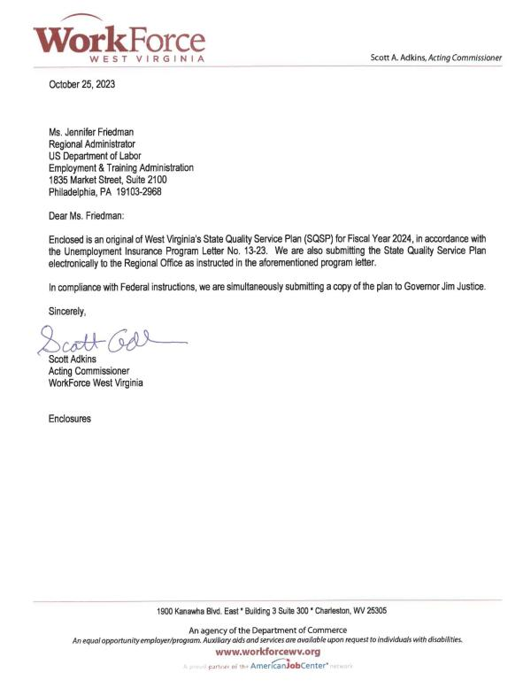

2. Budget Worksheets/Forms
Budget Worksheets.
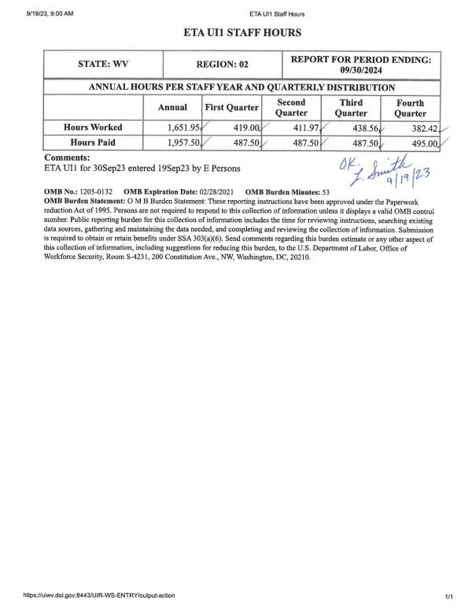
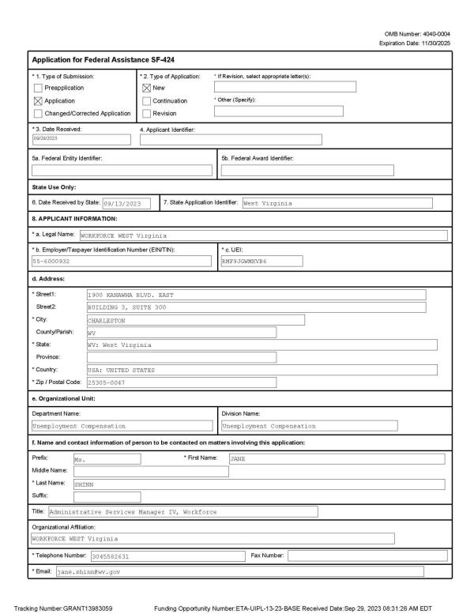
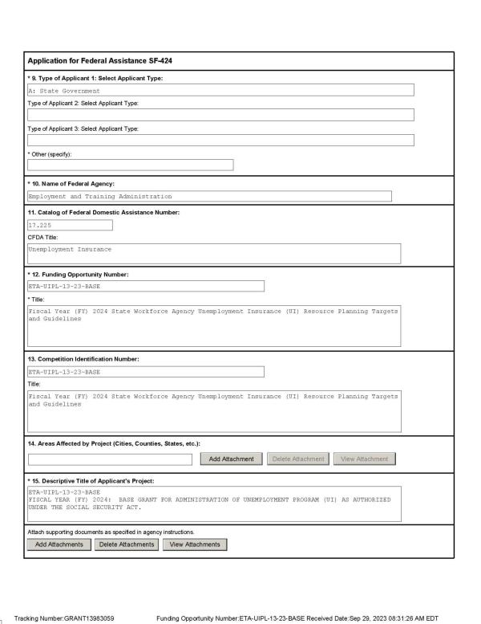
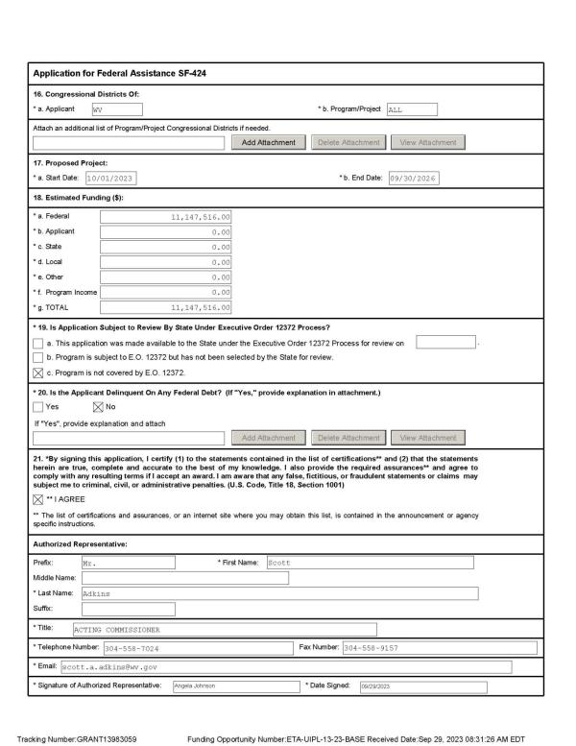
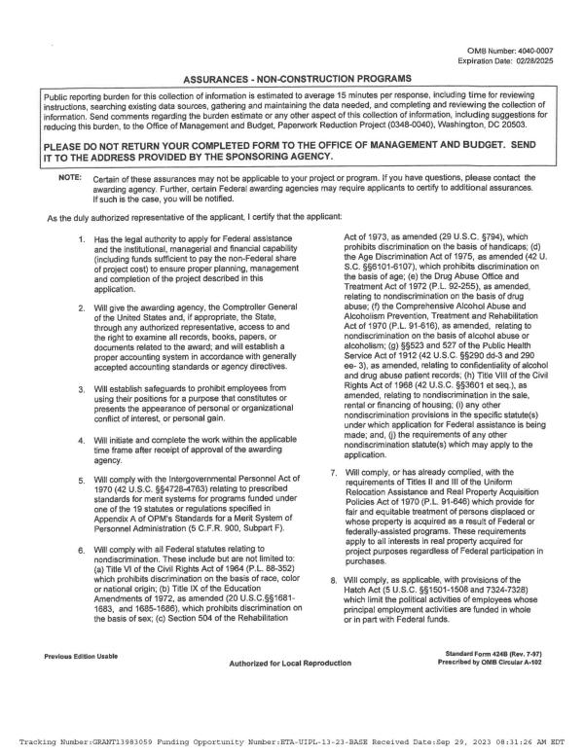
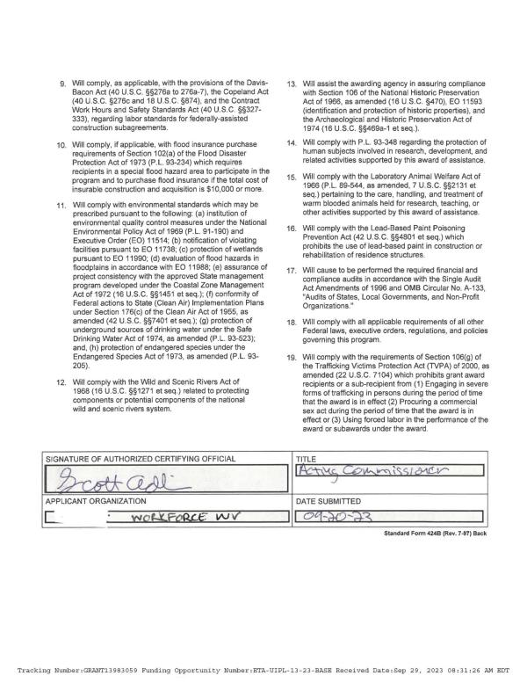

3. The State Plan Narrative
WorkForce West Virginia’s (WFWV) Unemployment Insurance (UI) Program is making progress in working through workload which occurred during the pandemic. The workload has steadily decreased in the past year due to the low unemployment rate, and the Agency is still working to clear backlogs in nonmonetary decisions, appeals and overpayment areas. While working to mitigate the backlog and ensure the current workload is processed in a timely manner, WFWV has used a two-team approach that involves staff working simultaneously on both the backlog and the current workload. This process has allowed the agency the ability to work to clear the backlog without significantly impacting the timeliness of the current workload.
The backlog was projected to be completed in early 2023. However, there are still pandemic era non-monetary determinations, lower and higher authority appeals workload remaining. During this rebuilding process, WFWV has worked to not only resolve all backlog but also restore the performance criteria West Virginia maintained prior to the pandemic. Therefore, the strategic plan begins with the completion of all backlog items and focuses on improving the timely delivery of every facet of the Unemployment Program. West Virginia has always taken pride in its ability to meet or exceed performance criteria associated with the delivery of unemployment benefits to the State’s unemployed. The Administrative Management Team continues to monitor the timeliness of initial claims, benefit payments, nonmonetary determinations, appeals, etc. This process will allow WFWV to make changes immediately to compensate for any unknown obstacles that could potentially cause an area of performance to fail. In reviewing the appeals backlog, particularly Higher Authority appeals, the state has discovered that there are appeals that have been adjudicated but not indicated as such on the benefits system. Agency unemployment staff are reviewing appeals backlog reports to determine if unresolved appeals have been adjudicated and working with the Board of Review to properly resolve these appeals. This process will provide an accurate accounting of which appeals are truly backlogged, so these hearings can be scheduled and completed.
For WFWV to evolve from the situation caused by the pandemic with a clear path forward, Agency initiatives must include various improvements to technology to increase productivity. Although technology is key in many instances, the Agency must also invest in human resources as well. For the agency to meet the challenges of a comparable economic decline, WFWV will not only need a skilled dedicated team of unemployment specialists, but also the completion of technologic endeavors such as a modernizing the UI System, call-centers to meet demand for information, and a mechanisms to ensure new staff are fully trained in an effective and efficient manner. As West Virginia and the nation recover from the pandemic and the repercussions left behind, it is imperative that lessons learned from this experience not be forgotten by states or nationally. West Virginia will need additional funding and assistance from the Department of Labor to not only ensure that new technology is adopted, but that states have the resources to maintain and attract a skilled workforce that can meet future service delivery issues which may arise. These rebuilding efforts for West Virginia will be achieved only through effective modernization of UI Systems and having the ability to attract qualified individuals and maintain a well-trained and dedicated workforce. Without technology and an investment in human capital, the high standards of performance in West Virginia cannot be maintained.
WorkForce West Virginia’s priorities are aligned with the national priorities listed in UIPL 09-23. The pandemic was instrumental in revealing business processes, performance, and key functions that did not promote an effective and efficient UI Program and WFWV is working to rebuild and improve program performance. The agency participated in the Tiger Team consultative assessment and will begin implementing recommendations in FY 2024. WorkForce WV will also begin using IT Modernization funding provided by UIPL 11-23 to begin the process of modernizing the state’s UI systems and processes. The state’s vision for modernization as defined in the current RFP is focused on a microservice architecture, allowing for modular upgrades and enhancements, while improving uptime. The system will also be able to scale to a cloud environment, as needed, while being primarily hosted on a private cloud to manage operating costs. APIs will be created to seamlessly integrate with other WorkForce systems and operations. Customer service will be improved in the system with program staff being able to change business rules and public facing webpages. Program staff, with business analysts, will assess all processes and update as necessary. This modernization effort will replace the legacy mainframe system currently in use. The RFP is currently under review by the West Virginia Purchasing Division, having been approved by the Office of Technology. Additionally, WFWV is still maintaining a physical presence in various locations around the state so in-person assistance can be obtained if the need exists.
During the pandemic, WFWV was forced to outsource calls to a corporate call center unfamiliar with unemployment and use in-coming staff that were not trained in all aspects of unemployment. These two issues caused more work on merit-based staff and delayed claim issues from being resolved quickly. The Agency has already begun to address this service delivery issue by establishing two in-house call centers which have the expertise to address claimant issues immediately and provide reemployment services to the unemployed quickly. In addition, the Agency has implemented more intensive training for staff who are being on-boarded as well as all UI staff. This training includes utilizing NASWA’s learning management platform and monthly e-learning courses specific to WFWV unemployment procedures. These training tools will allow the Agency to respond to an influx of staff due to workload or retirements. In addition, mandating the NASWA training modules will allow staff to be trained in all facets of unemployment. This type of training will give staff an overarching view of the Unemployment Program in every area instead of their specific area of assignment. It has been recognized by the Agency that an overall unemployment knowledge base is greatly beneficial during times when the Agency suffers a mass influx of workload or loss of staff.
WorkForce West Virginia is dedicated to promoting and improving equitable access to the UI program for underserved communities. To that end, the Agency will utilize equity grant funding to expand and improve the collection of demographic data to identify potential inequality patterns and trends to inform decision making strategies for improving equity. The Agency plans to improve claimant communication and outreach to help underserved citizens access UI benefits, measure delivery of benefits and claimant experience to improve service delivery and develop a mobile application to improve access to UI applications. WFWV will also use Tiger Team funding to implement the recommendation for plain language standards to simplify communications.
A top priority of the Agency is supporting the reemployment of UI claimants and jobless individuals. WFWV continues to use a combination of evidence-based strategies such as the WPRS profiling model and Job Search Assistance to identify and serve individuals that are selected for the RESEA program. Additionally, the Agency is incorporating an online virtual experience for these participants and self-scheduling to improve participation in the RESEA interviews, which will begin early in FY 2024.
West Virginia’s RESEA State Plan mandates that participants of the RESEA program have an individual re-employment plan and that the Agency provides them with a variety of resources that support obtaining reemployment as quickly as possible. WFWV conducts subsequent RESEA interviews for all program participants, which includes eligibility assessments, a review of the initial re-employment plan, and additional re-employment services as needed. Additionally, all RESEA participants have complete access to WIOA services and other workforce system partner programs.
Changes have been made within the Agency’s RESEA Program that include potential enhancements and best practices that may be implemented within the year. The Agency has established a separate unit that is designated to handle the RESEA Program. The staff in this unit are trained in the processing of unemployment claims, general reemployment services, and conduct RESEA virtual interviews. Through the training, staff involved in RESEA become familiar with the eligibility review portion of the documentation used during the RESEA interview that prompts additional questions which are geared toward not only to the ability to work but the availability for work and the individual’s job search efforts. It also includes questions that involve pension, retirement, and the receipt of worker’s compensation. Staff are trained to recognize potential eligibility issues during the RESEA process with emphasis on the importance of such recognition prior to improper payment of benefits. To further provide guidance for the RESEA Program and ensure improved integrity and employment outcomes, the new RESEA Unit has been provided a coordinator designated for oversight of the RESEA Program including the area’s productivity, performance outcomes, and grant expenditures. The improvements in the way the RESEA Program is monitored will enable the West Virginia RESEA Program to remain in compliance with the Department of Labor’s guidance. This change should also allow WFWV the ability to adopt general best practices and easily transform the RESEA Program into a program that provides statistical evidence that this type of intervention reduces the need for unemployment.
The Workforce Innovation and Opportunity Act (WIOA) has been implemented in the Agency’s local offices since WIOA’s inception. West Virginia’s WIOA Plan details specific attributes that address the goal of utilizing the Unemployment Insurance Program as a One-Stop partner. Developing the cohesive delivery of services between the partners as directed by WIOA guidelines was relatively straightforward for the state because WFWV’s UI and Employment Services staff are cross trained to assist individuals in all aspects of job placement and unemployment benefits. By providing access to a full range of services and colocation with partners, we can provide outstanding services to employers and claimants. This plan provides a step-by-step guide to assist claimants in returning to work, utilizing educational opportunities, and learning how to effectively network both in person and through social media to accomplish their overall goals. West Virginia has committed to submitting a Combined WIOA State Plan in FY 2024 that displays the coordination within WIOA and the states unemployment State Quality Service Plan.
In 2021, legislation was enacted which established a Short Time Compensation (STC) Program in West Virginia due to be implemented by July 1, 2023. WFWV launched the STC Program in January 2023. This includes marketing the program to employers, providing a means for employers to submit plans for approval, a pathway for claimants to apply for STC initial and continued claims, and programming changes in the State’s Automated Benefit Payment System to accommodate the STC Program. WorkForce West Virginia has approved several STC plans since launch and continues to work towards educating the state’s employers about the benefits of the program.
In conjunction with the RESEA Program, WFWV utilizes early intervention and customer service in the design and deployment of WorkForce West Virginia’s Rapid Response team. This team is utilized to provide quick services to dislocated workers to transition these individuals into new employment as soon as possible. To accomplish this goal, dislocated workers are advised of the programs and services that are available to them such as reemployment and transition services, including resume development, unemployment information, and various training opportunities. The Agency has also submitted and supported bills based on the Model Work Search Legislation per UIPL 17-19 and will continue to do so in the upcoming legislative session.
In coordination with the Department of Labor’s top priorities, WFWV has completed the task of incorporating an Integrity Unit under the Agency’s authority. This unit’s main goal is to intensify and streamline the Agency’s ability to combat fraud, prevent improper payments, and detect and recover improper or fraudulent overpayments. To ensure the area operates without bias, the Integrity Unit operates outside of the Unemployment Division and answers only to the Acting Commissioner of the Agency. In addition, all activities involved with combatting fraud and ensuring accurate payments are housed in this area. These areas include the Fraud Section, the Investigative Section, and the Crossmatch Section. At this point the unit is fully operational.
WFWV utilizes strategies that were highlighted in both UIPL 22-21, Change 2 regarding “Additional Planning Guidance for the Unemployment Insurance State Quality Service Plan”. As required, WFWV has highlighted the specific tools, services, strategies, process improvements, and/or procedural changes adopted by West Virginia to combat fraud, verify identities, and enhance recovery efforts in the SQSP IAP Narrative. The Agency will also implement Tiger Team recommendations to improve program integrity, including enhancing the use of the Integrity Data Hub, ID verification which utilizes the national offering for Login.gov and the United States Postal Service, and securing claimant login.
In conjunction with the practices, technology, and changes in policy directly mentioned in the SQSP IAP, WFWV continues to improve and utilize tools and strategies as well as long standing methods of detecting potentially fraudulent activity such as the submission of claims to the Social Security Death Registry. Due to the issues associated with claimants and banking accounts, WFWV worked with one of the Agency’s vendors to engineer a program that will “lock” banking accounts for twelve hours when a claimant or potential “bad actor” has attempted to register for direct deposit three (3) consecutive times unsuccessfully. This policy allows the Fraud Team the ability to review a daily list of “locked accounts” which can result in a team member either assisting a claimant with the direct deposit enrollment process, identify that the claim as a ID theft case, or concluding that a potential “bad actor” is attempting to hijack a claim and the benefits associated with that claim to facilitate payments being sent to a bank account not affiliated with the claimant. WFWV has continued its partnership with the West Virginia Division of Motor Vehicles (DMV) which is utilized for verification of identity. This agreement allows various staff members the ability to access DMV records for verification purposes. Since the Agency has begun to require claimants to upload government issued photo ID, it is imperative that the staff have the capability to discern if a driver’s license is authentic or fake. This policy change requiring identity verification was implemented using NASWA’s guidance and due to fraudulent activity was necessary. In addition, the partnerships formed during the Pandemic between various law enforcement entities and WFWV have been maintained and strengthened. In fact, the partnerships are resulting in actual prosecutions for fraudulent activities against the Unemployment Program in West Virginia. The Agency anticipates that as these cases are publicized by the media fraud may be reduced in the state.
To assist the Agency with reducing improper payments and assist the employer community in finding employees, in June 2021 West Virginia reinstated the waiting week statewide and changed state unemployment policy to again require weekly job search activities for claimants in active filing status. Additionally, the Agency will be working to provide claimants with targeted automated messages to educate claimants on proper work search and document retention. Automated reminders concerning job opportunities suited to their specific skill will also be sent through the Employment Service System. As mentioned previously, WFWV will continue to support Model Work Search Legislation.
Regarding the implementation of the various SIDES Modules, the Agency is making plans to utilize all aspects of the SIDES Exchange Systems. The state’s top priority Tiger Team recommendation is to expand the modules used and to increase employer uptake in utilizing SIDES. WFWV has always been an advocate for the modules within the SIDES Exchange Systems since the informational templates are beneficial in the fact-finding needed by state adjudicators. An additional benefit to the employer community is the ability for each employer to have immediate access to documents and postage savings for employers and the Agency.
WorkForce West Virginia continues to address worker misclassification by educating the employers during field audits and when issuing letters of compliance. The audit unit uses resources from participating in the GLDEP, such as the 1099-NEC data extract and the FUTA zero certification, to select field audits that are high risk for misclassification. The audit unit also receives and reviews DOL site inspection reports to identify employers who may not be registered with the agency or may not be fully reporting. Wage investigations, internal referrals and external tips are also used to address worker misclassification. The Agency continues to work on staffing and training of staff to efficiently complete field audits.
Timely and accurate federal reporting has always been an Agency goal. Although most of the federal reporting was completed in a timely manner, the loss of knowledgeable full-time staff with almost all in staff in the Budget & Statistics unit responsible for submitting many reports being with the unit for less than one year, has resulted in WFWV being submitting late or inaccurate reports. The Agency recognized the need for additional training on topics such as: the reason for timely submission of the federal reports, methods to get assistance from the National and Regional Office, review of due dates, etc. and training was provided to staff. To ensure federal reporting compliance and timeliness, the Agency is continuing training and having a seasoned staff member review all reporting. The Department of Labor can depend on the Agency to submit all federal with accurate statistics in a timely manner in the upcoming year.
The Agency will also address the incorrect recording of detection dates for non-monetary issues through a combination of on-line training courses for all staff involved in processing and adjudication of claims, and in-person training with staff who record detection dates incorrectly. Agency management will be informed of instances where detection dates are recorded incorrectly, whether it is discovered through the BTQ process or other claim review, so these can be addressed directly with the staff responsible.
Quality performance in all unemployment functional areas is a major concern for the Agency. The performance of timely intrastate payments has improved in the past year from 72.48% to 81.14% but is still short of the GPRA goal of 87%. The detection of recoverable overpayments has also improved in the past year to 65.90%, which is above the GPRA goal. Actions implemented as part of the state’s corrective action plan for payment promptness and detection of overpayments will continue for FY 2024 and should cause further improvements. The percentage of employer tax liability determinations made timely is 84.10%, which is lower than the GPRA goal of 90%. Improvements in the staffing of the Employer Status Determination Unit and changes made to the state’s online employer application, which have been completed, will help to improve performance in this area. The agency also continues to look for methods to streamline and improve the application and liability determination process in order to improve performance.
Although the Governor and Legislature of West Virginia awarded the Agency the ability to utilize exempt positions which afforded WFWV the capability to hiring individuals at higher salaries without approval from the Division of Personnel, staffing is still an issue. Due to the pandemic and aging staff, WFWV continues to lose knowledgeable merit employees. As private sector and government entities continue to have shortages of qualified staff, West Virginia has only been able to moderately increase staff. One issue the Agency has noticed is that even though staffing levels have increased it is difficult to maintain the newer staff. Therefore, the Agency is in a continuous cycle of training new staff. Based upon nationwide statistics, it is quite possible all employers, whether private or government, will continue to struggle to maintain knowledgeable staff. To mediate the staff turnover, WFWV is offering staff a stronger career mentorship program which will hopefully provide employees with a more professional outlook on their careers, enhanced skill sets to assist them in obtaining pay raises, and a ladder to higher level jobs within WFWV as they grow in their respective jobs.
The Agency provides the following assurances:
- Assurance of Equal Opportunity (EO).
- Assurance of Administrative Requirements and Allowable Cost Standards.
- Assurance of Management Systems, Reporting, and Recordkeeping.
- Assurance of Program Quality.
- Assurance on Use of Unobligated Funds.
- Assurance of Prohibition of Lobbying Costs (29 CFR Part 93).
- Drug-Free Workplace (29 CFR Part 98).
- Assurance of Conformity and Compliance
- Assurance of Confidentiality
The Agency also assures that staff has received training on Disaster Unemployment Assistance (DUA). DUA training for identified staff was completed on October 14, 2022. There will be additional training on DUA conducted in November 2023. WFWV has also developed a standard operating procedure for use during a major disaster.
The State of West Virginia, including the state workforce agency, WorkForce West Virginia, successfully migrated from the on-premises mainframe system to a vendor hosted Mainframe as a Service on April 16, 2023. The State’s Unemployment Compensation system resides on and operates from this mainframe. The new platform provides greater stability and up-time, as well as performance improvements. The primary mainframe server resides in Downers Grove, Illinois. The backup server resides in Omaha, Nebraska. The West Virginia Office of Technology conducted a Disaster Recovery and Business Continuity test for October 16, 2023, through October 20th, 2023. WFWV programming and functional personnel will be participating in that test. WFWV implemented Information Technology (IT) Contingency Plan on September 21, 2011.
In closing, the Agency hopes that the Department of Labor will understand the many hours staff are still working to resolve the workload and disruptions caused by the pandemic and moving forward to improve program performance. The pandemic unleashed hardships on the economy as well as all state unemployment programs. West Virginia has always prided itself in achieving high performance marks and providing excellent customer service to the citizens of West Virginia. Based upon the Agency’s dedication and work ethic, the Department of Labor can rest assured that the Agency will continue the rebuilding process to achieve its Unemployment Program mission critical goal, with the final objective being – “An Unemployment Program deliberately designed to utilize a specialized merit-based cross-trained workforce in conjunction with a modernized UI system where both are easily adaptable to program changes or an influx of workload associated with any economic decline or national disaster.”

4. Corrective Action Plans (CAPs)
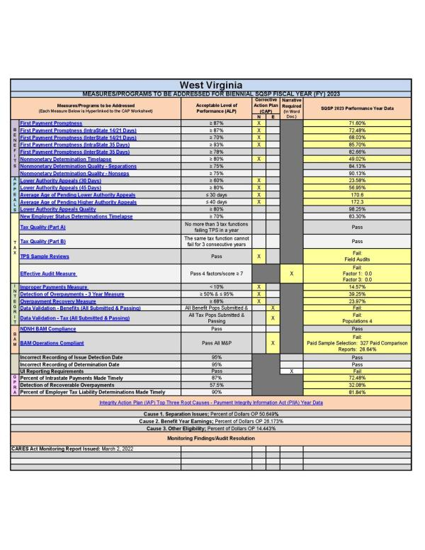
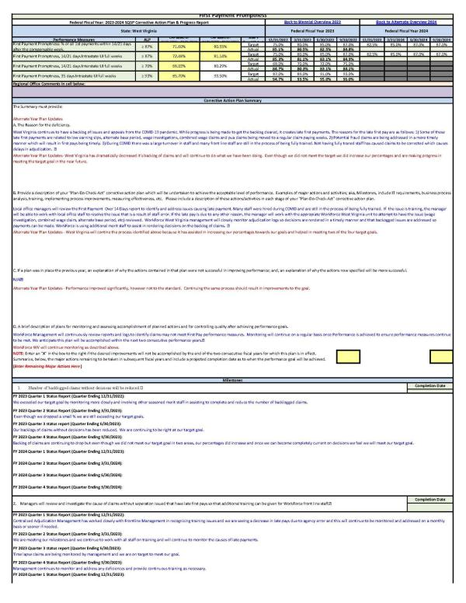
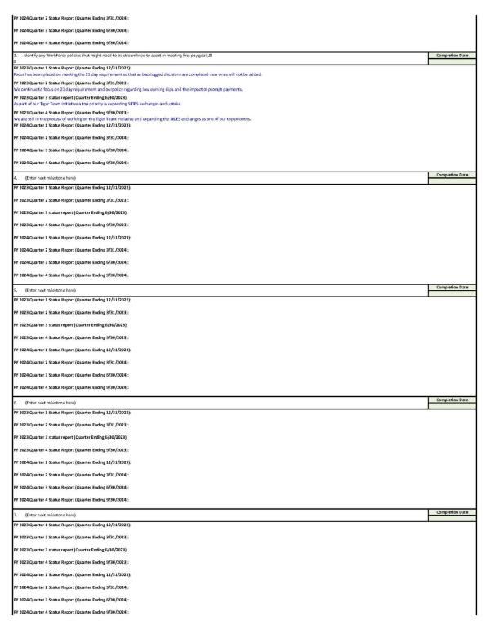

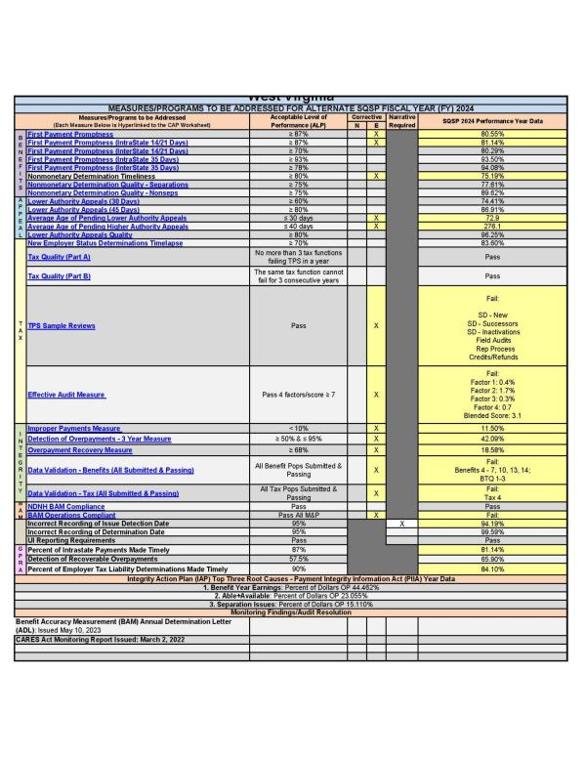
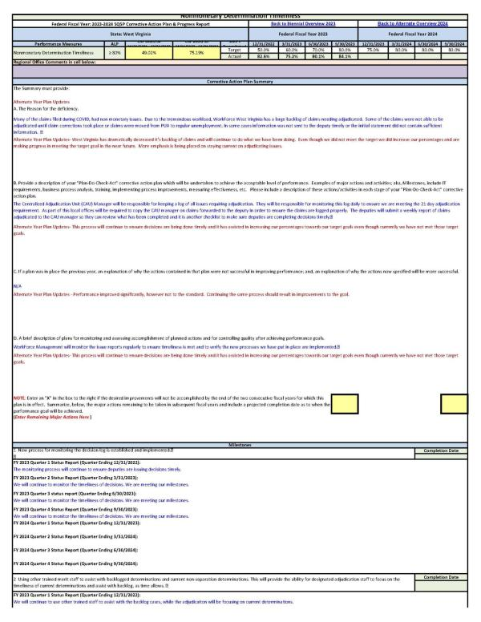
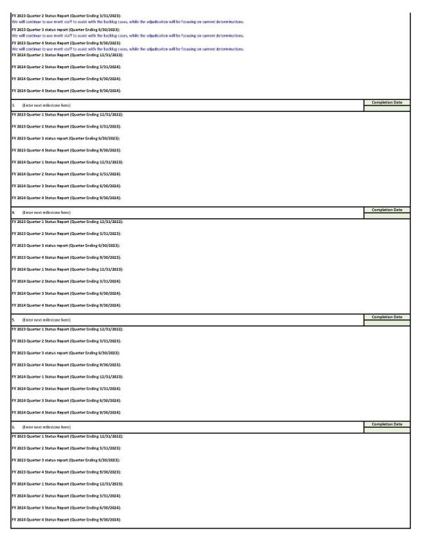

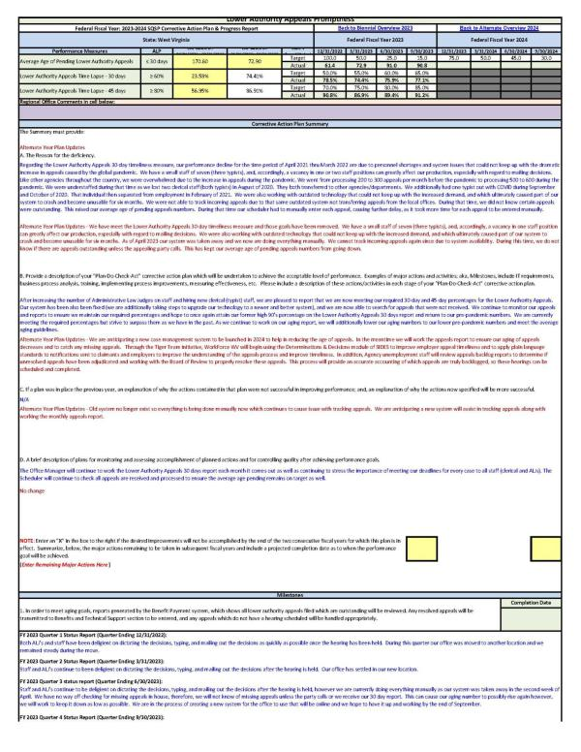
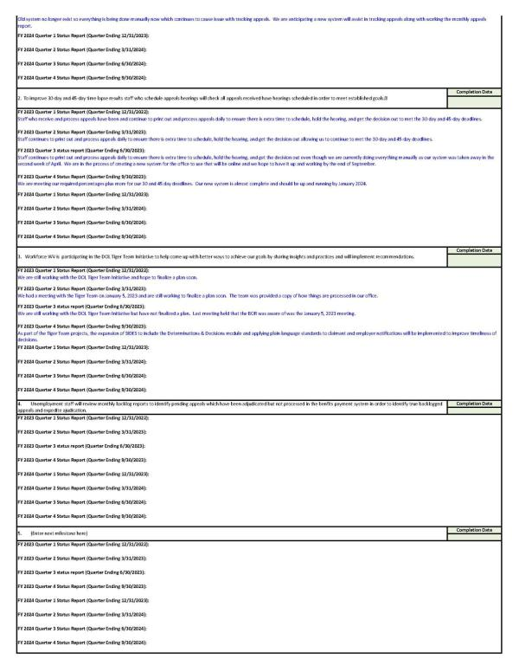

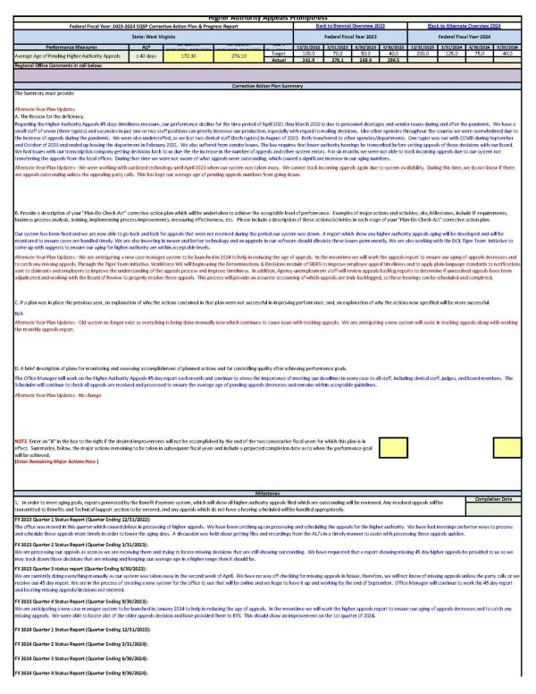
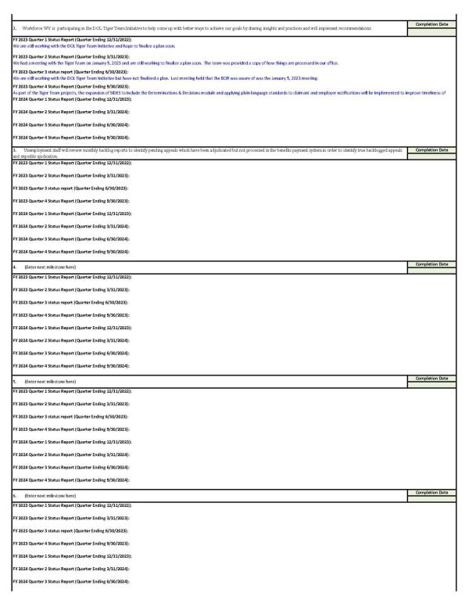

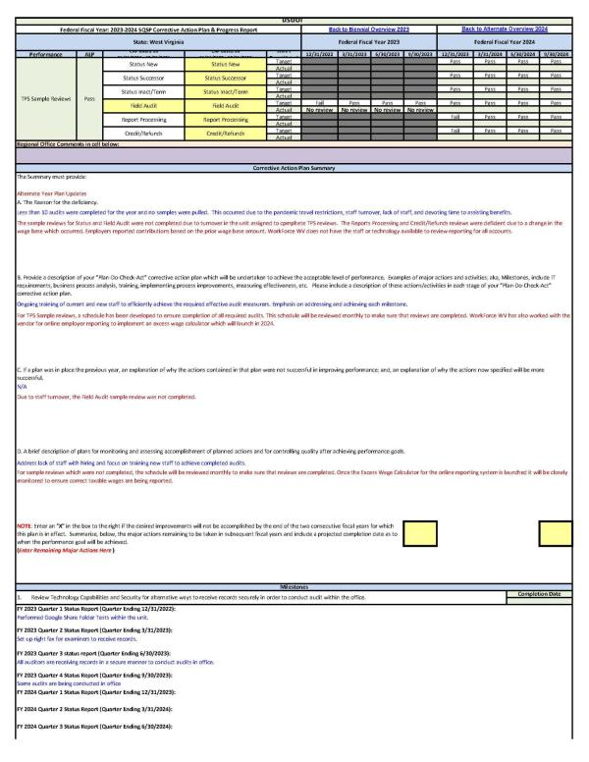
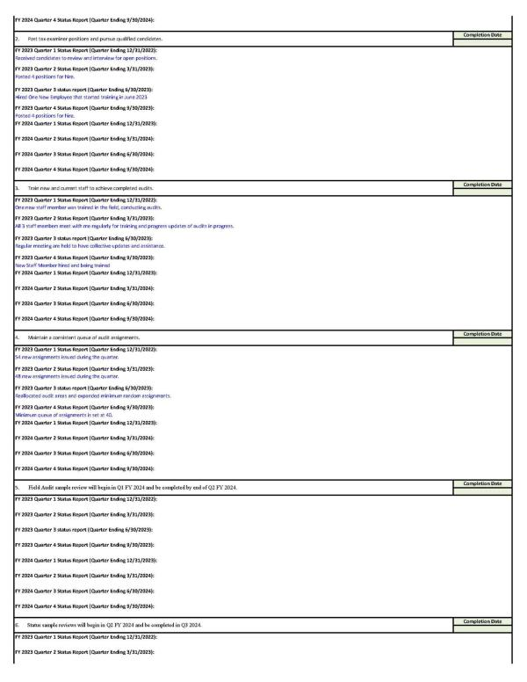

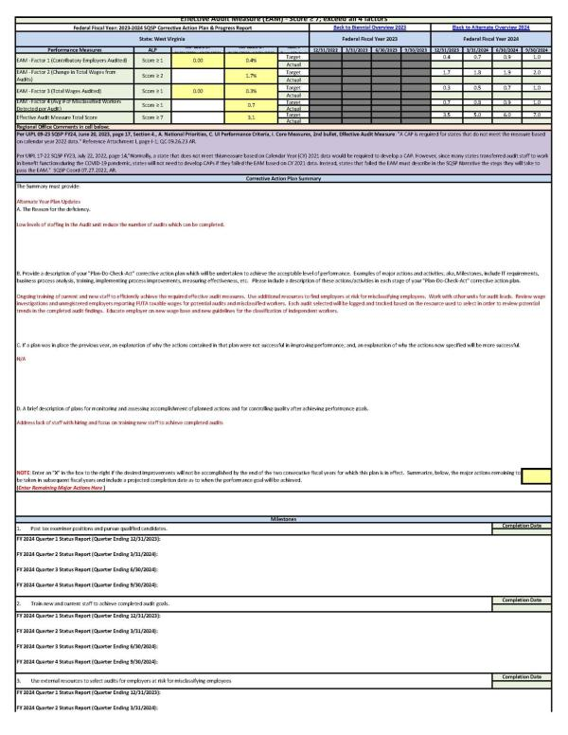
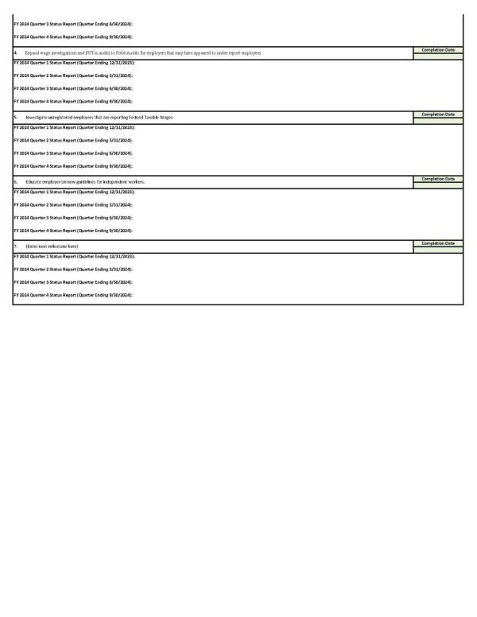
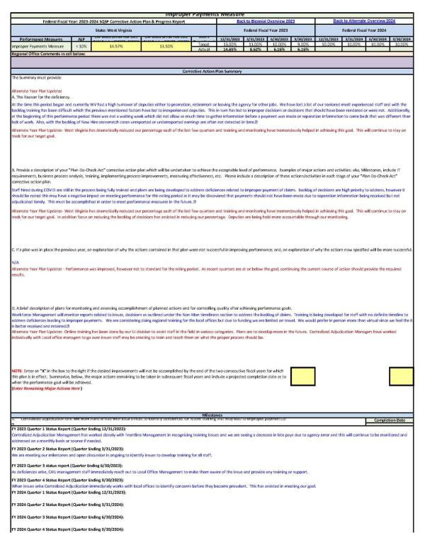
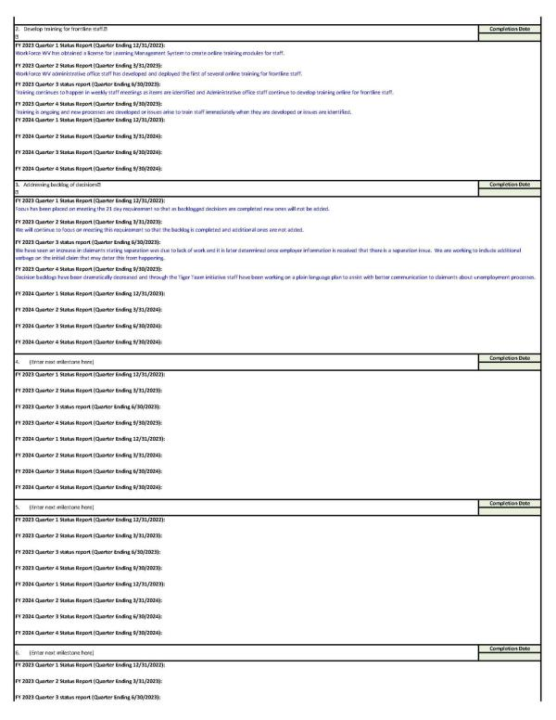

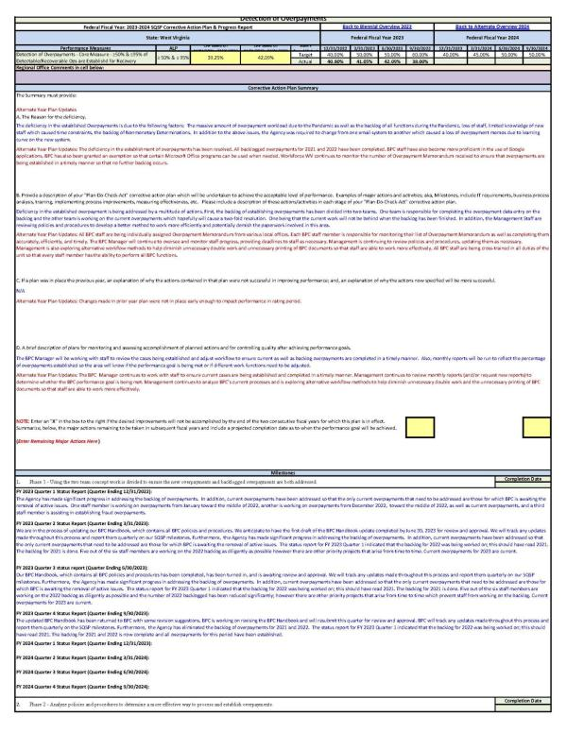
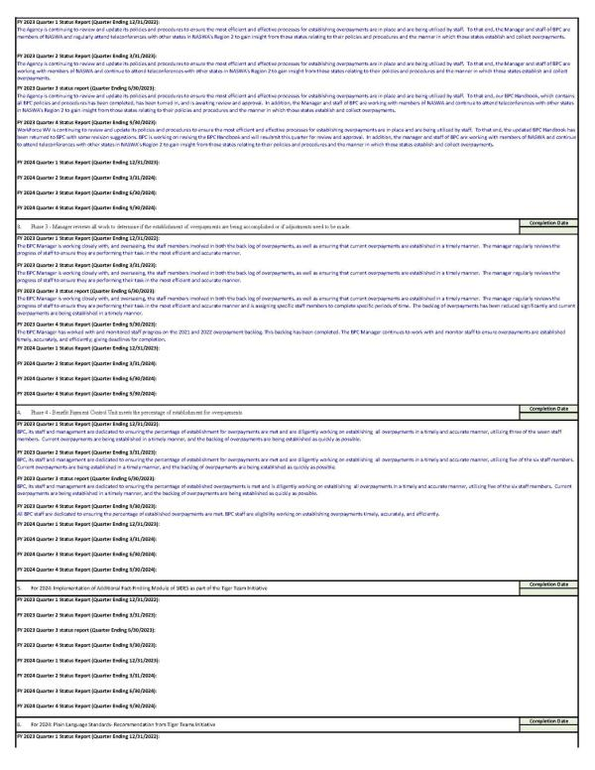

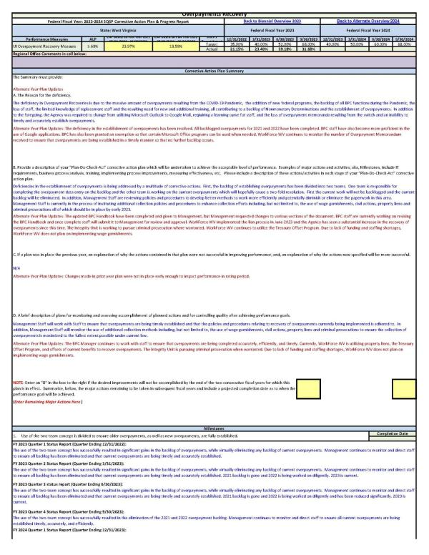
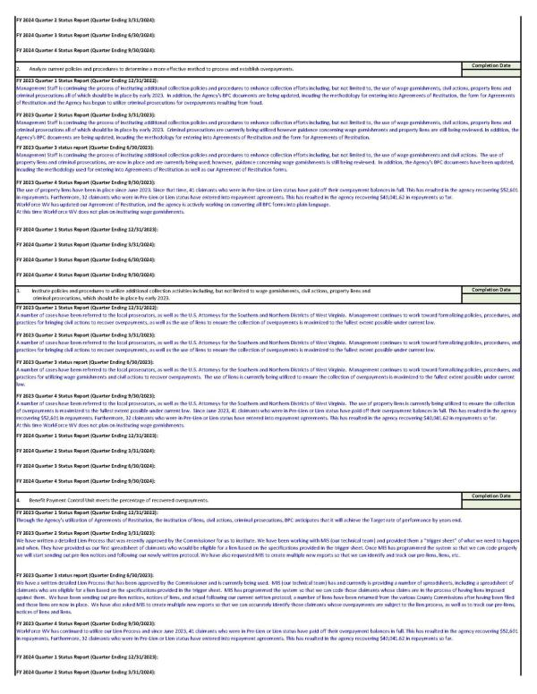
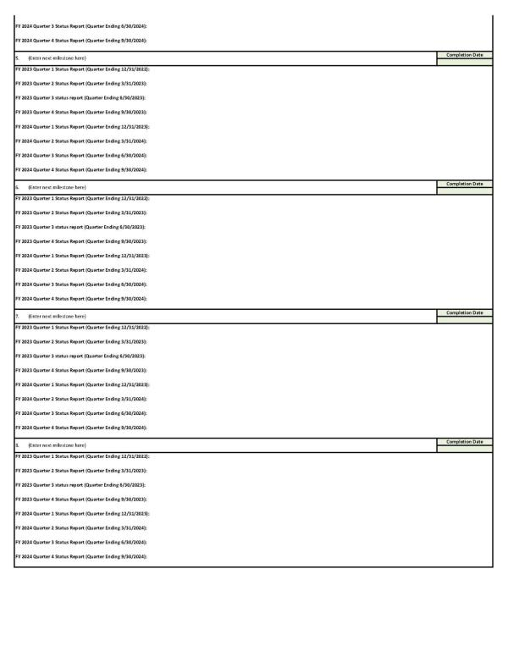
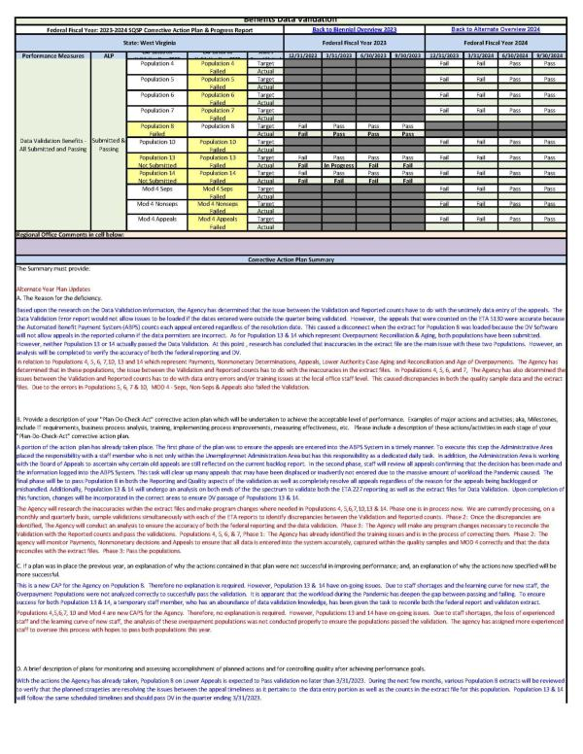
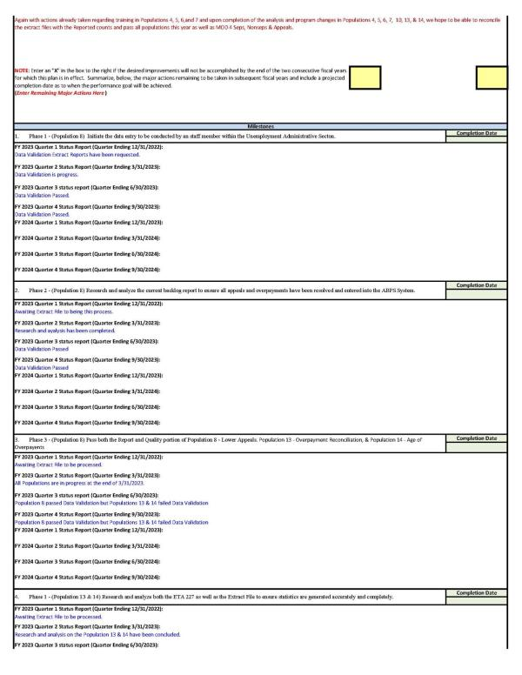
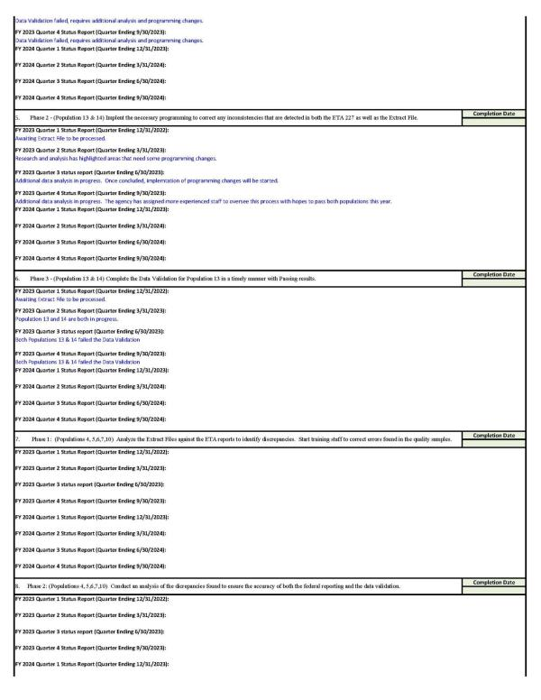
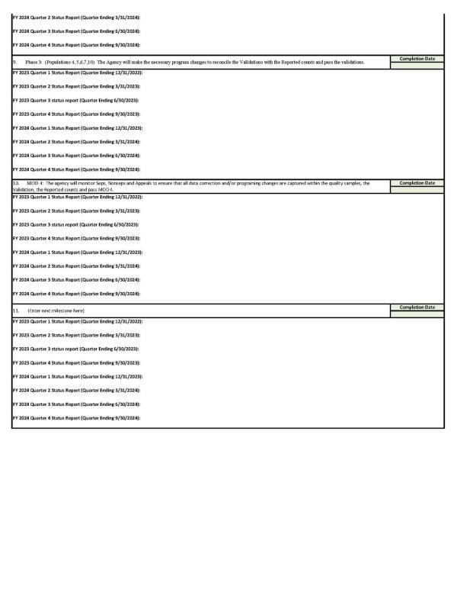
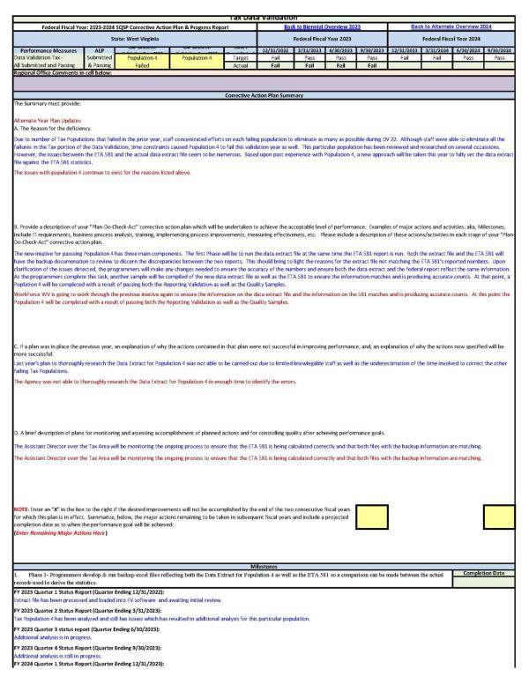
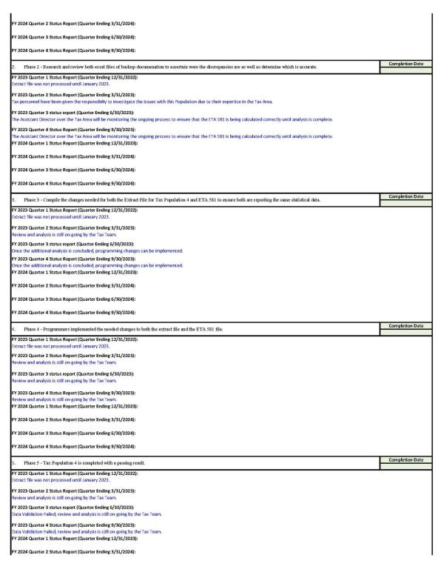

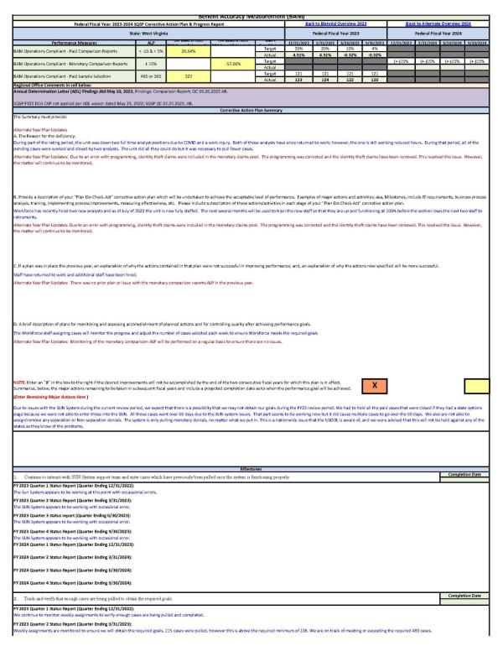

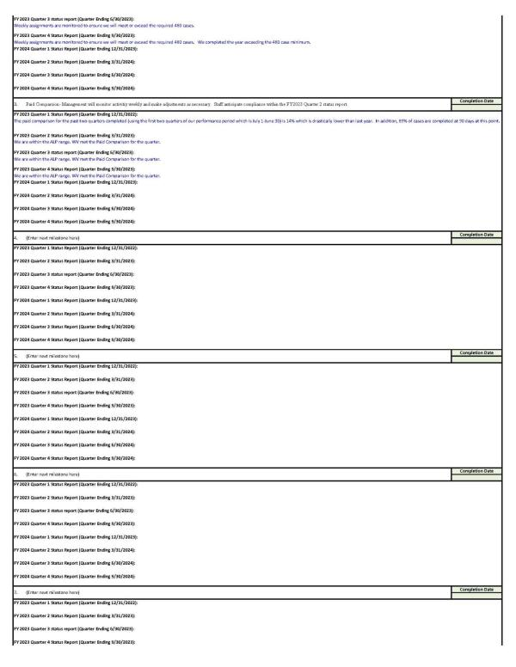


5. UI Program Integrity Action Plan (UI IAP)
State Quality Service Plan (SQSP)
Integrity Action Plan (IAP)
State Name West Virginia – Fiscal Year (FY) 2024
Accountable Agency Official(s).
List the person or persons accountable for ensuring integrity in the state’s unemployment insurance (UI) program.
Name: William Scott
Title: Acting Director, Unemployment Fraud & Integrity Unit
Email: William.J.Scott@wv.gov
Phone: (304) 558-7024
*Note: Unemployment Insurance Program Letter (UIPL) No. 09-23, issued on June 30, 2023, makes reference to UIPL No. 22-21, Change 2, throughout the guidance. However, on July 13, 2023, the Employment and Training Administration (ETA) issued UIPL No. 10-23, which rescinded UIPL No. 22-21, Change 2. UIPL No. 11-23, also issued on July 13, 2023, changed the amount of the integrity grant funding originally issued under UIPL No. 22-21, Change 2, but maintained the guidance on required and recommended fraud prevention and detection and overpayment recovery activities.
- (Topic #1: National Priority) – Ensuring UI program integrity by assessing and evaluating fraud risks, implementing, and maintaining sufficient controls to effectively mitigate the likelihood and impact of fraud, and reducing improper payments.
- In evaluating fraud risks, states should consider both eligibility fraud risks and identity (ID) fraud risks.
WorkForce West Virginia considers both eligibility and identity fraud risks throughout the claims process. All initial claims are reviewed by agency staff when filed and entered on the benefits system. All claims then have a second review, once entered on the benefits system, by trained staff in the recently established Integrity Unit. The Integrity Unit, established by legislation in 2022, empowers Workforce WV to now not only identify fraud and identity theft within unemployment claims, but to pursue those matters now independently through the investigation process as well as seek prosecution and restitution. The fraud unit presents criminal investigations for both federal and state prosecution and utilize court ordered restitution included in these prosecutions to greatly enhance the recovery efforts for monetary loss. The Integrity Unit can work in unison to accomplish multiple tasks to better protect the agency from fraudulent activity by identifying known fraud conduct and fraudulent schemes being used against the agency and be able to place checks and balances in place that are fluid and can quickly adapt to the everchanging attempts and efforts of fraudulent actors. The Integrity Unit also contains a dedicated cross match section, to review claims identified as potentially paid improperly due to unreported wages or incarceration.
- State plans to evaluate UI fraud risks and implement and maintain sufficient controls to effectively prevent fraud and reduce improper payments, including state actions to develop their own state-specific antifraud strategy.
- Key elements of an antifraud strategy include:
  - Who is responsible for fraud risk management activities?
    - Establish roles and responsibilities of those involved in fraud risk management activities, such as the antifraud entity and external parties responsible for fraud controls and communicate the role of the Office of Inspector General (OIG) to investigate potential fraud.
  - What is the program doing to manage fraud risk?
    - Describe the program’s activities for preventing, detecting, and responding to fraud, as well as monitoring and evaluation.
  - When is the program implementing fraud risk management activities?
    - Create timelines for implementing fraud risk management activities, as appropriate, including monitoring and evaluations.
  - Where is the program focusing its fraud risk management activities?
    - Demonstrate links to the highest internal and external residual fraud risks outlined in the fraud risk profile.
  - Why is fraud risk management important?
    - Communicate the antifraud strategy to employees and other stakeholders, and link antifraud efforts to other risk management activities, if any.
- See A Framework for Managing Fraud Risks in Federal Programs at https://www.gao.gov/assets/gao-15-593sp.pdf for additional information.
The Integrity Unit is primarily responsible for fraud risk management activities for WorkForce WV. The Integrity Unit is comprised of investigators, who are former law enforcement officers, a fraud intelligence section, investigative support section, and cross match section. The Integrity Unit works with and coordinates activities with USDOL-OIG, federal, state and local law enforcement agencies, the US Attorney’s Office for the northern and southern districts of West Virginia, as well as WorkForce WV agency staff.
After claims are filed and submitted, there are automated indicators that are placed on claims when identified “red flags” are present. Claims are reviewed and entered by agency staff, at which time staff can place a potential fraud indicator on a claim if necessary. All initial claims are reviewed by Integrity Unit staff after claim entry and all claims are submitted to the IDH. Claims are also reviewed when additional or re-opened claims are filed as well as when any change is made to payment methods. In addition, all adjudication of identity theft or fraud related non-monetary issues is performed by Integrity Unit staff. Fraud risk management activities continue through the entire claim cycle.
The Integrity Unit is constantly evaluating and monitoring activities, to maintain appropriate response and to be able to react to changes in fraudulent activities. Fraud risk management activities are focused primarily on identity theft, fictitious employer schemes, and cross match activities.
Integrity Unit staff meet with the agency’s executive team, claims and tax staff, and external stakeholders such as employers, law enforcement, and other government institutions to provide information on risk management activities and the importance of protecting the integrity of UI programs.
- State use of tools, services, strategies, process improvements, and/or procedural changes adopted by the state to combat fraud, verify identities, and enhance recovery efforts. States must identify which tools, solutions, and service provider(s) are used in the state’s fraud management operations, including but not limited, to the following areas: data analysis, risk-based ID verification, fraud prevention and detection, and cybersecurity.
- Include strategies, solutions, and/or activities using funds the Department has made available to states for combatting fraud and strengthening UI program integrity under UIPL Nos. 28-20; 28-20, Change 1; 28-20, Change 2; 28-20, Change 4; 22-21; 11-23; and 02-22.
- Provide details on overpayment recovery efforts including:
  - Actions with banks, financial institutions, and with Federal law enforcement’s forfeiture and seizure efforts.
  - Information on how the state is using waivers of recovery of overpayments both for regular UI and temporary UC programs created by the CARES Act, including if the state is using approved blanket waivers as described in UIPL No. 20-21, Change 1.
  - How the state is using the Treasury Offset Program (TOP) for benefit overpayment recovery, how the state is ensuring covered debts are being submitted, and any barriers/challenges in working with TOP.
Workforce WV information technology support staff are engaged in the fraud detection process, and they also work with Diamond Technologies, the agency’s cyber vendor, to use creative ways of utilizing captured data to prevent and detect fraud. The information technology support staff also work independently within the Workforce WV mainframe to diligently identify fraudulent patterns, indicators, known threats, etc.…, to be prepared to adjust operations of the mainframe to address identified issues in real time.
Recovery efforts are being greatly enhanced through prosecution/restitution related to fraudulent conduct and identity theft. The fraud unit is working closely with the United States Attorney’s offices in both districts of WV, while also working with Homeland Security, FBI and US Secret Service to increase efforts in pursuing and recovering monetary loss. The fraud unit is working with US Bank, who is the financial institution responsible for ACH payments made in response to claims filed with Workforce WV, to recover fraudulent payments made via debit card or direct deposit.
WV is still processing the backlog of overpayment waivers but are no longer accepting new overpayment waiver applications. WV does not have any barriers/challenges in working with TOP.
- State use of UI Integrity Center resources, with a particular focus on state connection to the Integrity Data Hub (IDH) and use of its datasets to cross-match unemployment compensation (UC) claims and aid in the prevention and detection of fraud and improper payments (see Training and Employment Notice (TEN) No. 24-21);
- Discuss the state’s connection to the IDH, including frequency of IDH use.
  - Does the state submit all initial and continued claims for IDH cross-matching? If not, what is preventing the state from sending all claims?
- If the state is not connected to the IDH and/or is connected but not regularly submitting UI claims data through a webservice/real-time connection to IDH, provide details on the state’s plan for how to increase usage and an anticipated timeline to:
  - Connect to the IDH.
  - Increase frequency of IDH use.
  - Fully leverage all available IDH capabilities. IDH capabilities include:
    - Suspicious Actor Repository (SAR)
    - Multi-State Cross-Match (MSCM)
    - Identity Verification (IDV)
    - Bank Account Verification (BAV)
    - Fraud Alerting
    - Foreign Internet Protocol (IP) Address Detection
    - Suspicious Email Domains and Patterns
  - Update the IDH connection to a webservice/real-time connection.
  - Identify barriers to using any of the available IDH capabilities.
- If the state has not executed IDH Participation Agreement - Version 5.0 (see TEN No. 24-21), provide details on the anticipated timeline to update to IDH Participation Agreement – Version 5.0.
- Discuss the state’s use of the UI National Integrity Academy’s virtual trainings and/or eLearning lessons.
- Discuss the state’s use of UI Integrity Knowledge Exchange Library resources, including the Behavioral Insights Toolkit (see TEN No. 15-21).
- Discuss the state’s participation in State Consultative Services.
Note: The IDH Team has a one-page dashboard report for each state summarizing current IDH utilization and areas where IDH use might be expanded. Please reach out to IDHTeam@naswa.org to request a copy of your state’s IDH utilization dashboard report.
The state submits every claim through the IDH weekly. Workforce West Virginia is fully participating in all available IDH capabilities. The state has executed the Version 5.0 participation agreement. The Assistant Director of our Integrity Section is an Integrity Steering Committee member, and each member of the Fraud team in the Integrity section has completed, or will complete, the National Integrity Academy’s IDH certificate by the end of September 2023. The Agency has received approval from the West Virginia Department of Personnel, to provide pay increases to staff upon completion of the National Integrity Academy’s Fraud certificate
- State use of required and recommended integrity controls and overpayment recovery activities as outlined in UIPL No. 11-23, including any additional effective cross-matching and overpayment recovery activities and identified best practices.
- Provide details regarding the state’s use of each cross-match/integrity control and overpayment recovery activity (required and recommended) as outlined in UIPL No. 11-23. Include details on the frequency of crossmatch/integrity controls use (e.g., conducted on all initial claims, all continued claims, only when suspicious activity is identified?) and frequency of overpayment recovery activities.
- Cross-matches/integrity controls and recovery activities include:
Cross-matches/Integrity Controls
- ID Verification;
- National Directory of New Hires (NDNH);
- Quarterly Wage Records Cross-match;
- Systematic Alien Verification for Entitlement (SAVE);
- Referral of allegations reasonably believed to constitute UC fraud, waste, abuse, mismanagement, or misconduct to DOL-OIG;
- UI Integrity Center’s IDH;
- Digital Authentication, such as Multifactor Authentication (MFA);
- Device Fingerprint/Reputation Management;
- Fraud Risk Scoring (i.e., Case Management Prioritization);
- Comparisons and cross-matches that detect shared characteristics;
- Social Security Administration cross-matches (i.e., Unemployment Insurance Query (UIQ), Prisoner Update Processing System (PUPS), Death Master File);
- Federal, state, and local incarceration cross-matches;
- Deceased Records cross-matches;
- Vital Statistics cross-matches;
- State Directory of New Hires (SDNH);
- Department of Motor Vehicle cross-match;
- Interstate Benefits (IB) cross-match;
- State Identification Inquiry (SID) and IB8606 enhancements made to the Interstate Connection (ICON) network cross-match to prevent concurrent claim filing in multiple states;
- Use of a unique identifier to identify claimants instead of using the full SSN;
- Fictitious employer cross-matches;
- Periodic IT security assessments and audits consistent with National Institute of Standards and Technology (NIST)-compliant information technology security guidelines;
- Adequate internal controls to protect the integrity and security of state assets;
- Implement a cross-functional integrity task force to develop and implement state-specific action plans to reduce UI improper payments.
Overpayment Recovery Activities
- Benefit Offsets;
- TOP;
- Cross Program Offset Recovery Agreement (CPORA);
- Interstate Reciprocal Offset Recovery Arrangement (IPORA);
- Negotiating repayment plans;
- Accepting repayments through various methods (e.g., online, via debit/credit card);
- State Income Tax Offset Program;
- Wage garnishments;
- Property liens and assessments;
- Offsets of lottery winnings, homestead exemptions, and other benefits;
- Active participation in probate and/or bankruptcy proceedings;
- Skip tracing;
- Work proactively and collaboratively with banks and financial institutions;
- Civil actions;
- Credit bureau referrals;
- State/federal prosecution;
- Penalties and interest on overpayments in compliance with state and federal law;
- Collection agency referrals;
- Implementing a voluntary fraud self-disclosure program;
- Other recovery methods as determined by state law or policy.
- Identify any additional integrity controls or recovery activities the state uses that are not listed in UIPL No. 11-23.
- Provide promising practices.
- Identify challenges with cross-matches or in overpayment recovery activities.
- If the state does not currently use one of the integrity controls or recovery activities listed in UIPL No. 11-23, provide the state’s plan and anticipated timeline to request and obtain access to the cross-match/integrity control or to implement the overpayment recovery activity.
Note: If the state does not plan to obtain access to a cross-match/integrity control or implement a specific recovery activity, please explain.
Currently WorkForce West Virginia performs manual ID verification of claimant ID documents uploaded through the initial application or presented in-person and utilizes the IDV functionality of the IDH. The agency has started the process to implement ID verification offering through Login.gov and the United States Postal Service. . The state also administers a weekly National New Hire, daily State New Hire, and Quarterly Wage Crossmatch. The state has a unit solely dedicated to the crossmatch process. West Virginia utilizes the Systematic Alien Verification for Entitlement (SAVE) program for initial claims, when appropriate. The state’s Unemployment Integrity Unit refers allegations reasonably believed to constitute UC fraud, waste, abuse, mismanagement, or misconduct to DOL-OIG. WorkForce WV also fully utilizes in all capabilities of the Integrity Data Hub.
WorkForce WV utilizes Multifactor Authentication (MFA) for staff access to certain systems, but currently does not utilize MFA for claimants. However, WorkForce WV is working towards securing claimant login and the use of MFA, which is one of the highest priority Tiger Team initiative recommendations for the state. The state does not currently use device fingerprint, reputation management or fraud risk scoring.
The WorkForce WV benefits system is programmed to identify multiple active claims with shared characteristics, such as email, phone number, and address. Each new claim entered is cross matched through the Social Security Administration Unemployment Insurance Query (UIQ) and the Death Master File cross match is also used. Workforce WV currently performs state incarceration cross matches and is working towards implementing the Prisoner Update Processing System (PUPS). The agency does not currently have cross match for Vital Statistics or the Department of Motor Vehicles, however some staff have access to the DMV system and can query the DMV information.
Staff review the State Identification Inquiry (SID) on ICON while entering new initial unemployment claims to prevent concurrent claim filing in multiple states and the Benefit Payment control unit uses the IB8606 Intestate Overpayment Reports to crossmatch claimant’s Open/New claims in other states against open/new claims in West Virginia. Each claimant filing unemployment claims is issued a unique claimant identification number, consisting of letters and numbers. Identifying fictitious employers is currently a manual process for WorkForce WV. The Agency’s internal controls for security are described in detail in Topic #5 of this plan.
WorkForce WV has a dedicated Integrity Unit, created by legislative action, which is tasked with maintaining the integrity of West Virginia’s unemployment system. The Integrity Unit contains investigators, who are former law enforcement officers, a fraud intelligence section, investigative support section, and cross match section. The Integrity Unit works closely with unemployment benefits, tax, and front-line staff to reduce improper unemployment payments.
WorkForce West Virginia negotiates repayment plans with claimants and accepts repayment of overpayments in-person or via mail. Claimants may repay their overpayment with a personal check, cashier’s check, or money order made payable to WorkForce West Virginia. One challenge WorkForce West Virginia faces is the inability to accept electronic payments from claimants, but this is something we would like to work towards in the future.
WorkForce West Virginia adds penalties and interest on overpayments in compliance with state law. When the benefit payment system identifies a claimant with a fraudulent overpayment, the 20% penalty is automatically applied.
WorkForce West Virginia utilizes the offset of current benefits to recover improper payment of benefits. When the benefit payment system identifies a claimant with a current claim who also has an overpayment established, current benefits are used to offset the pre-existing overpayment(s). The benefit payment system then prepares and mails a notification to the claimant which discloses the amount of the overpayment, the current benefits which are withheld and applied to that/those overpayment(s), and the balance of the overpayment remaining after application of the offset of current benefits.
WorkForce West Virginia is enrolled and utilizes the Treasury Offset Program (TOP). When the benefit payment system detects an overpayment that is eligible to be recovered through TOP a notice is sent to the claimant. If the claimant’s balance remains unpaid, the debt is submitted to the Department of Fiscal Services servers. When TOP matches the claimant’s name and SSN to a debt on TOP’s servers, certain payments to the claimant are intercepted and electronically sent to the agency, or programming is notified, who in turn notifies the Benefit Payment Control (BPC) unit that an offset has occurred and must be manually applied. Once notified of the existence of the payment, BPC then manually applies the offset to the overpayment(s) existing at the time.
Workforce West Virginia utilizes the Interstate Recovery Offset Recovery Arrangement (IRORA) IB8606 Intestate Overpayment Reports to crossmatch claimant’s Open/New claims in other states against open/new claims in West Virginia. The crossmatch detects potential overpayments due to open claims in two states and detects potential Identity Theft claims in other states and in West Virginia. Where potential identity theft claims are detected, WorkForce West Virginia notifies the integrity/fraud unit for follow-up. The state also uses the IRORA IB8606 request database to recover West Virginia overpayments and recover overpayments for other states.
WorkForce West Virginia’s legal counsel actively participates in bankruptcy proceedings and monitors bankruptcy filings. WorkForce West Virginia files Proof of Claims in cases where there are assets to be distributed by a trustee, and if Adversary Proceedings are warranted, WorkForce West Virginia will pursue it. WorkForce West Virginia will comply with the order issued by the Bankruptcy Court.
WorkForce West Virginia utilizes property liens against all claimant who have overpayments resulting from fraud and non-fraud causes. Overpayments caused by administrative error are not included in the overpayments subject to property liens. Where a claimant has an outstanding balance on an overpayment, the claimant will be notified that unless they contact BPC to either enter into an agreement of restitution, or pay their overpayment balance in full, a property lien will be presented to the appropriate court for issuance.
The Agency does not currently have the capability to offset state income tax, lottery winnings, or homestead exemptions. WorkForce West Virginia does not report to credit bureaus or collection agencies and does not plan to do so in the future. Many employers conduct background and credit checks prior to hiring and WorkForce West Virginia does not want to create any additional barriers to employment for the citizens of West Virginia.
WorkForce West Virginia’s Fraud Unit utilizes skip tracing, civil actions, and works proactively and collaboratively with banks and financial institutions.
WorkForce West Virginia is currently working on establishing policies and procedures to begin filing civil suits with the Magistrate and Circuit Courts to obtain judgments against all claimants who have overpayments resulting from fraud and non-fraud causes. Overpayments caused by administrative error will not be included in the overpayments subject to civil suit. Upon being granted a judgment against these claimants, WorkForce West Virginia will begin the process of garnishing the claimant’s wages.
- State use and employer participation in State Information Data Exchange System (SIDES) (see TEN No. 12-16).
- Provide details on the state’s current usage of SIDES.
- If the state does not currently use all available SIDES exchanges, provide the state’s plan for how to connect to all SIDES exchanges and an anticipated timeline to implement each SIDES exchange. Sides Exchanges include:
  - Separation Information
  - Monetary & Potential Charges
  - Additional Fact-Finding
  - Determinations & Decisions
  - Earnings Verification
  - Benefit Charges
- Identify any barriers to SIDES exchange participation, either in state promotion or in employer adoption.
Of the six available SIDES exchanges WorkForce West Virginia currently utilizes two: Separation Information and Earnings Verification. WorkForce West Virginia does not currently use all available SIDES exchanges, however WV plans on implementing additional exchanges over the course of the next year through the Tiger Team initiative. SIDES implementation is the state’s top priority Tiger Team recommendation. One challenge WorkForce West Virginia has encountered with employer adoption of the SIDES exchanges is the lack of reliable internet service within the rural areas of the state.
- State strategies designed to facilitate claimants’ compliance with state work search requirements while also supporting their reemployment such as adoption of the work search requirements in the Model Work Search Legislation (see TEN No. 17-19).
- Outline the state’s work search requirement and explain state challenges with work search improper payments.
- Discuss the state’s plan to improve work search compliance by reducing work search errors and strengthening reemployment.
Currently West Virginia law requires that unemployed individuals must be “doing that which a reasonably prudent person in his or her circumstances would do in seeking work.” Without a law specifying work search requirements, WV requires a minimum of one work search activity per week and only requires individuals to provide the number of job contacts. If claimants are selected for RESEA or a Quality Control Audit, further information regarding work search activities is required. Legislation was introduced in the 2021, 2022, and 2023 Legislative sessions pertaining to requirements on work search, based on the model work search legislation found TEN 17-19, but the bills have not passed in both houses of the Legislature. WorkForce West Virigina plans to reintroduce legislation based on the model work search legislation in the 2024 session
- (Topic #2) – State plans and actions to address the state's top three improper payment root causes in Payment Integrity Information Act (PIIA) 2022.
- Identify the state’s top three improper payment root causes.
- Explain the state’s challenges in reducing improper payments in the top three root cause categories.
- Discuss the state’s plan to reduce improper payments in each root cause category.
West Virginia’s top three improper payment root causes for 2022 were Benefit Year Earnings, Able and Available, and Separation Issues. Training for inexperienced staff has continued to be major hurdle due to backlog of claims, limitations on experienced merit staff to train, and funding to carry out the training. To address all causes of improper payments, the agency has developed online training courses addressing claims processing to better educate staff on proper procedures and how to recognize potential issues. With the creation of the Integrity Unit, a dedicated crossmatch section was also established which should improve the identification of unreported benefit year earnings. WorkForce WV has also changed the language on the separation reasons on the on-line application, adding terms such as lay off and fired, to help improve claimant responses. Additionally, through both the Equity grant and Tiger Team initiative, WorkForce WV has plain language projects to improve online applications and claimant notices and make these more understandable to claimants.
- (Topic #3) – State coordination and collaboration with the DOL-OIG and other state and Federal law enforcement agencies to investigate and prosecute UI fraud and recover overpayments. This should also include state plans to continue providing all confidential UC information to DOL-OIG for purposes of both investigating fraud and performing audits.
The WorkForce WV Integrity unit works closely with DOL-OIG agents to pursue federal prosecution of unemployment fraud and identity theft, as well as working with other federal state and local law enforcement and prosecutorial agencies, such as United States Attorney’s offices in both districts of WV, Homeland Security, FBI and US Secret Service.
WorkForce WV will continue provided confidential UC information, per DOL-OIG’s requirements, using an automated, encrypted, SFTP process, to DOL-OIG’s specifications.
- (Topic #4) – State plans to strengthen program integrity in UI tax operations, including current activities and plans to identify and prevent worker misclassification, State Unemployment Tax Act (SUTA) Dumping, and fictitious employer schemes, and development/use of effective employer audit strategies (i.e., use of remote audits).
- Identify current activities and plans to address:
  - Worker Misclassification
  - SUTA Dumping
  - Fictitious employer schemes
- Development/use of effective employer audit strategies (including, but not limited to, use of remote audits).
Currently, WorkForce West Virginia performs random verification audits and investigate tips received from the public concerning worker misclassification. The agency works to educate employers on the guidelines found in state code, which were amended in 2021, concerning the classification of workers as independent contractors. WorkForce WV plans to use additional resources, through the GLDEP, to select at-risk employers, which could potentially be misclassifying workers.
WV currently utilizes the SUTA Dumping Detection System (SDDS) to identify potential SUTA dumping. Queries are run quarterly to flag any potential employers which may be involved in SUTA dumping, based on employee movement from one account to another. The Contributions Accounting section investigates the employers identified to determine if any employers have registered new accounts to reduce their unemployment tax rates.
In order to identify fictitious employer schemes, each new employer application is reviewed. During this review, staff look for common identifiers of fictitious employers and information is verified through contact with the employer representative(s). Staff also review accounts which submit payments that are returned for non-sufficient funds and accounts which indicate potential fraud through wage and contribution reporting. The Contributions Accounting section works closely with the agency’s Integrity Unit for assistance with identifying potential fictitious employers. The Integrity Unit also provides alerts for fictitious employer schemes from IDH to the Contributions Accounting section. The Integrity Unit has trained staff in methods to assist in identifying fictitious employers. WorkForce WV is also developing reports listing employers with backdated liability dates for additional review.
To employ effective audit strategies, field auditors are working with employers to remotely perform audits and securely receive information utilizing secure shared drives. The agency is also exploring alternate methods to perform remote audits.
- (Topic #5) – State plans and actions to strengthen internal security and ensure that all appropriate internal controls and processes are in place and are adequate to assess internal risks and threats, ensure program integrity, and minimize program vulnerabilities (see UIPL No. 14-17).
Workforce West Virginia(WFWV) is the Agency that administers the Unemployment Insurance Program for the State of West Virginia. The Agency has always strived for Internal Security Controls that ensure all facets of vulnerability associated with Unemployment Insurance. In addition, various levels of staff are utilized to adequately access and mitigate these safety measures to ensure the integrity and security of the entire Unemployment operation. The Agency has continued to enhance various security policies related not only to its physical business locations and equipment but also the agency employees. In fact, all physical building locations have undergone intensive changes to upgrade building security and public access. One of these changes initiated a yearly review of all permitted building access for agency staff. This review not only ensures no entity has access to the facilities but also limits hours and days of the week that employees can access the premises based upon level of job responsibilities. Various premises also have official guards on duty as well as metal detectors. The administrative policy currently requires Agency employees to sign a new Privileged and/or Confidentially and Information Technology Usage Policy Acknowledgement agreement on an annual basis. Various other agreements are signed between employees and the Agency which relate to ethics, telephone usage, workplace security, acknowledge of policy to return an Information Security Incident, etc. To combat potential fraudulent employee activities the Agency has instituted various automated reports that list questionable system access, building access, or other factors are that considered to be abnormal behavior. The occurrence of this type of activity is investigated by the Agency’s Internal Security Division. The Internal Security Division is a separate impartial division within the Agency that has the authority to investigate any type of internal fraudulent activity, risk, or threat as well as perform reviews, assessment, or audits deemed necessary to ensure the integrity of the Unemployment Program operations or systems. To be diligent regarding separation of duties the Agency has always maintained separate divisions within the Unemployment Insurance Program. This security measurement not only provides the separation of duties required but also provides an additional measure of integrity against staff being able to manipulate various processes for personal gain. This type of separation also eliminates one staff member from having the ability to complete all transactions associated with either setting up an employer account or approving unemployment benefits for a claimant.
Currently, the Agency’s Unemployment Program is maintained and operated through a statewide Mainframe System. The Mainframe System is controlled overall by the State’s Office of Technology (OT) and potentially serves various other State Agencies such as the Department of Health and Human Resources. OT in conjunction with each Agency’s IT staff set user authentication, system access protocols, permissions, password criteria, event logs, fire walls, data encryption, data connections, data security, safeguards for the confidentially of the data, disaster recovery plans, antivirus software, security awareness policies & training and overall system security. WFWV’s Unemployment IT Staff are utilized by the Agency to monitor batch processes, system programming updates, issues within the Unemployment Programming files and data as well as monitor the mainframe for any system vulnerabilities that could prove to be a potential security risk. However, the Office of Technology has the overall management oversight of the Statewide Mainframe System. As the overall Mainframe management team, OT is responsible for maintaining the integrity, security, and data for the entire state’s mainframe computer system including libraries of backup files, disaster recovery, etc. WFWV has been involved in several attempts to acquire a more modernized system for the Unemployment Program, however, this has proven to be a difficult task based upon the Software Vendors that currently offer these types of modern systems. The vendors in the community of Unemployment Insurance System are either not diligent in the way the program is developed causing efficiency issues or long-term system vulnerabilities. In addition, the vendor’s prices for both the acquisition of the System and the maintenance are not affordable for a small state. WorkForce WV has developed an RFP for modernization of the UI system which is focused on a microservice architecture, allowing for modular upgrades and enhancements, while improving uptime, with APIs created to seamlessly integrate with other WorkForce systems and operations. WorkForce has submitted the initial application funding for modernization provided by UIPL 11-23 and has had discussions with the state legislature regarding funding for a modernized UI system.
- (Topic #6) – State plans and actions to evaluate the effectiveness and equity of fraud prevention and detection, ID verification, and improper payment reduction activities. State should include strategies to ensure that processes used to detect and prevent fraud are effective and do not limit the ability for a legitimate claimant to apply for and become eligible for UC. States implementing or using facial recognition technology in their ID proofing processes must also report findings from bias testing and provide updates on efforts to mitigate biases or barriers in this section of the IAP.
- Identify potential barriers that are created by fraud prevention and detection functions for legitimate claimants. Provide plans and actions designed to mitigate such risks.
- As required in UIPL No. 11-23, states must ensure there is at least one timely, effective, and accessible non-digital alternative to online ID verification, which should not be overly burdensome on applicants, limit access to public benefits programs or the timely receipt of benefits, or stigmatize members of the public in any way. Provide details on the state’s non-digital ID verification option(s).
- Include how the state flags cases for suspected fraudulent activity and how investigation resources are assigned, including:
  - What risk scoring elements and/or prioritization elements are used.
  - How the risk scoring elements and/or prioritization elements are weighted.
  - How the state evaluates the weights based on false positives and negatives.
  - How risk scoring elements and/or prioritization elements are updated.
  - How the state ensures the fraud risk scoring and/or prioritization of cases does not negatively affect legitimate claimants.
- Include details on how the state measures claimants’ usage of both digital and non-digital identity verification options, how the state reviews digital services for false positive and false negatives, and how the state ensures legitimate claimants have alternative paths to prove their identity and/or resolve issues, including providing a possible recourse.
Workforce West Virginia has designed our prevention measures specifically to avoid friction and barriers for legitimate claimants. In West Virginia, state law requires a one week waiting period for all claims. This allows the Integrity team to review and evaluate all claims filed for suspicious activity without delaying payments in most cases. All claims are entered manually. The Agency has trained claims professionals who review each claim entered for eligibility issues, traditional fraud indicators and suspicious activity. As previously stated, all claims also receive a similar review by an Integrity team member. This occurs within the initial waiting period. During the life of the claim, the Cross Match Unit monitors employer wage reports, with automated programs, to detect possible misuse or fraud. Currently, West Virginia does not use a scoring element or prioritization in our fraud detection process. The Integrity team maintains unique data identified in known identity theft claims that is used by the system to place review flags on initial claims with similar characteristics. Additionally, each new claim filed is reviewed by staff to identify red flags and suspicious behavior or to remove unwarranted stops within three days of the claim being received. All claimants are required to provide a government issued photo identification during the initial claims process, and anytime they change their direct deposit. These documents are reviewed in the previously mentioned two-phased staff review. Workforce West Virginia utilizes the full spectrum of NASWA’s IDH review in each claim. However, we do not place automated stops on claims based on IDH results. Workforce West Virginia has dedicated staff in local offices statewide who are trained to assist legitimate claimants with any barrier they encounter in the claims process. Any stops placed on claims can be removed by contacting one of our local offices or calling one of our customer service 1-800 numbers. In addition to providing information on-line or by phone, to resolve any potential issues due to suspected fraud, claimants may come in person to any WorkForce WV local claims office. All denied claims receive appealable decision letters that give them access to due process.
- (Topic #7) – State plans and actions to mitigate negative consequences for victims of UI ID fraud, including ensuring simplified processes to remove the victim’s liability for overpayments resulting from ID fraud.
- Include details regarding how the state provides a reporting mechanism for UI ID fraud on their websites, communicates status updates for such investigations, and takes action to protect the victim when the state determines that UI ID fraud has occurred (seeUIPL No. 11-23 for more details on protecting victims of ID fraud).
- Include the state’s procedures for mitigating negative impacts on the UI ID fraud victim (e.g., establishing a pseudo claim record, temporarily marking the overpayment as “uncollectible”, etc.).
Unemployment fraud can be reported via a dedicated email address, by phone, or through the WorkForce WV website. All emails, calls, and reports received via the website form are received by Integrity unit staff. Any reports of fraud in person at local offices are also referred to Integrity unit staff. Victims of ID theft unemployment claims who contact the agency receive information regarding recommended steps to take in the event of ID theft, such as credit reporting information and contact information for the three major credit reporting agencies, the FTC, IRS, and Social Security Administration.
Claims which have been identified as ID fraud are flagged as such on the benefits payment system. This prevents improper payment collections notices from being generated and sent to the victim of ID fraud and any overpayments on the claim are not offset from future benefits.
- (Topic #8) – If the state has not provided complete and accurate overpayment reporting on the ETA 227 reports (Overpayment Detection and Recovery Activities), and the ETA 902P report (Pandemic Unemployment Assistance Activities), the state must provide information on plans for improvement, including timeframes and milestones, for addressing the issue and ensuring complete, accurate, and timely reporting in FY 2024.
- If the state has submitted all data for the ETA 227 or 902P reports, this section is not applicable, and the state can input “N/A”.
WorkForce West Virginia has corrected the FPUC, PEUC, and EUC issues on the previously submitted ETA 227 reports. WorkForce West Virginia is reviewing and verifying the remaining information on those 227 reports are accurate. WorkForce West Virginia has trained new staff on how to properly complete the ETA 227 report and are working with the technical team to streamline the reporting process to maintain the integrity of the ETA 227 report.
WorkForce West Virginia has regained full access to the PUA system as of August 2023 and plans to review the PUA system to ensure the information provided on the 902P report is accurate.

6. Organizational Chart
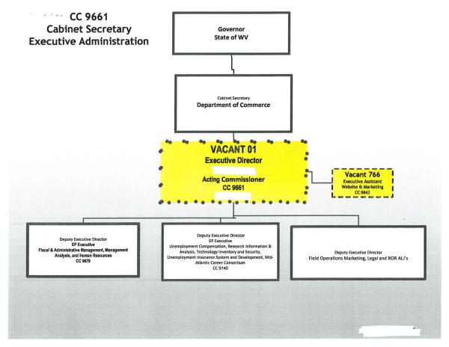
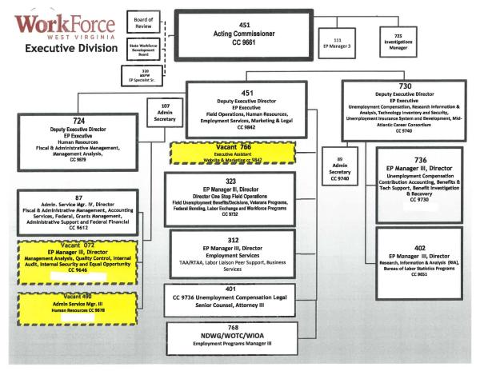
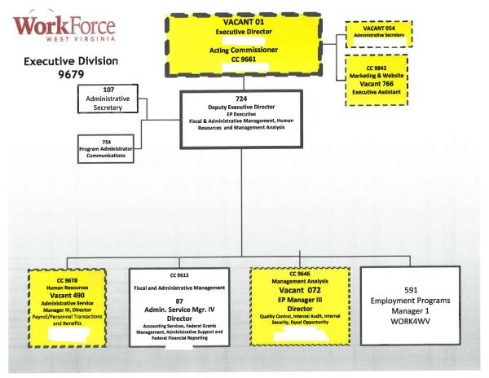
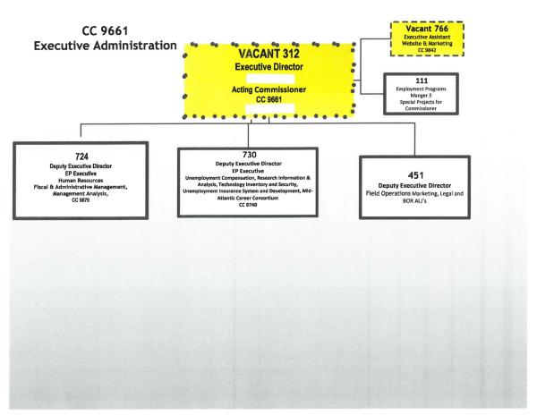
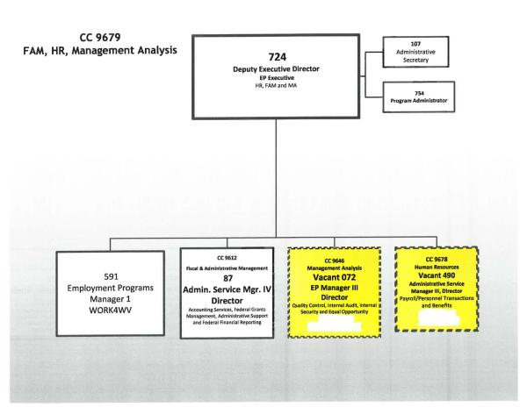
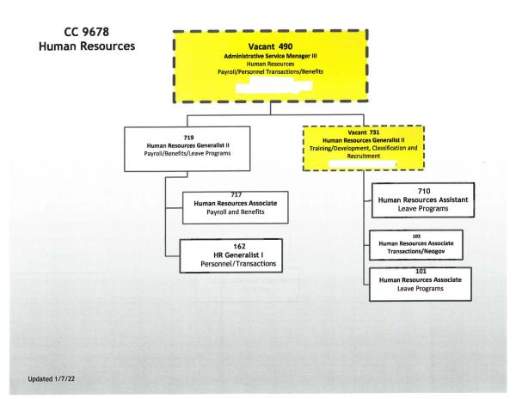
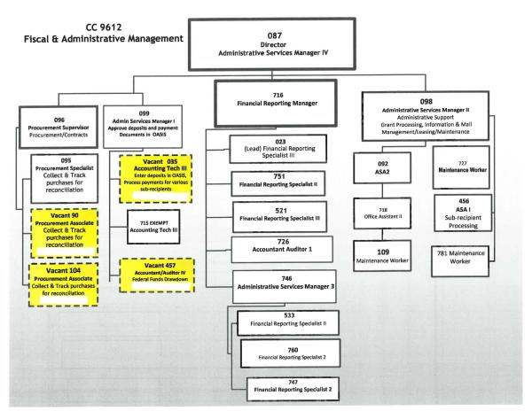
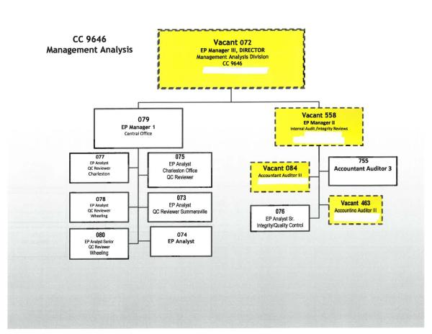
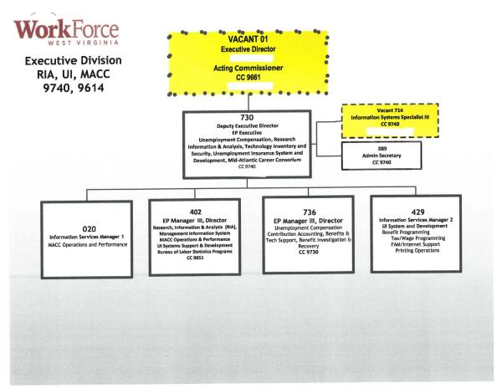
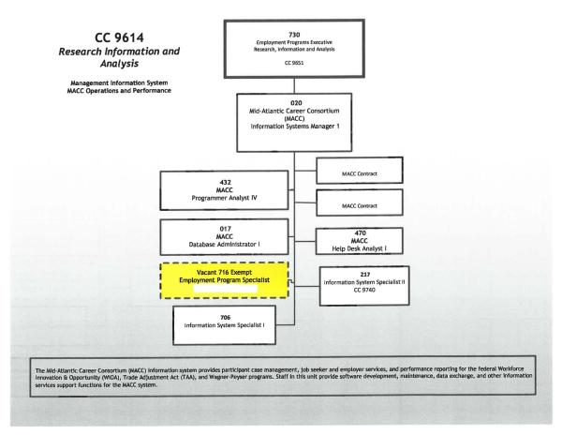
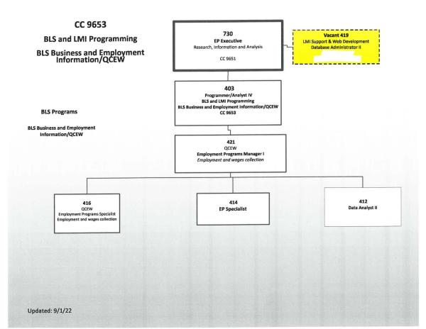
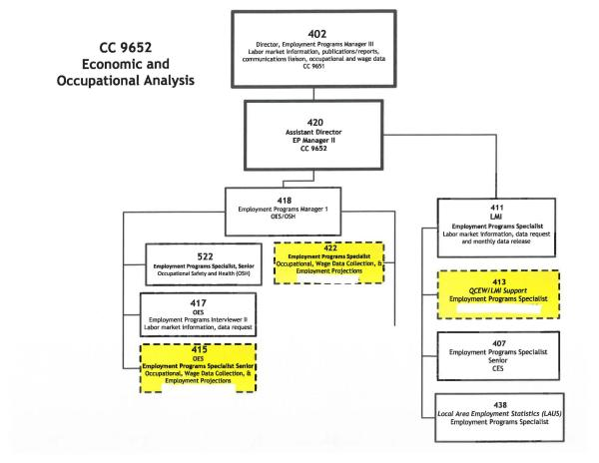
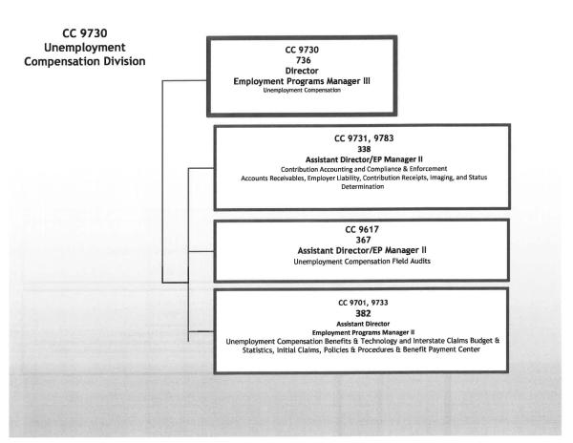
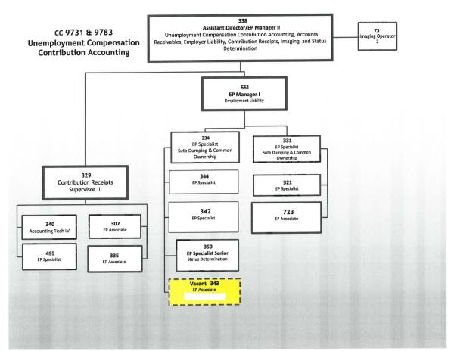
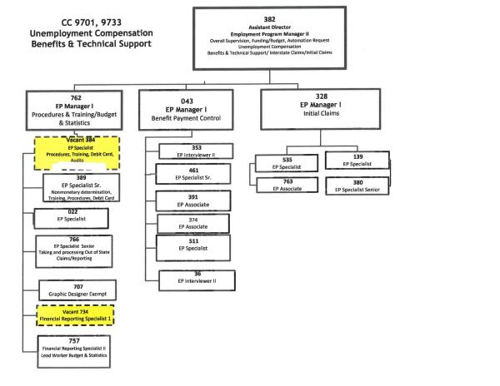
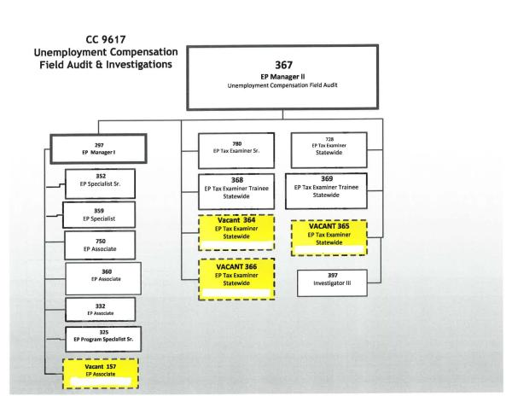
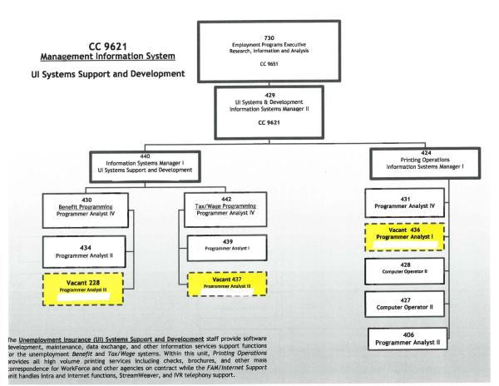
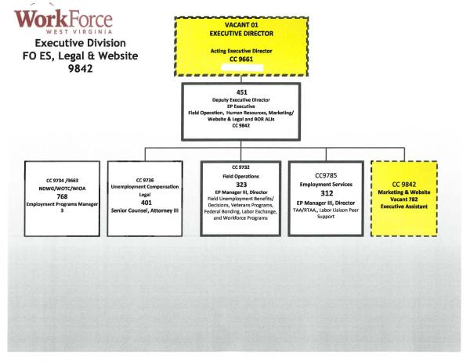
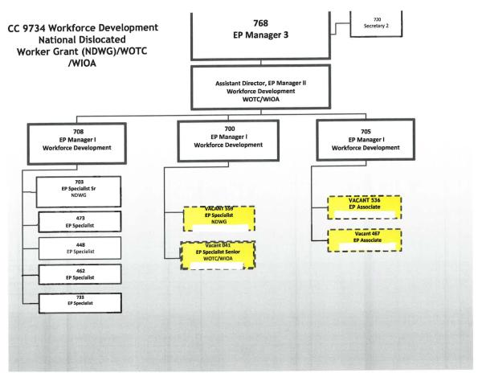
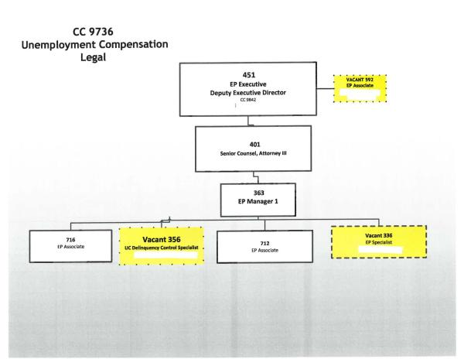
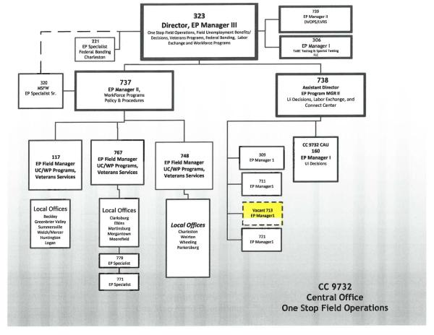
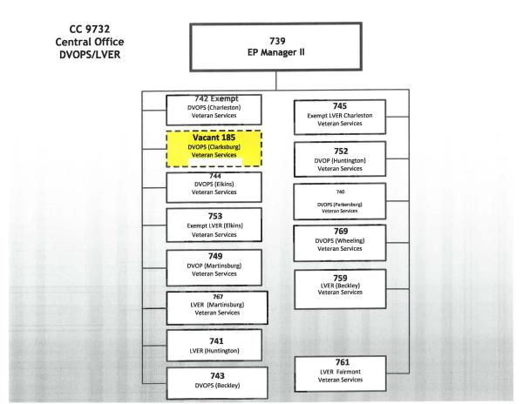
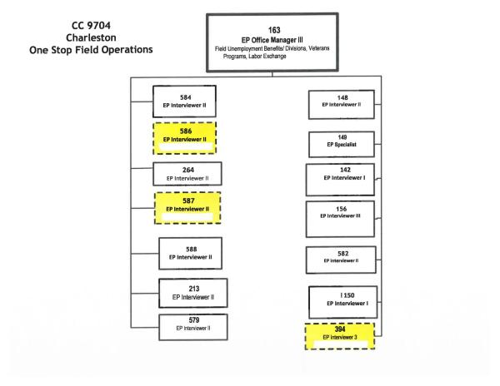
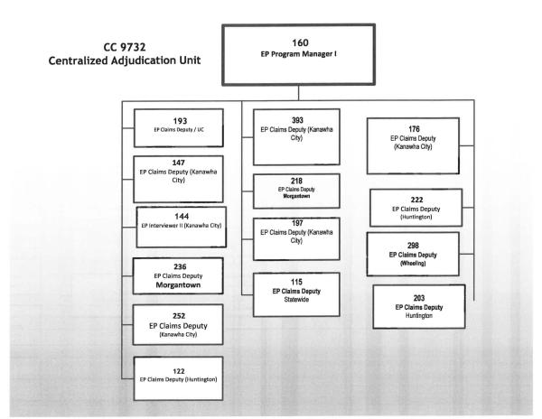
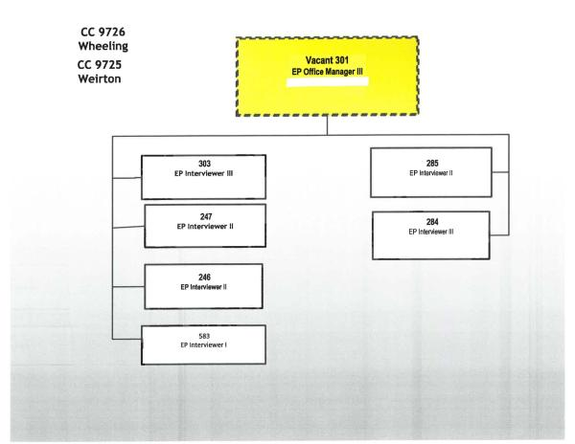
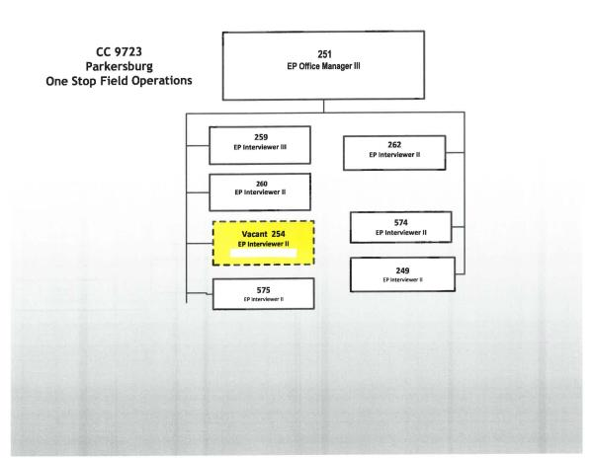
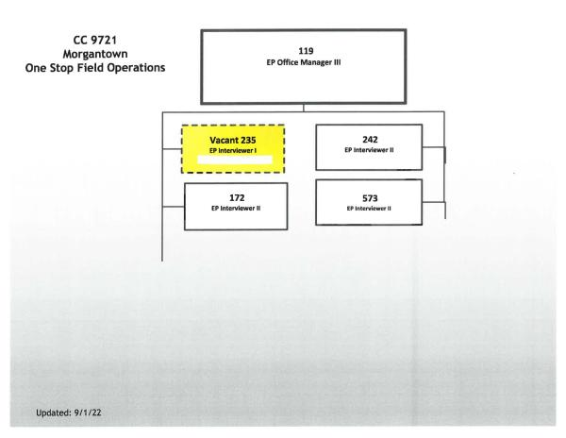
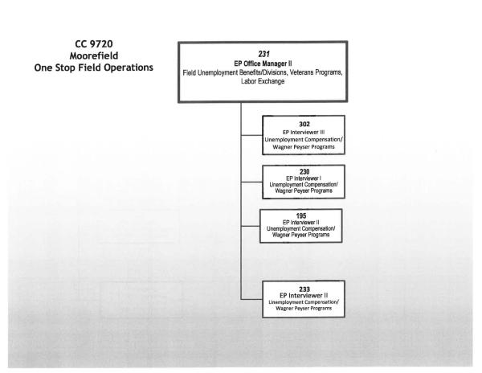
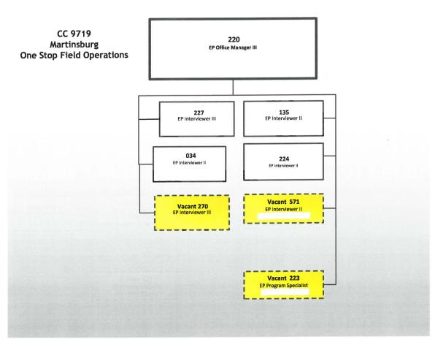
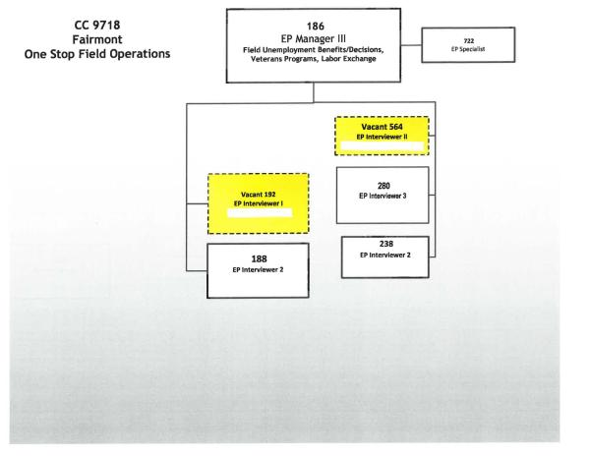
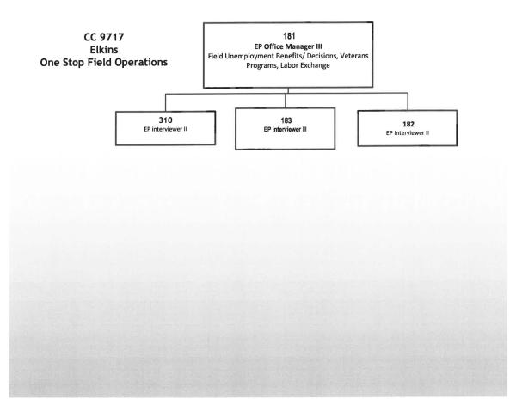
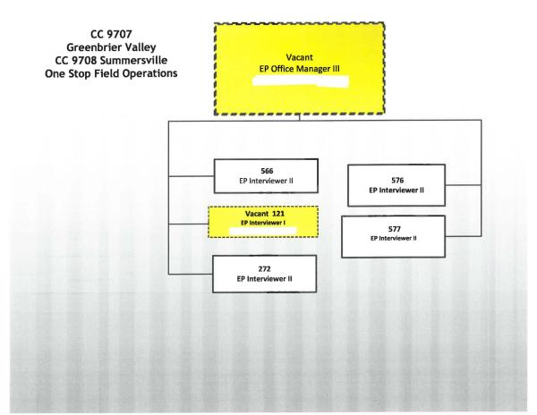
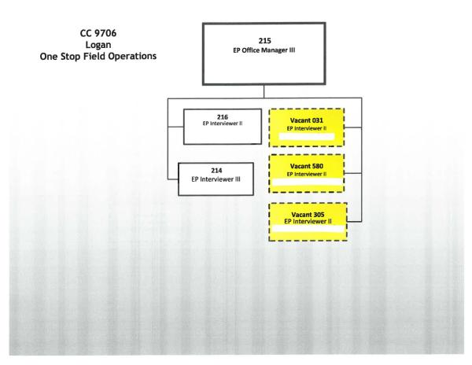
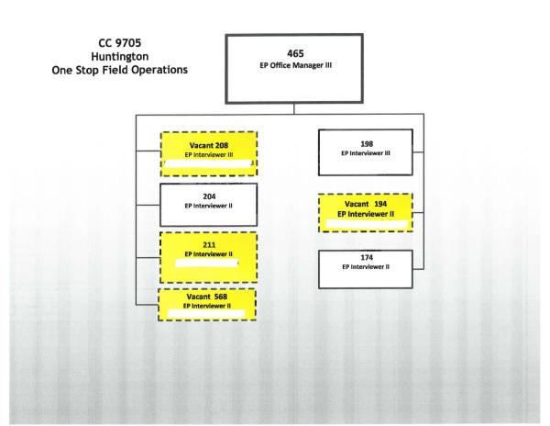
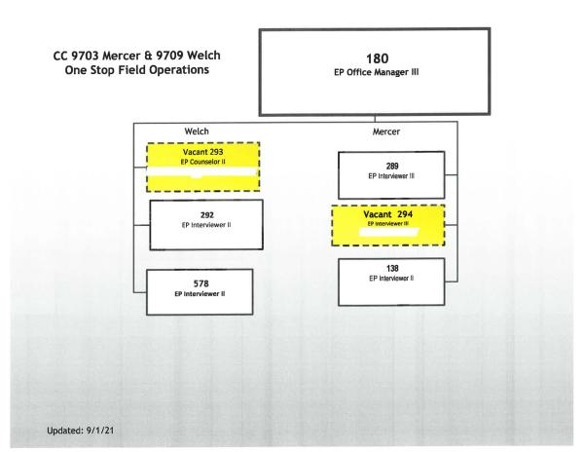
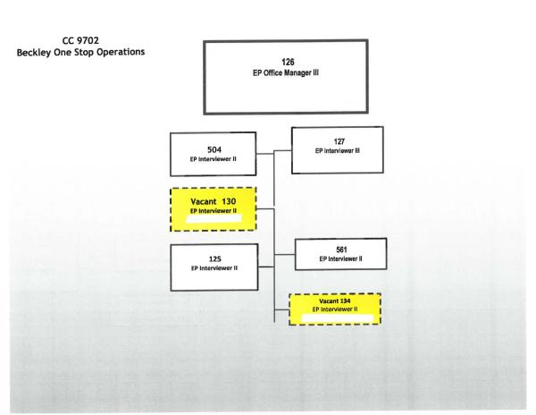
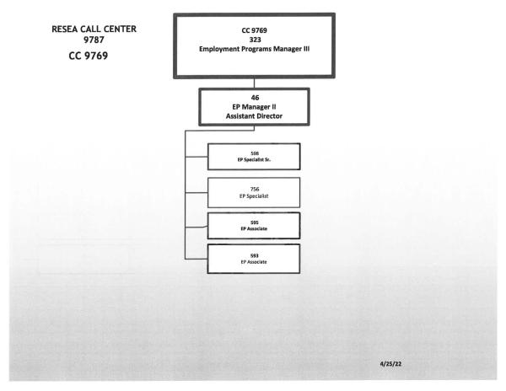
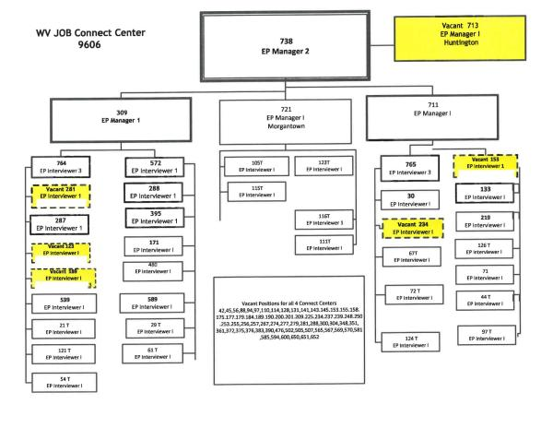
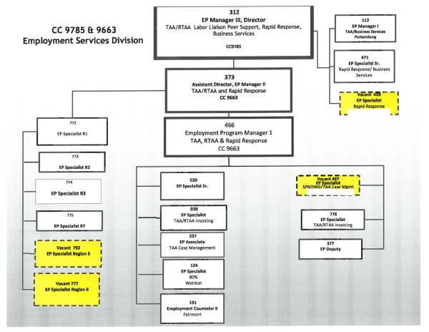
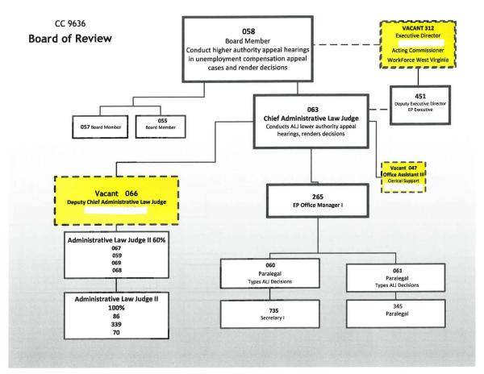
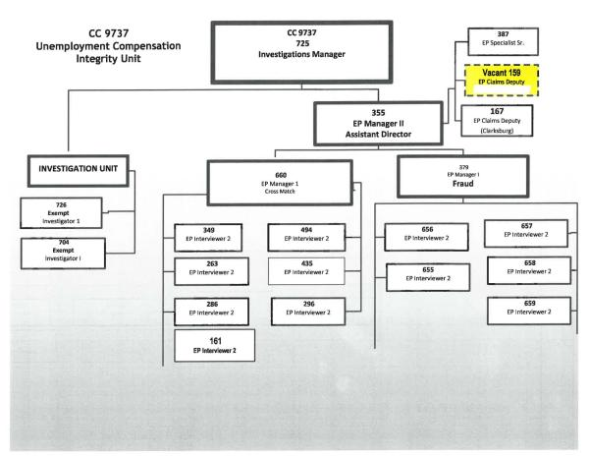

7. SQSP Signature Page
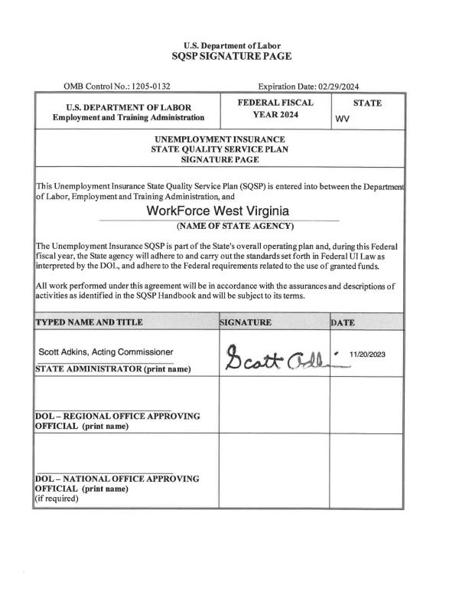

b. Requirements for States electing to include UI in the Combined State Plan

1. Submit an SQSP in the following manner depending on their timing in the SQSP cycle:

A. If a State is in the first year of their 2-year cycle, the State is required to submit the most recently approved complete SQSP package. A complete SQSP package will include the Transmittal Letter, Budget Worksheets/Forms, State Plan Narrative, CAPs (including the milestones and the completion date for each milestone), the UI IAP, Organizational Chart, and the SQSP Signature Page. One of the key goals for the UI program is to ensure that claimants are able to successfully return to work. As such, the SQSP State Plan Narrative must provide a discussion of the plan coordination with other WIOA Combined Plan programs to ensure a coordinated effort and integrated service delivery.
Please see the complete SQSP package submitted in section 'a' for all relevant elements.

B. If a State is in the second year of the 2-year cycle, the State is required to submit the most recently approved complete SQSP package with a modification that must include the Transmittal Letter, Budget Worksheets/Forms, Organizational Chart, and the SQSP Signature page. The modification may also include CAPs for new identified performance deficiencies, and any required modifications to existing CAPs. The CAP must list both specific milestones for key corrective actions or improvement activities, and the completion date for each milestone.
Please see the complete SQSP package submitted in section 'a' for all relevant elements.

2. Submit the required off-year SQSP components as a modification to the Combined State Plan on the same cycle as the regular SQSP process which must be approved by September 30th each year
Please see the complete SQSP package submitted in section 'a' for all relevant elements.

Senior Community Service Employment Program (SCSEP)

a. Economic Projections and Impact

1. Discuss long-term projections for jobs in industries and occupations in the State that may provide employment opportunities for older workers. (20 CFR 641.302(d)) (May alternatively be discussed in the economic analysis section of strategic plan.)
According to the United States Census Bureau, West Virginia’s population totaled 1,829,054 during the last conducted census in 2020. The total number of West Virginians aged 55 and older totaled 617,395, comprising 41.23% of the state’s total population (an 10.89% increase since 2010 census). Table 1-SCSEP illustrates the total population categorized by age ranges.
Table 1- SCSEP
West Virginia Population By Age Group
Age group | United States | West Virginia | Percent Total WV
15 to 19 years | 21,880,801 | 112,676 | 7.52%
20 to 24 years | 22,239,579 | 113,691 | 7.59%
25 to 34 years | 45,388,153 | 210,919 | 14.08%
35 to 44 years | 42,810,359 | 215,117 | 14.36%
45 to 54 years | 41,087,357 | 228,098 | 15.23%
55 to 59 years | 21,535,299 | 120,980 | 8.08%
60 to 64 years | 21,042,176 | 129,971 | 8.68%
65 to 74 years | 32,260,679 | 219,725 | 14.67%
75 to 84 years | 15,966,862 | 107,203 | 7.16%
85 years and over | 6,510,107 | 39,516 | 2.64%
(Source: Table 1 - SCSEP; US Census Bureau ACS 5-Year Estimates 2018-2022)
According to the Quarterly Workforce Indications (QWI), out of the twenty industries, the industry sectors that represented the largest numbers of employed seniors during 2019-2022 were Health Care and Social Assistance, Education Services, Retail Trade and Manufacturing. These sectors were the top four employers for older workers 55+ during 2019-2022. Table 2- SCSEP illustrates the industries during 2019-2022 that had the largest number of older workers.
Table 2- SCSEP
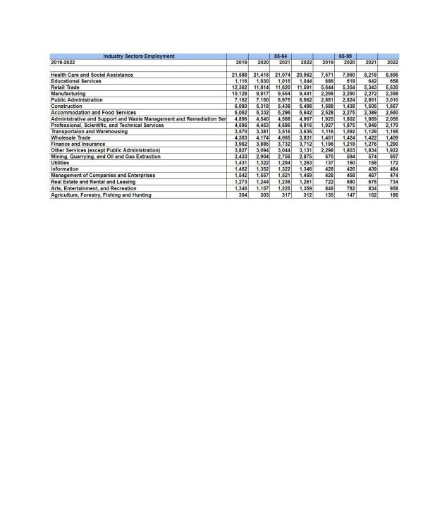
(Source: Table 2 - SCSEP; QWI, NAICS Sectors, 2019-2022)
Information from the QWI was narrowed down to display which of the 20 Industry Sectors had the highest number of hiring older workers (55+). Industry Sectors with the largest number of hires of older workers during 2019-2022 for age range 55-64 were Health Care and Social Assistance, Construction, Administrative and Support and Waste Management and Remediation Services, Retail Trade. For the age range of 65-99 the results varied. Similar to the age range 55-64, Health Care and Social Assistance was also the top employer for the age range 65-99. Educational Services, Retail Trade, Accommodation and Food Service were the remaining top employers that had the highest number of employed seniors for the age range 65-99 . Table 3 - SCSEP illustrates the industries during 2019-2022 that had the largest number of 55+ seniors hired.
Table 3- SCSEP
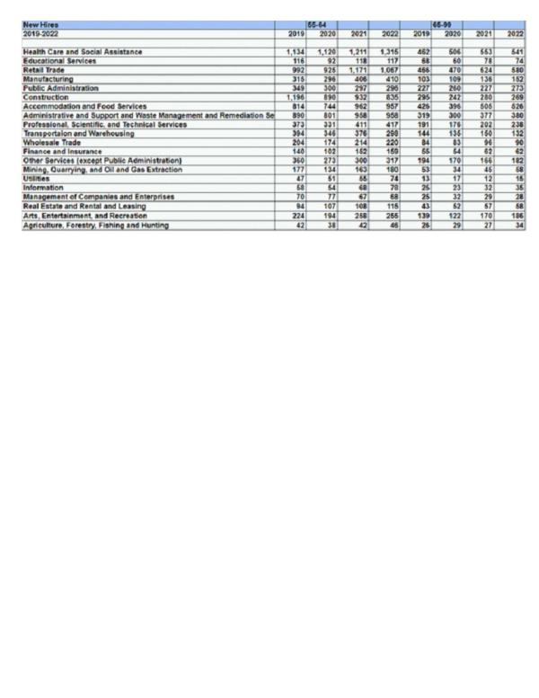
(Source: Table 3 - SCSEP; QWI, NAICS Sectors, 2019-2022)
From the information gathered in Table 3-SCSEP, the staffing patterns from the top three Industry Sectors of New Hires show employment in Healthcare and Social Assistance, Administration and Support Waste Management and Remediation Services, Construction, Accommodations and Food Services, Educational Services and Retail Trade . We can predict that these industries will continue to hire older workers, thus providing employment opportunities in the following Equal Employment Opportunities (EEO) Occupations Groups based off the Industry Sector of New Hires: Transportation, Natural Resources, Construction & Maintenance Occupations, Sales and Office Occupations, Service Occupations, Education, Legal, Community Service, Arts & Media Occupations, Management, Business & Science. EEO Occupational Groups are categorized into 14 groups and further categorized into nine job categories. Table 4-SCSEP illustrates the twelve Occupational Groups that were narrowed down from the top Industries.
Table - 4 SCSEP
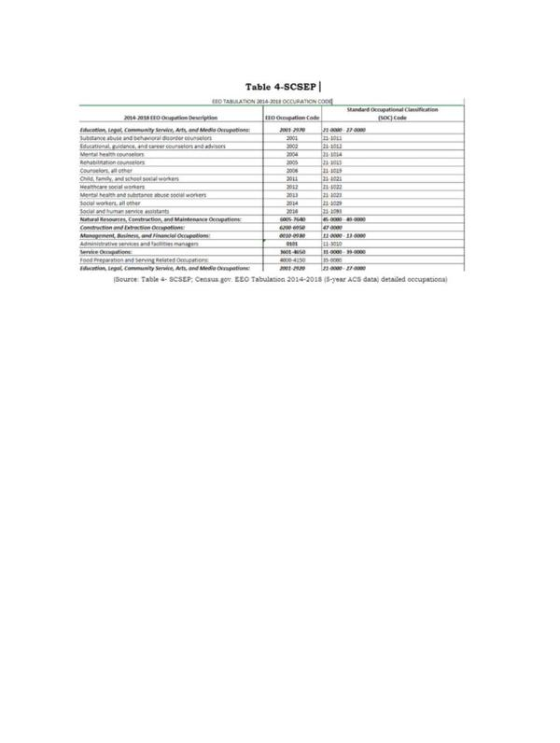

2. Discuss how the long-term job projections discussed in the economic analysis section of strategic plan relate to the types of unsubsidized jobs for which SCSEP participants will be trained and the types of skill training to be provided. (20 CFR 641.302(d))
In order to maximize SCSEP participant placement in unsubsidized employment in high demand jobs, the statewide SCSEP network; which consists of the one State and one National grantee, will focus their on-the-job training opportunities and host agency recruitment efforts with agencies that can provide training for the types of occupations that are listed in Table 3 -SCSEP that are forecasted based on Industry Sector of New Hires 2019 to hire older workers. When available, training opportunities will be increased to provide a variety of opportunities that have a higher percentage of developing into unsubsidized employment. Training for computer literacy will continue to be at the forefront, as this is a necessity in a majority of the occupations that forecast continued employment. Computer training opportunities are provided through many entities, such as local American Job Centers (AJC), local Community Colleges, and public libraries. When appropriate, program coordinators and host agencies will encourage participation in specialized computer training opportunities. SCSEP has also implemented the Senior Evolve program which provides iPads to eligible participants to help decrease technophobia, and to help improve computer skills and job searching.
Access to training classes offered by the local American Job Center and other non-profit organizations will help increase the skills that enrollees will need to continue to pursue employment. Another strategy for older workers to be placed into unsubsidized employment would be to look into occupations that require minimum training, as this would help the statewide SCSEP network meet the employment goals listed in the core measures that are set forth by DOL.

3. Discuss current and projected employment opportunities in the State (such as by providing information available under §15 of the Wagner-Peyser Act (29 U.S.C. 491-2) by occupation), and the types of skills possessed by eligible individuals. (20 CFR 641.325(c))
Per the Workforce West Virginia (WFWV), Labor Market Information (LMI) Ten(10) year projections of the high demand occupations that require minimum education and fit our SCSEP participants’ education and training levels include the following:
- • Bus Drivers, Transit and Intercity
- • Customer Service Clerks
- • Social and Human Service Assistants
- • Community Health Workers
- • Animal Caretakers • Post Secondary School
- • Personal Care Aides
- • Home Health Aides
- • Rehabilitation
- • Janitors
- • Counter Attendants
Some of these occupations require less than a high school education. Others require a high school diploma or some college. Per the data received from GPMS, the majority of our participants meet the education requirements for the jobs listed above. Hourly wages for the listed occupations start at a minimum of $10.41. Table 5- SCSEP provides the educational level of program participants. Table 5a- SCSEP showcases West Virginia's occupational projections by level of education.
Table 5- SCSEP
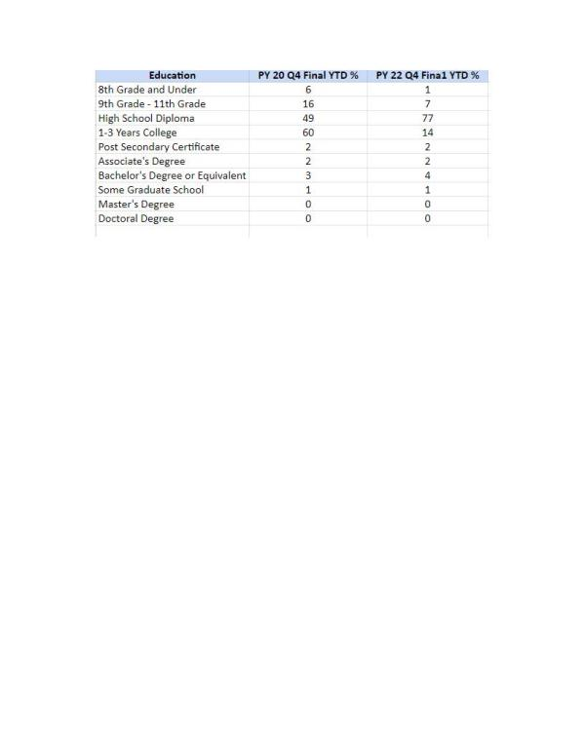
(Source GPMS; Quarterly Progress Report PY 20 & PY 22, Quarter 4 Final)
Table 5a - SCSEP
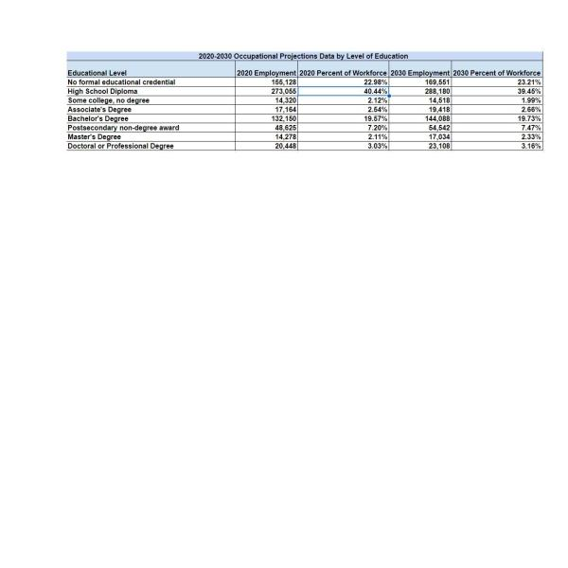
Table 6 - SCSEP illustrates the required level of education, on-the- job training, work experience required, and growth rate of each occupation.
Table 6 - SCSEP
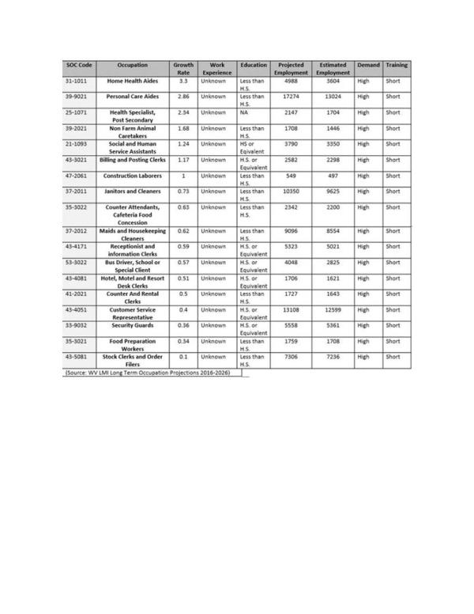
Not only does the WFWV consist of seven (7) geographic regions, the seven (7) regions each have at least one comprehensive AJC, at minimum. In total, the seven regions hold Ten (10) comprehensive centers, five (5) satellite centers and seventeen (17) affiliate sites throughout the State. One of the goals of the AJCWV is to offer job seekers and employers ready access to the many workforce development resources available in a local region. The WVWF office offers resources equally across the state as stated above. The SCSEP Network will continue to partner and utilize resources such as transition programs, adult displacement resources, utilization of the MAAC database, resume enhancement, computer classes, mock interviews and all other events that are offered at the AJC WV.
Within the seven (7) regions that WFWV has divided the state into, each region shows that Host Agency recruitment and enrollee training will have to be individualized to adapt to that particular Region’s occupational demands and projections. The SCSEP Network will maintain working relationships with all WFWV offices to obtain relevant employment and training information that pertains to that Region. Sub-grantees will continue to inform enrollees of their specific region’s occupational projections.
Also as the State continues to adapt to the unforeseen changes that have and continue to occur due to the pandemic, we will continue to develop and offer opportunities for program participants to participate when appropriate in a virtual platform to keep participants and program partners safe.

b. Service Delivery and Coordination

1. A description of actions to coordinate SCSEP with other programs. This may alternatively be discussed in the State strategies section of the strategic plan, but regardless of placement in document, must include:

A. Planned actions to coordinate activities of SCSEP grantees with WIOA title I programs, including plans for using the WIOA one-stop delivery system and its partners to serve individuals aged 55 and older. (20 CFR 641.302(g), 641.325(e))
West Virginia’s statewide SCSEP network includes the State Grantee and one National Grantee operating in WV. Communication with this network is accomplished through email and teleconference as needed throughout the Program Year. The State Grantee is the West Virginia Bureau of Senior Services, which provides a multitude of services for older Americans in West Virginia under the Older Americans Act (OAA). As the designated State Unit on Aging, the Bureau administers all OAA services throughout the 55 counties that are tailored to Older West Virginians. The Bureau maintains contracts with each of the 55 County Aging Programs, three (3) Statewide Aging & Disability Resource Centers and four (4) Area Agencies on Aging. The Bureau’s mission is to be West Virginia’s premier advocate for the provision of in-home and community-based services for the state’s seniors and others served by our programs and to be a faithful steward of the federal and state monies entrusted to our care for the provision of services throughout West Virginia.
Through a Memorandum of Understanding, the WV Statewide SCSEP network, a mandated partner, partners with the local Workforce Investment Boards operating the American Job Center (AJC)/ One-Stop Centers. The mission and vision between the AJC and WV SCSEP are to empower area employers, individuals and communities to prosper and grow the region’s economy through a workforce development system that is inherently customer-centered, seamless and effective. The mission is to establish a workforce system that provides data-driven and employer-validated talent solutions through the integration of education, workforce and economic development resources across the systems. Its vision is assisting individuals in obtaining employment.
West Virginia’s American Job Centers (AJC’s)/One-Stops are currently located within the local Workforce centers in West Virginia. All SCSEP information is disseminated throughout the AJC for other programs and to the general public. The WV Statewide SCSEP network will continue to work closely with the AJC’s to utilize the partners’ resources that are tailored to SCSEP’s target audience by co-enrolling and by providing SCSEP’s program eligibility requirements, priorities and training slots availability. SCSEP will continue to have a weekly presence at the AJC/One Stop. The Statewide SCSEP network will continue to require enrollment of SCSEP enrollees into the Local Workforce to ensure that enrollees are abreast of employment opportunities in their areas. The network will also continue to utilize all training, job postings and job fairs that are offered at the Local AJC’s and will also participate/relay information from other resources outside of the AJC’s One-Stop Partners. The WV Statewide SCSEP network will also encourage enrollees who are approaching their durational limit to enroll in other training programs to ensure a continuous improvement of skills that enrollees receive. As needs become prevalent, the WV Statewide SCSEP network will encourage AJC’s to become Host Agencies and/or consider enrollees for employment opportunities.

B. Planned actions to coordinate activities of SCSEP grantees with the activities being carried out in the State under the other titles of the Older Americans Act (OAA). (20 CFR 641.302(h))
As stated previously, West Virginia’s statewide SCSEP network includes the State Grantee and one National Grantee operating in WV. The State Grantee for SCSEP is the West Virginia Bureau of Senior Services, which provides a multitude of services for older Americans in West Virginia under the Older Americans Act (OAA). As the designated State Unit on Aging, the Bureau administers all OAA services throughout the 55 counties that are tailored to Older West Virginians. SCSEP Coordination with OAA programs, meetings and events will be continued. Information will continue to be disseminated throughout the State

C. Planned actions to coordinate SCSEP with other private and public entities and programs that provide services to older Americans, such as community and faith- based organizations, transportation programs, and programs for those with special needs or disabilities. (20 CFR 641.302(i))
The WV Statewide is a member of the Interagency Collaborative Team (ICT), which is composed of leadership from entities such as the Division of Rehabilitation, WV Correctional Industries, Veteran Services and more that represent the workforce target groups. One of the primary goals of this group is to enhance communications, maximize resource sharing and program standardization. Additionally, the Bureau sits on the WV Workforce Development Board, which is composed of key state players within the workforce arena, including legislators, members of the Governor’s Cabinet, labor leaders and corporate representatives. The main purpose of this group is to approach the system-based issues that require changes in law or formal regulations pertaining to workforce initiatives. As stated, these entities are composed of private and public key stakeholders. The WV Statewide SCSEP network will continue to maintain relationships and participate in meetings and events to guarantee that SCSEP is considered for program partnership, employment opportunities for enrollees and ultimately remains relevant in discussions regarding barriers to employment. The Bureau will remain an advocate for Older Workers in these groups.
Partnerships will be increased with organizations that provide resources on how to alleviate employment barriers throughout the state, such as transportation, rural location, age discrimination, fear of health care being discontinued due to program participation, fear of losing subsidized housing benefits, just to name a few. The Area Agencies on Aging (AAAs) who contract with county aging providers continue to be utilized and researched to determine what additional employment barriers seniors in rural/urban counties might face. Furthermore, the Bureau will take a more active approach with reaching out to AAA’s to also determine additional resources and/or training opportunities that may be available in covered areas. Faith based and community organizations will be utilized to help disseminate information regarding the program while reaching the most in need population. Also look to increase these entities as Host Sites.

D. Planned actions to coordinate SCSEP with other labor market and job training initiatives. (20 CFR 641.302(j))
The WV Statewide SCSEP network will continue to utilize the Labor Market Information (LMI) data that is county specific to ensure that enrollees are receiving the most updated training to warrant eligibility for those high demand occupations in growing industries as discussed in the “Economic Projections” of this report. Ultimate goal for enrollees is that when they leave the program, they will be better off than when they entered. Workforce WV provides quarterly information regarding the job market, as they are the clearing house of employment opportunities for State, Private and non-profit sectors. This information will be researched by the Grantee to ensure that Sub-Grantees are providing enrollees with the essential tools needed to be marketable. Also, resources such as O*net Online will be utilized to determine the necessary skills needed for different occupations that enrollees may be interested in. The WV Statewide SCSEP network will continue to participate with Boards and Commissions.

E. Actions to ensure that SCSEP is an active partner in the one-stop delivery system and the steps the State will take to encourage and improve coordination with the one-stop delivery system. (20 CFR 641.335)
As stated previously, The WV Statewide SCSEP network will continue to work closely with the AJC’s to utilize the partners’ resources that are tailored to SCSEP’s target audience by co-enrolling and by providing SCSEP’s program eligibility requirements, priorities and training slots availability to AJC partners. SCSEP will continue to have a weekly presence at the AJC/OneStop. The Statewide SCSEP network will continue to require enrollment of SCSEP enrollees into the Local Workforce to ensure that enrollees are abreast of employment opportunities, and training in their areas. The network will also continue to utilize all training, resources and job fairs that are offered at the Local AJC’s. The Statewide SCSEP network will continue to participate in quarterly meetings and retreats as this provides insight on each program that partners with the One-Stop.

F. Efforts to work with local economic development offices in rural locations.
The WV Statewide SCSEP network will continue to collaborate with entities such as the Workforce Development Board and AJC’s that have representation of local economic development offices whose presence is in both Rural and Urban locations throughout the state. Efforts will be continued to persuade these organizations to become Host Agencies. Outreach efforts to areas that have a more vulnerable populations of eligible enrollees will continue to be increased to maximize outreach efforts.

2. The State’s long-term strategy for engaging employers to develop and promote opportunities for the placement of SCSEP participants in unsubsidized employment. (20 CFR 641.302(e)) (May alternatively be discussed in the State strategies section of strategic plan.)
West Virginia’s local SCSEP projects will continue to recruit public and non-profit organizations in the communities that are covered. Local Projects will continue to advocate for older workers through presentations, brochure dissemination, poster dissemination, job fair and community Page 526 events participation and increasing awareness of the program's vision and mission to community stakeholders. We will also utilize social media as a resource to engage employers by showcasing SCSEP enrollees’ skills.
Local SCSEP projects train participants to help develop the skills and experience necessary to be competitive in the current labor markets. Due to the longevity of organizations that participate as Host Agencies, local SCSEP projects have built a rapport with current Host Agencies and past Host Agencies to consider enrollees for employment opportunities within their organization when available. They have established cooperative relationships with the local AJC and public and private employers as well. Coordination and co-location of services at the AJCs help to identify suitable job openings in high demand occupations. Local SCSEP projects will continue to build strong rapport with the communities they are in.

3. The State’s long-term strategy for serving minority older individuals under SCSEP. (20 CFR 641.302 (c))
West Virginia will continue its recruitment efforts in serving and recruiting eligible minority individuals as well as other eligible individuals. SCSEP projects will continue to locate offices in culturally and ethnically diverse neighborhoods (i.e., Community Centers, Church's). The SCSEP Network will continue to have a presence at events such as AJC collaborative events, Senior Centers, Senior listening meetings, the West Virginia Minority Business Expo, Juneteenth Celebration and Herbert Henderson Office of Minority Affairs Listening Tours to target minority audiences throughout the state. SCSEP will continue to collaborate with the State’s Minority Affairs office when available .Per the United States Census, West Virginia’s 55+ Older American population during 2020 represented 41.23 % of the overall population. Table 7a- SCSEP illustrates West Virginia demographics categorized by age, while Table 7b-SCSEP illustrates the overall race population in West Virginia.
Table 7a - SCSEP
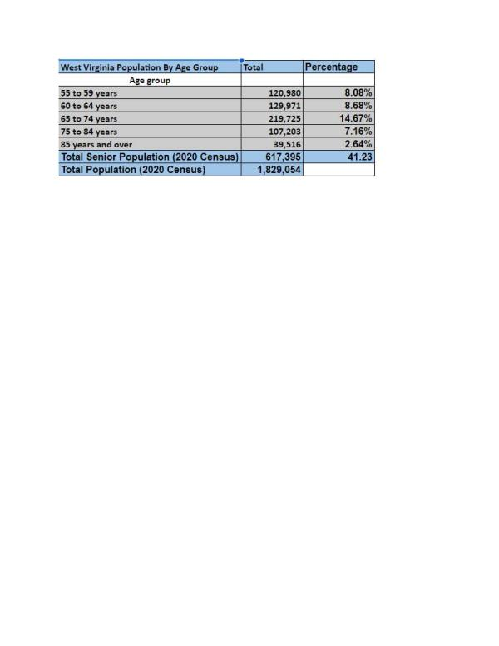
(US Census Bureau ACS 5-Year Estimates 2018-2022)
Table 7b - SCSEP
(US Census Bureau ACS 1-Year Estimates 2022)

4. A list of community services that are needed and the places where these services are most needed. Specifically, the plan must address the needs and location of those individuals most in need of community services and the groups working to meet their needs. (20 CFR 641.330)
SCSEP has a two-fold approach: helping Older Americans reacclimate themselves back into the workforce with the skills and training needed to be more marketable in the workforce while also helping the communities that the program operates in. The participant training hours support social services and other services provided in communities throughout the State.
West Virginia’s top occupations per the West Virginia Workforce, Labor Market Information (LMI) 10-year projections of high demand occupations that require minimum education that fit our SCSEP participants’ education and training levels include the following:
- • Bus Drivers, Transit and Intercity
- • Customer Service Clerks
- • Social and Human Service Assistants
- • Community Health Workers
- • Animal Caretakers
- • Post-Secondary School
- • Personal Care Aides
- • Home Health Aides
- • Rehabilitation
- • Janitors
- • Counter Attendants
With these projections, Host Agency (H.A.) training site recruitment will focus more on entities that will develop skills for these high demand jobs. Also, to ensure that SCSEP’s two-fold approach is being accomplished, local SCSEP projects will continue to research nonprofits, religious organizations and Government agencies in the counties that are covered to assess if there is a need. Recruitment of entities such as the West Virginia Department of Agriculture where they have programs such as Veterans and Warriors to Agriculture and Rural Rehabilitation programs that need participants will be utilized.
Recruiting of Host Agencies (H.A.) is currently accomplished by relationships with past and current H.A., great rapport with the American Job Centers (AJC’S), attending meetings, community events, job fairs, health fairs and presenting on behalf of SCSEP. Other avenues of recruitment include marketing campaigns, where Project Directors market SCSEP services and the skills of job ready participants to organizations. Word of mouth is also utilized to recruit host agencies.
Local SCSEP projects will continue to utilize Senior Centers, Aging & Disability Resource Centers (ADRN), OAA programs, AJC’s, and one-stop partners to determine the need in the counties and will continuously refine the strategy for job development to guide employer outreach and participant readiness. The WV Statewide SCSEP network will also continue to have a virtual Page 529 training presence to utilize in the event a training site is shut down due to circumstances at hand

5. The State’s long-term strategy to improve SCSEP services, including planned long-term changes to the design of the program within the State, and planned changes in the use of SCSEP grantees and program operators to better achieve the goals of the program. This may include recommendations to the Department as appropriate. (20 CFR 641.302(k))
The strategy to improve SCSEP services within the State is to do the following:
- • Marketing Campaign- not only disseminate information regarding SCSEP but also promote the program at key meetings to educate organizations of the Mission and Vision
- • Reach out to hiring entities to discuss SCSEP
- • Exchange information regarding eligible Older Workers with AJCs
- • AJCs become H.A.
- • Encourage cross training in training opportunities for enrollees
- • Inclusion within the WIOA State Plan
- • Provide more incentives, such as drug screenings, criminal background checks for hiring entities
- • Develop relationship with State DHHR to improve requirements for SCSEP target audience (i.e. Medicaid allotment of income)
- • Revise goals with DOL to reflect actual program funding
- • Increase funding to provide more trainings for enrollees
- • Increase H.A. recruitment for a variety of training opportunities ( I.e., having all state agencies utilize the SCSEP program)
- • Partnering with local Correctional industries to minimize recidivism rate of seniors 55+
- • Creating a virtual training platform to help most in need individuals.
These recommendations will strengthen the SCSEP program within the State, affording not only potential and current enrollees’ opportunities, but also strengthening the organizations that work with the program.
Regarding the long-term changes in the use of grantee and program operators to better achieve goals, the SCSEP network, with its sub grantees, continuously refines its expertise on the basic elements of job development by staying abreast of the many barriers that eligible enrollees face. By trying to alleviate these barriers, Sub-Grantees are continuously assessing skills of participants, revamping Individual Employment Plans, offering additional resources, preparing for exit, resume revamping through workshops and offering one-on-one interaction with SCSEP Staff. As new barriers arise, grantee staff will adapt and provide resources.

6. The State’s strategy for continuous improvement in the level of performance for SCSEP participants’ entry into unsubsidized employment, and to achieve, at a minimum, the levels specified in OAA Section 513(a)(2)(E)(ii). (20 CFR 641.302(f))
The entered employment performance goal continues to be a challenge due to various reasons such as, the untapped labor pool of seniors, difficulty tracking employment after participants leave the program, and the changing of contact information. During PY 18, the Core Performance measures were revamped from being measured as Common Measures Entered Employment and Common Measure Employment Retention to now Employment Rate 2nd and 4th quarter after exit. This major change came about with the Interim Final Rule (IFR) SCSEP Performance Accountability that was issued by USDOL/ETA on December 1, 2017. The purpose of the New Core Measures appears to be an alignment of SCSEP performance data with Workforce Innovation and Opportunity Act (WIOA) performance data to provide usable data comparisons between the programs. Prior to the adjustment, the rate of meeting the projected goals fluctuated. Table- 8 SCSEP reflects the performance of entered employment for 2nd and 4th quarter after exit during the final quarters of PY 21-23.
Table 8 - SCSEP
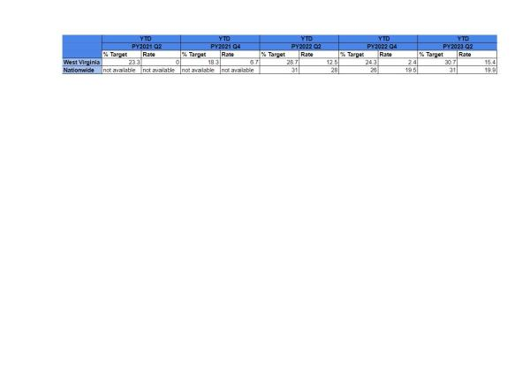
(GPMS, SCSEP data of participants entering into unemployment)
Due to the performance during the program years, our approach moving forward is to ensure that the program, specifically the employment aspect of the program, has continuous improvement, the following strategy must be implemented:
- Ensure that Sub-Grantees are aware of the LMI high-demand positions Page 532
- Provide adequate training for enrollees
- Increase accountability of job search log of enrollee
- Continue and increase partnerships with hiring entities to ensure that enrollees are being considered
- Increase H.A. sites to provide a variety of training opportunities
- Collaborate with other employment programs
- Increase program outreach and program resources
- Revamp individual employment plan (I.E.P) of individuals to ensure job search complies with employment plan
Another barrier that was identified is the majority of SCSEP’s target audience have supplemental insurance, reside in subsidized housing, and/ or receive Social Security Benefits, and because of this factor, the likelihood of them obtaining employment at the completion of the program is very slim. This is due to the fear that benefits will be lost and/or adjusted. Another strategy would be educating enrollees regarding employment and their current benefits. Eligible seniors want to work but are apprehensive due to this fear.

c. Location and Population Served, including Equitable Distribution

1. A description of the localities and populations for which projects of the type authorized by title V are most needed. (20 CFR 641.325 (d))
Most recent West Virginia U.S. Census data shows the 2020 total population for the state of WV at 1,829,054. The population of individuals who are the SCSEP target audience, 55+, shows 617,395, which is 41.23 % of the total population. Of this population, an estimate of 16.9% are at poverty rates for families and people for whom poverty status is determined.
WV partners with a plethora of State and non- profit organizations that play the role of Host Agencies (H.A.). Majority of our H.A. are unable to hire additional help within their organizations due to the limit in funding, but they express that help is needed. H.A. range from local municipalities to State agencies to a local YMCA. All H.A. are essential to the overall success of the program, as they provide the hands-on training that is needed and vital to the program.
Within the SCSEP, priority of service is offered to the following individuals:
- Veteran or a Spouse of a Veteran
- 65 Years or Older
- Has a Disability
- Has Limited English Proficiency
- Low Literacy Skills
- Resides in Rural Area
- Low Employment Prospects
- Homeless or At Risk of Homelessness
- Failed to Find Employment After Utilizing Services Provided Under Title I
- Severely Low Employment Prospects and Living in an Area of Persistent Unemployment
- Formerly Incarcerated

2. List the cities and counties where the project will be conducted. Include the number of SCSEP authorized positions and indicate where the positions changed from the prior year.
Within West Virginia, there were two SCSEP providers covering 455 authorized positions during PY 23. Modified positions during Program Year 2022 were 377. Currently, West Virginia has one National Grantee, National Council on Aging, and one State Grantee, West Virginia Bureau of Senior Services, that comprise the Statewide SCSEP Network. These grantees are experienced SCSEP administrators and are respected, capable partners. The Sub Grantee has created well-established relationships with host training sites, employers, supportive service resources and training providers.
Among these providers, they cover all 55 counties in WV. The distribution of authorizations is based on the Equitable Distribution as provided by U.S. DOL, which identifies each county’s percentage of the state’s program-eligible population.

Table 9-SCSEP represents the Authorized Positions that each grantee had during Program Year 2022 to Program Year 2023. Table 10-SCSEP goes more in-depth, showing how the counties are distributed amongst the 55 counties that are covered in West Virginia with each provider.
Table 9- SCSEP

Table 10- SCSEP
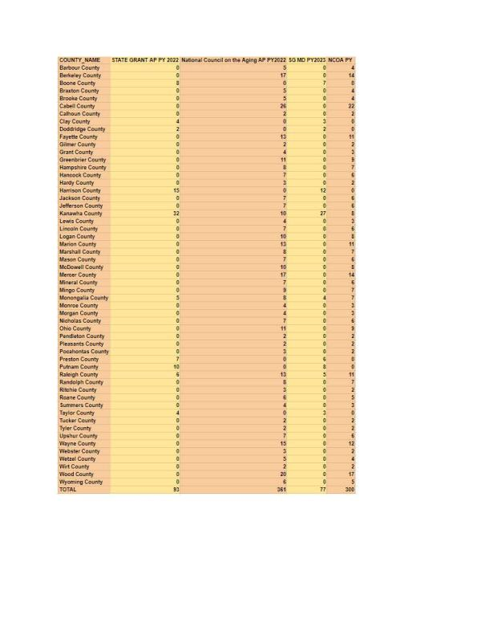
(Table 9 & 10 GPMS PY22&23, Authorized and Modified Positions by State)

3. Describe current slot imbalances and proposed steps to correct inequities to achieve equitable distribution.
Equitable distribution imbalance is caused by many factors, as shown below, that cause a variance in the slots in the Statewide SCSEP Network. The main variance factor in West Virginia is minimum wage. Due to the rising minimum wage and funding, the number of participants who can be assisted are impacted by this factor, and slots must be adjusted to meet the minimum wage fluctuations. In order to achieve the Modified Positions goal with the factors at hand, the SCSEP Network would have to minimize participant hours to accommodate more participants.
Another cause for imbalance/variance is the State’s layout. Majority of our counties are categorized as rural counties and because of this, there are many barriers such as:
- • Transportation
- • Limited training site opportunities
- • Limited hiring entities
- • Over income seniors
- • Small applicant pool
- • Unaware of program (potential enrollee and potential training)
As a State, we want to ensure that we are fully enrolled and want to minimize any variance in SCSEP’s equitable distribution enrollee count. How we will attain this goal is by continuing partnership with local WorkForce offices, continue and increase outreach in areas that are under enrolled while curtailing areas that are over enrolled and begin the discussion of interchanging information among National and State Grantees to fulfill the equitable distribution of all urban and rural counties that are under enrolled. We will also continue to secure partnerships with local AAA’s as well as trying to partner with local universities and HBCUs.

4. The State’s long-term strategy for achieving an equitable distribution of SCSEP positions within the State that:

A. Moves positions from over-served to underserved locations within the State in compliance with 20 CFR 641.365.
The U.S DOL determines how counties are distributed based on information obtained from the Bureau of Census report which is then transposed into the Equitable Distribution report for each county. The State of West Virginia SCSEP Grantee has no authority to move national grantee positions within the state; however, constant contact is maintained with the National. Conversations and recommendations to alleviate variances will continue to be discussed within the statewide SCSEP Network.

B. Equitably serves rural and urban areas.
As stated previously, West Virginia is divided into 55 counties. The State and National Grantee covers 13 urban counties collectively, with the remaining counties being considered rural. As stated previously, rural communities face a multitude of barriers such as limited resources, transportation , over income, low employment skills and more while on the other hand, Urban areas also face barriers. Barriers that Urban counties face are similar to those in Rural areas such as income requirements, duplication of efforts , low employment skills. and transportation. Efforts of dissemination of program specific material and partnership is equitable in both Urban and Rural areas. The WV SCSEP Network will continue its efforts in both urban and rural counties, specifically those counties that house individuals who are most in need will be continuously reviewed. To alleviate the imbalances, the SCSEP Network will continue and increase outreach (i.e., brochures, posters, partnerships and presentations) efforts in the rural counties to ensure that nonprofits and government entities are aware of the program.

C. Serves individuals afforded priority for service under 20 CFR 641.520. (20 CFR 641.302(a), 641.365, 641.520)
Program regulations require SCSEP Grantees to give priority service to individuals with one or more of the following characteristics:
- Veteran or a Spouse of a Veteran
- 65 Years or Older
- Has a Disability
- Has Limited English Proficiency
- Low Literacy Skills
- Resides in Rural Area
- Low Employment Prospects
- Homeless or At Risk of Homelessness
- Failed to Find Employment After Utilizing Services Provided Under Title I
- Severely Low Employment Prospects and Living in an Area of Persistent Unemployment
- Formerly Incarcerated
The statewide SCSEP Network employs the following tactics to ensure that individuals who meet the criteria above are targeted:
- Outreach Materials (brochures and posters) are strategically placed at locations that target our priority of service audience (i.e. Veterans Hospitals, shelters, library, rehab disability office, parole services, etc.)
- Locates offices in culturally and ethnically diverse neighborhoods
- Targets AJC’s
- Presents and collaborates with entities that target low income populations
- Collaborates with National Grantee on successful tactics utilized

5. The ratio of eligible individuals in each service area to the total eligible population in the State. (20 CFR 641.325(a))
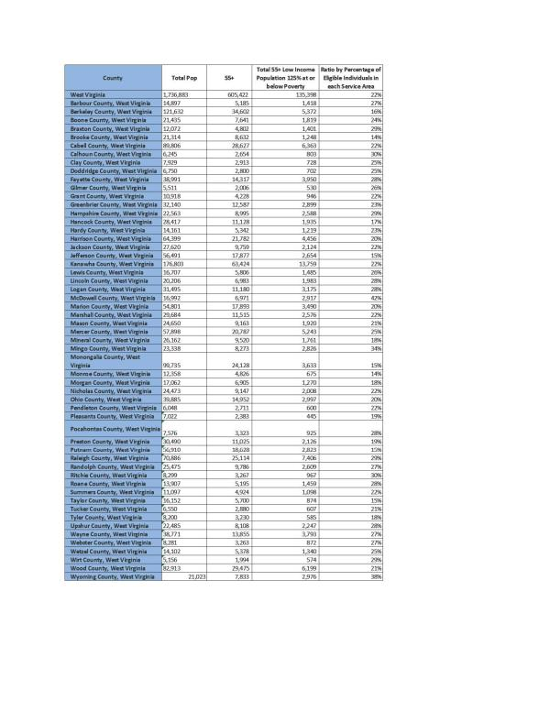
(Source B17024-ACSDT5Y2022)

6. The relative distribution of eligible individuals who:

A. Reside in urban and rural areas within the State
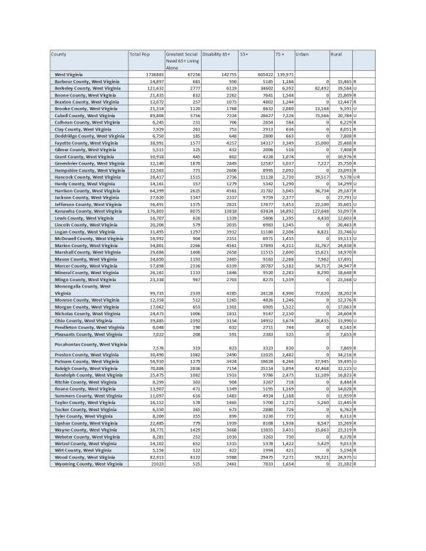
(65+ living alone and disability ACSDP5Y2022, P2 Urban/Rural)

B. Have the greatest economic need
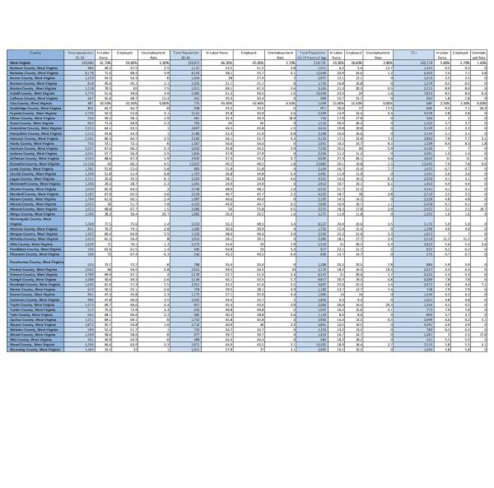
(Source: ACSST5Y2023 S2302)

C. Are minorities
Table 14 - SCSEP
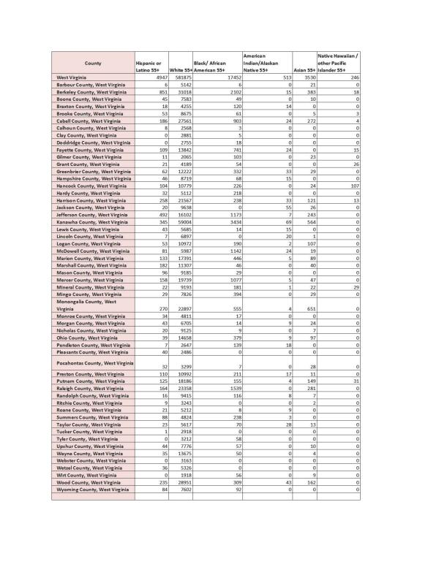
(Source : ACSDT5Y2022 B01001A-E)

D. Are Limited English Proficient
Table 15 - SCSEP

(Source:B17024- ACSDT5Y2022)

E. Have the greatest social need. (20 CFR 641.325(b))
Table 16 - SCSEP
(65+ living alone and disability ACSDP5Y2022, P2 Urban/Rural)

F. Formerly incarcerated individuals, as defined in TEGL 17-20
The WV SCSEP Network will continue to partner with the WV Division of Corrections and Rehabilitation and with entities whose target audience are the formerly incarcerated population. Entities that provide transitional housing will continue to provide referrals to the SCSEP program. The WV SCSEP Network will continue to provide outreach materials to case managers and parole officers so they are aware of the program’s mission. Table 20-SCSEP shows the formerly incarcerated release in each county of all ranges. Table 21-SCSEP further narrows down the data to illustrate formerly incarcerated individuals of the SCSEP target audience.
Table 17 - SCSEP

(West Virginia Department of Corrections and Rehabilitation FY 2022 Annual Report)

7. A description of the steps taken to avoid disruptions to the greatest extent possible, when positions are redistributed, as provided in 20 CFR 641.365; when new Census or other reliable data become available; or when there is over-enrollment for any other reason. (20 CFR 641.325(i), 641.302(b))
In the event new providers are entered into the state, be it National Grantee or State Grantee, we will utilize the Equitable Distribution to ensure that slots are distributed to all grantees. To avoid disruptions to current participants, a conversation with all affected Grantees in the state will be required. Counties with continuous variances will be considered. For a seamless transition, enrollees will be transferred in the GMPS database, which will allow the avoidance of disruption in service. Per Topic 81 of the SCSEP Data Collection Handbook, all records moved from the “old grantee” to the new are subject to data validation. During the transfer, we will ensure that all supporting documentation is sent via trackable delivery to the “new” grantee.
In response to the Covid-19 pandemic or any future outbreaks, to avoid disruptions in the event an agency shuts down or an enrollee becomes ill, the WV SCSEP Network has established a virtual training program platform for enrollees to participate in to encourage continuous growth and avoid disruption of services while recuperating.

Community Services Block Grant (CSBG)
(a) The Community Advancement and Development division (WVCAD) of the West Virginia Department of Economic Development administers the Community Services Block Grant (CSBG) to 16 Community Action Agencies throughout the State. The program has established active partnerships to facilitate and encourage coordination between the 16 Community Action Agencies (CAAs) participating in the State’s CSBG program and statewide and local workforce development systems. Several CAAs have executed memoranda of understanding with local workforce development agencies to foster greater workforce development coordination. The usual role of a CAA in workforce development is to provide supplemental services that assist employment goals. These goals are decided locally based on a community needs assessment. Whereas a workforce agency provides assessment and job training, CAAs often provide funding for resume writing, job-related clothes and tools, and transportation to interviews or to a place of employment.
(b) One Community Action Agency provides funding for car repair assistance for individuals who have been employed consistently for at least one year, meet our income guidelines, and are in need of a vehicle repair in order to continue their employment.
One Community Action Agency provides on the job training to laid off coal miners and others who are laid off due to the decline in the coal industry in trade areas including but not limited to plumbing, electrical, HVAC, welding, and construction.
A CAA in the North Eastern part of the state provides Fiscal management for the One-Stop Centers. As part of the direct service the CAA provides funds to assist with removing employment barriers such as assisting with the cost of textbooks, licensing, testing, special employment related clothing and other items necessary for the client to become employed after the training.

Performance Indicator Appendix

All WIOA Core Programs

Adult, Dislocated Worker, and Youth Activities - Adult Program Performance Indicators
Performance Indicators | PY 2024 Expected Level | PY 2024 Negotiated Level | PY 2025 Expected Level | PY 2025 Negotiated Level
Employment (Second Quarter After Exit) | 72.7% | 73.0% | 72.8% | 74.0%
Employment (Fourth Quarter After Exit) | 70.5% | 71.0% | 71.0% | 72.0%
Median Earnings (Second Quarter After Exit) | $6368.00 | $7000.00 | $6436.00 | $7500.00
Credential Attainment Rate | 82.9% | 79.0% | 84.9% | 80.0%
Measurable Skill Gains | 48.1% | 48.0% | 50.7% | 50.0%
Effectiveness in Serving Employers | Not Applicable ¹ | Not Applicable ¹ | Not Applicable ¹ | Not Applicable ¹
¹
The Departments have not issued the final rule defining Effectiveness in Serving Employers. As a result, states will not submit expected levels of performance for this indicator and the Departments will not establish negotiated levels of performance for PYs 2024 and 2025.

Adult, Dislocated Worker, and Youth Activities - Dislocated Program Performance Indicators
Performance Indicators | PY 2024 Expected Level | PY 2024 Negotiated Level | PY 2025 Expected Level | PY 2025 Negotiated Level
Employment (Second Quarter After Exit) | 79.6% | 79.0% | 81.6% | 80.0%
Employment (Fourth Quarter After Exit) | 83.0% | 83.0% | 83.7% | 84.0%
Median Earnings (Second Quarter After Exit) | $9697.00 | $10500.00 | $9893.00 | $11000.00
Credential Attainment Rate | 84.3% | 83.0% | 84.5% | 84.0%
Measurable Skill Gains | 43.3% | 44.0% | 43.5% | 45.0%
Effectiveness in Serving Employers | Not Applicable ¹ | Not Applicable ¹ | Not Applicable ¹ | Not Applicable ¹
¹
The Departments have not issued the final rule defining Effectiveness in Serving Employers. As a result, states will not submit expected levels of performance for this indicator and the Departments will not establish negotiated levels of performance for PYs 2024 and 2025.

Adult, Dislocated Worker, and Youth Activities - Youth Program Performance Indicators
Performance Indicators | PY 2024 Expected Level | PY 2024 Negotiated Level | PY 2025 Expected Level | PY 2025 Negotiated Level
Employment (Second Quarter After Exit) | 65.7% | 65.7% | 66.5% | 66.5%
Employment (Fourth Quarter After Exit) | 64.6% | 64.6% | 67.7% | 67.7%
Median Earnings (Second Quarter After Exit) | $3432.00 | $3600.00 | $3450.00 | $4100.00
Credential Attainment Rate | 60.2% | 61.0% | 60.3% | 62.0%
Measurable Skill Gains | 46.9% | 50.0% | 49.8% | 51.0%
Effectiveness in Serving Employers | Not Applicable ¹ | Not Applicable ¹ | Not Applicable ¹ | Not Applicable ¹
¹
The Departments have not issued the final rule defining Effectiveness in Serving Employers. As a result, states will not submit expected levels of performance for this indicator and the Departments will not establish negotiated levels of performance for PYs 2024 and 2025.

Wagner-Peyser Act - Wagner Peyser Program Performance Indicators
Performance Indicators | PY 2024 Expected Level | PY 2024 Negotiated Level | PY 2025 Expected Level | PY 2025 Negotiated Level
Employment (Second Quarter After Exit) | 61.6% | 61.6% | 61.6% | 61.6%
Employment (Fourth Quarter After Exit) | 66.8% | 64.0% | 66.8% | 65.0%
Median Earnings (Second Quarter After Exit) | $6411.00 | $6500.00 | $6411.00 | $6700.00
Credential Attainment Rate | Not Applicable | Not Applicable | Not Applicable | Not Applicable
Measurable Skill Gains | Not Applicable | Not Applicable | Not Applicable | Not Applicable
Effectiveness in Serving Employers | Not Applicable ¹ | Not Applicable ¹ | Not Applicable ¹ | Not Applicable ¹
¹
The Departments have not issued the final rule defining Effectiveness in Serving Employers. As a result, states will not submit expected levels of performance for this indicator and the Departments will not establish negotiated levels of performance for PYs 2024 and 2025.

Adult Education and Family Literacy Act Program - Adult Education and Literacy Program Performance Indicators
Performance Indicators | PY 2024 Expected Level | PY 2024 Negotiated Level | PY 2025 Expected Level | PY 2025 Negotiated Level
Employment (Second Quarter After Exit) | 30.1 | 43.0% | 31.0 | 43.1%
Employment (Fourth Quarter After Exit) | 36.0 | 38.2% | 37.0 | 38.5%
Median Earnings (Second Quarter After Exit) | $2700 | $3950 | $2800 | $3951
Credential Attainment Rate | 40.0 | 40.0% | 41.0 | 41.0%
Measurable Skill Gains | 53.0 | 49.0% | 54.0 | 49.5%
Effectiveness in Serving Employers | Not Applicable ¹ | Not Applicable ¹ | Not Applicable ¹ | Not Applicable ¹
¹
The Departments have not issued the final rule defining Effectiveness in Serving Employers. As a result, states will not submit expected levels of performance for this indicator and the Departments will not establish negotiated levels of performance for PYs 2024 and 2025.

Vocational Rehabilitation Program (Combined or General) - Vocational Rehabilitation Program Performance Indicators
Performance Indicators | PY 2024 Expected Level | PY 2024 Negotiated Level | PY 2025 Expected Level | PY 2025 Negotiated Level
Employment (Second Quarter After Exit) | 74.1% | 74.1% | 74.2% | 74.2%
Employment (Fourth Quarter After Exit) | 69.6% | 69.6% | 69.7% | 69.7%
Median Earnings (Second Quarter After Exit) | $6,529.88 | $6,530.00 | $6,530.00 | $6,830.00
Credential Attainment Rate | 47.5% | 49.0% | 47.6% | 50.0%
Measurable Skill Gains | 47.8% | 47.8% | 47.9% | 47.9%
Effectiveness in Serving Employers | Not Applicable ¹ | Not Applicable ¹ | Not Applicable ¹ | Not Applicable ¹
¹
The Departments have not issued the final rule defining Effectiveness in Serving Employers. As a result, states will not submit expected levels of performance for this indicator and the Departments will not establish negotiated levels of performance for PYs 2024 and 2025.

Additional Indicators of Performance
Additional Indicators of Performance
Not applicable

Other Appendices
Not applicable.

